XPS/TPD/ISS Chamber

Manual

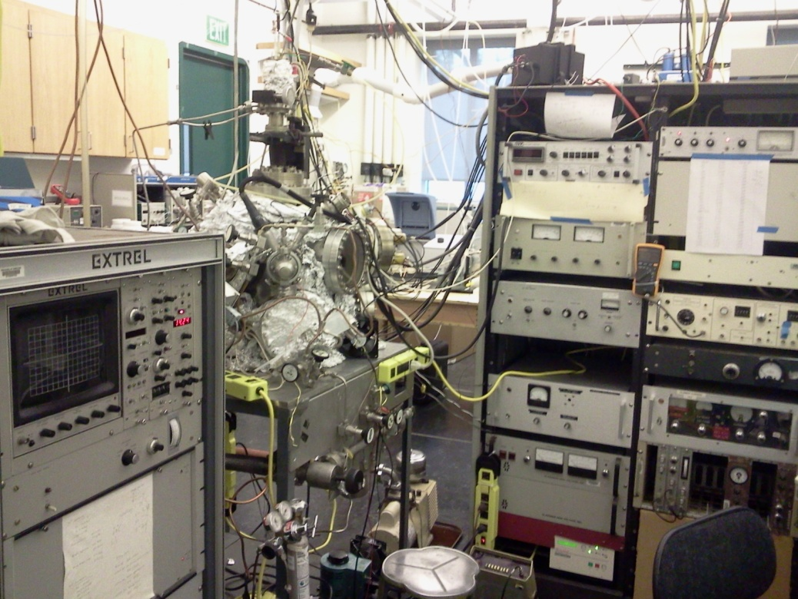

Revised by Yunxi Yao in December 2013

Updated by Bo Chen in November 2018

Table of Content:
- General Considerations/Overview of Equipment 5
- Vacuum System 5
  - Evacuating the system 5
  - Venting the instrument 5
  - UHV bake out 6
  - Ion gauge, Pressure reading, Filament replacement and maintenance 7
  - General maintenance 7
  - Leak detection 8
  - What to do after a power outage 8
- Sample 9
  - Mounting: 9
    - Metals 9
    - Semiconductors 9
    - Thin Film deposition (SiO₂ doser) 14
  - Repair of manipulator (wiring, etc.) 16
  - Heating, cooling, troubleshooting 17
  - Cleaning: 19
    - Chemical cleaning 19
    - Ar sputtering 19
    - How to determine that it is clean 20
  - Temperature reading 20
  - Heating power supply (operation, calibration) 20
- Gas handling, gas manifold 21
  - Design, schematics 21
  - General operation procedure 21
  - Gas and Liquid sample handling 22
  - H Radical production and dosing 24
  - Maintenance 25
  - Valves, regular and to UHV 26
  - Pressure gauges 26
- Mass spectrometer 26
- Extrel Mass
  - General operation: 26
    - Turning on, off, keeping in stand by 26
    - Displaying in Oscilloscope 26
    - Recording MS in PC 28
    - Calibration 29
    - Maintenance (filament, detector, etc.) 29
    - MS Control Panel Values 29
- UTI Mass
    - General operation 30
    - Turning on, off, keeping in stand by 30
    - Displaying in Oscilloscope 32
    - Recording MS in PC 32
    - Resolution adjustment 33
    - Calibration 33
- Temperature Programmed Desorption (TPD) 35
- Extrel Mass
  - General Considerations 35
  - Software 35
  - How to take TPD data 35
    - General details 35
    - Running procedure 36
    - Data acquisition 36
    - Data processing 37
    - Editing 38
- UTI Mass
- General Considerations 38
- Program 38
- Data acquisition and processing 39
- Electron and Ion Energy Analyzer 39
  - General considerations 39
  - Initial Operation 39
  - Turning the X-rays on 39
  - Turning the X-rays off 39
  - Maintenance 40
  - Replacing the Anode 40
  - Replacing the Filament (Cathode) 40
  - Replacing the Aluminum Window 40
- Electron Energy Analyzer and Detector System 41
  - Electron Energy Analyzer 41
    - General Considerations 41
    - Initial Operation 41
    - Turning the Analyzer on 41
    - Turning the Analyzer off 41
    - Typical Settings 41
    - Calibration 42
    - Maintenance 42
  - Detector 42
    - General consideration 42
    - Typical operation 42
    - Servicing/changing the multiplier 42
  - Software 42
  - How to take XPS data 42
    - General details 42
    - Running procedure 42
    - Data acquisition 43
    - Data processing 44
    - Editing 44
- Ion Sputtering Gun 44
  - General considerations 44
  - Typical operation 44
  - Alignment and calibration 44
    - Central spot position 44
    - Rastering 44
  - Sample cleaning 44
  - Low Energy Scattering data acquisition 44
- Potential hazards and safety procedures 45
- Other Items 45
- Appendices 46
Appendix A Temperature conversion table 47
Appendix B TC preamplier output 48
Appendix C Mass spectrometer setting 49
Appendix D Parameter for mass spectrometer 50
Appendix E- Working parameter for ion gauge, TC, and XPS 52
Appendix F- Sample holder Figure 56
Appendix G- Program installation 56
Appendix H- TPD program manual 59
Appendix I-Home-made Cu doser 67
Appendix J - Repair 70

- General Considerations/Overview of Equipment

The XPS/TPD/ISS chamber consists of a main chamber equipped with an Extrel mass spectrometer (to the left of the viewport), an X-ray source with an Mg/Al anode (to the right of the viewport, two ports over), a hemispherical energy analyzer (immediately to the right of the viewport), an Ar sputter gun (immediately to the left of the viewport ), and an electron gun (above the viewport) (currently replaced by TSP feedthrough). The end of the mass spectrometer comes to a cone, which forms the end of an energy analyzer system with lenses and focusing optics for use with secondary ion mass spectrometry (SIMS). The vacuum is maintained by a turbomolecular pump, mounted to the back of the chamber through a UHV-valve. The pump is operated by a power supply at the bottom of one of the electronics racks. To the left is the electronics rack that supports the mass spec and to the right are 2 electronics racks which contain the control electronics for the X-ray source, the analyzer, the ion gun, the electron gun, and the pressure readout

- Vacuum System

a. Evacuating the system
The system vacuum is maintained by a turbomolecular pump combined with a mechanical pump. Before evacuating the system, make sure all the flanges are tight.
- First turn on the mechanical pump, wait until the chamber pressure in the 30-50×10⁻³ torr range, which usually takes 10 to 20 minutes.
- Then turn on the turbo-molecular pump and wait the turbo pump to reach “normal operation” status, usually it takes 5 to10 minutes.
- After half an hour, Ion gauge can be turned on to check the chamber pressure. By then the pressure should be around 1×10⁻⁶ torr.
Note: Do not keep the ion gauge on with the chamber pressure higher than 1×10⁻⁶ torr in order to extend the life time of the filament of the ion gauge.

b. Venting the instrument
As a rule, the chamber is vented with liquid nitrogen (LN₂).

- Switch off the ion gauges by pressing "OFF" on the pressure gauge readout.
- Switch off the mass spectrometer by pressing "ON/OFF".
- Close all the leak valves.
- Wait at least 20 min for the thoroughly cooling down of the hot filaments.
- Close the valve between the turbo pump and the mechanic pump.
- Turn OFF turbo pump, wait until it is fully stopped, which can be seen through the front view window.
- Put the venting tube between the valve and turbo pump into a LN₂ tank
- Open the valve at the end of the venting tube slowly to fill the chamber with nitrogen.
- The venting process is done evidenced by the thawing of the condensed ice on the outsides of the venting tube. Fully open the valve to make sure the pressure inside the chamber equal to atmospheric pressure before open the vacuum chamber
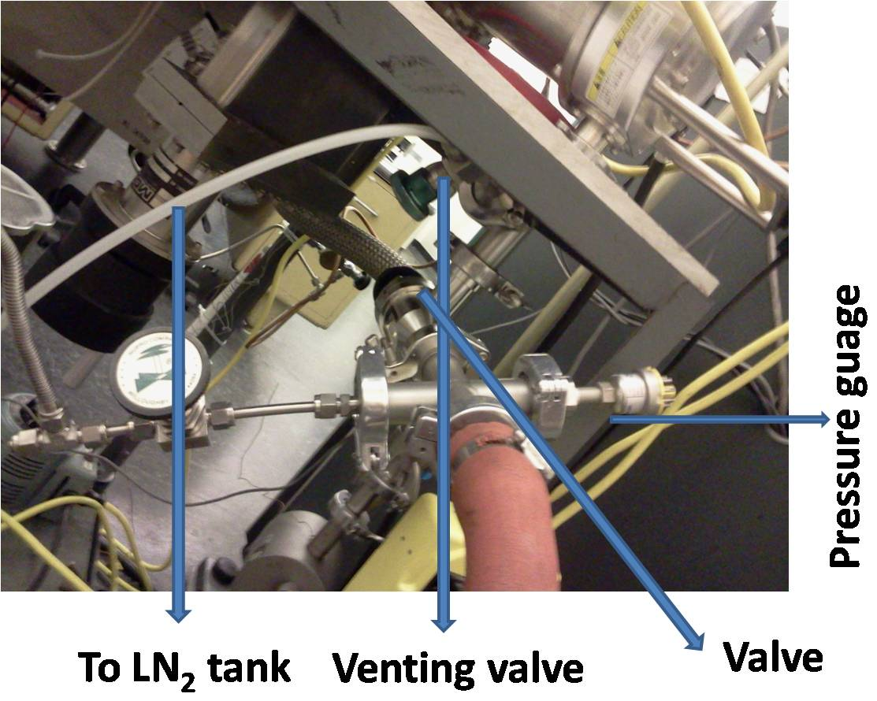

c. UHV bake out
- Before bake out the chamber, make sure the system is thoroughly evacuated with the vacuum pressure reading lower than 1 x 10⁻⁶ Torr.
- Remove cooling water of X-ray gun, and blow out the water inside the X-ray gun with dry air.
- Wrap a heating tape and aluminum foil around the bellows on the manipulator.
- Wrap a heating tape and aluminum foil around the sputter gun, X-ray gun, X-ray photoelectron spectrometer (should be there already).
- Start the bakeout process. Use approximately 80 V for the main chamber and the heating tapes. Turn on the I.R. lamps.
- Bake the chamber for about 24 hrs. The pressure should come down to the lower 10-8 Torr regime during the bakeout.
- When the bakeout is completed, switch off the heating tapes and the IR lamps and let the chamber cool down to room temperature. Leave the aluminum foil covers on the viewports during this cooling.
- When the chamber is at room temperature, it is ready to use!
Note: it is necessary to remove the cooling water for the X-ray gun and blow out the water inside the cooling tube. Otherwise severe consequence can be resulted. (It indeed happened before. The X-ray gun was leaking water caused by the long time bakeout with the cooling water on). It is necessary to wait long time for the electron energy analyzer to cool down to room temperature. The inside temperature can be higher than the outer surface after bakeout. Over-night cooling is suggested before the electron energy analyzer can be turned on safely.

- Ion gauge, Pressure reading, Filament replacement and maintenance

- The UHV-pressure is monitored by the ion gauge on the main chamber. The ion gauge is switched on and off by turning leftmost knob on the front of the pressure gauge control. The pressure is displayed on the meter, with the rightmost knob indicating the decade reading (i.e., 10-n where 4 < n < 11). The wires for filament, grid etc. are labeled.
- The lifetime of ion gauge depends on the environment where it works. Replacement of filament is often happened after both of the filaments are burned off. The filament can be easily replaced by a tungsten wire or tungsten belt. Tungsten belt is suggested if available, because it is more easily spot-welded to the supporter.
- The insulating ceramic of the grid and collector should be kept clean. Carbon deposits can cause short-to-ground of the grid or the collector. If happened, the carbon deposits can be cleaned and removed by sand paper
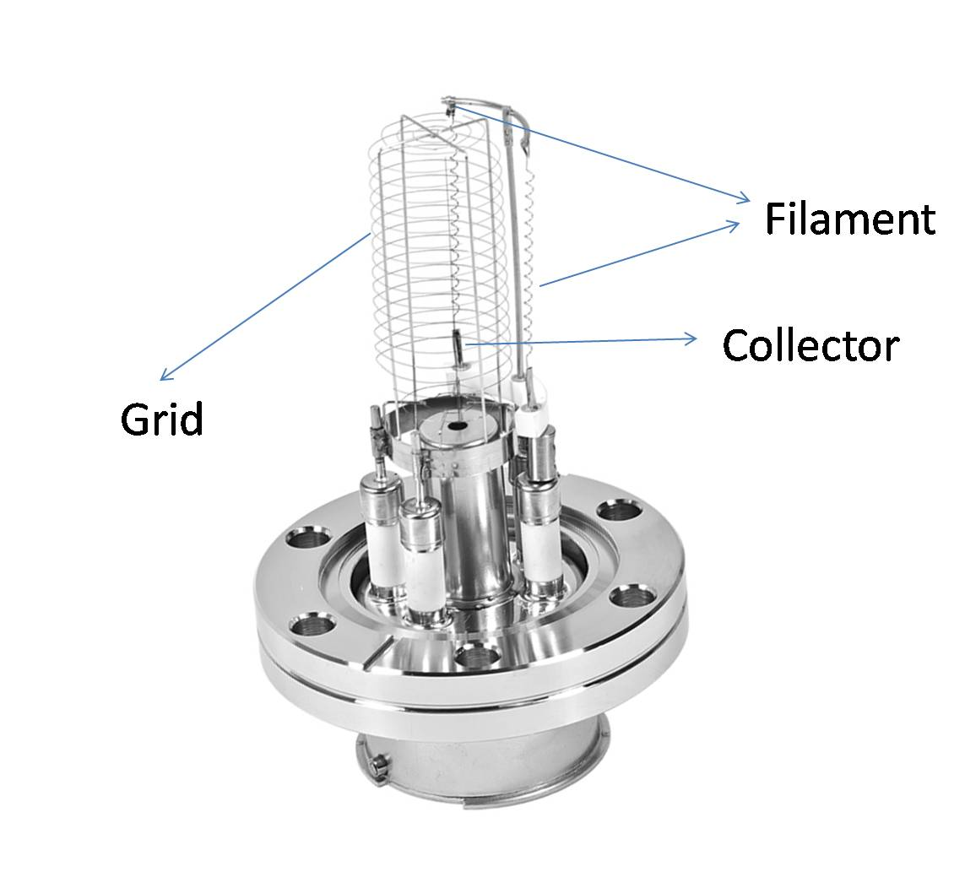

- General maintenance
During normal operation, keep eyes on the vacuum pressure and the status of the pump. The turbo pump is cooled by a fan. Make sure the cooling fan is working. Oil change is needed for the mechanical pump, usually once half a year. Keep the oil level in the proper range, between Min and Max.

- Leak detection
Chamber leaks are usually first noticed after the bakeout procedure. They can be located by blowing helium onto the outside of the chamber while monitoring the 4 amu signal with the mass spectrometer.

- Monitor the signal for 3 to 5 amu traces by using TPD software.
- Apply a tiny flow of helium through a syringe or something like that on all flange connections, feedthroughs, view ports etc. The He flow is sufficient if you can just feel it on your wet lips. Concentrate first on the parts that have been opened before the last bakeout.
- The intensity of the He peak in the mass spectrum should increase immediately upon spraying helium on the leak.
- Vent the chamber and repair the leak.

There is also a leak detector in the department which can be used. In principle, the UHV chamber could be checked with this leak detector. If you want to do this, do it immediately after closing the chamber, before starting to pump.

- What to do after a power outage
Procedure for Power Outage with Notice
- The preparation for the power outrage with notice is similar to normal venting the chamber.
Turn off all the filaments (mass spectrometer and ion gauge), wait long enough (20 min) for the cooling of the filament. Turn OFF the turbo pump. Close the valve between the turbo pump and mechanic pump. Vent the chamber with LN₂ after the turbo pump fully stops. Turn OFF and Vent the mechanic pump (to prevent the backflow contamination of pump oil), which is different from the normal venting process where the mechanic is not needed to be OFF.

Procedure for Power Outage Unexpected
- When unexpected power failure happens, first close the valve between the turbo and the mechanic pump. Put all the power supply to OFF position, especially those for filaments, such as power supply for ion gauge, mass spectrometer and X-ray gun.
Caution: The power cable connection of the turbo controller is loose. That could cause power cut if the cable is touched.
- Vent the mechanic pump.
- If the power outage is expected to last a long time, vent the main chamber with LN₂.
- If the power is back shortly, first turn on the mechanic pump, after several minutes, turn on the turbo pump and open the valve between the turbo and mechanic pump. After the turn pump reaches its normal status, Ion gauge can be turned on to check the vacuum of the chamber.

- Sample
  - Mounting:
    - Metals
Metal samples are supported and heated by tantalum wires at the end of the sample manipulator. The details of mounting a metal sample are as follows:
- Move the sample all the way back past the mass spectrometer (x=10 mm or so).
- Vent the chamber.
- Clear the desk and create an open space.
- Pull out the small tubes that are inside the 1/4" copper tubes, disconnect the heater connectors and the thermocouple.
- Take out the manipulator by opening the big 8" flange. Be careful not to break the ceramic feedthroughs at the end of the manipulator. The manipulator is very heavy (about 50 lbs. or so)! Ask for assistance if you are not sure you can lift it! Put the manipulator on the desk.
- Weld the sample to the tantalum wires. If necessary, clean the back of the crystal with a flat file. To weld, you can put the sample face down on a lab jack covered with Kimwipes and press it gently against the tantalum wires. Also, the copper wires can be bent a little to better center the sample in the chamber.
- Replace the (chromel-alumel) thermocouple wires: CHECK WITH A MAGNET FOR THE PROPER CONNECTION! The alumel wire is magnetic, the chromel is not.
- Verify that the thermocouple works by heating the sample with the heat gun. If the wires are connected correctly, the voltage on the thermocouple output increases with heating (8.0 mV can be reached easily). DO NOT PUT THE SAMPLE BACK IN THE CHAMBER BEFORE MAKING SURE THAT THE THERMOCOUPLE WORKS!
- Put a new copper gasket around the manipulator and attach the manipulator to the chamber.
- Connect the heating wires to the copper tubes, put the small tubes back into the 1/4" copper tubes by carefully pushing them in, and reconnect the thermocouple.

    - Semiconductors

For this system, no efficient way was found for mounting semiconductor sample. The main problems for semiconductor samples is the linear heating and temperature measurements. The follows show the method developed by Dr. Taesung for mounting of silicon wafer samples.

1. The procedure to mount a Si wafer
a) Cut a Si wafer to appropriate size, using a diamond pencil.
b) Make a tungsten clip with tungsten wire (1.0 mm diameter)
To make a tungsten clip
1) The information about a W wire
Vendor : ESPI metals (www.espimetals.com)
Specification : 0.04”DX12”L, Purity : 99.98%
Lot number : DK11207
2) Heat the tungsten wire until it emits light, using the torch in a fume hood. Bend the tungsten wire with two long nose fliers while making it hot.

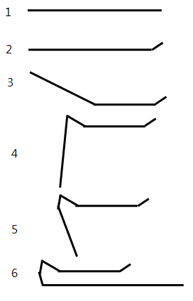
< the procedure to bend a tungsten clip>
End part should be adjusted according to the offset.
3) Etch clips to remove a tungsten oxide on the surface.
Make a 10wt % NaOH solution. Prepare a small power supply (~5V, 30mA). Connect a copper gasket to (-) electrode and tungsten clip to (+) electrode. Turn on the power supply and increase the current and vias voltage (~15mA, 1V). Stanley knows how to do that.

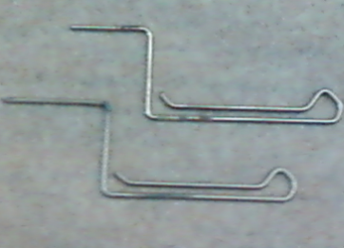
< tungsten clip after etching>

a) To avoid the abrupt transition from the semiconductor to metal during the heating process, 0.2 mm Ta foil was placed on the backside of a Si(100) wafer. (Glue doesn’t work because it decomposed when the sample is annealed over 1000K)

b) Thermocouple was glued by ceramic glue and attached on top of the backside of the silicon wafer. To avoid the outgassing from the glue, very small amount was used (~1.5 mm diameter). Thermocouple was attached on the Si wafer to measure the temperature directly by cutting the Ta Foil and making a small room on top of silicon. (To improve the attachment, make a scratch at the backside of Si wafer with diamond pencil)

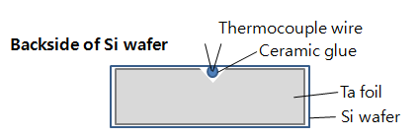
<configuration of TC and Ta Foil>

Information about a ceramic glue
Vendor : Aron alpha (http://www.aronalpha.net/index.html)
Specification : 150g
Product name : Aron ceramic E

c) Two tungsten clips (ɸ1.0 mm) are connected to copper blocks which contacts feed through. The copper blocks are similar with the current one, but was modified just a little to insert the tungsten clip. The other ends hold the silicon wafer as shown in the picture. Tungsten rod is strong enough to hold the sample at high temperature.

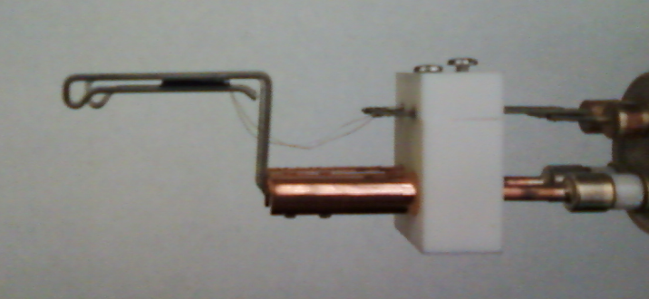
<Side view>

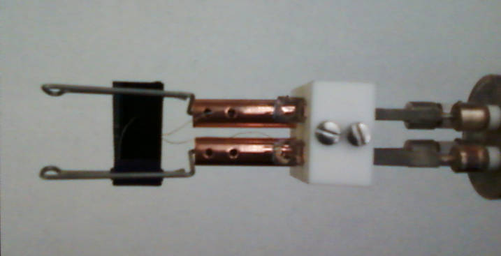
<Front view>

2. To heat the Si wafer

The substrate can be cooled to 87K and showed the constant heating rate up to 900K as shown in the following figure. In addition it can reach to 1140K.

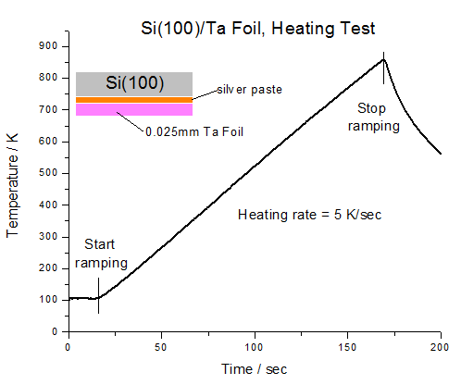
<Sample ramping from 87 K to 900 K>

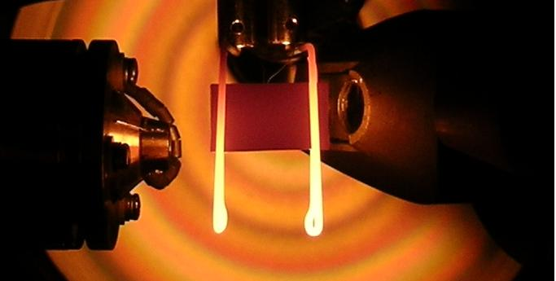
<To check the uniformity at 1040 K>

3. Si Sample cleaning

According to the literatures, the typical way to cleaning a Si wafer is to heat the sample to 1200K. It is known that SiO₂ layer is desorbed as SiO radicals. One interesting thing is that SiO desorption takes place at the interface between Si and SiO₂ layer.
The following XPS spectrum showed that O1s is getting smaller as the sample temperature increases and that the oxygen intensity is very small after heating to 1140K. In Victor chamber, the heating wire was too long to reach 1140K and it was shorten to 1m.

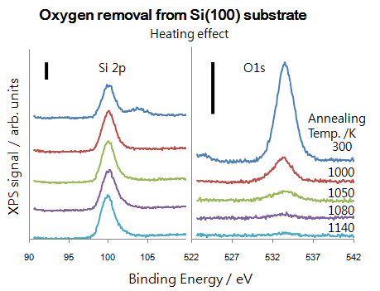

< Sample cleaning by heating a Si wafer>

    - Thin Film deposition (SiO₂ doser)

<Schematics of Si-doer>

    - Si-doer is made of a Si-wafer piece wrapped by a W-wire. The Si wafer piece is heated by passing current（10 A）through the W-filament. The current can be measured by a multimeter during deposition of SiO2. The actual current depends on the size of the filament, the O2 partial pressure, and the desired flux of SiO2 deposition. The higher O2 partial pressure, the higher flux of SiO2 deposition.

    - Usually 10 nm SiO2 thin films can be prepared by depositing SiO2 from Si-doer in about 1x10-5 torr O2 for 60 min with a current about 10 A passing through the filament at the substrate of 300K and subsequent annealing in O2 at 1000 K for 10 min. Note: the Si-doer flux should be compatible with the O2 pressure, otherwise partially oxidized SiOx samples can be prepared evidenced by the appearance of Si 2p XPS peaks between 99 and 103 eV.

    - SiO2 thin films on Si(100) and Ta plate: XPS spectra

SiO₂ thin film grown on Si(100) walfare
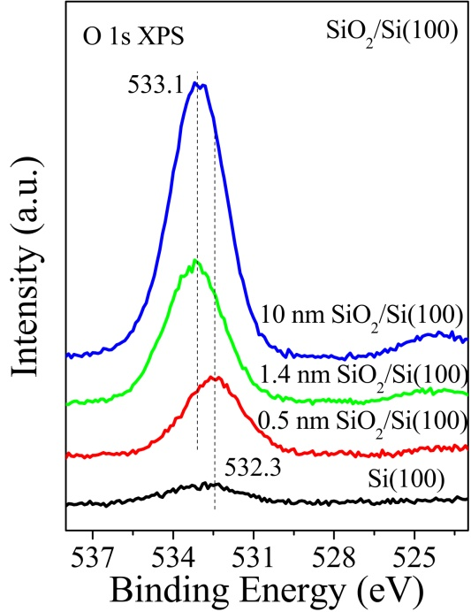
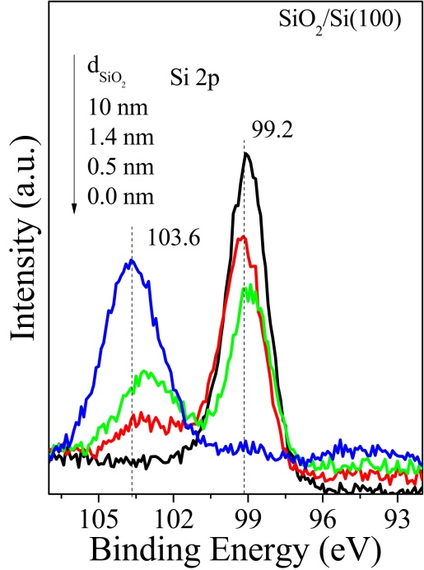

Si 2p and O1s XPS spectra of SiO₂/Si(100) prepared by depositing SiO₂ from a Si-doer in 1x10⁻⁵ torr O₂ for different times, followed by annealing to 1100 K in 1x10⁻⁵ torr O₂ for 10 min. The thickness of SiO₂ was estimated by the ratio of Si⁴⁺/Si⁰ combined with the electron inelastic mean free path in SiO₂ (λ=3.2 nm used in this case.)

SiO₂ thin film grown on Ta plate
Ta 4f, O 1s and Si 2p XPS of 10 nm SiO₂/Ta. SiO₂/Ta was prepared by depositing SiO₂ in 1x10⁻⁵ torr O2 at room temperature and subsequently annealed at 1100 K. (sample left in the chamber)

  - Repair of manipulator (wiring, etc.)
The sample sits at the end of the tube which comes in from the top of the chamber and can be rotated and moved to all the analysis positions by the manipulator at the top. The exact position of the sample is read from the scale on the right of the manipulator, the x and y micrometers, and on the rotary. The two copper wires that run through the manipulator tube are used for heating the sample while the funnel is used to add liquid nitrogen to cool the sample. The sample is grounded through the thermocouple wires near where these wires come out of the tube.
The rotary is differentially pumped by the same roughing pump that backs the turbo pump, but the pressure cannot be measured. Also note that the roughing pump backing the turbo is much better that the one on the gas manifold and therefore the two should not be switched.

NOTE: Always make sure that the sample is raised above the analysis level before rotating it to avoid bumping it into any equipment.

If the thermocouple wires or the copper tubes inside the manipulator need to be worked on, the manipulator has to be taken out to get in there. This is a lot of work, so try to avoid having to do this!

- First take out the manipulator as described above.
- Open the mini-flange at the end of the manipulator tube. BE CAREFUL. If you cannot do this without possibly damaging the sample surface, take the sample off and put it in a secure place.
- Carefully pull out the tubes: This may take some effort. Avoid tearing the sleeves around the tubes. This may cause shorts later. Also, be careful not to break the ceramics.
- Remove the copper gasket and discard it.
- The copper tubes are connected with set screws. Loosen the set screws and pull the tubes off. When you reconnect the copper tubes, make sure that they do not touch each other or ground. If they do, the sample cannot be heated.
- The thermocouple wires are spot welded to the feedthrough connectors. If you replace the T.C. wires, make sure that each wire goes to the right connector (check with a magnet! see above). Twist the thermocouple wires to reduce signal pickup due to magnetic fields.

REMEMBER TO PUT ON A NEW COPPER GASKET ON THE FEEDTHROUGH FLANGE BEFORE PUTTING THE MANIPULATOR TOGETHER.

- Carefully tighten the feedthrough flange with an Allen wrench.
- Leak testing of the feedthrough flange is strongly recommended before putting the sample back into the chamber. To do this, put a KF25 welding piece with a conical rubber ring (the ones chemists use for filtration) around it into the hole on the back of the manipulator. The leak detector is then connected to the KF25 flange. This is not a great connection, and it will actually leak, but it is good enough to check for leaks on the feedthrough.
- If necessary remount the sample and thermocouple wires.

  - Heating, cooling, troubleshooting
The sample is heated with an AC current supplied by the temperature controller through a transformer.

To use the temperature controller for heating:

The transformer must be plugged into the socket in the back of the temperature controller.
The thermocouple coming out of the manipulator must be plugged into the yellow TC-socket in the back of the controller.
The sample must be properly grounded!

See the Ramping Temperature Controller manual for a detailed description of the temperature controller. An important thing to notice is the little light below the variac which indicates that the controller is (trying) to heat the sample. The intensity of this light is an indication of the heating power. The maximum heating power is set with the variac on the front of the controller, typically about 50%. A SETTING too high may result in melting of the heating wires on the sample suppoRT!

If necessary, the sample can be heated by a variac connected to the transformer: Connect the transformer input to a variac and regulate the heating power with the variac. Never connect the transformer directly to a power outlet! This causes a very high heating current which will melt the heating wires.

Troubleshooting Sample Heating

Symptom: the sample does not get hot:
bad connection somewhere in the heater circuit. This could be inside or outside the chamber. The connector to the copper tube may be loose, the wire may be loose in the connector, the wires may be not well connected to the transformer, or the sample support wires in the vacuum are burnt out. The temperature controller operates normally in this case.
Thermocouple is not plugged in, or the thermocouple circuit is broken. In this case the red LED-indicator labeled "TC open" on the front of the temperature controller lights up, and the output power is interrupted to protect the sample support/heating wires.

Symptom: Temperature reading is not stable; the temperature controller may be heating irregularly.
One of the thermocouple wires is touching ground. The critical spot is the point where the thermocouple wires come out of the manipulator: the insulation may be rubbed through here.
Sample is not properly grounded.

Symptom: heating is very slow, though a lot of power is used.
Probably the sample support/heating wires are getting loose. This happens after some time and if it gets too bad, the sample has to be spotwelded again. If this is the case, cooling will be slow; and the lowest temperature that can be reached will be higher.

How to Cool the Sample

The sample is cooled by introducing liquid nitrogen at the top of the chamber through a funnel.

- Turn on the heating tape wrapped around the rotary stage of the manipulator (use a variac at about 30 v). If the rotary is not heated while using liquid nitrogen, ice may build up and it could leak when you try to rotate the sample!
- Insert a funnel into the small inlet at the top of the feedthrough. Then slowly add about one quarter cup of liquid nitrogen (filtered by a piece of cloth to remove ice) into the manipulator. During the experiment, liquid nitrogen should be added a little at a time (about every 5 minutes) in order to maintain a boiling liquid phase in the manipulator. This will prevent ice from forming on the inside.
It takes, typically, about 20 min. to cool the sample down from room temperature to about 100 K. Once the manipulator is cold, cooling is much faster (5-15 min, depending on the contacts between the heating wires and the sample in the vacuum). If the cooling is slow, check to make sure that the heater power on the temperature controller has been switched off. Otherwise it is possible that the sample heating/support wires have come loose and the sample will have to be remounted soon.
- Keep wiping off the condensed water on the ceramic beads and heating wire connectors at the top of the manipulator from time to time after LN2 refill to prevent water droplets into the manipulator.

Shut Down Cooling
- Remove the funnel and blow dry air through a tube into the manipulator while the liquid nitrogen boils away, and let it flow until the manipulator is at room temperature and dry. Do not add liquid nitrogen during this step, since if any water has accumulated in the manipulator through condensation, it will freeze and possibly fracture the ceramic feedthrough. Make certain that there is no resistance to the air stream. If there is, there may be some ice inside that is preventing the air from escaping, which will result in a build-up of pressure.
- A 3/16” OD Teflon tubing is set up to blow compressed air at the very bottom of the feedthrough. This Teflon tubing should be inserted all the way into the manipulator and touch the bottom of the feedthrough to ensure proper drying out of the ceramic feedthrough. A water filter is also set up in the compressed air line near the chamber to remove water droplets.
- The blowing air should be turned on right after cooling to blow off condensed water while LN2 boils away. The heating tape wrapped around the rotary stage should be left on overnight and can be turned off on the next day. Keep in mind that the blowing air should be left on all the time except during cooling.

  - Cleaning
Sample cleaning process depends on the nature of the sample and of the contamination species. Some sample can be cleaned by oxidation –reduction cycles, such as carbon contamination on noble metal surfaces. Some surface species can be removed by heating the sample above the desorption temperature of surface species. But usually, most of the samples can be cleaned by repeated cycles of sputtering and annealing.

    - Chemical cleaning
For heavy carbon contamination on metal surfaces, such as on Ni or Pt surfaces, the sample can be cleaned by heating in 10⁻⁶ torr O₂ at about 800-1000 K, and then reduced by heating in 10⁻⁶ torr H₂ at about 800-1000 K. Repeat the cycle if necessary. For Pt sample, the surface oxygen species can be removed by flashing the sample above 1300 K.

    - Ar sputtering

- Move the sample into the proper position using the adjusting screws on top of the manipulator. These settings should be re-optimized for maximum Ar⁺ beam current every time the sample is remounted.
- Switch on the main power of the ion gun power supply, located in the far right electronics rack. This automatically turns on the filament to the proper preset value.
- Open the Ar leak valve on the back of the sputter gun until the pressure in the main chamber is 3-4×10-7 Torr (4×10⁻⁷ torr for current use) (2×10-7 Torr from the perkin elmer 04-300 ion gun manual).
- Turn on the high voltage to the ion gun using the toggle switch. The voltage reads 2 kV. Adjust the emission current to 15 by using the knob rightmost. Under these conditions, the sample current will be about 1-2 µA (0.5 µA for current use). Note: The ion beam raster controller does not work due to the wires inside the ion gun not connected.
- After about 10-20 minutes of sputtering, anneal the single crystal to a certain temperature, which depends on the nature of the sample.

NOTE: Every time the sample is remounted to the manipulator, the optimum ion beam conditions for sputtering need to be determined. This is done visually using the oscilloscope:

- Place the sample in desired position.
- Disconnect the thermocouple plug and the sample heating wires.
- Connect the center conductor of a BNC cable from the input of the Keithley 480 Picoammeter to the chrome prong of the thermocouple plug and the shield to the chamber (or any other ground). The analog output of the picoammeter should be connected to the Y-channel of the oscilloscope.
- Switch on the sputter gun as described above.

NOTE: the sputtering position also will need to be adjusted when the sample is rotated to the other side of the chamber to do XPS and ISS, since it is generally not advisable to rotate between the TPD and XPS positions when the sample is cold.

    - How to determine that it is clean

The cleanness of the sample can be checked by XPS spectra. Usually C1s and O1s XPS spectra need to be checked to make sure the sample is clean. Other methods, such as H₂ TPD or CO TPD, are also can be used to check the cleanness of the sample, if XPS or AES spectra is not available.

  - Temperature reading

The temperature can be read with a voltmeter connected to the BNC output labeled "TC PREAMP OUT" on the front of the controller. This is the thermocouple voltage amplified by a factor of 245.5, which results in a voltage of (approximately) 10 mV/°C, e.g. 3.27 V is 327 °C etc. Below 0 °C the thermocouple table has to be consulted. A few values are compiled in appendix A of this manual. To read the temperature, the main switch of the temperature controller has to be on. If the sample is not heated, it is recommended that the heater power (the little switch below the variac) be switched off. If it is left on, a little heater power leaks into the sample which results in slower cooling of the sample and a higher initial temperature.

  - Heating power supply (operation, calibration)

The sample is heated by AC current supplied by the temperature controller through a transformer. During normal operation, a linear ramp of sample temperature is suggested in order to avoid overheating. The powerout limit should not be set too high, otherwise the tantalum wires can be burned off or over heating of the sample.50-60 % power output is suggested for heating the sample up to 1100 K.
The temperature ramp end can be set on the temperature controller. The relationship between the temperature ramp end set value and the “T.C. preamp. Out” can be referred to the temperature conversion table.

- Gas handling, gas manifold

- Design, schematics
Below the chamber is the gas manifold used for introducing the gases to the vacuum. It consists of a horizontal tube with 5 ports at the top, 5 needle valves at the bottom, a big valve to the mechanical pump on the left end, and a T.C. gauge on the right end. Dosing gases are introduced into the manifold from large gas tanks in the lab or from lecture bottles.

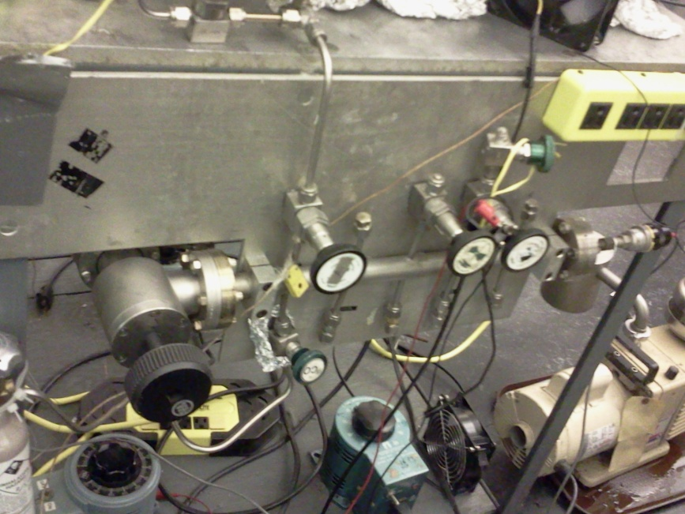

<gas manifold>
- General operation procedure
The four valves on the top of the gas manifold are connected to the leak valves on the chamber: one on the Ar sputter gun, two in the front of the chamber and one on the back. One (or two) of the tubes on the front of the chamber can be used to dose vapors of liquids by connecting a glass tube to the Ultra-Torr connector. Any of the gas dosing tubes can be heated with a heating tape wrapped around them to evaporate less volatile compounds. NOTE: If your sample is not evaporable, you can keep pumping the dosing tube when introducing the vapor into the UHV chamber.

- Gas and Liquid sample handling
How to Fill the Gas Dosing Tubes
Always evacuate the dosing tube to be refilled:
- Make sure all 4 valves at the bottom of the manifold are closed.
- Make sure all leak valves on the chamber are closed.
- Make sure the valve between the manifold and the pump is open.
- Evacuate the tube to be refilled by opening the corresponding needle valve. Watch the pressure in the manifold: it should normally come down to about 40-60 mTorr.
- Close the needle valve.

To fill with oxygen, hydrogen, or argon:
- Close the outlet valve of the Matheson-reducer on the big gas tank, and set all valves between the bottle and gas manifold so that gas can flow from the tank to the manifold. (Follow the lines).
- Evacuate the supply line by opening the appropriate needle valve.
- Open the valve to the tube to be filled to make sure that there is a good vacuum inside.
- Close the valve to the supply line and fill it with fresh gas from the bottle (good secondary pressure = 1-2 atm, or 40 psi) by slowly opening and closing the Matheson-reducer valve.
- Close the valve from the manifold to the pump. The valve to the dosing tube to be filled should still be open.
- Open the gas supply line to let in the gas; the pressure in the gas manifold will increase.
- Close both the valve to the dosing tube and to the supply line.
- Open the valve to the pump to evacuate the manifold.
- Check the purity of the new gas by taking a mass spectrum of it.

To fill with gas from a lecture bottle:
- Attach the lecture bottle to the manifold with the Ultra-Torr Connector to one of the dosing lines.
- Evacuate the dosing line up to the small valve of lecture bottle regulator.
- Make certain the secondary pressure on the regulator is about 20-30 psi.
- Close needle valve and pressurize behind the leak with the gas by opening the small valve on the regulator.

To fill the tube with a vapor:
- Fill a liquid sample tube with 1-2 ml of the liquid to be used. Use a new flint glass pipette. This is very important otherwise the chemicals can be contaminated! Discard the pipette immediately after use!
- Connect the glass tube to the dosing tube via an Ultra-Torr connector.
- Close the valve in the glass tube.
- Evacuate the dosing tube by opening the second valve to the right on top of the manifold. Watch the pressure. It should come down to about 5-6x10-3 Torr.
- Freeze the liquid by submerging the glass tube in liquid nitrogen. Use a small dewar to do this.
- When the liquid is frozen, open the valve in the glass tube. The pressure should increase now. Wait until the pressure is back to about 5-6x10-3 Torr.
- Close the valve in the glass tube.
- Thaw the liquid to release trapped air and freeze again, while keeping the glass tube closed!
- Repeat the last 2 steps until the pressure does not increase any more when the valve is opened.
- Close the needle valve.
- Fill the tube with the vapor of the liquid by slowly opening and closing the valve in the glass tube.
- Check the cleanliness of the vapor by taking a mass spectrum.

NOTE 1: For liquids with a low vapor pressure, both the glass tube and the dosing tube may have to be heated. Check for the stability and properties of the chemicals before doing this! Or, you can keep the needle valve and glass tube valve open when you are dosing the vapor into the chamber.

NOTE 2: If the vapor is contaminated, or different from what it is supposed to be, the liquid may be contaminated with compounds that are more volatile than the one to be dosed. If this is the case, directly pumping on the liquid at room temperature may cure the problem. However, find out about the vapor pressures etc., to make sure you are not pumping out the compound you want to use! It is hard to give a recipe for this kind of problem. The rule here is: Be creative and keep thinking!

Gas Dosing
In order to dose the sample with a particular gas, open the leak valve slowly by rotating the locking screws counterclockwise until the pressure in the main chamber rises to the pressure required to deliver a particular dose--i.e., if you want to dose the sample with 2.0 L of a gas, raise the chamber to 2x10⁻⁶ Torr and keep the pressure constant for 100 sec. (The leak valves are adjusted so that at least one full turn is usually required before any pressure rise is observed in the main chamber.) After dosing is finished, close the leak valve by turning the locking screws clockwise. DO NOT OVER TIGHTEN THE LEAK VALVE! --Simply close until it is sealed. The leak valve works by the sealing action of two sapphire plates against each other and the locking screws are preset to be 1-2 turns beyond the point at which the plates will seal--OVER TIGHTENING THE VALVE WILL DAMAGE THE SAPPIRE PLATES!

- H Radical production and dosing

- Atomic-H is produced by exposing a hot w-filament to hydrogen. The W-filament is made by a w-wire with a diameter of 0.02 inch. The atomic-H filament is heated by a DC power Supply ( HP 6260B) with a power of about 10 V×20A. H₂ pressure of 1x10⁻⁷ to 5x10⁻⁶ torr is used to produce atomic–H with the w-filament on.

<Schematics of atomic-H setup>

Note:
- The feedthrough should be safe for passing a current of 20 A. A feedthrough for a Titanium Sublimation Pump (TSP) is applicable for this purpose.
- Due to the high current used, fire can be resulted by the over heating of the cables. The campacity of the cable should be high enough (>20A).
- As shown in the schematics, the tungsten rod ( 0.05 inch dia.) between copper support and the tungsten filament is necessary. Otherwise, copper from the support will be evaporated during the atomic-H formation process.
- A fan should be used for cooling the feedthrough during the atomic-H experiments.
- due to the high radiation of the atomic-H filament and the insufficient cooling of the sample, even cooled by LN₂ during exposure to atomic-H, the sample temperature can be easily increased above 500 K. In order to do experiments at lower temperature, the distance between atomic-H filament and the sample should be as long as possible.

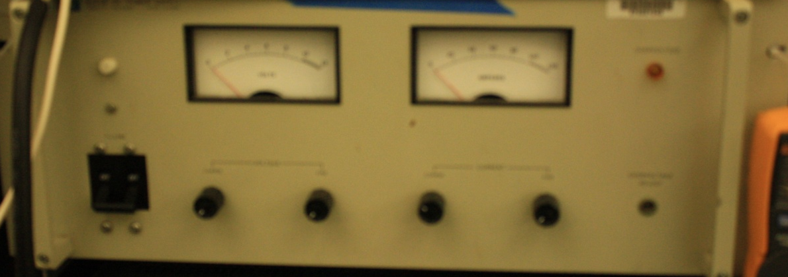

DC power Supply ( HP 6260B) for Atomic-H source

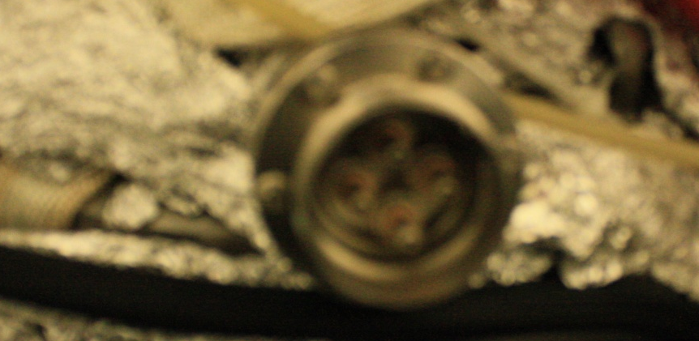

TSP feedthrough for Atomic-H source

- Maintenance
The gas manifold is always evacuated by a mechanical pump. Sometimes the base pressure of the gas manifold is not low enough for handling some liquid samples. A LN₂ trap can be added to the gas line to remove water contamination in the gas manifold system. If possible, a turbo-pump is suggested to be added to the gas handling system.
If liquid sample is used, a reasonable vapor pressure of the liquid sample can be remains in the gas line, and also in the mechanical pump, for a long time. Change the oil of the mechanical pump and bakeout the gasline are needed to remove the liquid remained in the gas handling system.

- Valves, regular and to UHV
All the gases introduced to the system are through leak valves. There are three leak valves equipped in this system. Due to the aging of the valve, all the three leak valves are not sealed well. So evacuate the gas line is suggested after gas dosing.
- Pressure gauges
The base pressure of the gas manifold can be read out through a TC guague. The gas exposure to sample can be controlled by gas pressure read by Ion guage and exposure time.

- Mass spectrometer
- Extrel Mass
  - General operation:
Mass spectra can be observed on the oscilloscope in the Extrel controller rack, or a spectrum can be acquired on the PC. The mass spectra observed on the oscilloscope cannot be permanently stored and are meant for reference while tuning up the mass spectrometer, doing experiments, checking for residual gas, checking cleanliness of the gases used in experiments, etc. The mass spectra taken on the PC are stored on disk and can be used for further analysis.
To be able to take a mass spectrum, the mass spectrometer has to be connected to the oscilloscope and PC. This has already been done, SO DON'T DISCONNECT ANYTHING WITHOUT NOTING HOW TO RECONNECT IT. It would, however, be worth your time to observe how the connections are made between the equipment and the cards (analog-to-digital and digital-to-analog) in the beige interface box on top of the main instrument rack.

    - Turning on, off, keeping in stand by
The main power controller is at the bottom of the Extrel controller rack. When venting the chamber or power outage, all the controllers of the mass spectrometer need to be turned off. During daily operation, the controllers can be operated in standby status, except the filament and the multiplier. Turn on the filament and the multiplier before mass spectroscopy measurement on the Extrel controller.

    - Mass Spectrum on the Oscilloscope:

- Turn the 'INTENSITY" knob under the scope clockwise in order to see a beam (or spot) on the screen. Note: there are other knobs under the scope screen that are used to adjust the height of the peaks, the width of the trace, etc.
- Switch on the mass spectrometer by moving the toggle switch from "SIMS" to "RGA". This turns on the mass spec filament.
- Make certain the sensitivity is set to "MED" (middle position on three position toggle switch on first module in the instrument rack--directly to the right of the screen) and that the scope width is set for "SPECTRUM" (upper position on three position toggle switch on second module in the instrument rack ).
- Make certain that the first switch on the second module is set to "MANUAL" in order to see the mass spectrum on the screen. When it is switched to "COMPUTER", it is ready for data acquisition with the computer.
- Turn on the multiplier by moving the toggle switch to "ON". When this toggle switch is centered, there is no voltage on the multiplier. The multiplier voltage (what’s the voltage value?) may need to be adjusted in order to observe any signal or to observe all peaks on the same scale. The multiplier voltage value can be read from the LCD screen to the right of the oscilloscope.
- At this point, there should be a spectrum of the background gases on the screen, with peaks at 2, 16, 18, 28, and 44 amu corresponding to H2, O (in mass spectra itself), H2O, CO, and CO2.
- If it is necessary to tune the mass spectrometer to obtain better separation of the masses, it is useful to introduce an iodide sample into the chamber, like propyl or butyl iodide, and then make adjustments to the peaks using the M or R knobs--M affects the width of the peaks at lower mass while R affects the higher masses. Making adjustments with either knob will cause the signal to decrease, which means the multiplier setting will need to be increased. In order to view a narrower region on the scope, the "WIDTH" toggle switch should be changed to "÷ 10", and then the low mass value adjusted with the 3 three thumbwheel switches directly below (currently it is set to 0-0-0). For example, it you would like to view the range between 40-45 amu, the 3 switches should be set to 0-3-8, where 38 amu will now be the lowest value in the range on the screen (rather than 2 amu).
- With an iodide sample in the chamber (about 10-8 Torr), the spectrum should be adjusted to that the peaks do not overlap--if the beginning of a peak is aligned with a vertical grid line and then the low mass knob is increased by 1, the peak should have moved completely past that vertical grid line. If not, the M knob needs to be adjusted to reduce the peak width.

The previous comments assume that the mass spectrometer is already "tuned" using the lens system on the front end of the mass spectrometer. The voltages on these lenses will have more of an effect when doing SIMS, but if any voltages are improperly set, it could adversely affect the signal intensity in RGA mode, although there should be no effect on the resolution of the peaks. Since the mass spec will most likely already have been tuned before you use it, you should record the current settings in your notebook and then consult the manual before making any changes. In addition, there are now only 4 lenses on our current bessel box (versus 6 on previous models). It is important that you know exactly what potentiometers (6 knobs at lower portion of last module) correspond to what lenses.

The emission current should be set to about 3 mA and can be checked by switching the dial on the last module to "em". The LED display should read 3.00 mA. The emission current can be adjusted by the potentiometer labeled "em" above the LED display. When done, switch off the filament by moving toggle switch to the "SIMS" position and the multiplier by moving toggle switch to center position.

See the appendices for the current settings of the lenses of the bessel box and the manual for any other information.

Mass Spectrum on the PC

Run the mass spectrum data acquisition program:
  - Change to the soft98 directory in DOS.
  - Get into data acquisition program by typing SOFT500
- Type load "mspectr" to take a mass spectrum; and after the "Ok" prompt, type RUN
- The program prompts for the initial and final masses and the number of scans. Pressing "RETURN" starts the scanning and the mass spectra are displayed on the screen. BE SURE TO SWITCH THE TOGGLE TO COMPUTER FIRST, OTHERWISE NO DATA CAN BE STORED IN COMPUTER!
- When the scans are finished, a filename is asked and the data are stored. Finally, some comments can be added, e.g. "1e-7 Torr ethylene to check for gas cleanliness". The comment line cannot contain commas. If it does, the program will prompt "?Redo" and you can type the comment line again. Other experimental parameters include the multiplier voltage and sensitivity. THE VALUES THAT ARE IMPUT HERE DO NOT INFLUENCE THE TPD DATA, INSTEAD THE PARAMETERS ON THE CONTROLLER WILL CHANGE THE SPECTRA.
- The data are stored automatically in the TDS directory in files: A data file "#####.DMS", which contains the word "BEGIN", the mass and intensity data (two column ASCII), and the word "END". (The labels "BEGIN" and "END" are necessary for the CSA spectrum analysis program). The second file is "#####.IMS" which contains the comment line and the experimental parameters. The data files can be imported in LOTUS-123, Excel, CSA, Sigma Plot, or any other program that supports ASCII-data for analysis and/or plotting. Save the *.DMS and *.IMS files on a floppy disk and store in a safe place!
- To go back from the program to the DOS-prompt, type SYSTEM on the "Ok" prompt. If there is no "Ok" prompt, hit "RETURN".

NOTE: Attention should be given to mass calibration otherwise the TPD might NOT provide information sufficiently accurate for species identification. Enter the soft500 system and print the command: LOAD “MSCALIB (wrong). Then input “Run” to initiate the program and do the calibration. The background spectra could be taken to confirm whether 2, 18, 28, or 44 amu peaks are in the right positions. These peaks are typical peaks for H₂, H₂O, CO and CO₂.

    - How to Calibrate the Mass Spectrometer

To get the best signal for the mass spectra, parameters on the panel and in the computer should be adjusted. On the panel, adjustments can be made with ΔM, F1, F2, and 2IE to get the best signal to appear on the screen. A common way to do this is put some Ar gas into the chamber and set the Scope Atten. from 10 to 1 so that the peak can be seen more clearly. When adjustments are properly made, the water peaks at 18, 17 and 16 amu should be clearly distinguished. Once all the parameters are optimized, they should be changed seldom in order to insure a meaningful comparison of data.

Mass position calibration can be done in the computer as follows:
- Enter the soft500 system and print: load “mascal”
- Then you will be asked to enter the mass you want to calibrate. Normally 2, 18, 28 or 44 can be chosen because at normal base pressure, these peaks are large enough. Argon can also be used for this purpose.
- Choose “U” or “D” (“u” or “d” won’t work) to change the voltage which determined the baseline of the mass spectrum.

    - Maintenance (filament, detector, etc.)
Possible replacement of filament and the detector is needed. No experiences is available on this. Please refer to the manual of the spectrometer before the replacement.
The spectrometer is not stable now due to the aging. Even use the same parameters for controllers, the intensity and the resolution can vary day by day. So tune the parameter and optimize the performance of the mass spectrometer are often needed.

- MS Control Panel Values
The following values are those recommended by the manuals for setting up Extrel MS:
Dynode -2.0 kV
Mult -1.3 kV
Em -2.0 mA
EV +100.0
2IE +10.0
FP +4.0
Pφ -3.0
F1 -100
F2 -15
BP -15.0
L1 +10
L2 +10
FiLI +2.6
FilV +2.8
These values are only used as the starting point for getting a good MS spectrum. Further adjustment is needed for optimization.

- UTI Mass
- General operation
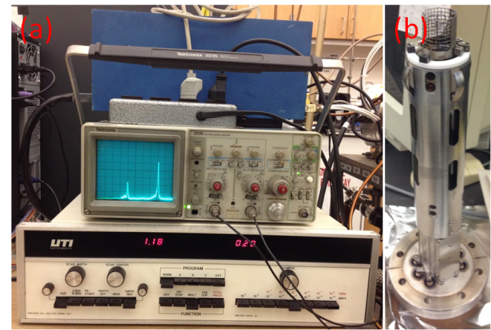
An UTI 100C mass spectrometer was set up on the Victor chamber in March 2015 when the Extrel Mass was out of service. This UTI Mass is equipped with a high-quality quadruploe and is well tuned to see masses up to 350 amu with decent resolution at each mass range. During operation, it takes at least 30 minutes for the electronics to reach thermal equilibrium and give trustable results. Both oscilloscope and computer are connected to the MS control unit at its rear panel. The major component of this UTI Mass is shown below:

Figure. UTI Mass system. (a) Stack of RF generator, oscilloscope, and control unit. (b) UTI Mass probe.

Please see Appendix H for the installation of interface card, card connector, and UTI MS program.

- Turning on, off, keeping in stand by
First turn-on procedure -
1) Check if the “Emission” dial is turned completely counter-clockwise.
2) Set the range to 10⁻⁵ amps to avoid possible burn out of filament.
3) Damper should be completely counter-clockwise.
4) “MAN” key depressed.
5) Depress “ON/STBY”. Wait for the instrument to equilibrate.
6) Depress “Multiplier”.
7) Depress “EMISS/(MA)” to display the emission current of the filament. Slowly increase emission with knob until ~ 2.00 mA.
8) Connect MS to oscilloscope (X to ramp generator, Y to signal out), set oscilloscope to observe spectrum (X-Y mode, DC decoupling).
9) Depress “EMISS/(MA)”, depress “VAR”, and adjust sweep time with the knob on the left side of the panel. The display above the range keys shows the MS intensity, whereas the one above “EMSS/(MA)” gives the mass number.
10) SCAN WIDTH and SCAN CENTER can be set with their respective knobs, while “EMISS/(MA)” being depressed and “WIDTH” or “MAN” being depressed (only one switch pressed at a time).
11) Switching to “MAN” yields a straight line on the scope. Mass number can be tuned from 1 until 300 amu manually with the “SCAN CENTER” knob. The height of the baseline gives the intensity of the peak.

To turn off MS safely -
1) Place the instrument in Faraday cup mode.
2) Set range to 10⁻⁵ amp.
3) Turn the emission knob completely counter clockwise, to the point that the knob clicks off.
4) Release the emission switch.
5) Depress “ON/STANDBY”, then depress “OFF”.

Optimized emission and voltages -
Emission current: 1.71 mA
ION ENERGY VOLTAGE: +15.1 V (default 15 V)
FOCUS VOLTAGE: -30.0V (default -30 V)
NEGATIVE ELECTRON ENERGY VOLTAGE: -56.1 V (default -55 V)
POSITIVE ELECTRON ENERGY VOLTAGE: +15.1 V (default +15 V)

Normal turn-on procedure in experiments -
1) Make sure chamber pressure is good.
2) Depress “ON/STBY” from “OFF”.
3) Set the amplifier range to 10⁻⁵ amps to start with.
4) Damper should be completely counter-clockwise to eliminate crosstalk between adjacent masses.
5) Depress “Multiplier”. Keep emission current the same for comparison between experiments.
6) Choose appropriate amplifier range and resolution setting for MS or TPD experiments.

Normal turn-off procedure in experiments -
1) Depress “ON/STBY” from “Multiplier”. The UTI control unit can be left on “ON/STBY” mode if chamber pressure is maintained in UHV.
2) Depress “OFF” from “ON/STBY” if chamber pressure significantly increases, e.g. when venting chamber.

- Displaying MS on Oscilloscope
The ‘PROGRAM’ on the UTI control unit should be selected as “NORM” mode. A Tektronix (Model 2235 100 MHz) oscilloscope is used to display MS spectrum. Both channels are connected to the MS with CH1 (or X) to the ‘ramp generator’ and CH2 (or Y) to the ‘signal out’. On the front panel of the oscilloscope, both ‘CH 1’ and ‘CH 2’ should be set in ‘DC’ mode. ‘A AND B’ should be set in ‘X-Y’ mode. In the box labeled as ‘vertical mode’, ’CH1’ and ‘alt’ should be selected. In the box labeled as ‘horizontal mode’, ‘A’ should be selected. Use the relevant knobs for each channel to adjust the horizontal and vertical scale and position.

- Recording MS on PC
The ‘PROGRAM’ on the UTI control unit should be selected as “EXT" mode. MS data is collected using a LabView program “UTI_scan_average.exe”. This program can be found in the directory C:/Program Files/UTI Mass Spectrometer. The following figure shows a snapshot of the UTI_scan_average program. When first open this program, choose “mass-cali.CAL” to for calibration file. Use these settings (A/D input channel: 14, D/A output: 1) communicate the interface card with the MS.

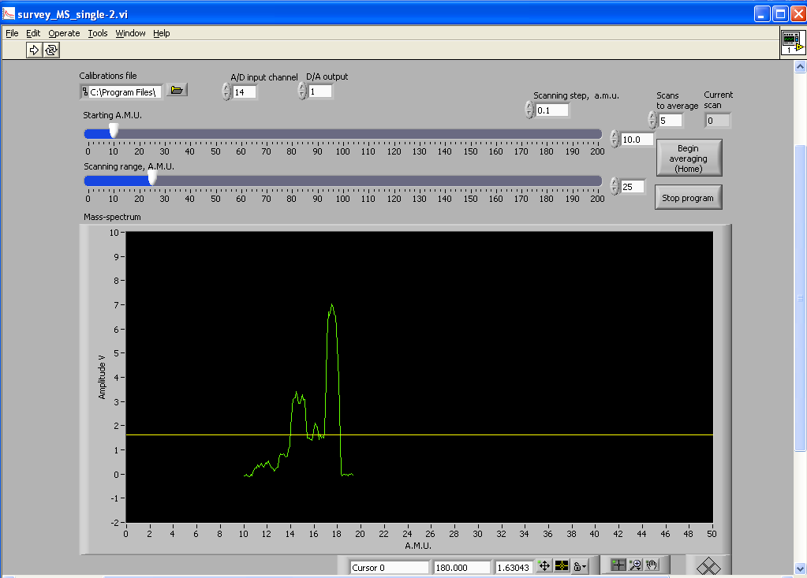
Figure: Snapshot of the UTI_scan_average program

To set up MS scan, input the starting A.M.U. (minimum 0.5), scanning range A.M.U. (the difference between the starting A.M.U. and ending A.M.U.), scanning step, and scans to average. To start data acquisition, click on the ‘Begin averaging’ button to get the average spectrum from consecutive scans, which smoothes out noises in the base line. When the data collection finishes, the program automatically opens a dialogue to save the data as a “*.dat” file. The filename and location to save the data file can be specified by the user. The data collection can be paused at any time by clicking on the ‘Stop program’ button and restarted by clicking on the run icon again.

- Resolution adjustment
This UTI MS has been well tuned to an excellent condition to balance between detection of high masses and resolution for low masses. The best resolution can be easily achieved for mid mass range with the current settings. The RF generator has already been well tuned and shouldn’t be touched during experiments.
Use the 10-turn dial potentiometer inside the control console to adjust the MS resolution. The highest resolution on low masses 1-20 amu, such as air fragments, can be reached by turning down the dial potentiometer to zero turn. When the dial potentiometer is gradually turned up, higher masses start to show up in MS scan with proper selection of amplifier range. The dial potentiometer can be turned up to ten full turns to access high masses over 300 amu with the selection of 10⁻¹¹ amps range.

- Calibration
The calibration procedure is essentially to determine the appropriate voltage to be applied to the ‘External Program’ input in order to tune the MS instrument on a certain mass number. This is done by interpolating between the voltages from known peak positions, which is stored in the mass-cali.CAL file.
The corresponding voltage for each mass in the mass-cali.CAL file should be determined first for a few known peaks by scanning over a range of voltages in the UTI_scan_average program. To start with, load the "dummy" calibration file, test.CAL:

0.000000 0.000000
1.000000 0.010000

This calibration file will make the x-axis on the plot scaled in volts multiplied by 100. Set the starting a.m.u. and the scan range to look for a few known peaks, e.g. 18 for water, 28 for CO, 44 for CO2. Additionally, oxygen, argon, and 1-iodobutane can be introduced into the chamber for calibration. Measure positions of these peaks and enter their values, divided by 100, into the calibration file. Then stop the program, select this file for calibration and start the program again to check whether the peak positions are calibrated or not. The following is the current mass-cali.CAL file:

12.010700 0.257010
15.999400 0.348090
18.015300 0.393860
19.974000 0.438950
26.000000 0.574810
27.000000 0.597310
28.000000 0.619450
29.000000 0.643380
31.998800 0.707090
39.000000 0.864440
39.948000 0.885340
41.000000 0.910450
44.009500 0.973320
55.000000 1.223500
57.000000 1.269100
127.000000 2.828400
128.000000 2.852400
141.000000 3.144400
155.000000 3.460000
184.000000 4.117400

The following figure shows the calibrated mass spectra of base vacuum, O₂ gas (2×10⁻⁸ torr), and Ar gas (2×10⁻⁸ torr), as well as the low-mass and high-mass spectra of 1-iodobutane (2×10⁻⁷ torr).
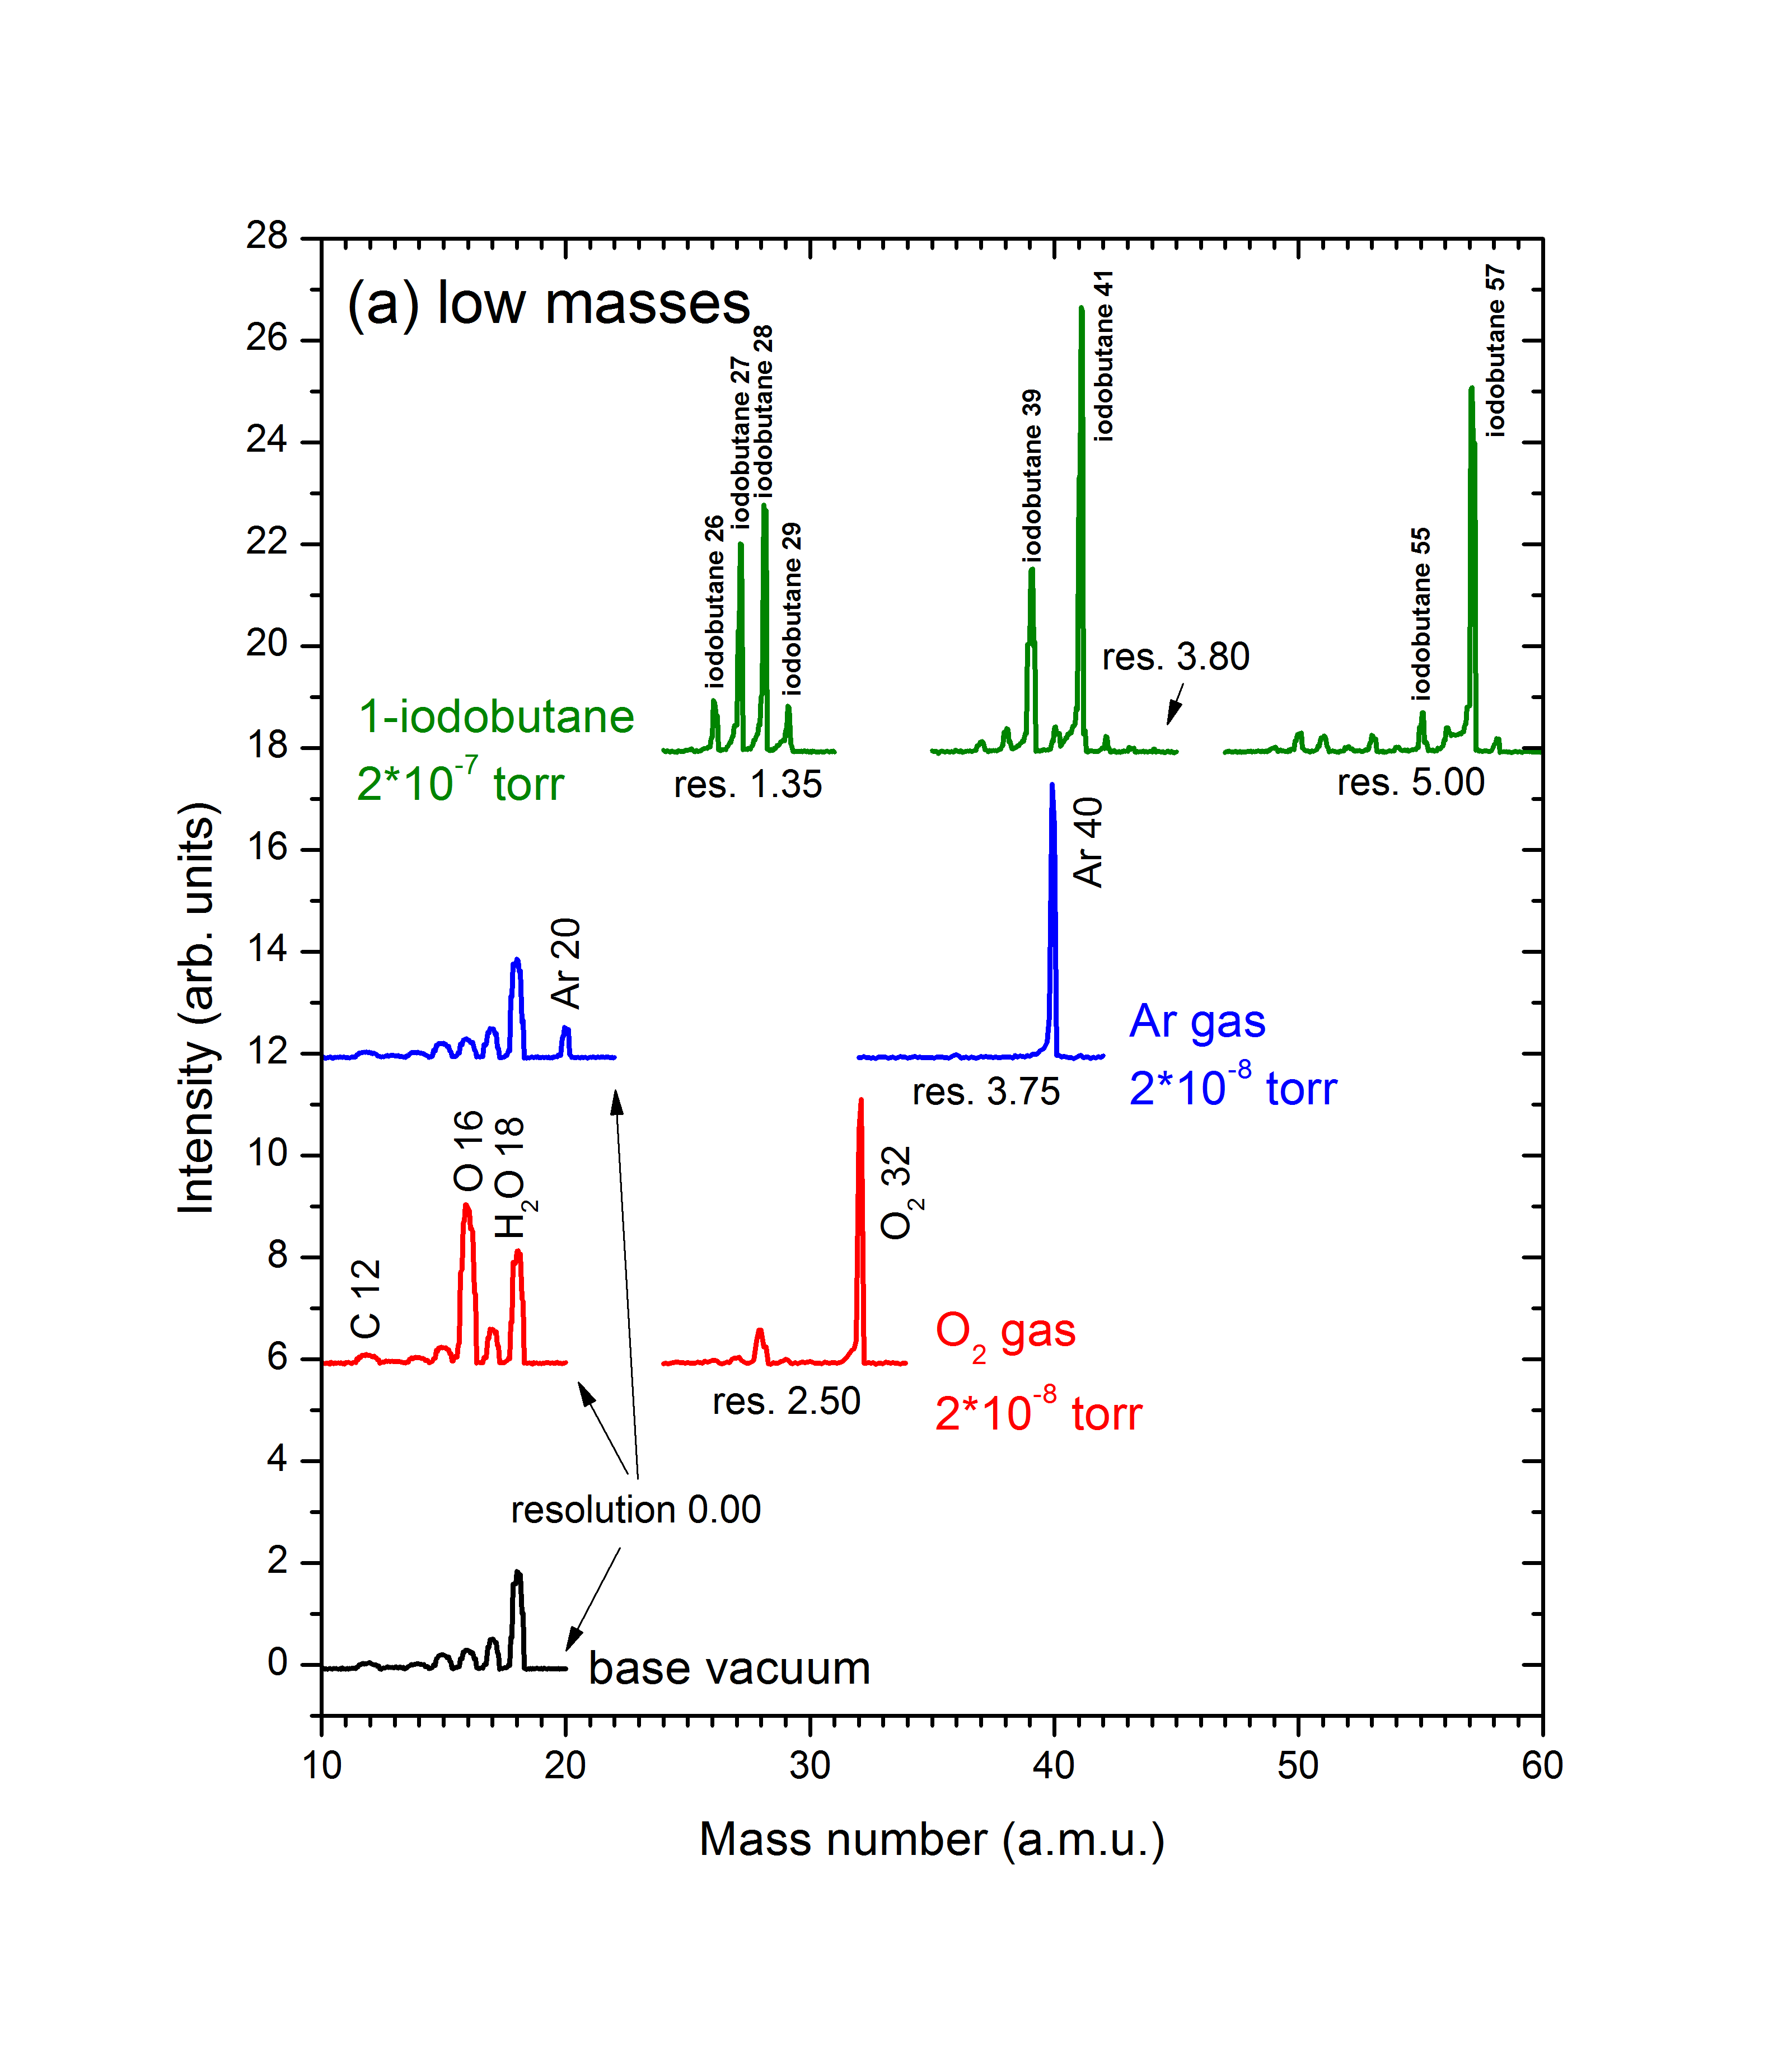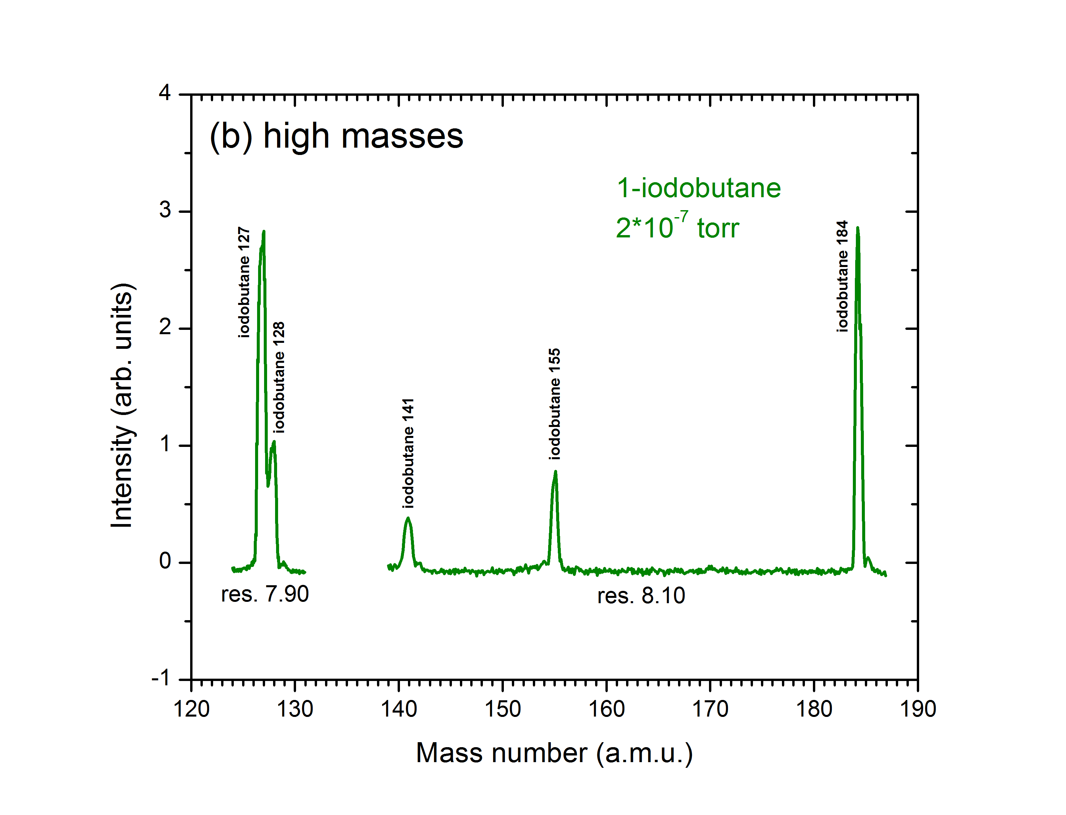
Figure. (a) Low-mass spectra of base vacuum, O₂ gas, Ar gas, and 1-iodobutane. (b) High-mass spectra of 1-iodobutane.

For some reason, the mass scale for this UTI MS keeps drifting toward lower mass over time. The calibration procedure has to be preformed from time to time.

- Temperature Programmed Desorption (TPD)
- Extrel MS
  - General Considerations
TPD measurement is recording the desorption species while linearly ramping the sample temperature. So make sure the sample can be heated with a linear ramp rate, and also the mass spectrometer is tuned to the right parameter to record the interested mass signal. The TPD data can be taken only on the PC. The PC has to be connected to both the mass spectrometer and the temperature controller (or just the thermocouple). As noted earlier, this has already been done and should not be disturbed.
It may be necessary to outgas the mass spectrometer before doing experiments. Ideally, only hydrogen, water, CO and CO2 should be observed in the mass spectrum of the vacuum. If other (hydrocarbon) signals are detected, degas the mass spectrometer by turning on the filament (RGA mode) and wait for half an hour or so. The intensity of compounds other than the ones mentioned above should be barely detectable. During the course of the day, the filament is always left on (except during lunch) to keep it outgassed.

  - Software
SOFT500 was used to record TPD data under DOS operation system.

  - How to take TPD data
    - General details
TPD spectra can be recorded with the interested mass under a certain ramp rate (5-10 K/s). The maximum of 15 mass traces can be recorded simultaneously by the mass spectrometer.
    - Running procedure
- Clean the surface by sputtering and start cooling.
- Wait until the sample has reached the desired adsorption temperature and adsorb the gases. The purity of the gases can be checked at this point by taking a quick mass spectrum on the oscilloscope. After dosing, it may be necessary to wait for a few minutes to pump out the gases; this will reduce the background in the data. It is during this time that the sample is lowered into position. MAKE SURE THE SAMPLE IS CLOSE TO THE MASS SPEC. ENTRANCE, OTHERWISE GAS FROM THE ROD WILL BE DETECTED.
- Make sure the heater power on the temperature controller is off.
- Set the maximum heater power to about 50%.
- Set the switch located above the BNC labeled "Vs EXT" to "INT." When this is set to "EXT", the sample will not be heated.
- Select the function "RAMP-HOLD" if you want the temperature to stay at the final level at the end of the experiment, or to "RAMP-OFF" if you want the temperature to go back to 77 K after the ramp has been completed.
- Select the heating rate with the "RAMP RATE" selector switch. A good value is "4" which gives a heating rate of approximately 5 K/s. These numbers indicate the rate of the digital ramp in steps per sec. There are 1.267 ºK per step. The higher heating rates will normally not be realized because they are heating limited by the maximum heater power.
- Select the octal value of the initial temperature on the "SET VOLTAGE Vs" thumbwheels then press the "LOAD" switch (SET?). (DO NOT FORGET THIS!) Make sure that the initial temperature is well below the actual temperature, otherwise an uncontrolled temperature-jump may occur. Since the data are usually taken from 100-1000 ºK, "0000" is always a safe choice. (If the actual temperature is significantly higher, say 300 K, the actual heating just starts later. It will never result in a temperature-jump, when turning on the heater.) "Vs OUT" should then read 0.00.
- Select the octal value of the end point temperature on "RAMP END POINT" thumbwheels. ("1503" corresponds to approximately. 850 °C or 1120 K. In most of our experiments, “1250” corresponding to about 900 ºK, is chosen.
- Turn on multiplier and switch the Extrel power supply to "COMPUTER". Set the PC to acquire the data:

    - Data acquisition

Run the TPD data acquisition program by typing load "TDS . (Remember, you must be in the SOFT500 system.) At the "Ok" prompt, type RUN.

The program asks for the following information: number of masses to be scanned, mass values to be scanned, output file and -directory, and the time of data acquisition. For a typical TPD experiment running from about 100 to about 1000 K with a heating rate of about 5 K/s, 250 s is a good choice: This leaves enough time to start the scan before the heating begins and leaves some time after the temperature ramp is completed. (If necessary, the program can be aborted by pressing CRTL-Break. But you must exit the program (type SYSTEM) and then restart it (type SOFT500). To stop a running DOS program, press right Ctrl+C. Be aware that the computer may become black screen when you exit the SOFT500 program. Then you have to reset the computer.).

Press "RETURN" on the PC-keyboard. The data acquisition will start now. If everything is set up correctly, the desorption traces can be seen on the screen. If nothing can be seen here, something is wrong. Abort the program now and correct the error. DO NOT START HEATING because the experiment can still be saved.

If everything seems to work correctly, turn on the heater power (the sample temperature may increase slightly now) and hit the "START" switch below the "RAMP RATE" selector switch. After a few seconds (depending on the difference between the selected initial temperature and the actual temperature) the temperature of the sample will start to increase at a constant rate. The TPD-traces are displayed on the PC-screen.

When the final temperature has been reached, turn off the multiplier, back the sample away from the mass spectrometer, position for Ar+ and start cleaning the sample. Avoid heating the sample unnecessarily at very high temperatures, since this may eventually damage the heat contacts to the sample. Let the data acquisition program run!

The program asks for comments, and the experimental parameters and the data are saved on disk. Three output files are created: "#####.MDT" which contains the temperature and intensity data--but in an unusable format, "#####.TDT" which contains ???, and "#####.IDT" which contains the comments and experimental parameters in an ASCII-format. The values of the scanned masses are written in the corresponding *.IDT file in the same order as they appear in the *.MDT file. The time elapsed between two temperature data points is also given in the *.IDT file, which allows evaluation of the actual heating rate.

    - Data processing
The *.MDT-file must be converted in order to get the data in ASCII-format. To do this, TDSPRO is run. This program prompts you to enter the file name (excluding the suffix MDT) and then select the default directory (the TDS directory) for the new file that will be created, the "#####.DAT". Once created, the *.DAT file consists of n+1 columns (n=number of scanned masses), the first of which is the temperature in ºK and the others are the intensity data (in V) for the scanned masses (col 2 = intensity mass 1 etc.) The *.DAT and *.IDT data files can be imported in a number of programs (see "mass spectrum on the PC" section) for further analysis. Save the *.MDT, *.TDT, and *.ITD files on a disk and store them in a safe place! The *.DAT files should be saved for your own use, but at some point they must be deleted from the hard drive because they take up too much space.
To go back from the TPD-program to the DOS-prompt, type "SYSTEM" on the "Ok" prompt. If there is no "Ok" prompt, hit "RETURN".

    - Editing
After data processing, the ASCII-format DAT file can be edited and processed by data analysis software. TPD spectra can be plotted with selected mass traces. Weak mass trace signal can be multiplied by a constant for easy comparison.

- UTI MS
- General Considerations
It is necessary to outgas the mass spectrometer for at least half an hour before TPD experiments. The MS signal is usually out of range as soon as the MULT is depressed and gradually decreases and stabilizes with the ionizer being outgassed.

- Program
The UTI TPD data is collected by using a LabView program “TDS_RTC.exe”, which can be found in the directory C:/Program File /UTI Mass Spectrometer. When the UTI TPD program is first opened, a dialogue window is prompted to choose a configuration file: (*.cfg), which contains the information such as A.M.U. to be tracked, MS settings, and temperature calibration. A typical configuration file for hydrogen and air fragments is given below:

[Data acqusition]
A.M.U. to be tracked="1.6 2.1 11.6 12.6 13.6 14.6 15.6 16.6 17.6"
total time, min=5
interval, ms=200
[Input-output settings]
mass-spec A/D=14
mass-spec D/A=0
thermocouple A/D=15
masses calibration file="C:\Program Files\UTI Mass Spectrometer\mass-cali.cal"
data output folder="/C/Program Files/UTI Mass Spectrometer"
[Thermocouple input]
pre-amplifier: slope=245.6
pre-amplifier: intercept=0.000000
reference temperature for thermocouple=-4.0

Once the appropriate configuration file is selected, the TDS_RTC program opens a window for TPD experiment as shown below.
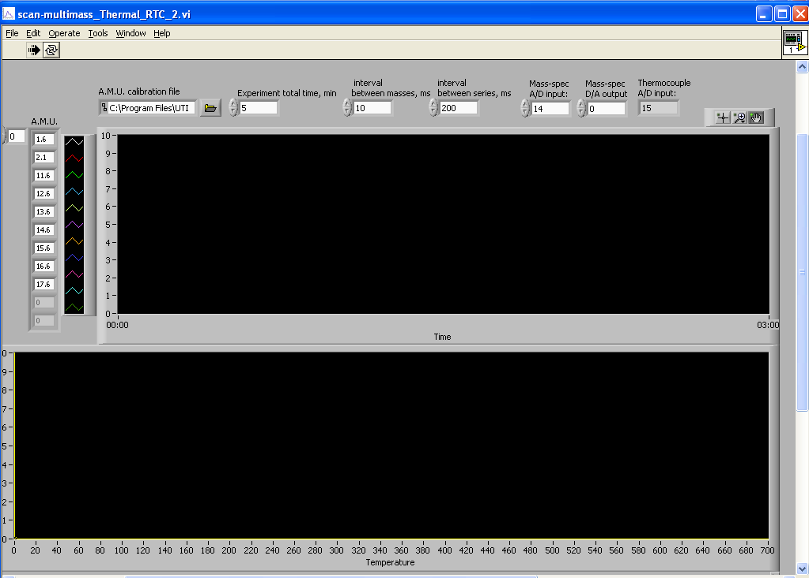
Figure: Snapshot of the UTI TDS_RTC program

- Data acquisition and processing
TPD traces can be recorded simultaneously for the maximum of 15 masses. The interval between masses is set as 20 ms to eliminate crosstalk between adjacent masses. The TPD scan can be started by clicking on the “Start scan” button. Then hit the "START" switch on the temperature controller to start heating. When the temperature ramp reaches its highest value, the TPD scan can be stopped by clicking on the “Stop scan” button. The program automatically prompts a dialogue window to save the actual data as a “*.dat” file in the folder specified in the configuration file. The saved data can be imported in data processing software, such as origin or excel.

- TPD settings

The TPD settings used for the UTI MS, shown in the following table, have been properly optimized for their corresponding mass ranges. These parameters include number of masses to be tracked, time interval between masses, and time interval between series in the LabView program. Also, they contain the settings for resolution, amplifier, and damper on the MS control unit.

Table. TPD settings for UTI MS as of Jan., 2016.
Mass range (amu) | number of masses | interval between masses (ms) | interval between series (ms) | resolution (turns) | amplifier (amps) | damper (o’clock)
0-2 | 10 | 20 | 200 | 0.02 | 10⁻⁷ | off
10-20 | 10 | 20 | 200 | 0.02 | 10⁻⁹ | 9
20-35 | 10 | 20 | 200 | 3.00 | 10⁻⁹ | 9
35-50 | 10 | 20 | 200 | 4.50 | 10⁻⁹ | 9
50-60 | 10 | 20 | 200 | 5.50 | 10⁻¹⁰ | 10:30
60-100 | 10 | 20 | 200 | 6.00 | 10⁻¹⁰ | 10:30
100-180 | 10 | 20 | 200 | 7.00 | 10⁻¹⁰ | 10:30
180-350 | 4 | 80 | 320 | 9.00 | 10⁻¹¹ | 9

- Electron and Ion Energy Analyzer
  - General considerations
Electron energy analyzer should be operated under UHV conditions (less than 1×10⁻⁸ torr). Do not turn on the electron energy analyzer when it is hot after bakeout.
  - Initial Operation
The analyzer and the X-ray gun controller is controlled by an interlock signal from the ion gauge controller and the cooling water flow meter. Make sure the vacuum is good enough and the cooling water is on before turn on the X-ray gun and electron energy analyzer.
  - Turning the X-rays on
When the cooling water is on, turn on the X-ray gun controller, and slowly increase the HV to 7.46 turn (15 kV). Then slowly increase the filament current and the emission current, meanwhile watch out the vacuum, until the emission reaches to 35 mA with the filament current at about 3.3 A.
  - Turning the X-rays off
Decrease the emission current and filament current to zero, then decrease the HV to zero, turn off the X-ray gun controller. Let the cooling water flow for a while (10-20 min) for thoroughly cooling the X-ray gun before turn it off.

  - Maintenance
Watch out the water level of the water cooling pump. Deionized water is needed for the cooling pump in order to reduce the leaking current.
There is a cooling water interlock system that will shut down the anode voltage in the X-ray source if the water is not flowing. This system should be checked frequently to see that it is working. An overheated anode could be catastrophic. Make sure there are no cooling water leaks inside the anode housing. Replace any fittings that are leaking. Moisture around the high voltage is dangerous.
The temperature of cooling water has to be preferably kept above 10 Celsius degree. Otherwise, the HV supply can be unstable during operation because the water condensation at the rear of x-ray gun may shorten the HV input. Too cold cooling water after long time running can even cause water condensation on pipe lines and water droplets that can wet the floor. Please be aware that the water chiller doesn't control temperature well. Fortunately, partly opening the valves to chilled water (~ 30 degree open) can effectively regulate cooling temperature.
The six connections to the XPS hemispheric analyzer should be in their correct positions. They are numbered. Also, there should be no contact between these six conductors and the chamber walls. Verify this using an ohmmeter.
Assuming all the electronics (preamplifier, NIM modules) are working properly, a poor signal-to-noise at the computer from the XPS analyzer could be due to a marginal or bad multiplier. Turn up the multiplier voltage to see if the signal improves. If not, it may be time to replace the multiplier.

  - Replacing the Anode
Replacement of the anode is required if the anode is leaking or the Al/Mg coating is thinned with the Cu surface exposed. The process is not difficult. Note: caution should be paid to the insulating ceramic of the X-ray when mounting the X-ray gun.

  - Replacing the Filament (Cathode)
The structure of the filament can be seen in the following picture. It can be replaced with a commercial filament or with thin tungsten wires.

  - Replacing the Aluminum Window
When the aluminum window is broken, replacement can be made by putting new aluminum foil into the metal holder.

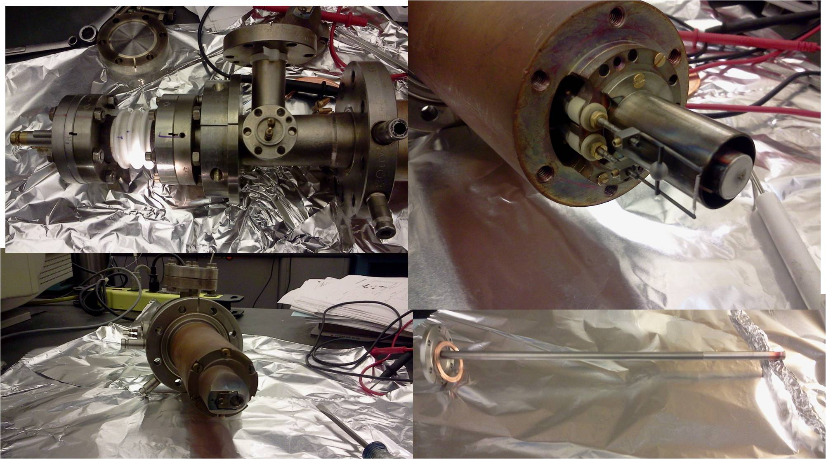

<X-ray gun>

- Electron Energy Analyzer and Detector System
  - Electron Energy Analyzer

General Considerations
As stated above, the electron energy analyzer should be operated under UHV conditions. Thoroughly bake out the chamber is usually needed before XPS measurements.

Initial Operation
Analyzer is set to measure negatively charged particles (electron). A pass energy of 50 eV is used for XPS measurement. 2.4 kV is used for the multiplier.

Turning the Analyzer on
Turn on the power supply, and set the multiplier to 2.4 kV.

Turning the Analyzer off
Decrease the multiplier to zero and turn off the power supply.

Typical Settings
Pass energy: 50 eV; multiplier :2.4 kV.

Calibration
The electron energy is usually calibrated with known binding energies of clean metals by software, such as Cu 2p3/2 BE at 932.4 eV ()

Maintenance
Keep the HV of multiplier as low as possible. Usually 80% of the plateau value is suggested for extended life time of the multiplier. Make sure the interlock signal is working to prevent the analyzer operating at vacuum failure conditions.

  - Detector

General consideration
As stated above, the detector should only be operated under UHV conditions.

Typical operation
2.4 kV is used for the operation of the multiplier.

Servicing/changing the multiplier
No experience is available for replacement of the multiplier.

  - Software
SOFT500 is used for recording XPS spectra under DOS operation system.

  - How to take XPS data

General details
In the XPS experiments, photons from the X-ray source are focused onto the sample in the UHV-chamber at grazing incidence. The analyzer at approximately normal incidence samples the photoelectrons that are emitted from the surface.

Running procedure

- Turn on the cooling water. Make sure water is flowing, look at the flow indicator (overhead above the chamber). (It is in series with the cooling lines.) Note: If the chamber has recently been baked, the water lines will need to be re-connected to the X-ray source. You must make certain that the "right" water line is connected to the "right" tube on the source: this corresponds to the flow inlet. Incorrectly connecting the water lines to the source could result in major damage.
- If the flow rate is sufficient, both the X-ray filament and high voltage supplies will come on (red indicator lights on each). A certain minimum flow is necessary to keep the source from overheating. Since these supplies are interlocked to the flow indicator, the inability to turn on the supplies indicates a problem. Get help before proceeding.
- If both supplies are operational, then it is time to turn on the X-ray source to its normal operating conditions so that it will outgas while the sample is being cleaned. First, increase the anode voltage to about 12 kV. Second, begin increasing the emission current (right knob) slowly. It will "jump" on at about 1 mA, which may initiate a pressure burst, depending upon how well the source was outgassed after baking or how long it has been since the last set of X-ray experiments. When the pressure has dropped, continue to slowly increase the filament current until the filament current supply reads "3.3 A" and the high voltage supply reads "35 mA" (7.10 on the pot). The emission current, filament current, and the current on the high voltage supply are interlocked and have to be adjusted at the same time. Finally, adjust the high voltage until it reads exactly 15 kV (or 7.46 on the pot). The current reading has to be larger than 7 in order to maintain the HV at 15 kV.
- Make sure the analyzer power supply is on and is switched to detect electrons.
- If this is the first time that X-ray spectra will be taken after venting the chamber, it is best to determine the correct positions for sputtering and data acquisition before cleaning. The best way to determine the analysis position is to first rotate the sample so that it faces the analyzer directly. Lower the sample to the analysis level, but be very careful not to hit the X-ray source. It may be necessary to move the x and y micrometers to avoid any contact. Once lowered, the sample should be moved toward the X-ray source until it is about 5-7 mm from the window. At this point, the analyzer should be set for a kinetic energy of about 984 eV(Al kα 1486.5 eV-V 2p3/2 512.1 eV=974.2 eV) --the V 2p3/2 peak-- 953 eV (O 1s 543.1 eV) and the channeltron voltage should be set to 2600 V. With the X-ray source on (so that photons are striking the sample), you should read some counts, probably 15000 or greater, on the rate meter. Now it is time to do minor adjustments on the angle and the x and y positioning to optimize the signal. Note, however, that if the sample is very dirty, the signal may not improve by much here.
- Extra grounding should be provided in XPS experiments by connecting the heating wires to ground even the sample is grounded through thermal couple.

Data acquisition
The following parameters are important for acquiring XPS spectra:
- The pass energy for core level data should be 50 eV
- The kinetic energy ranges for usual core levels when Al kα (1486.5 eV) X-ray source used are:
O 1s 945-960 eV
C1s 1196-1207 eV
For all core level data, the energy step should be 0.1 eV.
Getting started:
Start the data acquisition program (in the soft98 directory), and then type LOAD "XPSNEW" in order to start the subroutine for XPS. The program will ask for specific information, some of which is listed above for the individual core levels. After entering some of the information, the computer will lead you through the steps necessary to properly set the analyzer. The initial and final kinetic energies need to be set on the analyzer using the course and fine adjustments for "First Energy" and "Scan", respectively. Note: if you are careless in setting the analyzer, the binding energies of the data will not be accurate.

Note: The current X-ray gun is a Al/Mg twin anode with the coexistence of Al kα (1486.5 eV) and Mg kα (1253.6 eV) X-ray with similar intensity during XPS measurements. Some interference on the XPS peaks can be expected during the measurement due to the coexistence of Al kα and Mg kα X-ray.

Data processing
Unlike TPD data, the directly recorded DXP file is in ASCII format. No conversion process is needed. XPS data is saved in the folder C:\XPS.

Editing
The DXP data file can be read by data process software. Plotting, background subtraction and XPS spectra fitting can be done on the recorded XPS data.

- Ion Sputtering Gun

  - General considerations
A Phi ion gun is mounted on the chamber on the right of the view window. The diameter of the cylinder of this ion gun is bigger than normal inside diameter of 2.75 inch flange. This port, specially designed, is the only port through which we can put in the sputtering ion gun.
  - Typical operation
Usually P_{Ar}= 3-4×10⁻⁷ torr (4×10⁻⁷ torr for current use) , 2 kV, 15 mA emission are used for Ar⁺ sputtering. The measured current on the sample is about 1-2 µA (0.5 µA for current use).
  - Alignment and calibration

Central spot position
The central spot of the ions cannot be seen on normal samples. However, the light from the ion gun filament can be used to help position of the sample.

Rastering
The disconnected wires inside the ion gun for rastering have been repaired by Stan.

  - Sample cleaning
The details has been shown in section 3 of sample cleaning by Ar sputtering.

  - Low Energy Scattering data acquisition
It has never worked for the current setup. ISS spectra has been collected by Prof. Zaera by setting the angle between ion gun and energy analyzer to about 50º . But the currently used ion gun cannot be switched to other ports due to its large diameter of the cylinder, which cannot fit normal 2.75 inch port.

- Potential hazards and safety procedures

NOTE: Never handle the cooling water pipe with the X-ray gun on. Fatal injury could occur because the high voltage (15 KV) is grounded through the cooling water. Do not let anybody touch the X-ray gun and the cooling water pipe during X-ray experiments for their safety. Make sure the feedthrough of the X-ray gun is well wrapped with the Teflon sleeves and the cover of the X-ray gun is well grounded when mounting the cooling water after bakeout. Never expose the X-ray gun feedthrough to air. The X-ray gun and its cooling water are potential hazards and high risk. Make sure you understand the procedure before you turn on the X-ray gun for the safety of your own and others.

Compressed gases are often used for the experiments. Do not over pressure the gas line. After fill the gas line, make sure to close the gas tank. Special caution is required for handling CO-like gas. Make sure no leaking in the gas line system, and the exhausting gas is not vented inside the room.

Fire is a potential hazard when use high current to heat sample or doers, such as atomic-H experiments. Make sure the wires or cable used is capable for high current usage. Enough cooling is required for the feed through during the heating process.

- Other Items

Things to Keep an Eye On

The things listed below should be checked regularly, even if no experiments are done with the chamber.

Pressures in the Vacuum Chamber and Gas Manifold

There are numerous things that may cause a pressure increase in the chamber or the gas manifold. If the pressure is really out of line, the problem should be fixed as soon as possible. Just keep an eye on it and take action when necessary.

Things to Check before Going Home

- The following should be off:

- the X-ray source power supplies (high voltage and filament)
- the cooling water to the X-ray source
- the heater around the rotary on the manipulator
- the heater power on the temperature controller. The main power can be left on.
- the air flow into the manipulator
- the filament and multiplier of the mass spectrometer (toggle switches in appropriate positions)
- the sputter gun

- Do you have a backup of the data you took today on a diskette? (Only the *.DXP, *.IXP,*.ITD, *.DTD, *.IMS, *.DMS ; the *.DAT files can be saved separately for data processing).

- Appendices

Appendix A

Conversion table for the temperature controller "T.C. preamp. out" for temperatures below 0 °C.

Temp. | Temp  °C | Output "T.C. preamp. out  V
70 | -203 | -1.450
80 | -193 | -1.411
90 | -183 | -1.369
100 | -173 | -1.322
110 | -163 | -1.272
120 | -153 | -1.217
130 | -143 | -1.158
140 | -133 | -1.096
150 | -123 | -1.031
160 | -113 | -0.962
170 | -103 | -0.890
180 | -93 | -0.815
190 | -83 | -0.737
200 | -73 | -0.656
210 | -63 | -0.573
220 | -53 | -0.487
230 | -43 | -0.400
240 | -33 | -0.310
250 | -23 | -0.218
260 | -13 | -0.124
270 | -3 | -0.029

Appendix B

In most tests, chemical adsorption will be carried out at liquid nitrogen temperature at which the T.C. preamp. Out reading should be about –1.28V. Sometimes TPD and XPS tests require chemicals to be adsorbed at other temperatures, such as 200 ºK, 100 ºK. See Appendix A for readings below 0ºC. The table below shows the relationship between the RAMP END POINT and the T.C. PREAMP OUT reading.

Ramp End Point | T.C Preamp Out Reading  V
10 | -0.96
20 | -0.94
30 | -0.92
40 | -0.85
50 | -0.78
60 | -0.72
70 | -0.65
100 | -0.56
110 | -0.51
120 | -0.41
130 | -0.34
140 | -0.25
150 | -0.17
160 | -0.08
170 | 0.01

Appendix C

Settings Mass Spectrometer Control Unit

The current settings on the mass spectrometer control unit are listed below. These values can be measured by pulling out the front panel of the control unit and measuring the voltages on the appropriate pins. The legend for the pins is written on the bottom of the control unit.

Resolution 5.24
-15V/GND -15.0 V
+15V/GND +15.0 V
VIE/GND 15 V
Focus/GND -17.2 V
-VEE/+VEE 70 V
Filament protection On
HV -16.9 V ( ??1.69 kV)

Appendix D

Parameters for MS (working mode). Details can be found in MS manual

Description | Parameter | Set |  |  | Low | Depends on your need!!!
 | Multiplier | On |  | Sensitivity | Medium | Depends on your need!!!
 |  |  |  |  | High | Depends on your need!!!
 | Ions | ×
 | Comp |  |  |  | Analog | ×
 | Dynode | on |  |  | Countering
 | 0.01
TEST | 0.1 | × |  |  | Ion polarity | Standby Pos
 | 1
 |  |  |  |  | HV Adj | 3.2
 | Scope | 1
 |  |  |  |  | Pole DC | On
 | 0.5
Computer | 0.1 | × |  |  | Sweep | 500
 | 1
 |  |  |  |  | Width | 5
 | 1 | ×
Scope atten | 10 |  |  | Offset | On | ×
 | 100 |  |  | Offset | Off

MS Control Panel Values

Width | 6.60 | 14.00
Dynode | -1.90 | -2.00
FP | 2.30 | 2.10
Pφ | 64.5 | 64.5
F2 | -23.1 | 31.3
F1 | -164.7 | 0.4
BP | -7.8 | -8.4
L1 | 2.4 | 81.4
2IE | 0.7 | 82.7
EV | 70.2 | 70.0
FiLI | 1.0 | 1.6
FilV | 2.8 | 2.7
Em | 3.0 | -3.00
PS: Once the filament of the MS is changed, you have to optimize the parameter settings by yourself. Perhaps you could follow the steps I list below.
  - Set the EV to 70.0, Em to -3.00. If the Em is very low, you can increase the FilI a little bit (no higher then 3.0) to increase the limitation of Em, then you can increase the Em
  - Set the Dynode, FP, Pφ to the value list. It should be easy.
  - Set L1 and L2 to the value where you can see the peak. Those two parameters do not affect the shape of peaks a lot.
  - 2IE, F1, F2 and BP are interacted with each other. You can fix BP, F1, F2 at 0, then find the value of 2IE at which the MS peak has the highest intensity. Then fix the value of 2IE you got, optimize the value of BP at which the MS peak has the highest intensity. Fix the value of 2IE and BP, find F1 value, and F2 value at last. Enjoy it!

Appendix E

Working parameters for the other systems including ion gauge controller, temperature controller, and XPS, etc.

Ion Gauge Controller

N/A | Off
N/A | On
N/A | Auto | ×
Low | Off | ×
Low | On
Low | O/R
High | Off | ×
High | On
High | O/R
N/A | On
N/A | Fil | ×
N/A | Off
 | Emission | 10 Watts

Temperature Controller

 | Heater power | 50
 | Threshold voltage | 500
N/A | Int | ×
N/A | Ext

HAC Controller (For XPS control)
 | 500V |  |  |  | Ext Trig
 | 5000V | × |  |  | Rep | ×
 | Meter range | Kinetic Energy |  |  | Scan Up | ×
 | Rate | 1 |  |  | Scan Down
 | Excitation | A1
 |  |  |  |  | Multiplier supply | 2.40 kV
 | Reset |  |  | Mode Control
 | Single Scan | × |  |  | FAT | 50eV
 |  |  |  |  | Local | ×
 |  |  |  |  | Remote
 |  |  |  |  | Electrons | ×
 |  |  |  |  | Ions

OrTeC Detector ( Yellow box under the XPS controller, used for optimization of sample position)

 | Range | 3×10⁴ |  |  | UNI | ×
 | Time constant | 0.03 |  |  | BI
 | Zero Suppression | 0
 | Coarse gain | 20 |  |  | INT | ×
 |  |  |  |  | Windows
 | POS | ×
 | NEG

Ion Gun Controller
 | Beam Voltage | 41
 | Focus Voltage | 0-3.2
 | Raster Size | On
 | Emission (Ma) | ×
Pressure
(10⁻³)

XPS Glassman High Voltage

Current: 716

Appendix F

Sample holder Figure:
Heater Conductors
Thermocouple
Conductors

There should be good contact between the sample and heating wires. There should be no contact, at any point, between the thermocouple and heating wires. This will produce a false temperature reading.

Appendix G

The procedure to install the Soft500 program

- Compatible hardware
Processor : 33Mz(386 computer)
Graphic Card : Old type - 9 inch long
- Other graphic card (7 inch long) is not compatible with the program because of the confliction in memory setting.

- Board setting
There are two dip switches on the base board named IBM interface card.
Check the configuration of dip switches.
S101 switch
1 | 2 | 3 | 4 | 5 | 6 | 7 | 8
on | on | on | on | off | off | on | on
-This switch is related with selecting the memory address. This setting correspond to 11110011, which is equal to CF in hexadecimal bit address. One should read the number from the switch 8 and 4 digit make one letter. Ex. A(1010), B(1011), C(1100), D(1101), E(1110), F(1111)

S102 switch
1 | 2
On | Off
This switch is for the clock setting. This configuration means write enable clock setting.

- To copy the files in c:＼ directory
Location of files and folders related with program running
C:＼soft 98 installation and soft500 files are included
C:＼basic basic program
C:＼UHV1 the directory to include the function
To make TDS directory for data storage in c folder
C:＼TDS

- To install the program
C:＼> cd soft98 <enter>
C:＼soft98> install <enter>
In the newly appeared window, enter the path for the basic program
C:＼basic＼basica.exe <enter>
Then new window appeared,
At first raw, there are options such as modify, new, save, load, configuration, and quit.
Move the cursor to load and <enter>
If all settings are normal and hardware is compatible, Loading parameters should be as follows:
Array Space/Maximum Size : 140K/171K
Master IBIN Timer Speed : 1.667 MHz
Machine Type : IBM AT or compatible

Processor Type : 80386
RTMDS Graphics: Disabled

Interface Board
IBIN address : cff8h
Config File Name : CONFIG

SOFT500 Working Directory :
C:＼soft98＼
Interpretive basic:
C:＼basic＼basica.exe

To move the cursor to save and <enter>

To move the cursor to quit and <enter>

The configuration file is automatically loaded after installation. To check the configuration file, we can choose the configuration in the options and press F2 button and load the CONFIG.TBL file. The right configuration is as follows:

Slot1: AMM1 – A/D converting
Slot3: AIM7 – thermocouple reading
Slot6: AOM1 – D/A converting
Slot8: PIM2 – Pulse counting

- Connection check between S500 terminal and instruments
In Slot 1 (A/D)
Channel 0 QMS input signal
Channel 2 XPS input signal
In Slot 3 (thermocouple)
Channel 15 thermocouple
In Slot 6 (D/A)
Channel 1 XPS external
Channel 2 QMS external
In Slot 8 (pulse counter)
Channel0 XPS
Channel2 SIMS

Appendix H

Manual for TPD and RGA program

Ⅰ. UTI MS installation procedure

1. Computer requirements
The PC should run Windows XP at tolerable speed, Pentium-3500 MHz or faster. The mother board also should have an ISA slot at for Advantech PCL-812PG card.

2. Interface card information:
Card Name: PCL 812-PG
Vendor: Advantech
2 output channel and 16 input channels

3. Jumper settings
The most important thing is to set the I/O address switch position.
You can adjust the I/O address using switch 1 (SW1).

 | 1 | 2 | 3 | 4 | 5 | 6
 | A9 | A8 | A7 | A6 | A5 | A4
200-20F | 1 | 0 | 0 | 0 | 0 | 0
210-21F | 1 | 0 | 0 | 0 | 0 | 1
220-22F | 1 | 0 | 0 | 0 | 1 | 0
230-23F | 1 | 0 | 0 | 0 | 1 | 1
300-30F | 1 | 1 | 0 | 0 | 0 | 0
3F0-3FF | 1 | 1 | 1 | 1 | 1 | 1

Factory setting is “220-22F” and in most case it works. If it does not work, you may try other settings one by one.

Set D/A output range is 0 to 10 V, using jumper 8 (JP8).
Set A/D converter maximum input range is 10V, using jumper 9 (JP9).
Set IRQ level as IRQ 5 using JP5.
Set DMA channel as DMA 3 using JP6 and JP7.
Set D/A reference source as INT for CH1 using JP3 and INT for CH2 using JP4.

4. PCL 812-PG board connector
Output channel 13(0 for other chambers): Mass ramp
Input channel 14 (10 for other chambers): Mass signal
Input channel 15 (11 for other chambers): Temperature input (connected to T.C. preamp out of temperature controller)
The following figure shows a snapshot of the connector between PCL 812-PG board and the UTI MS.
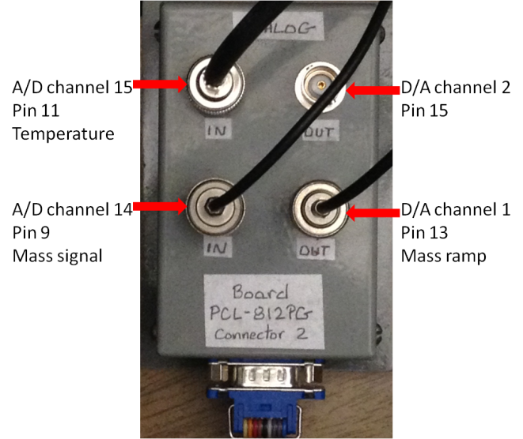

5. Install the card and libraries
1) You can find following three files in the Advantech web site.

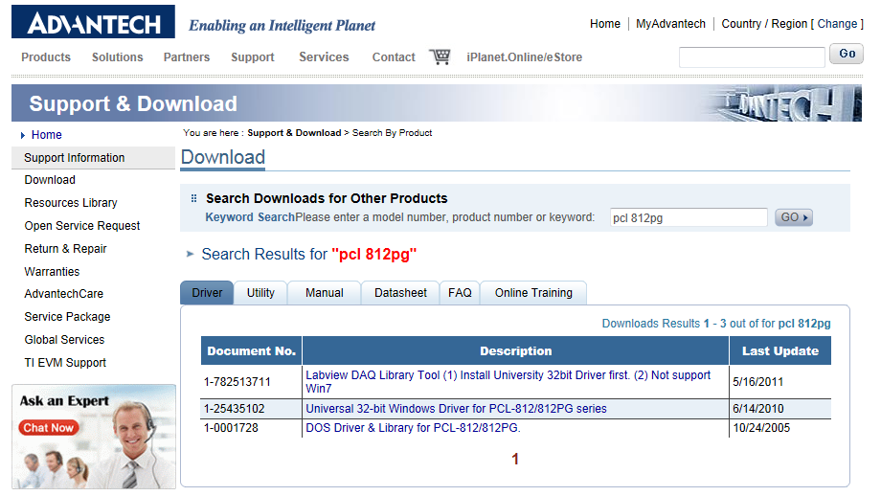

Download all three files and install them in your computer.

2) If the address setting is right and the driver is installed normally, you can test the input and out voltage in the Advantech device manager.
- Run the Advantech device manager as follows.

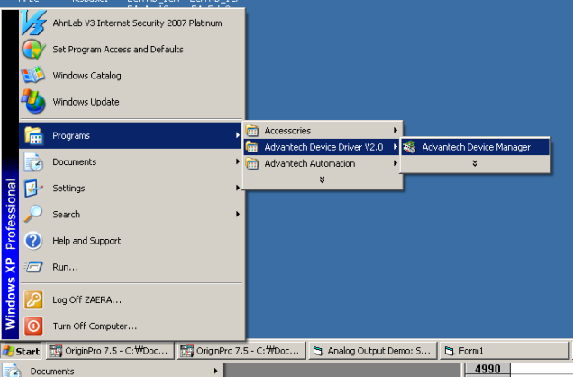

-If computer recognizes the card normally, you can see the green sign of the window as follows.

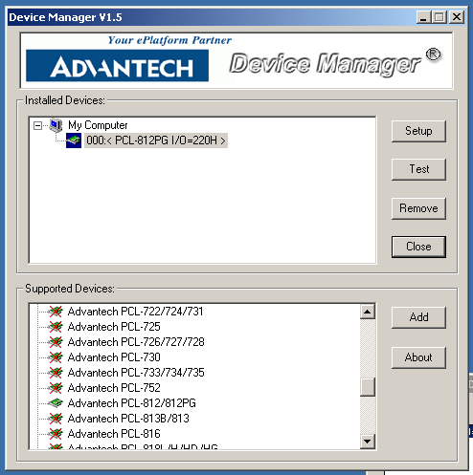

The following figure shows the correct parameters for setting up a working PCL812 card for the current UTI MS computer.
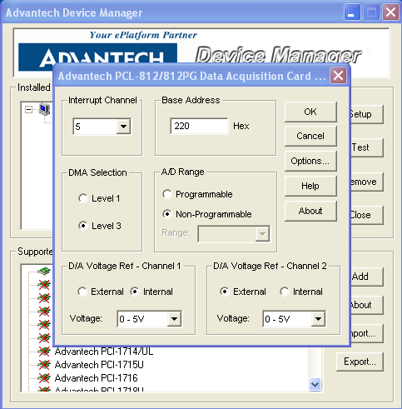

- Then click the test button and you can see the following windows.

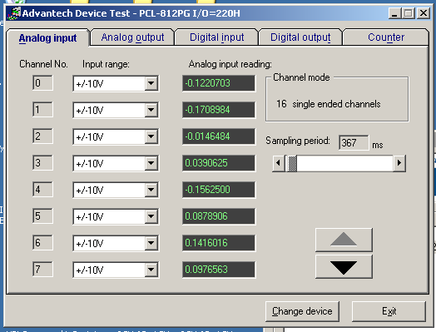

In the “Analogue input” tap, you can see the voltage input of all the channels. Give a known voltage using a battery or a power supply, than you can check the voltage reading in that channel. Click the “Analogue output” tap, then you can apply the voltage to output channel 0 and output channel 1.

3) Copy the TPD program and RGA program file to the desktop
4) Copy the MassCalibration.txt to c:/ folder.

For the current UTI MS computer, a Labview version of MS and TPD program is installed. To reinstall the software, install “LVRunTimeEng.exe” and “Install” files included in the installation files folder, then copy “UTI Mass Spectrometer” folder to the directory C:/Program Files.

3. The way going back to the former computer
At the back panel of mass spectrometer controller, there is a D-connector (50 pin) port which was written as “AUX”. Take out the current cable and put the old connecter back. (It is easy to find. Old cable is connected to the Keithley Series 500 terminal)

Ⅱ. TPD program

1. Click a TPD program icon.

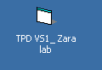
2. Choose the PCL-812-PG I/O=220H and Chen#0 and click “run” button. “PCL 812 PG” is the card name of Advantech company and I/O=220H means the address of mother board slot.

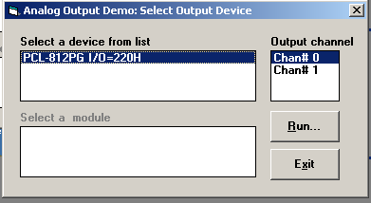
3. Next you can see the setting of TPD mode.
1) Choose the number of masses you want to detect (up to 15)
2) Enter the mass number in to the 15 text box
3) Choose the scan rate (default 20 ms)
4) Click Save settings, then applying voltages which are correspondent to mass numbers will be displayed at right text box. (Right panel of a following figure)
5) Click End button
∗ Parameters related with temperature and mass calibration was imported the file c:/masscalibration.txt
∗ The voltage from the TC amplifier (made by Stanley) is converted to temperature.
The relation between the temperature and voltage is as follows:
Temp = (Voltage+b)/a+c
This equation and the initial parameters are the same equation with the manual of AD597 chip inside the temperature controller.
Temperature should be connected to T.C. PREAMP OUT port (not LIN. TEMP. OUT. port)
∗ After changing the mass calibration factor, you can run the TPD program with the changed value. However, you should change the masscalibration.txt to change it permanently.

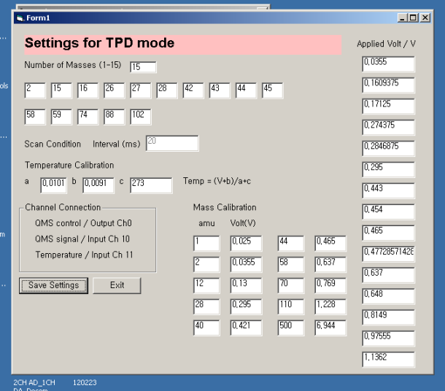
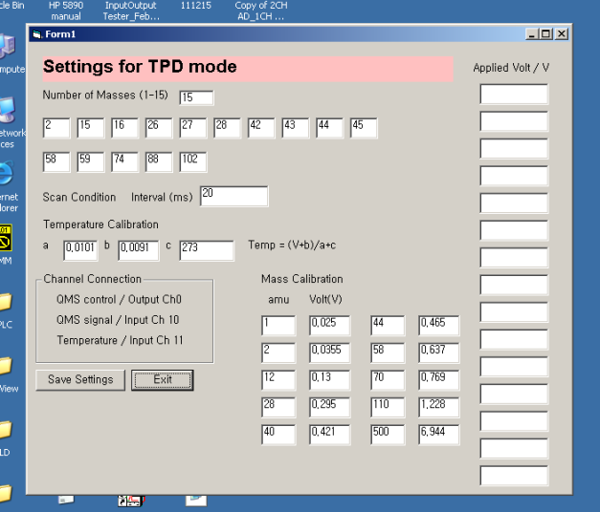

4. You can see the new window as follow. Click select button.

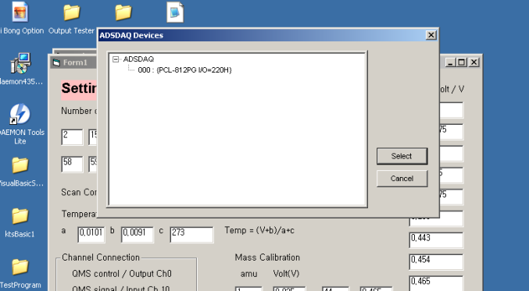

5. Programming running
1) Click the save button and enter the path and filename.
2) Then the path and filename will be displayed in the fifth text box
3) Click the start button, then the intensity of each species will be given in the text box at the bottom and the signal will be displayed in the graph as shown below. The colors of dots are same with those of mass number.
4) After conducting an experiment, click the stop button.

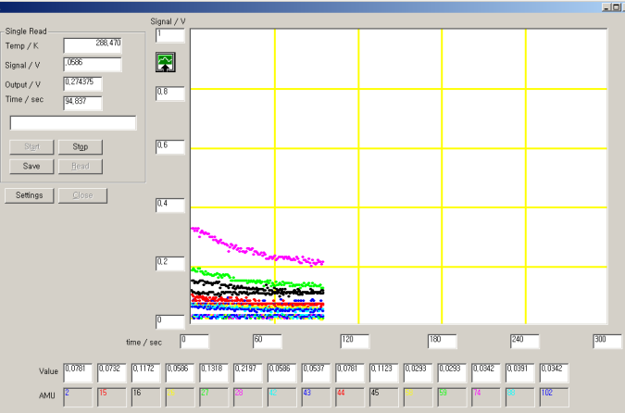
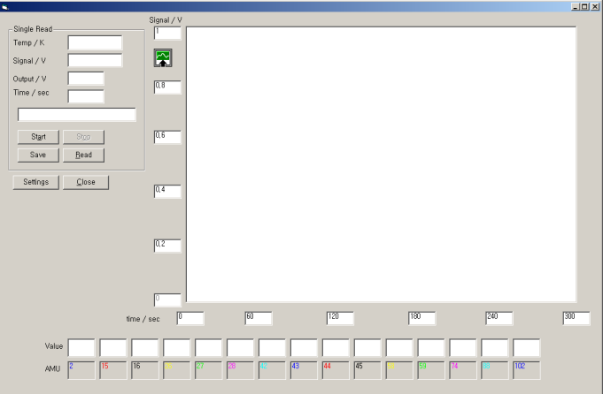

Ⅲ. RGA (residual gas analysis) program

1. Click a TPD program icon.

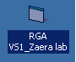

2. Choose the PCL-812-PG I/O=220H and Chen#0 and click “run” button. “PCL 812 PG” is the card name of Advantech company and I/O=220H means the address of mother board slot.

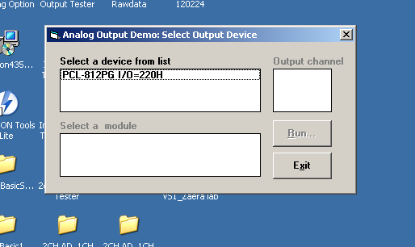

3. Settings

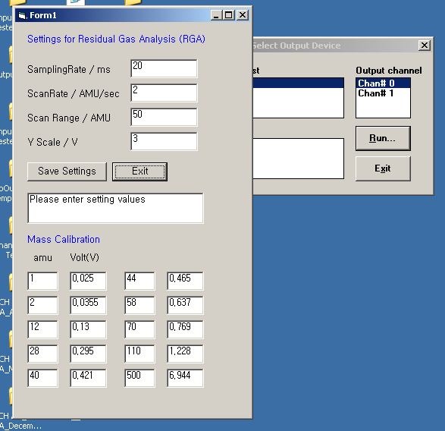

(1) Enter the sampling rate, scan rate, scan range. Y scale means the maximum value of y-axis in the graph
(2) Click the “save setting” button
(3) Click the “Exit” button
* By changing the Mass calibration factor, you can change the value. Although, there are 10 values, they are all linear between them. The reason why it has 10 values is that it is needed to adjust the values only for higher masses.
* The values you changed are valid until you turn the program off. To change them permanantly, change the value in the file c:/masscal.txt.

4. RGA program

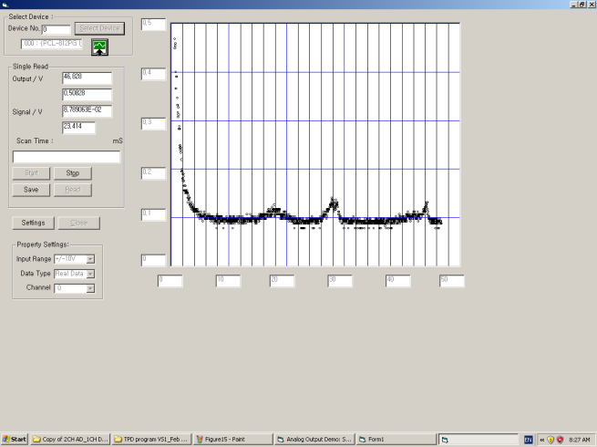
Click the start button, then you can get the spectrum for residual gas analysis.

Appendix I
Homemade Cu-Doer
- Cu-doser can be made of Cu-rod wrapped with a Ta-wire, and used by passing a current (6-10 A) through the Ta-wire. A Cu-flux of 0.25 nm/min can be obtained for the 10 A current. The evaporated Cu amount can be controlled by the deposition time and the current used for heating the doer.
- Note: High pure Cu-rod is much better and easier to control than thin Cu wires used as Cu-source due to the low melting point of Cu. Copper can be deposited before the filament becomes glowing. Slowly increase the current after the filament becomes red (500 celsius degree), watch out the possible over heating the doser!!

Schematics of Copper-doser

Cu deposited on SiO₂ from a homemade Cu-doser

Figure 1. (a) Cu 2p_{3/2}, (b) Cu LMM, (c) O 1s XPS from 10 nm SiO₂/Si(100) deposited with different amount of Cu from a homemade Cu-doser. #a, clean 10 nm SiO₂/Si(100); #b, 5 min Cu deposit (Cu-doser power 8.5 Ax3.5 V); #c, 10 min Cu deposit (Cu-doser power 8.5 Ax3.5 V); #d, 20 min Cu deposit (Cu-doser power 8.5 Ax3.5 V); #e 20 min Cu deposit (Cu-doser power 8.5 Ax3.5 V) +10 min Cu deposit (Cu-doser power 8.5 Ax3.5 V). (d) O1s and Cu 2p_{3/2} XPS intensity changes were summarized. Cu coverage can be estimated by the attenuation of O1s signal by Cu deposition at low Cu coverages.

Appendix J
Repair
- The PERKIN-ELMER ion gun was maintained by Stan during Sept - Oct 2016 and Sept 2017 – Oct 2018. The major repairs include the replacement of the filament, the connections to the deflection plate and the extractor, and the replacement of the 1Mohm resistor. In addition, Stan replaced the extraction aperture and all the wirings.
- The Extrel MS was out of service from Jan. 2015 to Oct. 2018. There was no signal. Stan repaired a lot of things until he got a spectrum. These include the replacement of all the old wirings, rusted trimports and switches, a broken ionizer connector on the flange, bad ramping capacitors for ramp generator, a 5V power supply, and multiplier channeltron, etc. It was later tested on the Victor chamber. But the MS spectrum was unstable and hydrogen peak didn’t show up. Stan replaced the filament and bad component on the MS ramp board.

Appendix K
Pump Oil Change
Oct 2018
Nov 2017
Sept 2016 (molecular sieve absorbents replaced)
Oct 2015
Nov 2014

