Praxis Molecular Beam UHV Chamber (#4)
Operating Instructions

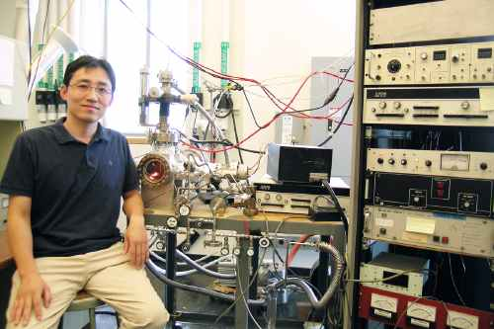

Updates:
Taeseung Kim, March 2010
Stavros Karakalos, Jan 2014

Table of Contents

- General Considerations/Overview of Equipment…………………………………1
- Vacuum System………………………………………………...…………………7
        - General UHV chamber……………………………………...…………………7
        - Flange assignment…...……………………………………...…………………8
        - Pumping…...…………………………...…………………...…………………8
        - Ion gauge, Pressure reading, Filament replacement and maintenance.….……9
        - Evacuation of the system…...……...…………………...……………………11
        - Venting, Shutting down…...……...…………………...…………..…………11
        - UHV bake out, degasing…...……...…………………...……….……………11
        - General maintenance…………….……….………………………………..…14
          - Removing and remounting flanges…………….……….……………14
          - Gaskets…...………………...…………………………...……………15
          - Turbopump…...………………...…..……………………………...…15
            - Oil replacement…...………………...…..…………………..……15
            - Mechanical backing pump…...………………...…..………….…15
        - Leak detection…...………………...…..…………………………….…….…16
        - What to do after a power outage …...………………...…..……………….…16
- Sample…...………………...…..………………………………………...…….…16
  - Mounting …...………………...…..……………………………………….…17
  - Repair of manipulator: …...………………...…..………….………………...19
    - Power and thermocouple feedthrough…...………………...…..….…19
    - Wiring…...………………...…..………….…………………………..20
    - Sample holder…...………………...…..………………………..….…21
    - Rotating platform…...………………...…..……………………….…21
  - Heating, cooling, troubleshooting…...………………...…….....………….…22
  - Biasing…...…………………………………….…………...…..………….…23
  - Cleaning…...……………………….………….…………...…..………….…23
  - Chemical cleaning…...………………………...…..………….…23
  - Ar sputtering…...………………...…..……………….……….…24
  - How to determine that it is clean…………………………………25
  - Temperature reading…...…………………...….………….…..…………..…26
  - Heating power supply…...…………………….…………...………….…..…26
- Gas handling, gas manifold..…...…………..……….…………...…..………..…28
  - Design, schematics...…...………………….…………...…..……………...…28
  - Valves, regular and to UHV…...…………………...…..…...……….…….…29
  - Tubing, Connectors…...…………………....………….......…..……….….…29
  - Pressure gauges…...…………………….……………..…...….……….….…30
  - Pumping system…...…………………….…………...…..………………..…31
  - General operation procedure…...…………………….…………...….…....…31
  - Gas and liquid sample handling…...………………….…………..…..…...…33
  - Use of glove box…...……………………………………...……...…….....…33
  - Maintenance…...…………………….…………...…..……………….…...…34
- High-Flux doser…...…………………….………….............................….....…34
  - Design, schematics…...…………………….…………...…..….................…34
  - Regular operation…...…………………….…………….………...…..…...…35
  - Calibration …...…………………….………………………...…...…..…...…35
  - Maintenance: …...…………………………………....…………...…..…...…36
    - Capillary array…...…………………….…………...…..….............…36
    - Flag…...…………………….…………...…..…..............................…36
- Mass spectrometer (UTI 100)….…...…………………….…………...…..…...…37
  - General operation…...……………………….……….…………...…..…...…37
    - Turning on, off, keeping in stand by…...…….…………...…..…...…37
    - Displaying in Oscilloscope…......…………….…………...…..…...…38
    - Recording MS in PC…...…………………….…………...…..…...…39
    - Calibration…...…………………….…………...…..……………...…39
    - Maintenance: …...…………………….…………...……...…..…...…43
      - Filament…...…………………….………………...…..…...…43
      - Detector…...…………………….…………...........…..…...…43
  - Temperature Programmed Desorption (TPD) …...…………………...…...…44
    - General Considerations…...…………………….…………...…..…...44
    - Software…...…………………….…………...……………….…...…45
    - How to take TPD data…...…………………….……...…..……….…46
      - General details…...…………………….……...…………...…46
      - Running procedure…...…………………….……………...…46
      - Data acquisition…...…………………….……………...….…47
      - Data processing…...………………….…………...…..…...…48
      - Editing…...…………………….…………..……...…..…...…48
- Ion Gun…...…………………….………………………………...…...…..…...…49
  - General considerations…...…………………….…………......…...…49
  - Typical operation…...…………………….………….........…..…...…49
  - Sample cleaning…...…………………….…………..........…..…...…50
  - Maintenance, troubleshooting…...………………...……...…..…...…51
- Potential hazards and safety procedures…...…………………….………….....…51
- Other Items…...…………………….…………...………………………...…...…52
- Appendices…...…………………….………………………….……...…..…...…54

      - General Considerations/Overview of Equipment

This document is intended to give the reader the necessary instrument specific information for immediate operation of the chamber labeled “Praxis” located in Chemical Sciences building room 137.
Some general considerations about the system should be:
i) the pumps and electronics should always be kept in a cool room.
ii) abnormal pump noise or elevated temperature of any part of the chamber needs immediate action.
iii) the user should always be advised by the system manual for the working procedures.

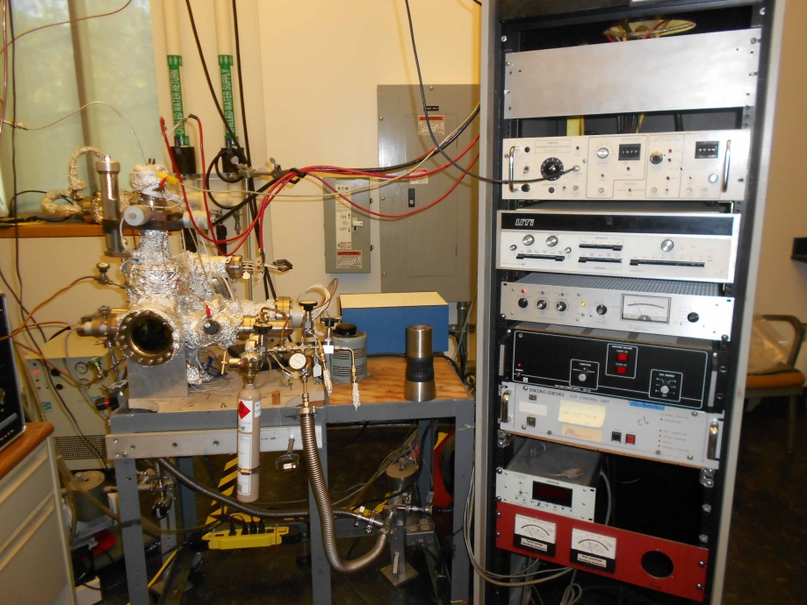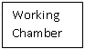
Gas Manifold
Electronics Cabinet

Figure 1: Overview of Praxis system.

Figure 1 shows the overview of the working chamber as well as the supporting electronics. The working chamber is wrapped in Al foil, taking up the bulk of the left hand side of figure. The electronics cabinet, is shown at the right hand side of the figure.

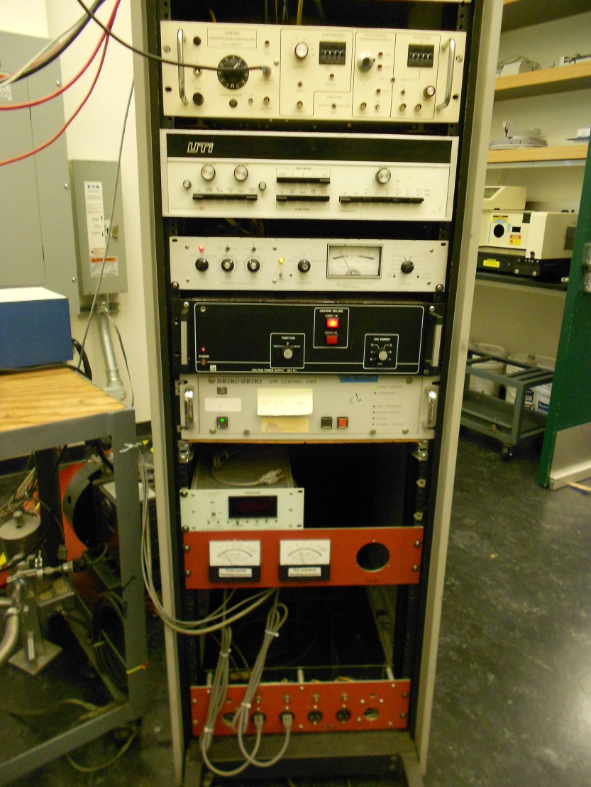
Ion Gun Controller
Turbo Pump Controller
Ion Pressure Gauge
Temperature Controller
MS Controller
Gauges
Baraton Gauge

Figure 2: Electronics Cabinet

Figure 2 shows the electronic cabinet of the Praxis system. The electronics of the system from top to bottom are: temperature controller, mass spectrometer, ion pressure gauge, ion gun controller, turbo molecular pump controller, baraton gauge, gauges.
Mechanical pumps are located directly beneath the working chamber. Computer controlling the acquisition of data is located directly left from the working chambers view portal. Gas can be introduced into the system via gas manifold located in the lower side of figure 1.

      - Vacuum System
        - General UHV chamber.
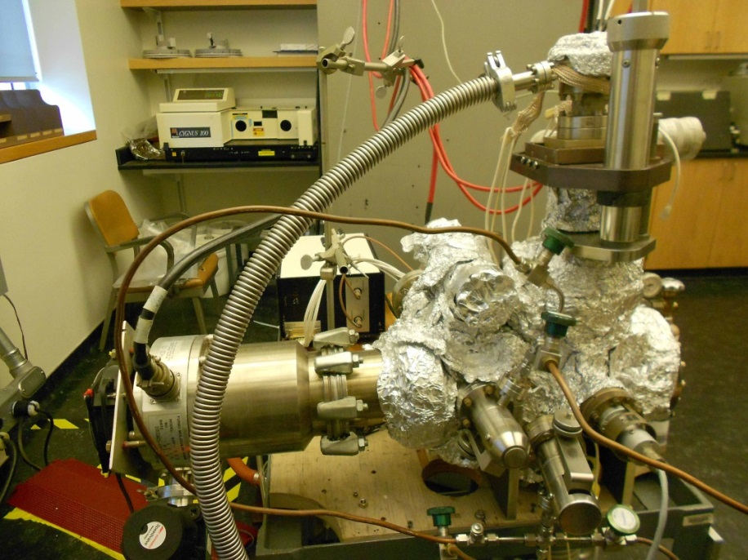

Figure 3: Side View of Working Chamber

Figure 3 shows the side view of the Praxis UHV chamber wrapped in Al foil and the turbo molecular pump in the center left hand side of figure.
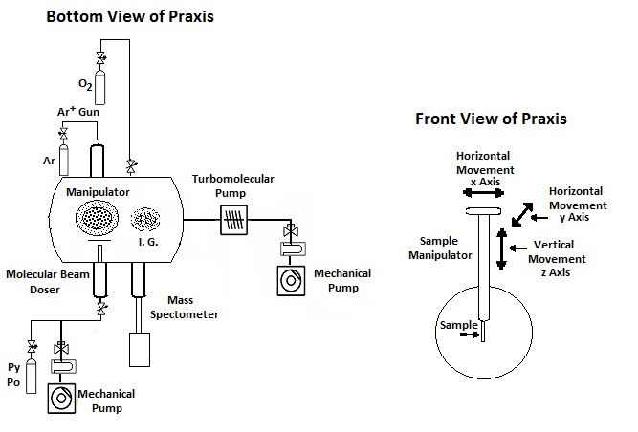
A more detailed demonstration of the parts consisting the UHV chamber can be seen in the drawing of figure 4.

Figure 4: Schematic representation of Praxis system.

Figure 4 shows the parts that are mounted on the UHV chamber: the manipulator with the sample holder, the ion gun, the molecular beam doser, the mass spectrometer and the ionization gauge.

  - Flange assignment.

When closing a port on UHV chamber with copper gasket–sealed CF flange, it is very convenient to use a torque-wrench. It helps to establish uniform crash of the gasket and prevents over-tightening, especially if Viton gasket is used instead of copper for a temporary mount. If chamber will be baked after the mount, less torque should be applied than the maximum, as it is better to tighten bolts a little more after bake-out is done. The following table will help to set a proper torque:
Flange size, inch | Bolt number | Torque, lb-ft
1 1/3 | #8–32 | 7
2 ¾ | 1/4–28 | 10
4, 6, 8 | 5/16–24 | 12
10 | 5/16–24 | 15
Viton gaskets, all flange sizes |  | 7

  - Pumping

There are two mechanical pumps located on the instrument. One is directly connected to the gas manifold and the second acts as a backing pump to the turbo pump.

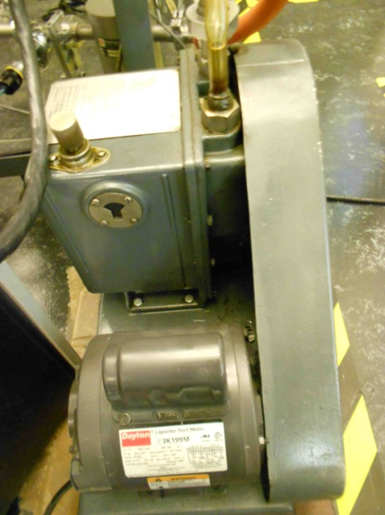
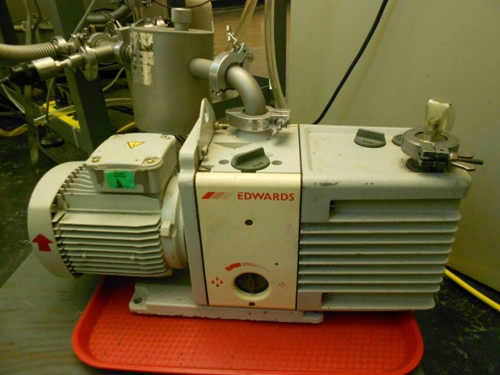
a) b)

Figure 5: a) Backing mechanical pump to the turbo. b) Mechanical pump directly connected to the gas manifold.

Both are equipped with oil traps. These pumps need to have their oil changed, refer to the section titled “Maintenance” for schedule.
There is a single turbo molecular pump. It is attached directly to the working chamber outputting to a mechanical roughing pump. The turbo pump should never be turned off except for complete shutdown. Also, the pump should not be engaged if the pressure inside the working chamber is above the mill torr region. The pump has a fan that cools the exterior at all times, as well as an interior cooling system based on circulation of compressed air. The oil needs to be replaced and this aspect has been discussed in section “Maintenance”. During bake, it has its own heating elements and heating ribbons are not necessary. The turbo and mechanical pumps are connected in parallel.

  - Ion gauge, Pressure reading, Filament replacement and maintenance.

There are three pressure sensing instruments located on this instrument. The first is a MKS Instruments’ “PDR-C-1C Power Supply/Readout” that is located on the outer left hand side of the electronics cabinet. The readout is connected to a “Type 221A Electronics” signal conditioner that is in turn connected to a “Baratron” sensor. The sensor operates based on a diaphragm design The front panel has an LED display, a power switch, and a controller knob. This knob is used to indicate its mode of operations. For pressure reading, turn the knob to the ‘mbars’ position. On the back of the component there is a cluster of four DIP switches and six screw downs leads. The DIP switches should be set as follows (starting with one to four): Open, Closed, Open, Open. The electrical leads between the readout unit and signal conditioner should be (reading left to right): Black, Black, Green, White, Red, Black. Refer to the instrument’s manual for detailed information
Located on the electronics cabinet is the “GP 271 Gauge Controller”.
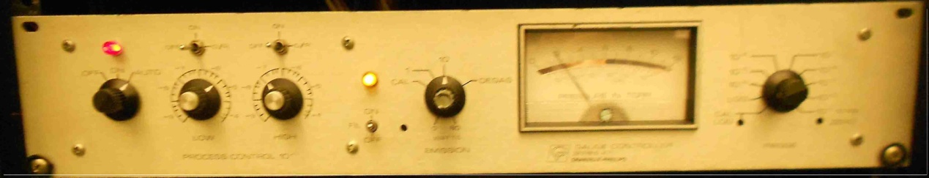

The sensor is located inside the working chamber and is of a Bayard-Alpert design. On the controller itself, there is a ‘on/off/auto’ knob underneath a red light. This controls the state of the instrument. For normal operations, it should be in the ‘auto’ position. To the LHS of the yellow light, there is another knob that controls the amplification of the instrument. When the chamber is in relatively low vacuum, the knob may be in the ‘10’ position; otherwise, for high pressures the controller may be in the ‘1’ position to read the pressure. Engagement of mode is via the flip switch directly beneath the yellow light. Whenever the instruments mode of operations is to be changed, the actual change does not occur until this switch is flipped.
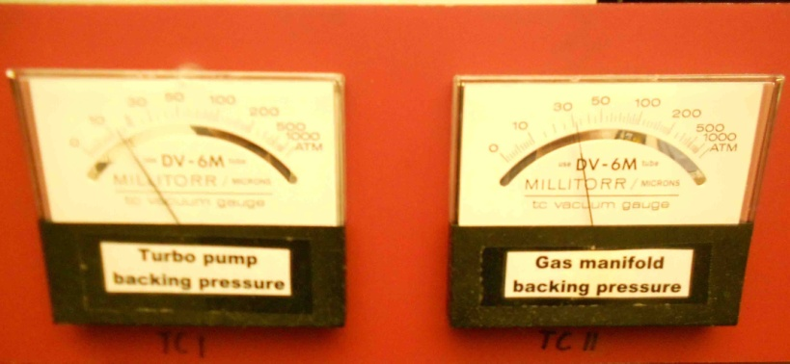
The pressure of the gas manifold and the turbo/mechanical pump is through the use of the Jarrel Ash component located at the very bottom of the instrument.

This gauges utilizes for its sensor a “Baratron” design. ‘Ext Timer’ reads the pressure from the LHS of the gas manifold and the latter at the junction between the turbo and mechanical pumps.
  - Evacuation of the system

If the chamber is at atmospheric pressure (for whatever reason), the following are the stepsnecessary to regain ultra-high vacuum:
1. Make sure all valves are closed to the atmosphere and all seals are tight.
2. Ensure that the valve between the mechanic pump and the turbo pump is open.
3. Turn on the low vacuum gauge labeled Turbo backing pressure, located on the electronics cabinet.
4. Turn on the backing mechanic pump.
5. Allow the pressure to decrease into the 10⁻² Torr range.
6. Turn on the turbo pump by pressing the start button on the pump control panel.
7. After 30 minutes, or when the pressure on the low vacuum gauges is in the 10⁻³ range, turn on the ionization gauge by pressing the power on and then the filament emission (Set power button to Auto, Fil button to ON, Emission to 1).
8. Pressure should fall steadily to 10⁻⁸ –10⁻⁹ Torr in the chamber.

  - Venting, Shutting down.

There may be situations where the chamber needs to be vented, such as to replace a filament. To do this you should:
1. Ensure that all HV sources are switched off.
2. Turn off all ionization gauges, and wait for 30 minutes.
3. Close the valve between the turbo pump and the backing mechanic pump, and press
the STOP button on the turbo pump controller unit.
4. After about 2 hours, very slowly open the nitrogen flow.
5. Power off the turbo pump and backing mechanical pump.

- UHV bake out, degassing.

Bake out:
1. Wrap the exterior of the instrument in heating ribbon. Concentrate tape density away from the turbo pumping system, as the pump must not be heated higher than 120⁰C even during bake out.
2. Cover the instrument completely in aluminum foil. Include the glass portals to decrease the thermal gradient across the glass/metal. This will minimize the possibility of cracking the glass.
3. Plug the heating ribbons into a rheostat, but do not turn on. The pumping mechanisms should be on. Make sure that the mass spectrometer (MS) is in the off position. Step the rheostat to 50% output and switch on. The heating ramp should be from room temp to 100 deg C in two hours. This corresponds to a setting of 50% on the rheostat currently located on the instrumental cabinet.
4. Ramp the temperature to the final temperature of 453 K by setting the output of the rheostat to 65±5% output. Monitor the temperature by the thermocouple under the sample which is located inside the chamber, as well as those connected to the exterior shell. There may exist a temperature gradient of plus ten degrees between the exterior of the front and rear of the instrument. The bake out should last for a period of 24 hours minimum; however, the process should ideally be performed until the pressure stabilizes.

Degassing:
After allowing the system to bake, the filaments need to be degassed. This process also needs to be performed whenever the filaments have been allowed to cool for an extended amount of time. This process should ideally be performed while the exterior of the instrument is set to 443 K but is not necessary. This temperature is cool enough to prevent the possibility of damaging the MS. Start degassing with the filament on the pressure gauge.
1. On the GP GAUGE CONTROLLER measure the pressure to verify the vacuum. This is performed by switching the knob to the far left hand side to the ‘auto’ position, and the other knob to the ‘10’ position, engagement is by flipping the flip--switch to ‘on’. If the pressure reading is normal, then flip ‘off’ and turn to ‘degas’ mode flipping ‘on’ to engage degassing.
2. After engaging ‘degas’ there should be a momentary blip on the scale, indicating the instrument has switched its mode of operation. Locate the knob within the previously used knob. This controls the potential between the electron beam and filament. Turn the knob until the gauge reads one. The numbers on this scale correspond to x10 volts. Ramp ten volts per twenty minute period, ending when the maximum voltage of 35-40 V has been achieved. Ramp the voltage back down to zero at 40 voltages per half minute. Turn off the GP GAUGE CONTROLLER. The first degassing of the GP GAUGE CONTROLLER filament has been preformed.
3. On the instrument itself, locate the electrical feeds from the GP GAUGE CONTROLLER. This will be found on the underside of the shaft between the turbo pump and quartz window. There are a number of electrical leads, locate only the yellow and green ones. Switch their positions and degas as before. After completion, both filaments to the pressure GP GAUGE CONTROLLER will have been degassed for the first time.
4. The filament in the MS needs to be degassed as well; however, before this filament can be degassed the sample must be taken to a temperature of 500~600 K to prevent condensation of the filament effluent. Also, a temperature much greater than this range is not optimal as adsorbates may be taken into the bulk. Make sure that the GP GAUGE CONTROLLER is in pressure reading mode. On the MS controller have the following switched: ‘VAR’, ‘EMISS (MA)’, and ‘ON/STBY’. Wait a moment and then switch to ‘FAR CUP’. Turn the emission current knob slowly to the on position. The pressure will increase quickly once this has been performed. Ramp the emission current to one slowly, taking clues from the pressure readings. Maintain this current for fifteen minutes, after such time ramp to two and hold for another fifteen minute period. End the cycle at 2.50 holding for two hours.
5. Next the ION GUN must be degassed. Ramp the exterior temperature down to 125⁰ C. Keep the filament in the MS on to prevent condensation onto it. Locate the ION GUN CONTROLLER component. Press the power but and set to ‘degas’ mode. The ION SUPPLY should be in the ‘zero’ position as there is no feeding of gases into the system. The light on the controller will blink to indicate that it is finished.
6. The last stage of bake out is to perform a degassing of all the filaments simultaneously. The crystal should still be 500~600 K, the exterior temperature can between 80-125 degree Celsius. Monitor the M/Z using the oscilloscope. Pay particular attenuation to hydrogen, water, carbon monoxide and carbon dioxide. If there is a large amount of hydrogen in the system, then open the gas ballast for 5~10 minutes. This will allow the hydrogen to escape into the atmosphere.
7. Turn off the rheostats, then degas the MS, GP GAUGE, and ION GUN simultaneously. As before to degas the MS, turn the instrument to ‘ON/STBY’ then to ‘FAR CUP’. Begin the emission at one and then slowly ramp to ~2.50. On the GP GAUGE, put in ‘degas’ mode and flip on. Begin the voltage at 10 volts and slowly increase to 40. While holding these instruments are at their maximum values, degas the ION GUN 2~3 times. Repeat this process after switching the leads from the GP GAUGE. Periodically monitor the pressure and repeat the degassing process. The pressure should drop as the exterior temperature of the instrument falls. The crystal should still be heated to prevent condensation.
8. Finish by setting the MS filament to 2.00 milli Amps. Turn off the ION GUN, TEMPERATURE CONTROLLER, multi meter, heating element of the turbo pump and digital pressure gauge. Clean the Rh crystal by sputtering and anneal under oxygen. The instrument has been successfully baked out. The sample need only be prepared.

- General maintenance
          - Removing and remounting flanges

Prior to opening the chamber, think of which flange should be opened and why. This entails deciding how to best enter the instrument. Next those bolts to the target entrance must be removed. Remove the bolts in a cross pattern to distribute the weight equally. If the flange that is to be removed lies parallel to the horizon, then remove the top bolts last. This will offer added support as the copper gasket will act to stabilize the flange. Once the flange has been removed, the copper gasket must be removed and discarded. Place the spent copper gaskets in a central location.
These gaskets may be stuck to the side of the flange. To remove, use a pair of pliers or one’s gloved finger. Position such that the direction of motion is directly perpendicular to the wall of the flange. This will ensure that no marks are accidentally incurred to the knife edges of the flanges. If one should occur, then the flange must be removed and rewelded. Therefore, never pry off gaskets with metallic objects. Opened flanges should immediately be either wrapped in aluminum foil or covered with a plastic cap. These measures will protect from dust and scratching the knife edges. It is good practice to keep the spent copper gasket in the grove until the flange is to be reinserted. This will act to further protect the flange from an accidental mishap.
Place a new copper gasket into the grove of the chamber upon closing the system. Upon insertation of the flange, the copper gasket may fall out of alignment. If repeated attempts to keep the gasket in place fail, then try placing a small amount of tape on the outer most edge of the gasket to secure it to the wall. Press the flange against the chamber, when the copper gasket falls into place you cannot move the flanges laterally. Align the notches on the flange and the working chamber. The ends of the bolts need to be coated in Molykote before insertion. Finger tighten to make sure that the bolts go smoothly into the flange. During the finger tightening stage the copper gasket may come off its tracks, if so then gently shake the shaft to realign. The heads of the bolts should be able to go to the flange without a need for a wrench. Finally, tighten the bolts with the proper wrench using a cross-over pattern to distribute the stress on the flange equally. Tighten until the copper gasket has been ‘cut’. The flanges need not necessarily touch.

ii) Gaskets

Removal of the copper gasket.
The gaskets are often stuck to one of the flanges. ABSOLUTELY NEVER TRY TO PRY THE GASKETS OUT WITH A SCREWDRIVER! When the gasket jumps out, you will probably damage the knife edge on the flange causing leaks. Place pliers on the edges of the gasket and pull straight away from the flange. It may take some force, but they usually come out. Discard the old copper gaskets. There is a plastic tub in the lab in which they are collected for recycling.

iii) Turbopump.
            - Oil replacement

The turbo molecular pump (Seiko-Seiki) does not need oil change.

      - Mechanical backing pump

There is a Edwards 12 two stage mechanical pump connected to the TPH050 turbo pump. This backing pump is also connected in parallel to differentially pump the rotary platform at the head of the manipulator. It is equipped with oil traps. This mechanical pump need to have their oil changed on a regular basis and need to be rebuilt from time to time. Ballasting may be needed. The ballast valve is located on the side.
It is advisable to change the oil every four months; but more frequent oil changes may be necessarily if using corrosive substances.

          - Leak detection

A higher than normal vacuum (5x10-9 torr) is usually the first indication of a chamber leak. Determine if the mass spectrometer shows the presence of oxygen, if so then a leak has been detected. A less obvious indications come from a higher than normal 14 AMU peak (splitting of N2). If UHV pressures are unobtainable yet no characteristics of a chamber leak are observed in the mass spectrum, then check the hydrogen partial pressure. Hydrogen is the only gas which can significantly back migrate from the roughing side of the turbo pump passed the rotor blades. The back migration of hydrogen can be minimized by either ballasting or changing the oil in the roughing pump.
Leaks can be located by blowing helium on suspected port seals or electrical feed--throughs while monitoring the 4 AMU signal with the mass spectrometer. When performing this test start with all joints and then check the hoses themselves.
Similarly, spraying connections and feed--throughs with a volatile organic (e.g. acetone) while monitoring the pressure. A pressure increase is a sign that a leak has been detected.
Major leaks (low vacuum) can found by backfilling the chamber with argon to a maximum of 2 atmospheres. Wet the exterior of the instrument with a soap or use “snoop”. To properly use “snoop”, pull the hose from the top until the interior side of the hose is just above the surface of the liquid. Then shake the bottle until there is a head of foam. Apply the foam to the suspect areas of the instrument. If there is a major leak, then the argon escaping will create bubbles in the wetting agent. Lastly, a leak detector located in the departmental IR lab, room 2416, is made available for general use.
If a minor leak has been detected and its location is known, then cover the area in vacuum sealant glue. This is a quick means of temporary correction with minimal down time to the instrument.

j. What to do after a power outage

Verify all flanges are closed before proceeding. Next, close all valves in the system.
Connect the pressure gauge to the mouth of the mechanical pump connected to the turbo pump. Turn on the mechanical pump. If this pumps into the milli Torr region, then the pump and hookups are leak tight. This step is simply to verify that there are no leaks in the assembly prior to connection to the main instrument. This is to decrease trouble shooting down time. Turn off the mechanical pump and disconnect the pressure gauge.
Reconnect this pump to the turbo and open the valves going to the working chamber. Switch on the mechanical pump. When roughing pressure is 10-2 Torr, turn on turbo pump. Wait a couple of seconds until red LED (Emergency procedure) is off, press black start button. Wait for the "full Speed" LED to come on before switching the chamber ion gauge.
If the roughing pump cannot pump down to the 10⁻³ torr range or turbo pump does not reach nominal operations, then check the venting valve. In the event of recent repairs, check all opened flanges by dropping some acetone or ethanol around the flange. Also the oil may need to be changed. Also consider that the mechanical pump or the turbo pump may have a problem. Consult the respective manual.
If the Pirani gauges does not show a drop in pressure and the pumps are functioning, then check if there is a leak between the quick connector and gauge. Otherwise the gauge needs to be replaced
If the ionization gauge does not turn on, then check if filament has been burned through (make sure that there is conduction between "green" and "black" pins). Change to second filament by connecting the green cable to the pin with the yellow cable. The yellow cable is only for protection. Flip the ionization gauge on and off repeatedly to remove the possibility of oxide formation on the switch.

      - Sample
        - Mounting

It may become necessary to remount as the spot welding may deteriorate in time. To weld the sample to the tantalum heating wires again, first move the sample all the way back past the MS. The chamber itself must now be vented. Follow the procedure laid out in the section titled “Shut Down”. Prepare the work space with a clean sheet of aluminum foil and secure the procurement of two skip jacks.
Remove the heating ribbons and any loose wrappings to the flange in the upper most portion of the instrument. Next remove the bolts of the flange in a cross-over pattern. Slowly pull straight up the assembly and carry the entire assembly over to the working area. Lay the assemble flat using the skip jacks to level. Pull out the small tubes inside the quarter inch copper tubing and disconnect the heater connectors and thermocouple. Remove the sample either with gloved hands or pliers, touching the sample only on the sides as not to mare the surface.
The tantalum wires may need to be replaced as well.
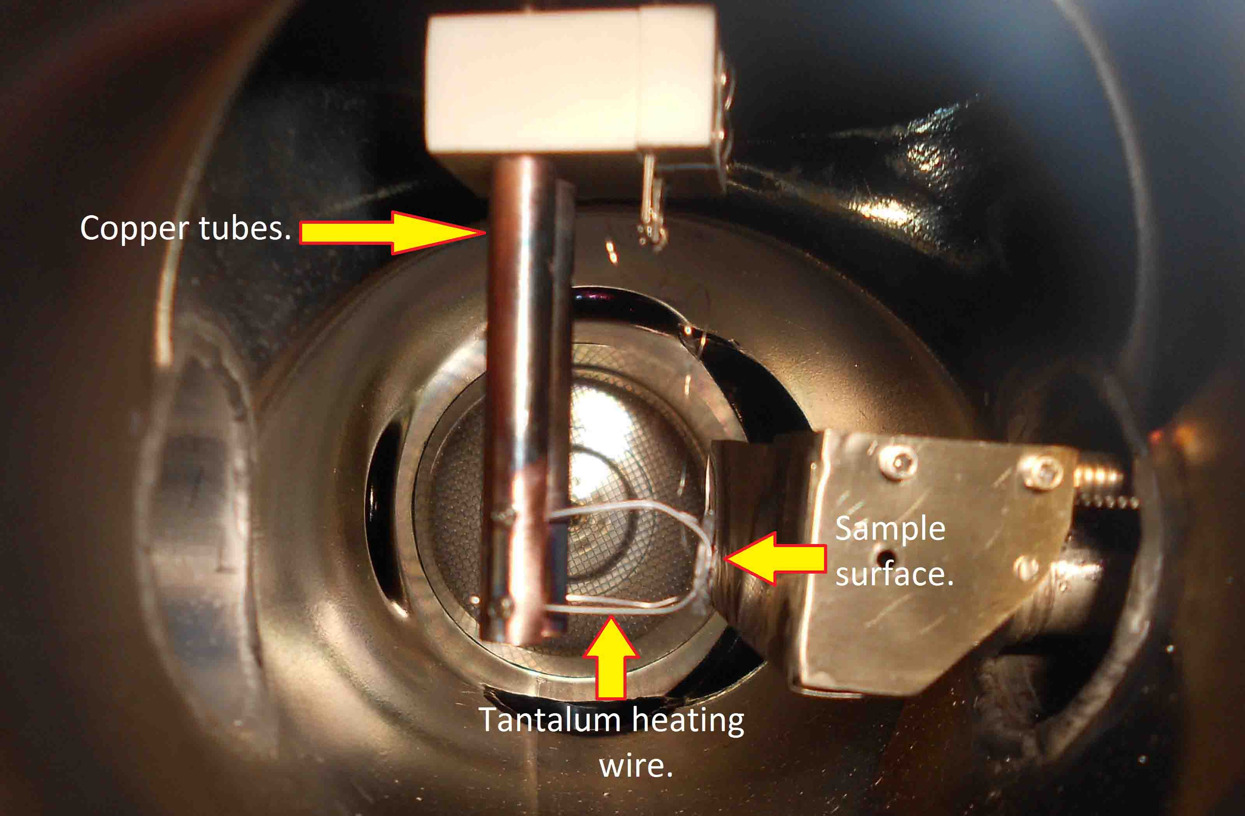

Figure 6: Sample holder parts.

Check to see if all set screws are tightened as a loose contact will decrease thermal transport efficiency. Weld the sample to the tantalum wires using the arc welding device. Make sure that the distance that the sample on the tantalum wires is correct. Replace the chromel-alumel thermocouple wires. Double check if the two materials are not labeled with a magnet as the alumel wire will be magnetic. Check to see if the thermocouple is functioning properly by using a heating gun. Reinsert the assembly after placing a new copper gasket into the flange. Connect the heating wires to the copper tubing.
Remounting of the sample will require the repositioning for optimal performance. Movement is performed using the controllers on the top portion of the instrument. Position the sample until it is flush with the gas inlet.
To spot-weld a sample to wires, use the "low" setting at an energy of 40~60% (upper scale). For a thermocouple, use between 20~40 % to spot-weld on to a crystal and between 15~30% to fix it to the feed--throughs.

- Repair of manipulator:
- Power and thermocouple feedthrough

This is the electrical feed through to which the sample is mounted. It conducts the thermocouple signal out of the chamber, electrical power to the sample for heating, and heat out of the sample when the liquid nitrogen is flowing. The present system employs a feedthrough purchased from Insulator Seal that requires a special order. When requesting this part number, explain that it will be used in a cryogenic application; otherwise the seals will be chemically attacked by the liquid nitrogen and eventually fail to keep vacuum.

Fig. 1. Thermocouple circuitry

Thermocouple circuit was slightly modified for more effective retention of low specimen temperature. Reference junction was added, to be held at 0 °C when running TPD. This two-couple sensor has been wired directly to RTC circuit board, to eliminate intermediate junctions . In is this type of connection, there must not be junctions between different materials, or at least equal number of them in the left and right arms of the circuit (e.g. alumel-chromel or alumel-copper), mounted on an isothermal block .
Hint: Insulated thermocouple wires are colored (alumel red, chromel yellow), but even when working with bare chromel and alumel wires, it is easy to tell magnetic alumel with a small magnet.

    - Wiring

The heating wires are connected to the copper tubes of the samble holder. By putting the two small copper feedthroughs of the manipulator back into the 1/4" copper tubes of the sample holder by carefully pushing them in we can heat the sample. Finally we reconnect the thermocouple wires.
If the thermocouple wires or the copper tubes inside the manipulator need to be worked on, the manipulator has to be taken out to get in there. This is a lot of work, so try to avoid having to do this!

- First take out the manipulator as described above.
- Open the mini-flange at the end of the manipulator tube. BE CAREFUL. If you cannot do this without possibly damaging the sample surface, take the sample off and put it in a secure place.
- Carefully pull out the tubes: This may take some effort. Avoid tearing the sleeves around the tubes. This may cause shorts later. Also, be careful not to break the ceramics.
- Remove the copper gasket and discard it.
- The copper tubes are connected with set screws. Loosen the set screws and pull the tubes off. When you reconnect the copper tubes, make sure that they do not touch each other or ground. If they do, the sample cannot be heated.
- The thermocouple wires are spot welded to the feedthrough connectors. If you replace the T.C. wires, make sure that each wire goes to the right connector (check with a magnet! see above). Twist the thermocouple wires to reduce signal pickup due to magnetic fields.

REMEMBER TO PUT ON A NEW COPPER GASKET ON THE FEEDTHROUGH FLANGE BEFORE PUTTING THE MANIPULATOR TOGETHER.

- Carefully tighten the feedthrough flange with an Allen wrench.
- Leak testing of the feedthrough flange is strongly recommended before putting the sample back into the chamber. To do this, put a KF25 welding piece with a conical rubber ring (the ones chemists use for filtration) around it into the hole on the back of the manipulator. The leak detector is then connected to the KF25 flange. This is not a great connection, and it will actually leak, but it is good enough to check for leaks on the feedthrough.
- If necessary remount the sample and thermocouple wires.

    - Sample holder

Sample holder Figure:
Heater Conductors
Thermocouple
Conductors

There should be good contact between the sample and heating wires. There should be no contact, at any point, between the thermocouple and heating wires. This will produce a false temperature reading.

The sample sits at the end of the tube which comes in from the top of the chamber and can be rotated and moved to all the analysis positions by the manipulator at the top. The exact position of the sample is read from the scale on the right of the manipulator, the x and y micrometers, and on the rotary. The two copper wires that run through the manipulator tube are used for heating the sample while the funnel is used to add liquid nitrogen to cool the sample. One can also use some plastic tubing connected to a liquid nitrogen tank for cooling of the sample. The sample is grounded through the thermocouple wires.

    - Rotating platform

The sample rest on an assembly of two tantalum wires. The position is controlled via turn able knobs located on the top of the instrument. These are to position the sample until it is aligned as desired. The up and down direction is controlled by movement of the entire manipulator arm.

- Heating, cooling, troubleshooting

Sample does not Heat.
- Check the fuse at the front panel of the temperature controller.
- Verify that all connections between the temperature controller and the external power transformer and between the transformer and the heating rods are made. These contacts tend to become oxidized or even loosen over time. Using a clamp meter, verify that current is flowing from the transformer to the sample. This should be several amps to as much as 60 amps.
- Verify that the heating power knob on the temperature controller is at its normal setting of 50~60%. A setting below this may not deliver enough heating power to the sample.
- Has a spot weld on the sample come undone?

The recorded temperature does not seem to be correct when heating-cooling.
- Take an exploratory TPD of a known system, such as CO adsorbed on Pt(111). If the temperature of the peaks are not as expected then the sample may be either dirty or the temperature controller needs to be repaired. If the sample has been cleaned thoroughly and the problem persists, then the temperature controller needs to be examined.
- Before removing the temperature controller, double check that it is in error. Perform a dummy TPD experiment in which the thermocouple in the back of the controller has been inserted into an ice bath. Perform a TPD as usual and see if the temperature being read off the computer is that of the ice bath. If not then it is time to remove the temperature controller from the instrumentation rack for examination.
- NOTE: Most failures of the temperature controller are the result of a blown AD597-AH thermocouple preamplifier chip. Changing out this component usually solves the problem. When the AD597 is replaced, the system needs to be recalibrated with a type K thermocouple immersed in liquid nitrogen. A full calibration procedure can also be performed if desired. These procedures are described in the RAMPING TEMPERATURE CONTROLLER manual.

- Biasing

By means of opto-isolation circuitry, the thermocouple and its preamplifier circuit are floating with respect to the system ground, i.e. the chamber and instrumentation chassis. The sample, which is in contact with the thermocouple, can be placed at any desired potential by simply applying that voltage to the either of the thermocouple leads or to the common of the preamplifier circuit. There are three banana jacks at the rear of the temperature controller where these connections can be made: TC COM (thermocouple common), SYS COM (system common), and BIAS OUT. The controller has an internal bias supply which provides a negative voltage in steps of 50, 100, 150, 200, and 250 volts.

- To ground the sample or give a zero bias voltage, connect SYS COM to TC COM with a banana cable.
- To apply a negative bias to the sample using the internal bias supply, connect TC COM to BIAS OUT, select the desired voltage and turn on the switch.
- To apply a negative bias with an external voltage source, connect its positive terminal to SYS COM and its negative terminal to TC COM. To apply a positive bias, reverse the polarity of the voltage supply.
- When using an external source, the bias current can be monitored by connecting a current meter (usually the Kiethly Picoammeter) in series with the voltage source between SYS COM and the terminal of the source.

e. Cleaning (single crystal)
          - Chemical cleaning

Anneal and ion sputtering of sample will complete the cleaning cycle, no chemical cleaning is needed for the metal single crystals.

          - Ar sputtering

The cleaning cycle can be performed at any time to clean the surface; however, ion sputtering need only be performed it the surface of the sample has been covered in hydrocarbons or by impurities that cannot be removed by regular annealing and this is the only method that will remove these contaminates. The ion gun power supply is located on the electronics cabinet.
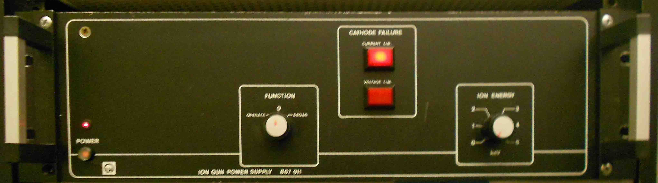

The MS must be off as the working chamber will be bathed in oxygen otherwise the filament will break. Check the connections to the oxygen tank. Purge this line to remove any impurities. Next introduce an amount of oxygen into the gas manifold. Set the temperature of the sample to 700 K and introduce 10⁻⁷ torr of oxygen. Maintain these parameters for 20 minutes. Then close the leak valve and vacuum anneal at 1200 K at 10⁻⁹ torr for 20~30 minutes. Repeat this process 4~6 times or until there is no considerable degassing of CO₂, CO etc. during vacuum anneal. After this process the surface is reasonably cleaned.

          - How to determine that it is clean

Take an exploratory TPD of a known system, such as CO adsorbed on Pt(111). If the temperature of the peaks are not as expected then the sample may be dirty. If the sample has been cleaned thoroughly and the problem persists, then the temperature controller needs to be examined.

f. Temperature reading

Desired temperature can be set with RTC dial in some abstract number, which can be converted to actual degrees after a calibration procedure (described below). First of all, it is worth pointing to the nature of the dial number: it is octal, not decimal.
People are confused when there is no 8 and 9 going after 7, but this is just how octal arithmetic works – 777 is octal representation of 511, but next number is 1000, and it is just 512. The most important thing, that on calibration one cannot fit mill volts of thermocouple output, or temperature in K, with octal “Set value” (SV) numbers – they must be converted to decimal format first. Otherwise, a good linear fit can never be achieved, – there will be steps on the curve every time the octal place is switched to next, like from 777 to 1000.
When working at specimen temperature in range 78–200 K, additional care should be taken on thermocouple wiring and adjustments of ramping temperature controller (RTC). Originally, this RTC was designed for experiments at room temperature and above; when TPD is started from lower temperature, ramping may be non-linear. The controller can not hold very low specimen temperature when power is 30% or higher. If ramping is started at low temperature, initial heating rate may be very high. TC circuitry and controller parameters are described below.
When it is necessary to start TPD from 100-200 K, the problem is that RTC can hold this low temperature only at 5–10% of maximum heater power. With this adjustment, a good linear ramping is achievable up to the room temperature, but for further heating such power is not enough. The solution can be in a smooth manual turn of the “Heater power” pot on RTC panel after low- temperature range is passed, up to 60% which is enough to heat to 1000 K.

  - Heating power supply (operation, calibration)
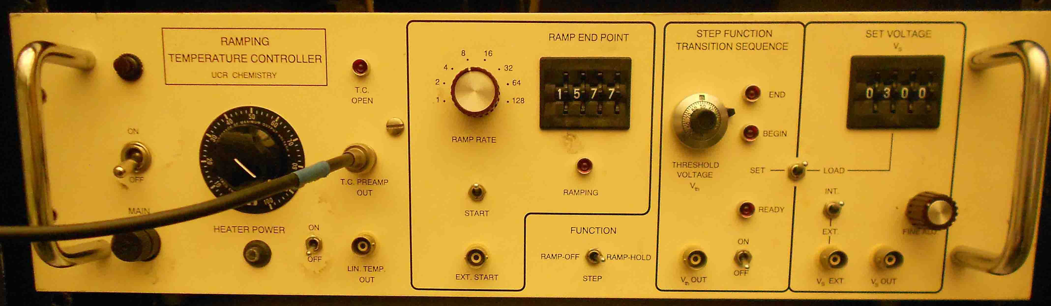

Therefore, a proper operation and calibration procedure should be the following:
Dip the reference junction into distilled ice–distilled water mixture;
Connect thermocouple to RTC;
Connect a mill voltmeter to thermocouple output (parallel to RTC input);
Start TPD recording program on the computer and set it for a short run, about 5 seconds. Analog-to-digital converter on the controller receives the signal from thermocouple through RTC amplifier, so X-scale recorded by computer depends on the temperature in the same way than direct thermocouple output, but to convert it to the actual temperature, calibration must be done.
Establish a constant temperature at the specimen junction: set a certain octal number on RTC “Setting voltage” (SV) dial and click by “Load” switch, keep the power knob at the level below 30%. (Notice: at low temperatures 10% or less is sufficient, or there may be a long wait for specimen cooling after RTC hits it with high current.) “Function” switch should be on “Ramp-hold.”
Record thermocouple output from mV–meter. Current specimen temperature can be calculated directly from this value and above.
Record a few data points to computer. What is actually needed is the average value for X-coordinate, taken from this file;
Increase the number on “Set value” dial to 10–20 units.
Repeat steps 5-8 until 20–25 points will be acquired.
Make a linear fit of the program output (X-coordinate) against temperature. It will be used to convert X-scale to the temperature in TPD data.
Also make a fit for temperature dependence of SV, to know what temperature will be established after a certain value is set on the dial. Do not forget to convert octal SV numbers to decimals (Fig. 10).
Two files located in “Reference_material” can be helpful to make such calibration:
“TPD_calibration.opj” – MS Excel worksheets and graphs for temperature calibration;
“K_type_calculate.xls” – Origin plot for conversion of thermocouple millivolts and SV to temperature (Warning: linear approximation used in this file has been made with a certain RTC adjustment. Current parameters may vary. Before use, please update it with recent data from a fit you made).

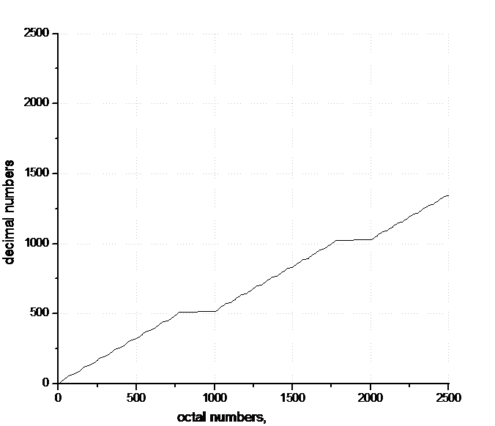

Fig. 7. The wrong way to fit octal numbers with decimals

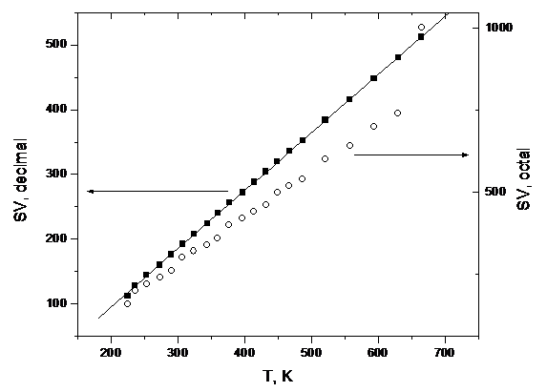

Fig. 8. Temperature fit for “Set value” dial numbers.

4. Gas handling, gas manifold
- Design, schematics
To the LHS of the chamber’s window is a gas manifold. There are presently three gas outlets where propylene oxide is mounted.

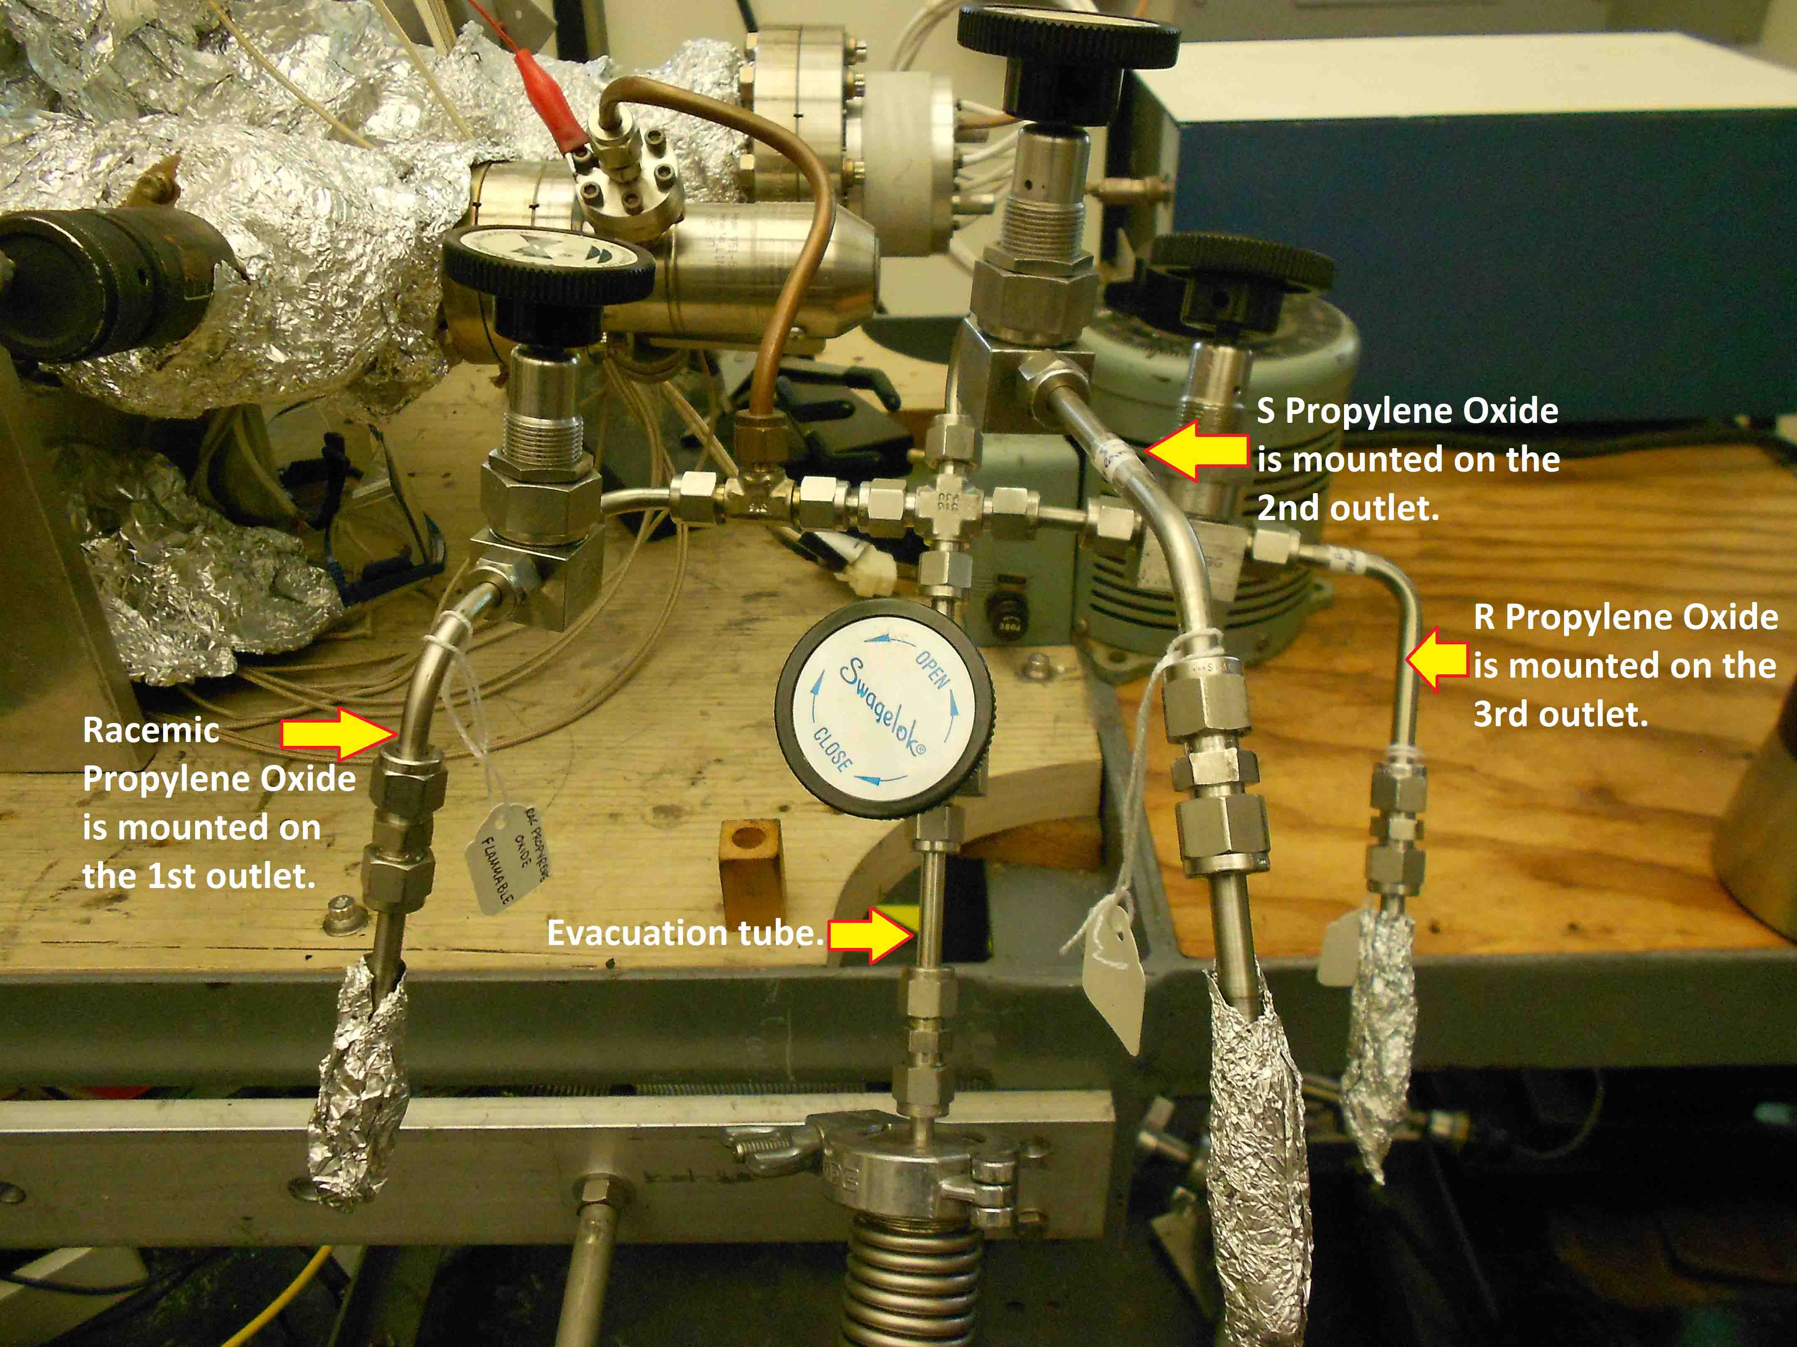

Figure 9: Gas manifold outlets.

The manifold has a pressure sensor and is evacuated via a mechanical pump connected on the opposite side.

- Valves, regular and to UHV

There is a turn-able valve that can be used to isolate the manifold from said pump. It is connected to a leak valve that opens directly to the working chamber.

- Tubing, Connectors (Swagelock, etc.)
Although the building of gas lines is not an important concern for ultra high vacuum, it is often necessary in the lab and does require some attention. Refer to the description of the parts and their handling in the Swagelok catalogue.
Avoid mixing brass and stainless steel connections, since brass is softer. Otherwise ferrules and threads may become damaged or prematurely worn. The nuts should go smoothly onto the thread, and a bolt should never need force to make the connection. The nut and bolt may require pre—conditioning before operational use. Thread the target bolt and nut separately, using force if needed. This should straighten any kinks in the thread. Figure 10 shows the proper method of setting up a connection.

Furrel Bolt
Figure 10: Proper method of setting up a connection.

Clean stainless steel tubing with acetone prior to assembly. Cut the tubing to the required length. Use a metal tube cutter, turn the cutter one turn prior to tightening the fitting. Next debar the opening and smooth the end with a file.
Insert the cut tube into the fitting or nut. First place a ferrule in with the small ring first. Turn the nut finger tight while holding the body of the fitting with a wrench. With a wrench tighten the nut 1 and a quarter turns. Reopen the nut to verify that the ferrule is properly sitting. This entails making sure that the lower ring is in a fixed position. Verify that the tubing (and connection) itself does not possess any leaks prior to use. To test the actual tubing, pour acetone over the length while monitoring the pressure.

- Pressure gauges
There are three pressure sensing instruments located on this instrument. The first is a MKS Instruments’ “PDR-C-1C Power Supply/Readout” that is located on the outer left hand side of the electronics cabinet. The readout is connected to a “Type 221A Electronics” signal conditioner that is in turn connected to a “Baratron” sensor. The sensor operates based on a diaphragm design The front panel has an LED display, a power switch, and a controller knob. This knob is used to indicate its mode of operations. For pressure reading, turn the knob to the ‘mbars’ position. On the back of the component there is a cluster of four DIP switches and six screw downs leads. The DIP switches should be set as follows (starting with one to four): Open, Closed, Open, Open. The electrical leads between the readout unit and signal conditioner should be (reading left to right): Black, Black, Green, White, Red, Black. Refer to the instrument’s manual for detailed information
Located directly beneath the turbo pump controller is the “GP 271 Gauge Controller”. The sensor is located inside the working chamber and is of a Bayard-Alpert design. On the controller itself, there is a ‘on/off/auto’ knob underneath a red light. This controls the state of the instrument. For normal operations, it should be in the ‘auto’ position. To the LHS of the yellow light, there is another knob that controls the amplification of the instrument. When the chamber is in relatively low vacuum, the knob may be in the ‘10’ position; otherwise, for high pressures the controller may be in the ‘1’ position to read the pressure. Engagement of mode is via the flip switch directly beneath the yellow light. Whenever the instruments mode of operations is to be changed, the actual change does not occur until this switch is flipped.
The pressure of the gas manifold and the turbo/mechanical pump is through the use of the Jarrel Ash component located at the very bottom of the instrument. This gauges utilizes for its sensor a “Baratron” design. ‘Ext Timer’ reads the pressure from the LHS of the gas manifold and the latter at the junction between the turbo and mechanical pumps.

- Pumping system (mechanical pump)

There is a Dayton 3K 199M mechanical pump connected directly to the gas manifold. This pump receives corrosive gasses from the manifold hence will require maintenance. It is equipped with oil trap. These mechanical pump need to have its oil changed on a regular basis and need to be rebuilt from time to time. Ballasting may be needed. The ballast valve is located on the side.
It is advisable to change the oil every four months; but more frequent oil changes may be necessarily if using corrosive substances.

- General operation procedure

Always evacuate the dosing tube to be refilled:
- Make sure all 3 valves of the manifold are closed.
- Make sure the leak valve on the chamber is closed.
- Make sure the valve between the manifold and the pump is open.
- Evacuate the tube to be refilled by opening the corresponding needle valve. Watch the pressure in the manifold: it should normally come down to about 30 mTorr.
- Close the needle valve.

To fill with gas from a lecture bottle:
- Attach the lecture bottle to the manifold with the Ultra-Torr Connector to one of the dosing lines.
- Evacuate the dosing line up to the small valve of lecture bottle regulator.
- Make certain the secondary pressure on the regulator is about 20-30 psi.
- Close needle valve and pressurize behind the leak with the gas by opening the small valve on the regulator.

To fill the tube with a vapor:
- Fill a liquid sample tube with 1-2 ml of the liquid to be used. Use a new flint glass pipette. This is very important otherwise the chemicals can be contaminated! Discard the pipette immediately after use!
- Connect the glass tube to the dosing tube via an Ultra-Torr connector.
- Close the valve in the glass tube.
- Evacuate the dosing tube by opening the second valve to the right on top of the manifold. Watch the pressure. It should come down to about 5-6x10-3 Torr.
- Freeze the liquid by submerging the glass tube in liquid nitrogen. Use a small dewar to do this.
- When the liquid is frozen, open the valve in the glass tube. The pressure should increase now. Wait until the pressure is back to about 5-6x10-3 Torr.
- Close the valve in the glass tube.
- Thaw the liquid to release trapped air and freeze again, while keeping the glass tube closed!
- Repeat the last 2 steps until the pressure does not increase any more when the valve is opened.
- Close the needle valve.
- Fill the tube with the vapor of the liquid by slowly opening and closing the valve in the glass tube.
- Check the cleanliness of the vapor by taking a mass spectrum.

- Gas and liquid sample handling

In many cases, additional purification is needed for gases stored in lecture-bottles and used for molecular beam experiments. For example, isotope-labelled ¹⁵NO may contain significant amount of ¹⁵N₂, and regular NO may contain NO₂ and other admixtures. Usually, gases are purified by a freeze-pump-thaw cycle in a small stainless-steel cylinder or a glass bulb. For ¹⁵NO, the only way to get rid of N₂ is to freeze NO down to the temperature of liquid nitrogen and the pump nitrogen out. Partial pressure of NO at 78 K is less than 3 torr, so pumping to this level is enough. Regular NO can be purified by passing it through an U-bended tube, dipped into a cooling bath. Following mixtures are suitable:

Cooling bath mixture | Temperature, °C
Pentane / Liquid Nitrogen | -131
Methanol / Liquid Nitrogen | -98
Hexane / Liquid Nitrogen | -94
Acetone or Isopropyl Alcohol / Dry Ice | -78
Acetonitrile / Dry Ice | -42
Carbon Tetrahcloride / Dry Ice | -23

- Use of glove box

A glove box can be used for sample preparation under controlled environment.
A glove box can interface directly with load locks and other chambers and allow safe handling of hazardous or air sensitive samples.

- Maintenance

The oil in the mechanical pumps will eventually spoil. This usually occurs in a six month time period. To change the oil pump needs to be turned off; however, the oil trap needs to be opened before powering the pump down. If the oil trap is not opened first, then the oil will be taken up ruining the molecular sieves. After the pump has had time to cool slightly, open the top screw first. Place a properly labeled waste bottle under the cap on the side of the pump and then drain. Wait until all oil has been drained.
Recap the side opening and pour in approximately the same amount of oil that was drained. Monitor the oil level using the window on the side.. Because the new oil will be aerated, fill with new oil to the very top of the window. During the course of normal use the oil level will drop to the recommended level, as the dissolved air will be pumped away. Label the date the oil was changed and make a note in the instrument log book. This will give a consistent approach to servicing.

- High-Flux doser

- Design, schematics
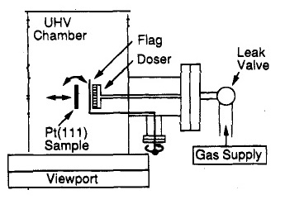

Figure 11: Schematic representation of the High-Flux doser.

The collimated beam doser consists of a 1.2 cm diameter multichannel array made up of microcapillary glass tubes 2 mm in length and 10 pm in diameter each. The gas flux is set by setting the leak valve. A movable stainless steel flag was placed between the doser and the sample in order to be able to intercept the beam at will.
Most of the holding parts of the sample in the manipulator, are placed behind the sample so that adsorption of the gas from the doser onto the manipulator could be minimized.

- Regular operation

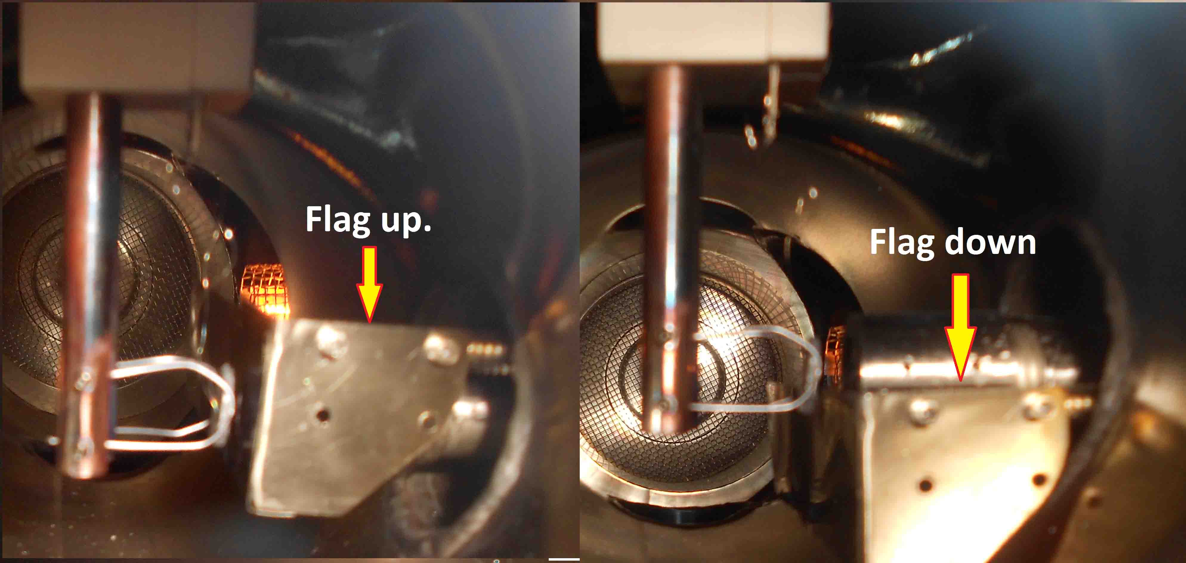

Figure 12: Flag movement in front of the sample.

- The gas flux is set by setting the leak valve.
- The sample surface is placed behind the flag.
- While recording the gas pressure with the MS, we take the flag out of the molecular beam’s way.

- Calibration

The beam effusive rate can be monitored by measuring the UHV equilibrium pressure, P_{eq}, taking advantage of the fact that the two parameters are proportional to each other. The effusive rates could then be modified by changing the backing pressure, making use of the fact that again those two parameters are linearly related.
- Maintenance:
    - Capillary array

Normal repairs are usually opening the chamber for part replacement such as a damaged capillary aray. As such some points need special attention while working on whose parts directly exposed to vacuum. All parts exposed to vacuum should be handled with gloved hands as fingerprints and grease will prolong pump down time. Should a piece of equipment become contaminated with oil, e.g.. fingerprints or vacuum grease, then those afflicted parts need to be cleaned.
Cleaning of component pieces follows standard practice for lab ware. Large pieces such as stainless steel flanges and tubes may be washed with hot water and soap. Rinse multiple times to ensure no residue that may be coating the piece. Finish with an acetone rise and bake to dry. Smaller parts can be placed directly in acetone and ultrasonicated. If a beaker is being used as the vessel containing the small part to be cleaned, then do not place directly in the ultrasonic bath as the beaker may crack. Use a retort stand to hold the beaker/part assembly.
Inspection for cracking, tears and broken valves is recommended prior to beginning experimentation. Metal tubing should not be unduly stressed as this will lead to warping. This will cause the connectors and valves to become less effective and will result in leakage.

    - Flag
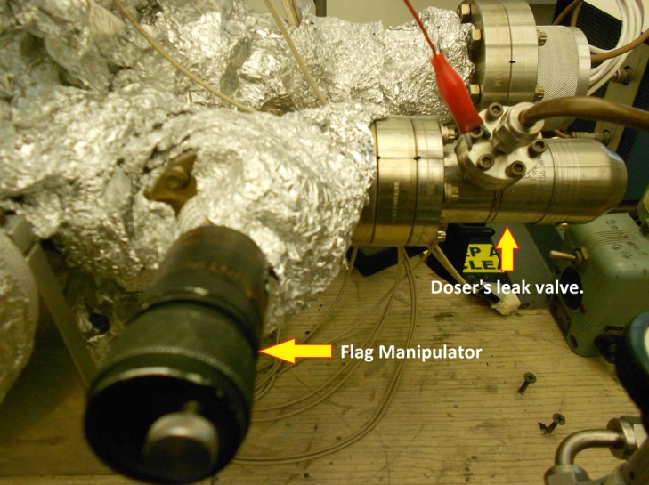

Figure 13: Flag manipulator and doser’s leak valve.

The flag manipulator must be maintained in a condition that allows the user to turn the flag up and down easily.

- Mass spectrometer (UTI 100)
  - General operation
    - Turning on, off, keeping in stand by mode.

Whenever the MS is to be left unattended for a long amount of time, it is good practice to put the instrument into standby mode. As the MS requires a relatively long degassing time.
1. To engage this mode of operation from normal data acquisition mode, make sure that the ‘var’ and ‘emiss (ma)’ switches are on.
2. Next slowly turn the emission knob to a reading of 1.00 milli Amp. The damper should be in the nine o’clock position.
3. Next, flip to the ‘far cup’ switch. The amplifier should then be set to 10⁻⁵. it on overnight in "total pressure" setting before running experiments. Keeping the instrument in this mode will prevent gas build up, and decrease the number of times that the MS needs degassing.
To put the instrument into data acquisition mode, first verify the state of the instrument. The MS should be in standby mode with an emission current of around one milli Amp. If this is not the case, then the instrument may need to be degassed. Otherwise, the instrument is ready to obtain data.
1. Flip the ‘on/stby’ switch to disengage the ‘far cup’ mode and then the ‘mult’. Switch to 10⁻⁸ on the amplifier and make sure that the damper is still in the 9 o’clock position.
2. Slowly adjust the emission current to a target level (e.g.: 1.50 mA). There are two ways that the signals may be acquired from the instrument, either in ‘norm’ or ‘ext’ modes. The former outputs the signal to the attached oscilloscope and the latter to the computer acquisition unit.
If the instrument needs to be degassed, then refer to the proper subsection in the section labeled “Bake” of this manual for instructions. For general information such as for explanation of the controls and settings, refer to the instrument’s manual.
Turning the MS on from standby mode (summary):
Check if the ‘Emission’ reads ~1.00 mA, i.e. the MS does not need to be degassed.
Press "ON/STBY".
Press "Multiplier".
Press "EMISS/(MA)" to follow the display of the emission of the filament. Slowly increase emission with knob until 1.50±0.01 mA. Always use the same value to keep experiments comparable. Check if the protection mode is on (slide front panel out, little switch on right hand side: to the right: protection mode on; to the left: protection mode off.
Connect scope (x to ramp generator, y to signal out), set scope to x,y mode to observe spectrum with scope (x,y DC decoupling).
Depress "EMISS/(MA)", press "VAR" and adjust sweep time with knob on left side. The display over the range keys show the intensity, whereas the one over "EMISS/(MA)" gives the mass.
Scan width and scan center can be varied with the respective knobs while "EMISS/(MA)" is depressed and "WIDTH" or "MAN" are pressed (only one switch pressed at a time).
Switching to "MAN" yields a straight line on the scope. You can tune from amu=1 until 300 manually with the :"Center" knob. The height of the baseline gives the intensity of the peak.
Placing MS into standby mode (summary):
Set range to 10⁻⁵.
Turn emission to 1, switch to “Far Cup” mode.

    - Displaying in Oscilloscope

The oscilloscope is connected to the MS and provides a means of measuring m/z signals. The instrument is a Tektronix 100 MHz Model No. 2235. There are two channels labeled CH1 (or X) and CH2 (or Y). Both channels are connected to the MS via a BNC cable with the first channel to the ‘ramp generator’ and the second channel to the ‘signal out’. Both channels should be in the ‘DC’ mode. In the box labeled ‘vertical mode’ both ’CH1’ and ‘alt’ should be selected. Use the knobs about the channels to control the horizontal and vertical scale.

    - Recording MS in PC

Make sure that the MS is in front of the sample. Otherwise, the signal will be too weak for measurement. Also, when finished obtaining data switch off the multiplier mode.
To begin data acquisition, go into the directory Program Files / UTI Mass Spectrometer and select UTI TDS shotcut. Put the MS to "EXT" mode setting damper to 9 o'clock and following the steps of the program to perform a TPD. Cross talk may be experienced if the damper is set too high, i.e. the MS is picking up the signal of one m/z and the m/z before the actual signal. This can be checked by varying the order in which the m/z’s are taken. Set to an appropriate range, and perform a dry-run of the heating to determine the time you needed for a TPD. Run both the computer and heating simultaneously to get the TPD. The software creates one file that are suffixed: “dat” and contains the actual data. This file will be stored in the folder specified by the user.

    - Calibration

The MS will need to be calibrated from time to time. There is a UTI Mass Spectrometer program which is to perform the necessary calibrations. To calibrate the MS (summary):
At the computer coupled to the instrument, go to the directory Program Files / UTI Mass Spectrometer and select UTI_scan shotcut. The program will ask you to import the calibration file located at Local Disc (C:) called: cal.txt.
Pick a peak to begin calibration, set MS to "MAN" mode and observe the line on the oscilloscope.
Switch to "EXT". Pick the same mass with the computer program and compare the intensity on either the oscilloscope or the intensity display above the range switches.
Use the commands "UP", "DOWN" to move the calibration of the peak until the intensity is equivalent to the manually measured one.

Figure 14 shows a snapshot of the UTI_scan program.
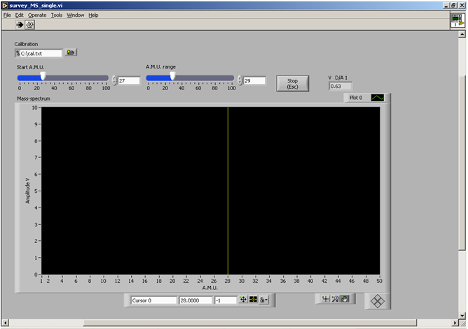

Figure 14: Snapshot of the UTI_scan program

To collect a single spectra go to the directory Program Files / UTI Mass Spectrometer and select UTI TDS shotcut. Don't forget to put the mass spec to "EXT" and set the damper to the correct position. When the UTI TDS program starts, it will ask you to select a configuration file: (*.cfg). These files are usually located at the Desktop.
After selecting the configuration file, we can record the TPD spectra we chose, by using the start-stop buttons. The software creates one file that is suffixed: “dat” and contains the actual data. This file will be stored in the folder specified by the user, in the configuration file.
Generally the MS does not need maintenance. Refer to the manual for a complete description of the system. Technical support is available from MKS. The filaments may need replacement and are made of tungsten. Replacement filaments are in the "filament" drawer. There, you can also find insulation ceramics.
If the filament does not turn on, then remove the connector plug located at the back of probe. The filament feed-through on the RHS (marked) may have carbon deposits, decreasing the contact to the pins. These deposits should be immediately removed using emerald paper. Similarly, small pliers can be used to scrape away these deposits on the fourfold metal feed--through. Check for shorts in the feed-through at the same time. Small insulation ceramics are used in the head of the probe were the filaments sit. If they get covered with tungsten deposit, shorts are possible, leading to power leakage and causing further problems, e.g. the filament not turning on. Sometimes, small nuts get wedged between the focus plate and the quadruple rods, causing a 0 resistance between focus and RF.
The calibration procedure for UTI C100 mass-spectrometer,
The procedure will be the following:
Connect Y-input of oscilloscope to the mass-spectrometer output (“Signal out”). Make it running on automatic X-scan to watch the signal amplitude;
Set a proper emission level (1.5 mA is enough), and turn the multiplier on;
Get some helium to the chamber. Even if helium tank is not connected to a leak-valve, it is easy to make it leaking into the chamber by carefully blowing helium to the mechanical pump exhaust port;
Set the mass-spectrometer to be controlled manually by pressing the “Norm” switch on “Program” set of switches;
Tune to the maximum of helium peak at mass 4 by turning the “Mass” knob and watching the signal on oscilloscope;
Set the mass-spectrometer to be controlled by an external programming device (computer) by pressing the “Ext” switch on “Program” set of switches;
Go to the directory Program Files / UTI Mass Spectrometer and select UTI_scan_average shotcut. The program will ask you to import the calibration file located at Local Disc (C:) called: cal.txt. The calibration file looks like this:

0 0.000
18 0.350
28 0.635
44 0.970

The procedure will be the following:
- Connect Y-input of oscilloscope to the mass-spectrometer output (“Signal out”). Make it running on automatic X-scan to watch the signal amplitude;
- Set a proper emission level (1.5 is enough), and turn the multiplier on;
- Get some helium to the chamber. Even if helium tank is not connected to a leak-valve, it is easy to make it leaking into the chamber by carefully blowing helium to the mechanical pump exhaust port;
- Set the mass-spectrometer to be controlled manually by pressing the “Norm” switch on “Program” set of switches;
- Tune to the maximum of helium peak at mass 4 by turning the “Mass” knob and watching the signal on oscilloscope;
- Set the mass-spectrometer to be controlled by an external programming device (computer) by pressing the “Ext” switch on “Program” set of switches;
- Run UTI_scan_average shotcut program on the computer, track amu 4;
- By changing the value up or down, tune it to the same maximum. Match of the masses can be checked by switching from “Ext” to “Norm” and back, the signal should stay at approximately the same level;
- When the position of low mass is calibrated, save the result and switch to mass 300;
- Tune manually to the maximum of mass 44 peak (it will be harder because in clean chamber mass 44 signal is weak). Better if other gas with high molecular mass is available, for example, xenon, but a calibration on 44 position also gives a satisfying accuracy;
- Shift the position of mass 300 up or down several times, then switch to mass 44 and see, whether the peak position match by switching from “Ext” to “Norm” and back;
- When the position of high mass is calibrated, save the result.

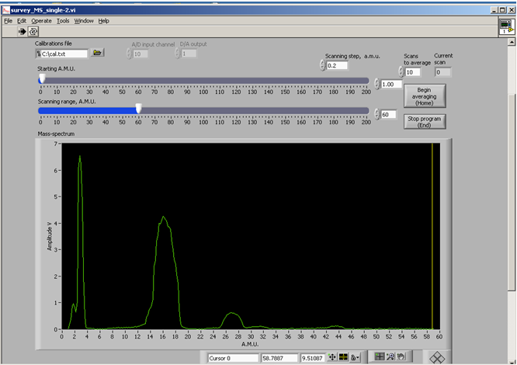
A snapshot of this program can be seen in figure 15.

Figure 15: Snapshot of the UTI_scan_average program.

    - Maintenance:
      - Filament

To change a filament the probe needs to be first disassembled. Refer to the manual to the RAIRS chamber on how to take the z-shift apart. The shift will be rough if the set-screw has been tighten too much.

      - Detector

Note: Vacuum Technology, (423) 481-3342, can do repairs on the UTI systems. If they are unable to perform the needed repairs, then MKS can be contacted directly, (408) 988-4020 ext 280 contact: Marti Suorsa.

There are three of four UTI 100C manuals in the lab. They are in large three ring binders and contain all the needed technical information about these instruments.

When work has to be done on the mass spectrometer, consult the UTI-manual for the repair procedures of the mass spectrometer itself. Make sure you have two 4.5" and one mini flange Cu-gasket before you start.
The UTI manual contains a complete set of schematics, a description of the system, and extended troubleshooting procedures. Technical support can be obtained from MKS, or Vacuum Technology. The filaments are made of tungsten/rhenium. Spare parts, tooling, and filament material are kept in a clear plastic partitioned box labeled “UTI 100-C Gas Analyzer Parts”.

  - Temperature Programmed Desorption (TPD)
    - General Considerations

The overall calibration (maximum at full mass value) is not perfect, the reason therefore is that a peak shift problem appears during use. During the operation of the mass spec the position of high mass peaks will move slowly to lower masses. The amount is about 0.2 amu, but this is enough to make the rates completely irreproducible, especially because most peaks are very sharp on the high-mass-side of the peak.
If necessary the calibration file (cal.txt) could changed again. The fastest calibration procedure was in my opinion to use a text editor to manipulate cal.txt directly and then to take a reference scan of a gas containing high masses (like N₂O, CO₂) after each change. The effect of this change can then be seen directly in a plot containing the different scans. This process was repeated until the maximum was on full numbers (unfortunately the QMS was not shifted to the final status at this time). With the small clock on the left hand side of the grey box behind the front cover the resolution / Peak separation could be adjusted. Both steps have to be repeated, because they interfere each other.
It was further found that the only really working procedure to archive a constant peak position without constant shifting was to put the filament to 1.5 mA and switch on the multiplier. After about 4 h the final position of the peaks was reached and reproducible data could be taken.
In the moment these positions are finally off about 0.1 to 0.2 amu and the followed masses have to be set in this way (e.g.43.8 instead 44). Otherwise cal.txt has to be changed under this conditions to readjust to full numbers.
When a 4 h pre-experimental phase was not possible, I measured more masses, e.g. 43.7, 43.8, 43.9 and 44 and then saw the shifting over time. Picking out always the mass with the maximum was the second way to avoid this prooblem.

Sometimes I have observed spikes on a data curve. I found two reasons for this. First possibility the spikes are going up and a channel is in saturation (higher than 10 V), e.g. a mass is measured which is signal too high in this range, but the overall measuring time is not prolonged. Further indication they are present in all scans and go to 10.24 V as value in a reasonable fraction of all data points. You can avoid this spikes by measuring only masses which fit in the selected amplification range. A later removal via software is possible, but is difficult and sometimes not successful, e.g. two spices in points next to each other.
The other possibility is that the peaks normally go to the value of another measured mass and the overall measurement time is extended. In this case the reason is a timing problem between data acquisition card, the software and the windows operation system. There is no way to repair this problem later, the measurement has to be repeated. You can lower the appearance by avoiding any action with the PC during taking data, e.g. moving mouse, network access even passive ones, swapping by the operation system because of a too full HDD (remove files to another storage).

    - Software

To collect a single spectra go to the directory Program Files / UTI Mass Spectrometer and select UTI TDS shotcut. Don't forget to put the mass spec to "EXT" and set the damper to the correct position. When the UTI TDS program starts, it will ask you to select a configuration file: (*.cfg). These files are usually located at the Desktop. The configuration files can be opened as .dat files and they contain the information below:

[Data acqusition]
A.M.U. to be tracked="1.8, 2.0, 3.8, 4.0, 4.2, 57.8, 58.0, 58.2, 63.8, 64.0, 64.2"
total time, min=90
interval, ms=200
[Input-output settings]
mass-spec A/D=10
mass-spec D/A=0
thermocouple A/D=11
masses calibration file=C:\cal.txt
data output folder=/c/rawdata
[Thermocouple input]
pre-amplifier: slope=245.46
pre-amplifier: intercept=-0.0000
reference temperature for thermocouple=2

    - How to take TPD data
      - General details

We select the amus that we would like to track, then the input-output pin numbers of the oscilloscope (these are always the same), the calibration file, the output folder and the thermocouple input. The slope that we choose at the thermocouple input, has to do with the linear output of the electronic chip inside the temperature controller. Next to the Praxis system there is a manual with the temperature tables, which also includes a manual for the AD597 temperature chip, used for this system. It is written in the manual that the slope for the ideal function of the linear output is: 245.46, which is the one we use in the configuration file above. The reference temperature might have to be changed every time we spot-weld the thermocouple, by using a reference temperature in the configuration file that results in the recording of a well know TPD peak at the right temperature.

      - Running procedure

Make sure that the MS is in front of the sample. Otherwise, the signal will be too weak for measurement. Also, when finished obtaining data switch off the multiplier mode.
To begin data acquisition, go into the directory Program Files / UTI Mass Spectrometer and select UTI TDS shotcut. Put the MS to "EXT" mode setting damper to 9 o'clock and following the steps of the program to perform a TPD. Cross talk may be experienced if the damper is set too high, i.e. the MS is picking up the signal of one m/z and the m/z before the actual signal. This can be checked by varying the order in which the m/z’s are taken. Set to an appropriate range, and perform a dry-run of the heating to determine the time you needed for a TPD. Run both the computer and heating simultaneously to get the TPD. The software creates one file that are suffixed: “dat” and contains the actual data. This file will be stored in the folder specified by the user.

      - Data acquisition

After selecting the configuration file, we can record the TPD spectra we chose, by using the start-stop buttons. The software creates one file that is suffixed: “dat” and contains the actual data. This file will be stored in the folder specified by the user in the configuration file. Two snapshots of the UTI TDS program can be seen in figure 16.
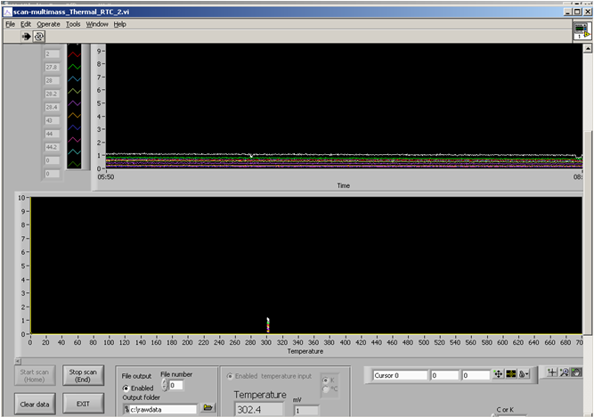
Recording background UHV gases at room temperature:

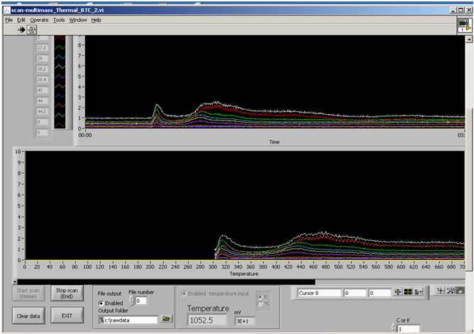
Running TPD measurements:

Figure 16: Snapshot of the UTI TDS program

      - Data processing

After saving the data in the .dat file, it can be imported in any data processing software like origin or excel.

      - Editing

Figures of series of TPD spectra can be made showing possible desorption temperature differences. The TPD area can be measured which is proportional to the gas molecules that desorb from the surface.

- Ion Gun
- General considerations
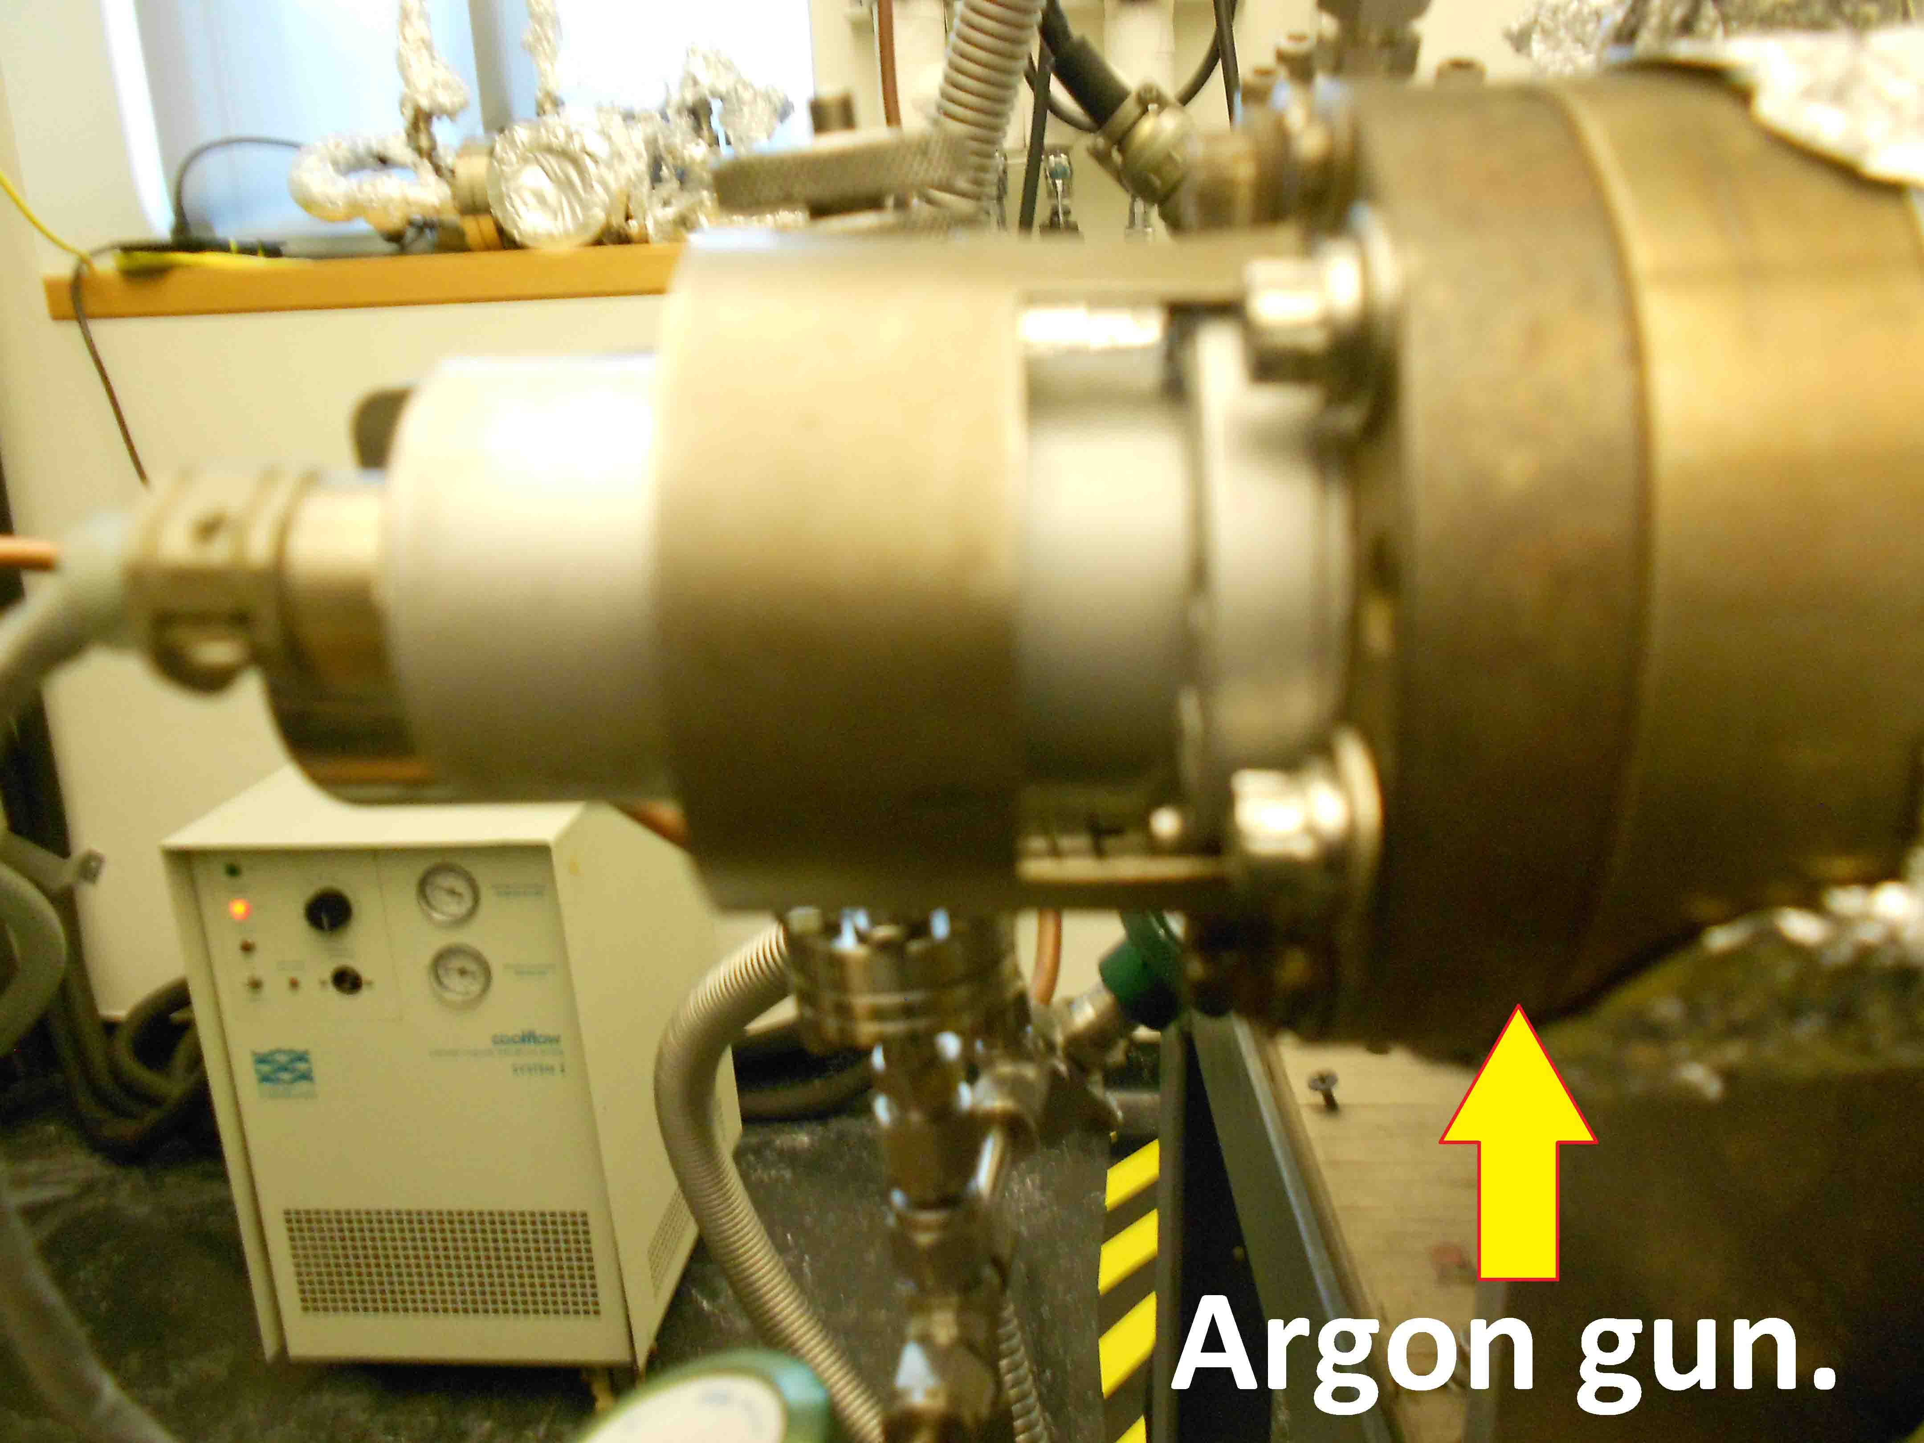

Figure 17: Argon gun picture from the outside of the UHV chamber.

The PHI ion gun, model 04-191 is controlled by unit 20-115, and is used to etch the surface of the samples. This is done by heating a filament, which emits electrons. These electrons are then attracted to a more positive anode. Some of the electrons collide with inert gas molecules (usually argon) that have been bled into the chamber, and thus form ions (Ar+). As the filaments, anode, and shield are all biased positively, these positive ions are accelerated out of the ion gun and on to the sample. On the way out of the ion gun, they pass through deflection plates and are focused by additional optics.

- Typical operation

Turning on the Ion Gun
1. Make sure that the power switch is off and the emission control is turned fully
counterclockwise on the control unit (20-115)
2. Backfill the chamber with the desired gas to a pressure, typically 3x10-6 Torr
3. Position the sample in front of the ion beam
4. Turn the “Beam Voltage” to 5 kV
5. Turn the “Beam Voltage” switch to OFF
6. Turn the “Raster” switch to OFF
7. Turn the power ON
8. Turn the “Focus” control to New Std
9. Slowly turn up the “Emission Current” to 25 mA (on meter)
10. Turn on the “Beam Voltage”
11. Adjust the “X, Y position” and “Raster” controls as necessary. Typical values: X = 2.5,
Y = 6.0 for regular rod; X = 2, Y = 5.5 for heating rod. Sample position: 1.5cm.

Turning off the Ion Gun
1. Turn the “Beam Voltage” switch OFF
2. Turn the “Emission” control fully counterclockwise
3. Turn the “Raster” switch OFF
4. Turn the power switch OFF

- Sample cleaning

- Move the sample into the proper position using the adjusting screws on top of the manipulator. These settings should be re-optimized for maximum Ar⁺ beam current every time the sample is remounted.
- Switch on the main power of the ion gun power supply. This automatically turns on the filament to the proper preset value.
- Open the Ar leak valve on the back of the sputter gun until the pressure in the main chamber is 2-3x10-5 Torr.
- Turn on the high voltage to the ion gun using the toggle switch. The voltage reads 2 kV. Adjust the emission current to 15 by using the knob rightmost. Under these conditions, the sample current will be about 2-3 µA. The ion beam will be rastered across the entire sample.
- After about 30 minutes of sputtering, anneal the single crystal to about 1150 ºK by setting the ramp end point to 1450.

- Maintenance, troubleshooting

Replacing the Filament
1. Remove the external connections as described in the “Bake-Out” section.
2. Vent the chamber as described above, in “Venting the Instrument” section.
3. Remove the ion gun from the chamber.
4. Loosen the end-cap screws and gently pull off the end cap.
5. Undo the fixing grub crews and pull off the old filament
6. Place the new spiral tungsten filament on the supporting pins and slide it down.
7. Tighten the fixing grub screws
8. Replace the end cap, making sure that it does not touch the filament.
9. Screw the end cap in place and check the connectivity of the filaments before placing the ion gun back in the vacuum chamber

- Potential hazards and safety procedures

Pressures in the Vacuum Chamber and Gas Manifold
There are numerous things that may cause a pressure increase in the chamber or the gas manifold. If the pressure is really out of line, the problem should be fixed as soon as possible. Just keep an eye on it and take action when necessary.
Things to Check before Going Home

- The following should be off:

- the heater around the rotary on the manipulator
- the heater power on the temperature controller. The main power can be left on.
- the air flow into the manipulator
- the filament and multiplier of the mass spectrometer (toggle switches in appropriate positions)
- the sputter gun

Safety procedure:

- Cool down LN₂ trap on backside of dozer
- Clean crystal
- Start QMS (2 mA, multiplier)
- Wait till peak shift is over (about 4 h)
- Do experiments

- Other Items

Gaskets
Part NO. GK-150
MDC
23842 Cabot Blvd
Hayward, CA, 94545

Valves and Gas Lines/Connectors
NUPRO
4800 East 345th St.
Willoughby, OH, 44094

Mechanical Pumps
Varian 3/4 horse power. Vacu-Tech (714)-798-873.
Oil Type: TKO-19
Kurt J. Lesker Co.
1515 Worthington Ave.
Chairton, PA, 15025, (800)-245-1656.

Mass Spectrometer
UTI Instruments Co.
2030-C Fortune Drive, San Jose, CA, 95131
(800)-346-0100, (408)-942-0949 (FAX)
497 S. Hillview Drive, P.O. Box 4008. Milpitas, CA,95035-2008
(408)-945-1955.

Oscilloscope
Tektronix 100 MHz Model No. 2235

- Appendices

Appendix A (Maintenance Schedule)

Date Changed Oil:

Mech. Pump 1 | Mech. Pump 2 | Turbo Pump

Inspection of O-Rings/Gaskets/Tubing:
Date | Notes

Annealment/Ion Sputtering:
Date | Notes

Bake Out:
Date | Notes

Appendix B (References)

R.S. Barton, J. C. Riviere, A.H. Turnbull; An Introduction to Vacuum Technique; John Wiley & Sons, Inc.; New York; 1962.
J.H. Moore; C.C. Davis; M.A. Coplan; Building Scientific Apparatus, Sec. Ed.; Addison-Wesley Publishing Co., Inc.; New York; 1989.
N.W. Robinson; Ultra-High Vacuum; Chapman and Hall Ltd.; London; 1968.
P.A. Redhead; J.P. Hobson; E.V. Kornelsen; Ultrahigh Vacuum; Chapman and Hall Ltd.; London; 1968.
J.A. Dillon; V.J. Harwood; Experimental Vacuum Science and Technology; Marcel Dekker, Inc.; New York; 1973.
A. Gurthrie; Vacuum Technology; John Wiley and Sons, Inc.; New York; 1963.

Appendix C (Figures-Drawings)
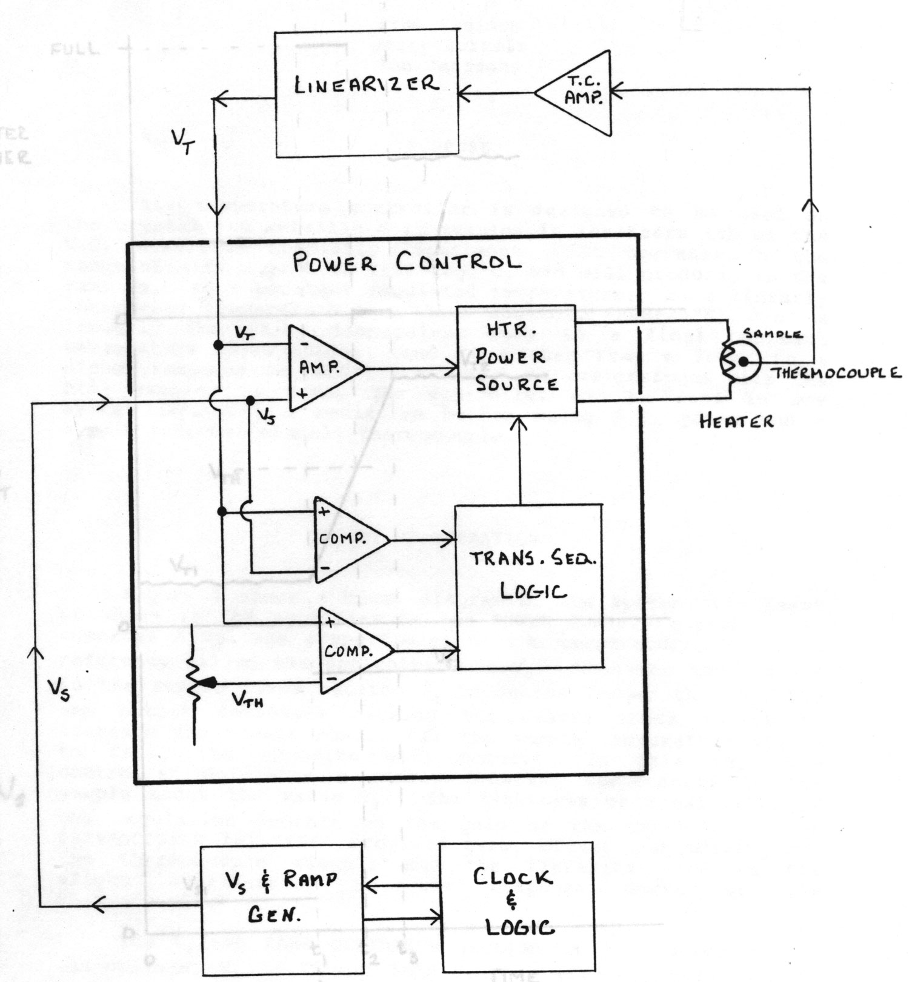
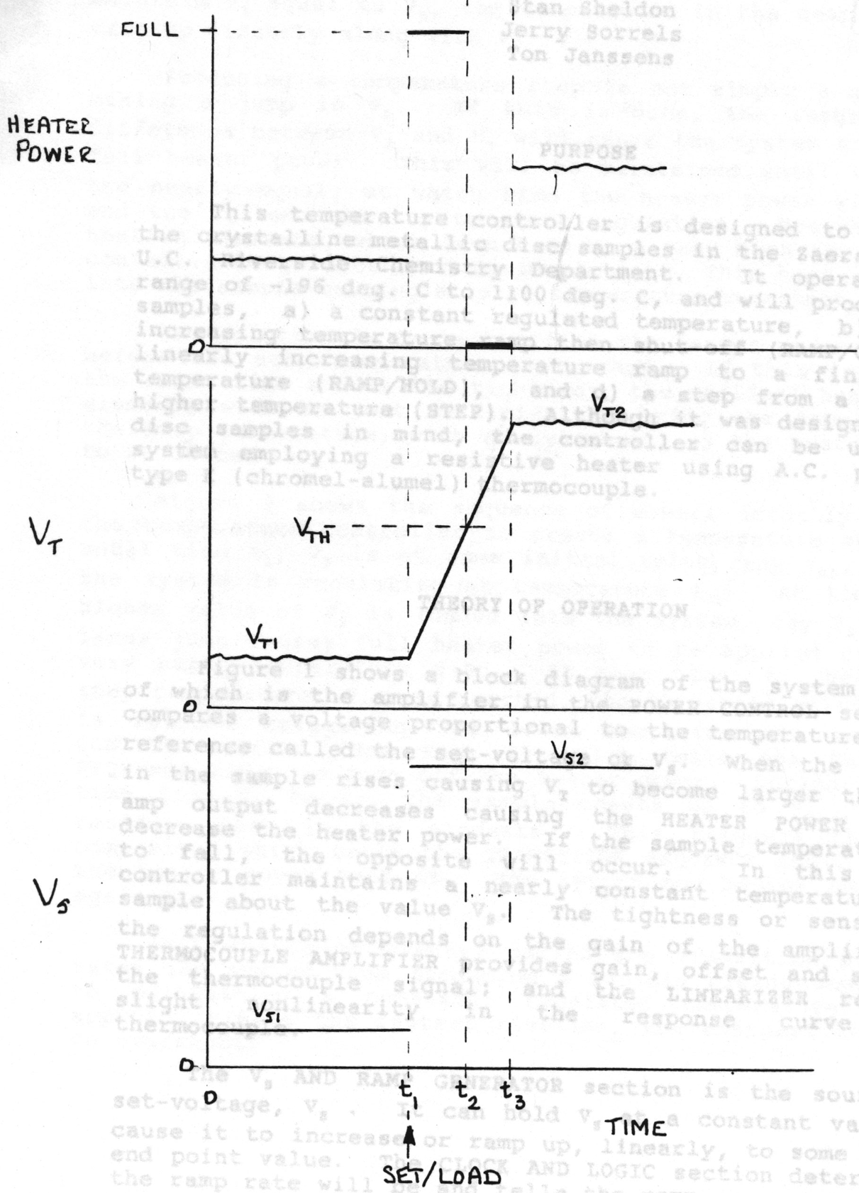

Figure 18: System Block Diagram
Figure 19: Step Function Transition Sequence
Appendix D (TC Calibration Curve)

Appendix E: Additions to Manual PRAXIS

Mass Spectrometer:

I found that the best data were gotten with 1.5 mA Emission, the multiplier set to the 10⁻⁹ range and used with a HV of 1000 V.

Peak position

The overall calibration (maximum at full mass value) is not perfect, the reason therefore is that a peak shift problem appears during use. During the operation of the mass spec the position of high mass peaks will move slowly to lower masses. The amount is about 0.2 amu, but this is enough to make the rates completely irreproducible, especially because most peaks are very sharp on the high-mass-side of the peak.
If necessary the calibration file (cal.txt) could changed again. The fastest calibration procedure was in my opinion to use a text editor to manipulate cal.txt directly and then to take a reference scan of a gas containing high masses (like N₂O, CO₂) after each change. The effect of this change can then be seen directly in a plot containing the different scans. This process was repeated until the maximum was on full numbers (unfortunately the QMS was not shifted to the final status at this time). With the small clock on the left hand side of the grey box behind the front cover the resolution / Peak separation could be adjusted. Both steps have to be repeated, because they interfere each other.
It was further found that the only really working procedure to archive a constant peak position without constant shifting was to put the filament to 1.5 mA and switch on the multiplier. After about 4 h the final position of the peaks was reached and reproducible data could be taken.
In the moment these positions are finally off about 0.1 to 0.2 amu and the followed masses have to be set in this way (e.g.43.8 instead 44). Otherwise cal.txt has to be changed under this conditions to readjust to full numbers.
When a 4 h pre-experimental phase was not possible, I measured more masses, e.g. 43.7, 43.8, 43.9 and 44 and then saw the shifting over time. Picking out always the mass with the maximum was the second way to avoid this prooblem.

Spikes

Sometimes I have observed spikes on a data curve. I found two reasons for this. First possibility the spikes are going up and a channel is in saturation (higher than 10 V), e.g. a mass is measured which is signal too high in this range, but the overall measuring time is not prolonged. Further indication they are present in all scans and go to 10.24 V as value in a reasonable fraction of all data points. You can avoid this spikes by measuring only masses which fit in the selected amplification range. A later removal via software is possible, but is difficult and sometimes not successful, e.g. two spices in points next to each other.
The other possibility is that the peaks normally go to the value of another measured mass and the overall measurement time is extended. In this case the reason is a timing problem between data acquisition card, the software and the windows operation system. There is no way to repair this problem later, the measurement has to be repeated. You can lower the appearance by avoiding any action with the PC during taking data, e.g. moving mouse, network access even passive ones, swapping by the operation system because of a too full HDD (remove files to another storage).

Experimental Setup:

There are no more relevant changes in the way of operation or the machinery. Some of the components have been replaced by better ones, e.g. rubber hoses by all metal ones.

All pressure gauges (TC type) were changed to D-6M types, 531 tubes will produce wrong reading, be aware of this difference, when changing or adding one of these parts.
A software upgrade was performed by installing the UTI scan program instead of Basica, which was used previously for Data acquisition.

See, for example, section “Deal-Seal CF Flanges” in MDC Vacuum Products catalog
Varian 3/4 horse power. Local Contact: Vacu-Tech (714)-798-873.
Type: TKO-19+; Kurt J. Lesker Co., 1515 Worthington Ave., Chairton, PA, 15025, (800)-245-1656.
Pfeigger, Type: TPU 170.
Model: PDR-C-1C; MKS Instruments Inc, Six Shattuck Rd, Andover, MA, 01810; (800)-227-8766, (508)-975-0093 (FAX)
Oil Type: TKO19+, Obtainable from the Kurt J Lester Company.
NUPRO Co.
Insulator Seal Part Number: 9392015
See also: “Practical Temperature Measurements” in “Reference_material” folder on CD
For further details see RTC manual.
National Contact: Swagelok Co., Solon, Ohio, 44139; Local Contact: San Diego Valve and Fitting Co., Inc., 1295 Morena Blvd, Suite C, San Diego, CA, 92110
Model: PDR-C-1C; MKS Instruments Inc, Six Shattuck Rd, Andover, MA, 01810; (800)-227-8766, (508)-975-0093 (FAX)
Oil Type: TKO19+, Obtainable from the Kurt J Lester Company.
UTI Part Number: 02878.

