Leybold EA11-MCD (UC) XPS UHV Chamber (#5)

Operating Instructions

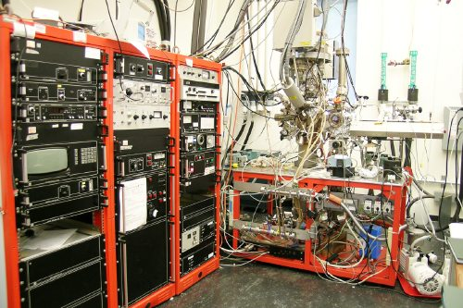

Updates:

Nathan Havercroft on April 30 2001
Hugo Tiznado on April 08 2005
Xiangdong & Huaxing in Aug 2009
Huaxing Sun in May 2014

Table of Contents

Table of Contents 2
Electronic Units 4
Vacuum System 5
Evacuating the Instrument 5
Venting the Instrument 5
UHV Bake-Out 6

Pumps Maintenance ………………………………………………………………………7
Turbo pump for preparation chamber…………………………………………………..7
Turbo pump for main chamber……………………………………………………….10
Mechanical Pumps……………………………………………………………………11

Cooling System…………………………………………………………………………..12

X-ray Source 13
Initial Operation……………………………………………………………………….14
Turning the X-rays on…………………………………………………………………15
Turning the X-rays off 15
Maintenance 16
Replacing the Anode 16
Replacing the Filament (Cathode) 16
Replacing the Aluminum Window 16

Electron Energy Analyzer and Detector System ………………………………………..17
Electron Energy Analyzer…………………………………………………………..17
Turn the analyzer on………………………………………………………………..17
Turn the nanlyzer off……………………………………………………………….17
Typical settings………………………………………………………………….17
Testing the Analyzer………………………………………………………………..18 Alignment of lenses to increase the counts…………………………………………18
Calibration of the PS EA-11N ……………………………………………………..18
Multi Channel Plates (MCP)………………………………………………………..21
Servicing the detector system………………………………………………………21

Using the SPECTRA software 22
Setting up the data acquisition card 22
Collecting an XPS spectrum 22
Analyzing XPS Data 23
Tools Window 25
Background Subtraction 25
Curve Fitting 25
Quantification 27
Difference Spectra 27
Calibration 27
Adding Labels 27

Flood Gun 28
Operation 28

Ar sputtering 28
Turning the Ion Gun on 29
Turning the Ion Gun off 29
Ar sputtering…………………………………………………………………………..29

Mass Spectrometer 29
Turning on the MS 29
Standby Mode 30
Turning off the MS 30
Software 30
Collecting a mass spectrum 30
Collecting a TPD spectra using TDS_RTC………………………………………...31

Sample Manipulation…………………………………………………………………….32
a. Mounting…………………………………………………………………………...32
b. Transfer from air to main chamber………………………………………………...35
c. Heating and cooling, and T measurements………………………………………...37
d. Maintenance of the transferring system……………………………………………38

Gas Handling…………………………………………………………………………….41
a. Manifold design, schematics, and operation………………………………………41
b. Gas feeding in the main chamber………………………………………………….42
c. Gas feeding to the reactor………………………………………………………….43

Operation of the ALD Reactor…………………………………………………………...44
a. ALD Deposition……………………………………………………………………44
b. Angle-Resolved XPS………………………………………………………………45
c. Depth Profiling……………………………………………………………………..46

MCP Maintenance ………………………………………………………………46
- Removing the MCD Flange………………………………………………………46
- Changing the MCP………………………………………………………………..52
- Mounting the MCD Flange……………………………………………………….54

Contacts…………………………………………………………………………………..56
Appendix A………………………………………………………………………………57
Electronic Units

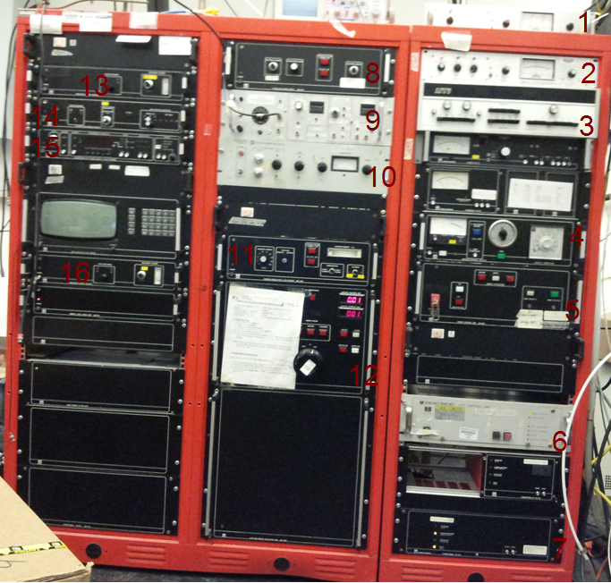

Figure 1 Photograph of the electronic units
Parts:
- GP-271 Ionization Gauge located in preparation chamber.
- GP-271 Ionization Gauge located in main chamber.
- UTI 100C precision mass analyzer.
- Bake-out Control (861915) inc.
- Power Control Unit (861900).
- SEIKO-SEIKI STP Control Unit for main chamber turbo pump.
- Turbotronik NT450 for preparation chamber turbo pump.
- Flood gun power supply (869900).
- Ramping Temperature Controller for TPD.
- PHI ion gun 20-115 located in main chamber.
- Emission regulation X-ray source (865920).
- High voltage supply (865925).
- Multiplier supply (865976).
- HV amplifier bipolar (865978).
- Energy analyzer power supply PS-EA11N (865903).
- Multiplier supply (865976)

Items that are not labeled are not in use, except some fans are running.

Vacuum System

Evacuating the Instrument
If the chamber is at atmospheric pressure for whatever reason the following are the necessary steps to obtain ultra-high vacuum.

- Make sure all valves are closed to atmosphere and all seals are tight.
- Ensure that the cooling water is flowing to the turbo pumps for preparation chamber with a pressure of at least 3 L/m.
- On the Power Control Unit (861900) turn pump groups A and B on.
- Ensure the valves between the backing mechanic pump and the turbo pumps are open, there is one valve per turbo pump
- Turn on the low vacuum gauges labeled main (tc Vacuum Gauge, Model M53T, located just beside the backing mechanic pump for the turbo pump for main chamber) and preparation chamber (tc Vacuum Gauge, Model M53T, located just beside the backing mechanic pump for the turbo pump for preparation chamber)
- Turn on the two backing mechanic pumps.
- Allow the pressure to decrease in to the 10⁻² Torr range.
- Turn on the two turbo pumps by pressing the start buttons on both turbo pump control panels.
- After 30 minutes or when the pressure on the low vacuum gauges is in the 10⁻³ range turn on the two ionization gauges by pressing the power on followed by the filament emission(Set power button to Auto, Fil button to ON, Emission to 1, for both of the two ion gauges units).
  - GN-271 Ionization Gauge unit in main chamber.
  - GN-271 Ionization Gauge unit in preparation chamber
- Pressure should fall steadily to 10⁻⁷-10⁻⁸ Torr in the preparation chamber and 10⁻⁸ –10⁻⁹ Torr in the main chamber.

Venting the Instrument
There may be situations where the chamber needs to be vented, such as to replace a filament in the X-ray source. To do this you should,

- Ensure all HV sources are switched off.
- Turn off all ionization gauges, and waited until 30 minutes.
- Close both the valves between the turbo pumps and backing mechanic pumps, and press the STOP buttons on both turbo pump controller units.
- Power off the two turbo pumps and backing mechanic pumps.
- After about 2 hours, open the Nitrogen flow very slowly.
- Open the vent valves bellow the turbo pumps slowly so as not to blow the X-ray window.

UHV Bake-Out
- Ensure the main chamber has good vacuum
- Remove all non bakeable cables
- Detach water cooling lines and HV from X-ray gun
- Blow residual cooling water out of the anode with compressed air
- Ensure all bake out lines are correctly attached
- The X-ray bypass switch should be in the interlock position
- Throughly wrap the main chamber with heating tapes, and use Al foils to cover the whole system
- Insert the thermal couple between the chamber and heating tapes at a representative position in the chamber
- Select the bake out temperature by reading on the thermal controller.
- Monitor and control the baking out temperature (~150ºC) for the desired time (generally 48 hours).
- After bake out allow to cool and reassemble in reverse order.

PUMPS Maintenance

Leybold TurboVac 450 Turbo pump for the preparation chamber

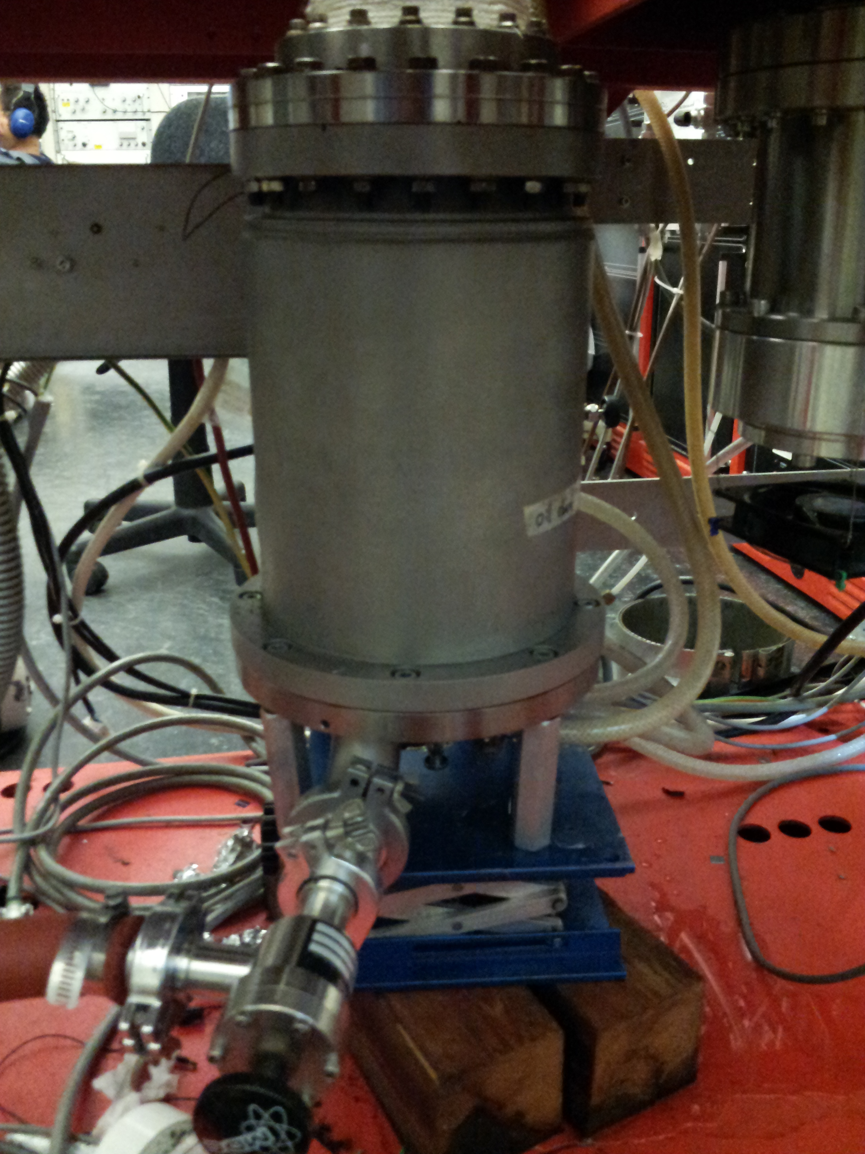

Figure 2. Leybold TurboVac 450 pump
This pump is placed on the ground level of the platform, with support of the elevating platform. Turbotronik NT450 (part 7) is the controller for this pump. Cooling water is needed to keep the pump running, though it could run without cooling water for 5 minutes when you have to stop the cooling water for a repair of the system. The speed of cooling water for this turbo vacuum pump should be larger than 0.5 LPM. Turbo pump oil should be changed every 12 months. When you do oil change for this turbo pump, follow the procedures as described here:

      - Turn off the ion gauge controller, and wait for at least 30 minutes until the filament inside the chamber is cooled
      - Close the valve between the turbo pump and mechanical pump
      - Close the gate valve between the turbo pump and the preparation chamber
      - Push the STOP button on the controller (part 7), and wait for at least 20 minutes until it stops running completely
      - Locate the oil pan at the bottom of the pump, loose the two screws in the following picture, and detach the oil pan
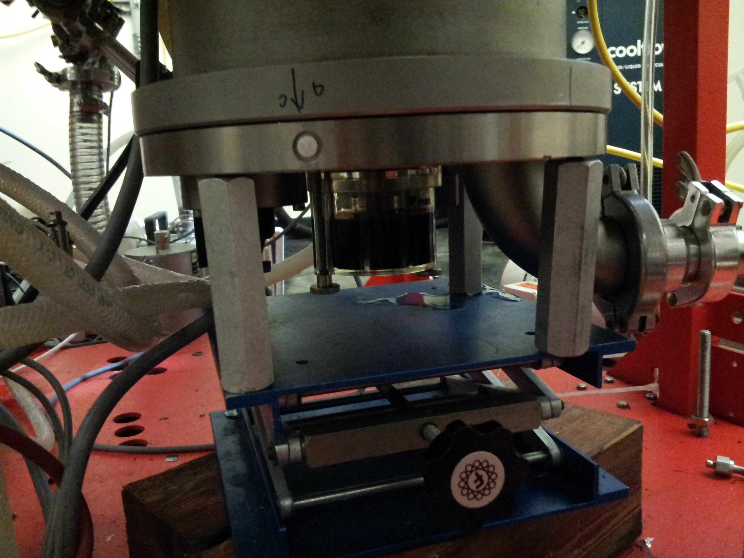
Figure 3. Bottom of the Leybold TurboVac 450 turbo pump

      - Pour the used oil into a waste oil container
      - Pour the new oil from the HE-500 Fluid on the left into the empty oil pan until the top is among the max and min.
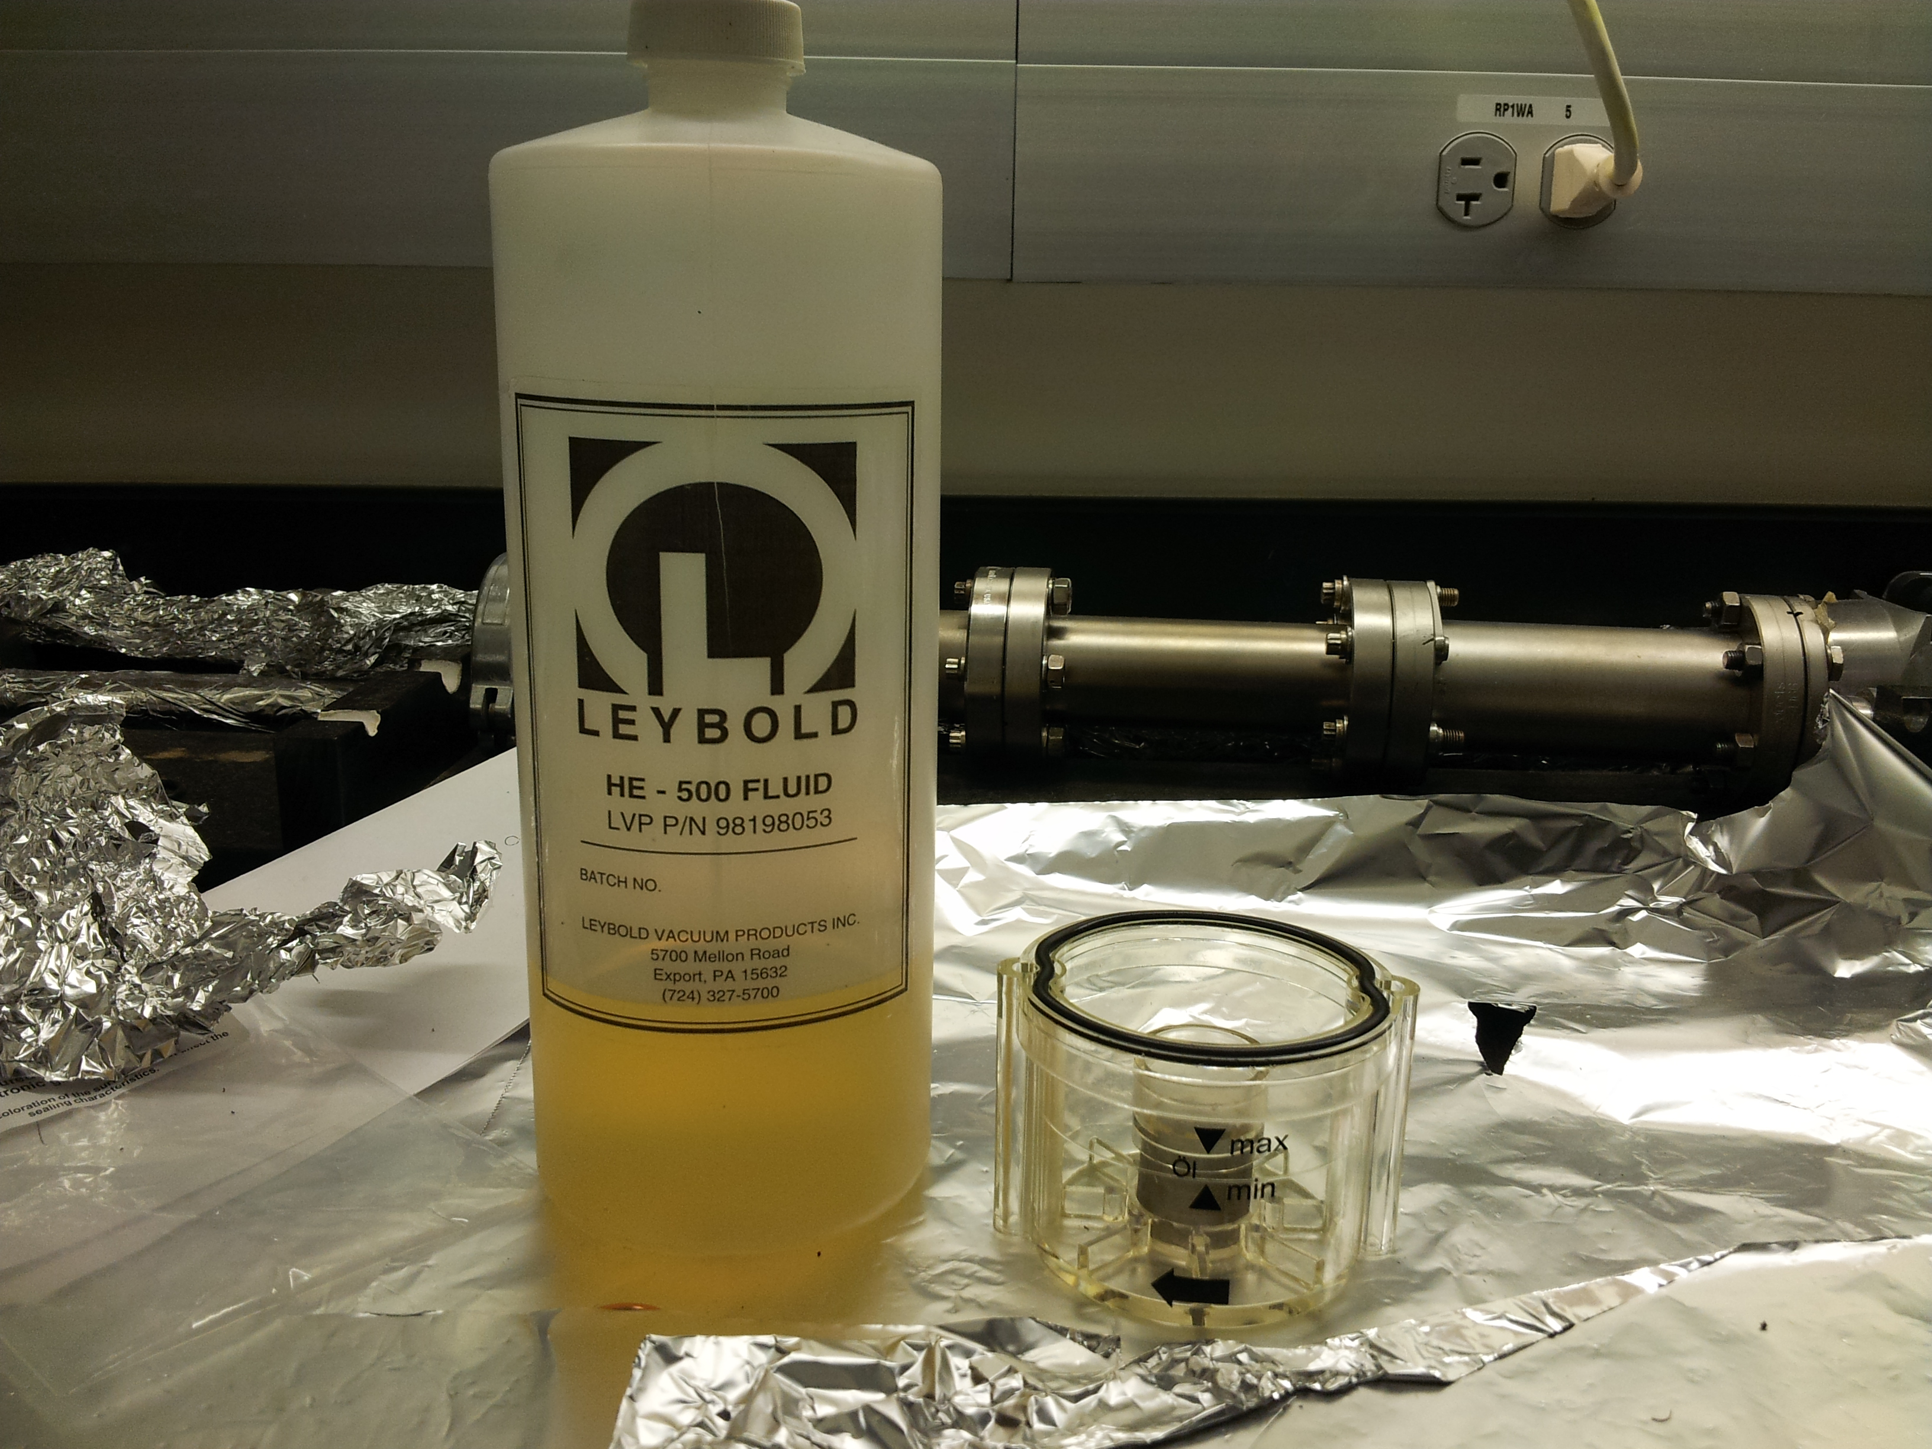
Figure 4. Oil for Leybold turbo pump and oil pan

      - Place the oil pan back to the pump, and tighten the two screws
      - Open the gate valve above
- Press the START button on the controller, and then open the valve between the
turbo pump and mechanical pump
- Wait until the light of NORMAL OPERATION is on, and the pressure in the
preparation chamber should be pumped down in a day.

Turbo Pump for the main chamber

Controller is the SEIKO-SEIKI STP Control Unit (part 6). No cooling water is needed for this pump, as this is a pump using air-cooling. However, a fan is placed to make it cooler. It is mounted at the bottom of the pump, and separate power supply is provided. It does not need oil change as described above to keep it running.
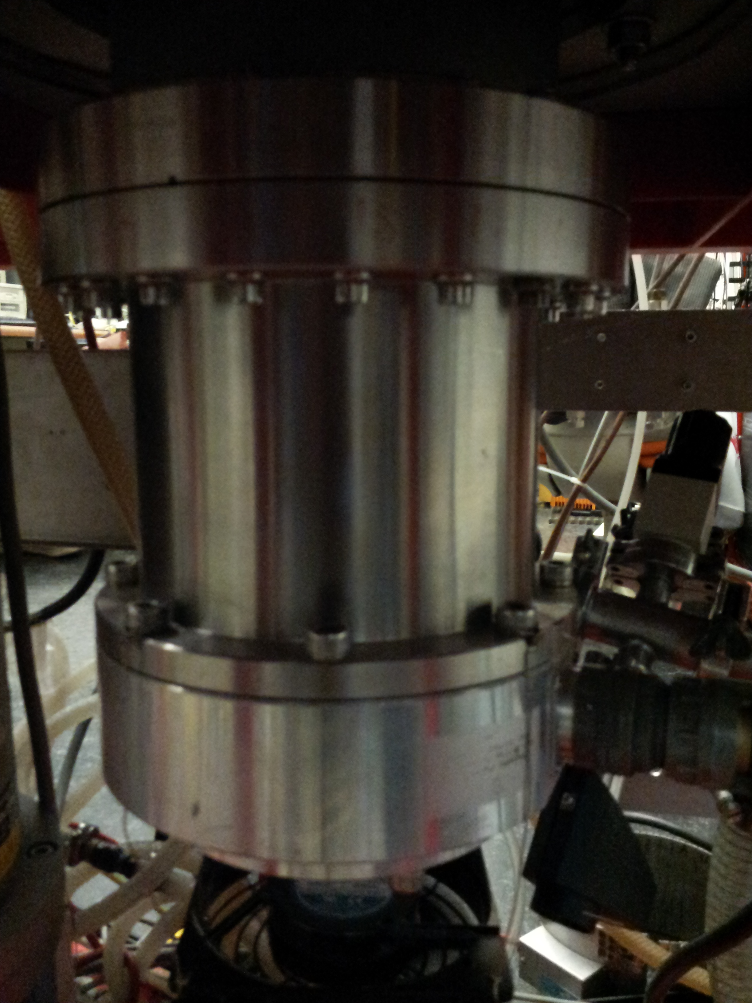
Figure 5. Molecular Pump for main chamber

Mechanical Pumps

Mechanical pumps are necessary to maintain the operation of the two turbo pumps and main the pressure in the load lock chamber. The oil inside these mechanical pumps should be changed every 6 months or whenever the oil is very dark. New oil is located in the northwest corner in the room 137, with name of Kurt J. Lesker Premium Semi-synthetic vacuum oil. No need to stop the turbo pumps, but the oil change should be finished in 15 minutes.
To change the oil of the mechanic pumps, use the following procedures:
      - Bring the new oil bucket, waste oil can, funnel, paper towels, and a plastic bag
      - Close the valve between the turbo pump and mechanical pump
      - Loose the clamp between the oil trap can and mechanical pump
      - Get someone to help to be ready to unplug the powerline of the pump
      - Slightly detach the oil trap can from the pump, and unplug the powerline of the pump
      - Place the pump onto the cart, and put the waste oil can below
      - Loose the two plastic screws (first the top one, and then the bottom one)
      - Slightly lift the other end of the pump, and drain the used oil into the waste oil can
      - Place and tighten the bottom oil hole with a plastic screw when the used oil is fully drained out
      - Use the funnel to fill the pump with new oil to the normal line between the mix and max marks
      - Tighten the top hole with a plastic screw
      - Place and tighten a blank flange onto the incoming gas port
      - Power the pump, and make it run for 1 minute
      - Power off the pump, detach the blank flange, and repeat the steps 8-11
      - Place and tighten the clamp between the turbo pump and oil trap
      - Power on the pump, and check the leak if necessary
      - Open the valve between the mechanical pump and turbo pump when the pressure for the mechanical pump is down to 30 mTorr
      - Clean and return the new oil bucket to Room 137, pour the waste oil into the waste pump oil container in Room 135, clean and return the waste oil can, funnel, place the dirty paper towels into a plastic bag, and leave these in the outside storage.

Oil trap is necessary to prevent the pump oil sucked into the vacuum chambers in case of power shutdown. If the oil is sucked into the oil trap after an accident, the molecular sieve inside the oil trap should be replaced. Usually, it’s also the time to change the pump oil at the same time.
            - Repeat the steps 1-15 above for changing oil
            - Loose the screw on the top of the oil trap, and pour the used oil trap out of the oil trap, which should be finished in a fume hood
            - Fill the oil trap with new molecular sieve, and tighten the screw
            - Repeat the steps 16-18 above for changing oil
            - Place the used molecular sieve into the waste container for molecular sieve in Room 135.

Cooling System

Cooling System is crucial for running XPS and turbo molecular pumps. The cooling system is partially shared with the Michel system in the same room. Before making any changes, check with Xiangdong and do the changes when the XPS is not running. The two water speed meters in Figure 6 are in charge of monitoring the flow speed for each channel: left one for turbo pump for preparation chamber, and the middle one for XPS anode. The flow speed for the left one should be kept above 0.5 LPM all the time, while the speed for the middle one should be kept above 3.5LPM only during the XPS running time.
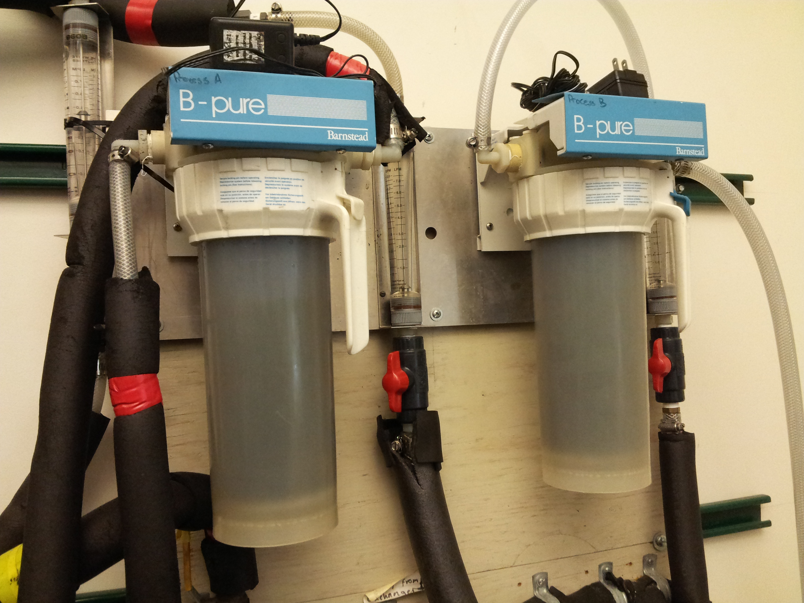
Figure 6. Water flow speed monitors

Before running a XPS experiment, the cooling water must be turned on and the flow speed should be larger than 3.5 LPM. Pull up the upper valve with green tapes in the middle to the up, while slowly pull the valve on the left with yellow tape when the flow speed in the left meter is about 0.5 LPM. At this time, the meter reading in the middle for the XPS anodes should be around 3.5 LPM.

The purifying water filter should be replace every year. The cooling water should be replace very year with DI water from second floor stock room.

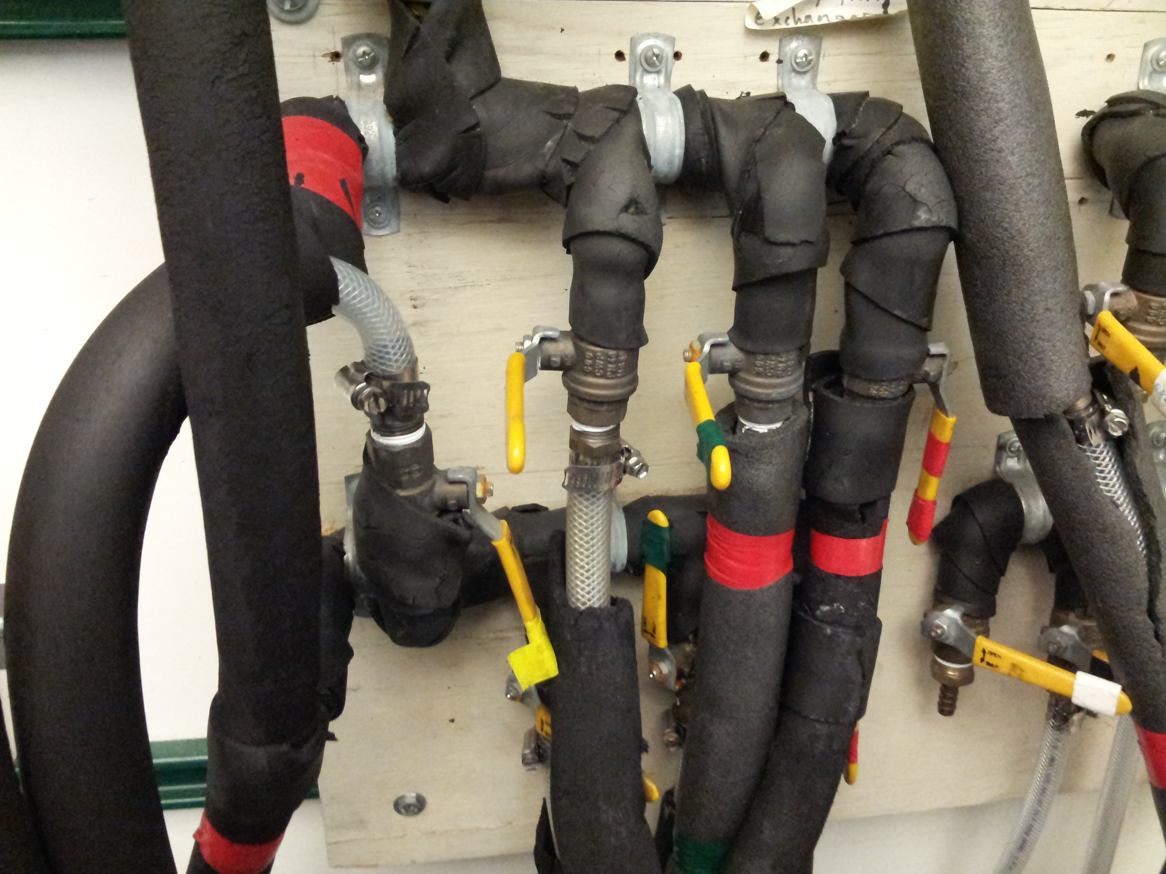
Figure 7. Water control of the system

X-ray Source
The X-ray source is specifically designed for use with X-ray photoelectron spectroscopy (XPS) systems and is fitted with a dual source anode, magnesium (1253.6 eV) and aluminum (1486.6 eV). This allows easy switching between the sources and therefore rapid distinction between photoelectron and Auger peaks. It also helps with a linear caliboration of binding energy scale.

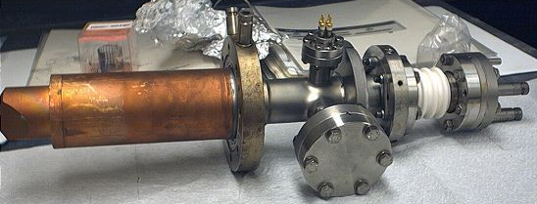
Figure 8. X-ray Source

Initial Operation
When using the X-ray source for the first time after it has been at atmospheric pressure (after changing the anode, filaments or aluminum window, for example), follow these steps:

      - Check all connections are correct
      - Vacuum should be lower than 1x10⁻⁸ Torr
      - Ensure HV dial is fully counter clockwise on the HV Supply Unit (865925)
      - Ensure Emission Regulator is set to “stand by” on Emission Regulation Unit (865920)
      - Turn on the cooling water at a pressure of about 3.5 – 4.0 L/m. Steps:
a. Open two green color labeled valves.
b. Partially close the yellow color labeled valves.
c. Adjust the yellow valve to make sure the flow rate of turbo line is about 0.2 L/m, and the flow rate of the XPS line is about 3.5 L/m.
d. Wait about 10 min.
      - On the Power Control Unit urn the Main Switch Key to ON and Press the Electronics button to ON (If the buttton ON bounded again and again, you should just keep trying).
      - On the HV unit press the water on button
      - When the water light is off, press the HV button
      - Turn HV to 8kV and leave for 45 – 60 minutes
      - Slowly increase to desired value (11.20kV in this experiment)
11.On the Emission Regulation Unit, chose the desired anode
12. Wait for 10 minutes to let the source degas
- Switch it from “stand by” to “operate” and wait until the CATHODE FAILURE CURRENT LIM light turns off
- Wait for 10-30 minutes to let the source degas, then wait longer for the pressure in the main chamber to fall down to an acceptable level (close to the value before).
- Turn the emission dial to the minimum value (2 mA), and leave it there for 20 minutes to degas.
- Increase the emission current in a stepwise manner until reaching the desired value (20 mA for both anodes), leaving it alone for at least 20 minutes between each step.

The actual emission current may be about 2 or 3 mA greater than the value set on the Emission Regulation Unit because of some current leakage that occurs through the water supply. At present it is 0 - 1 mA lower than the set value!

Note: If in the “operate” mode the “current limit” lamp is on, it means that the chosen HV is not sufficient to support the desired current. Increase the voltage or decrease the current immediately in order to maintain the life of the filament. Also, the “stand by/operate” switch is temperamental, so be sure that it has indeed been moved by monitoring the current dial.

Turning the X-rays on
The following procedure assumes that the source has been operated previously with its current anode, filaments and x-ray window. If not please follow the procedure above, “Initial Operation”.

- Follow steps 1 to 8 from the list in the previous section
- Turn the HV directly to the desired value (11.2 kV)
- On the Emission Regulation Unit, chose the desired anode
- Turn on the Emission Regulation Unit. The “Current limit” light will be on. And the filament current should be about 3-3.2A. The pressure of the main chamber will slightly increase, then fall back down.
- Wait for a few minutes. The “Current limit” light will flash, then it will turn off.
- Switch from “stand by” to “operate”.
- Slowly increase the emission current from 0 to 20 mA (the final desired value). The HV will drop when increasing the emission current. Maintain the HV at about 11.2 kV.

Note: If in the “operate” mode the “current limit” lamp is on, it means that the chosen HV is not sufficient to support the desired current. Increase the voltage or decrease the current immediately in order to maintain the life of the filament. Also, the “stand by/operate” switch is temperamental, so be sure that it has indeed been moved by monitoring the current dial.

Turning the X-rays off
- Turn the Emission Regulation Unit to “stand by”
- Reduce the emission current to 0.
- Turn off the Emission Regulation PS.
- Turn the High voltage dial completely counterclockwise
- Switch off the HV by pressing the “HV off” button
- Press the “Water off” button
- Switch the electronic knob off.
- Wait for 10 min, then turn the water supply for X-ray source off

Note: If for some reason the HV is automatically switched off, the above procedure should be carried out before the HV is switched on again.

Maintenance

Replacing the Anode

Technically this can be done without removing the entire X-ray source from the chamber. However, due to alignment issues, it is best to remove the source from the chamber.

- Remove the external connections as described in the “Bake-Out” section
- Vent the chamber as described above, in the “Venting the Instrument” section
- Remove the source from the chamber by undoing the 4½” flange (½” bolts)
- Loosen the end-cap screws (M6) and gently pull off the end cap
- Remove the screws on the 2¾” CF water-inlet flange of the anode
- Remove the water cooling tube from inside the anode, and then remove the anode
- Replace the anode and all copper gaskets, including the water sealing ring, before replacing the cooling water tube
- Re-insert and tighten the screws so that the anode is perfectly centered
- Screw the end cap in place and check the connectivity of the filaments before placing the x-ray source back in the vacuum chamber

Replacing the Filament (Cathode)
- Remove the external connections as described in the “Bake-Out” section
- Vent the chamber as described above in “Venting the Instrument”
- Remove the source from the chamber by undoing the 4½” CF flange (½” bolts)
- Loosen the end cap screws (M6) and gently pull off the end cap
- Undo the 4 fixing grub (set) screws and pull off the old filament
- Place the new spiral tungsten filament on the supporting pins and slide down until the upper part of the filament is level with the surface of the anode.
- Tighten the 4 fixing grub (set) screws
- Replace the end cap being sure that it does not touch either of the filaments.
- Screw the end cap in place and check the connectivity of the filaments before placing in the vacuum

Replacing the Aluminum Window
- Remove the external connections as described in the “Bake-Out” section
- Vent the chamber as described above, in “Venting the Instrument” section
- Remove the source from the chamber by undoing the 4½” flange (½” bolts)
- Unscrew the window from the end cap, and gently slide out the window
- Remove the aluminum foil by gently scraping and rubbing with iso-propanol
- Clean the metallic plate with iso-propanol
- Cut a new 2 μm Al foil (99.1%) piece to the a size slightly larger than needed
- Fix the new window to the metallic plate with a small amount of colloidal graphite
- Allow to dry, and trim off the excess aluminum foil
- Carefully replace the window into the groove and screw into place
- Check the connectivity of the filaments before placing in the x-ray source back in the vacuum chamber

Electron Energy Analyzer and Detector System
The Leybold system is fitted with a Leybold EA11 MCD hemispherical electrostatic energy analyzer, used for the measurement of positive and negative particles with kinetic energies ranging from 0 to 2.6 keV. The analyzer is equipped with an 18-channel detector system bake-able to up to 150°C. It is also equipped with a variable slit mechanism for a selectable acceptance area and a tilt mechanism for better alignment of point/line sources such as AES, SAM, ISS and monochromatic XPS.

Electron Energy Analyzer

Turning the Analyzer on

- Turn on the power of the Energy Analyzer PS (865903), HV-Amplifier Bipolar PS (865978) and Multiplier Supply (865976) modules.
- Energy Analyzer PS: Set the desired pass energy (transmission energy). The normal setting is 100.8 eV for acquiring low-resolution spectra and 31.5 eV for high resolution. Set the TUBUS 1 to ground.
- HV-Amplifier Bipolar PS: The “HV Fail” red light will flash several times when the power is on. It will be off after a few seconds.
- Multiplier Supply: Wait until the “XPS” green light is on. Slowly increase the HV to 8.0 on the knob (2 kV).
- The system will be ready for data acquisition (see below, "Collecting an XPS Spectra" section)

Turning the Analyzer off

- Multiplier Supply: Slowly reduce the HV from 8.0 to 0 on the knob.
- Energy Analyzer PS: Set the pass energy (transmission energy) to 0.
- Turn off the Multiplier Supply (865976), HV-Amplifier Bipolar PS (865978) and Energy Analyzer PS (865903) units

Typical Settings

Energy analyzer PS:
Lens: 0.665 Control: Local Polarity: Negative Mode: ΔE=Constant
Modulation: 0 Tubus 1: Ground

HV-Amplifier bipolar PS:
Detection Mode: XPS Work Function: 5.0 HV Amplifier Range: 1.6 KV

Multiplier Supply:
Detection Mode: XPS Multiplier Voltage: 8.0 (2 KV)

Testing the Analyzer
After any modifications to the analyzer system, the lens, hemispheres or detector, the system should be tested in the following manner:

Alignment of lenses to increase the counts
- Etch a piece of silver to remove any oxide and contaminants present. Insert in the analysis chamber. Clean it with the Ar ion gun until getting a reasonably clean survey spectrum (pass energy = 100.8 eV).
- Select the anode to be used (Mg) and set the x-rays source filament (20 mA/10kV). Chose Processing tools>setup card> MCD>Histogram in the “Collects” program. Look for the Ag 3d_{5/2} peak kinetic energy.
- (Optional) Open the aperture micrometer to maximum. The counts will go up.
- Play with the lenses micrometer until getting the maximum counts.
- Run the Ag 3d_{5/2} region and measure the FWHM at a pass energy of 31.5 eV. It should be 0.9 eV. Adjust the multiplier voltage until it is (try 8.4 scale units as a starting point)
- Run the Ag 3d_{5/2} region at other varying pass energies to characterize any peak position changes. It is recommended to take several spectra for both Ag 3d peaks at the following pass energies: 100.8, 63, 31.5, and 15.75 eV (multiples of 3.15), all with step = 0.025 eV. This is useful to observe the shape and change in position of the peaks and to compare them after recalibration.

Calibration of the PS EA-11N
This is done to obtain constant kinetic energy positions vs. pass energy and to be able to acquire symmetrical peaks. More info is available in p. 27; Energy Spectrometer EA11 MD manual.

- Bring out the EA-11N from the rack and open the top cover, keeping all cables and power at the back connected.
- Set the multiplier voltage to 0 scale units, the X-rays off, the Work Function dial to 0 scale units, and the pass energy to 100 eV.
- Short the “Sweep In” BNC connector (ground to live, see picture) in the back of the HV preamplifier.
Figure 9. HV preamplifier

- Attach the High Voltage probe to a multimeter. Attach the ground of the probe to the ground #12 in the board of the EA-11N controller.

Figure 10. EA-11N controller
- With the probe, check the voltages in the terminals and adjust them to the values in the table below using the corresponding potentiometers in the board:

Terminal | Voltage for KE = 0 (sweep in shorted) | Voltages for KE = 198
U11 (Lens 1) | 0 | -137
U10 (inner hemisphere) | +128 | -69
U10’ | +108 | -88
U8 | +99 | -97
U9’ | +92 | -104
U7 | +84 | -112
U9 (outer hemisphere) | +72 | -124
U7’ | +14 | -183
U2 | +395 | +198

- Collect a spectrum at pass E= 100.8 eV and another at 31.5 eV, with step = 0.025 eV. The position of the peaks should be the same, otherwise adjust them by turning potentiometers U9 and U10 in opposite directions. At this point, the peak position should be independent of the pass energy, and they should also be symmetric.
- Once the voltage has been adjusted so that the peak position is independent of pass energy, all the voltages should be measured carefully with an HV probe.

Calibration of the HV preamplifier
To obtain a linear energy scale. More info in p. 26; Energy Spectrometer EA11 MD manual.

- Introduce a Au/Cu sample and clean it by Ar sputtering.
- Collect a spectrum using Pass Energy = 31.5 eV. The difference between the Au 4f_{7/2} and Cu 2p_{3/2} peaks should be 848.7 ± 1 eV. If that is not the case, adjust the energy scale by turning the potentiometer for “1.6” in the front panel (turn it 1/10 or less of a turn at the time). If the difference is less than 848.7 eV, move the potentiometer counterclockwise.
- Adjust the Gain for the 1.6 kV range setting on the HV Bipolar unit until the separation between the Au 4f_{7/2} (84.0 eV) and Cu 2p_{3/2} (932.66 eV) peaks is correct
- Once the linearity has been corrected, any linear offset can be adjusted with the Work Function dial on the HV Bipolar unit (it is zeroed at present).

Multi Channel Plates (MCP)
An MCP is an array of millions of single channel multipliers fused together in a precision matrix. It is made from lead-doped glass, and typically has channel walls of about one micron thick. The MCP’s should always be handled by their solid glass border, and it is very important that they should be kept under vacuum at all times. Extended exposure to atmospheric conditions can lead to early degradation of the plates.

Servicing the detector system
Multi channel plates should be considered a consumable item, as over a period of time they will lose their electronic gain. When a significant change in performance is noticed, they should be changed. The SPECS EA11MCD users manual (page 38) should be consulted when changing the plates; below is a synopsis of the procedure. Care should be taken to remember exactly where all connections and parts are situated.

- Remove the MCD pre-amplifier and coupling box
- Vent the system as described previously
- Remove the analyzer vacuum hood and mu metal shielding, making sure to note their orientation and the position of the spacers on the lens side of the mu metal shielding
- Disconnect the electrical connections to the outer hemisphere
- Unscrew the outer hemisphere from the ground plate and remove it carefully
- Unscrew the slit mechanism from its ceramic holder
- If necessary, remove the 20-pin lens feedthrough and the 6-pin MCD feed through (this may not be necessary to remove the hemispheres but it will be necessary to remount them)
- Remove the four springs
- Remove the two screws around the exit grid; this will detach the MCD from the ground plate
- If the hemispheres and lens system need to be removed, the outer hemisphere should be reattached and then the whole assembly lifted from the chamber. Note: this is very heavy; two people will be needed for this task.
- If the MCP’s are replaced, care should be taken to ensure that they are replaced in the correct orientation, with the marks aligned opposite to each other.
- The MCP labeled “output” should be placed on the bottom and the one labeled “input” should be positioned on the top
- As stated above, the 20-pin lens feedthrough and the 20-pin detector feedthrough (if the MCD has been removed) will need to be removed before the hemisphere and lens assembly is replaced
- Once the hemispheres and MCD are back in place, these feedthroughs need to be carefully positioned so that all the pins fall completely into the correct hole.
- Once everything has been replaced and checked for no undesired contacts, the system should be evacuated before testing (see the testing section below)

Using the SPECTRA software
XPS spectra should be taken using the SPECTRA program on the PC. This suite of programs consists of three parts, COLLECTS, PRESENTS and DATABASE. COLLECTS is used for collecting data, PRESENTS is the data analysis part of the package and DATABASE contains information on peak positions and relative intensities. A comprehensive manual exists for the software however the manual is for version 7 and the software is actually version 8.0E-7 so some differences exist. The full details are,

Version: 8.0E-7
Serial number: SP-03-721-20015
Hardware type: 1.2.1.0
Drive type: SP721-00-I-SPEC

Setting up the data acquisition card
- Boot up the PC if necessary, network password is ea11lmcd and just click cancel for the windows password
- Double click on the COLLECTS icon on the PC
- Three windows will open up, a COLLETCS screen, a LABBOOK screen and a window to open a LABBOOK file
- Hit cancel on the open LABBOOK window
- Click on the tools icon which is located in the top right hand corner of the COLLECTS window, it is the middle of the three and looks like a hammer
- From the available menu select Set Up Card
- A new window will appear with several options
- Some of the basic options should be set to,
  - Sig Source: 5 (MCD)
  - X-max: 1638.4
  - Timebase: 0 (10ms)
  - Region 10: 0 (normal)
  - Excitation: Choose the appropriate source, 1486.6 for Al or 1253.6 for Mg
  - To setup the MCD card look to the bottom right hand corner
  - The driver type should be: SPF01xch
  - By clicking on Linear the dispersion value can be set to: 0.003968 This value is very important and should not be changed without consulting the instrument manufacturer
- The work function can be used to adjust for any linear drift in the axis
- Click on OK to accept all the settings

Collecting an XPS spectrum
Using the following procedure a series of spectra can be obtained:

- Boot up the PC if necessary (network password is ea11lmcd). Click cancel for the windows password
- On the Power Control Unit, turn the Main Switch Key to ON and Press the Electronics button to ON
- Switch on the EA11N power supply followed by the HV Bipolar amplifier and the multiplier supply
- Set the multiplier supply to the correct voltage (8.9 scale units at present)
- Ensure that the x-rays are on as described in the "Turning on the X-rays" section above
- Double click on the COLLECTS icon on the PC
- Three windows will open up, a COLLETCS screen, a LABBOOK screen, and a window to open a LABBOOK file
- Note: the lab book allows users to enter comments about the experiment much like a real lab book
- Either choose the desired LABBOOK or enter a new filename for a new experiment
- To set up binding energy regions to be run, click on the Edit Regions/Summary icon situated immediately to the right of the region numbers (1-10)
- This will open a spreadsheet where the region details can be entered
- When finished, this screen can be minimized by clicking on the Edit Regions/Summary icon again
- Note: the pass energy is not set by the computer program, you will have to set it independently on the PS-EA11N
- To choose which regions will be run, click on the check boxes above the appropriate number. Regarding item 12, only regions with the same pass energy should be set to run at the same time
- To start the spectral series, click Go
- The data collection can be paused at any time by clicking on Go again and restarted by clicking again on Go
- When the data has been collected, they can be saved by clicking on the appropriate icon
- Note: Only regions with a check mark above them will be saved

Analyzing XPS Data
The XPS data collected using the COLLECTS program can be analyzed using the PRESENTS program. The data can be loaded directly into the program without any modifications or conversions.

PRESENTS contains all of the data reduction features of the SPECTRA program with several important additions:

- Quantification via editable database.
- Copy peak/quantification information to documents via clipboard.
- Addition of title and peak labels.
- Cursor and peak separation display.
- Scalable generation of transferable images (via clipboard/bitmaps).
- Twin column (Energy/intensity) text values can be transferred via clipboard to other programs, e.g. spreadsheets and graphics.
- Uniquely powerful on-line graphical help.
- Full color printing support with spectral details.
- Data pre-scaled on file input.
- Preservation of region scaling.
- Individually lockable and re-scaleable X- and Y-axis.
- Labbook facility, to aid communications with data collection package.
- Region by region charge compensation.

Toolbox features:
- Smoothing (3, 5 point, FFT, Savitzky-Golay and Optimal).
- Background (Minimum, Linear, Shirley, Tougaard)
- FWHM - peak measurement generating a table of values (primitive quantification).
- Two Curve fitting methods, 8 peaks with Gauss-Lorentz sum and product function, and the ability to use any analytical or non-analytical function.
- Spectra feature can be used as curve fit shapes.
- Fitting provides statistical evaluation parameters for error estimates.
- Update quantification table from peak-fit results.
- Tabulation of Standard deviations and fit quality.
- De-convolution with measured spectral features as a template.
- Differentiation, Integration and De-spiking.
- Copy of Peak Fit data to clipboard as Bitmap or text with axis labels.
- Plotting of Fit/Quantification results with editable peak colors/fillings.
- Plotting of Envelope and residuals from curve fit results.
- Automatic peak labeling.
- Automatic peak location and tabulation.
- Process macros can be stored for repeatable and faster processing.
- Transmission function correction by either E**n or rational polynomial method.
- Multi-experiment bulk data reduction (Macro generation).

File processing:
- Multiple TEXT File I/O formats (Standard, VAMAS, E-Y, and E-dE,Y).
- Auto detection of simple file formats.
- The users own file formats can be included using DLL extensions.
- Files can be appended to existing regions.
- Selected regions can be deleted.

Tools Window
The tools window contains several icons that are used to perform the majority of data analysis tasks as well as containing a zoom feature. These can be seen below in figure 12.

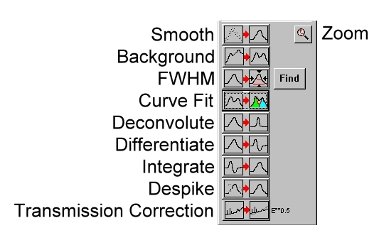
Figure 12 The Tools Window

Background Subtraction
- This is achieved very simply:
- With the desired spectrum on the screen, click on the Background Subtraction icon in the Tools window
- Chose the desired type of background.

The spectra may disappear from the screen; if this happens, simply click on the left arrow key to rescale the screen.

Curve Fitting
- Remove a linear background using the method described above before starting the curve fitting process.
- Click on the Find button in the Tools window
- Enter the desired options
- Click OK.
- A new window labeled Peak List will appear containing the starting parameters for the fit, as shown in Figure 13 below.
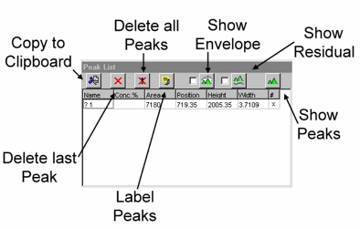
Figure 13 The Peak List Window

- By clicking on the boxes in the column labeled #, the starting peaks can be seen.
- If this process has not found all the relevant peaks, the user can add additional peaks by drawing a box with the dimensions and desired location of the peak on the screen and then pressing Alt-N.
- Next click on the Curve Fit icon in the Tools window and choose the desired background to be included in the fit (generally Shirley for a narrow region).
- Right-clicking on the relevant boxes can alter the properties of the peaks.
- These values can be linked to other peaks; for example, you can specify that peak 2 should be 1.2 eV to lower binding energy than peak 1.
  - To do this, enter the following syntax: P1+0, where P1 is peak 1 (in this example), + is add, and 0 is the amount.
  - Other allowed operators are "–" and "*", where "*" signifies a ratio.
  - You cannot use multiple operators in a single cell and you cannot use "*" when referring to peak position.
- Double left-clicking on the boxes will fix the peak parameter, which is indicated by a red bar inside the box.
- After choosing which fit method you desire to use, you can start the fitting process by clicking on the Start Fit button.
- The procedure will stop when a suitable fit has been found or when the fit crashes, indicated by the green progress bar turning red.
- If a blue bar appears in one of the Peak Fit Window cells, this indicates that the parameter has reached its maximum allowed value and the fit needs changing.
- Once you have a suitable fit, you can click on OK to return to the main PRESENTS screen.
- Clicking on the relevant button in the Peak List window will show the envelope of the fit.

Quantification
In order to quantify the signal for the elements present, all peaks need to be curve-fitted as described in the above section. In order to obtain the concentration percentage (column 2 in the peak list window), you should:

- Double click in the Name column for each peak. This will open the database
- Choose the desired atomic level, e.g. C 1s, etc. This will automatically calculate the concentration for all the peaks that have elements assigned to them.
- Note: the database cannot be opened in PRESENTS if COLLECTS is also running.

Difference Spectra
This is achieved as follows:

- Click on the difference spectra icon (diff A-B).
- Regions can only be added or subtracted over the energy range that they share.
- A dialogue box will open up, and you should input your request using the following syntax: Destination region = region A – region B
- Therefore, a free region is needed to display the results.
- Spectra can also be added in the form of fractional spectra, e.g., 10 = 1 + 5*0.5, which indicates that region 10 will display the resulting spectra from the addition of region 1 plus half of the intensity of region 5.

Calibration
This is achieved as follows:

- Display the desired region (usually C 1s for internal calibration against hydrocarbons)
- Draw a box from the actual peak location to the desired location
- Click on the "calibrate" button at the top right of the PRESENTS screen.
- You will be asked if all regions or just the one displayed should be shifted by the amount indicated by the box width.
- Select the desired option and click OK.

Adding Labels
In order to add a label to a spectrum:

- Draw a box whose coordinates will determine the position of the label.
- By holding down the left mouse button and starting in the bottom left hand corner of the box and releasing the mouse button in the top right hand corner, a label such as the one shown in figure 14 can be drawn.
- Other labels can be drawn by varying the start and end positions of the box.
- If the selected region is changed, all labels will be lost.

Figure 14 A Typical Label

Flood Gun
The flood gun is used to compensate charge build up on insulated samples by electron bombardment.

Operation
- Ensure the 4-pin plug is connected to the flood gun with the 3 screws; it will only go one way due to the combination of a 4 fold and 3 fold symmetry.
- Turn the power unit (869900) on
- Set the desired “Electron Energy” 0 to 500 eV
- Set the desired “Electron Current” 0 to 100 μA
- If necessary correct by using the “Extractor Voltage”
- Note: if the electron energy is 0 eV the electron current should be 0μA in order to preserve the filament life
- To turn off the flood gun repeat steps in reverse order

Ar sputtering

Ar sputtering is usually to remove the contaminants on the surface to get a cleaner surface, like Si surface. Caution should be taken to sputter the surface with surface coating, like 300 nm SiO2 surface. Long Ar sputtering would remove most of the coating from the substrate, so time should be limited.

Note this gun has been removed from the chamber for use on the micro reactor chamber.

The PHI ion gun, model 04-191 is controlled by unit 20-115 and is used to etch the sample surface. This is done by, heating a filament, which then emits electrons. These electrons are then attracted to a more positive anode. Some of the electrons collide with inert gas molecules (usually argon), which have been bled into the chamber and thus form ions (Ar⁺). As the filaments, anode and shield are all biased positive these positive ions are accelerated out of the ion gun and on to the sample. On the way out of the ion gun they pass through deflection plates and are focused by additional optics.

Turning the Ion Gun on
- Make sure that the power switch is off and the emission control is turned fully counterclockwise on the control unit (20-115)
- Backfill the chamber with the desired gas to a pressure, typically 3x10-6 Torr
- Position the sample in front of the ion beam
- Turn the “Beam Voltage” to 5 kV
- Turn the “Beam Voltage” switch to OFF
- Turn the “Raster” switch to OFF
- Turn the power ON
- Turn the “Focus” control to New Std
- Slowly turn up the “Emission Current” to 25 mA (on meter)
- Turn on the “Beam Voltage”
- Adjust the “X, Y position” and “Raster” controls as necessary.
- Typical values:
  - X = 2.5, Y = 6.0 for regular rod;
  - X = 2, Y = 5.5 for heating rod.
  - Sample position: 1.5cm.

Turning the Ion Gun off
- Turn the “Beam Voltage” switch off
- Turn the “Emission” control fully counter clockwise
- Turn the “Raster” switch off
- Turn the power switch off

Mass Spectrometer
The following section describes the operation of the UTI 100C Precision Mass Analyzer in the main chamber.

Turning on the MS
- Ensure the Emission dial is turned completely counter-clockwise
- Set the range to 10⁻⁵ amps, to avoid possible filament burn out
- Make sure the damper dial is turned completely counter clockwise
- Depress the MAN key
- Check if the instrument is in protection mode, there is a little switch on the inside of the front panel (right hand side). If the switch is to the right the protection mode is on
- Press ON/STANDBY key, wait for 30 – 45 minutes for the system to reach thermal equilibrium
- Press MULT
- Press EMISS/(MA) and slowly increase the emission current to 2.00±0.01 mA
- Connect the oscilloscope (x to ramp generator and y to signal out), set the scope to x,y mode
- Depress the EMISS/(MA) key and press VAR to adjust the sweep rate with the knob on the left hand side. The display over the range gives intensity where as the one over EMISS/(MA) shows mass
- The scan width and scan center can be adjusted while the EMISS/(MA) button is depressed and WIDTH or MAN are pressed

Standby Mode
Switch the instrument in to standby mode if the instrument will be re-used in a relatively short amount of time, e.g. same day.

- Place the instrument in TOTAL PRESSURE mode
- Set the range to 10⁻⁵ amps
- Make sure that the emission switch is on
- Turn emission dial fully counter clockwise but not off

Turning off the MS
- Place the instrument in FARADAY CUP mode
- Set the range to 10⁻⁵ amps
- Turn the emission dial off
- Turn the EMISS/(MA) switch off
- Press ON/STANDBY
- Press OFF

Software

Collecting a Mass spectrum
Using the following procedure a series of spectra can be obtained in a very similar manner to collecting an XPS spectrum.

- Boot up the PC in the middle if necessary
- Switch on the Mass Spectrometer as described above
- Make sure the MS unit is in the EXT mode with the Damper dial set between 9 and 11 o’clock
- Double click on the UTI_scan_average application file icon on the PC
- Click the yellow ion for Calibration file, and choose the mass-spec.cal to open
- Set the parameters to: A/D input channel 10, D/A output 1, Scanning step, 0.2 a.m.u, Scans to average(2-20)
- To set up regions to be run, input the starting A.M.U (usually starting from 4.00), Scanning range, A.M.U( usually smaller than 100)
- Slightly open the leak valve to introduce the sample gas to the main chamber to collect Mass spectrum, ~10⁻⁶ Torr is usually enough to see the peaks clearly
- When finished this screen can be minimized by clicking on the -->> icon again to start the collecting a mass spectrum
- Check the typical A.M.U., like H2O, CO, and O2 in the spectrum to make sure that the calibration file is good
- Click the Begin Averaging button on the right side to get the average of several scans to minimize the random error in the base lines
- The data collection can be paused at any time by clicking Stop program button, to restart the collection click on -->> icon again
- When the data has been collected, it can be saved by clicking on the appropriate icon
- Note Only regions with a check mark above them will be saved

Collecting a TPD spectra using TDS_RTC
The TDS_RTC application file is designed to collect the TPD data, and the calibration file for A.M.U. s are obtained in the above procedure for Collecting a Mass spectrum.

- Choose the proper substrate, and transfer the sample to the main chamber
- Connect the liquid nitrogen tube to the incoming gas port
- Make sure the MS unit is on and in the EXT mode with the Damper dial set to between 9 and 11 o’clock
- Double click on the TDS_RTC icon to launch the program
- Choose the tds.cfg Custom Pattern file
- Click the yellow ion for Calibration file, and choose the mass-spec.cal to open
- Set the parameters to: A/D input channel 10, D/A output 1, Thermocouple A/D input 2, and set and adjust the following parameters to to get the best TPD curves, Experiment total time, 5 mins, interval between masses, 10 ms, interval between series, 200 ms
- Input the A.M.U. numbers of these species, reading from the Mass Spectrum, and each A.M.U is represented by one line with unique color
- Locate the part 9, Ramping Temperature Controller for TPD, turn on the power, and the temperature reading should be on the screen now
- Open the valve for liquid nitrogen port on the liquid nitrogen tank to make the liquid nitrogen to flow into the rod to cool the sample, which usually takes about 20 minutes
- When the temperature reading is stable, slightly open the leak valve and choose the proper pressure for the sample(~10⁻⁶ torr) and exposure length( s to mins)
- Tighten the leak valve
- Click the Start scan(Home) icon on the screen, and you will see the spectrum running in the middle
- Pull down the switchs on the part 7 panel: load, start and on/off button to on beside the lights
- Close the valve for liquid nitrogen, and detach the link tube from the rod in a minute
- Now you should the running spectrums for different A.M.U. s , wait until it reaches the maximum temperature, and pull up the on/off to off
- When the program stops, name the data in the box, and save the data
- Re-connect the liquid nitrogen tube if you want to continue another TPD experiment, otherwise connect the Clean Air tube to the rod to prevent the water condensed inside

Sample Manipulation

- Mounting
A sample means a certain kind of substrate (Si, Si with native oxide, 300nm SiO2) with some deposition of target material on it. Mounting a substrate is the first step to carry on the deposition experiments. Usually, a substrate is cut by a glass cutter to 1.2cm x 1 cm, cleaned by acetone, water and blew dry by clean air. The substrate will be mounted onto a heating bridge, which is made by a piece of Ni foil (0.125mm). A scheme of the heating bridge is shown in the following chart (Figure 15, top view and side view). The substrate is mounted onto the heating bridge with three small Ni clippers. By heating the heating bridge with current, the heating of the sample is done through the heat transfer from heating bridge to the sample. Cooling the heating bridge with liquid nitrogen fulfills the cooling of the sample.
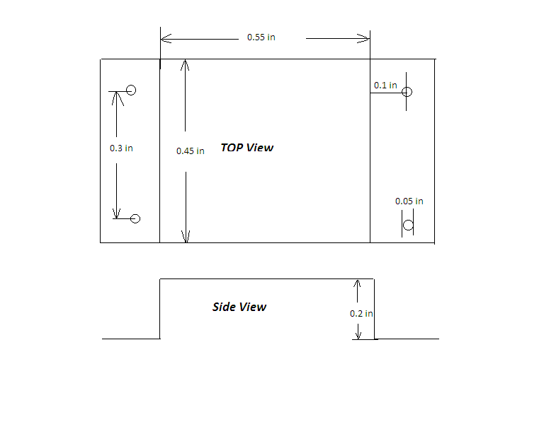
Figure 15. Scheme of the heating bridge
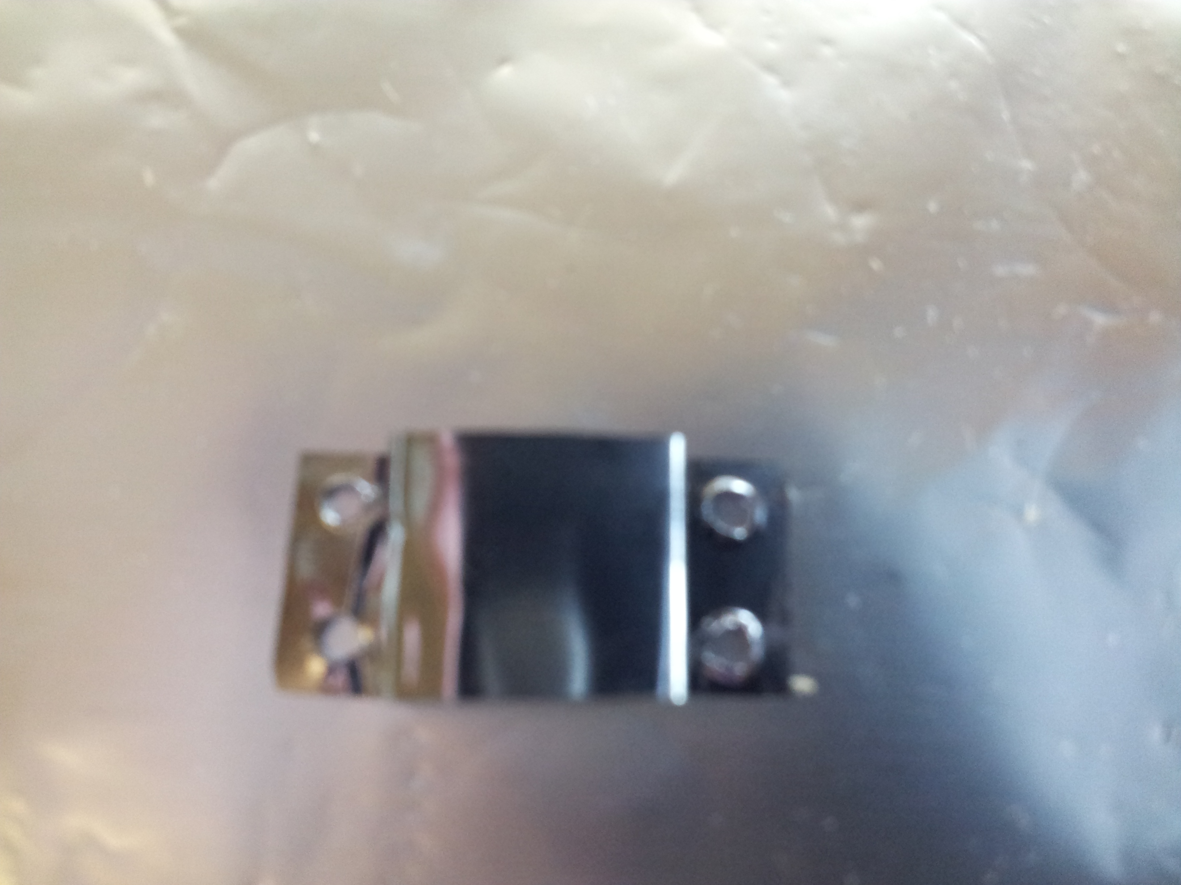

Figure 16. Heating bridge

- Make a heating bridge as in Figure 16
- Clean the hearing bridge with acetone and water, blow it dry with clean air
- Put it onto the rod, and place the two copper bars on the side shoulders (Figure 17)
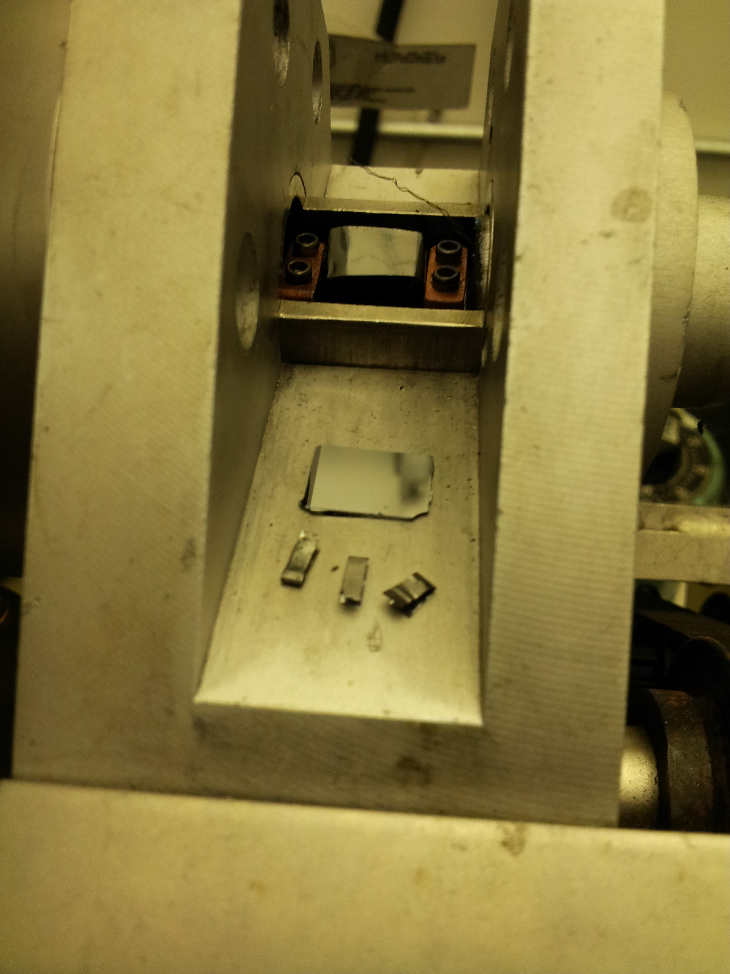
Figure 17. Mounting the heating bridge

- Tighten the four screws
- Put the substrate onto the heating bridge using forceps
- Fix the substrate with three Ni clippers on three corners (not the left bottom corner in Figure 18)
- Place the thermocouple between the clipper and substrate to measure temperature
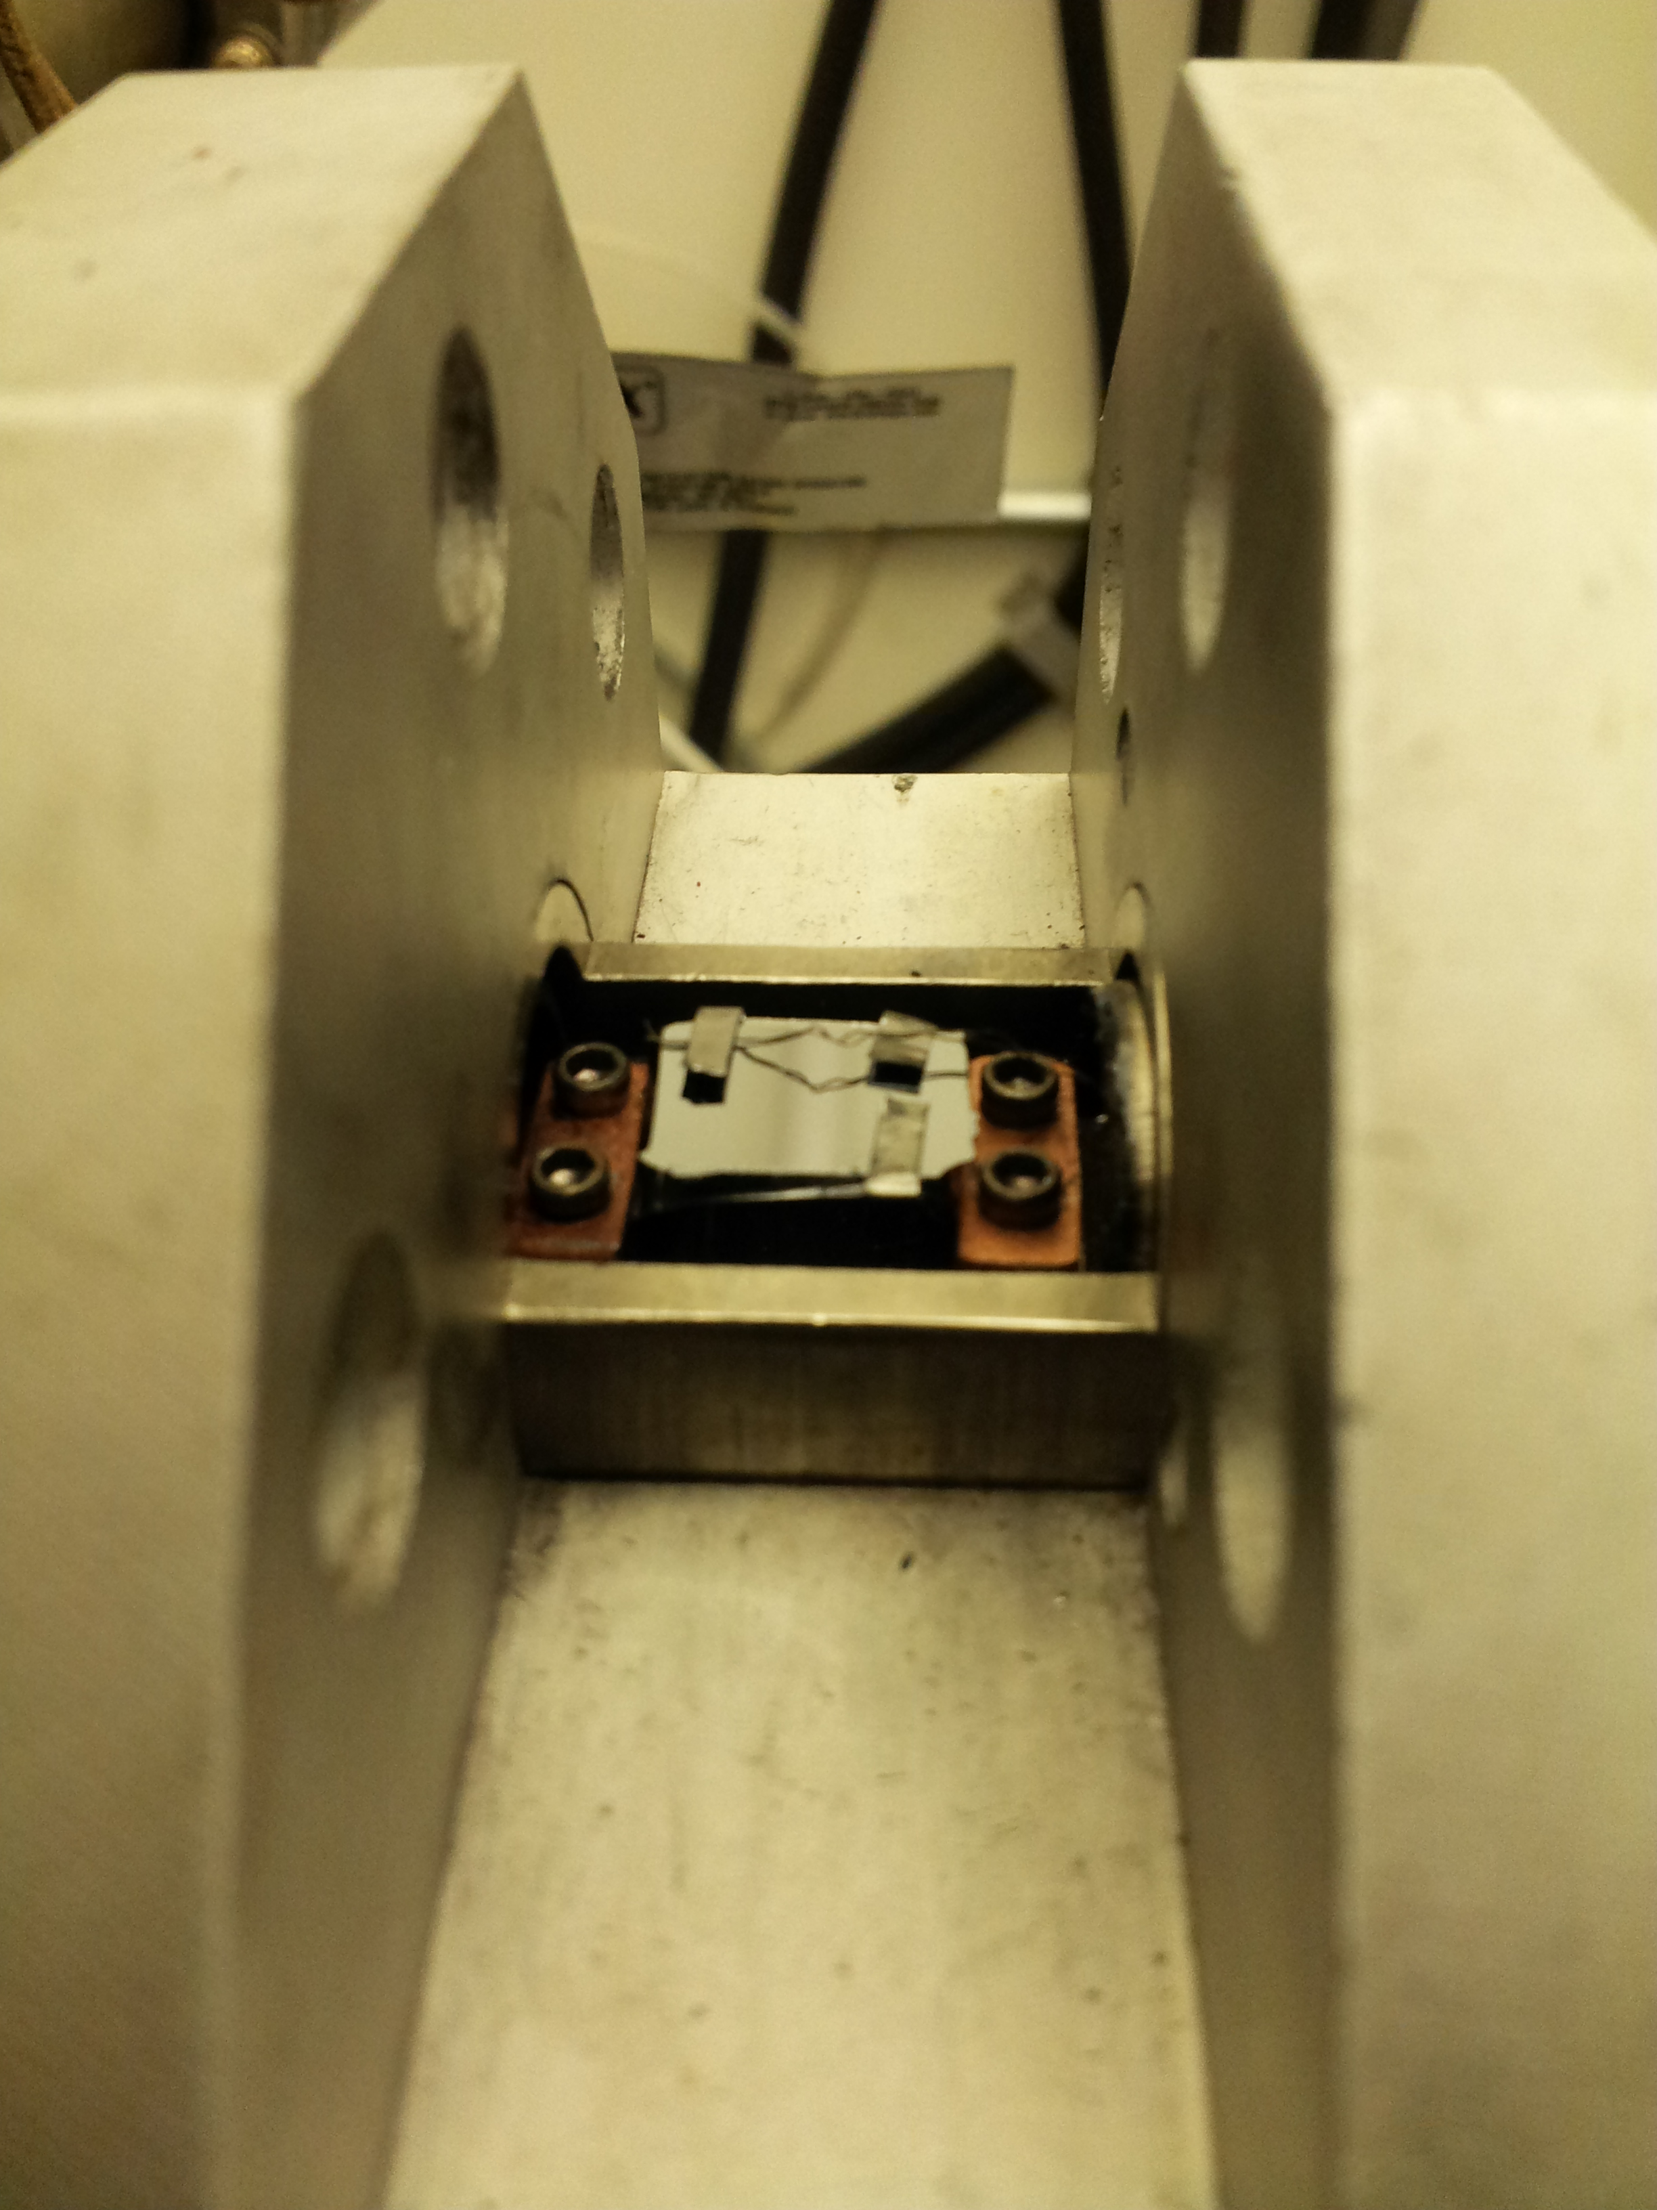
Figure 18. Sample mounting

- Transfer from air to main chamber

After mounting the sample, it will take half a day to transfer from air to load lock chamber, preparation chamber, and main chamber. It’s important to follow the procedures below when transfer the sample, and attention should be paid to the pressure changes in all the three chambers all the time.

- Check the mounting of the sample, make sure that its edge is completely within
the rod
- Using the slow speed mode on the motor control to transfer the sample to the
load lock chamber ( the tip should be at the Load lock mark in Figure 19)
- Open the valve on the load lock chamber and the valve for the rod in Figure 20, and close the two valves after 10 minutes
- Transfer the sample slowly using slow mode on the motor control to the preparation chamber
- Open the Valve in Figure 21, wait the pressure in the preparation chamber indicated by the Part 1 in Figure 1 down to 2E-6 Torr, which usually takes about 2 hours
- Slowly transfer the sample to the main chamber, and the tip should be at 1.4 cm on the mark meter in Figure 22
- It usually takes about 3 hours before the pressure is low than 6E-9 Torr for XPS data collection
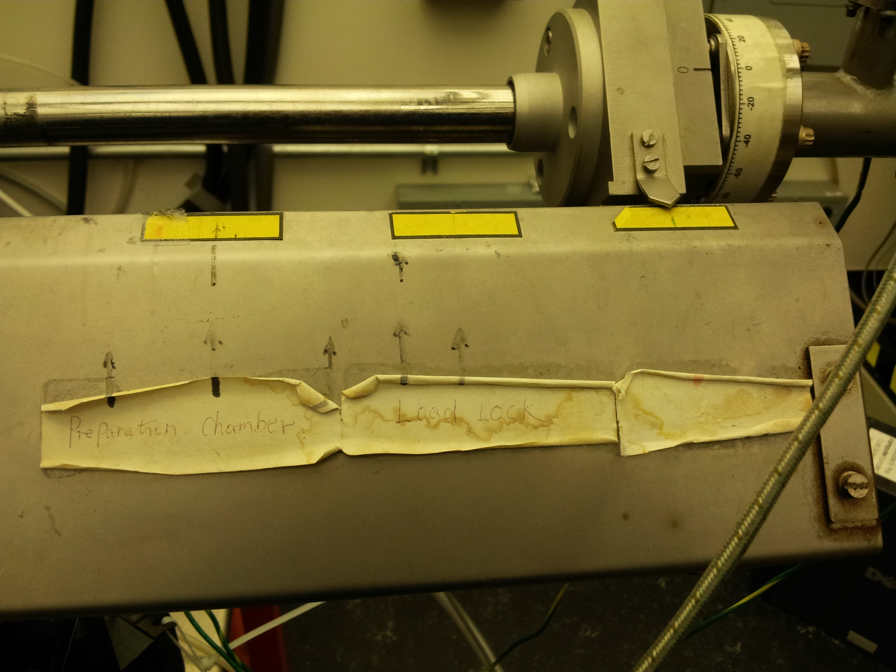
Figure 19. Marks for load lock chamber and preparation chamber

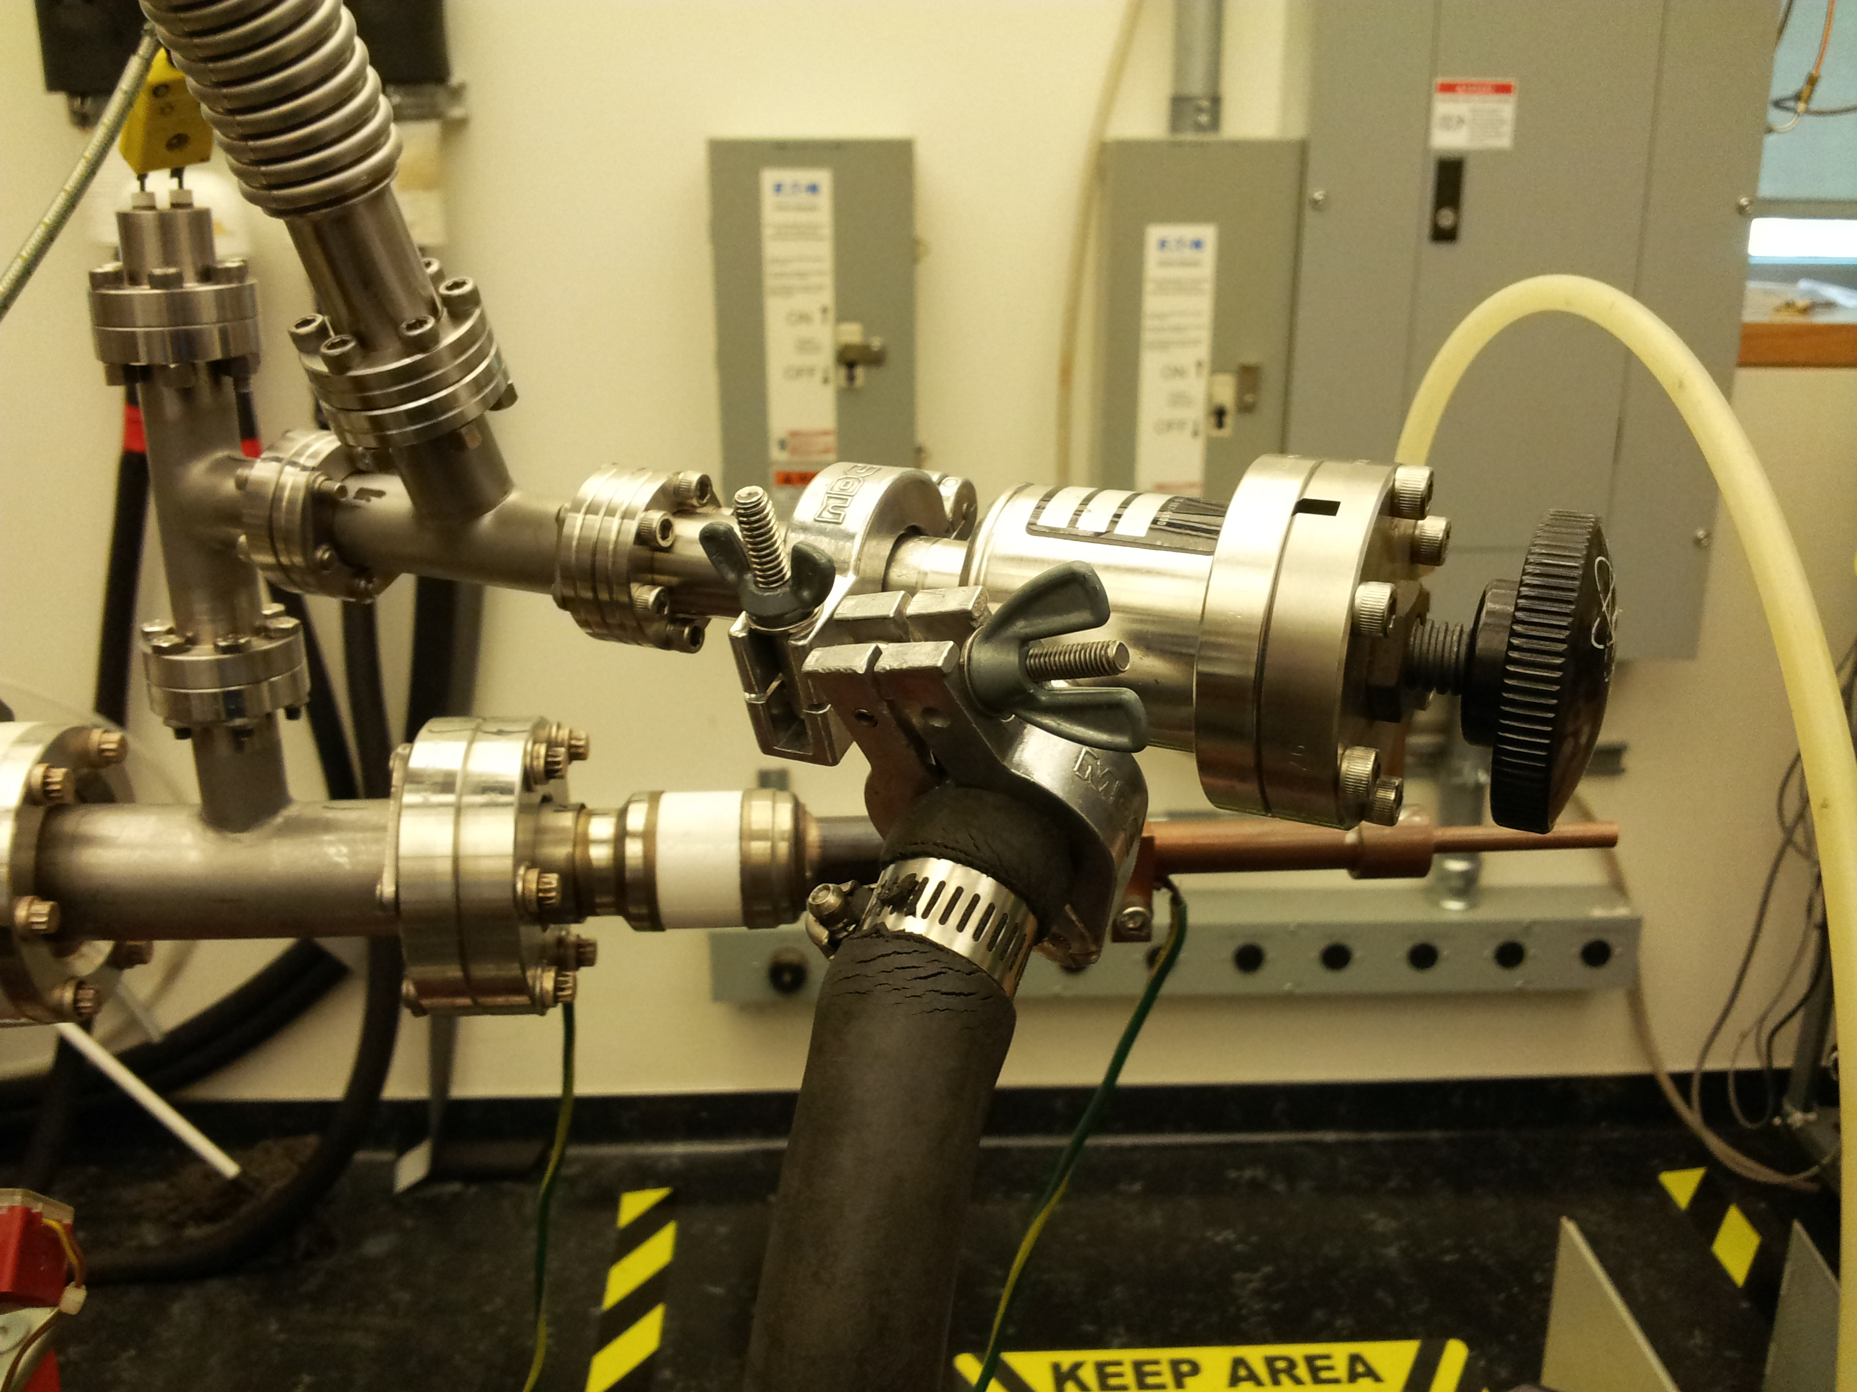

Figure 20. Valve for the rod, connected to the mechanical pump

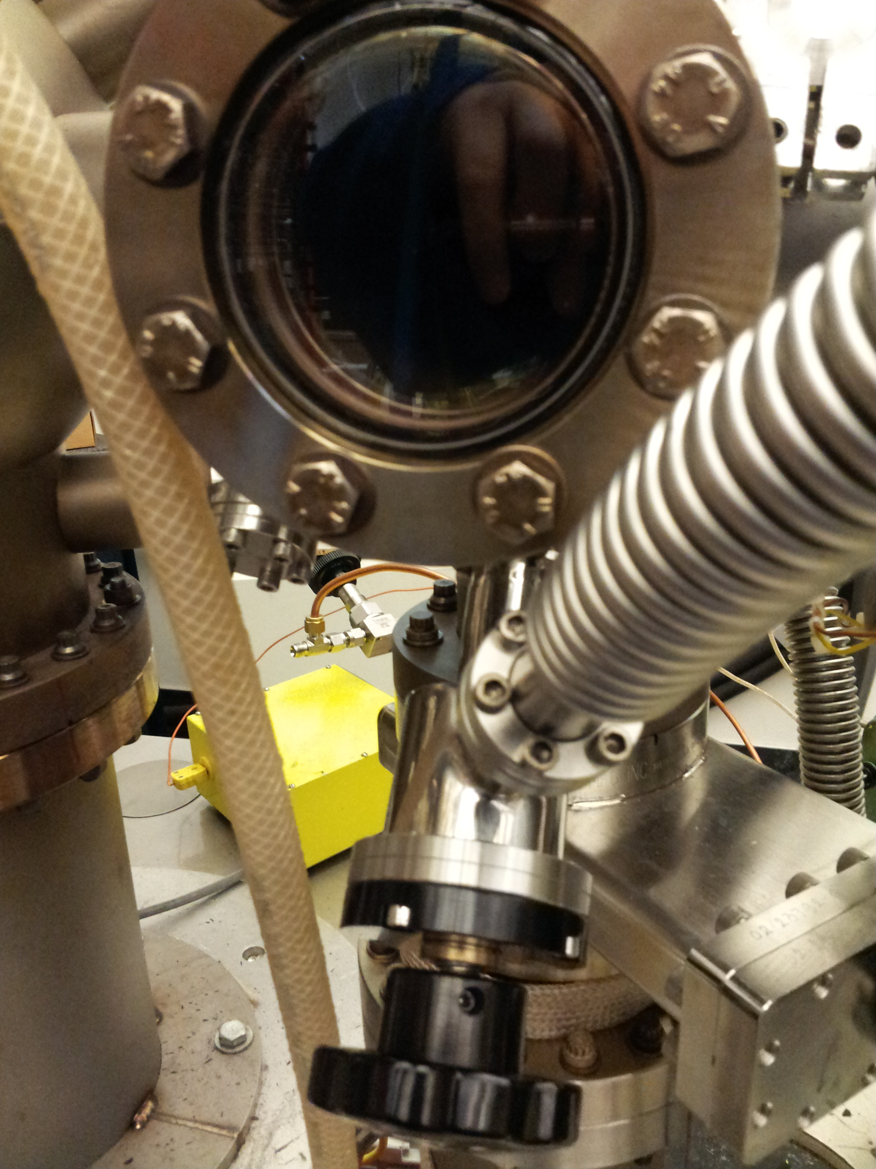
Figure 21. Valve for the rod, connected to the preparation chamber
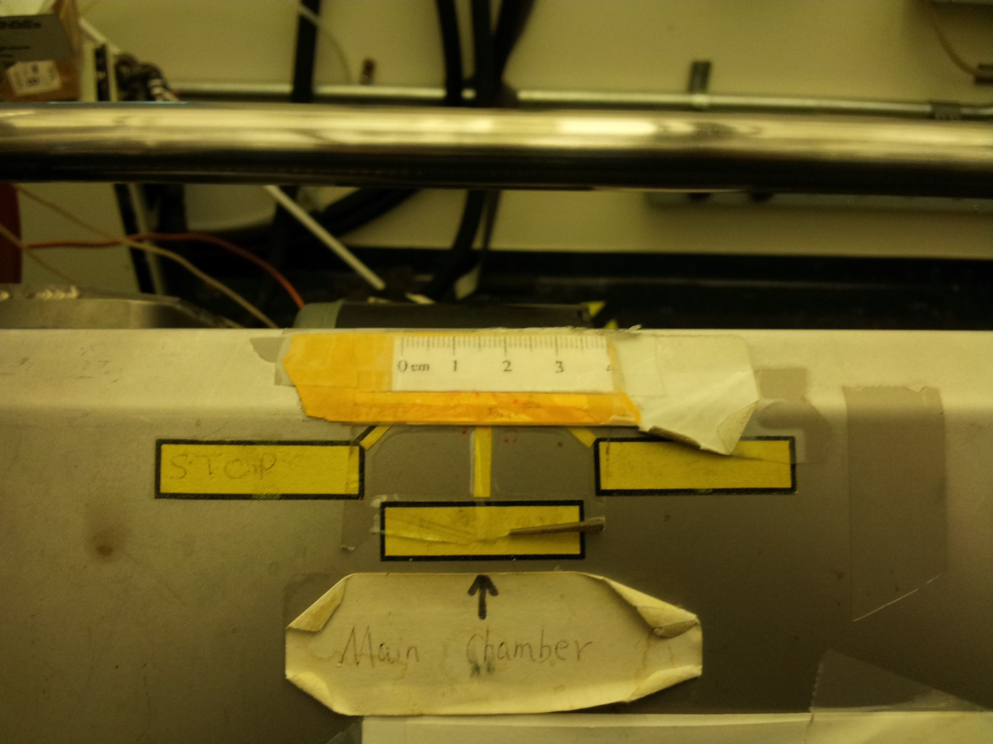

Figure 22. Mark meter for the sample in the main chamber

Transfer between the main chamber and preparation chamber is easy. After a deposition, the sample is transferred into the main chamber for XPS data collection. Then the sample can be transferred back to the preparation chamber for deposition by pushing the Slow button for OUT on the motor controller. The sample will not be exposed to outside air when transferring between the main chamber and preparation chamber.
After the deposition and TPD experiments, the sample can also be transferred outside the system to air. First, close the valve in Figure 21, and then choose the Slow mode for OUT on the motor controller to slowly transfer the sample outside.

- Heating and cooling, and T measurements
Sample heating is fulfilled by applying the proper voltage on the transformer in Figure 23 to heat the heating bridge, usually the voltage is less than 90V. For deposition experiments, the cooling of the sample is done by blowing the cool clean air into the incoming gas port. For the TPD experiments, the cooling function is archived by introducing the liquid nitrogen to the incoming gas port on the rod too. Temperature reading for deposition experiments is on the temperature controller in Figure 23. For the TPD experiments, the thermocouple for deposition experiments should be removed and the thermocouple for TPD experiments should be mounted， while the temperature reading is available on the TPD data collection program screen.
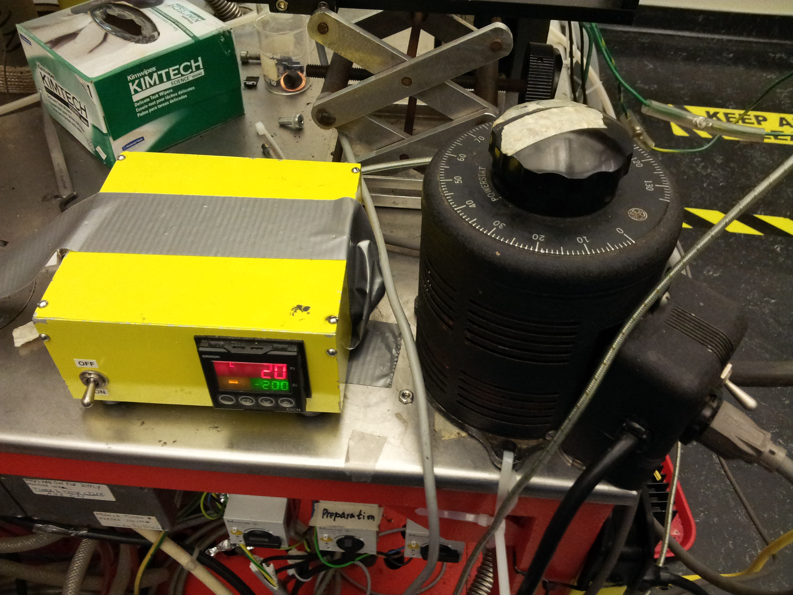
Figure 23. Temperature controller and transformer

- Maintenance of the transferring system

The transferring system is crucial in the whole system, which enables the fast transfer from air to main chamber and maintains the UHV in main chamber and preparation chamber. The lifetime of the transferring system depends on slow transferring speed, efficient lubricant, and well-shaped o-rings. If there is a strong fluctuation or obviously longer than usual pressure pumping down when the rod is moved, it’s necessary to check the sealing of the corresponding seal units: one unit between the preparation chamber and main chamber, and the other unit between preparation chamber and load lock chamber. Here is the instruction to check the seal unit between the main chamber and load lock chamber. The two sealing units are similar, so please follow the instruction to do the maintenance of the seal unit between preparation chamber and load lock at the same time.
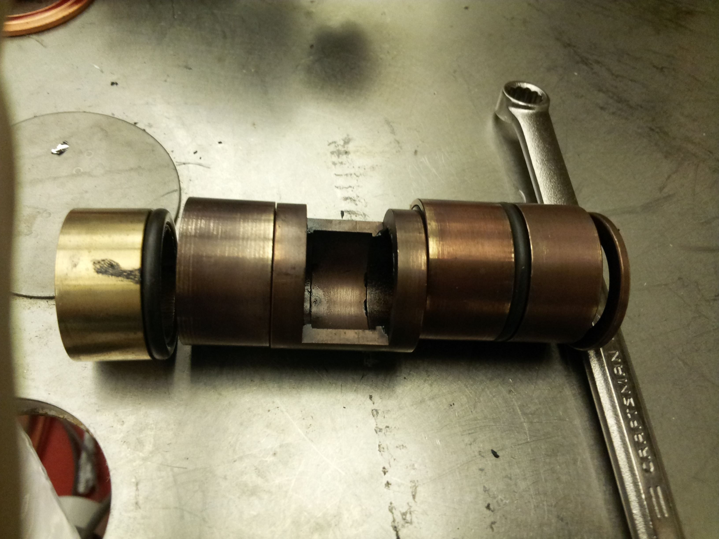
Figure 24. Seal unit between preparation chamber and main chamber

- First of all, follow the instruction in venting the instrument section to vent
the three chambers
- Move the rod to the sample mounting area, dismount all the connectors, tubes,
power lines, valves
- Disconnect the power of the motor, and dismount the motor from the loadlock chamber, pull out the seal unit between the preparation chamber and loadlock chamber
- Use strips to secure the position of the preparation chamber (under gate vavle)
- Remove the cables for filaments, heating strips, gas delivery
- Close the gate valve for the preparation chamber
- Loosen and remove the screws just above the gate valve
- Get help to hold the small preparation chamber, loosen and remove the screws between the main chamber and preparation chamber
- Loosen and remove the four golden screws for securing the unit in Figure 25
- Change the worn o-rings like in Figure 26
- Lubricate the inner wall of the o-rings, assemble the seal unit in the same sequence in Figure 24
- Follow the opposite steps, from step 9 to step 1, to assemble the system
- Follow the instructions to evacuate the system
- Check the sealing by moving the rod, and do the maintenance again if necessary

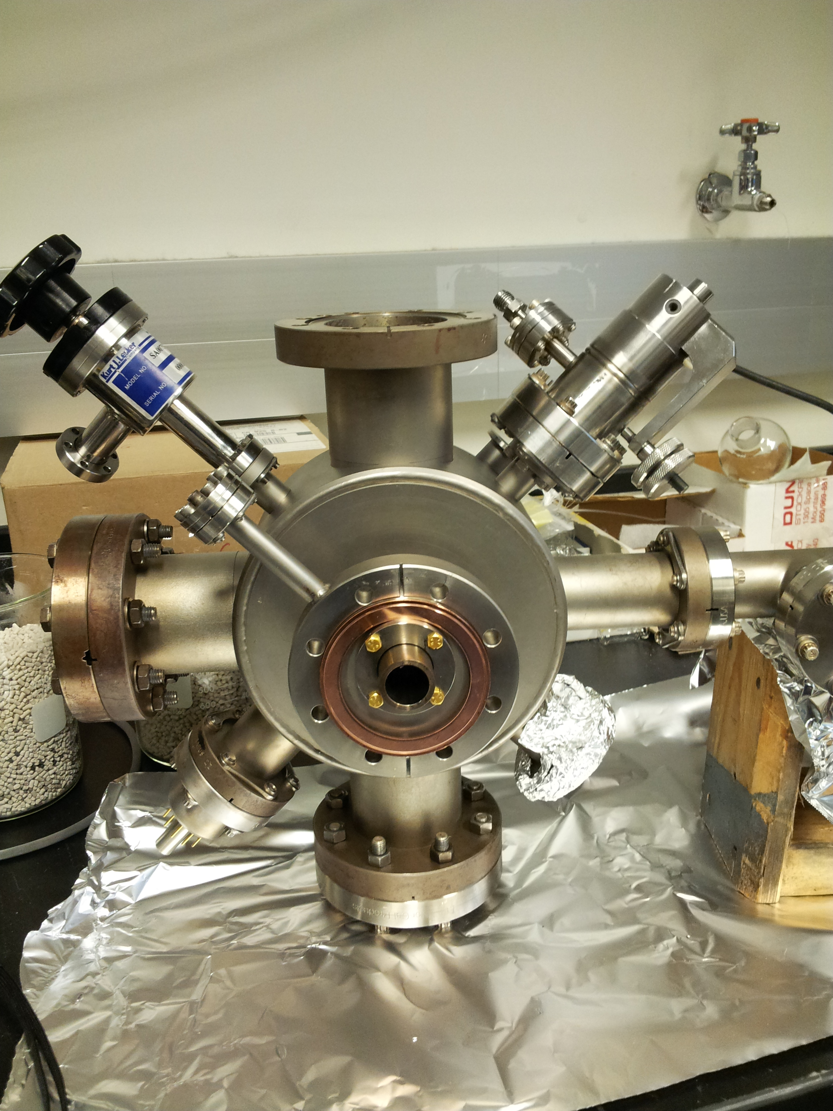
Figure 25. View of the seal unit between the preparation chamber and main chamber
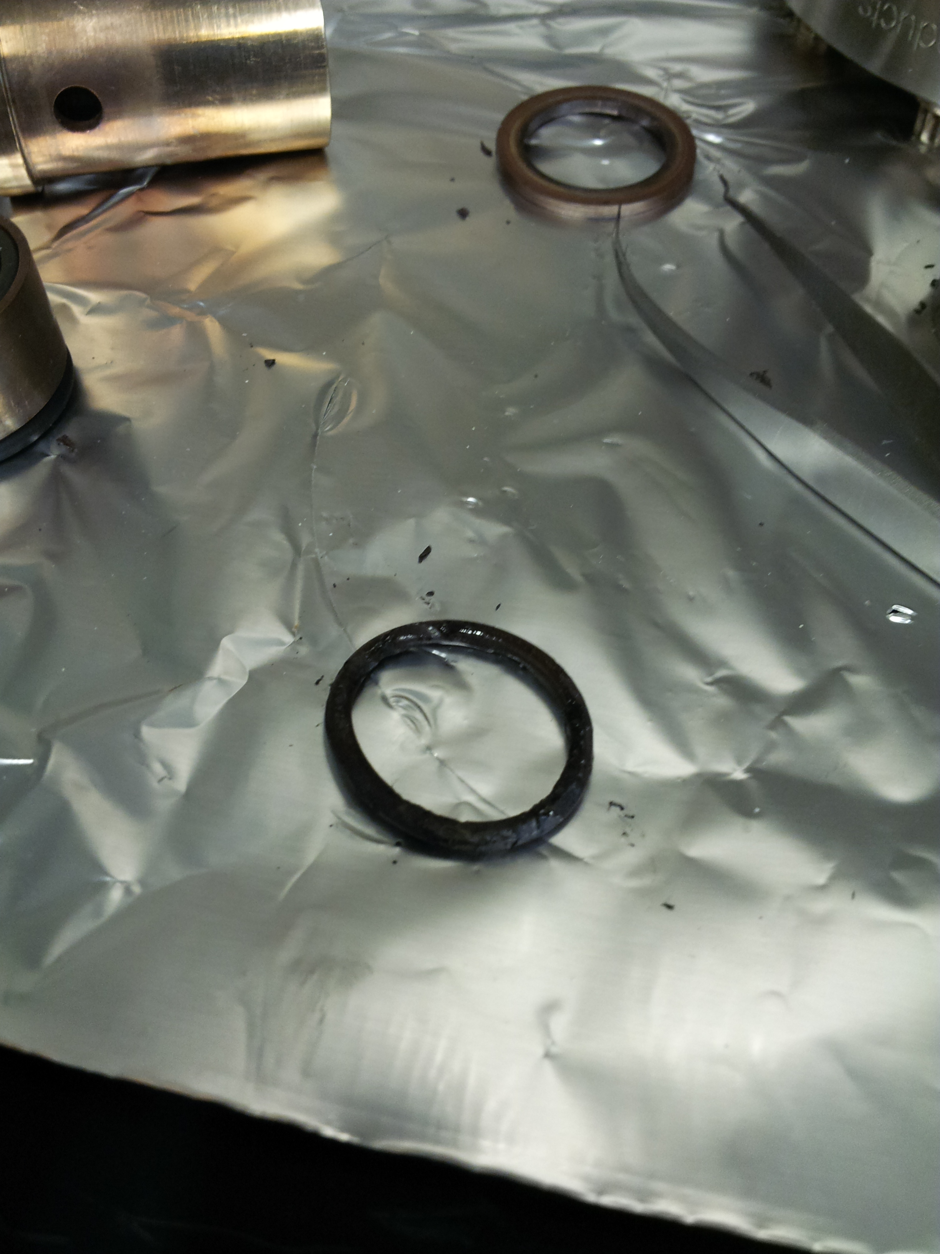
Figure 26. Worn o-ring for the sealing unit

Gas Handling

a.Manifold design, schematics, and operation

Manifold in this system is simple and easy to change when necessary. The original manifold in this system is also used to keep the dual X-ray anodes. Figure 27 shows the manifold in the system.
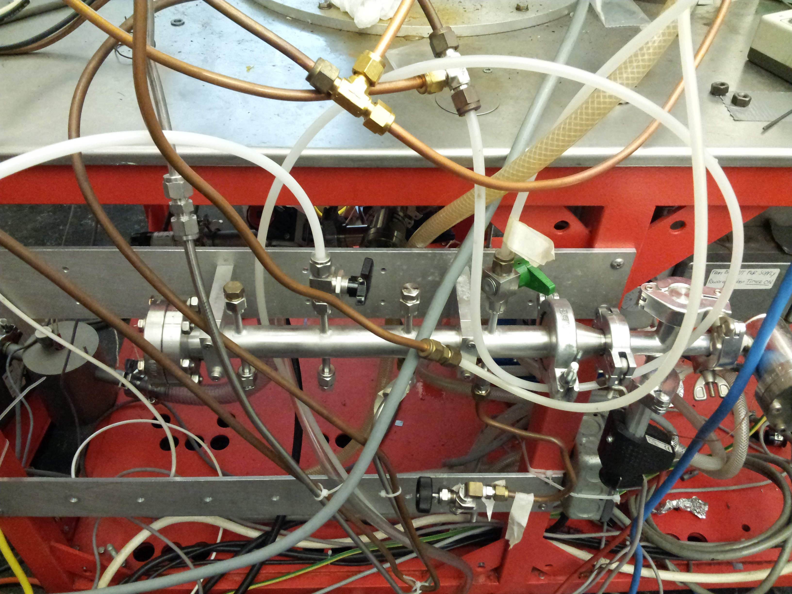
Figure 27 Manifold for the preparation chamber (reactor)
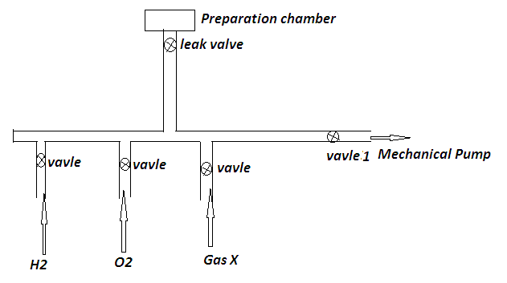

Figure 28 Manifold scheme

There are three ports for H₂, O₂, or Gas X (flexible) on the manifold. H₂ is usually to reduce the sample while O₂ is for oxidation. If H₂ is needed to introduce to the reactor, follow the instructions below. O₂ or Gas X are almost same.

- Make sure all the valves closed except the valve 1
- Fully open the valve 1, wait the pressure in the manifold is below than 30 mTorr
- Close valve 1, then open the valve for H₂, the manifold should be filled with H₂ in a second
- Close valve for H₂
- Repeat step 3 for 3 times
- Close vavle 1 for mechanical pump, keep the valve for H₂ open
- It’s assumed that the manifold is filled with H₂ now, and slightly open the leak valve to introduce the desired H₂ to the reactor (time lengths, and pressure)

b.Gas feeding in the main chamber

Gas feeding in the main chamber is mainly controlled through leak valve. For Ar sputtering, the Argon gas tube is directly linked to the leak valve. All you have to do is to control the leak valve to obtain the desired pressure for Argon in the main chamber.
For the gas feeding for TPD experiments, instructions for air sensitive or stable chemicals are different.
For stable chemicals, use the following procedure.
- Detach the glass tubing from the leak valve, fill the stable chemical in the fume
hood, and seal it with parafilm
- Remove the parafilm, and mount the glass tubing to the leak valve quickly
- Use liquid nitrogen to frozen the chemical, then open the leak valve slowly to evacuate the glass tubing for 5 minutes
- Close the leak vavle, and let the frozen chemical to melt in room temperature
- Repeat the frozen-melt twice
- The chemical is ready to use, heat if necessary to get enough vapor pressure.

For air sensitive chemicals, use the following procedure.

- Follow the procedure to vent the system
- Dismount the leak valve from the main chamber, and detach the glass tubing too.
- Clean, dry and cool down the valve and glass tubing
- Take the valve, glass tubing, screws, tools, and parafilms to the glove box
- Follow the procedure to fill the glass tubing with the air sensitive chemical, mount it to the leak valve, and close the leak valve
- Mount the leak valve to the main chamber
- Follow the procedure to evacuate the main chamber
- When the pressure in the main chamber is lower than 1x10⁻⁷ torr, repeat the frozen-melt process described above in the procedure for stable chemical
- Heat the glass tubing if necessary
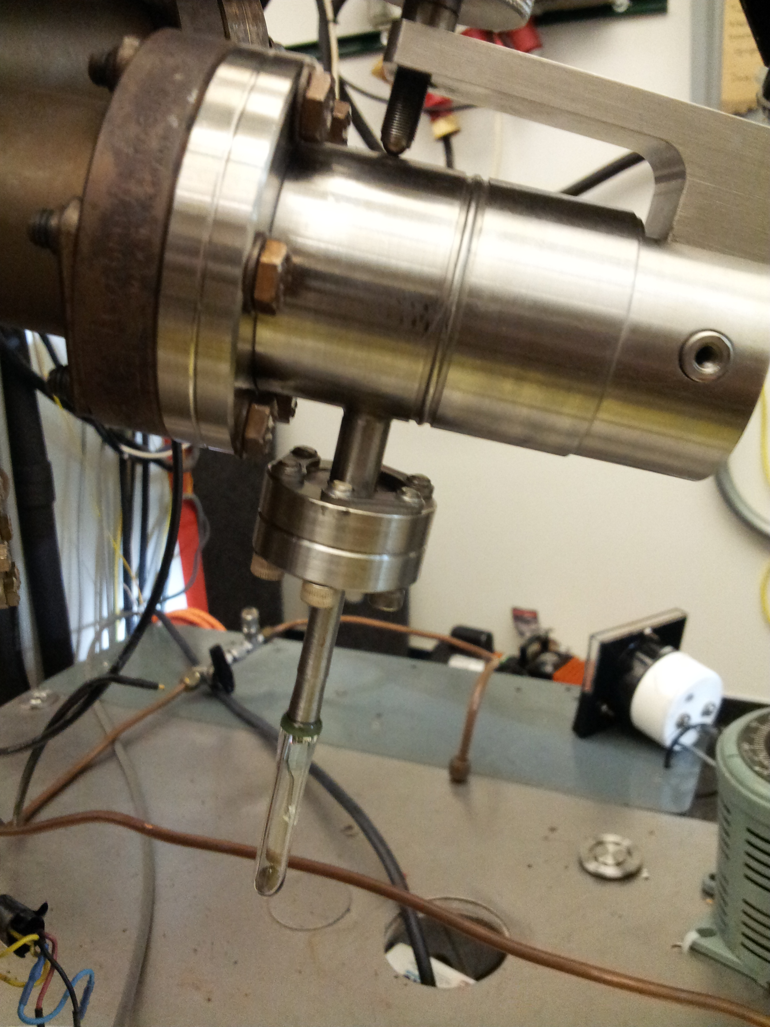

Figure 29. Leak valve with glass tubing

c. Gas feeding to the reactor

Gas feeding to the reactor includes two parts: one is to deliver the precursor, and the other is to deliver the reactants, like H₂ and O₂. The feeding of precursor is similar to the gas feeding to the main chamber above. The delivery of the reactants is described above in manifold design part. One thing is to point out is that heating the gas delivery parts for some precursors. Wrap the leak valve with heating strip, apply variable voltage to get T1 temperature by buring the thermocouple in the strips. Put the glass tubing in the silicone oil bath, get the temperature of the precursor (T2) using the thermocouple into the tubing like in Figure 30. T1 should be at least 10K higher than T2.
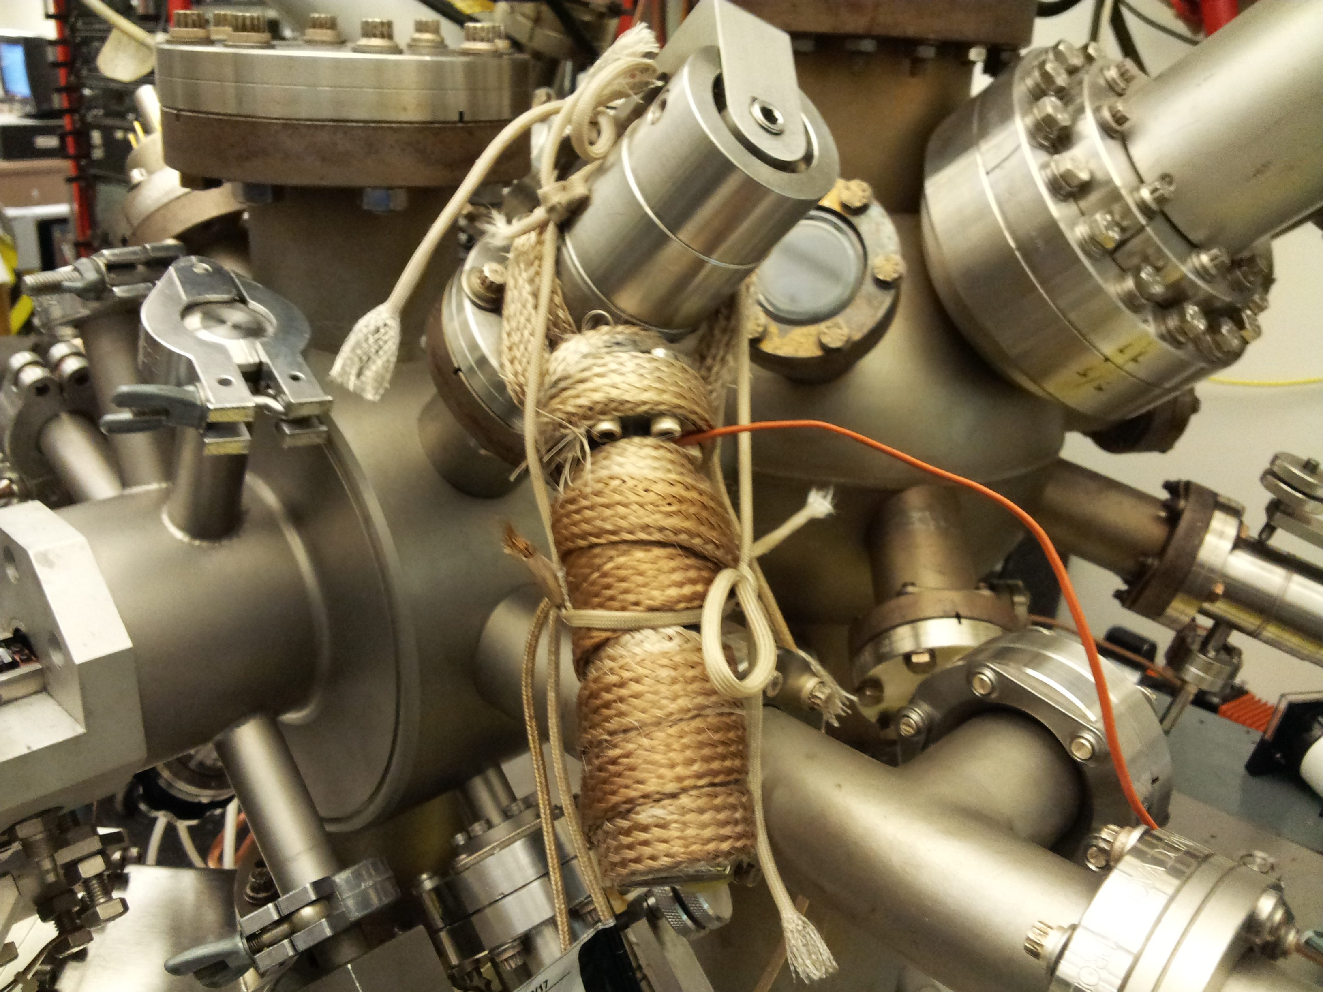
Figure 30. Heating of the glass tubing and leak valve

Operation of the ALD Reactor

a.ALD deposition

ALD/CVD deposition experiments are done in the preparation chamber. Usually, ALD includes several cycles, and each cycle contains two sequential half cycle reactions: 1st half cycle, introduce the precursor to the reactor, after the saturation is reached, purging is needed to remove the precursor from the reactor; 2nd half cycle, introduce the reactant to react with precursor adsorbed on the substrate to form a thin layer, purging the reactant to be ready for another cycle. Please follow the procedure below to do one ALD cycle.
- Clean the desired substrate, and mount the substrate
- Transfer the substrate to the load lock, preparation chamber, and finally to the main chamber
- Heat the substrate to 300C in the main chamber for 5 mintues
- Collect XPS signal for control experiment using the Collect icon on the computer
- Turn off the XPS
- Turn on the Ion Gauge
- Power on the heating of the sample to heat the sample to desired T
- Open the leaking valve with glass tubing to get the desired dosing pressure in the preparation chamber
- Transfer the sample back to the preparation chamber, timer is set on now
- Deposit the precursor to the substrate for a desired dosing length
- When the timer is stopped, close the leaking valve, power off the heating of the sample, push the SLOW button for IN to transfer the sample back to the main chamber
- Collect XPS data for the 1st half cycle after the sample is cooled down
- Turn off the XPS
- Heat the sample to desired T
- Transfer the sample back to the preparation chamber
- Open the leak valve to introduce the reactant, like H2, to the preparation chamber at desired pressure and length
- When the timer is stopper, transfer the sample back to the main chamber
- Collect XPS after the 2nd half cycle
- Repeat the steps above to get more cycles if necessary

One thing if the sample is left in the chamber for a long time ( more than 1 hour), the sample must be heated to the same deposition temperature for at least 1 minute to remove the adsorbed water or other contaminants.

b.Angle-Resolved XPS

Angle-resolved XPS is very helpful to figure out the relative position on the surface for a certain component. In our experiment, the positions of analyzer and XPS anodes are fixed, the angle-resolved XPS experiments can be fulfilled by rotating the rod to a certain degree. Follow the procedure above to do a ALD experiment, and the angle-resolved data can be obtained for a specific half-cycle.

            - Collect the sample’s XPS data at 0º, where the surface normal is pointed directly to the analyzer
            - Loosen the screw for the degree control, and rotate the rod to a certain degree, like 10 in Figure 10, and then tighten the screw
            - Take XPS for this position
            - Rotate the rod to other degrees to get XPS data
            - Put the XPS data for different angles in one chart, compare the change of each peaks in the process.
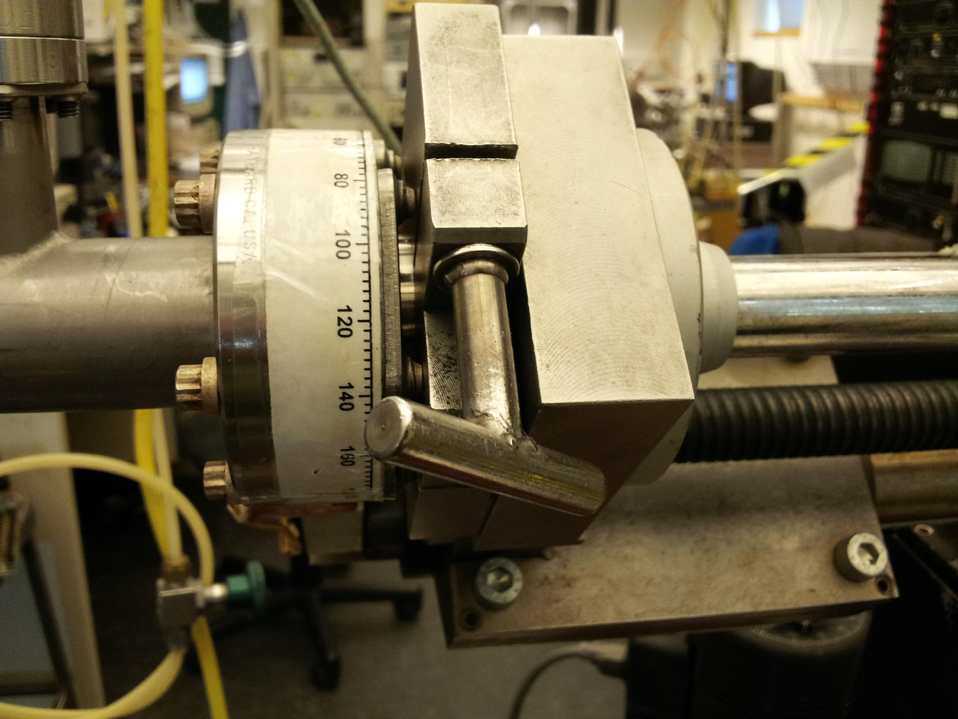
Figure 31. Angle-resolved XPS

c. Depth Profiling
Depth porfiling is obtained by collecting XPS after each Ar sputtering. Usually, the Ar sputtering will remove the surface coverage at a rate about 1 monolayer per minute. As a result, it’s necessary to control the length of each Ar sputtering to less than 1 minute. For a surface with thick thin films, the length of each Ar sputtering can be extended to 2 minutes. Compare the change in the XPS charts as Ar sputtering goes on, the depth profiling can be obtained.

MCP Maintenance
a.Removing the MCD flange
- Remove the MCD Preamplifier (PA-MCD) and the MCD supply box (SB-MCD).
- Vent the system.
- Open the DN 350 CF flange (remove the screws) and remove the vacuum hood.
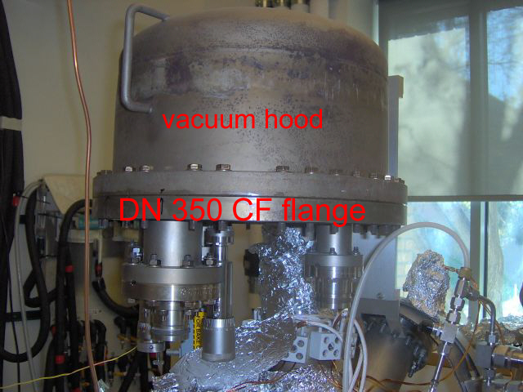

- Remove the magnetic shielding hood (remove the 3 metal clips before removing the shield).
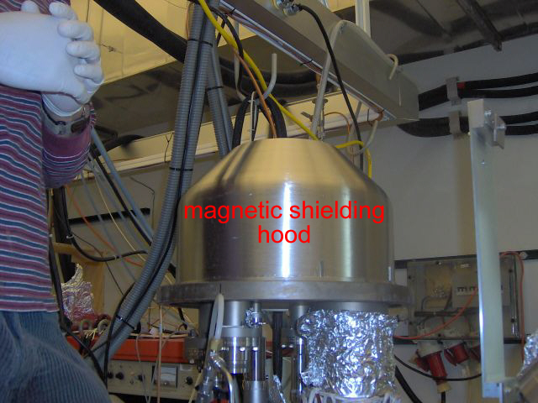

- Unscrew four screws connecting the hemispheres.
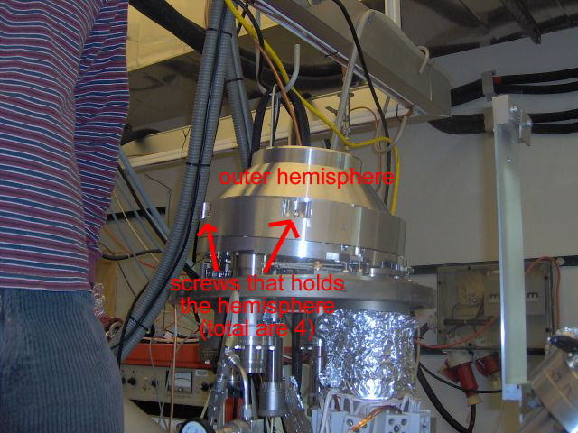

- Disconnect the electrical connections to the outer hemisphere. Remove the ceramic isolation tube that will come out from the screw.
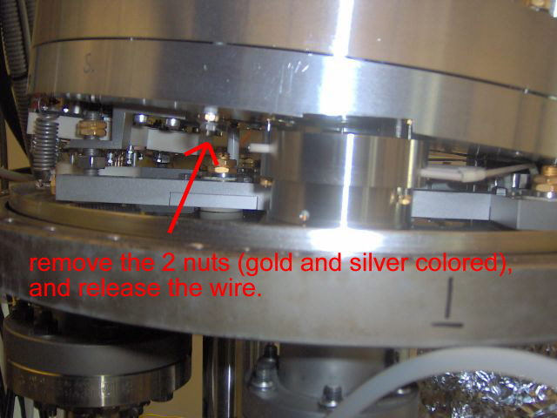

- Mount the handle to the outer hemisphere and remove it carefully. Take care of the small ceramic plates after remove the hemisphere.
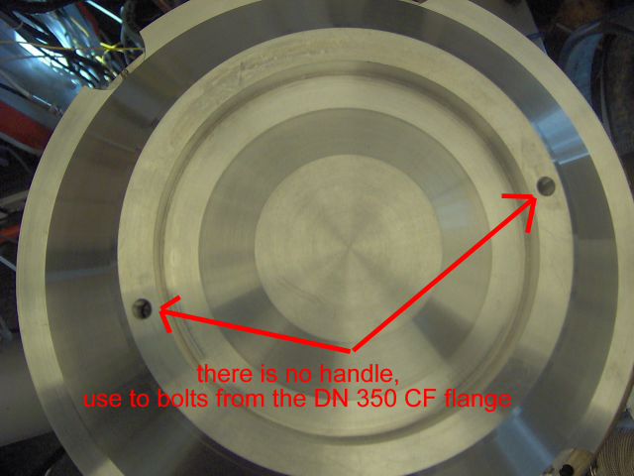

- Loosen the slit width mechanism.
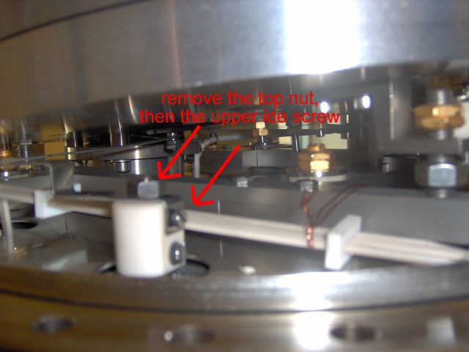

- Remove the 20-pins HAS/lens feedthrough, if necessary.
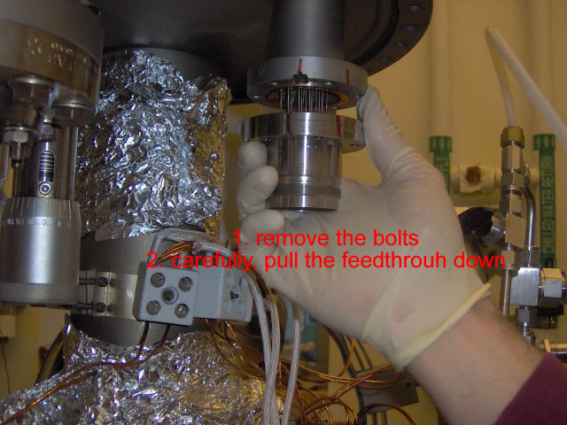

- Disconnect the 6-pin feedthrough from the MCD assembly.
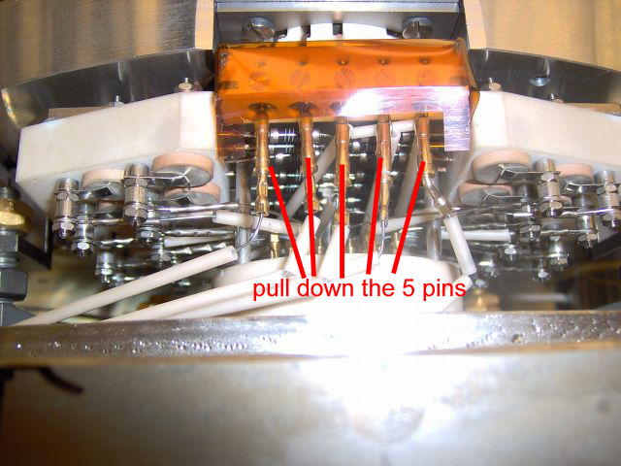

- Remove the four sticking springs.
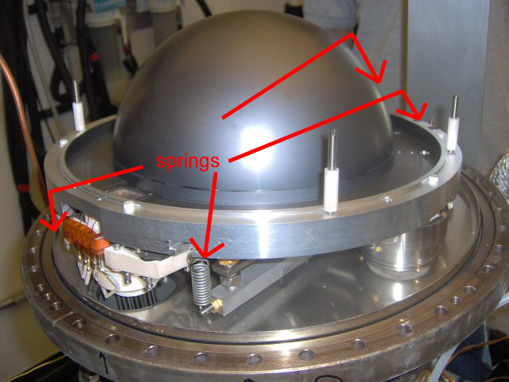

- Loosen and remove the two screws on the exit grid sheet around the exit grid.
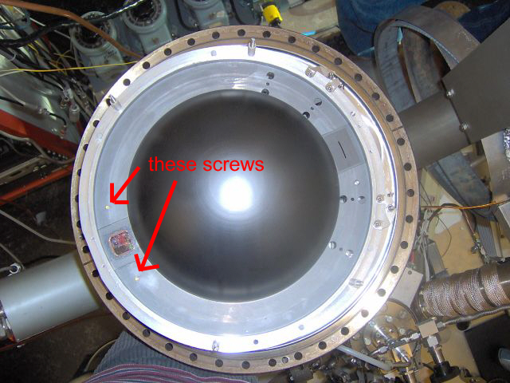

- Remove the analyzer and put it carefully on a table.
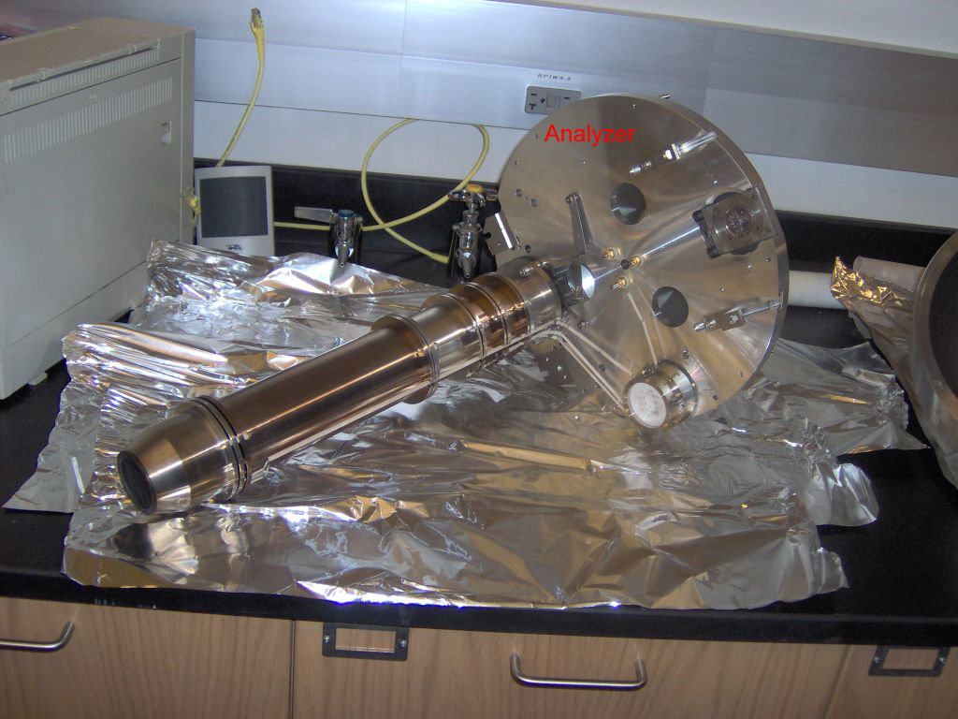

b.Changing the MCP
- Loosen in turn four screws on the MCD head and remove them together with four metal clips.
- Remove the top contact ring.
- Note the orientation key of the top MCP.
- Remove the top MCP (12 o’clock).

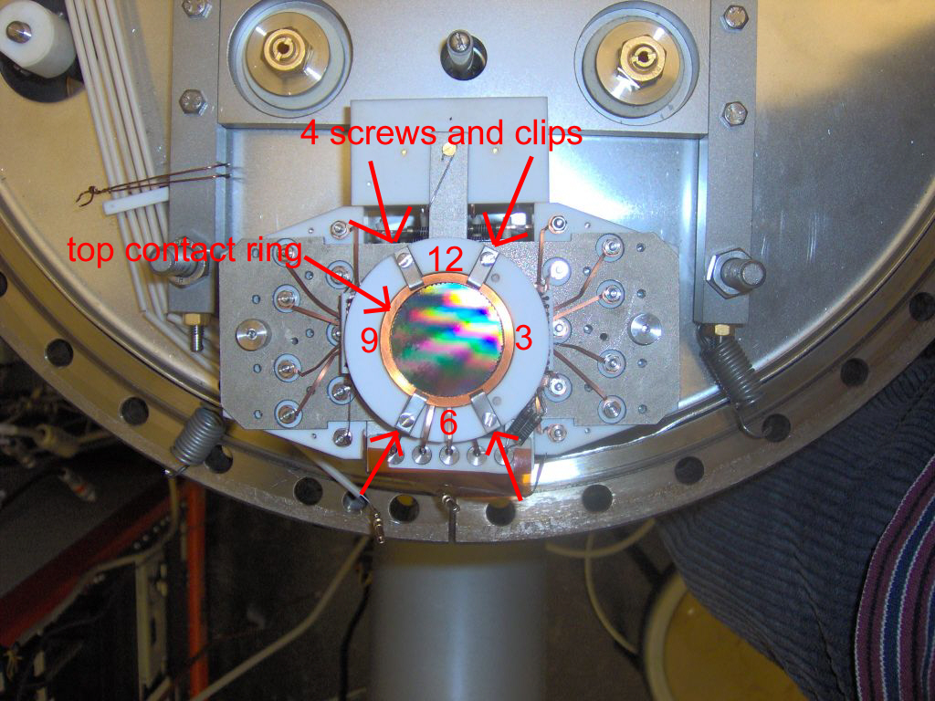

- Remove the ring between the MCP’s.
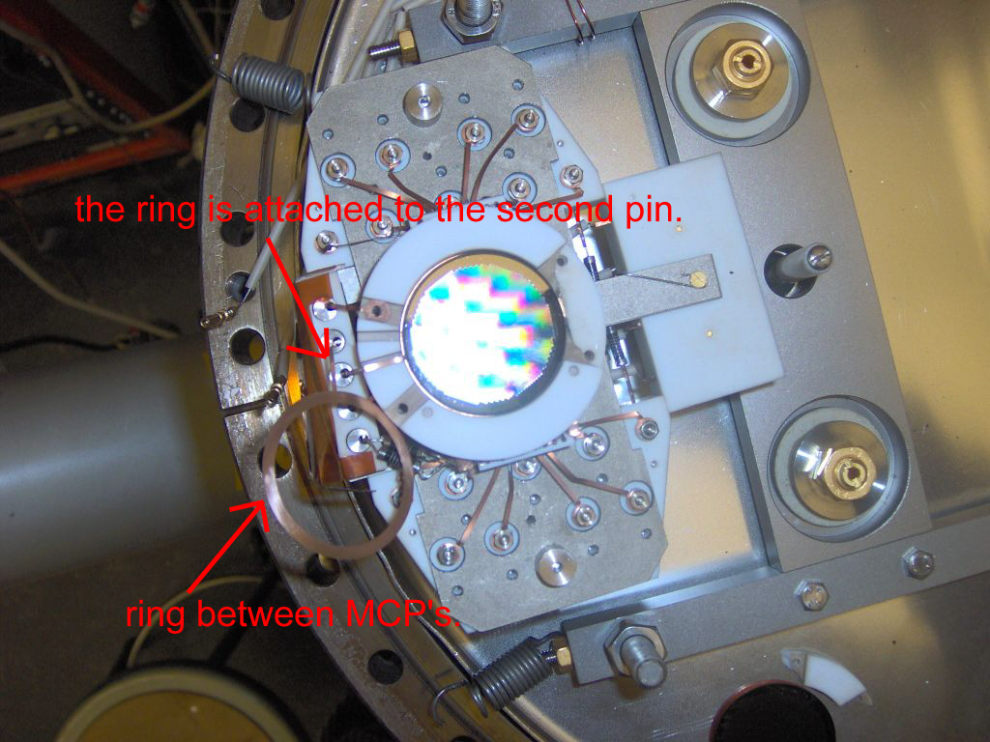

- Remove the bottom MCP.
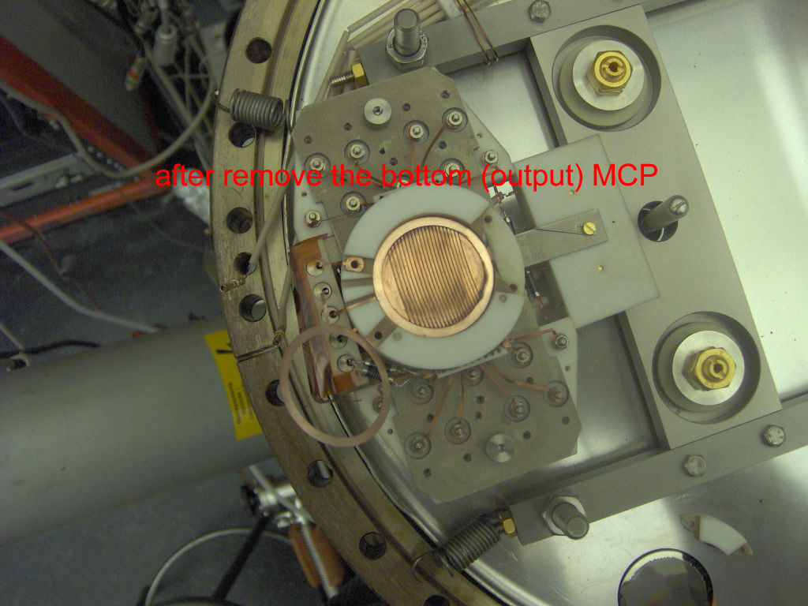

- Unpack the new MCP named “output” (this is the bottom MCP).

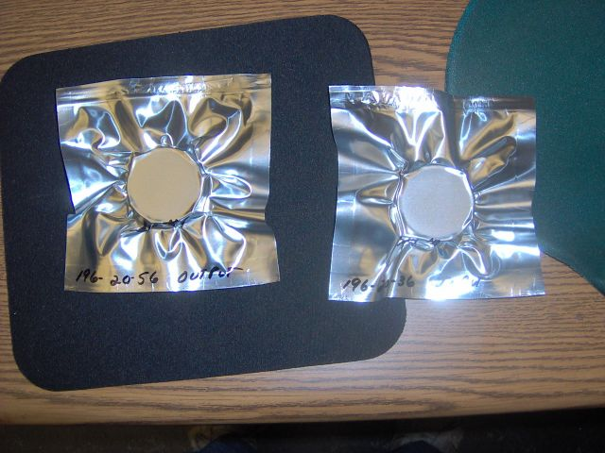

- Orient the new MCP as the bottom old one (with the orientation key – the arrow head- above and away from the sphere centre –at 6 o’clock-) and put it in place.
- Place back the ring between the MCP’s.
- Unpack the second new MCP named “input”.
- Orient the second new MCP as the top old one (with the orientation key above and towards the sphere centre –at 12 o’clock-) and put it in place.
- Put in the top contact ring.
- Check the MCP’s on being properly centered.
- Put four screws together with four metal clips and the MCD head and fasten them.
- Check the connection between cathode, middle and anode.

c. Mounting the MCD flange.
- Position the MCD unit in such a way that the two ceramic setting pins of the MCD head go through holes on the exit grid sheet.
- Put in the two screws on the exit grid sheet around the exit grid and fasten them.
- Connect the 20-pin MCD feedthrough.
- Connect the 6-pin MCD feedthrough.
- Check that there is no short circuit for all the pins of the MCD supply feedthrough to each other and to ground.
- Fasten the slit width mechanism.
- Fasten the MCD flange bolts.
- Put in the outer hemisphere.
- Check the connections of the base plate and of the outer hemisphere to the corresponding pins of the analyzer feedthrough.
- Check that there is no short circuit for all the pins of the analyzer feedthrough to each other and to ground.
- Put in the magnetic shielding hood and fasten it.
- Put in the vacuum hood and fasten it.
- Pump down.
- The EA 11 MCD must be baked out at a vacuum pressure better than 1x10⁻⁶ mBar. It is bakeable up to 150 C.

Contacts

These contacts maybe old. Please go the ir company website, and contact customer service for help.

Ron Unwin
SPECTRA software
Email: PC_SPECTRA@compuserve.com

Tim Cotter
Vacuum Technology Inc. (UTI Mass Spec)
Tel: (865) 481-3342
Fax: (865) 481-3788
Email: tcotter@vacuumtechnology.com

Andreas Hupfer (last visit to Riverside on March/7-16/2005)
hupfer@specs.de

Appendix A: Dr. Andreas Hupfer March Visit
Dr. Andreas Hupfer, hupfer@specs.de
Visit to UCR on March/7-16/2005.
Notes by Hugo Tiznado.

Summary of the work done

- The Al window for the X-ray source was replaced.
- The anodes were cleaned with a glass fiber brush.
- The filament for the Mg anode was replaced because of a bad contact.
- The PS EA 11N was recalibrated to be able to get constant kinetic energy positions with different pass energies.
- The HV preamplifier was recalibrated to ensure linearity along the energy scale.
- A new work function for the instrument was estimated: 5.15 scale units.
- The maximum for the multiplier voltage was increased from 2.2 to 2.6 kV.
- The “voltage limitation” threshold value in the "Emission Controller" was slightly increased.
- Some manual files were handed over as *.pdf files.
- The intensity value is now approx. 50% of the designed intensity for a new analyzer and a new anode.
- A scheme of electrical connections can be found in the “XPS Leybold electrical connections.ppt” file (power point format).
- Provided steps to calibrate the Electron Analyzer system (described in the "Testing the Analyzer" section)
- The Multiplier Controller (865-976) voltage was increased from 2.2 to 2.6 kV by means of a set of resistors (~ 3 Megaohms) placed in parallel. To check the voltages applied to the MCD, put the high voltage probe as indicated in the picture.
