Infrared Characterization
System #2: Transmission IR Catalysis
& Micro-Batch Reactor (Hector)

Manual

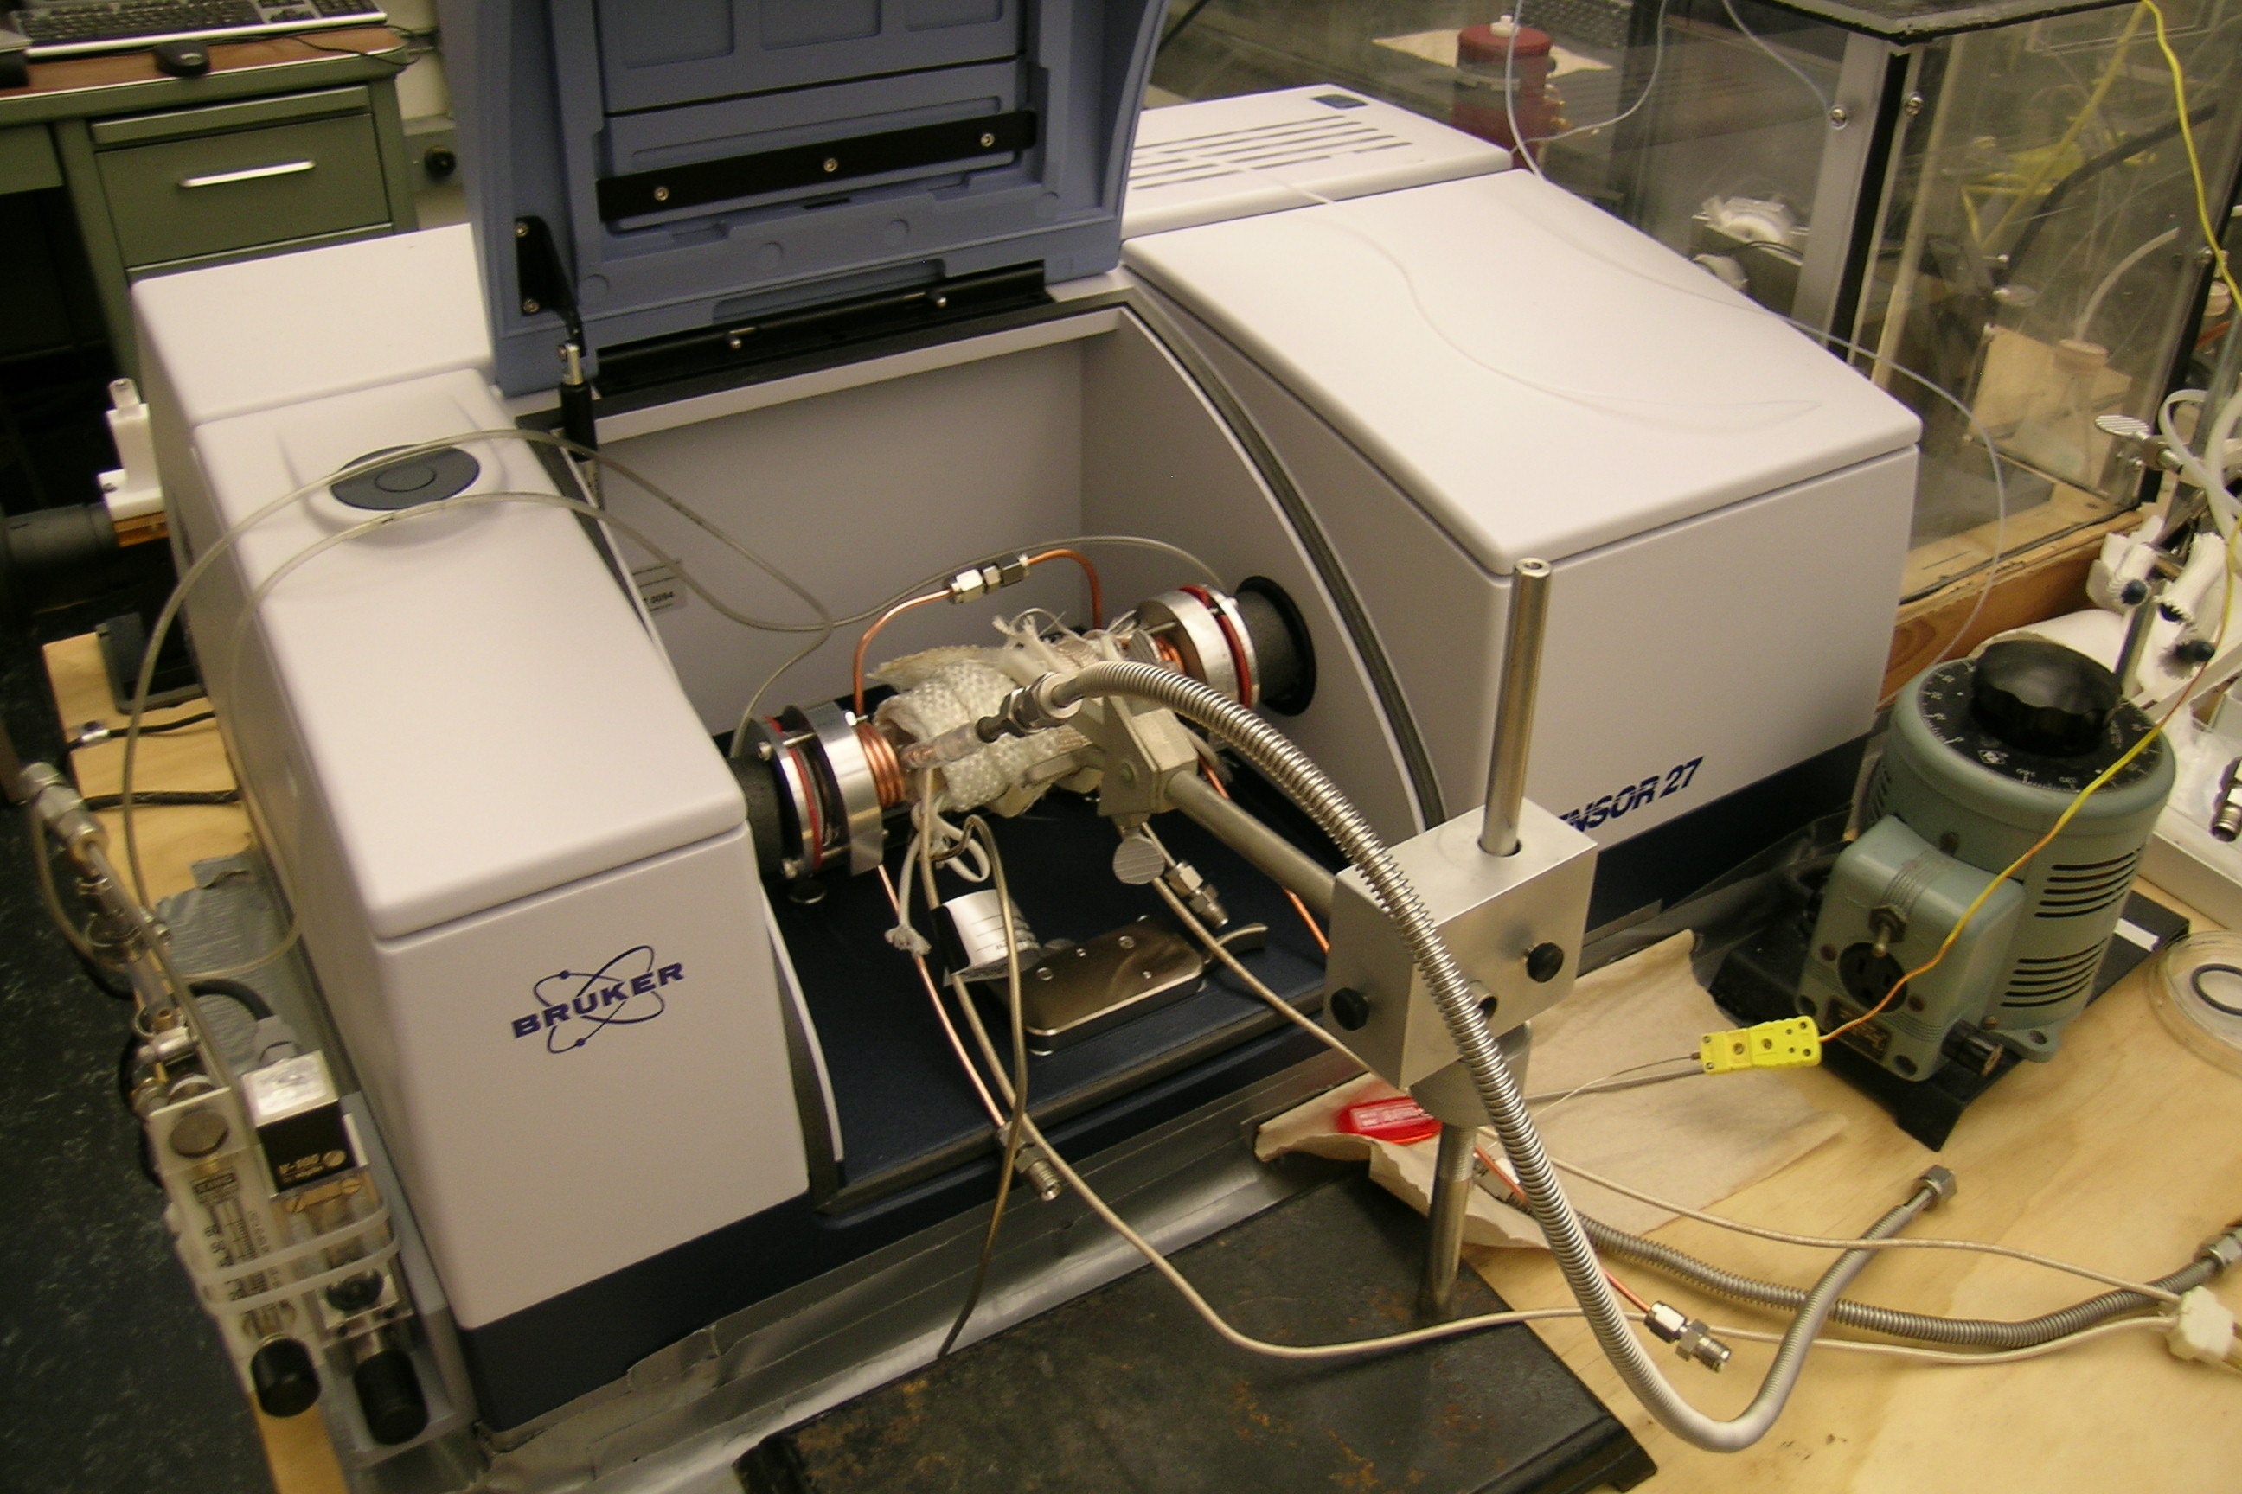

Francisco Zaera Group
prepared by Ilkeun Lee
September 2014

Table of Contents
1. General Considerations/Overview of Equipment 4
2. FT-IR Instrument and General Operation 5
a. Spectrometer General Description 5
b. FTIR Performance Characterization 5
i. Measuring Spectral Signal-to-Noise 5
ii. Maximizing Absorbance Signal 5
c. Main FTIR Parameters 5
d. Detector 6
i. Types 6
ii. Substitution 7
iii. Preparation 7
iv. Maintenance 7
e. Optical Alignment 9
f. Transmittance spectra 9
i. Choice of Background Spectra 9
g. OPUS Software 9
i. Spectra Acquisition 9
ii. Data Processing 11
h. Maintenance 12
i. IR Source 12
ii. HeNe Laser 14
iii. Gas Purging 16
3. Gas Handling System (need update) 17
a. Design 17
b. General Operation Procedure 18
c. Gas and Liquid Sample Handling 18
d. Maintenance 18
e. Valves 19
f. Pressure Gauges 19
g. Mechanical Pumps 19
4. Transmission IR Cell 20
a. General Description 20
b. Initial Setup 20
i. NaCl Window Assembly 20
ii. Purge Installation 21
iii. Thermocouple 21
c. Alignment 21
i. Alignment 21
d. Sample Preparation, Mounting, and Processing 21
i. Sample Preparation and Loading 21
ii. Sample Heating 22
iii. Sample Pretreatment 22
iv. Collecting Background Spectra 23
v. Sample Spectrum 23
e. Maintenance 24
i. Leak Checking 24
ii. Replacing the O-ring 24
iii. Cleaning and Replacing NaCl Windows 25
iv. Cleaning the Transmission IR Cell 25
v. Heating and Temperature Measurement 25
5. Typical Experiment Sequence 25
a. Initial Steps 25
b. Sample Loading 25
c. Optimization of IR Cell Position 26
d. Background Spectra Acquisition 26
e. Adsorbate Gases Introduction 26
f. Sample Spectra Acquisition 27
g. Final Steps 27
6. Suggested Training for Beginner 27
7. Reference Materials & Contacts 28
a. Reference Materials 28
b. Contacts 28

1. General Considerations/Overview of Equipment

Please read this manual carefully before using the Transmission IR system and keep it in a suitable place for future reference. Always follow the instruction described in this manual to ensure safety and to avoid damage. Improper use or failure to do safety instructions can result in serious injuries and/or property damage. Especially ensure that the CO alarm on the ceiling is ON when you use CO gas. If it doesn’t work, replace the battery inside or have another one prior to work.

Transmission IR system is placed on a bench in Chemical Science building room 135, and consists of six parts: a Fourier-transform infrared (FTIR) spectrometer (Tensor 27, Bruker), a gas manifold with vacuum, a transmission IR cell (homemade), a temperature controller (homemade), and a computer (OPUS program version 7).

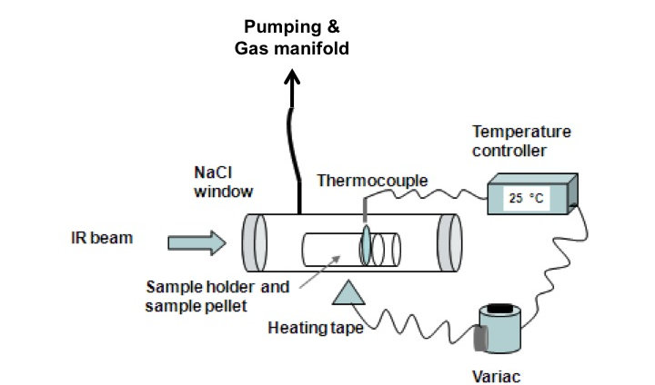

Tensor 27 FTIR spectrometer is equipped with Mid-IR source, KBr beam splitter, and DLaTGS detector. The transmission IR cell sits in the sample compartment and is purged with dry air. The cell is made of a quartz tube (6 ½ × 1 ½ "), enclosed with two NaCl windows (diameter 44 mm, thickness 6 mm) on each side and the sample holder. The sample holder is designed to hold a self-sustained pellet of a powder catalyst for gas exposure. Resistance heating of the cell is performed by using a variac and a temperature controller (Omron E5CN, the maximum temperature tested in the system is 550 ºC). The sample can be cooled with high-pressure air and/or by flowing liquid nitrogen through stainless tubing coiled around the cell (the minimum temperature that can be reach using liquid N₂ is -185 ºC). OPUS (ver. 7) program is installed in Windows 7 (service pack 1) computer. A mechanical pump pumps both the cell and the gas manifold. A system of valves allows for the separation of the components from each other and from the pump. All the manuals should be stored in the manual cabinet, right next to Stan’s desk in the room 139, so please return them after you read.

2. FT-IR Instrument and General Operation

a. Spectrometer General Description

The FTIR instrument used for this system is a Bruker Tensor 27 in Chemical Science building room 135. More details about this instrument can be found in its manual (7th updated edition, September 2011). General FTIR principles are well described in several books. See, for instance: Peter R. Griffiths and James A. de Haseth, "Fourier Transform Infrared Spectrometry", John Wiley & Sons, New York, 1986.

The transmission IR cell is placed in the sample compartment, with insulating tubes for dry air purging placed between the IR beam windows and the cell.

b. FTIR Performance Characterization

The FTIR spectrometer should be setup for optimal performance by choosing the appropriate parameters and aligning the sample and optics.

i. Measuring Spectral Signal-to-Noise
Signal-to-noise (S/N) ratio: This is a critical value dependent on the other parameters that should be minimized before performing experiments. It is checked by acquiring back-to-back spectra under identical conditions and ratioing those. S/N ratios can be calculated by the OPUS software (one of “Evaluate” menus), and should be done for two frequency regions, typically 2000–2200 cm⁻¹ (the region with the least noise), and a second in a region of interest, around 3000 cm⁻¹, for example.

ii. Maximizing Absorbance Signal
This is done by choosing a particular IR absorption peak in the spectra in the sample and following that by taking spectra as parameters are optimized.

c. Main FTIR Parameters

- Total intensity (Amplitude): This is measured by the peak-to-peak voltage value on the centerburst of the interferogram, which can be display in the computer screen as other parameters are optimized and sample alignment is performed (see the section 4c). It should be as high as possible.
- Iris opening (Aperture Setting): the iris opening is available with pre-selected sizes from 0.25 to 6 mm. It should be optimized to obtain maximum throughput while minimizing the beam size, to minimize the beam divergence. The original IR beam is approximately 1" in diameter. Based on this value and the focal length of the focusing mirrors, a divergence range at the sample could be calculated. Total light throughput should also be kept at values low enough so the signal is proportional to light intensity (there is a saturation of the detector at high light fluences).
- Scanning rate (Scanner Velocity): the most interesting values available are 10 or 20 kHz for DLaTGS detecter and 80 or 100 kHz for MCT detectors. Faster scanning rates lead to faster data acquisition, but very fast scanning rates may lead to increases in S/N. The maximum scanning rate should be chosen where noise levels are not increased (this can be evaluated by taking S/N measurements for the different scan rates using the same conditions).
- Number of scans (or Scan Times in minutes): to signal average. S/N ratios should be increased as the square root of the number of scans, but too long data acquisition times lead to drifts in IR background and in changes in the nature of the sample (adsorption, etc.).
- Resolution: High resolutions are needed to separate different IR peaks, but require longer acquisition times (require further travel of the interferometer mirror), introduce noise (from the wings of the interferogram), and may reduce total peak signal intensity. Typical value is 4 cm⁻¹, sufficient for surface adsorbates, but sometimes 2 cm⁻¹ is required.
- Amplification (Signal Gain): there are preamplifier gains (Automatic, ×1, ×2, ×4, ×8, or ×16), to be set to optimize signal without saturating the centerburst. The gain at the centerburst may be set separately (at a lower value) than for the rest (wings) of the interferogram.

d. Detector

i. Types
There are three different types of IR detectors: thermal, pyroelectric, and photoconducting detectors. Thermal detector such as thermocouple or bolometer is used over a wide range of wavelengths at room temperature, but not preferred due to slower response time and lower sensitivity than other types of detectors. Pyroelectric detector has a much faster response time as it depends on the rate of temperature change. The most common material is “deuterium L-alanine doped triglycene sulphate (DLaTGS). Photoconducting detector relies on the interaction between photons and a semiconductor such as mercury cadmium telluride (MCT) or indium antimonide (InSb), so response time is much faster and sensitivity is also much higher. Usually it has to be cooled first prior to use for thermal noise. Tensor 27 for DRIFT uses DLaTGS detector on the internal beam line.
Detector | Range (cm⁻¹) | Sensitivity  (cm Hz^{1/2} W⁻¹) | Cooling
DLaTGS | 12,000–350 | >4 x 10⁸ | Room Temperature
MCT Wide Band | 12,000–420 | >5 x 10⁹ | LN₂ cooling
MCT Medium Band | 12,000–600 | >2 x 10¹⁰ | LN₂ cooling
MCT Narrow Band | 12,000–850 | >4 x 10¹⁰ | LN₂ cooling
InSb | 12,800–1850 | >1.5 x 10¹¹ | LN₂ cooling

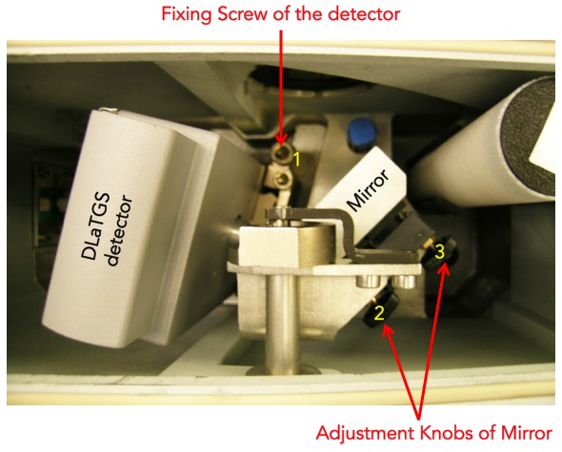
Figure 1. Detector compartment of Tensor 27 FTIR spectrometer.

ii. Substitution
1. Loosen the fixing screw of the detector compartment cover by using 6 mm Allen wrench.
- Open the detector compartment.
- Loosen the fixing screw of the detector with 6 mm Allen screw wrench (see Figure 1).
- Pull the detector straight upward out of the dovetail guide.
- Insert the detector you want into the dovetail guide and press it right down.
- Fasten the Allen screw.
- Close the detector compartment.
- Check the signal intensity using the OPUS program.

iii. Preparation
MCT or InSb detector has to be cooled down to liquid nitrogen temperature prior to use. Always wear blue Cryo-gloves (Tempshield) when you handle liquid nitrogen, LN₂ (please refer SOP of cryogenic materials in the “Lab Safety Manual” folder or download “SOPs Process” (http://research.chem.ucr.edu/groups/zaera/images/documents/4_sop_processes_2013-07.pdf) from our group homepage. Cool the detector with LN₂ using the funnel fill tube. Keep filling the funnel in cone increments. Repeat until reservoir is full (spill over). Cool down time is about 5 to 10 minutes. The detector is at working temperature once the rapid boil off venting has stopped. Place the plug (cap) in the fill port

iv. Maintenance
The LN₂ dewar may require a vacuum refreshing. If the vacuum level of LN₂ dewar will be decreased below acceptable, then the surface of that vacuum jacket is very cold. Sometimes it is covered with ice because of the condensation of moister form the air, so water peaks appear on the spectra.
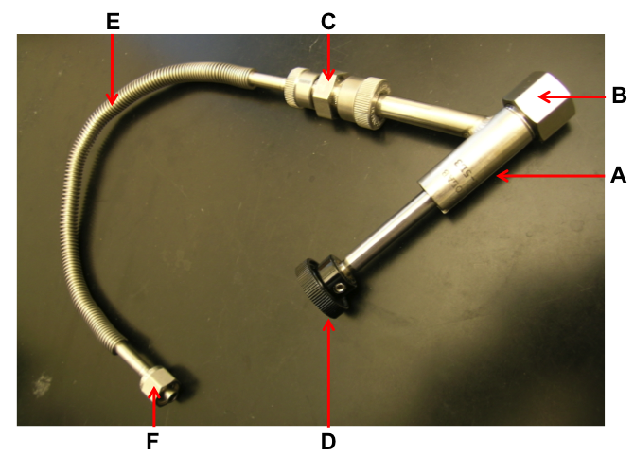
Figure 2. Adapter with flexible metal hose and Swagelok connection.

            - Remove the MCT detector from the spectrometer.
            - Connect the adapter (Figure 2) to one of vacuum valves.
            - Switch on the vacuum pump and open the valve.
            - Inspect the O-ring inside the adapter (B in Figure 2) for signs of wear.
            - Remove the cap from the connection nozzle of the detector.
            - Pull the adapter knob (D in Figure 2).
            - Loosen the coupling nut (B in Figure 2).
            - Push the adapter carefully over the connection nozzle of detector dewar.
            - Fasten the coupling nut hand-tight while holding the adapter and detector.
            - Push the adapter knob in the closed position until the threaded rod of the adapter is in contact with the sealing plug of the dewar evacuation valve.
            - Evacuate the detector dewar.
            - Close the vacuum valve.
            - Screw the threaded rod of the adapter in the connection thread of dewar evacuation valve by turning the adapter knob clockwise.
            - Pull the knob to the open position in order to open the dewar evacuation valve.
            - Evacuate the detector by opening the vacuum valve to pressure less than 10⁻⁶ Torr.
            - Close the dewar evacuation valve by pushing the adapter knob (D in Figure 2).
            - Press adapter knob firmly to the stop position,
            - Screw the threaded rod of the adapter out of the connection thread of the dewar evacuation valve by rotating the adapter knob.
            - Vent the section between vacuum pump and adapter.
            - Pull the knob to the open position.
            - Loosen the coupling nut and remove the adapter from the connection nozzle of the detector dewar.
            - Reinstall the MCT detector in the spectrometer.

e. Optical Alignment

Tensor 27 is equipped with a high stability interferometer with ROCKSOLID permanent alignment. Also detector substitution is possible with Tensor 27. DLaTGS detector is default, and optional MCT detectors are available in our lab. After substituting the detectors, re-alignment is not necessary due to the dovetail detector mounting. However, it has to be done properly whenever any accessory like DRIFTS or ATR system is installed or uninstalled in the sample compartment. Adjustment knobs for the alignment are shown in Figure 1.

            - Remove all the accessory and samples from the IR beam path. Make sure that there is nothing in the sample compartment.
            - MCT detector has to be cooled first prior to measurement.
            - Run OPUS program.
            - Select the “Measurement” menu.
            - Click the “Check Signal” tab.
            - Select the “Interferogram” radio button.
            - The amplitude value indicates the signal intensity that is currently detected.
            - Loosen the fixing screw of the detector compartment cover by using 6 mm Allen wrench.
            - Open the detector compartment.
            - Adjust two knobs (2 and 3 in Figure 1) of the mirror to get the highest value while watching the amplitude on the monitor. If you lost IR beam, use IR card to find it.
            - Once you get a good alignment, close the cover.
            - Wait for 6 hrs at least to be purged completely.

f. Transmittance spectra

i. Choice of Background Spectra
Depending on how to prepare your sample, it is strongly recommended to perform the background measurement with a proper material. The purpose of the background measurement is to detect the influence of the ambient conditions (e.g. humidity or temperature) and the auxiliary materials (e.g. solvents) that are required for preparing the sample. The subsequent sample measurement results in the sample spectrum from which the influence is eliminated. So, do both background and sample measurements with the same parameter settings in OPUS program. Ensure that the ambient conditions are identical or at least nearly identical.

g. OPUS Software

i. Spectra Acquisition
- Start the OPUS program:
  - Click the short-cut icon of the OPUS program on the desktop.
  - The OPUS login window will appear on the screen.
  - Type "OPUS" in the password line (for default operator).
- Select "Measure" and then "Measurement". After a few seconds, the measurement set-up windows will appear on the screen. Check the experimental parameters under "Advanced", "Optics", "Acquisition", "FT", and "Display".
- Set the sample temperature as needed.
- When the sample reaches the desired temperature, take a background spectrum by selecting "Measurement", "Basic", and "Collect Background". The program will display a message in the bottom line high-lighted by a green color indicating that the data are being taken.
- When the message disappears, the measurement is done. From this point on, you can proceed with the experiments (e.g. heating of the sample, adsorption of gases etc.).
- During the data acquisition, the interferogram cannot be seen on the check signal menu. After the background scans are finished, the "Measurement" window remains on the screen.
- Go to “Background” and Click “Save Background” to save the spectrum. The Filename (####.0) is saved automatically on the hard drive and displayed on the left (Window List) of the screen.
- The file can be saved as other formats on the hard drive. Select "Save File As", then check the file name and path to be saved. If you want an ASCII file, in the "Mode" option on the Save Spectrum window, select "Data Point Table" before clicking the "Save" button.
- Fill the chamber with the desired pressure of the reactant gases, at the same temperature used for the acquisition of the background spectrum.
- Take the sample spectra by selecting "Collect Sample", and wait until the highlighted message disappears.
- To take the spectra with different backgrounds saved previously, select “load background” and click any background spectrum.
- Type the sample name and explanation in the lines for sample name and sample form. (e.g. Sample Name: 1% Pt/SiO₂; Sample Form: after CO dosing of 10 Torr for 5 min at -150ºC)
- Take the sample data by selecting "Collect Sample" and wait until the highlighted message disappears.
- Select “load background” again, and click another background spectrum for the next experiment.

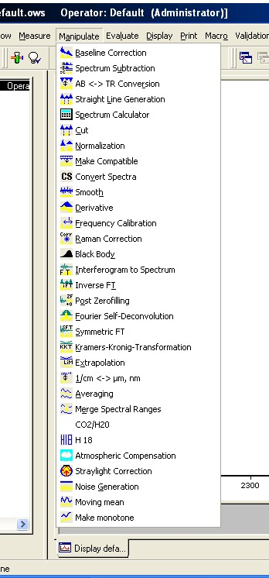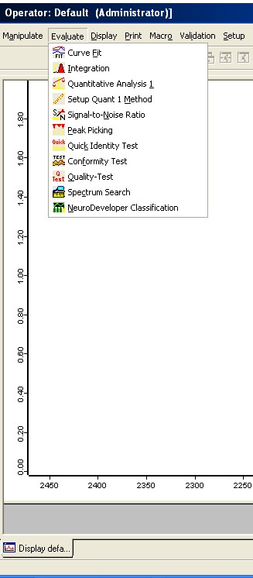

Figure. 3. “Manipulate” and “Evaluate” menus in OPUS program.

ii. Data Processing
Very useful processing tools are available in OPUS program. For example, Base Line Correction and Spectrum Calculator are in “Manipulate” menu, while Curve Fit and Integration are in “Evaluate” menu. Use helpful menu to learn how to do them.

h. Maintenance

i. IR Source
Tensor 27 uses only one mid IR source (MIR) in an U-shaped silicon carbide piece, which is pre-aligned, so realignment is not required after replacement. During the spectrometer operation, it becomes very hot and has risk of skin burn. Please avoid any skin contact and wait until the source cools down enough before you remove it.
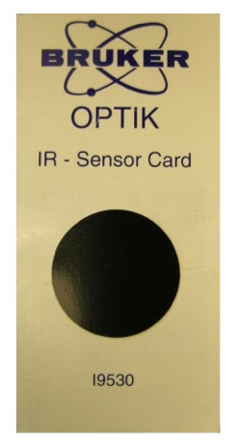
1. Beam Detection

If you like to check the IR beam visually, you can use an IR sensor card (see the right image) supplied from Bruker when the spectrometer was installed. You may confuse the red light on your sample with the IR beam, but actually it is He-Ne laser light (632.8 nm) that travels along the IR beam path.

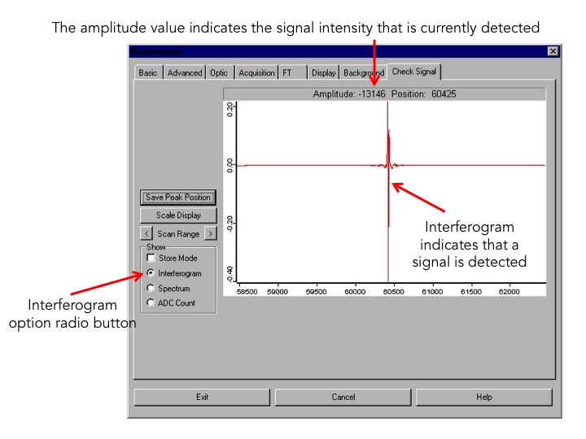

Figure 4. OPUS dialog window for “Measurement”.

2. Intensity Measurement

IR beam signal can be checked on the OPUS program.

1. Remove all the accessory and samples from the IR beam path. Make sure that there is nothing in the sample compartment.
2. Run OPUS program.
3. Select the “Measurement” menu
4. Click the “Check Signal” tab
5. Select the “Interferogram” radio button
6. The amplitude value indicates the signal intensity that is currently detected.

3. Cooling

Tensor 27 uses air-cooled MIR source, so additional cooling system isn’t required for normal operation. However, please do not block the ventilation slot of the source/laser compartment at the spectrometer top-side. During the spectrometer operation, the IR source generates heat, which is dissipated by the slots. Failure to do so can lead to spectrometer component damage.

4. Replacement

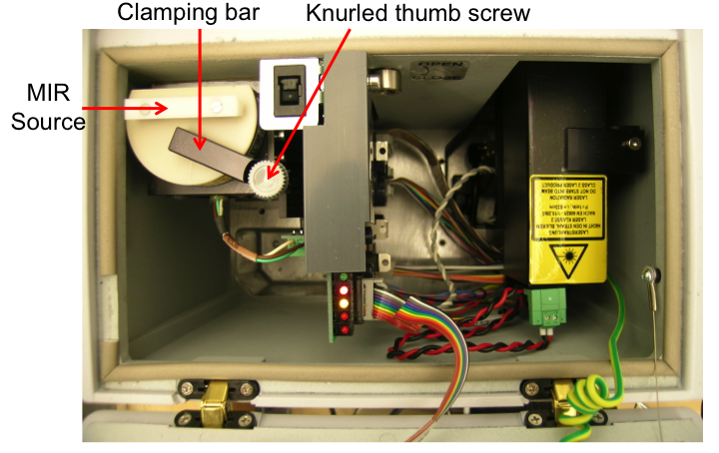
Figure 5. Source/Laser compartment.

            - Switch off the spectrometer.
            - Wait until the source cools down sufficiently.
            - Open the source/laser compartment.
            - Loosen the Knurled thumb screw of the clamping bar (approximately one turn).
            - Press the source downward while rotating the clamping bar aside.
            - Take the source out of the holder.
            - Insert a new source in the operating position holder.
            - While pressing the source downward, rotate the clamping bar over the source.
            - Tighten the knurled thumb screw of the clamping bar about one turn.
            - Close the source/laser compartment.
            - Switch on the spectrometer.
            - Check the signal intensity using OPUS program.
            - Select “Optics Diagnostics” in Measure menu.
            - Click the source icon on the “Instrument Status” window.
            - Click on “Service Info” button.
            - Click on the “Reset” button (Figure 6).
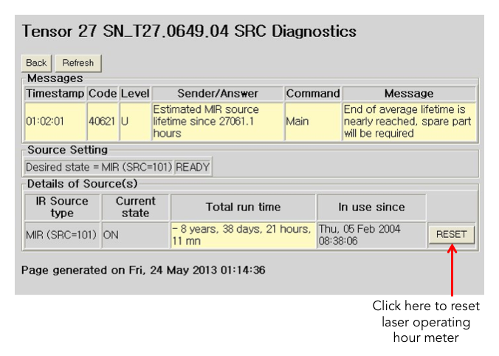
Figure 6. Source diagnostics page.

ii. HeNe Laser
FTIR spectrometer is equipped with a He-Ne laser (632.8 nm), which controls the position of the moving mirror in interferometer for IR beam scanning. If you have a problem with the laser, a red STATUS indicator or a failed performance qualification test (PQ).
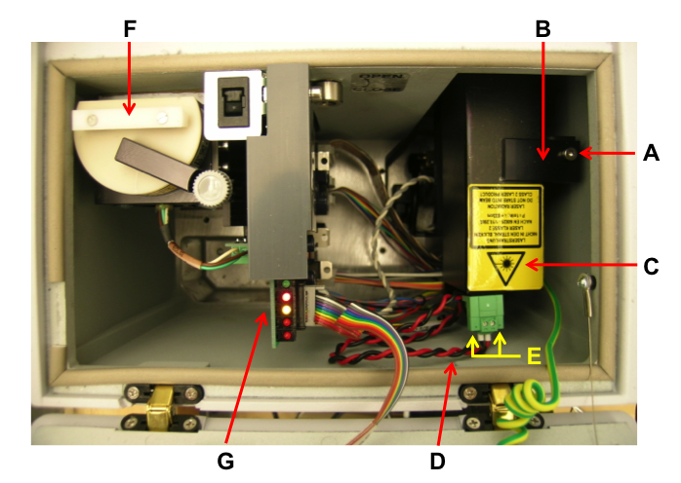
Figure 7. Source/Laser compartment.

1. Measuring and Adjusting Signal Intensity

If you have laser problem, you need to check the laser amplitude. For this test you nee an oscilloscope. There are two test points (LA2 and LB2) on IFM board (G in Figure 7) You should see minimum of 2 V p-p sign wave on these points.

There are parameters that can and should be checked with respect to the HeNe laser intensity.
- HeNe laser output intensity – this value can be checked under measurement. Go “Optics Setup and Service Option”. Select “Service” tab, if the log window is blank. Select “Repeat Diagnostics Test” button, when the results appear take note of the current and initial laser intensity values as well as the number of laser dropout value.
- HeNe laser modulation intensity – this value can be obtained via the measurement. Go “Direct Command Entry Option”. In there type; VEL=6 <Enter>, SCM=3 <Enter>, LAA <Enter>. Do this three times and record the approximate average value given (the value is the peak to peak modulation amplitude in millivolts). LAB <Enter>. Do this three times and record the approximate average value given (the value is the peak to peak modulation amplitude in milllivolts).

2. Replacement

In case of defective laser you have to replace the complete laser module (C in Figure 7), which consists of the laser tube and the laser power supply.

            - Switch off the spectrometer.
            - Unplug the main power cable.
            - Open the source/laser compartment.
            - Loosen the Allen screw (A in Figure 7)
            - Rotate the holding plate (B in Figure 7)
            - Take the laser module out of the holder. Be aware of the fact that the laser module is still connected to the laser supply cable (D in Figure 7).
            - Loosen the two slotted screws (E in Figure 7) and unplug the supply cable (D in Figure 7).
            - Connect the supply cable to the replacement laser module.
            - Fasten the two slotted screws.
            - Open the front shutter of the laser tube if it is closed.
            - Insert the laser module in the holder. Make sure that the laser rests on the holder bottom in a plane manner to ensure the correct orientation of the laser beam.
            - Rotate the holding plate (B in Figure 7) in place.
            - Fasten the Allen screw (A in Figure 7).
            - Close the source/laser compartment.
            - Plug the main power cord
            - Switch on the spectrometer.
            - Check the laser indicator on the spectrometer topside lights yellow after a few seconds. Otherwise, solve this issue.
            - Wait until the STATUS indicator lights green. If the indicator remains red, the laser module is not installed correctly. Correct the laser installation.
            - Check whether the IR signal is detected using the OPUS program.
            - Run the “Optics Diagnostics” in OPUS
            - Open “Instrument Status” window.
            - Click “HeNe laser” icon.
            - Click “Service Infor” button.
            - Click “Reset” button in the laser diagnostics page (Figure 8).
            - Perform an OQ Test using OVP (OPUS Validation Program).

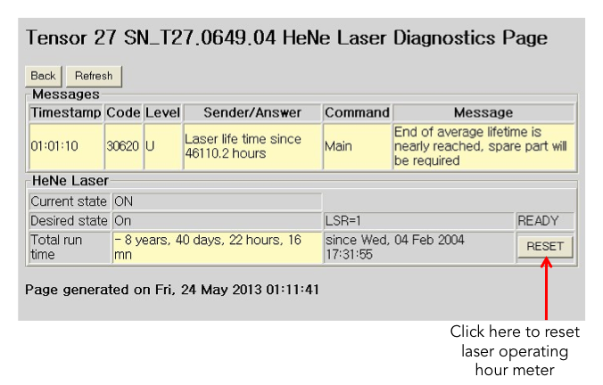
Figure 8. Laser diagnostics page.

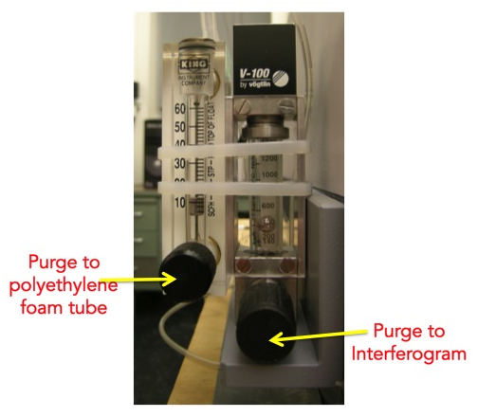
iii. Gas Purging

At least, the optical bench has to be purged with dry air or nitrogen gas as the beam splitter is made of KBr, which is a hygroscopic material. Also, purging the FTIR spectrometer reduces the content of undesired atmospheric interference from moisture and carbon dioxide, which absorb IR light in both detector and sample compartments as well as the optical bench.

Right now the Transmission IR system is purged with dry air. The flow rate is controlled by two rotameters (right image): one is for the optical bench and the detector compartment; the other is for sample compartment.

3. Gas Handling System (need update)

Gas manifold of Transmission IR system includes Ar, H₂, O₂, and reactant gas lines. The pressure is monitored by two sets of Baratron (10 and 11 in Figure 9) and Pirani Penning (13 and 14 in Figure 9) gauges. One set (10 and 13) is for the IR cell, and the other set (11 and 13) is for gas manifold.

a. Design
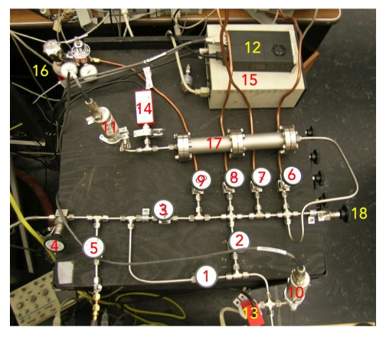
Figure 9. Gas manifold for the transmission IR system.

            - valve to pump the transmission IR cell
            - valve to supply gas
            - main valve to pump gas manifold
            - auxiliary valve to pump gas manifold
            - valve to Liquid/Solid IR cell
            - Ar gas valve
            - H₂ gas valve
            - O₂ gas valve
            - CO gas valve
            - Baratron gauge 1 to monitor the transmission IR cell
            - Baratron gauge 2 to monitor the gas manifold
            - Baratron gauge reader
            - Pirani Penning gauge 1 to monitor the transmission IR cell
            - Pirani Penning gauge 2 to monitor the gas manifold
            - Pirani Penning gauge reader
            - CO gas lecture bottle
            - Tube for gas reservoir
            - Valve to H-D gas manifold (Please don’t open to use!)

b. General Operation Procedure

For Sample Change

            - Close valves #1, #2, and #5.
            - Open valves #3 and #4 to pump the tube (17 in Figure 9).
            - Close valve #3, and then fill the tube with Ar gas as desired.
            - Fill the IR cell with Ar gas by opening valve #2 up to 800 Torr.
            - Close valve #2.
            - Open valve #3 to pump the tube.
            - Disassemble the IR cell and change the sample.
            - Assemble the IR cell.
            - Open valve #1 to pump the IR cell.

For Gas Supply

            - Close valves #2 and #3.
            - Fill the tube (17 in Figure 9) with gases you want.
            - Close valve #1.
            - Fill the IR cell with the gases by opening valve #2 slowly.
            - Close valve #2.
            - Open valve #3 to pump the tube.

c. Gas and Liquid Sample Handling
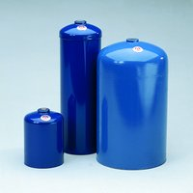
Gas samples is delivered in a lecture bottle or Sure/PacTM steel cylinder (Aldrich, right image), so use a proper regulator and Swagelok connection to the gas manifold. Liquid sample is placed in a glass container, which is specially designed by modifying glass-stainless steel tube adapter that facilitates connection to the gas manifold via Swagelok union. Freeze-pump-thaw cycles are required to remove air from the liquid sample prior to use.

d. Maintenance

All systems in Chemical Science building room 135 including Transmission Catalysis and Victor are sharing the three gas cylinders (O₂, Ar, and H₂). When you need to use any gas, please check first if someone is already using the gas line. If so, you need to let them know you’re going to open the gas valve and a sudden pressure drop may be seen.

e. Valves

Bellow-sealed BK series (e.g. SS-4BK) from Swagelok are preferred for the valves in the manifold system. The valves can be disassembled for cleaning inside, and the PCTFE stem tip is also replaceable.

f. Pressure Gauges
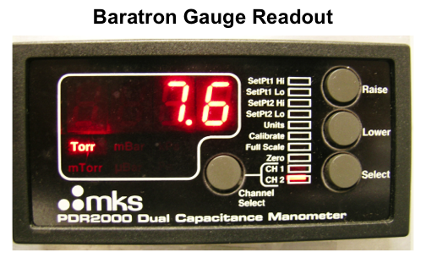
Two different types of pressure gauges are used in the gas manifold. One is Baratron gauge with digital readout for the range from 0 to 1000 Torr to control the amount of reactant gases quantitatively. Channel 1 (CH 1) is to the transmission IR cell side, and channel 2 (CH 2) is to the gas manifold side. The other is thermocouple gauge to monitor vacuum status in the gas manifold and the reaction chamber.

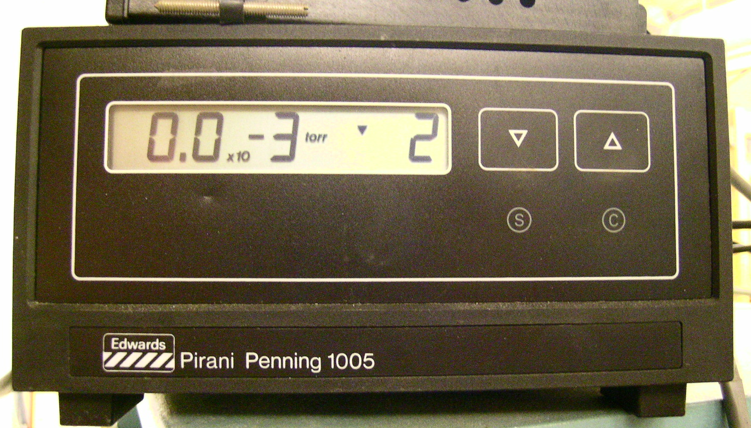
The other is Pirani Penning gauge with digital readout for the range from 10⁻³ to 1 Torr to control to control the amount of reactant gases quantitatively and to monitor the vacuum status. Channel 1 (CH 1) is to the transmission IR cell side, and channel 2 (CH 2) is to the gas manifold side.

g. Mechanical Pumps

The mechanical pump requires regular oil changes, approximately once every half year or when large quantities of corroding or contaminants gases are used in the experiments. The oil can be occasionally degassed by leaking air in the inlet for a short period of time, but once the oil becomes dark, changes consistency, or has solid particulate, it is best to change the oil. The process for handling vacuum oil is available in the SOP of “Pump Oil”. Refer it in our “Lab Safety Manual” or download “SOPs Process” (http://research.chem.ucr.edu/groups/zaera/ \images/documents/4_sop_processes_2013-07.pdf)

4. Transmission IR Cell

a. General Description
The transmission IR cell is made of quartz (6 ½ × 1 ½ "), enclosed with two NaCl windows (diameter 44 mm, thickness 6 mm) on both sides. Cooling water lines protect the windows from damage, so check water circulation first prior to use. The sample holder is placed in the middle of inside. It can be heated by heating tape wrapped or cooled by LN₂ line on the outer surface. Type K thermocouple monitors the cell temperature, not the catalyst directly.
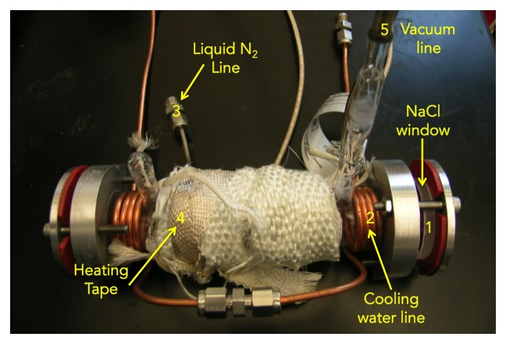
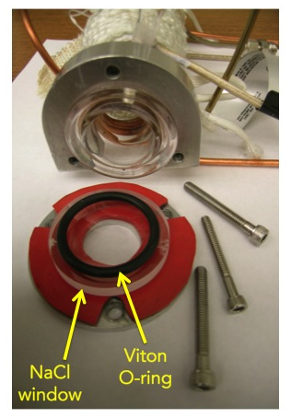

b. Initial Setup

i. NaCl Window Assembly
Double sides-polished NaCl window (diameter 44 mm, thickness 6 mm) sits on a red rubber sheet. Viton O-ring is placed to seal the IR cell as shown in the photo (right). Tighten three bolts with valance not to break the windows.

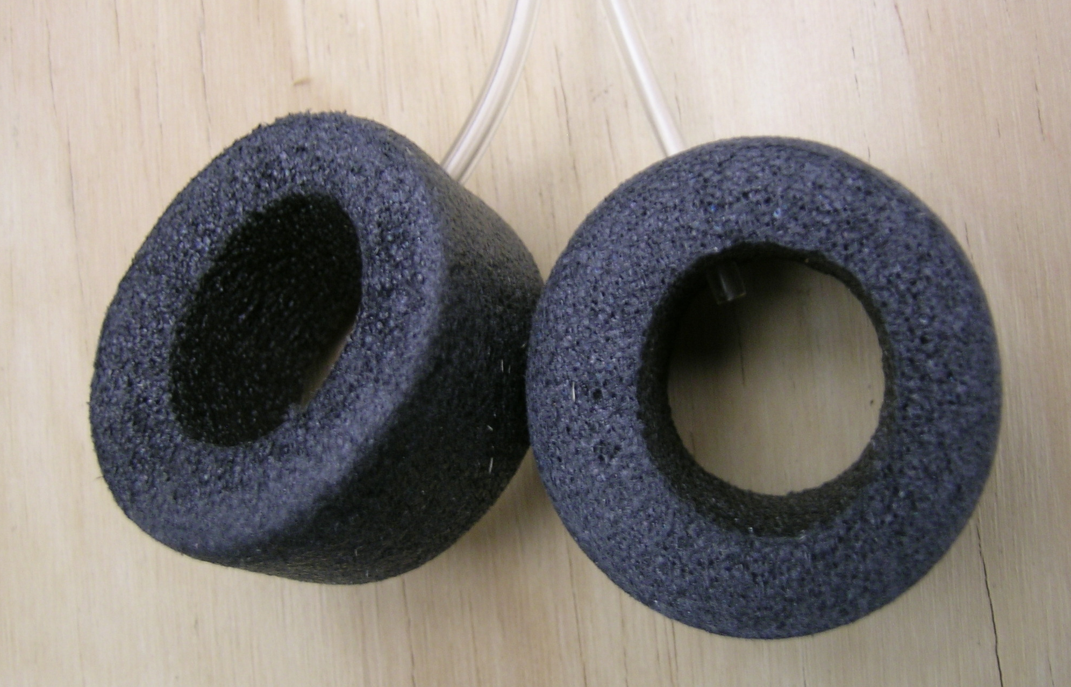
ii. Purge Installation
Install the polyethylene foam tubes on both the NaCl windows and insert purge tubing (dry air) into a hole on each side. Adjust the rotameter level properly and purge it enough.

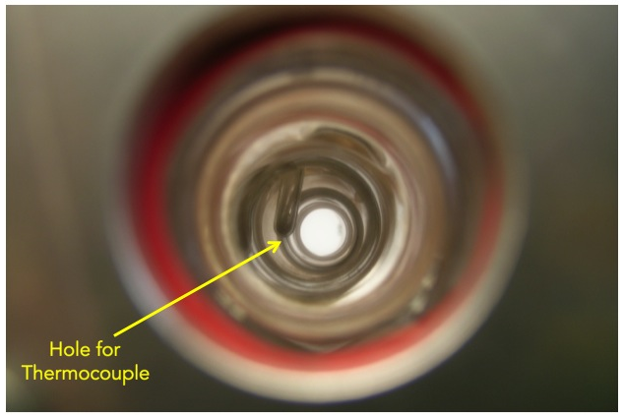

iii. Thermocouple
Type K thermocouple is used to measure temperature of the IR cell surface, not the sample directly. It has to be inserted into the hole as seen in the photo below.

c. Alignment

i. Alignment
- Select “Measure”, “Measurement” and “Check Signal” in the Measurement window.
- If everything is OK, an interferogram will be displayed on the screen.
- Check the amplitude; select ADC Count to see a numerical value.
- Slowly move the IR cell within its position in the sample compartment until a maximum value is obtained.
- Insert polyethylene foam tubes at both sides of the IR cell, between the NaCl windows of the cell and the windows of the FTIR spectrometer to purge the IR beam path (Both ends of the cell should be touch the windows on the wall of the sample compartment).
- Purge those tubes with dry air or N₂ gas.

d. Sample Preparation, Mounting, and Processing

i. Sample Preparation and Loading
- Powder catalyst (10–30 mg) is pressed into a self-supported disk (13 mm in diameter) by using a manual press kit in room CS ???. Transmittance of the pellet needs to be checked by the centerburst intensity in the interferogram mode. If it is too thick, IR bands may be too weak and noisy.
- The catalyst pellet is mounted on a sample holder held in the center of the IR cell.
- Both ends of the IR cell are sealed with NaCl windows.
- The IR cell is connected to a gas manifold.
- The IR cell is pumped to reach a background pressure to 10⁻² Torr range.

ii. Sample Heating
Heating the IR cell is performed by using a Variac and a temperature controller (homemade). Usually it can be heated above 200 ºC by setting the Variac at 100%. For lower temperatures, please use a combination of electrical heating (Variac at 50%) and N₂ cooling. Auto-tuning is required for better temperature control.
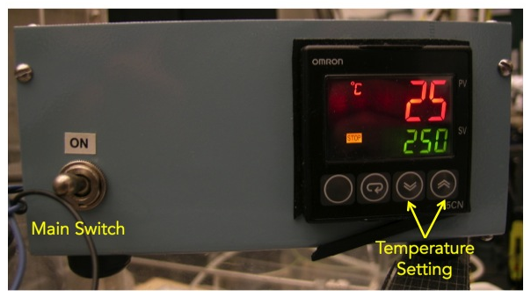

iii. Sample Pretreatment
Supported metal catalysts need to be pre-activated or -treated as reported in literatures. In case of Pt/SiO₂:
- The pellet is first dried in vacuum at 150–200 ºC for 30 min in order to eliminate adsorbed water.
- Anneal to 350 ºC with slowly.
- Keep the catalyst at 350 ºC for 3~4 hours under 200 Torr of H₂.
- Pump H₂ gas for 15 min.
- Cool down to room temperature right before introducing the reactant gases.
For a supported Ni catalyst:
- The pellet is first dried in vacuum at 550 ºC for 3 hours in order to eliminate adsorbed water (the surface of silica or alumina support may be partially dehydroxylated by this treatment).
- Cool to 450 ºC with slowly.
- Keep the catalyst at 450 ºC for 1 hour under 200 Torr of O₂. To remove any surface carbon (it desorbs as CO₂)
- Pump O₂ gas for 15 min.
- Keep the catalyst at 550 ºC for 3~4 hours under 200 Torr of H₂ to reduce the NiO to metallic nickel.
- Pump H₂ gas for 15 min.
- If the reactions are to be performed on the reduced nickel catalyst, the sample is finally cooled down to room temperature before introducing the reactant gases.
- For reactions on oxidized nickel catalysts, the catalyst needs to be:
  - cooled from 550 to 450 ºC after pumping.
  - annealed again at 450 ºC under 200 Torr O² for 1 hour.
  - cooled to room temperature.

iv. Collecting Background Spectra

For temperature-dependent sequences, reference spectra can be obtained during the cooling after pretreatment. These spectra are used as background spectra at the corresponding temperatures.

- Cool down or heat up the sample to the desired or lowest temperature.
- When the sample reaches the desired temperature, take a background spectrum by selecting "Measurement", "Basic", and "Collect Background". The program will display a message in the bottom line high-lighted by a green color indicating that the data are being taken.
- When the message disappears, the measurement is done. From this point on, you can proceed with the experiments (e.g. heating of the sample, adsorption of gases etc.).
- During the data acquisition, the interferogram cannot be seen on the check signal menu. After the background scans are finished, the "Measurement" window remains on the screen.
- Go to “Background” and Click “Save Background” to save the spectrum. The Filename (####.0) is saved automatically on the hard drive and displayed on the left (Window List) of the screen.
- The file can be saved as other formats on the hard drive. Select "Save File As", then check the file name and path to be saved. If you want an ASCII file, in the "Mode" option on the Save Spectrum window, select "Data Point Table" before clicking the "Save" button.
- In temperature-dependent sequences, take and save background spectra during the cooling of the catalyst with about a proper interval (10 to 50 ºC).

v. Sample Spectrum

Once the temperature reaches the lowest temperature, introduce the desired pressure of the reactant gases (see Section 3. Gas Handling System, b. General Operation Procedure) into the IR cell and keep it for 5 min.

- Pump the gases out from the IR cell.
- Remove the liquid N₂ reservoir or heat the IR cell.
- Select “load background” and click the corresponding background spectrum at the same temperature.
- Type the sample name and explanation in the lines for sample name and sample form. (e.g. Sample Name: 1% Pt/SiO₂; Sample Form: after CO dosing of 10 Torr for 5 min at -150 ºC)
- Take the sample data by selecting "Collect Sample" and wait until the highlighted message disappears.
- Select “load background” again, and click another background spectrum for the next experiment or temperature.

NOTE 1: Make sure that the sample position in the sample scan is exactly the same as in the background scan: Do not try to optimize the sample position between a background and sample scan, even if the signal intensity is lower than it was in the background scan! Also, make sure that the temperature at which the sample is taken is the same as that at which the background was taken, so that the contraction of the manipulator is the same in both cases. Do not change any parameter between the background and sample scans.

NOTE 2: Keep accurate records of the data type in the files. Know exactly which files contain the sample ASCII data.

NOTE 3: Keep backups of the OPUS files only. These files contain the actual data from which all other data can be easily derived.

e. Maintenance

i. Leak Checking
The transmission IR cell may have a leak because of contamination on the O-rings, so please check them carefully prior to the assembly after sample loading. If NaCl window surfaces become rough and causes poor sealing with the O-ring, you may polish the roughed surface.

Gas lines should check for leaks once assembled:

- Isolate the gas lines in sections by closing the appropriate valves when possible.
- Pressurize the line and check for bubbling while spraying a few drops of a soapy solution such as "Snoop".
- If that does not work, spray helium around the suspect connection and look for any pressure change in the gas manifold with the thermocouple vacuum gauge.
- A third way of identifying leaks is to use acetone or isopropyl alcohol, pouring some drops in the suspected connection and looking for pressure changes inside the manifold.
- Ultimately, if the pressure inside the manifold cannot be brought down, or if it increases rapidly upon closing the valve to the pump, a leak detector may need to be used to isolate the leak.

ii. Replacing the O-ring
If the O-rings are worn out and caused a leaking, please replace them with new ones.

iii. Cleaning and Replacing NaCl Windows
NaCl windows may be cleaned by ethyl ether, but not alcohol such as isopropyl alcohol. Hence, please handle them well not to be foggy by moisture. Replacement windows could be purchased from Reflex Analytical Corp.

iv. Cleaning the Transmission IR Cell
The IR cell can be cleaned by any solvent, but recommended only when disassembled completely. You may use a cotton tip to remove any broken pellet or powder on the inside wall of the cell.

v. Heating and Temperature Measurement
To get the desired temperature, use arrow keys on the front panel of the Omron temperature controller.

5. Typical Experiment Sequence

Below a description is provided of the procedure to generate a transmission IR spectrum of a pellet sample. Both background spectra, which are taken with the clean sample, and sample spectra, which are taken after adsorption (and sometimes reaction) of the molecules on the pellet are needed for final spectra, but they are taken separately. The transmission IR data are collected on the PC using the Bruker OPUS software.

a. Initial Steps
- Sign-in the logbook
- Vent transmission IR cell and load sample
- Reinstate vacuum environment
- Start up the OPUS program
  - Click the short-cut icon of the OPUS program on the desktop.
  - The OPUS login window will appear on the screen.
  - Type “OPUS” in the password line for the default operator
  - Select “Measure” and then “Measurement”
  - After a few seconds, the measurement set-up window will appear on the screen.
  - Check the experimental parameters under “Advanced”, “Optics”, “Acquisition”, “FT”, and “Display”

b. Sample Loading

- Prepare a pellet sample.
- Vent the transmission IR cell
- Disassembly one side of the IR cell and take the sample holder out
- Load the sample pellet into the slot of the sample holder.
- Put the sample holder gently back into the IR cell.
- Assembly the NaCl window set.

c. Optimization of IR Cell Position

- Select “Measure”, “Measurement” and “Check Signal” in the Measurement window.
- If everything is OK, an interferogram will be displayed on the screen.
- Check the amplitude; select ADC Count to see a numerical value.
- Slowly move the IR cell within its position in the sample compartment until a maximum value is obtained.
- Insert polyethylene foam tubes at both sides of the IR cell, between the NaCl windows of the cell and the windows of the FTIR spectrometer to purge the IR beam path (Both ends of the cell should be touch the windows on the wall of the sample compartment).
- Purge those tubes with dry air or N₂ gas.

d. Background Spectra Acquisition

- Cool down or heat up the sample to the desired or lowest temperature.
- When the sample reaches the desired temperature, take a background spectrum by selecting "Measurement", "Basic", and "Collect Background". The program will display a message in the bottom line high-lighted by a green color indicating that the data are being taken.
- When the message disappears, the measurement is done. From this point on, you can proceed with the experiments (e.g. heating of the sample, adsorption of gases etc.).
- During the data acquisition, the interferogram cannot be seen on the check signal menu. After the background scans are finished, the "Measurement" window remains on the screen.
- Go to “Background” and Click “Save Background” to save the spectrum. The Filename (####.0) is saved automatically on the hard drive and displayed on the left (Window List) of the screen.
- The file can be saved as other formats on the hard drive. Select "Save File As", then check the file name and path to be saved. If you want an ASCII file, in the "Mode" option on the Save Spectrum window, select "Data Point Table" before clicking the "Save" button.
- In temperature-dependent sequences, take and save background spectra during the cooling of the catalyst with about a proper interval (10 to 50 ºC).

e. Adsorbate Gases Introduction

- Gas manifold is sharing argon, hydrogen, and oxygen gas cylinders with Victor and Oxidation reactor. Let them know you’re going to use the gas lines.
- Fill the gas reservoir first with the first reactant gas while checking the pressure on Baratron gauge channel 2. It is safer and easier way to control lower pressures than atmosphere.
- Fill the IR cell as slowly as possible while monitoring Baratron gauge channel 1 because the powder in the sample cup can pop up as pressurized suddenly.
- Empty the reservoir (17 in Figure 9) for the next gas.
- Open the value slowly also to pump the chamber after measuring sample spectra.

f. Sample Spectra Acquisition

- Once the temperature reaches the lowest temperature, introduce the desired pressure of the reactant gases (see Section 3. Gas Handling System, b. General Operation Procedure) into the IR cell and keep it for 5 min.
- Pump the gases out from the IR cell.
- Remove the liquid N₂ reservoir or heat the IR cell.
- Select “load background” and click the corresponding background spectrum at the same temperature.
- Type the sample name and explanation in the lines for sample name and sample form. (e.g. Sample Name: 1% Pt/SiO₂; Sample Form: after CO dosing of 10 Torr for 5 min at -150 ºC)
- Take the sample data by selecting "Collect Sample" and wait until the highlighted message disappears.
- Select “load background” again, and click another background spectrum for the next experiment or temperature.

g. Final Steps

- Evacuate the gas manifold and IR cell
- Fill them with ~1 atm of Ar
- Stop the purge to polyethylene foam
- Remove one of the NaCl windows to remove the catalysts sample holder
- Place back the NaCl window
- Put the IR cell back to the beam line
- Evacuate the IR cell
- Begin the purge to polyethylene foam tube
- Exit the OPUS software
- Make sure that all the valves are closed, in particular the ones to the gas lines
- Close the valve for water-cooling.
- Sing-out the logbook.

6. Suggested Training for Beginner

For beginners to learn how to obtain consistent and reliable data, the following training is strongly recommended. The data obtained from the suggested experiments should be contrasted with previous results for the same system, and checked by an experienced operator.

- 1 wt% Pt/SiO₂ catalyst (or commercial catalyst) is recommended for the standard sample.
- Prepare a pellet by using 10 mg of the catalyst.
- Obtain transmission IR spectra after each step of the sample cleaning procedure, during the activation under vacuum.
- Measure background spectra during the cooling from 200 to -150 ºC with 25 ºC or a smaller interval.
- Fill the IR cell with 10 Torr of CO gas for 5 min at below -150 ºC
- Measure sample spectra up to 200 ºC with the same interval.
- Plot the CO peak area in the spectra as a function of time.

7. Reference Materials & Contacts

a. Reference Materials

Tensor User Manual, 7th updated edition, September 2011

b. Contacts

Bruker Optics, Inc.
19 Fortune Dr. Billerica, MA 01821, USA
978-439-9899 (ext. 5227)
www.brukeroptics.com
info@brukeroptics.com

