Infrared Characterization
System #3: Transmission for ALD

Manual

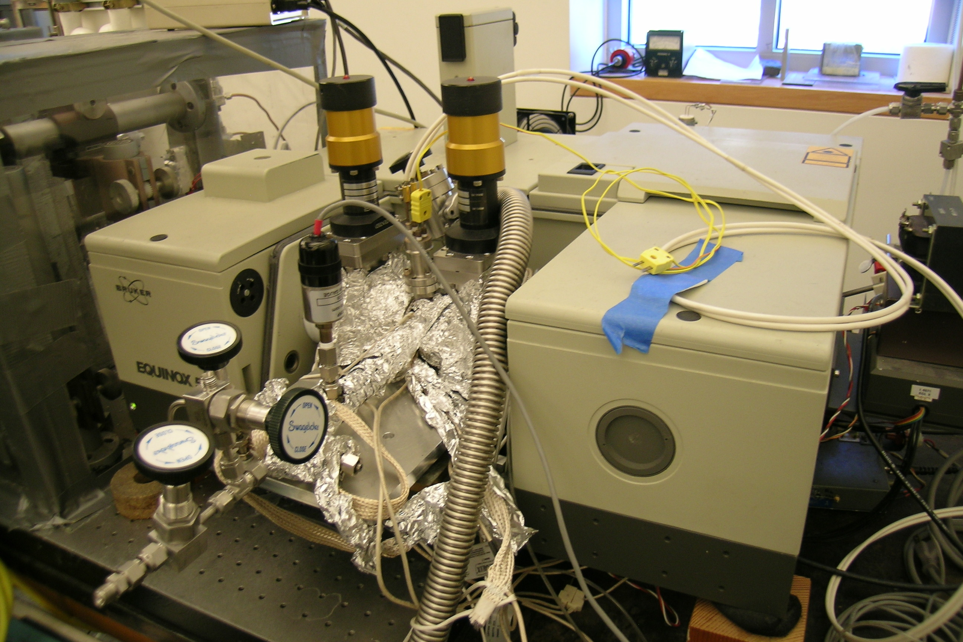

Francisco Zaera Group
written by Menno Bouman, Byungchang Kang, 2013,
modified by Francisco Zaera, January 2014,
updated by Ilkeun Lee, September 2014

Table of Contents
1. General Considerations/Overview of Equipment 4
2. FT-IR Instrument and General Operation 4
a. Spectrometer General Description 4
b. FTIR Performance Characterization 5
i. Measuring Spectral Signal-to-Noise 5
ii. Maximizing Absorbance Signal 5
c. Main FTIR Parameters 6
d. Detector 6
i. Types 6
ii. Substitution 7
iii. Preparation 7
iv. Maintenance 8
e. Optical Alignment 9
f. Transmittance spectra 9
i. Choice of Background Spectra 9
g. OPUS Software 10
i. Spectra Acquisition 10
ii. Data Processing 11
h. Maintenance 12
i. IR Source 12
ii. HeNe Laser 14
iii. Gas Purging 17
3. Vacuum System 18
a. Vacuum System Setup 18
b. Mechanical Pump 18
c. Operation 18
4. Gas Handling System 19
a. Schematics, Components 19
b. General Operational Procedure 20
c. Gas and Liquid Sample Handling 20
i. Gas ALD Precursors 20
ii. Liquid or Solid ALD Precursor 21
iii. Heating Precursors 21
d. Maintenance 21
e. Valves 21
f. Pressure Gauges 21
g. Mechanical Pumps 22
5. Transmission IR ALD Reactor 22
a. General Description 22
b. IR Cell Assembly 22
c. Alignment 23
d. Substrate Preparation and Mounting 23
i. Sample Preparation and Loading 24
ii. Sample Pretreatment 25
iii. Collecting Background Spectrum 25
iv. Taking Sample Spectrum 25
e. Maintenance 26
i. Leak Checking 26
ii. Replacing the O-ring (Viton gaskets) 26
iii. Cleaning and Replacing NaCl windows 26
iv. Cleaning the Reaction Chamber 27
v. Heating and Temperature Measurement 27
6. Typical Experiment Sequence 27
a. Initial Steps 27
b. Sample Temperature Calibration 28
c. Setup, Pumping and Purging 28
d. Optimization of IR cell Position 28
e. System Purging Test 28
f. Substrate Drying and Background Spectra Acquisition 29
g. Gas Line, Precursor, and Substrate Heating 29
h. ALD on Substrate 29
g. Final Steps 29
7. Suggested Training for Beginners 30
8. Reference Materials & Contacts 30
a. Reference Materials 30
b. Contacts 30

1. General Considerations/Overview of Equipment

Please read this manual carefully before using the Transmission ALD system and keep it in a suitable place for future reference. Always follow the instruction described in this manual to ensure safety and to avoid damage. Improper use or failure to do safety instructions can result in serious injuries and/or property damage.

Transmission ALD system is placed on the optical bench in Chemical Science building room 135, and consists of six parts: FTIR spectrometer (Equinox 55/S, Bruker), Gas manifold with vacuum, Transmission IR cell (homemade), Temperature controller (homemade), and Computer (OPUS program).

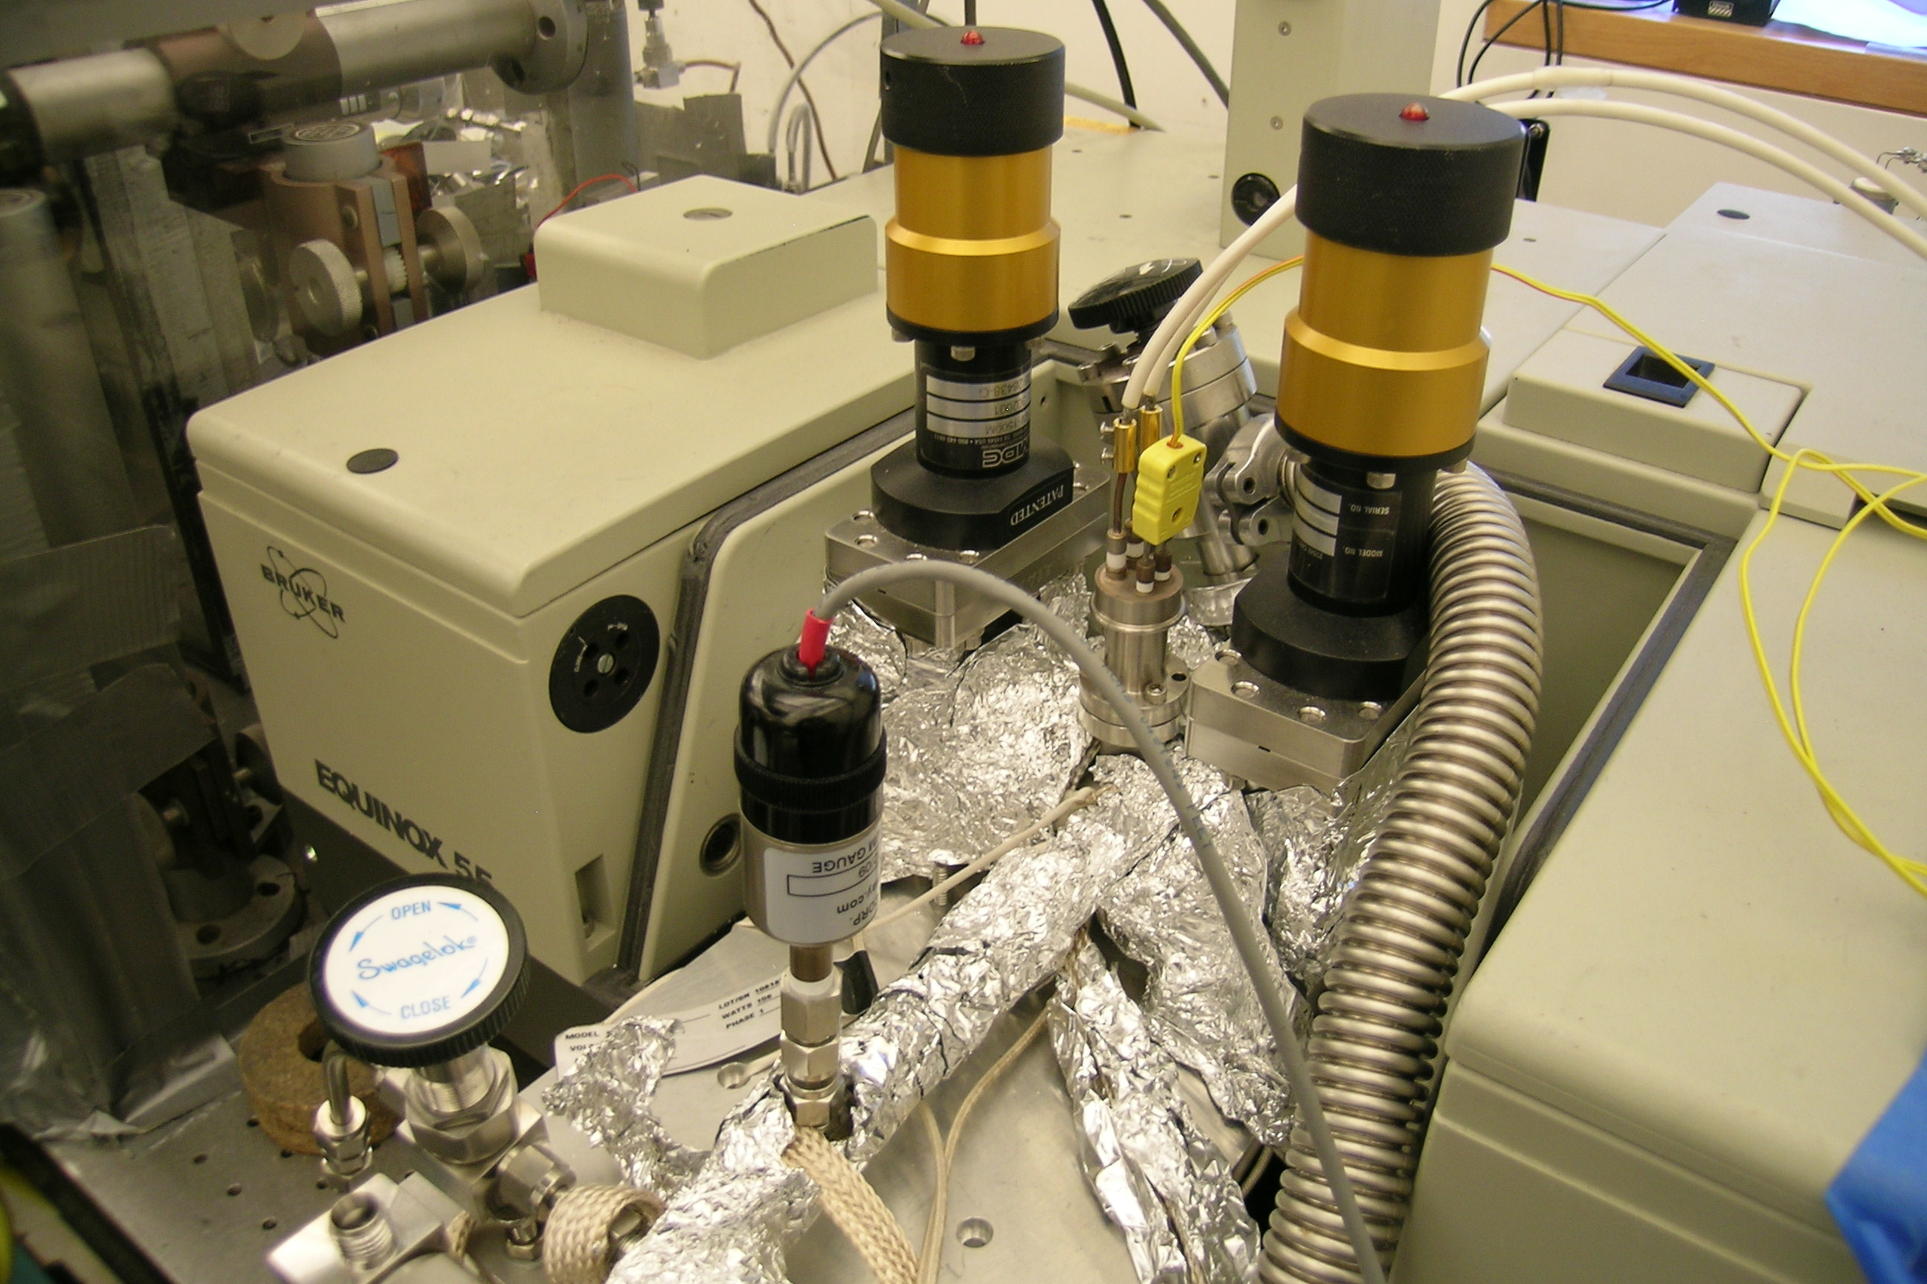

Equinox 55/S FTIR spectrometer is equipped with Mid-IR source, KBr beams plitter, and DLaTGS detector. The DRIFT cell sits in the sample compartment and is purged with nitrogen gas. The transmission IR cell is designed for operation from room temperature up to 200 ºC under vacuum. The pressure range covers 10⁻² to 10³ Torr only, so do not try higher pressure to break the NaCl windows. OPUS (ver. 3.1) program is installed in Windows NT computer. All the manuals should be stored in the manual cabinet, right next to Stan’s desk in the room 139, so please return them after you read.

2. FT-IR Instrument and General Operation

a. Spectrometer General Description

The Fourier-transform infrared (FTIR) instrument used for this system is a Bruker Equinox 55/S in Chemical Science building room 135. More details about this instrument can be found in its manual (July, 1996). General FTIR principles are well described in several books. See, for instance: Peter R. Griffiths and James A. de Haseth, "Fourier Transform Infrared Spectrometry", John Wiley & Sons, New York, 1986.

The Transmission ALD system is placed in the sample compartment, with insulating tubes placed between the IR beam windows and the cell for dry air purging (to minimize IR absorption from moisture and carbon dioxide, and to protect the NaCl windows). These tubes are fed or purged with dry air (or nitrogen gas by small tubes that are pinned in the foam, as shown in the figure below.

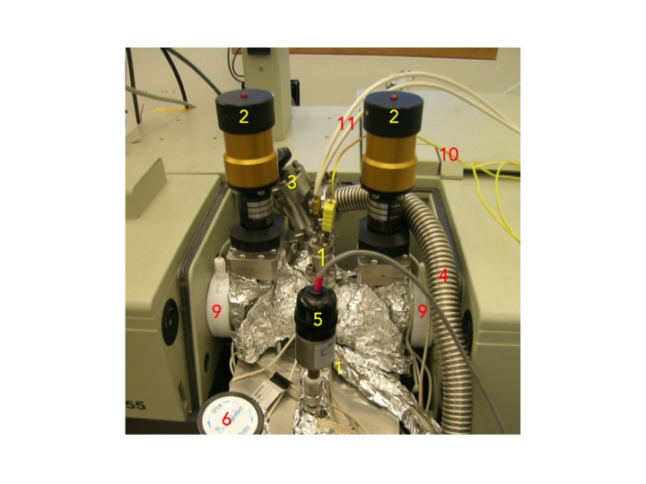

Figure 1. Transmission ALD system; electrical feedthrough [1], two gate valves [2], metal valve [3], flexible hose [4] to mechanical pump, thermocouple gauge [5], precursor valve [6], two Teflon tubes [9] for dry-air purging, K-type thermocouple [10], and electric wires [11].

b. FTIR Performance Characterization

The FTIR spectrometer should be setup for optimal performance by choosing the appropriate parameters and aligning the sample and optics.

i. Measuring Spectral Signal-to-Noise
Signal-to-noise (S/N) ratio: This is a critical value dependent on the other parameters that should be minimized before performing experiments. It is checked by acquiring back-to-back spectra under identical conditions and ratioing those. S/N ratios can be calculated by the OPUS software (one of “Evaluate” menus), and should be done for two frequency regions, typically 2000–2200 cm⁻¹ (the region with the least noise), and a second in a region of interest, around 3000 cm⁻¹, for example.

ii. Maximizing Absorbance Signal
This is done by choosing a particular IR absorption peak in the spectra in the sample and following that by taking spectra as parameters are optimized.

c. Main FTIR Parameters

- Total intensity (Amplitude): This is measured by the peak-to-peak voltage value on the centerburst of the interferogram, which can be display in the computer screen as other parameters are optimized and sample alignment is performed (see the section 4c). It should be as high as possible.
- Iris opening (Aperture Setting): the iris opening is available with pre-selected sizes from 0.25 to 6 mm. It should be optimized to obtain maximum throughput while minimizing the beam size, to minimize the beam divergence. The original IR beam is approximately 1" in diameter. Based on this value and the focal length of the focusing mirrors, a divergence range at the sample could be calculated. Total light throughput should also be kept at values low enough so the signal is proportional to light intensity (there is a saturation of the detector at high light fluences).
- Scanning rate (Scanner Velocity): the most interesting values available are 10 or 20 kHz for DLaTGS detecter and 80 or 100 kHz for MCT detectors. Faster scanning rates lead to faster data acquisition, but very fast scanning rates may lead to increases in S/N. The maximum scanning rate should be chosen where noise levels are not increased (this can be evaluated by taking S/N measurements for the different scan rates using the same conditions).
- Number of scans (or Scan Times in minutes): to signal average. S/N ratios should be increased as the square root of the number of scans, but too long data acquisition times lead to drifts in IR background and in changes in the nature of the sample (adsorption, etc.).
- Resolution: High resolutions are needed to separate different IR peaks, but require longer acquisition times (require further travel of the interferometer mirror), introduce noise (from the wings of the interferogram), and may reduce total peak signal intensity. Typical value is 4 cm⁻¹, sufficient for surface adsorbates, but sometimes 2 cm⁻¹ is required.
- Amplification (Signal Gain): there are preamplifier gains (Automatic, ×1, ×2, ×4, ×8, or ×16), to be set to optimize signal without saturating the centerburst. The gain at the centerburst may be set separately (at a lower value) than for the rest (wings) of the interferogram.

d. Detector

i. Types
There are three different types of IR detectors: thermal, pyroelectric, and photoconducting detectors. Thermal detector such as thermocouple or bolometer is used over a wide range of wavelengths at room temperature, but not preferred due to slower response time and lower sensitivity than other types of detectors. Pyroelectric detector has a much faster response time as it depends on the rate of temperature change. The most common material is “deuterium L-alanine doped triglycene sulphate (DLaTGS). Photoconducting detector relies on the interaction between photons and a semiconductor such as mercury cadmium telluride (MCT) or indium antimonide (InSb), so response time is much faster and sensitivity is also much higher. Usually it has to be cooled first prior to use for thermal noise. Equinox 55/S for Transmission ALD uses DLaTGS detector on the internal beam line.

Detector | Range (cm⁻¹) | Sensitivity  (cm Hz^{1/2} W⁻¹) | Cooling
DLaTGS | 12,000–350 | >4 x 10⁸ | Room Temperature
MCT Wide Band | 12,000–420 | >5 x 10⁹ | LN₂ cooling
MCT Medium Band | 12,000–600 | >2 x 10¹⁰ | LN₂ cooling
MCT Narrow Band | 12,000–850 | >4 x 10¹⁰ | LN₂ cooling
InSb | 12,800–1850 | >1.5 x 10¹¹ | LN₂ cooling

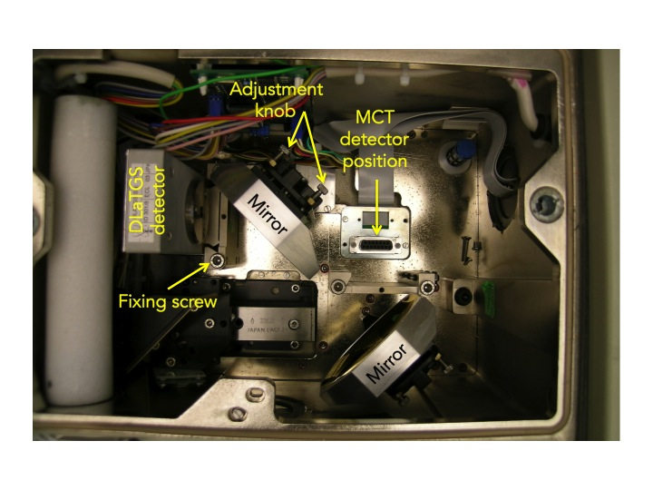
Figure 2. Detector compartment of Equinox 55/S FTIR spectrometer.

ii. Substitution
1. Loosen the fixing screw of the detector compartment cover by using a screwdriver.
- Open the detector compartment.
- Loosen the fixing screw of the detector with an Allen screw wrench (see Figure 2).
- Pull the detector straight upward out of the dovetail guide.
- Insert the detector you want into the dovetail guide and press it right down.
- Fasten the Allen screw.
- Close the detector compartment.
- Check the signal intensity using the OPUS program.

iii. Preparation
MCT or InSb detector has to be cooled down to liquid nitrogen temperature prior to use. Always wear blue Cryo-gloves (Tempshield) when you handle liquid nitrogen (please refer SOP of cryogenic materials in the “Lab Safety Manual” folder or download “SOPs Process” (http://research.chem.ucr.edu/groups/zaera/images/documents/4_sop_processes_2013-07.pdf) from our group homepage. Cool the detector with LN₂ using the funnel fill tube. Keep filling the funnel in cone increments. Repeat until reservoir is full (spill over). Cool down time is about 5 to 10 minutes. The detector is at working temperature once the rapid boil off venting has stopped. Place the plug (cap) in the fill port

iv. Maintenance
The LN₂ Dewar may require a vacuum refreshing. If the vacuum level of LN₂ dewar will be decreased below acceptable, then the surface of that vacuum jacket is very cold. Sometimes it is covered with ice because of the condensation of moister form the air, so water peaks appear on the spectra.
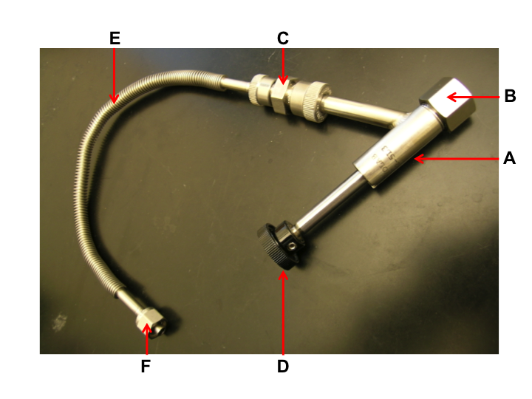
Figure 3. Adapter with flexible metal hose and Swagelok connection.

            - Remove the MCT detector from the spectrometer.
            - Connect the adapter (Figure 3) to one of vacuum valves.
            - Switch on the vacuum pump and open the valve.
            - Inspect the O-ring inside the adapter (B in Figure 3) for signs of wear.
            - Remove the cap from the connection nozzle of the detector.
            - Pull the adapter knob (D in Figure 3).
            - Loosen the coupling nut (B in Figure 3).
            - Push the adapter carefully over the connection nozzle of detector dewar.
            - Fasten the coupling nut hand-tight while holding the adapter and detector.
            - Push the adapter knob in the closed position until the threaded rod of the adapter is in contact with the sealing plug of the dewar evacuation valve.
            - Evacuate the detector dewar.
            - Close the vacuum valve.
            - Screw the threaded rod of the adapter in the connection thread of dewar evacuation valve by turning the adapter knob clockwise.
            - Pull the knob to the open position in order to open the dewar evacuation valve.
            - Evacuate the detector by opening the vacuum valve to pressure less than 10⁻⁶ Torr.
            - Close the dewar evacuation valve by pushing the adapter knob (D in Figure 3).
            - Press adapter knob firmly to the stop position.
            - Screw the threaded rod of the adapter out of the connection thread of the dewar evacuation valve by rotating the adapter knob.
            - Vent the section between vacuum pump and adapter.
            - Pull the knob to the open position.
            - Loosen the coupling nut and remove the adapter from the connection nozzle of the detector dewar.
            - Reinstall the MCT detector in the spectrometer.

e. Optical Alignment

Equinox 55/S is equipped with a high stability interferometer with ROCKSOLID permanent alignment. Also detector substitution is possible with Equinox 55/S. DLaTGS detector is default, and optional MCT detectors are available in our lab. After substituting the detectors, re-alignment is not necessary due to the dovetail detector mounting. However, it has to be done properly whenever any accessory like DRIFTS or ATR system is installed or uninstalled in the sample compartment. Adjustment knobs for the alignment are shown in Figure 2.

            - Remove all the accessory and samples from the IR beam path. Make sure that there is nothing in the sample compartment.
            - MCT detector has to be cooled first prior to measurement.
            - Run OPUS program.
            - Select the “Measurement” menu.
            - Click the “Check Signal” tab.
            - Select the “Interferogram” radio button.
            - The amplitude value indicates the signal intensity that is currently detected.
            - Loosen the fixing screw of the detector compartment cover by using 6 mm Allen wrench.
            - Open the detector compartment.
            - Adjust two knobs (in Figure 2) of the mirror to get the highest value while watching the amplitude on the monitor. If you lost IR beam, use IR card to find it.
            - Once you get a good alignment, close the cover.
            - Wait for 6 hrs at least to be purged completely.

f. Transmittance spectra

i. Choice of Background Spectra
Depending on how to prepare your sample, it is strongly recommended to perform the background measurement with a proper material. The purpose of the background measurement is to detect the influence of the ambient conditions (e.g. humidity or temperature) and the auxiliary materials (e.g. solvents) that are required for preparing the sample. The subsequent sample measurement results in the sample spectrum from which the influence is eliminated. So, do both background and sample measurements with the same parameter settings in OPUS program. Ensure that the ambient conditions are identical or at least nearly identical.

g. OPUS Software

i. Spectra Acquisition
- Start the OPUS program:
  - Click the short-cut icon of the OPUS program on the desktop.
  - The OPUS login window will appear on the screen.
  - Type "OPUS" in the password line (for default operator).
- Select "Measure" and then "Measurement". After a few seconds, the measurement set-up windows will appear on the screen. Check the experimental parameters under "Advanced", "Optics", "Acquisition", "FT", and "Display".
- Set the sample temperature as needed.
- When the sample reaches the desired temperature, take a background spectrum by selecting "Measurement", "Basic", and "Collect Background". The program will display a message in the bottom line high-lighted by a green color indicating that the data are being taken.
- When the message disappears, the measurement is done. From this point on, you can proceed with the experiments (e.g. heating of the sample, adsorption of gases etc.).
- During the data acquisition, the interferogram cannot be seen on the check signal menu. After the background scans are finished, the "Measurement" window remains on the screen.
- Go to “Background” and Click “Save Background” to save the spectrum. The Filename (####.0) is saved automatically on the hard drive and displayed on the left (Window List) of the screen.
- The file can be saved as other formats on the hard drive. Select "Save File As", then check the file name and path to be saved. If you want an ASCII file, in the "Mode" option on the Save Spectrum window, select "Data Point Table" before clicking the "Save" button.
- Fill the chamber with the desired pressure of the reactant gases, at the same temperature used for the acquisition of the background spectrum.
- Take the sample spectra by selecting "Collect Sample", and wait until the highlighted message disappears.
- To take the spectra with different backgrounds saved previously, select “load background” and click any background spectrum.
- Type the sample name and explanation in the lines for sample name and sample form. (e.g. Sample Name: 1% Pt/SiO₂; Sample Form: after CO dosing of 10 Torr for 5 min at -150ºC)
- Take the sample data by selecting "Collect Sample" and wait until the highlighted message disappears.
- Select “load background” again, and click another background spectrum for the next experiment.

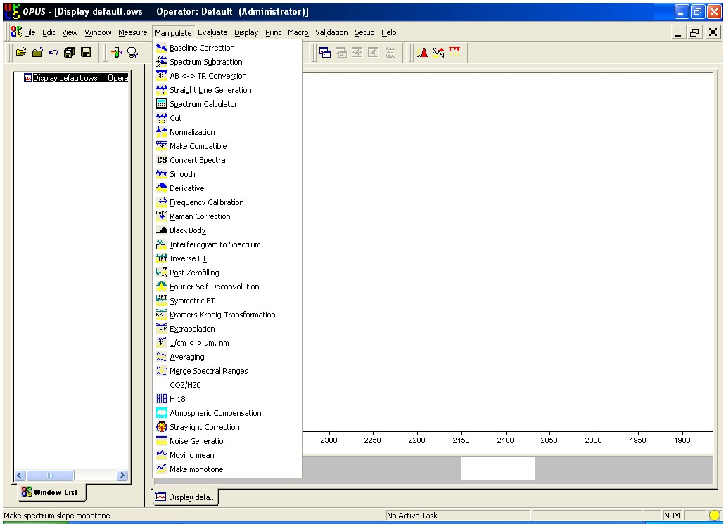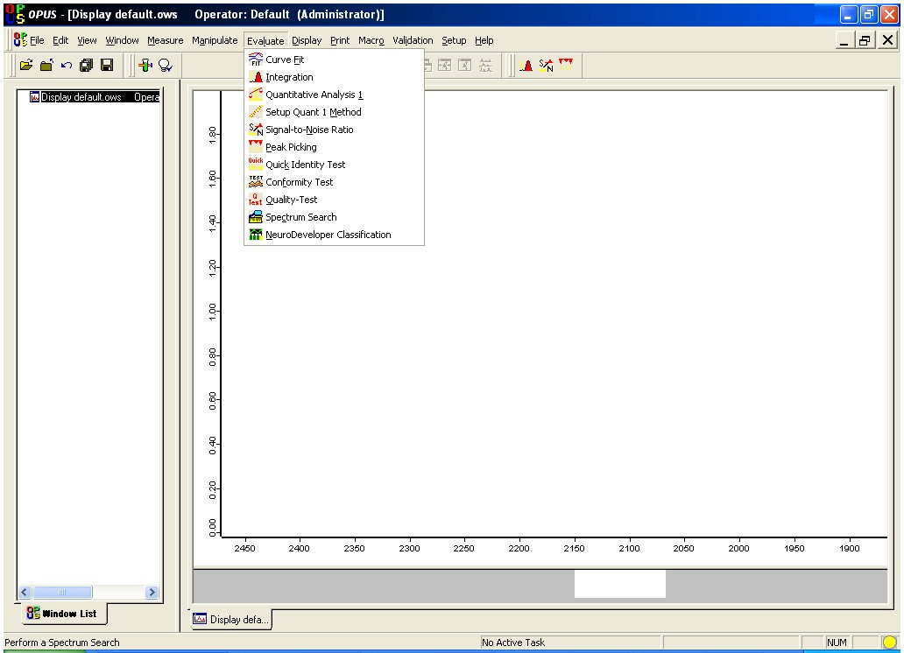

Figure. 4. “Manipulate” and “Evaluate” menus in OPUS program.

ii. Data Processing
Very useful processing tools are available in OPUS program. For example, Base Line Correction and Spectrum Calculator are in “Manipulate” menu, while Curve Fit and Integration are in “Evaluate” menu. Use helpful menu to learn how to do them.

h. Maintenance

i. IR Source
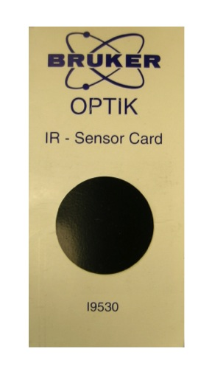
Equinox 55/S uses two mid-IR (MIR) sources: one is water-cooled and the other is air-cooled. They are pre-aligned, so realignment is not required after replacement. During the spectrometer operation, it becomes very hot and has risk of skin burn. Please avoid any skin contact and wait until the source cools down enough before you remove it.

- Beam Detection

If you like to check the IR beam visually, you can use an IR sensor card (see the right image) supplied from Bruker when the spectrometer was installed. You may confuse the red light on your sample with the IR beam, but actually it is He-Ne laser light (632.8 nm) that travels along the IR beam path.

- Intensity Measurement

IR beam signal can be checked on the OPUS program.

1. Remove all the accessory and samples from the IR beam path. Make sure that there is nothing in the sample compartment.
2. Run OPUS program
3. Select the “Measurement” menu
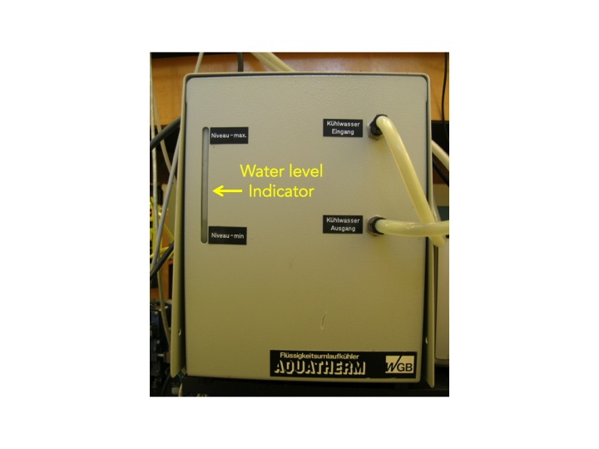
4. Click the “Check Signal” tab
5. Select the “Interferogram” radio button
6. The amplitude value indicates the signal intensity that is currently detected.

- Cooling

Equinox uses a water-cooled MIR source with a cooling system (Aquatherm Model # WLR 200), so its water level has to be checked frequently. Please do not block the ventilation slot of the source/laser compartment at the spectrometer top-side. During the spectrometer operation, the IR source generates heat, which is dissipated by the slots. Failure to do so can lead to spectrometer component damage.

- Replacement

Low signal intensity may indicate that the IR source needs to be replaced. Perform the “OPUS/IR” system diagnostics and check the source’s voltage and operating hours before considering the source replacement.

air-cooled MIR source
- Turn off the spectrometer.
- Wait until the source cools down sufficiently.
- Disconnect the spectrometer power cord form its socket.
- Disconnect the power cable (A in Figure 5) to the source.
- Use a 3 mm hex wrench to loosen the two screws that hold the back plate in place.
- Pull the back plate off.
- Disconnect the insulated wires by using a slotted screw driver.
- Disconnect the source block from the back plate by unscrewing hex screws (C in Figure 5).
- Set aside the used source.
- Attach the new source and block to the back plate by using 2 mm Allen head screws (C in Figure 5)
- Connect the new source’s wires by using a slotted screw driver.
- Reattach the back plate to the spectrometer by using 3 mm Allen head screw (B in Figure 5).
- Reconnect the source power cable to the spectrometer.
- Reconnect the spectrometer power cord and turn the spectrometer on.

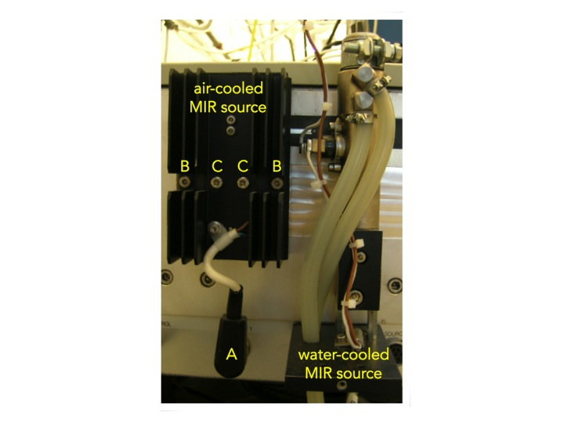
Figure 5. IR sources of Equinox 55/S FTIR spectrometer.

NOTE: Power up the source for at least 1 h so that the source can condition itself and stabilize before acquiring data. Acquiring a 100% line at this point is recommended, to confirm the source is behaving properly.

water-cooled MIR source
            - Switch off the spectrometer.
            - Wait until the source cools down sufficiently.
            - Open the cage of water-cooled source.
            - Loosen the wire connections (1 in Figure 6).
            - Loosen the bolt (2 in Figure 6) with a screwdriver.
            - Take the source (3 in Figure 6) out of the holder.
            - Insert a new source into the holder.
            - Tighten the bolt (2 in Figure 6).
            - Close the source cage.
            - Switch on the spectrometer.
            - Check the signal intensity using OPUS program.
            - Select “Optics Diagnostics” in Measure menu.
            - Click the source icon on the “Instrument Status” window.
            - Click on “Service Info” button.
            - Click on the “Reset” button.

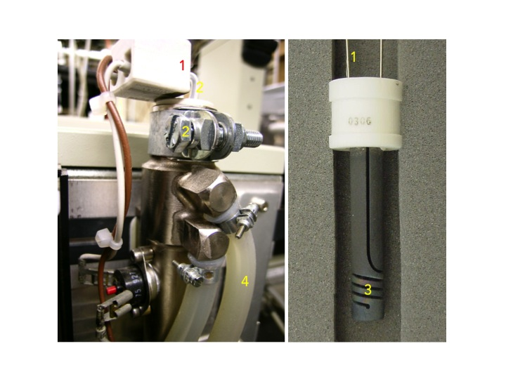
Figure 6. Water-cooled MIR Source.

ii. HeNe Laser
FTIR spectrometer is equipped with a He-Ne laser (632.8 nm), which controls the position of the moving mirror in interferometer for IR beam scanning. If you have a problem with the laser, a red STATUS indicator or a failed performance qualification test (PQ).

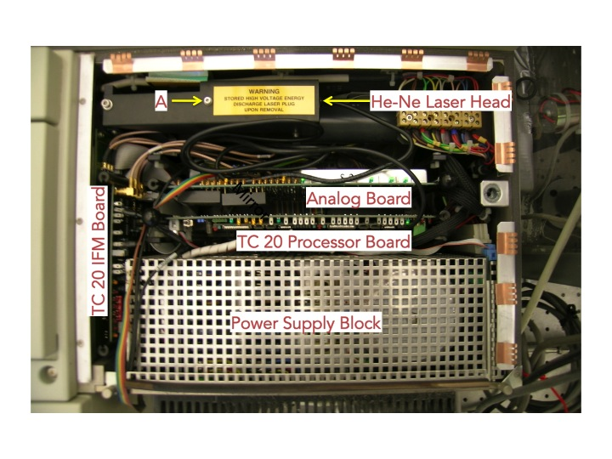
Figure 7. Power supply compartment (inside view).

- Measuring and Adjusting Signal Intensity

If you have laser problem, you need to check the laser amplitude. For this test you nee an oscilloscope. There are two test points (LSA2 and LSB2) on IFM board in Figure 8. You should see minimum of 2 V p-p sign wave on these points. There are parameters that can and should be checked with respect to the He-Ne laser intensity.

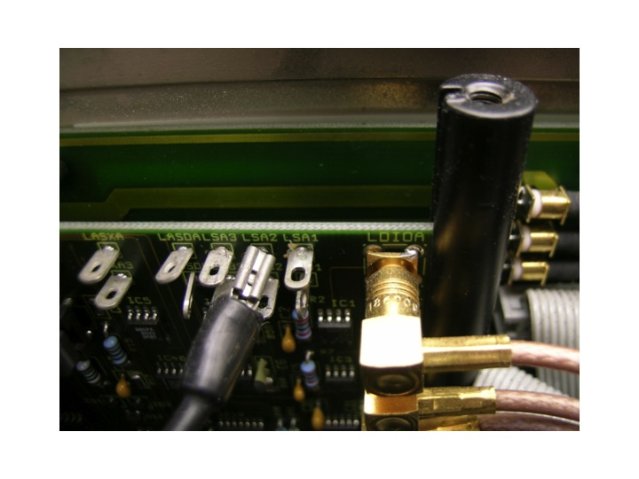
Figure 8. TC 20 IFM board.

- He-Ne laser output intensity – this value can be checked under measurement. Go “Optics Setup and Service Option”. Select “Service” tab, if the log window is blank. Select “Repeat Diagnostics Test” button, when the results appear take note of the current and initial laser intensity values as well as the number of laser dropout value.
- He-Ne laser modulation intensity – this value can be obtained via the measurement. Go “Direct Command Entry Option”. In there type; VEL=6 <Enter>, SCM=3 <Enter>, LAA <Enter>. Do this three times and record the approximate average value given (the value is the peak to peak modulation amplitude in millivolts). LAB <Enter>. Do this three times and record the approximate average value given (the value is the peak to peak modulation amplitude in milllivolts).

- Replacement

Perform the system diagnostics and check the He-Ne laser’s operating hours before considering replacement. The software diagnostics will report whether the He-Ne laser needs replacement or not. In case of defective laser you have to replace the complete laser head only.

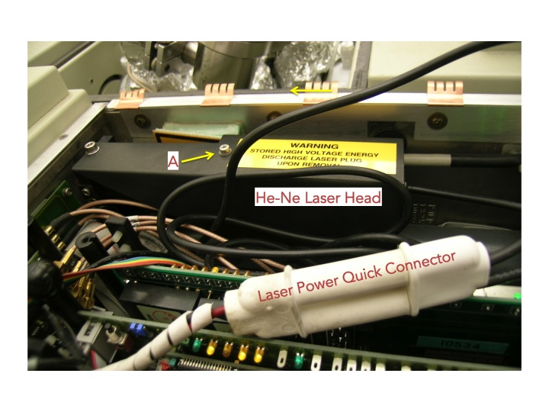
Figure 9. He-Ne laser head and power connector.

            - Switch off the spectrometer.
            - Unplug the main power cable.
            - Open the power supply compartment (Figure 7).
            - Loosen the Allen screw (A in Figure 9).
            - Follow the power cable from the laser head til you find a white plastic quick connector (Figure 9).
            - Lift up the laser power connector so it is above the power supply compartment circuit boards.
            - Disconnect the laser head from the laser power supply by gripping both ends of the quick connector and pulling it apart.
            - Short the exposed lead on the laser head side of the connector using an insulated screwdriver.
            - Check if the new source has a shutter blocking laser emission.
            - Look at the exit hole from the laser.
            - If a black metal shutter is visible, insert the blade of a slotted screwdriver into the slot on the laser head and turn the screwdriver approximately ¼ turn. The shutter should disappear.
            - Thread the power cable of the new laser and connect to the other half of the white plastic power connector.
            - Place the laser head in the “cradle” below the laser lid making sure the label does not interfere with laser support (rotate the laser head if the label gets in the way).
            - Press on the back of the laser head till the laser head can move no further to the right.
            - Drop the laser lid down and secure the Allen screw that holds the laser head snugly in place.
            - Connect the two ends of the laser power connector.
            - Put the power supply compartment cover back into place.
            - Use a screwdriver to secure the cover to the spectrometer.
            - Replace the plastic hood over the screw.
            - Check whether the IR signal is detected using the OPUS program.
            - Run the “Optics Diagnostics” in OPUS
            - Open “Instrument Status” window.
            - Click “He-Ne laser” icon.
            - Click “Service Infor” button.
            - Click “Reset” button in the laser diagnostics page (Figure 10).
            - Perform an OQ Test using OVP (OPUS Validation Program).

iii. Gas Purging

At least, the optical bench has to be purged with dry air or nitrogen gas as the beamsplitter is made of KBr, which is a hygroscopic material. Also, purging the FTIR spectrometer reduces the content of undesired atmospheric interference from moisture and carbon dioxide, which absorb IR light in both detector and sample compartment as well as the optical bench.

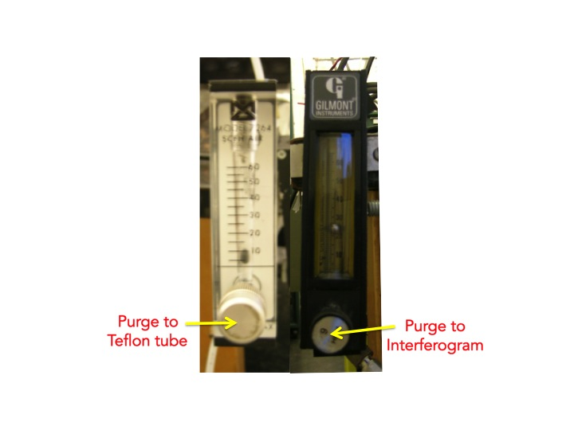
Right now the Transmission ALD system is purged with dry air. The flow rate is controlled by two rotameters (right images): one is for the optical bench and the detector compartment; the other is for sample compartment.

3. Vacuum System

a. Vacuum System Setup

The vacuum system is built according to the schematic diagram below.
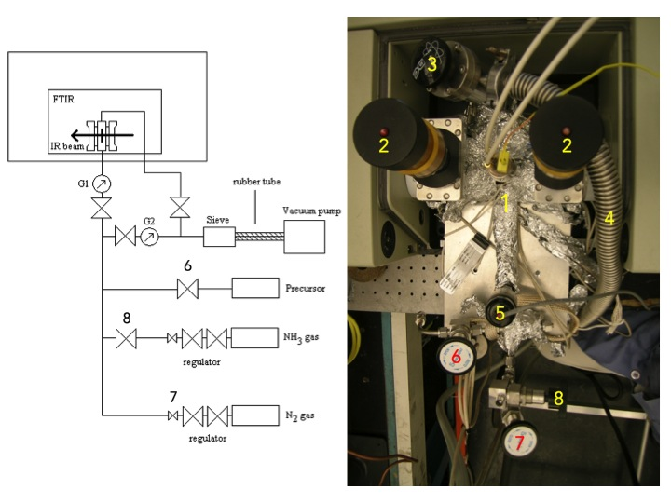
Figure 10. Gas manifold for the Transmission ALD system.

b. Mechanical Pump

A mechanical pump is used to create a vacuum as low as 10 to 20 mTorr in the ALD system. It is equipped with:

            - Molecular sieve trap: placed at the pumping port of the mechanical pump to trap water and other condensable.
            - Optional glass U-trap: placed between the reactor and the sieve to intercept condensable gases from the ALD reactor to minimize damage to the pump.
            - Rubber tube: Used to connect the molecular sieve with the pump and to reduce the vibrations caused by the pump.
            - Oil trap.
            - Exhausting gas line.

c. Operation

- Make sure all the connections are tight.
- Check oil level. If it is lower than half, add pump oil up to 70%.
- Turn on the mechanical pump.
- Wait until the pressure reaches to 20 mTorr.
- Establish a stable N₂ gas flow of 200 mTorr.

4. Gas Handling System

a. Schematics, Components
The gas delivery system is place between the pumping stage and the ALD reactor. It is used to deliver the ALD precursors to the ALD reactor. The main precursor is typically in liquid, but delivered by using its vapor. Ammonia gas is a co-reactant. Nitrogen gas is used as purge and carrier gas. The flows of nitrogen and ammonia gases are controlled by 3 regulating valves.
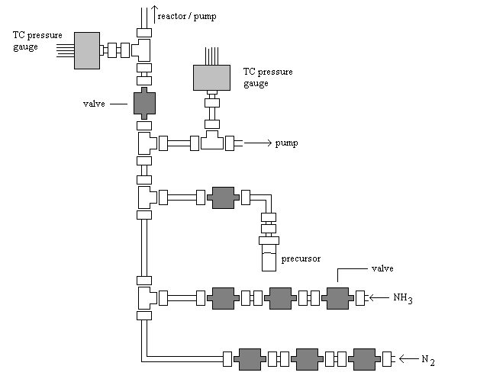
Figure 11. Gas manifold for the Transmission ALD system.

Components
- ¼” stainless steel tubes
- thermocouple vacuum gauges
- vacuum valves (bellows-sealed valves, 3-way ball valves)
- precursor bottle
- N₂ gas tank with regulator, 99.9%
- NH₃ (or appropriate ALD co-reactant) gas tank with regulator
- gas manifold
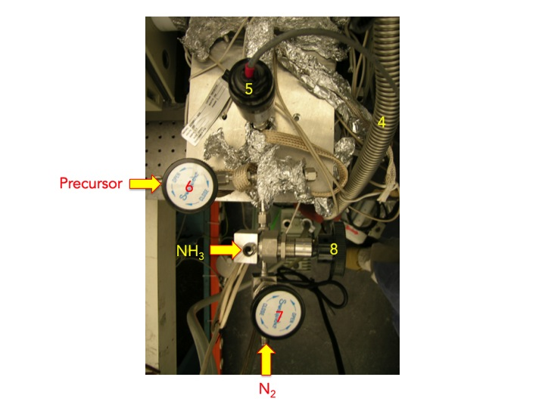

Figure 12. Transmission ALD system; flexible hose [4] to mechanical pump, thermocouple gauge [5], precursor valves [6], nitrogen valve [7], and ammonia (NH₃) valve.

b. General Operational Procedure

Some ALD precursors are volatile liquid stored in stainless steel containers. It should be connected to a well-pumped reactor all the time for storage. Do not try to get neat precursor liquids out from the original container.

Once the system has reached a stable vacuum of approximately 20 mTorr, the system can be purged with nitrogen. Using the regulator valves of the nitrogen gas line a stable gas flow of 200 mTorr can be established. The stability of the system can be checked taking FTIR spectra every several minutes. By comparing these spectra relatively to each other the fluctuations become visible. After about 2 hours the fluctuations will be leveled off to less than 1%. The system has become stable, this process is called system purging test.

c. Gas and Liquid Sample Handling

i. Gas ALD Precursors
- Gas ALD precursors are typically delivered in Sure/PacTM steel cylinder or lecture bottle, so use a proper regulator and Swagelok connection to the gas manifold.
- Do not apply heat to the container.
- ALD precursors are flammable, irritant, and/or water reactive.
- They may need to be kept attached to the gas manifold.
- Consult the SOP of the particular precursor for proper handling.

ii. Liquid or Solid ALD Precursor
- Liquid and solid ALD precursors are typically delivered by placing them in a glass container within the gas line and by using their vapors.
- If the ALD precursor is liquid or solid, heat may be applied to increase its vapor pressure. Put the container in a silicon oil bath, which is on a heater.
- Many precursors are flammable, irritant, and/or water reactive.
- They may need to be kept in a bottle filled with inert gas.
- Handle them in a glove box.
- Consult the SOP of the particular precursor for proper handling.

iii. Heating Precursors
- Wrap an electric radiator around the precursor bottle and the gas lines from the bottle to the reactor.
- Set a K-type thermocouple in an appropriate point to measure the temperature of the bottle.
- Heating the gas lines will cause some pollutants attached to the inner walls of the line.
- Close the valve toward the reactor to prevent these pollutions from contacting the substrate.

d. Maintenance

If the base pressure of gas manifold goes higher 20 mTorr, do leak test or check the contamination of stainless tube inside. Valves are often contaminated due to the bellow structure. If needed, disassembly the valves and clean the inside with a proper solvent.

e. Valves

Bellow-sealed BK series (e.g. SS-4BG) from Swagelok are preferred for the valves in the manifold system. The valves can be disassembled for cleaning inside, and the spherical stem tip is also replaceable.

f. Pressure Gauges

Two thermocouple gauges are used in the gas manifold. One is for the pressure in the transmission ALD cell to monitor the amount of total reactant gases quantitatively. The other is to monitor vacuum status in the gas manifold.

g. Mechanical Pumps

A mechanical pump is used for low vacuum in the gas manifold. Please check the oil level, and refill when the level is too low or replace dirty oil when the color is too dark. The process for handling vacuum oil is available in the SOP of “Pump Oil”. Refer it in our “Lab Safety Manual” or download “SOPs Process”
(http://research.chem.ucr.edu/groups/zaera/images/documents/4_sop_processes_2013-07.pdf)

5. Transmission IR ALD Reactor

a. General Description

In atomic layer deposition (ALD) gaseous precursors are dosed alternately onto a surface (silica in this case) on which they undergo self-limiting reactions with each other. Films grown by ALD have a uniform thickness and conformability. Zirconium nitrides are produced by atomic layer deposition from tetrakis(ethylmethylamido) zirconium, Zr(NEtMe)₄, and ammonia (NH₃) at low substrate temperatures (150~250 °C). The precursor is commercially available from Sigma Aldrich Co and liquid at room temperature. To increase vapor pressure and reactivity, the liquid heated up to 95 °C. It is highly flammable, irritant and reacts violently with water. Therefore the precursor should be kept in a glove box filled with inert gas. The film that is grown by applying these precursors is Zr₃N₄. This material is insulating, transparent and colored.

b. IR Cell Assembly

The reactor is the place where the ALD process actually takes places. The transmission IR ALD reactor consists of a double-side 2 3/4” stainless steel flange capped by two NaCl windows fixed using two CF flanges and four O-rings. The central flange has a feedthrough for insertion of electrical power, thermocouple wires to the sample and two inlet/outlet ½” gas tubes. The overall assembly is shown in the figure below.

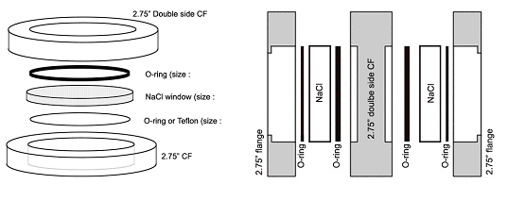
Figure 13. Assembly of NaCl windows, O-rings and CF flanges in the ALD reactor.

Components
- Two 2.75” CF flange
- Two NaCl windows
- Four O-rings
- Double side CF flange equipped with electrical feedthrough and gas inlets (see below).
The sample is positioned in the middle of the reactor, facing both NaCl windows, as shown in the figure below. The double side CF flange is equipped with two tubes: an inlet for the nitrogen and precursor gases, and an outlet to pump. A third tube of ½” diameter is attached for the feedthrough and thermocouple.
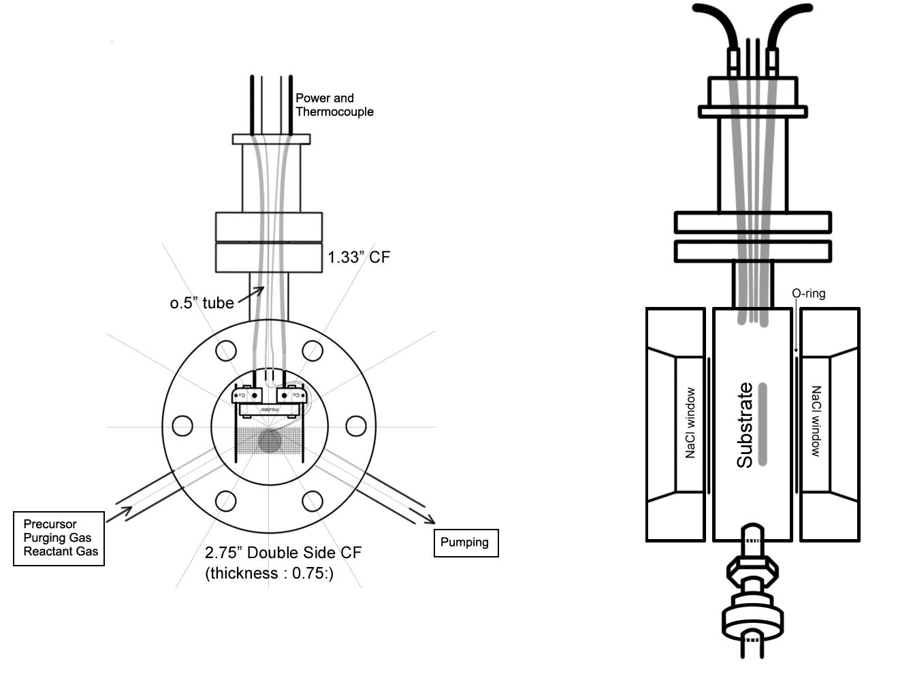
Figure 14. Schematic front (left) and side (right) view of the reactor cell.

c. Alignment

Once the assembled reactor cell is placed on the base in sample compartment, tighten the lockers to fix it at the alignment position. No further optimization is required if the silica substrate on nickel grid is placed exactly at the focused IR beam position.

d. Substrate Preparation and Mounting

Many ALD reactions are carried out on a silica (SiO₂) pellet. Silica has a large surface area powder representing the silicon oxide used in many microelectronics applications, and is transparent for infrared light, which makes it very suitable for FTIR studies.

i. Sample Preparation and Loading
Powder samples, silica powders in particular, are pressed on a Ni grid using a manual press (Chemical Sciences building room 310):

- Some silica powder needs to be pressed on both sides of the grid using a pressure of 4000–5000 psi as shown in the Figure below.

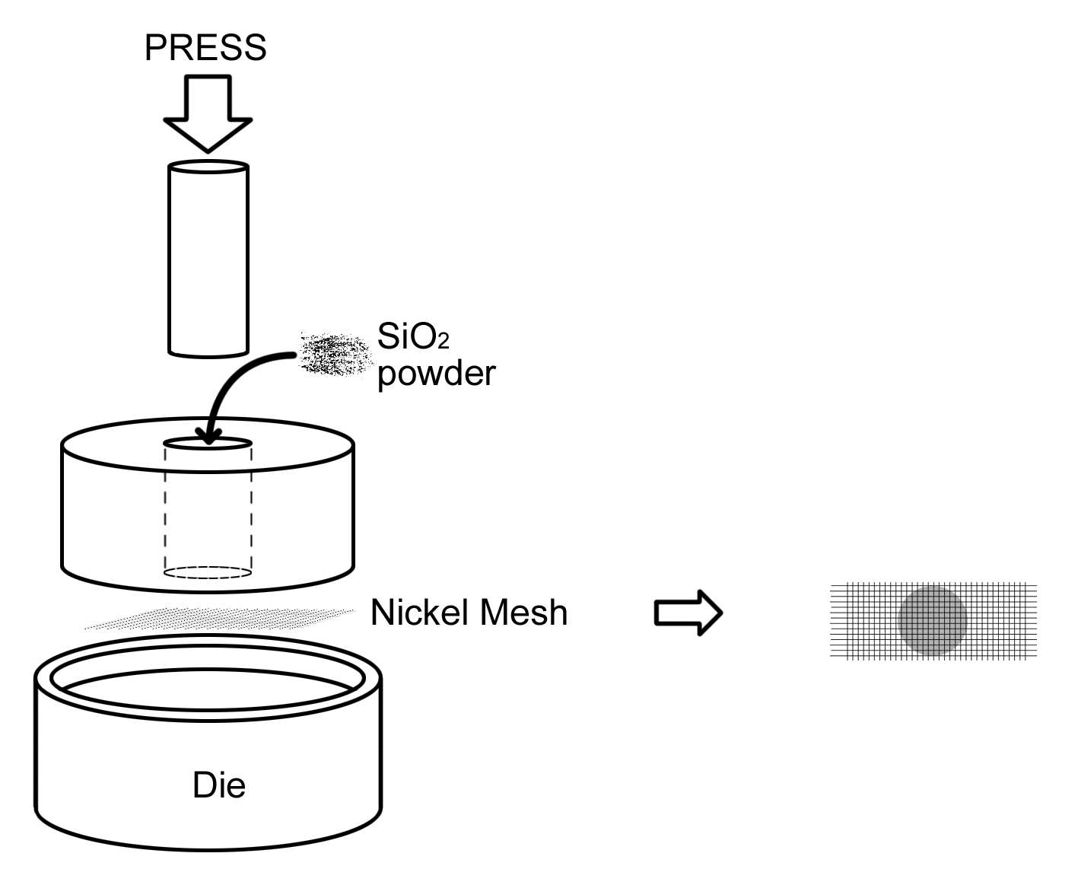
Figure 15. Schematic picture of how to press the silica substrate.

- The nickel grid with the silica pallet is then welded onto two nickel wires (1 mm dia.) using a spot welder to provide electrical contact and facilitate resistive heating.
- This sample is then tightened between two copper blocks and a ceramic insulator to prevent the sample from creating a short circuit.
- The fixation is made using setscrews as shown in the Figure below. The electric power is fed through two copper wires.
- A Chromel-Aluminum thermocouple needs to be welded onto the grid to measure the substrate’s temperature. Welding conditions: Low voltage, manual, ~ 5 Watt.
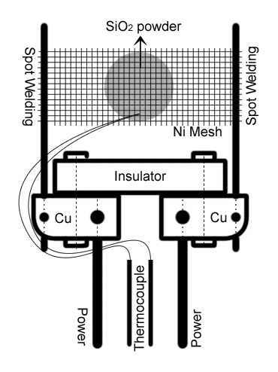
Figure 16. Schematic view of the sample mounting.
Components
- Nickel grid; dimensions 1” x 0.5”, thickness 0.002”, grid spacing 80 lines per inch.
- Sample, silicon dioxide powder (SiO₂, also called silica).
- Nickel wire; diameter 1 mm, 99.9+%.
- Ceramic insulator.
- Two copper blocks.
- Copper wires
- Thermocouple (type K, chromel-alumel)
- Power transformer to generate the current for electrical heating
- Set screws

ii. Sample Pretreatment

In order to remove water and other impurities and pollutions from the silica pallet, the substrate is heated up to 400–500°C. This is done for about two hours long. The greater part of the former present water is then disappeared. The effect of the heating can be checked taking FTIR spectra and comparing them relatively. Water shows peaks and bands in FTIR spectra at 3900–3600 and 1900–1300 cm⁻¹.

iii. Collecting Background Spectrum

- Heat the sample to 400~500 ºC for 2 h to remove water and other impurities.
- Take spectra and check them relatively.
- Water peaks are observed at 3900~3600 and 1900~1300 cm⁻¹.
- When those have disappeared or minimized, record a background spectrum.

iv. Taking Sample Spectrum

- Set the conditions for sample dose.
- Typical parameters:
  - Substrate Temperature: 150~250 ºC.
  - Precursor Temperature: 95 ºC.
  - N₂ gas Flow Pressure: 200 mTorr
- Exposure the substrate to the ALD precursor gas or co-reactant, depending on the place within the ALD process at which you are.
- Set the precursor pressure and keep it constant for the pre-established amount of time.
- Pump away the precursor.
- Wait until the vacuum comes back to the base pressure.
- Take a spectrum.
- Repeat this procedure from step (3) until your experiment is completed.

e. Maintenance

i. Leak Checking

The transmission ALD cell may have a leak because of contamination on the Viton gaskets, so please check them carefully prior to the assembly after sample loading. If NaCl window surfaces become rough and causes poor sealing with the O-ring, you may polish the roughed surface.

Gas lines should check for leaks once assembled:

- Isolate the gas lines in sections by closing the appropriate valves when possible.
- Pressurize the line and check for bubbling while spraying a few drops of a soapy solution such as "Snoop".
- If that does not work, spray helium around the suspect connection and look for any pressure change in the gas manifold with the thermocouple vacuum gauge.
- A third way of identifying leaks is to use acetone or isopropyl alcohol, pouring some drops in the suspected connection and looking for pressure changes inside the manifold.
- Ultimately, if the pressure inside the manifold cannot be brought down, or if it increases rapidly upon closing the valve to the pump, a leak detector may need to be used to isolate the leak.

ii. Replacing the O-ring (Viton gaskets)

If the Viton gaskets are worn out and caused a leaking, please replace them with new ones.

iii. Cleaning and Replacing NaCl windows
The sodium chloride windows are sealed with a Viton gasket on the both sides. Take care when these flanges are tightened, since the sodium chloride is very brittle!

- Gently loosen the bolts of the ALD reactor cell
- Disassembly the cell carefully.
- Take the old NaCl windows out.
- Put Viton gaskets on both sides of new NaCl windows and place them into the flanges.
- Assembly the whole cell carefully.
- GENTLY press the window into it. Secure the flange with 2 bolts.
- Put all the bolts in and finger tighten them.
- Use a wrench and VERY CAREFULLY TIGHTEN THE BOLTS using a crossover pattern to distribute the force evenly.

NOTE: These flanges do not have to be very tight. It is recommended that they be checked for leaks using the department leak detector. If a leak if found, tighten the bolts a little more. If there is no leak, stop right there. Further tightening could break the window.

- Measure an IR spectrum to see if everything works as it should. Verify that the low wavenumber cutoff is close to 700 cm⁻¹. (There are several kinds of windows in the lab labeled as NaCl.).

iv. Cleaning the Reaction Chamber

The transmission ALD cell can be cleaned by any solvent, but recommended only when disassembled completely. You may use a cotton tip to remove any thing that stuck on the inside wall of the cell.

v. Heating and Temperature Measurement

Heating the IR cell is performed by using a Variac and a temperature controller (homemade). Usually it can be heated above 200 ºC by setting the Variac at 100%. For lower temperatures, please use a combination of electrical heating (Variac at 50%) and N₂ cooling. Auto-tuning is required for better temperature control. Type-K thermocouple is used as a probe.
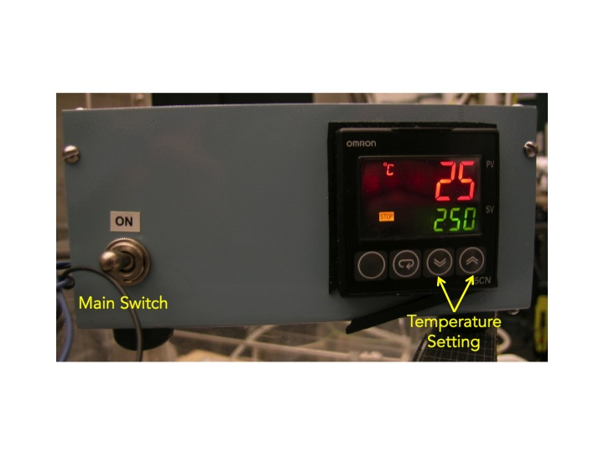
Figure 17. Homemade temperature controller equipped with Omron E5CN.

6. Typical Experiment Sequence

a. Initial Steps
- Sign-in the logbook
- Start up the OPUS program
  - Click the short-cut icon of the OPUS program on the desktop.
  - The OPUS login window will appear on the screen.
  - Type “OPUS” in the password line for the default operator
  - Select “Measure” and then “Measurement”
  - After a few seconds, the measurement set-up window will appear on the screen.
  - Check the experimental parameters under “Advanced”, “Optics”, “Acquisition”, “FT”, and “Display”

b. Sample Temperature Calibration

The temperature of the substrate is measured with a K-type (Chromel-Aluminum) thermocouple mounted on the nickel mesh. However, the temperature of the silica may differ from the temperature of the nickel mesh. The relation between the temperature of the nickel mesh and silica substrate can be calibrated by using a pyrometer. The pyrometer (OMEGA, OSP100) has the smallest area of measurement at a distance of 9 inch from the object. The temperature is measured with the pyrometer and K-type thermocouple as function of the voltage applied on the feed through. This way a relation between the temperature measured with pyrometer and thermocouple can be derived

c. Setup, Pumping and Purging

- Place the reactor cell in the FTIR spectrometer.
- Connect the pumping line and gas feeding tubes.
- Start the mechanical pump
- After 30 min, vacuum should reach to around 20 mTorr.
- Connect purging lines to the Teflon tubes (9 in Figure 1).

d. Optimization of IR cell Position

The transmission ALD system is fixed on the base in the sample compartment, so further optimization isn’t available. Instead, silica substrate on nickel grid has to be placed exactly at the focused IR beam position.

e. System Purging Test

- Wait until the system has reached to 20 mTorr.
- The system can then be purged with dry air
- Establish a stable gas flow of 200 mTorr using the regulator valves of nitrogen gas.
- Check the system stability by taking FTIR spectra every several minutes.
- Comparison of these spectra relatively to each other should show any fluctuations.
- After 2 h, the fluctuations should level off to less than 1%.

f. Substrate Drying and Background Spectra Acquisition

- Heat the sample to 400~500 ºC for 2 h to remove water and other impurities.
- Take spectra and check them relatively.
- Water peaks are observed at 3900~3600 and 1900~1300 cm⁻¹.
- When those have disappeared or minimized, record a background spectrum.

g. Gas Line, Precursor, and Substrate Heating

- Turn on the electric heater wrapped around the precursor container and the gas lines.
- Wait the required temperature for the precursor delivery is obtained.
- Close the valve towards the reactor to prevent pollutants from contacting the substrate.
- Apply an appropriate voltage to the electrical feedthroughs of the reactor for heating the substrate up to the desired temperature, typically 150~250 ºC.
- Test the system purging again before starting ALD reactions.

h. ALD on Substrate

- Set the conditions for sample dose.
- Typical parameters:
  - Substrate Temperature: 150~250 ºC.
  - Precursor Temperature: 95 ºC.
  - N₂ gas Flow Pressure: 200 mTorr
- Exposure the substrate to the ALD precursor gas or co-reactant, depending on the place within the ALD process at which you are.
- Set the precursor pressure and keep it constant for the pre-established amount of time.
- Pump away the precursor.
- Wait until the vacuum comes back to the base pressure.
- Take a spectrum.
- Repeat this procedure from step (3) until your experiment is completed.

g. Final Steps

- Evacuate the gas manifold and the ALD cell.
- Fill them with ~1 atm of N₂.
- Stop heating the system.
- Wait until the system is cooled down fully.
- Stop the purge to Teflon tubes.
- Stop the mechanical pump.
- Disconnect the pumping line and gas feeding tubes
- Take the reactor cell out from the sample compartment.
- Exit the OPUS software.
- Make sure that all the valves are closed, in particular the ones to the gas lines.
- Sing-out the logbook.

7. Suggested Training for Beginners

For beginners to learn how to obtain consistent and reliable data, enough training is strongly recommended. Please refer the following paper (or the suggestions below) and repeat the experiments in there. The data obtained should be checked by an experienced operator.

Reductive Eliminations from Amido Complexes, J. Electrochem. Soc. 2011, 158(8), D524.

Suggestions:
- SiO₂ powder for the standard substrate.
- Any commercial Ti precursor.

8. Reference Materials & Contacts

a. Reference Materials

Equinox 55/S User’s Manual, July 1996

b. Contacts

Bruker Optics, Inc.
19 Fortune Dr. Billerica, MA 01821, USA
978-439-9899 (ext. 5227)
www.brukeroptics.com
info@brukeroptics.com

