Infrared Characterization
System #5: GeATR-ALD

Manual

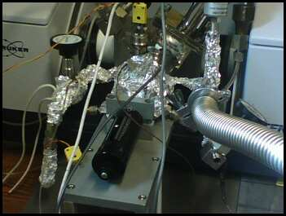

Francisco Zaera Group
Prepared by Menno Bouman, November 2010
Modified by Ilkeun Lee, September 2014

Table of Contents
1. General Considerations/Overview of Equipment 4
2. General Laboratory Safety 6
3. FT-IR Instrument and General Operation 6
a. Spectrometer General Description 6
b. FTIR Performance Characterization 6
i. Measuring Spectral Signal-to-Noise 6
ii. Maximizing Absorbance Signal 7
c. Main FTIR Parameters 7
d. Detector 7
i. Types 7
ii. Substitution 8
iii. Preparation 9
iv. Maintenance 9
e. Optical Alignment 10
f. ATR spectra 11
i. Choice of Background Spectra 11
g. OPUS Software 11
i. Spectra Acquisition 12
ii. Data Processing 13
h. Maintenance 14
i. IR Source 14
ii. HeNe Laser 16
iii. Gas Purging 18
3. Gas Handling System 19
a. Precursor Preparation 19
b. Precursor Dosing 19
c. NH₃ Dosing 20
d. Maintenance 20
e. Valves 20
f. Pressure Gauges 20
g. Mechanical Pumps 21
4. GeATR ALD Cell 21
a. General Description 21
b. Sample Heater Preparation 22
c. Sample Manipulator Design and Assembly 23
d. Assembly of Main GeATR-ALD Cell 24
e. Substrate 25
f. Beam Alignment 27
g. Operation 28
h. Maintenance 30
i. Collecting Spectra 32
i. Background Spectra 32
ii. Sample Spectra 32
j. Long Term Maintenance 33
6. Typical Experiment Sequence 33
a. Initial Steps 33
b. Sample Mounting 34
c. ALD Process 34
d. Final Steps 34
6. Suggested Training for Beginner 34
7. Reference Materials 35

1. General Considerations/Overview of Equipment

Please read this manual carefully before using the GeATR-ALD system and keep it in a suitable place for future reference. Always follow the instruction described in this manual to ensure safety and to avoid damage. Improper use or failure to do safety instructions can result in serious injuries and/or property damage. Right now it has been detached from the IR system and stored in Chemical Science building room 141.

The Germanium Attenuated Total Reflection (Ge ATR) Infrared attachement is used to study the reactions of compounds (specifically precursors for atomic layer deposition, ALD) on surfaces of substrates such as silicon wafers (which are cover by a ~ 1 nm native SiO_{x} layer). GeATR accessory is placed in the sample compartment of a Fourier-transform infrared (FTIR) spectrometer (Tensor 27, Bruker) in Chemical Science building room 143.

The IR beam is directed through a hemispherical germanium crystal, used as a crystal to guide the IR light, reflected off of its flat surface inside the crystal, and collected and directed to the detector. An evanescent wave extends from the Ge flat surface outside the crystal at the point where the IR beam reflects. The three dimensional electric field of the evanescent wave decays exponentially from the sight of reflection, and absorbates inside this field can absorb the infrared light. The penetration depth of the electric field of the evanescent wave formed from infrared light is around 100 nm, and it is wavelength dependent. This makes ATR a surface sensitive technique.

In our application, the silicon wafer where the surface chemistry is to be investigated is brought into close contact with the flat surface of the Ge crystal. The SiO_{x} surface is retracted and heated to a desired temperature, and a compound is dosed inside the attachment to react with the SiO_{x} surface. The surface is then cooled down and brought in contact with the Ge crystal to once again measure the IR spectra of the silicon wafer.

Version 2
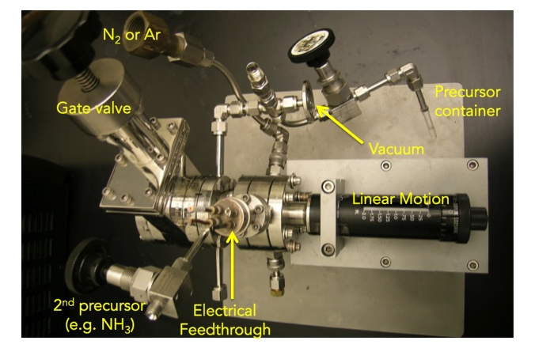
Version 1
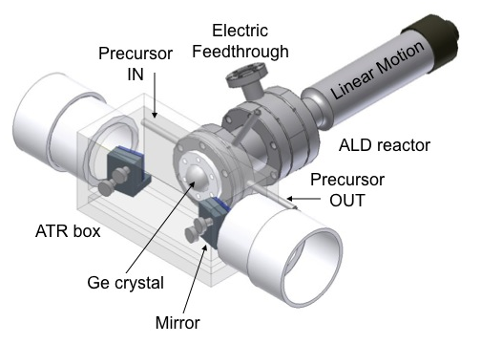
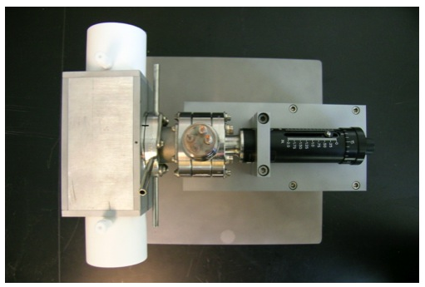

2. General Laboratory Safety

Before starting any experimental work in the laboratory, all users must learn The Laboratory Safety Manual and pass all exams. Users must also get familiar with the Injury and Prevention Program (IIPP) and Chemical Hygiene Plans (CHP), and wear PPE according to the Laboratory Hazard Assessment (LHAT, ehs.ucop.edu/lhat/) or Hazard Assessments in Lab Safety Manual.

All users must be familiar with the location of the fire extinguishers, safety showers, and other safety equipment before starting any experimental work. In Room CS 143:

- Fire Extinguishers: Located next to exit door of CS 143.
- Safety Showers and Eyewash Station: Located next to the exit door of CS 143.
- Fire Exit: one door for CS 143.
- First Aid Kits: Located next to exit door of CS 143.

3. FT-IR Instrument and General Operation

a. Spectrometer General Description

The FTIR instrument used for this system is a Bruker Tensor 27 in Chemical Science building room 143. More details about this instrument can be found in its manual. General FTIR principles are well described in several books. See, for instance: Peter R. Griffiths and James A. de Haseth, "Fourier Transform Infrared Spectrometry", John Wiley & Sons, New York, 1986, and Brian C. Smith, “Fundamentals of Fourier Transform Infrared Spectroscopy (2nd edition), CRC press, Taylor & Francis Group.

The GeATR accessory is placed in the sample compartment of the FTIR spectrometer and use internal IR beam line.

b. FTIR Performance Characterization

The FTIR spectrometer should be setup for optimal performance by choosing the appropriate parameters and aligning the sample and optics.

i. Measuring Spectral Signal-to-Noise
Signal-to-noise (S/N) ratio: This is a critical value dependent on the other parameters that should be minimized before performing experiments. It is checked by acquiring back-to-back spectra under identical conditions and ratioing those. S/N ratios can be calculated by the OPUS software (one of “Evaluate” menus), and should be done for two frequency regions, typically 2000–2200 cm⁻¹ (the region with the least noise), and a second in a region of interest, around 3000 cm⁻¹, for example.

ii. Maximizing Absorbance Signal
This is done by choosing a particular IR absorption peak in the spectra in the sample and following that by taking spectra as parameters are optimized.

c. Main FTIR Parameters

- Total intensity (Amplitude): This is measured by the peak-to-peak voltage value on the centerburst of the interferogram, which can be display in the computer screen as other parameters are optimized and sample alignment is performed (see the section 4c). It should be as high as possible.
- Iris opening (Aperture Setting): the iris opening is available with pre-selected sizes from 0.25 to 6 mm. It should be optimized to obtain maximum throughput while minimizing the beam size, to minimize the beam divergence. The original IR beam is approximately 1" in diameter. Based on this value and the focal length of the focusing mirrors, a divergence range at the sample could be calculated. Total light throughput should also be kept at values low enough so the signal is proportional to light intensity (there is a saturation of the detector at high light fluences).
- Scanning rate (Scanner Velocity): the most interesting values available are 10 or 20 kHz for DLaTGS detecter and 80 or 100 kHz for MCT detectors. Faster scanning rates lead to faster data acquisition, but very fast scanning rates may lead to increases in S/N. The maximum scanning rate should be chosen where noise levels are not increased (this can be evaluated by taking S/N measurements for the different scan rates using the same conditions).
- Number of scans (or Scan Times in minutes): to signal average. S/N ratios should be increased as the square root of the number of scans, but too long data acquisition times lead to drifts in IR background and in changes in the nature of the sample (adsorption, etc.).
- Resolution: High resolutions are needed to separate different IR peaks, but require longer acquisition times (require further travel of the interferometer mirror), introduce noise (from the wings of the interferogram), and may reduce total peak signal intensity. Typical value is 4 cm⁻¹, sufficient for surface adsorbates, but sometimes 2 cm⁻¹ is required.
- Amplification (Signal Gain): there are preamplifier gains (Automatic, ×1, ×2, ×4, ×8, or ×16), to be set to optimize signal without saturating the centerburst. The gain at the centerburst may be set separately (at a lower value) than for the rest (wings) of the interferogram.

d. Detector

i. Types
There are three different types of IR detectors: thermal, pyroelectric, and photoconducting detectors. Thermal detector such as thermocouple or bolometer is used over a wide range of wavelengths at room temperature, but not preferred due to slower response time and lower sensitivity than other types of detectors. Pyroelectric detector has a much faster response time as it depends on the rate of temperature change. The most common material is “deuterium L-alanine doped triglycene sulphate (DLaTGS). Photoconducting detector relies on the interaction between photons and a semiconductor such as mercury cadmium telluride (MCT) or indium antimonide (InSb), so response time is much faster and sensitivity is also much higher. Usually it has to be cooled first prior to use for thermal noise. Tensor 27 for DRIFT uses DLaTGS detector on the internal beam line.

Detector | Range (cm⁻¹) | Sensitivity  (cm Hz^{1/2} W⁻¹) | Cooling
DLaTGS | 12,000–350 | >4 x 10⁸ | Room Temperature
MCT Wide Band | 12,000–420 | >5 x 10⁹ | LN₂ cooling
MCT Medium Band | 12,000–600 | >2 x 10¹⁰ | LN₂ cooling
MCT Narrow Band | 12,000–850 | >4 x 10¹⁰ | LN₂ cooling
InSb | 12,800–1850 | >1.5 x 10¹¹ | LN₂ cooling

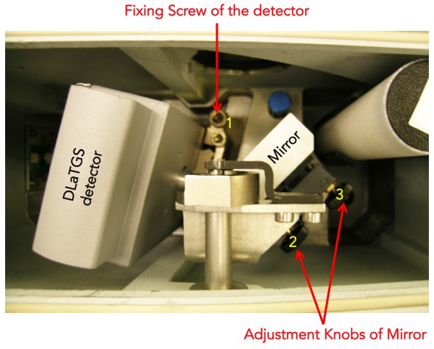
Figure 1. Detector compartment of Tensor 27 FTIR spectrometer.

ii. Substitution
1. Loosen the fixing screw of the detector compartment cover by using 6 mm Allen wrench.
- Open the detector compartment.
- Loosen the fixing screw of the detector with 6 mm Allen screw wrench (see Figure 1).
- Pull the detector straight upward out of the dovetail guide.
- Insert the detector you want into the dovetail guide and press it right down.
- Fasten the Allen screw.
- Close the detector compartment.
- Check the signal intensity using the OPUS program.

iii. Preparation
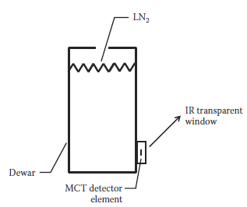
MCT or InSb detector has to be cooled down to liquid nitrogen temperature prior to use. Always wear blue Cryo-gloves (Tempshield) when you handle liquid nitrogen, LN₂ (please refer SOP of cryogenic materials in the “Lab Safety Manual” folder or download “SOPs Process” (http://research.chem.ucr.edu/groups/zaera/images/documents/4_sop_processes_2013-07.pdf) from our group homepage. Cool the detector with LN₂ using the funnel fill tube. Keep filling the funnel in cone increments. Repeat until reservoir is full (spill over). Cool down time is about 5 to 10 minutes. The detector is at working temperature once the rapid boil off venting has stopped. Place the plug (cap) in the fill port

iv. Maintenance
No daily maintenance is required for the detector. The LN₂ dewar may require a vacuum refreshing. If the vacuum level of LN₂ dewar will be decreased below acceptable, then the surface of that vacuum jacket is very cold. Sometimes it is covered with ice because of the condensation of moister form the air, so water peaks appear on the spectra.
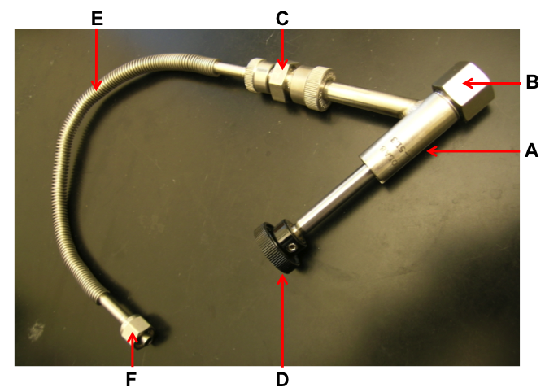
Figure 2. Adapter with flexible metal hose and Swagelok connection.

            - Remove the MCT detector from the spectrometer.
            - Connect the adapter (Figure 2) to one of vacuum valves.
            - Switch on the vacuum pump and open the valve.
            - Inspect the O-ring inside the adapter (B in Figure 2) for signs of wear.
            - Remove the cap from the connection nozzle of the detector.
            - Pull the adapter knob (D in Figure 2).
            - Loosen the coupling nut (B in Figure 2).
            - Push the adapter carefully over the connection nozzle of detector dewar.
            - Fasten the coupling nut hand-tight while holding the adapter and detector.
            - Push the adapter knob in the closed position until the threaded rod of the adapter is in contact with the sealing plug of the dewar evacuation valve.
            - Evacuate the detector dewar.
            - Close the vacuum valve.
            - Screw the threaded rod of the adapter in the connection thread of dewar evacuation valve by turning the adapter knob clockwise.
            - Pull the knob to the open position in order to open the dewar evacuation valve.
            - Evacuate the detector by opening the vacuum valve to pressure less than 10⁻⁶ Torr.
            - Close the dewar evacuation valve by pushing the adapter knob (D in Figure 2).
            - Press adapter knob firmly to the stop position,
            - Screw the threaded rod of the adapter out of the connection thread of the dewar evacuation valve by rotating the adapter knob.
            - Vent the section between vacuum pump and adapter.
            - Pull the knob to the open position.
            - Loosen the coupling nut and remove the adapter from the connection nozzle of the detector dewar.
            - Reinstall the MCT detector in the spectrometer.

e. Optical Alignment

Tensor 27 is equipped with a high stability interferometer with ROCKSOLID permanent alignment. Also detector substitution is possible with Tensor 27. DLaTGS detector is default, and optional MCT detectors are available in our lab. After substituting the detectors, re-alignment is not necessary due to the dovetail detector mounting. However, it has to be done properly whenever any accessory like DRIFTS or ATR system is installed or uninstalled in the sample compartment. Adjustment knobs for the alignment are shown in Figure 1.

            - Remove all the accessory and samples from the IR beam path. Make sure that there is nothing in the sample compartment.
            - MCT detector has to be cooled first prior to measurement.
            - Run OPUS program.
            - Select the “Measurement” menu.
            - Click the “Check Signal” tab.
            - Select the “Interferogram” radio button.
            - The amplitude value indicates the signal intensity that is currently detected.
            - Loosen the fixing screw of the detector compartment cover by using 6 mm Allen wrench.
            - Open the detector compartment.
            - Adjust two knobs (2 and 3 in Figure 1) of the mirror to get the highest value while watching the amplitude on the monitor. If you lost IR beam, use IR card to find it.
            - Once you get a good alignment, close the cover.
            - Wait for 6 hrs at least to be purged completely.

f. ATR spectra

i. Choice of Background Spectra

The background spectrum includes spectral contributions from the instrument and the environment. Majority of the environment absorbance is due to water vapor and CO₂. And contribution of the instrument to the spectrum is called the instrument response function including absorbance from the source, beam splitter, mirrors, and detector. A good background is of great significance to the sample measurement. As a result, the absorbance peak of each ‘species’ is supposed to maintain the same otherwise it will lead to bad reproducibility.

Depending on how to prepare your sample, it is strongly recommended to perform the background measurement with a proper material. The purpose of the background measurement is to detect the influence of the ambient conditions (e.g. humidity or temperature) and the auxiliary materials (e.g. solvents) that are required for preparing the sample. The subsequent sample measurement results in the sample spectrum from which the influence is eliminated. So, do both background and sample measurements with the same parameter settings in OPUS program. Ensure that the ambient conditions are identical or at least nearly identical.

g. OPUS Software

OPUS is a suite of software packages for the measurement, processing and evaluation of IR/Raman spectra. The main OPUS window is shown below with Key icons and areas labeled.
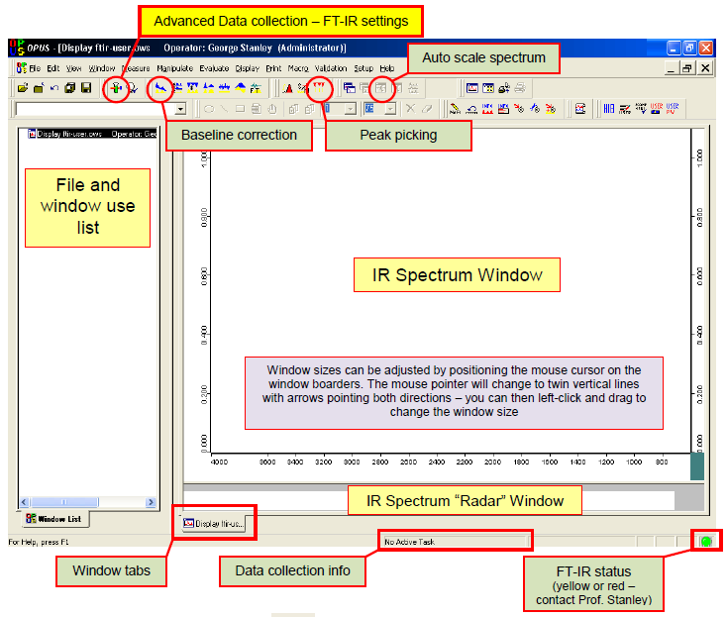

i. Spectra Acquisition
- Start the OPUS program:
  - Click the short-cut icon of the OPUS program on the desktop.
  - The OPUS login window will appear on the screen.
  - Type "OPUS" in the password line (for default operator).
- Select "Measure" and then "Measurement". After a few seconds, the measurement set-up windows will appear on the screen. Check the experimental parameters under "Advanced", "Optics", "Acquisition", "FT", and "Display".
- Set the sample temperature as needed.
- When the sample reaches the desired temperature, take a background spectrum by selecting "Measurement", "Basic", and "Collect Background". The program will display a message in the bottom line high-lighted by a green color indicating that the data are being taken.
- When the message disappears, the measurement is done. From this point on, you can proceed with the experiments (e.g. heating of the sample, adsorption of gases etc.).
- During the data acquisition, the interferogram cannot be seen on the check signal menu. After the background scans are finished, the "Measurement" window remains on the screen.
- Go to “Background” and Click “Save Background” to save the spectrum. The Filename (####.0) is saved automatically on the hard drive and displayed on the left (Window List) of the screen.
- The file can be saved as other formats on the hard drive. Select "Save File As", then check the file name and path to be saved. If you want an ASCII file, in the "Mode" option on the Save Spectrum window, select "Data Point Table" before clicking the "Save" button.
- Fill the chamber with the desired pressure of the reactant gases, at the same temperature used for the acquisition of the background spectrum.
- Take the sample spectra by selecting "Collect Sample", and wait until the highlighted message disappears.
- To take the spectra with different backgrounds saved previously, select “load background” and click any background spectrum.
- Type the sample name and explanation in the lines for sample name and sample form. (e.g. Sample Name: 1% Pt/SiO₂; Sample Form: after CO dosing of 10 Torr for 5 min at -150ºC)
- Take the sample data by selecting "Collect Sample" and wait until the highlighted message disappears.
- Select “load background” again, and click another background spectrum for the next experiment.

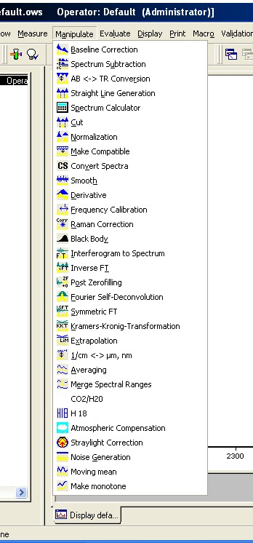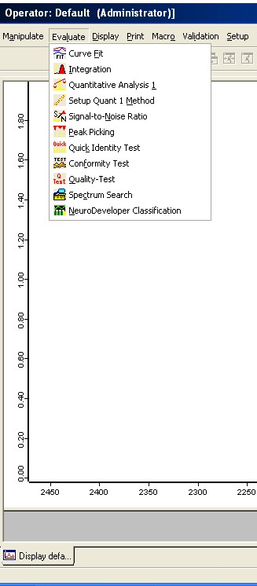

Figure. 3. “Manipulate” and “Evaluate” menus in OPUS program.

ii. Data Processing
Very useful processing tools are available in OPUS program. For example, Base Line Correction and Spectrum Calculator are in “Manipulate” menu, while Curve Fit and Integration are in “Evaluate” menu. Use helpful menu to learn how to do them.

h. Maintenance

i. IR Source
Tensor 27 uses only one mid IR source (MIR) in an U-shaped silicon carbide piece, which is pre-aligned, so realignment is not required after replacement. During the spectrometer operation, it becomes very hot and has risk of skin burn. Please avoid any skin contact and wait until the source cools down enough before you remove it.
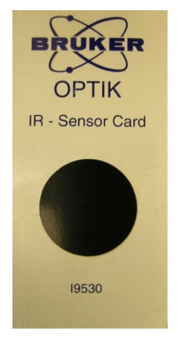
1. Beam Detection

If you like to check the IR beam visually, you can use an IR sensor card (see the right image) supplied from Bruker when the spectrometer was installed. You may confuse the red light on your sample with the IR beam, but actually it is He-Ne laser light (632.8 nm) that travels along the IR beam path.

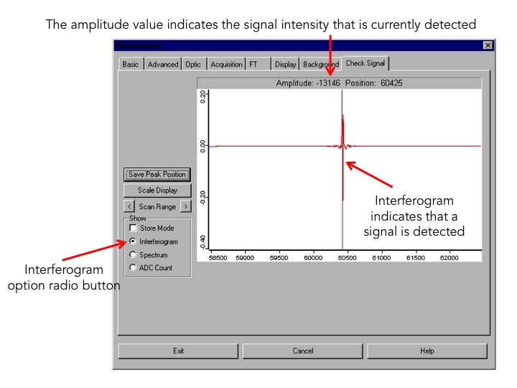

Figure 4. OPUS dialog window for “Measurement”.

2. Intensity Measurement

IR beam signal can be checked on the OPUS program.

1. Remove all the accessory and samples from the IR beam path. Make sure that there is nothing in the sample compartment.
2. Run OPUS program.
3. Select the “Measurement” menu
4. Click the “Check Signal” tab
5. Select the “Interferogram” radio button
6. The amplitude value indicates the signal intensity that is currently detected.

3. Cooling

Tensor 27 uses air-cooled MIR source, so additional cooling system isn’t required for normal operation. However, please do not block the ventilation slot of the source/laser compartment at the spectrometer top-side. During the spectrometer operation, the IR source generates heat, which is dissipated by the slots. Failure to do so can lead to spectrometer component damage.

4. Replacement

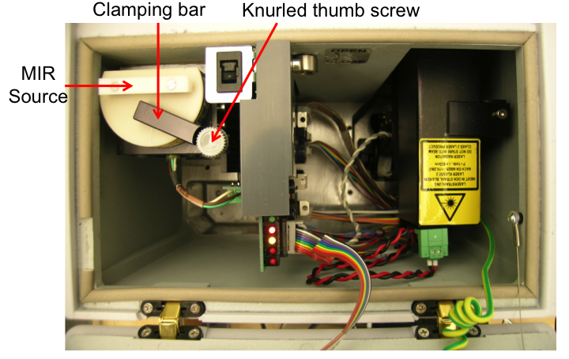
Figure 5. Source/Laser compartment.

            - Switch off the spectrometer.
            - Wait until the source cools down sufficiently.
            - Open the source/laser compartment.
            - Loosen the Knurled thumb screw of the clamping bar (approximately one turn).
            - Press the source downward while rotating the clamping bar aside.
            - Take the source out of the holder.
            - Insert a new source in the operating position holder.
            - While pressing the source downward, rotate the clamping bar over the source.
            - Tighten the knurled thumb screw of the clamping bar about one turn.
            - Close the source/laser compartment.
            - Switch on the spectrometer.
            - Check the signal intensity using OPUS program.
            - Select “Optics Diagnostics” in Measure menu.
            - Click the source icon on the “Instrument Status” window.
            - Click on “Service Info” button.
            - Click on the “Reset” button (Figure 6).
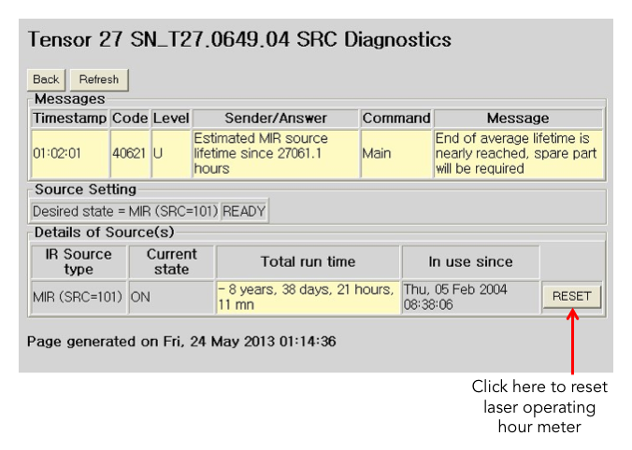
Figure 6. Source diagnostics page.

ii. HeNe Laser
FTIR spectrometer is equipped with a He-Ne laser (632.8 nm), which controls the position of the moving mirror in interferometer for IR beam scanning. If you have a problem with the laser, a red STATUS indicator or a failed performance qualification test (PQ).
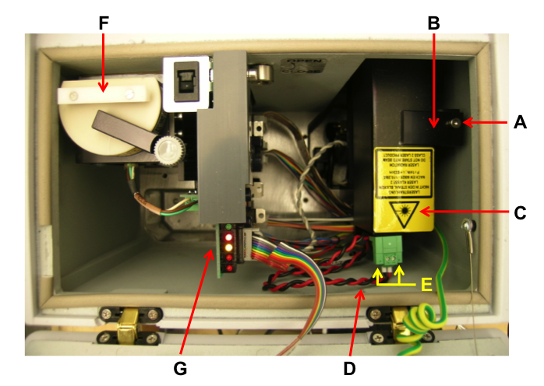
Figure 7. Source/Laser compartment.

1. Measuring and Adjusting Signal Intensity

If you have laser problem, you need to check the laser amplitude. For this test you nee an oscilloscope. There are two test points (LA2 and LB2) on IFM board (G in Figure 7) You should see minimum of 2 V p-p sign wave on these points.

There are parameters that can and should be checked with respect to the HeNe laser intensity.
- HeNe laser output intensity – this value can be checked under measurement. Go “Optics Setup and Service Option”. Select “Service” tab, if the log window is blank. Select “Repeat Diagnostics Test” button, when the results appear take note of the current and initial laser intensity values as well as the number of laser dropout value.
- HeNe laser modulation intensity – this value can be obtained via the measurement. Go “Direct Command Entry Option”. In there type; VEL=6 <Enter>, SCM=3 <Enter>, LAA <Enter>. Do this three times and record the approximate average value given (the value is the peak to peak modulation amplitude in millivolts). LAB <Enter>. Do this three times and record the approximate average value given (the value is the peak to peak modulation amplitude in milllivolts).

2. Replacement

In case of defective laser you have to replace the complete laser module (C in Figure 7), which consists of the laser tube and the laser power supply.

            - Switch off the spectrometer.
            - Unplug the main power cable.
            - Open the source/laser compartment.
            - Loosen the Allen screw (A in Figure 7)
            - Rotate the holding plate (B in Figure 7)
            - Take the laser module out of the holder. Be aware of the fact that the laser module is still connected to the laser supply cable (D in Figure 7).
            - Loosen the two slotted screws (E in Figure 7) and unplug the supply cable (D in Figure 7).
            - Connect the supply cable to the replacement laser module.
            - Fasten the two slotted screws.
            - Open the front shutter of the laser tube if it is closed.
            - Insert the laser module in the holder. Make sure that the laser rests on the holder bottom in a plane manner to ensure the correct orientation of the laser beam.
            - Rotate the holding plate (B in Figure 7) in place.
            - Fasten the Allen screw (A in Figure 7).
            - Close the source/laser compartment.
            - Plug the main power cord
            - Switch on the spectrometer.
            - Check the laser indicator on the spectrometer topside lights yellow after a few seconds. Otherwise, solve this issue.
            - Wait until the STATUS indicator lights green. If the indicator remains red, the laser module is not installed correctly. Correct the laser installation.
            - Check whether the IR signal is detected using the OPUS program.
            - Run the “Optics Diagnostics” in OPUS
            - Open “Instrument Status” window.
            - Click “HeNe laser” icon.
            - Click “Service Infor” button.
            - Click “Reset” button in the laser diagnostics page (Figure 8).
            - Perform an OQ Test using OVP (OPUS Validation Program).

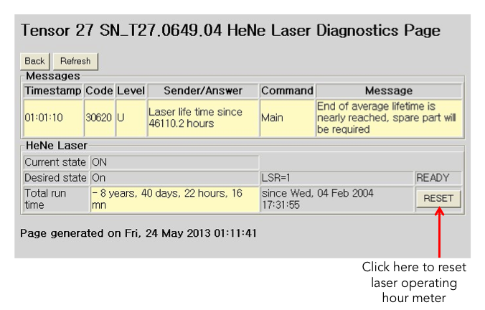
Figure 8. Laser diagnostics page.

iii. Gas Purging
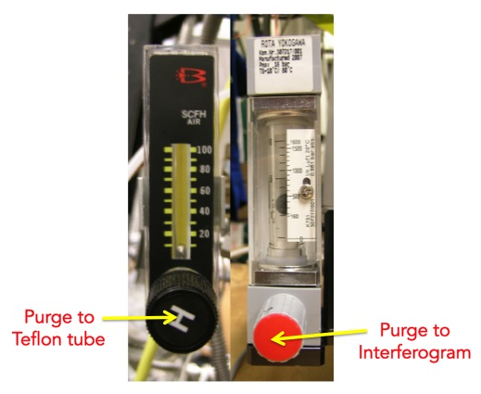
At least, the optical bench has to be purged with dry air or nitrogen gas as the beam splitter is made of KBr, which is a hygroscopic material. Also, purging the FTIR spectrometer reduces the content of undesired atmospheric interference from moisture and carbon dioxide, which absorb IR light in both detector and sample compartments as well as the optical bench.

Right now the Transmission IR system is purged with dry air. The flow rate is controlled by two rotameters (right image): one is for the optical bench and the detector compartment; the other is for sample compartment.

3. Gas Handling System

Gas manifold of GeATR system includes N₂, NH₃, and precursor lines. The pressure is monitored by Baratron and thermocouple gauges.

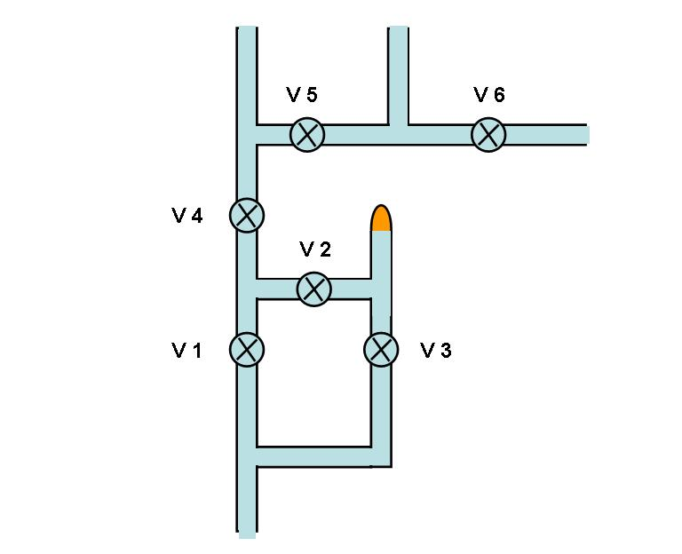
Figure 9. Gas manifold for the transmission IR system.

a. Precursor Preparation

V1 (opened), V2 (closed), V3 (closed), V4 (opened), V5 (closed), V6 (closed),

            - Precursor is prepared in the sample tube.
            - The tube has to be connected immediately to the system.
            - Open V2 and keep N₂ pressure up to 200 Torr by adjusting V1.
            - Close V4, open V3, close V1, and reopen V4 slowly.
            - Adjust the N₂ pressure back to 200 Torr.
            - Leave it for 30 min.
            - Close V2 and V3.
            - Open V1.

b. Precursor Dosing

V1 (closed), V2 (closed), V3 (closed), V4 (closed), V5 (closed), V6 (closed),

- Open V4 and V1 up to 200 Torr of N₂
- Set the temperature of Si wafer to 200 ºC and run the program to do heating.
- Close V4, open V3, close V1, and reopen V4 slowly.
- Adjust the N₂ pressure back to 200 Torr.
- Count the time as you planned.
- Close V2 and V3, and open V1.
- Stop the program of PID controller.
- Wait until the substrate is cool down to room temperature.
- Run the OPUS program
- Click “Measure” command.
- Select ‘interferrogram”
- Watch the value while the substrate is moving to the Ge ATR crystal.
- Stop moving the sample at the position of measuring.
- Take a single spectrum after typing the sample information.
- Move the substrate back to the ALD position.
- Repeat 2–14 until the spectra don’t change any more.
- Close V4.

c. NH₃ Dosing

V1 (opened), V2 (closed), V3 (closed), V4 (closed), V5 (closed), V6 (closed),

- Open V6 and pump the line.
- Stop pumping and fill the line with NH₃.
- Open V5 slowly, as you planned.
- Close V5 and open V4 until N₂ pressure to 200 Torr.
- Stop the program of PID controller.
- Wait until the substrate is cool down to room temperature.
- Watch the value while the substrate is moving to the Ge ATR crystal.
- Stop moving the sample at the position of measuring.
- Take a single spectrum after typing the sample information.

Repeat this procedure as you need.

d. Maintenance

All systems in Chemical Science building room 143 including UHV chambers are sharing the three gas cylinders (O₂, Ar, and H₂). When you need to use any gas, please check first if someone is already using the gas line. If so, you need to let them know you’re going to open the gas valve and a sudden pressure drop may be seen.

e. Valves

Bellow-sealed BK series (e.g. SS-4BK or SS-4BG) from Swagelok are preferred for the valves in the manifold system. The valves can be disassembled for cleaning inside, and the PCTFE stem tip is also replaceable.

f. Pressure Gauges
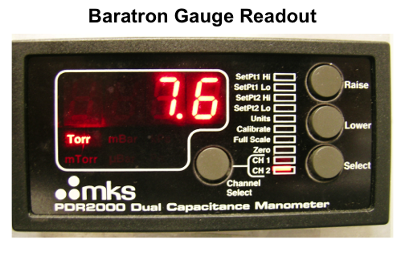
Two different types of pressure gauges are used in the gas manifold. One is Baratron gauge with digital readout for the range from 0 to 1000 Torr to control the amount of reactant gases quantitatively. Channel 1 (CH 1) is to the transmission IR cell side, and channel 2 (CH 2) is to the gas manifold side. The other is thermocouple gauge to monitor vacuum status in the gas manifold and the reaction chamber.

g. Mechanical Pumps

The mechanical pump requires regular oil changes, approximately once every half year or when large quantities of corroding or contaminants gases are used in the experiments. The oil can be occasionally degassed by leaking air in the inlet for a short period of time, but once the oil becomes dark, changes consistency, or has solid particulate, it is best to change the oil. The process for handling vacuum oil is available in the SOP of “Pump Oil”. Refer it in our “Lab Safety Manual” or download “SOPs Process” (http://research.chem.ucr.edu/groups/zaera/ \images/documents/4_sop_processes_2013-07.pdf)

4. GeATR ALD Cell

a. General Description

The GeATR ALD Cell is designed to carry out ALD experiments and to characterize the surface of the substrate by IR without removing the sample from the system or exposing it to the outside atmosphere. It consists of two volumes, for ALD reactions and IR characterization, accessible to the sample via a translational holder and separated by a gate valve (when closed). Pictures of the system are provided below.

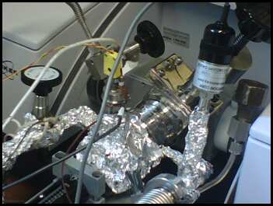
The GeATR ALD Cell consists of the following main components:

1. A translational micrometer onto which the surface (silicon wafer) is mounted, used for control of the sample position. The micrometer is shown as the black dial in pictures above. The dial of the translational control has markings approximately 0.2 inches apart that indicate a movement of the silicon wafer of 0.001 inches. It affords the translation of the substrate in between a position in close contact with the Ge crystal to collect IR spectra and away, to a position behind the gate valve, for gas dosing.
2. A gate valve, used to isolate the reaction volume from that where the sample sits during the IR characterization (where the Ge ATR crystal is). It should only be closed when the SiOx wafer is moved all the way back (-0.025 inches).
3. A heater and an internal thermocouple, to change and monitor the temperature of the surface.
4. A cooling rod, which allows the surface to be cooled more rapidly after heating.
5. A pressure reader, to monitor the internal pressure of the attachment and to indirectly monitor the pressure that the sample exerts on the germanium crystal when they are placed in contact with each other. The later is key to the recording of consistent IR spectra.
6. Swageloks connections and tubing designed as gas supply lines, used to introduce the precursors and Ar gas separately into the reactor volume.
7. A heating wire wrapped around the outside of the gas supply lines and a couple of external thermocouples to monitor their temperature. This allows the precursor and tube walls to be heated, to increase its vapor pressure. Typically, the walls are kept at or above the temperature of the precursor.
8. A purge box with two mirrors. This box allows the IR beam to be aligned, to direct it through the Ge crystal to the detector. The box is kept purged under dry air or nitrogen.

b. Sample Heater Preparation

Sample heater can be prepared by using a nickel sheet as seen in the pictures below.

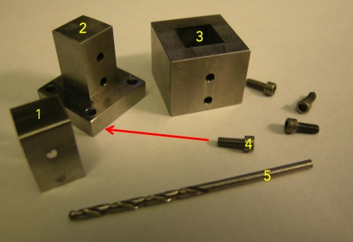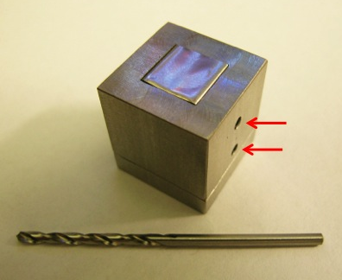

- Nickel sheet (1) is cut to be sat on the block (2).
- Insert block (3) with the holes matched.
- Tight the bolts (4) to fix the blocks.
- Drill the two holes (5).
- Disassembly the whole parts.
- A nickel heater (1) is ready.

c. Sample Manipulator Design and Assembly

The general details of the sample holder can be seen in the pictures below.

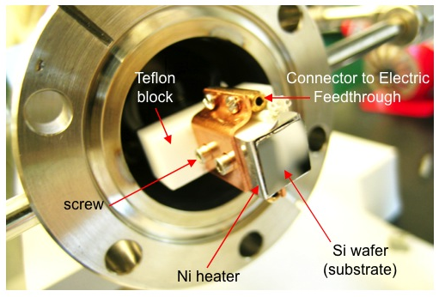

- A Teflon block is attached to the shaft of the micrometer linear translator through a barrel connector attached to the back of the Teflon block by two screws.
- This barrel connector sits flush to another barrel connector. This second barrel connector is used to attach a round piece of stainless steel (not tubing) cut to a specific length to extend the overall length of the shaft.
- Both barrel connectors use 1/8" 4/40 screws.
- The barrel connector that is screwed into the Teflon block may only have one screw on top, at the position furthest from the Teflon block. The other two screws must be placed in the bottom position (The barrel connectors are threaded through on both sides). This must be done or the screws will hit the gate valve.
- The Teflon block must be oriented so that the longest part perpendicular to the shaft is pitched down 30 degrees counterclockwise from the horizontal when looking at the tip (as shown in the pictures). This again is to provide clearance with the gate valve.
- There is a notch cut out at the top of the Teflon block.
- There is a sheet of nickel at the tip of the Teflon block where the sample (silicon wafer) is placed.
- There is a sheet of copper on each side of the nickel sheet to attach the wires used for each leg of the heater circuit.
- Two screws go through each copper sheet and the nickel sheet to attach it to the Teflon block.
- Also attached to the nickel sheet is the thermocouple, which is spot-welded to the surface.
- All of these wires are coiled around the shaft.
NOTE: THE ALIGNMENT OF THE NICKEL SHEET, FLUSHED TO THE FLAT TEFLON BLOCK, IS ONE OF THE MOST IMPORTANT ALIGNMENTS IN ORDER TO OBTAIN USEFUL SPECTRA. There is a separate section bellow that describes how to tell from the IR intensity and spectra if the sample is aligned properly.

- The thermocouple and the first leg of the heater, the black wire in the picture, needs to be connected from the sample mount to the barrel connecters connected to the external leads that go through the mini-flange.
- The thermocouple connections through the mini-flange are further away from the Teflon block than the first leg of the heater. Note the orientation of the external leads in the first two pictures of this section.
- The black wire, which is the wire for the first leg of the heater, is connected to the external electrical lead by a barrel connector that has sheathing over it (left picture).
- This sheathing must be secured over the barrel connector or the circuit may be grounded to the walls of the cell.
- The other side of this black wire is connected to the copper sheet (which is connected to the nickel sheet) by a barrel connector that has its screws going through the copper sheet.
- This barrel connecter is secured under the Teflon block.
- Unlike the first leg of the heating wire, the second leg of the heating wire cannot be secured to the copper sheet (which is secured to the nickel sheet) by a barrel connector. (The barrel connector securing the wire from the first leg does not allow it to be mounted bellow the Teflon block, the gate valve does not allow it to be mounted above the Teflon block, and the screws securing the copper and nickel sheets do not allow it to be mounted on the sides).
- Instead, the 12 gauge wire is secured directly to the copper sheet (left picture).
- The other end of this wire is attached directly the cooling rod (which is in ohmic contact with the walls of the attachment).
- 12 gauge copper wire is used for these electrical connections as it is the largest diameter wire with enough flexibility to allow for the motion inside the cell, yet thick enough to minimize ohmic loses between the copper cooling rod and the silicon sample during heating.
- The original sheathing of the 12 gauge copper wire was replaced with fiberglass sleeves to add flexibility.
- The copper cooling rod is custom made from a round piece of copper cut to length and spun down to have sections with 3/16 and 1/8 inch diameters.
- The 1/8 inch diameter end of the cooling piece is attached by a barrel connector to the heating/cooling wire.
- The 3/16 inch diameter piece extends outside the chamber and is connected to a funnel and tubing used to hold liquid nitrogen.

d. Assembly of Main GeATR-ALD Cell

The main GeATR-ALD cell comprised of six major parts:

- The translational control and the shaft.
- The external connections for the heater and the thermocouple
- The cooling rod.
- The 2 inch extension and the 1/4 inch tubing that is used to attach the precursors and the argon line.
- The gate valve
- The blank flange with a hole to which the Ge crystal is attached.

To assemble the cell, note that:

- The first four parts are attached together with the same bolts, and need to be put together all at the same time.
- However, the bolts to attach the 2 inch extension and the gate valve should be inserted into this extension prior to attaching the first three parts do to clearance issues.
- These bolts are cut to length to allow them to fit.
- The first three parts must be attached so that the backing of the holder of the Ge crystal attached to the last part is vertical.
- The gate valve must be attached at a specific orientation: the side of the gate valve shown in the left picture below must be closer to the translational control, while the side shown in the right picture below must be closer to the Ge crystal.

e. Substrate

The most typical substrate used in these ALD experiments is a piece of silicon wafer. These silicon wafers are typically covered with a native ~1 nm thick silicon oxide layer.

- Cleaning

A piece (0.5×0.5 inch²) needs to be cut from a commercial wafer, and cleaned to remove the old native oxide and re-grow a clean oxide layer. This is typically done by using the RCA procedure, which involves three steps:

- Etching. This is done using hydrofluoric acid, ammonium fluoride, or a mixture of the two.
- SC1 cleaning. This involves exposing the silicon wafer to a solution composed of water, hydrogen peroxide, and a base (typically sodium hydroxide or ammonium hydroxide).
- SC2 cleaning. This involves exposing the silicon wafer to a solution composed of water, hydrogen peroxide, and an acid (typically hydrochloric acid or sulfuric acid).

IMPORTANT: Carefully read the hydrofluoric acid section of the chemical hygiene plan before performing any RCA cleaning. Use Proper PPE. Do not use glass or metal glassware (or tweezers) with hydrofluoric acid solutions.

The current RCA cleaning procedure in our lab comprise of the following steps:

- Prepare a water bath at 80 degrees Celsius.
- In a plastic beaker add 20 mL of milli-Q water.
- Add 5 mL of 30% hydrogen peroxide solution to the beaker using a Pasteur pipette (The full pipettes contain approximately 5 mL).
- Add 5 mL of sodium hydroxide to the beaker using a Pasteur pipette. The sodium hydroxide used for this purpose is a 29 wt.% solution prepared from sodium hydroxide pellets.
- Add the silicon wafer to this solution and place the beaker in the water bath for 10 minutes.
- Rinse the wafer in another beaker containing milli-Q water and place the wafer in an empty beaker.
- Dispose of the SC1 solution and the first rinse of the beaker in a waste container.
- In the beaker containing the wafer, add a small amount of buffered HF (7:1 ammonium fluoride: hydrofluoric acid) and let it set for two minutes.
- Rinse the wafer in another beaker containing milli-Q water and place the wafer in an empty beaker.
- Dispose of the buffered HF solution and the first rinse of the beaker in a waste container.
- Add 20 mL of milli-Q water to the beaker containing the wafer.
- Add 5 mL of a 30% hydrogen peroxide solution to the beaker using a Pasteur pipette.
- Add 5 mL of 12.1 N hydrochloric acid to the beaker using a Pasteur pipette.
- Place the beaker in the water bath for 10 minutes.
- Rinse the wafer in another beaker containing milli-Q water and place the wafer in an empty beaker.
- Dispose of the SC2 solution and the first rinse of the beaker in a waste container.
- Add 20 mL of milli-Q water to the beaker containing the wafer.
- Add 5 mL of a 30% hydrogen peroxide solution to the beaker using a Pasteur pipette.
- Add 5 mL of a 29 wt.% sodium hydroxide solution to the beaker using a Pasteur pipette.
- Place the beaker in the water bath for 5 minutes.
- Rinse the wafer in another beaker containing milli-Q water
- Place the wafer on a clean Kimwipe tissue.
- Dispose of the SC1 solution and the first rinse of the beaker in a waste container.
- Wipe the wafer. It is ready to be mounted in the attachment.

- Mounting

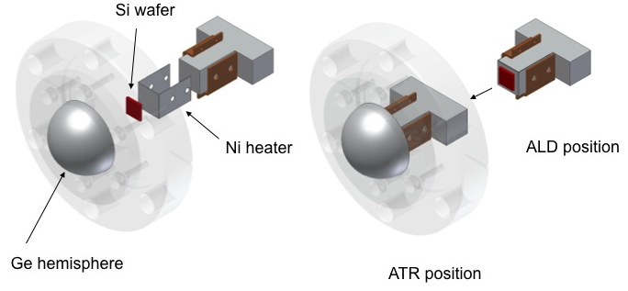

After RCA cleaning, the silicon sample needs to be mounted on the nickel sheet described above. Follow these steps:

- Place a single drop of silver paste at the center of the nickel sheet. Try to avoid using an excess of silver paste; that is undesirable.
- Place the silicon sample on top of the silver paste, with the polished side up, and push against the nickel sheet.
- Retract the sample using the translational control.
- Clean the gasket and Ge crystal:
  - Rinse them with hexane and wipe them with a Kimwipe tissue.
  - Rinsed them with milli-Q water and wipe them with a Kimwipe tissue.
  - Perform a second rinse with milli-Q water and wipe with a Kimwipe tissue.
- Place the gasket and Ge crystal on the end of the attachment and secure them with the Ge crystal holder.
- The holder should be secured so that the backing is vertical.
- Attach the purge box.
- Align the purge box properly by using a torpedo level. The purge box is secured when the torpedo level indicates that the box is level.
- Place the attachment in the beam path.

f. Beam Alignment

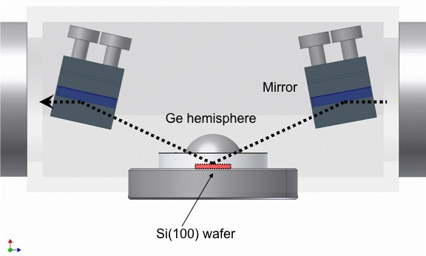

As stated above, the alignment of the sample with the Ge crystal is critical for proper data collection. A typical single beam intensity of around 1300 units should be seen in the centerburst of the interferrogram. The single beam intensity can be viewed in the OPUS software by selecting the ”Signal” tab after clicking on the “Advanced measure” button under the “Measure” table. Fortunately, there are a couple of easily discernable indicators to show the quality of the alignment once the attachment is assembled and placed in the IR beam path:

- Examine the change in the single beam intensity, as viewed under the “Signal” tab in the "opus" software, between when the silicon sample is placed in contact with the Ge crystal and when it is not in contact with the Ge crystal. The single beam intensity should drop by over 50% when the sample is in contact with the Ge crystal.
- Examine the IR spectra themselves. Below are two IR spectra collected with a SiO_{x}/Si wafer in contact with the Ge crystal, using the data for the Ge crystal that is not in contact with the sample as the background. Figure 10(a) is a spectrum collected when the sample was misaligned, whereas Figure 10(b) has the sample correctly aligned. The two most prevalent differences between the two spectra are the differences in baseline absorbance and the visibility of vibrational modes for surface species such as CH and OH stretches.
- Note: both examinations should be performed after initially heating the sample and after allowing it to cool down.

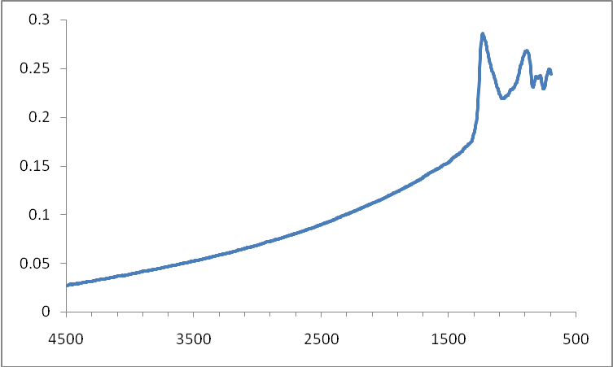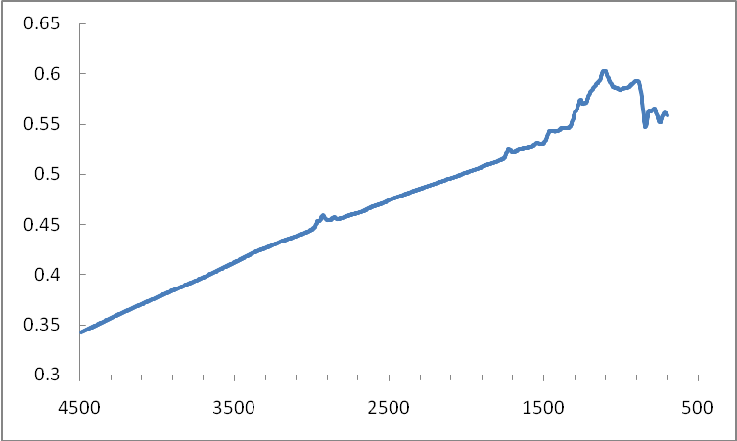
(a) (b)
Figure 10. GeATR spectra; (a) misaligned and (b) aligned.

If the sample is not aligned correctly:

- Remove the purge box and the Ge crystal and realign the nickel sheet of the sample mount.
- The sample mount must be extended to allow access to the screws holding the copper and nickel sheets to the Teflon block.
- Take out the sample from the mount by loosening the screws on one side.
- Press the nickel sheet flat against the Teflon block and tighten these screws.
- Follow the same steps with the screws on the other side as well.
- If the nickel sheet does not lie flat on the Teflon block still, repeat the same procedure again.
- After the nickel sheet is correctly secured to the Teflon bock remount the sample and recheck the alignment.
- If the alignment is still incorrect, you may need to take the nickel and copper sheets off the Teflon block and file the end of the Teflon block to make it flatter. Checking the flatness of the end of the Teflon with a torpedo level may help.

g. Operation

- Initial Steps

To collect IR data, follow the initial sequence listed next:

- Mount the silicon sample and place the GeATR-ALD cell in the beam path.
- Make sure that the system is aligned so the single beam intensity value is around 1300
- Check for the cleanliness of the Ge crystal. Follow these steps:
  - Collect a blank spectrum (with the sample retracted) and ratio against a previous background obtained before with the clean Ge crystal.
  - Examine this spectrum for signs of surface contamination (C–H stretching peaks from the precursor, O–H stretching peaks from unreacted sites on the surface, etc.).
  - If this spectrum indicates surface contamination, remove the Ge crystal and clean it with hexane and milli-Q water (refer to the section above for details).
  - It may also help to wipe the mirrors in the purge box with a dry Kimwipe.
  - Reassemble the cell and collect another spectrum to check for surface contamination again.
- Alternatively, the cleanliness of the Ge crystal can be checked as follows:
  - Collect a background spectrum of the Ge crystal.
  - Heat the walls of the GeATR-ALD cell.
  - Collect a second spectrum and check for signs of contamination. These should appear as negative peaks (i.e., negative C–H or O–H stretching peaks).
  - It is recommended to carry out both contamination tests
- Once the Ge crystal is clean, collect a background spectrum, to be used as reference for the series of sample spectra to be taken in the experiments.
- Check for any source of contamination of the GeATR-ALD cell:
  - Retract the (silicon) sample, to the value of -0.025 in the translational unit.
  - Close the gate valve.
  - Heat the sample to the temperature at which precursors will later be dosed.
  - Cool the sample back to room temperature.
  - Open the gate valve
  - Move the sample so it is in contact with the Ge crystal (this is typically between 1.950 and 2.000 inches in the translational unit.
  - Collect a sample spectrum to evaluate the possible presence of contaminants on the surface.
  - If contaminants are detected, clean the GeATR-ALD cell as described above.

- Data Collection

Once the GeATR crystal and the GeATR-ALD cell are deemed clean, experiments can be initiated:

- Heat the attachment to the desired temperature:
  - This temperature will depend on the precursor used.
  - The precursor is heated to increase its vapor pressure.
  - Also, the walls need to be held at or above the temperature of the precursor.
  - Typically, the heating variac needs to be set to the voltage setting known to produce the desired temperature (with the heating wire)
  - Allows the cell an hour to reach the desired temperature and to stabilize.
- Collect a background spectrum of the Ge crystal.
- Collect a spectrum of the sample before dosing any precursors.
- Dose the ALD precursor:
  - Fully retract the silicon sample and close the gate valve.
  - Flow argon gas and let the pressure stabilize (at around 100 mTorr)
  - Heat the sample to the desired temperature.
  - Open the Swagelok to the precursor for the desired amount of time.
  - Stop heating (and start cooling) the sample
  - Allow the argon gas to flow for a couple minutes to purge the cell.
  - Stop the flow of argon gas.
  - The pressure should now be the same as before you started dosing.
  - NOTE: The sample can be more rapidly cooled by pouring liquid nitrogen down the tube attached to the cooling rod.
- Return the sample to the IR position:
  - Open the gate valve.
  - Bring the sample in contact with the Ge crystal.
- Repeat this process as many times as desired.

When collecting multiple spectra it is important to insure continuity and reproducibility of the spectra obtained

- Make sure that all spectra are collected at the same temperature and pressure. The IR spectra are temperature dependent.
- Make sure to contrast all the spectra (before any baseline correction) to insure that they are of the same intensity and shape.
- Make sure that the sample is always pressed against the GeATR crystal with the same pressure. This can be determined indirectly by measuring the pressure inside the cell, which can change when applying high pressures leading to the partial breaking of the seal between the Ge crystal and the gasket underneath, used to attach it to the cell. Typically, spectra can be collected when the pressure in the chamber is at a steady value of 100 mTorr).

h. Maintenance

The attachment must be routinely taken apart to decontaminate the internal surfaces, as the precursor compounds studied stick to the internal surfaces. Additionally there are several places in the attachment where pieces of the attachment must be properly aligned or oriented in order for the attachment to function properly.

To determine if the attachment needs to be cleaned:

- Examine the IR spectrum of the SiO_{x} surface after it is heated (to the temperature that you are planning to perform that days set of experiments) and allowed to cool without dosing any precursors.
- Examine the C–H stretching region for indications of presence of the precursor on the surface
- Examine the O-H stretch region for indications of the presence of unreacted OH groups on the surface (The Si-H stretch region should be examined if a Si-H surface is used).
- If there are no O–H stretching peaks present in the spectra, the cell needs to be cleaned.
- If O–H stretching peaks are detected, confirm that an additional dose of precursor will result in a reduction of this peak (and a possible increase of the C–H stretching peaks).
- If this is not the case, the cell must be cleaned.
- Otherwise, use your own judgment.

To clean the cell:

- Disassemble it.
- Set the pressure reader aside, as it should not be cleaned with any solvents.
- Also set the Ge crystal aside.
- Wipe the interior surfaces of the cell with a Kimwipe soaked in hexane or dichloromethane (A mixture of the two solvents may also be used).
- Be careful to not only wipe the internal walls but also the shaft.
- Be careful to expose the internal wires to the solvent as well.
- Examine the Teflon surfaces for discoloration. There are two internal pieces of Teflon, One inside the mini-flange and the other at the end of the shaft.
- If the Teflon surfaces are discolored, they will need to be filed to remove the discoloration.
- The Teflon block at the end of the shaft must be removed from the shaft and have the nickel and copper sheets removed from it as well in order to be able to file all of its surfaces.
- The 1/4 inch tubing must be cleaned with a Q-tip soaked in hexane or dichloromethane (or a mixture of the two).
- While the elbows, Swageloks, and four-way connector can be cleaned easily with Q-tips, to clean the 1/4 inch tubing the cotton from the Q-tip (soaked in solvent) must be removed and forced through the tubing with the stick of the Q-tip.
- Once the internal surfaces have been wiped down, reassemble the cell.
- Check that the assembled cell can be pumped down to the same base pressure that it could achieve prior to disassembly.
- Remove off all precursors and the pressure reader.
- Also take off the Ge crystal.
- Place blanks on any openings of the 1/4 tubing.
- Fill the cell (through the opening where the Ge crystal is normally attached) with hexane (not dichloromethane).
- Let it sit overnight.
- Drain the hexane.
- Remove the blank, to which the Ge crystal is normally attached, to remove any hexane that may have accumulated inside the gate valve.
- Move the cell around to drain all the hexane from the 1/4 inch tubing.
- Reassemble the rest of the cell (leaving a blank in place of the pressure reader).
- Attach it to the mechanical pump.
- Start pumping.
- Be certain the heating tap is raped around the cell and turn it on (using a variac).
- The walls and sample mount should be held at a temperature of ~60 °C.
- After an hour, reattach the pressure reader.
- Continue pumping until the cell reaches its base pressure.
- Mount a new silicon sample.
- Check the extent of contamination.

NOTE: The walls of the cell should not be heated to temperatures above 100 °C, because the gate valve may get damaged (Most gate valves are rated to 150 °C).

i. Collecting Spectra

i. Background Spectra

For temperature-dependent sequences, reference spectra can be obtained during the cooling after pretreatment. These spectra are used as background spectra at the corresponding temperatures.

- Cool down or heat up the sample to the desired or lowest temperature.
- When the sample reaches the desired temperature, take a background spectrum by selecting "Measurement", "Basic", and "Collect Background". The program will display a message in the bottom line high-lighted by a green color indicating that the data are being taken.
- When the message disappears, the measurement is done. From this point on, you can proceed with the experiments (e.g. heating of the sample, adsorption of gases etc.).
- During the data acquisition, the interferrogram cannot be seen on the check signal menu. After the background scans are finished, the "Measurement" window remains on the screen.
- Go to “Background” and Click “Save Background” to save the spectrum. The Filename (####.0) is saved automatically on the hard drive and displayed on the left (Window List) of the screen.
- The file can be saved as other formats on the hard drive. Select "Save File As", then check the file name and path to be saved. If you want an ASCII file, in the "Mode" option on the Save Spectrum window, select "Data Point Table" before clicking the "Save" button.
- In temperature-dependent sequences, take and save background spectra during the cooling of the catalyst with about a proper interval (10 to 50 ºC).

ii. Sample Spectra

Once the temperature reaches the lowest temperature, introduce the desired pressure of the reactant gases into the IR cell and keep it for 5 min.

- Pump the gases out from the IR cell.
- Remove the liquid N₂ reservoir or heat the IR cell.
- Select “load background” and click the corresponding background spectrum at the same temperature.
- Type the sample name and explanation in the lines for sample name and sample form.
- Take the sample data by selecting "Collect Sample" and wait until the highlighted message disappears.
- Select “load background” again, and click another background spectrum for the next experiment or temperature.

NOTE 1: Make sure that the sample position in the sample scan is exactly the same as in the background scan: Do not try to optimize the sample position between a background and sample scan, even if the signal intensity is lower than it was in the background scan! Also, make sure that the temperature at which the sample is taken is the same as that at which the background was taken, so that the contraction of the manipulator is the same in both cases. Do not change any parameter between the background and sample scans.

NOTE 2: Keep accurate records of the data type in the files. Know exactly which files contain the sample ASCII data.

NOTE 3: Keep backups of the OPUS files only. These files contain the actual data from which all other data can be easily derived.

j. Long Term Maintenance

In order to provide the maximum transmission in the infrared, with the minimum spectral interferences, the mirrors used in this device are uncoated (bare) aluminum on a glass substrate. Since the coatings are soft, care must be taken to avoid damage. Normally, these mirrors will not need cleaning, since they are contained within the housing of the accessory. If they do need cleaning, they may be gently wiped with a lint free, abrasive free cloth, such as lens tissue, or with a camel hairbrush.

6. Typical Experiment Sequence

Below a description is provided of the procedure to generate a transmission IR spectrum of a pellet sample. Both background spectra, which are taken with the clean sample, and sample spectra, which are taken after adsorption (and sometimes reaction) of the molecules on the pellet are needed for final spectra, but they are taken separately. The transmission IR data are collected on the PC using the Bruker OPUS software.

a. Initial Steps
- Sign-in the logbook
- Start up the OPUS program
  - Click the short-cut icon of the OPUS program on the desktop.
  - The OPUS login window will appear on the screen.
  - Type “OPUS” in the password line for the default operator
  - Select “Measure” and then “Measurement”
  - After a few seconds, the measurement set-up window will appear on the screen.
  - Check the experimental parameters under “Advanced”, “Optics”, “Acquisition”, “FT”, and “Display”

b. Sample Mounting

- Silicon wafer is cleaned by using the RCA procedure.
- The cleaned wafer is mounted on the nickel sheet (heater) with the help of silver paste.
- Assembly the GeATR-ALD cell.
- Place the cell in the IR beam path.
- Align the optics.

c. ALD Process

- Heat the attachment to the desired temperature.
- Collect a background spectrum of the Ge crystal.
- Collect a spectrum of the sample before dosing any precursors.
- Dose the ALD precursor:
- Return the sample to the IR position:
- Repeat this process as many times as desired.
- Collect a sample spectrum.

d. Final Steps

- Log out of the OPUS software.
- Detach the GeATR-ALD cell.
- Take off the Ge crystal.
- Check that the flow of all gasses in the manifold is stopped.
- Close the regulator valves in the gas cylinders if necessary.
- Clean and disassemble the cell.
- Wash and store the parts.
- Wash the gas flushing bottles in the manifold.
- The main body and sample holder of the cell should be kept in a dry and clean place after washing.
- Sign out in the logbook.

6. Suggested Training for Beginner

For beginners to learn how to obtain consistent and reliable data, enough training is strongly recommended. Please refer the following papers (or the suggestions below) and repeat the experiments in there. The data obtained should be checked by an experienced operator.

Thermal Chemistry of Tetrakis(ethylmethylamido)titanium on Si(100) surfaces, J. Phys. Chem. A 2009, 113, 3946-3954.
Mechanistic details of atomic layer deposition (ALD) processes for metal nitride film growth, J. Mol. Catal. A. 2008, 281, 35-43.

Suggestions:
- Si wafer for the standard substrate.
- Any commercial Ti precursor.

7. Reference Materials

Tensor User Manual, 7th updated edition, September 2011

