Reactor System #3:
Reactor for Photocatalysis

Manual

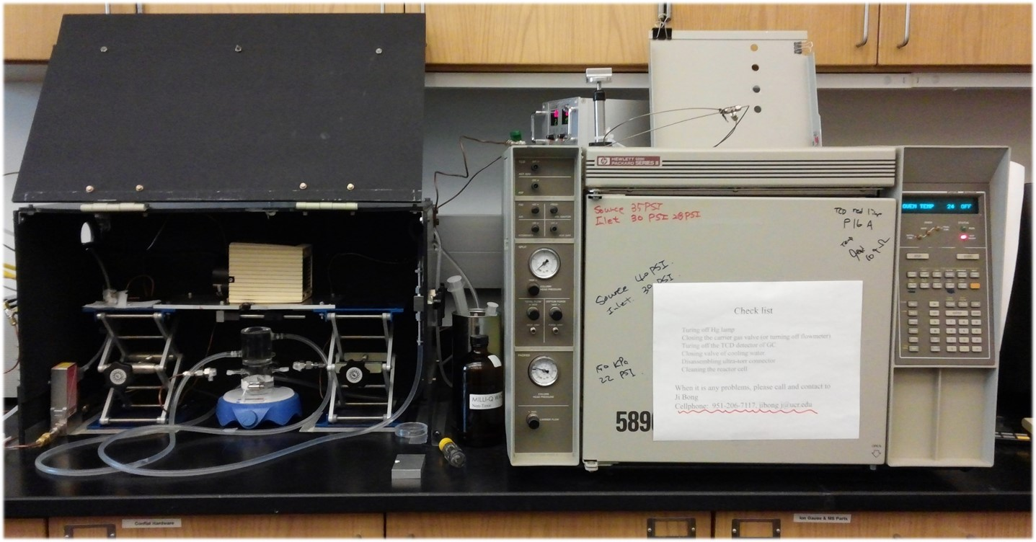

Francisco Zaera Group
Prepared by Ji Bong Joo, December 2013
Updated by Yoon Jae Lee, June 2014

Table of Content

- General Considerations/Overview of Equipment
- Gas Handling System
  - Design, Schematics
  - General Operation Procedure
  - Gas Sample Handling
  - Maintenance
    - Building Gas Lines
    - Valves
    - Finding Leaks
- Photocatalysis Reactor
  - General Description
  - Initial Assembly
  - Experimental Procedure
  - Maintenance and Troubleshooting
- Gas Chromatograph (GC)
  - General Description
  - Column Installation or Replacement
  - Setting and Checking the Gas Flow
  - Setting the Operating Temperatures
  - Turning on the TCD detector and Checking for Signal
  - Turning the GC off
- Typical Experiment Sequence

- General Considerations/Overview of Equipment

This manual provides a simple guide for the use of a homemade photocatalysis reactor equipped with a HP-5890 Series II gas chromatograph (GC).

The photocatalysis system consists of:

- A Hg UV-Vis light lamp (Mercury short arc lamp-100W/5A) with its power supply.
- A Pyrex reactor cell.
- Inlet and outlet gas lines with ultra-torr connections and a gas flow controller.
- A six-way gas sampling valve.
- A gas chromatograph (HP-5890 Series II).

The photoreactor and lamp are enclosed in a dark box.

The main use of the GC is to detect hydrogen, oxygen, and nitrogen generation from the photocatalysis system.

Below, a diagram of the complete system is provided.

Below the assembled reactor is shown:

- Gas Handling System

- Design, Schematics

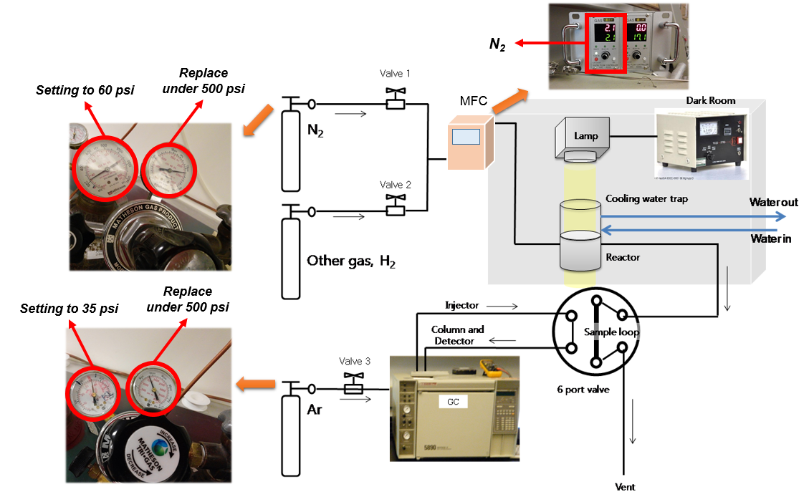

- General Operation Procedure

N₂ and Ar are mainly used this system. N₂ is used for flowing gas of photoreactor and Ar is used for carrier gas of GC column.

To start experiments:

- Check the primary indicator of N₂ gas regulator. If its pressure is under 500 psi, replace it new one. Set the secondary indicator to 60 psi.
- Turn on the MFC (Mass Flow Controller) after ultra-torr connector was linked with photoreactor (See the picture below.).

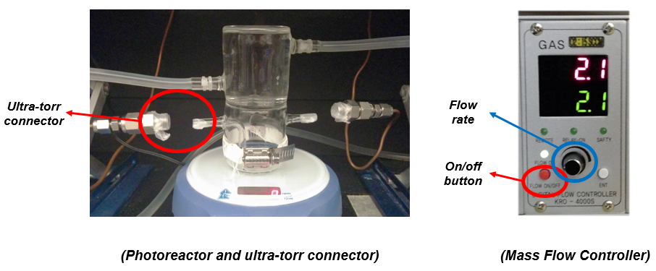

- Check the primary indicator of Ar gas regulator. If its pressure is under 500 psi, replace it new one. Set the secondary indicator to 35 psi.
- Set the column head pressure of GC to 28 psi.

To shut down the instrumentation:

- Turn off the MFC.
- Close the main valve of N₂ gas.
- When oven temperature falls under the room temperature, close the main valve of Ar gas in order to prevent a damage of TCD detector.

- Gas Sample Handling

The outlet gas line of reactor is connected to 6-way valve inlet. Turn on the 6-way valve to inject the gas sample to GC column (See the picture below.).
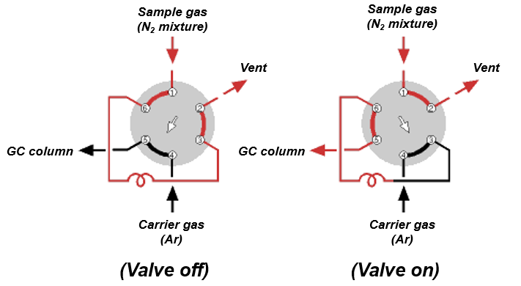
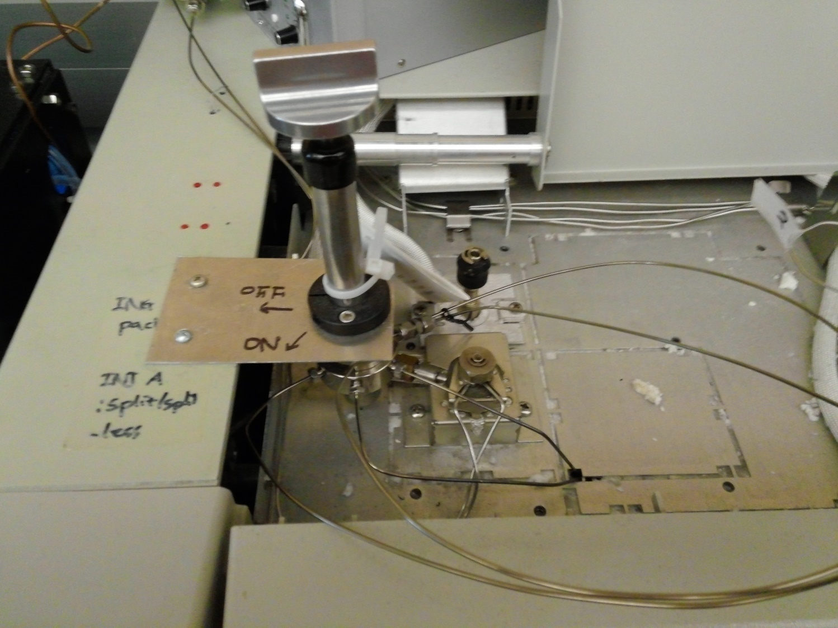

- Maintenance

- Building Gas Lines

To build gas lines, typically stainless-steel (or sometimes copper) tubing is assembled using Swagelock connections. These connections can create ultrahigh vacuum level of sealing and can be reused if handled properly. Refer to the description of the parts and their handling in the Swagelok catalogue. Avoid mixing brass and stainless steel connections, as brass is softer and ferules and threads can be damaged. All nuts have to go smoothly on the thread; do not force a nut on a connection!

To assemble a section of a vacuum line:

- Clean the tubing with acetone before assembly.
- Cut the tubing to the required length.
- Attach the fitting:
  - Insert the tubing into the fitting (or into a nut and place the ferrule in it, the small ring first).
  - Turn the nut finger tight against the male component of the Swagelock (the coupling piece, elbow, "T", cross, etc.).
  - Hold the body of the fitting with a back-up wrench.
  - Tighten the nut 1-1/4 turns (only a 3/4 turn for tubing smaller than 3/16").
  - Open the nut again to check if the ferrule is sitting tight and the lower ring cannot be moved.

For easy-to-remove connections, ultra-torr connectors are used (See the picture below):

- Insert an ultra-torr connector into the inlet and outlet of photoreactor.
- Put an o-ring the following.
- Fasten a copper tube connected ferule tightly (copper tube was used for easy connection due to its flexibility.).

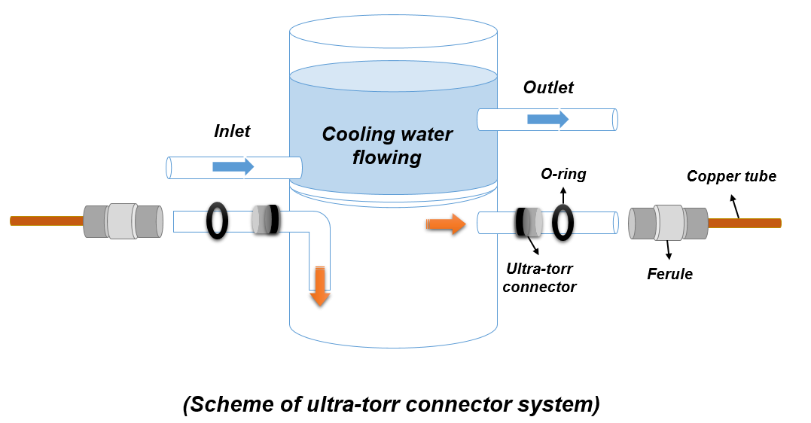

- Valves

In this system, two types of valve are mainly used. One is a gas regulator valve and the other is a 6-way valve.

To use and maintain of a gas regulator valve (See the picture below.):

- Connect a regulator valve to a gas tank with spanner.
- In order to prevent leaks of gas, wrap an each connecting point with teflon tape.
- Primary indicator shows pressure of a gas tank. If its pressure is under 500 psi, replace it new one.
- Secondary indicator shows pressure of a gas line. Set a pressure of gas line to adjust a valve.
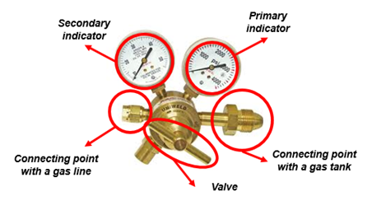

To use and maintain of a 6-way valve (See the picture below.):

- In order to prevent leaks of gas, wrap an each connecting point with Teflon tape.
- Primary indicator shows pressure of a gas tank. If its pressure is under 500 psi, replace it new one.
- Secondary indicator shows pressure of a gas line. Set a pressure of gas line to adjust a valve.

- Finding Leaks

Gas lines should check for leaks once assembled:

- Isolate the gas lines in sections by closing the appropriate valves when possible.
- Pressurize the line and check for bubbling while spraying a few drops of a soapy solution such as "Snoop".
- If that does not work, spray helium around the suspect connection and look for any pressure change in the gas manifold with the thermocouple vacuum gauge.
- A third way of identifying leaks is to use acetone or 2 propanol, pouring some drops in the suspected connection and looking for pressure changes inside the manifold.
- Ultimately, if the pressure inside the manifold cannot be brought down, or if it increases rapidly upon closing the valve to the pump, a leak detector may need to be used to isolate the leak.

Purging the photoreactor line and checking leaks for ultra-torr connection:

- After fastening ultra-torr connectors with photoreactor, set a mass flow rate of N₂ MFC up to 9-10 cc/min and purging the photoreactor line during 1 h.
- Turn on the 6-way valve for analyzing the mixture gas components of photoreactor line by GC.
- If O₂ peak is observed in GC spectra, refasten the ultra-torr connector and purge one more until only N₂ peak is shown (See the picture below.).
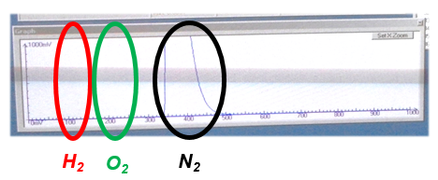

- Photocatalysis Reactor

- General Description

In order to evaluate the photocatalytic performance of the prepared catalyst, handmade Pyrex reactor was used. Hg UV-Vis light lamp was installed for the light source. Ultra-torr connector was adopted for easy-to-remove connections. Detailed the use and experimental procedure were described below.

- Initial Assembly

To assemble a section of a photocatalysis reactor for the reaction:

- Put the magnetic bar in the reactor through the outlet.
- Load a known amounts of the catalysis in the reactor (Specific amount of the catalysis depends on the morphology of the catalysis such as core particle diameter, shell thickness, and void size of yolk shell structure.).
- Add 45 mL Milli Q water and 5 mL methanol as sacrificial agent.
- Put the reactor into ultrasonication bath until the catalyst and Milli Q water + methanol mixture well mixed.
- Connect the ultra-torr connections at the inlet and outlet of the reactor tightly.
- Fasten the chain of reactor holder when reactor was loaded.
- Turn on the magnetic stirrer with 1200 rpm.

- Experimental Procedure

Before reaction started, purging and checking leaks of the reactor should be performed as described above. After checking the leaks with GC, start an experimental procedure described as below.

- Set the flow rate of N₂ MFC to 2.1 mL.
- Open the cooling line valve.
- Turn on the Hg lamp to begin the photocatalytic reaction by turning on the power supply.
- Turn on the 6-way valve to analyze the production amount of H₂ by GC every 30 min.
- When 180 min was passed from the beginning of reaction (six data was collected), turn off the Hg lamp and N₂ MFC.
- Unfasten the ultra-torr connectors and collect the used photocatalyst at a plastic tube.
- Clean the reactor cell and turn off the main valve of N₂ regulator.

- Maintenance and Troubleshooting

Clean the photoreactor as soon as reaction finished. The inlet and outlet of photoreactor should be sealed with parafilm to protect from dust. Cleaned photoreactor must be loaded in reactor holder and fasten tightly to look out for an unexpected impact.

Below is a listing of commonly occurred troubles and basic solution for the photocatalyst reactor.

- Leakage: If O₂ peak was observed after 1 h purging, fasten the ultra-torr connectors once again carefully and replace the O-ring with new one.
- Flickering the Hg lamp: Replace the Hg lamp with new one.
- Breaking the Pyrex reactor: Turn off cooling line first and reconnect the inlet and outlet of cooling line with cable tie tightly.

- Gas Chromatograph (GC)

- General Description

The HP-5890 GC includes two injectors (Packed and Split/Splitless Injectors) leading to two different detectors (flame-ionization –FID– and thermal-conductivity –TCD– detectors). The packed injector connected with FID and split/splitless injector connected with TCD, respectively. A picture is provided below.

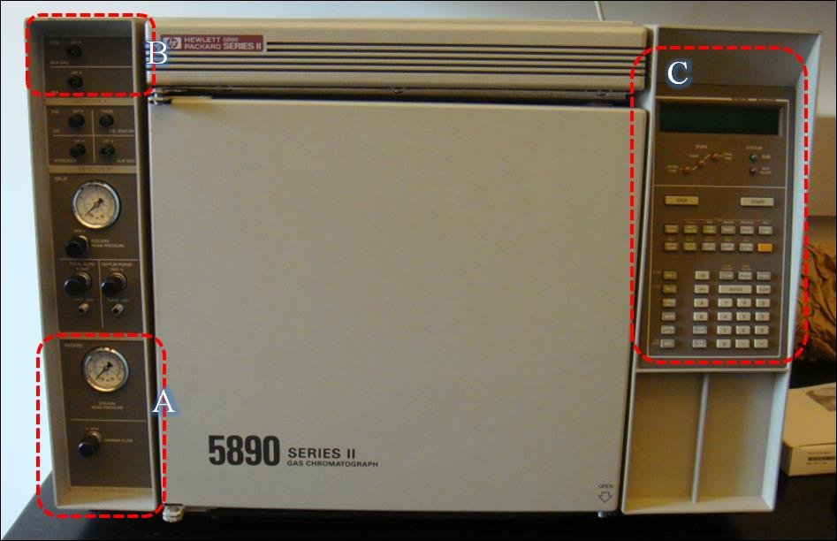

The column installed (split/splitless injector with TCD) in the oven of this GC is a 1/8" molecular sieve 5A (80/100, Restek), used to separate H₂, O₂, and N₂. In order to maximize the H₂ signal peak, Ar should be used as the carrier gas. If it’s necessary to quantify the O₂ with high accuracy, He should be used as the carrier gas. A picture is provided below.

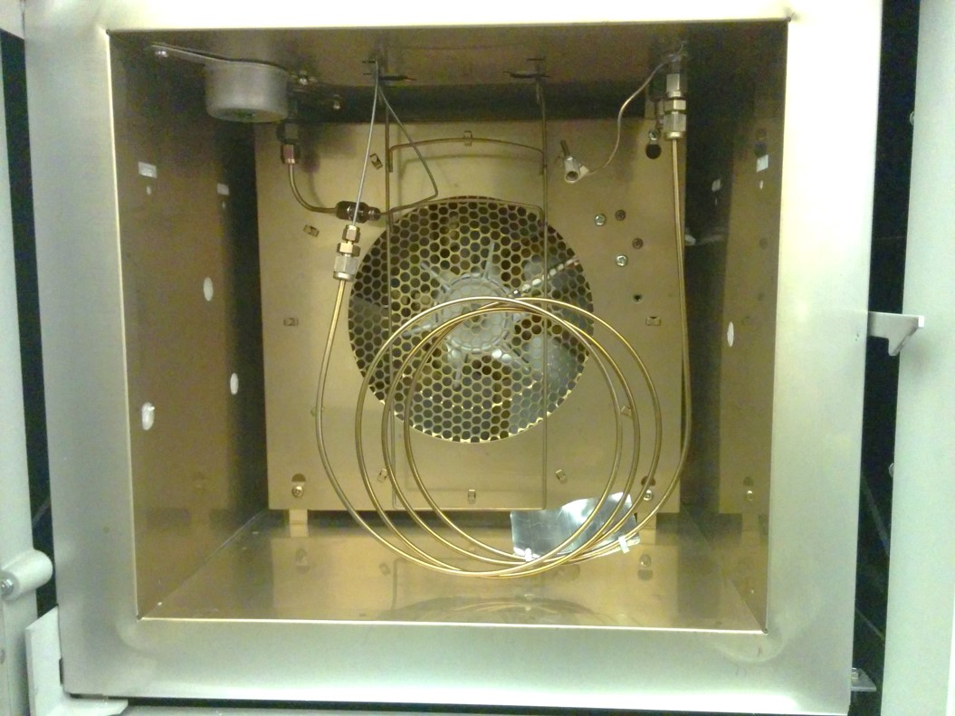
More details on the operation and service of this GC can be read in the following files:
- HP-5890II_operating manual.pdf
- HP-5890II_Service manual.pdf
- HP-5890II_reference manual.pdf).

- Column Installation or Replacement

All injector and detector fittings (GC column inlet and outlet) are located on the interior ceiling of the column oven. For this two-detector GC, there are two injector (column inlet) fittings and four detector (column outlet) fittings, one each for the two ionization detectors and two for the TCD detector. The injector body that is used is a ¼” OD fitting. The two ionization fittings are also of ¼” OD fittings. In order to install the preconditioned column:

- Push the OVEN TEMP (oven temperature) switch in the front power panel to OFF. This shuts off the oven fan and heater while detectors and injectors maintain operating temperatures.
- Shut off the hydrogen and air flows at the cylinders (that way, it is not necessary to change the set flows for those gases).
- Let the carrier gas to continue to flow to prevent back diffusion of air into the carrier gas lines and line filters.
- Push in latch at right side of oven door, then open door and lift off hinge pins.
- Allow oven interior to cool.
- Remove columns that are to be replaced.
- Insert new column(s).
- Attach to injector (inlet).
- If the column has not been preconditioned, do not connect it to the detector (outlet) until the preconditioning is completed.
- Precondition the column at 25ºC below the maximum operating temperature of the liquid phase for 10 hours with 10–15 ml/h carrier gas flow.
- Attach to detector (outlet).
- Be sure the column is inserted far enough so it bottoms out against the internal shoulders of the injector and detector fittings.
- Stainless steel columns should be installed with stainless steel ferrules and nuts. For best sealing and longest life, follow the installation and tightening procedures used for any Swagelok connection.
- Close the oven door and set the appropriate heating.

- Setting and Checking the Gas Flow

These instructions are to set the flow for columns attached to the TCD detector. Similar procedures would apply for the FID detector. In case of FID, He was recommanded to carrier gas of the column.

- Make sure that the carrier gas (N₂, Ar, Air) is connected to the GC.
- Open the gas carrier valve at the gas cylinder.
- Set the regulator pressure to the 35 psi.
- Close the AUX GAS and REF gas flow valves (Box B in Picture above) of the TCD by rotating the knobs to the off position.
- Check the column head pressure at the Injection Port B (packed injector). Usually, it should be ~30-40 psig (For analyzing H₂, 30 psig is good).
- If the pressure is lower than 30 psig, check the carrier gas cylinder and/or increase the carrier gas flow using the rotating knob. (Box A in Picture above).
- Measure the gas flow at the TCD gas outlet by using a bubble flow meter (see Figure). This is the flow rate though the packed column. The recommended flow rate is ~20-30 ml/min.

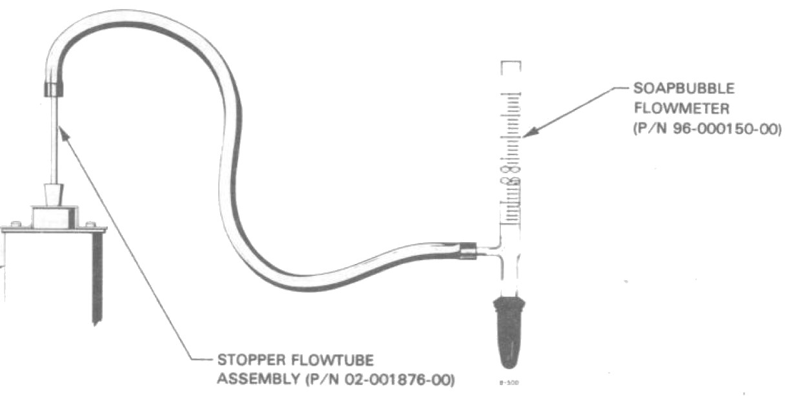

- The AUX GAS flow is not in use at present. Keep the knob of the AUX GAS off (Box B in Picture above).
- Open the REF Knob, rotating the inner knob by using a small plate screwdriver.
- Measure the gas flow at the TCD gas outlet by using a bubble flow meter. This is the flow rate though the packed column + Reference flow (e.g., if it is 40 ml/min and the gas flow value though the packed column measured before is 20 ml/min, the reference flow rate is 20 ml/min).
- Set the reference flow at a value as close as possible to the gas flow though the packed column.
- Make sure that gas is always flowing through the TCD to protect the TCD filament.

- Setting the Operating Temperatures

- Turn on the GC by switching on the right-side bottom.
- Wait for all the self-diagnosis procedure to be done (the display panel should say "passed ~").
- In order to set the injector B temperature (at 50°C in this case), type INJ B TEMP + 5 + 0 + ENTER.
- To heat injector B to the set value, type INJ B TEMP + ON.
- To turn off the injector B heating, type INJ B TEMP + OFF.
- To set the TCD detector heating, (to 50°C in this example) type DET A TEMP + 5 + 0 + ENTER.
- To heat/turn off the TCD detector heating, type DET A TEMP + ON/OFF.
- To set the OVEN temperature (to 50°C), type OVEN TEMP + 5 + 0 + ENTER.
- To heat/turn off the OVEN heating, type OVEN TEMP + ON/OFF.
- Usually, the INJ B (packed injector) TEMP, DET A (TCD) TEMP and OVEN TEMP are all set to 50°C for H₂ detection.

- Turning on the TCD detector and Checking for Signal

- The most important part of the GC is the TCD detector. Operate with care.
- The TCD detector MUST be off when not in use.
- To see the current status of the TCD detector, type DET + A, then SIG 1.
- Usually, DET A should be off and SIG 1 should be 0 (because the detector is off).
- To turn on the TCD detector, type DET + A + ON. A non-zero value should be seen in SIG 1.

The output Signal can be recorded by using a digital multimeter (DMM) equipped with appropriate software (see Picture below).

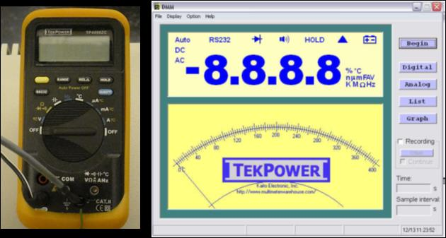

To check for signal in a H₂ detection test:

- Flip the 6 port-valve to inject a sample in the GC (and flip back after a few seconds).
- Start recording the GC signal from the digital multimeter by using the appropriate software.
- Acquire data for a set period of time, longer than the elution time of all gases to be detected.
- The resulting chromatogram should look like that in the Figure below.

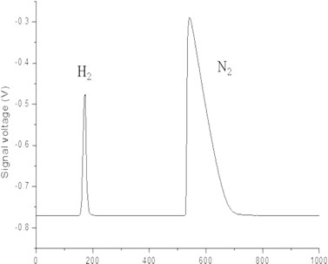

- Turning the GC off

Once the experiments are finished:

- Turn off the TCD detector, type DET + A + OFF.
- Turn off INJ B (packed injector) TEMP, DET A (TCD) TEMP and OVEN TEMP.
- Let the detector and oven cool off.
- Close the gas cylinders off.

- Typical Experiment Sequence

  - Place a fixed (predetermined) amount of the powder catalyst into bottom part of the Pyrex glass cell though the outlet tube.
  - Add the required amount of water (or water + methanol mixture) by using a syringe.
  - Add a small stirrer bar to the reactor.
  - Sonication the liquid plus catalyst mixture to make sure that the powder catalyst is dispersed well in the solution.
  - After sonication, place the reactor cell into the reactor holder at the right position.
  - Fasten the chain in order to hold the reactor in place by using the wrench driver.
  - Connect the ultra-torr connectors to both inlet and outlet tubes of the reactor cell.
  - Turn on the magnetic stirrer to 1200 rpm.
  - Turn on the N₂ gas (purging and carrier gas) and set it to a flow rate of slightly above 10 ml/min rate.
  - Purge the system for at least 1 h.
  - Turn on the cooling water valve near the sink and check the water flow rate:
    - Be careful: If the water flow at the outlet is too strong, it may cause some water leaking in the water line, or even breakage of the reactor cell.
  - Control the height of Lab-Jacks to set a 2 inch between the bottom of the UV-Vis lamp and the top of the reactor cell.
  - Place the Hg Lamp in center arrangement with photoreactor.
  - Check for leaks by searching for any O₂ signal in the GC:
    - Take a gas sample by turning the 6-port valve.
  - If there is no oxygen peak, adjust the N₂ gas flow to 2.1 mL/min by turning on the MFC.
  - Turn on the power supply of the lamp to start the photocatalysis experiment.
  - Make sure that the N₂ gas flow is maintained at a constant value of 2.5 ml/min all throughout the experiment.
  - Take periodic gas samples using the 6-way valve, as preset during the design of the experiment mentioned above, to analyze their composition using the GC.
  - Once the experiment is finished:
    - Turn off the UV-Vis lamp.
    - Disassemble the gas inlet/outlet unltratorr connectors from reactor cell.
    - Turn off the N₂ carrier gas flow.
    - Close the cooling water valve.
    - Clean the reactor cell.

