Reactor System #1:
Batch Reactor for Catalysis

Manual

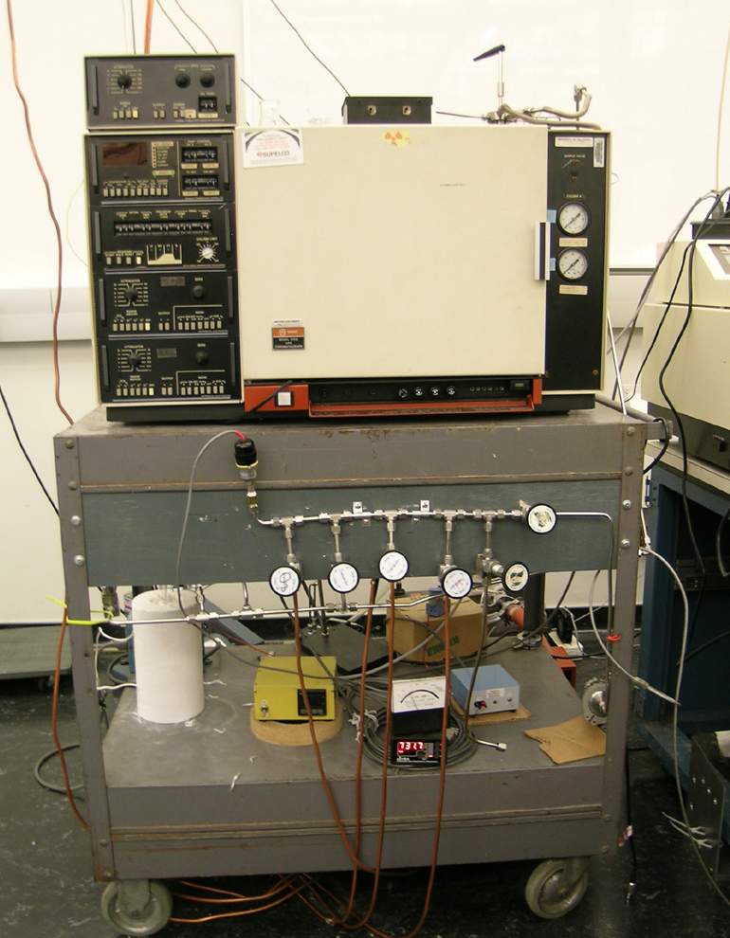

Francisco Zaera Group
prepared by Ilkeun Lee, Ricardo Molares, August 2007,
updated by Ilkeun Lee, September 2014

Table of Contents
1. General Considerations/Overview of Equipment 3
2. General Laboratory Safety 4
3. Gas Handling System 4
a. Design 4
b. General Operation Procedure 5
c. Maintenance 5
d. Valves 6
e. Pressure Gauges 6
f. Mechanical Pumps 7
g. Finding Leaks 8
4. Catalytic Reactor 8
a. General Description 8
b. Initial Assembly 8
c. Experimental Procedure 9
d. Final Steps 10
i. Turn Off 10
ii. Shut Down 10
e. Maintenance and Troubleshooting 11
i. Leak Checking 11
ii. Replacing the O-rings 11
iii. Cleaning the Reaction Chamber 11
iv. Heating and Temperature Measurement 11
5. Gas Chromatograph (GC) 12
a. General Description 12
b. Column Installation or Replacement 12
c. Setting and Checking Gas Flows 13
d. Setting the Operating Temperatures 15
e. Turning On the FID detector and Checking for Signal 16
f. Operation 17
g. Turning the GC Off 18
6. Typical Experiment Sequence 18
a. Initial Steps 18
b. Catalyst Loading and Pretreatment 18
c. Setting GC and Digital Multi-meter 19
d. Catalytic Reaction Runs 19
e. Final Steps 19
6. Suggested Training for Beginner 20
7. Reference Materials 20

1. General Considerations/Overview of Equipment

Please read this manual carefully before using this batch reactor and keep it in a suitable place for future reference. Always follow the instruction described in this manual to ensure safety and to avoid damage. Improper use or failure to do safety instructions can result in serious injuries and/or property damage.

This is a homemade circulating reactor designed as a loop made of stainless-steel tubing to carry out catalytic kinetic studies. It consists of the following main elements (see diagram below):

- A quartz-made U-shape tube for the catalyst sample. This section is inserted in the main loop, and can be heated by using an outside oven (or cooled) and is inserted into the main loop.
- A separate gas manifold, used to feed the reactant gases.
- A mechanical pump, capable of pumping the system to ~ 10 mTorr.
- One thermocouple (TC) pressure gauge, located in the gas manifold and used to check the quality of its vacuum
- One Pirani pressure gauge, used to monitor the pressure in the reactor loop (keep in mind that the sensitivity of the gauge depends on the type of gas introduced).
- A circulating pump.
- A 6-way-sampling valve, located in between the reactor loop and the GC, used to take and introduce aliquots of the reaction gases into the GC for analysis.
- A Varian 3700 Series gas chromatograph (GC)

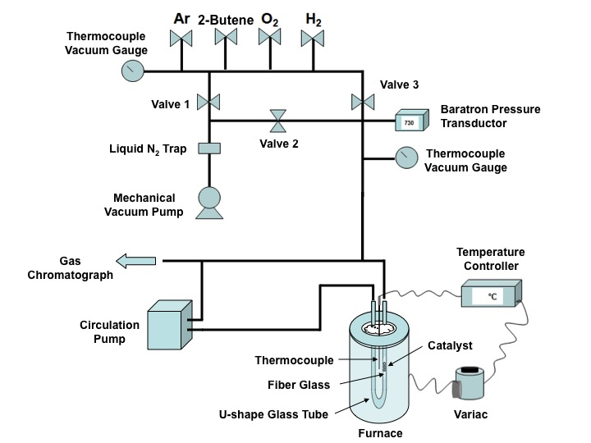

Varian GC system is equipped with FID and TCD detectors. The U-shape glass tube is placed in a furnace and connected to a circulated gas manifold, which is designed for operation up to 400 ºC below atmosphere. The pressure range covers 10⁻³ to 10³ Torr only, so do not try higher pressure. The circulation pump is operated by a power supply (homemade), so please refer Stan for troubleshooting. DMM software program is installed in a computer.

The reactor and gas manifold has a total of 8 regular and 2 three-way valves:

- One valve to connect the dosing line to the mechanical pump
- Four valves in the gas manifold, used for handling Ar, H₂, O₂ and the main reactant gas.
- One valve to connect the gas manifold to the main reactor loop.
- Two valves to connect the reactor loop to the quartz reactor.
- Two three-way valves, used to switch the reactor loop from the batch reactor to the high-pressure cell.

2. General Laboratory Safety

Before starting any experimental work in the laboratory, all users must learn The Laboratory Safety Manual and pass all exams. Users must also get familiar with the Injury and Prevention Program (IIPP) and Chemical Hygiene Plans (CHP).

All users must be familiar with the location of the fire extinguishers, safety showers, and other safety equipment before starting any experimental work. In Room CS 135:

- Fire Extinguishers: Located next to front door of CS 135.
- Safety Showers and Eyewash Station: Located next to the front door of CS 135.
- Fire Exit: two doors in CS 135.
- First Aid Kits: Located next to front door of CS 135.

3. Gas Handling System

Gas manifold of batch reactor system includes Ar, H₂, O₂, and reactant gas lines. The pressure is monitored by two sets of Baratron and thermocouple (or Pirani Penning) gauges. One set is for he circulation loop, and the other set is for gas manifold.

a. Design

            - Oxygen gas valve
            - Main valve to the circulation loop
            - Argon gas valve
            - Hydrogen gas valve
            - Reactant gas valve
            - Vacuum valve
            - CO gas regulator
            - Baratron gauge readout 1
            - Pirani Penning gauge readout 1
            - Baratron gauge readout 2
            - Pirani Penning gauge readout 2
            - Power supply of circulation pump
            - Furnace
            - Thermocouple gauge

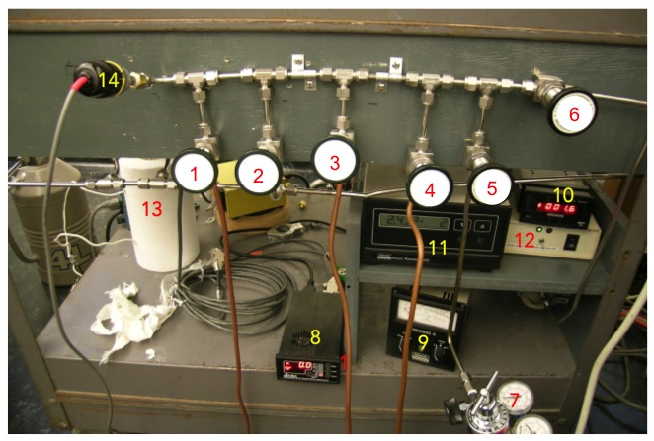
Figure 1. Gas manifold for the batch reactor system.

b. General Operation Procedure

To start pumping:

      - Close all valves, particularly the ones to the gas supply lines.
      - Turn on the rotary vacuum pump.
      - Check the pressure in the line by using the TC gauge that is connected directly to the gas line close to the pump.
      - Once the pressure in the gas manifold is below the 2 mTorr, open the valve that connects the dosing line to the batch reactor loop.
      - The pressure reading at this point should be close to 2 mTorr.
      - If this is not the case, close the valve again and check the connections for leaks.

c. Maintenance

To build gas lines, typically stainless-steel (or sometimes copper) tubing is assembled using Swagelok connections. These connections can create ultrahigh vacuum level of sealing and can be reused if handled properly. Refer to the description of the parts and their handling in the Swagelok catalogue. Avoid mixing brass and stainless steel connections, as brass is softer and ferules and threads can be damaged. All nuts have to go smoothly on the thread; do not force a nut on a connection!

To assemble a section of a vacuum line:

- Clean the tubing with acetone before assembly.
- Cut the tubing to the required length.
- Attach the fitting:
  - Insert the tubing into the fitting (or into a nut and place the ferrule in it, the small ring first).
  - Turn the nut finger-tight against the male component of the Swagelock (the coupling piece, elbow, "T", cross, etc.).
  - Hold the body of the fitting with a back-up wrench.
  - Tighten the nut 1-1/4 turns (only a 3/4 turn for tubing smaller than 3/16").
  - Open the nut again to check if the ferrule is sitting tight and the lower ring cannot be moved.

d. Valves

Bellow-sealed BK series (e.g. SS-4BK) from Swagelok are preferred for the valves in the manifold system. The valves can be disassembled for cleaning inside, and the PCTFE stem tip is also replaceable.

e. Pressure Gauges
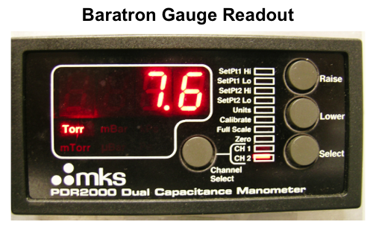
Two different types of pressure gauges are used in the gas manifold. One is Baratron gauge with digital readout for the range from 0 to 1000 Torr to control the amount of reactant gases quantitatively. Channel 1 (CH 1) is to the reaction chamber side, and channel 2 (CH 2) is to the gas manifold side. The other is thermocouple gauge to monitor vacuum status in the gas manifold and the reaction chamber.

Thermocouple gauges are prone to burnout, especially when used with corrosive gases. If the pressure readout is high, first check to see that the cable connecting the pressure sensor to the readout unit is solid. If the connection is good, it is likely that the TC gauge needs to be replaced.

f. Mechanical Pumps
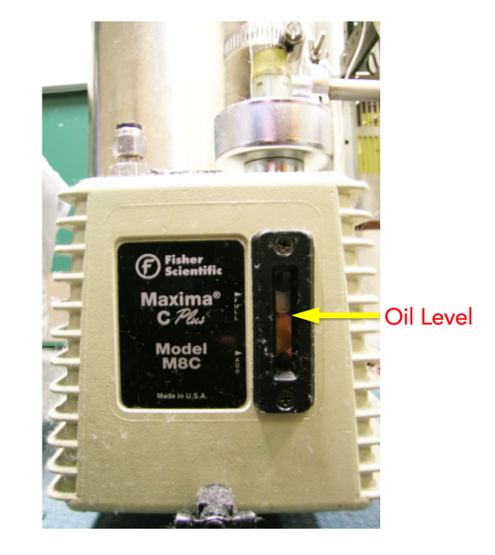
A mechanical pump is used for vacuum in the gas manifold. The pump requires regular oil changes, approximately once every-half year or when large quantities of corroding or contaminants gases are used in the experiments. The oil can be occasionally degassed by leaking air in the inlet for a short period of time (this heats up the oil), please check the oil level, and refill when the level is too low. Once the oil becomes dark, changes consistency, or has solid particulate, it is best to change the oil. The process for handling vacuum oil is also available in the SOP of “Pump Oil”. Refer the details in our “Lab Safety Manual” or download “SOPs Process”
(http://research.chem.ucr.edu/groups/zaera/images/documents/4_sop_processes_2013-07.pdf)

Standard Operation Procedure for Oil Change:

      - Wear proper PPE (gloves, safety goggles, and lab coat).
      - Stop the pump and remove all the connection.
      - Isolate the mechanical pump from the reactor.
      - Wait for 10 min before starting the oil change; the pump oil may still be hot.
      - Lift the pump on a moving cart (there is one stored in CS 137).
      - Place the waste oil bucket below the pump.
      - Remove the top screw of the pump.
      - Slowly unscrew the bottom screw and let the oil drain into the bucket.
      - Drain the existing oil.
      - Make sure that all the oil has been drained.
      - Fill the pump with 0.5 L or a little less of clean oil.
      - Rinse the pump by running it for 5 min.
      - Stop the pump and drain the oil (again, wait until it cools off before proceeding).
      - Multiple rinses may be needed depending on the extent of the contamination of the pump. Judge based on the quality of the oil drained after rinsing
      - Add new mechanical pump oil using a syringe or a funnel. Typically Kurt Lesker (TKO-19) is used. Do not overfill.
      - Tighten all the screws and connect the pump back to the reactor.
      - Replace the molecular sieve in the sieve trap at the same time with the oil is changed.
      - The used oil and molecular sieve material must be disposed through the Environmental Health and Safety department.
      - Start the pump and check the base pressure.

Parts replacement and rebuilding of mechanical pump may be done in the machine shop.

g. Finding Leaks

Gas lines should check for leaks once assembled:
- Isolate the gas lines in sections by closing the appropriate valves when possible.
- Pressurize the line and check for bubbling while spraying a few drops of a soapy solution such as "Snoop".
- If that does not work, spray helium around the suspect connection and look for any pressure change in the gas manifold with the thermocouple vacuum gauge.
- A third way of identifying leaks is to use acetone or 2 propanol, pouring some drops in the suspected connection and looking for pressure changes inside the manifold.
- Ultimately, if the pressure inside the manifold cannot be brought down, or if it increases rapidly upon closing the valve to the pump, a leak detector may need to be used to isolate the leak.

4. Catalytic Reactor

a. General Description

The catalytic activity is investigated in a small batch reactor consisting of a stainless loop with ~150 mL of total volume evacuated with a mechanical pump to a base pressure of 5×10⁻² Torr and equipped with thermocouple and baratron gauges for pressure determinations. Samples of the catalysts (5 mg) were sandwiched between two quartz wool plugs and placed in one of the vertical arms of a U-shaped quartz tube cell (10 mm I.D.) inserted in the reactor loop, which could be heated in a furnace (Omega) controlled by a temperature controller (Omron). The reactant gases (at least total 400 Torr) were introduced sequentially into the reactor loop and mixed using a recirculation pump (BTC, miniature diaphragm pump, Hargraves). Aliquots (10 mL) of the gas sample were taken with an interval during the catalytic reactions by using an eight-port valve (VICI; Valco) and analyzed with a Varian 3700 gas chromatograph (GC) equipped with a 23% SP-1700 on 80/100 Chromosorb PAW column (30 ft × 1/8 in O.D., stainless steel; Supelco) and a flame ionization detector. The GC data were digitally recorded by using a multi-meter (Tekpower) and a RS232 connection. Nitrogen (98% purity) was used as the carrier gas for the GC.

b. Initial Assembly
- Place the catalyst (typically about 3–5 mg) in the quartz cell, in between a few layers of quartz wool and/or above the metal mesh (see Figure 2).
- Place the quartz reactor inside the heating jacket.
- Carefully connect the quartz piece to the reactor loop using the ultra-torr connectors.
- Open the valve to the pump, evacuate the loop.
- Wait until the pressure reaches a value below 60 mTorr.
- If the pressure cannot be lowered to such value, check the connections or disconnect the quartz reactor and connect it again. Be careful not to break it. If the pressure is not reduced still, there may be leaks; you may need to perform a leak check and rebuild the loop.
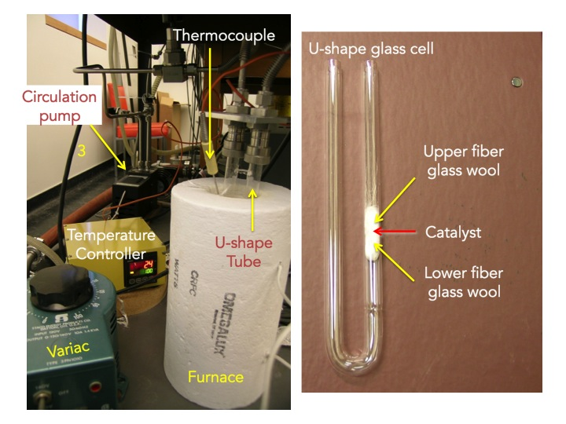
Figure 2. U-shape glass cell in the batch reactor.

c. Experimental Procedure
- Dry the catalyst, usually at 150 °C for 1 h.
- Activate the catalyst via reduction and/or oxidation cycles at the appropriate conditions. For Pt catalysts, O₂ and/or H₂ treatments, with 100 Torr of the gas, and temperatures around 350 °C, may be appropriate for this pretreatment. However, more stringent conditions may be required to burn all carbonaceous deposits. Be careful to avoid sintering. Tests may be needed to check for pretreatment reproducibility.
- After reaching the pre-treatment temperature, fill the system to a pressure of up to 400 Torr of the gas and turn on the recirculation pump.
- After the pretreatment of catalyst is over, turn off the heating and wait until the temperature comes back to below 100 °C.
- Turn off the circulation pump.
- Evacuate the system.
- Once the vacuum is reinstated, introduce the reaction mixture gases:
  - The gases with lower partial pressure are introduced first (usually Ar, used as a ballast, is introduced last).
  - Isolate the gas manifold from the mechanical pump by closing the proper valve.
  - Open the valve for the reactant molecule and add the desired pressure in the reactor loop, as measured with the Pirani gauge.
  - Close the valve that connects the manifold to the reactor loop, and check that the pressure in the sample loop remains stable.
  - Evacuate the gas manifold (check the pressure with the TC gauge).
  - Repeat the same procedure for gas addition to the loop with the second reactant (typically H₂ or O₂) and with the Ar ballast if needed
- After all the gases are introduced, turn on the circulation pump.
- Wait ~2 min, take an initial gas aliquot for GC analysis:
- Flip the 6-way valve handle.
- Immediately after, push the START button in the GC controller and the START button in the DMM software to initiate the data collection.
- Wait until all GC peaks have appeared, then leave the system run for additional 10 min in order to be sure that nothing else remains in the GC column.
- Push the STOP buttons in the GC controller and the software.
- Save the collected data and wait until the system is ready for a new run (indicated by the LEDs in the GC).
- If multiple runs are desired within one GC run, the handle of the 6-way valve can be flipped every 12–20 min (once, alternating positions) without the need to press any button in the software or GC controller.

d. Final Steps

i. Turn Off
      - Set the GC to a standby mode:
        - Press the RESET button in the GC.
        - In the Temperature Controller Readout, set the TEMP CONTROL INJ A to 00 (0 °C) and the TEMP CONTROL ION DET to 00 (0 °C). The temperatures in the GC injector and detector should start to decrease.
        - Turn the COL OVEN switch to the FAN only position.
        - Set the PID controller from RUN to STOP.
      - Turn off the circulation pump in the reactor.
      - Pump out the gases inside the reactor.
      - Close the H₂ and Ar gas cylinders.
      - Wait until the DMM reaches negative values.
      - Turn the COL OVEN Switch off.
      - Close N₂ cylinder.

ii. Shut Down
- Close all valves, in particular the ones to the gas lines.
- Close the valve connecting the dosing line to the rotary vacuum pump.
- Turn off the rotary pump.
- Slowly open the cap in the molecular sieve trap to vent the pump.
- Fill the whole system with Ar by sequentially open the valves from the Ar source toward the pump until the pressure reading at the line next to the pump is slightly above atmospheric pressure.
- A third option for venting is to use nitrogen from a cylinder connected to the system.

e. Maintenance and Troubleshooting

i. Leak Checking

Batch reactor may have a leak at around ultra-torr connections for U-shape glass cell. If so, check the O-rings first whether it is damaged or contaminated.

ii. Replacing the O-rings

If the Viton O-rings are worn out and caused a leaking, please replace them with new ones.

iii. Cleaning the Reaction Chamber

This batch reactor can be cleaned by any solvent, but recommended only when disassembled completely. You may use a cotton tip to remove any thing that stuck on the inside wall of the U-shape quartz cell.

iv. Heating and Temperature Measurement

Heating the U-shape quartz cell in furnace is performed by using a Variac and a temperature controller (Omron). Usually it can be heated above 500 ºC by setting the Variac at 100%. For lower temperatures, please use lower voltages (Variac at 50%). Type-K thermocouple is used as a probe.

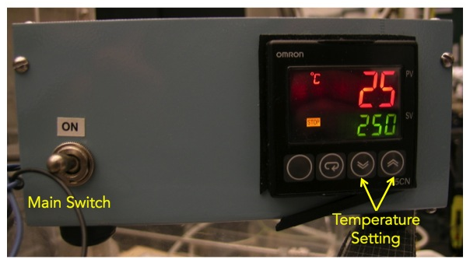
Figure 3. Temperature controller equipped with Omron E5CN.

5. Gas Chromatograph (GC)

a. General Description

The series Varian 3700 Gas Chromatograph is a modular, dual-column instrument comprised of the basic unit to which a broad range of optional modules may be added. The actual instrument is equipped with a flame ionization detector (FID) and an electron capture detector (ECD). At present, the detector that is connected to the column and has been used for the type of analysis required is the FID.

The instrument also has removable front-opening door. Each heated zone (injectors, detectors, column oven) is insulated to minimize heat-transfer effects between zones. The temperature of each heated zone can be controlled independently.

The column that is installed in the system at the present time is a 23% SP-1700 on 80/100 Chromosorb PAW (30’ × 1/8” OD SS). The maximum temperature for this column is 110 ºC; for this reason, it is recommended not to use temperature ramps that may exceed this value.

The system is connected to a multi-meter capable of transmitting the voltage values (signal from the FID detector) to a PC via a RS232 connection.

b. Column Installation or Replacement

All injector and detector fittings (GC column inlet and outlet) are located on the interior ceiling of the column oven. For this two-detector GC, there are two injector (column inlet) fittings and four detector (column outlet) fittings, one each for the two ionization detectors and two for the TCD detector. The injector body that is used is a ¼” OD fitting. The two ionization fittings are also of ¼” OD fittings. In order to install the preconditioned column:

- Set the COL OVEN (column oven) switch in the front power panel to OFF. This shuts off the oven fan and heater while detectors and injectors maintain operating temperatures.

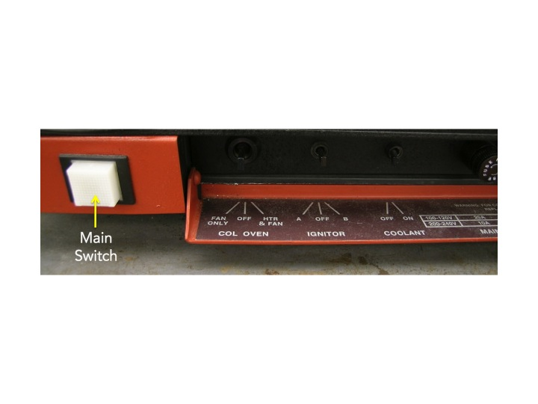

- Shut off hydrogen and airflow at the cylinders (that way, it is not necessary to change the set flows for those gases).
- Let the carrier gas to continue to flow to prevent back diffusion of air into the carrier gas lines and line filters.
- Push in latch at right side of oven door, then open door and lift off hinge pins.
- Allow oven interior to cool.
- Remove columns that are to be replaced.
- Insert new column(s).
- Attach to injector (inlet).
- If the column has not been preconditioned, do not connect it to the detector (outlet) until the preconditioning is completed.
- Precondition the column at 25 ºC below the maximum operating temperature of the liquid phase for 10 hours with 10–15 mL/h carrier gas flow.
- Attach to detector (outlet).
- Be sure the column is inserted far enough so it bottoms out against the internal shoulders of the injector and detector fittings.
- Stainless steel columns should be installed with stainless steel ferrules and nuts. For best sealing and longest life, follow the installation and tightening procedures used for any Swagelok connection.
- Close the oven door and set the appropriate heating.

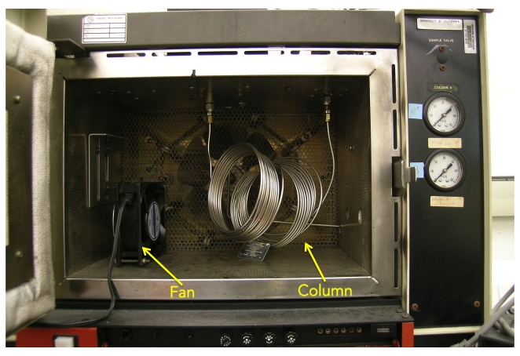

c. Setting and Checking Gas Flows

All gases are connected on the rear panel of the pneumatics cabinet by means of Swagelok 1/8” fittings. All fittings are labeled for specific gases. For the operation of the FID, Three gases are being used:

      - N₂, the carrier gas. Pressure: N₂ = 60 psi.
      - H₂, the fuel for the flame in the FID detector. Pressure: N₂ = 40 psi.
      - Compressed air, also for the flame of the FID detector. Pressure: Air = 40 psi.
All gas flows are regulated at the control panel of the pneumatics cabinet (see Figure below).

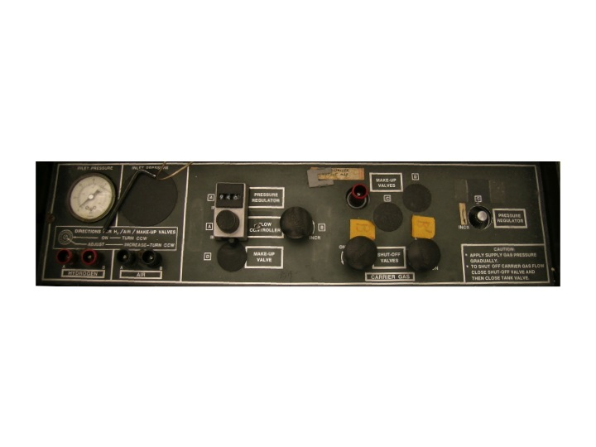
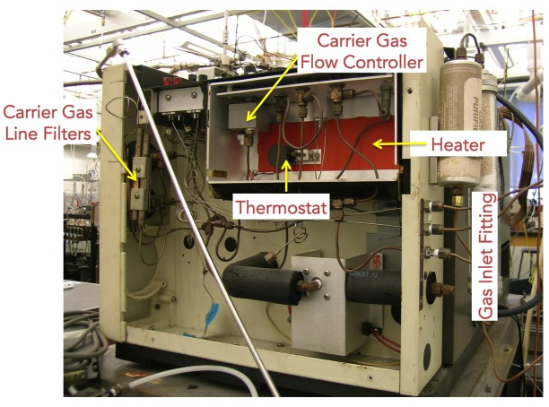

To adjust the flow of the gases:

- Make sure that the gases (N₂, H₂, Air) are connected to the GC.
- Set the supply pressure of the gas being measured to the appropriate pressure listed above. The gas pressures are indicated in the second stage regulator gauge on the supply cylinders. The carrier gas pressure can be also checked on the gauge located in the front panel of the GC.
- Connect a soap-bubble flow meter to the selected detector as shown in the Figure below.
- Turn the appropriate gas shutoff valve all the way counterclockwise.
- Then turn that valve 1/8 turn clockwise.
- Force a bubble above the inlet of the flow meter by squeezing the soap reservoir bulb.
- To avoid contamination of the cell, do not allow the soap solution from the flow meter to flow into the detector exit tubes.
- Using a stopwatch, measure the elapsed time it takes the bubble to move from the 0 to the 10 mark.
- From that time, calculate the rate in cc/min.
- Carefully adjust the appropriate gas flow regulator valve to obtain the desired rate.
- Unless the hydrogen flame in the FID detector is lighted immediately after making the flow adjustment, be sure to shut off the hydrogen flow. Flowing unburned hydrogen gas is both a waste and a potential hazard.

d. Setting the Operating Temperatures

      - Open the N₂ carrier gas and set the appropriate pressure. The flow should be set to 25 mL/min.
      - Set the oven temperature to 35 ºC in the Initial Temp entry on the Auto Linear Temperature Controller Panel.
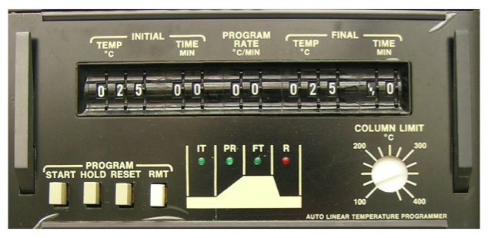
      - The temperature can be checked by pressing the COL button.
      - Turn the COL OVEN switch to the HTR & FAN position.
      - In the Readout Temperature Controller, set the TEMP CONTROL INJ A to 10 (which is 110 ºC) and the TEMP CONTROL ION DET to 11 (110 ºC).
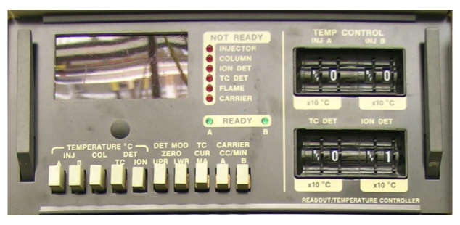
      - Those temperatures will start to increase; check them by pushing the bottom below the temperature reading screen.
      - Wait until all the red LEDs for the Injector, Column, and Ion Detector are turned off. (Less than 20 min). This indicates that all temperatures are set and stable.

e. Turning On the FID detector and Checking for Signal

- Once the oven, detector and injector temperatures have reached the desired temperature, open the Air and Hydrogen cylinders.
- Connect the digital multi-meter (DMM) from the back panel of GC to the PC
- Run the DMM software.
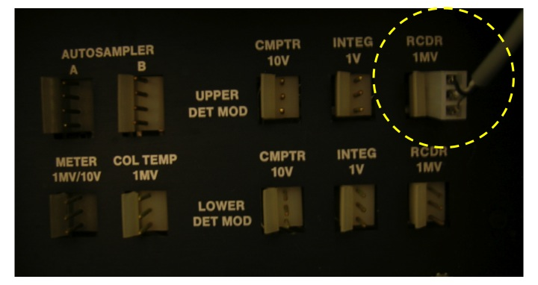
- You should see a voltage reading in the DMM window, as indicated in the Figure below.
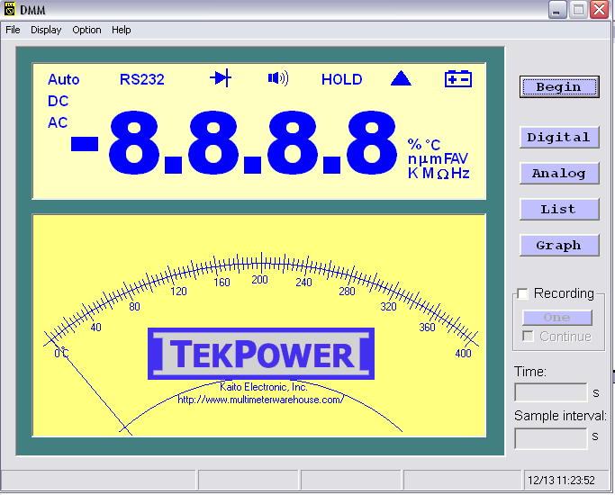
- Do not try to set this value to zero by using the ZERO knob in the FID controller.
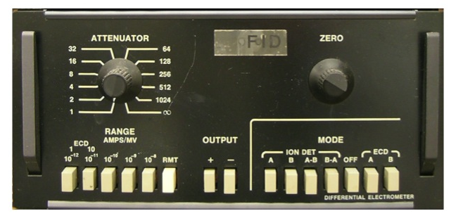

- Turn the IGNITOR switch to A to ignite the flame of the FID detector till the voltage in DMM jumps to around 30.

- This value will decrease immediately afterwards.
- A sound like an explosion should be heard. If not, use a mirror or another shiny object metal next to the top of the detector and look for evidence of water vapor condensation to indicate that the flame is on.
- If the flame fails to ignite, repeat the procedure described above one more time.
- If the problem persists, check the flows of both air and hydrogen.
        - The ignition of the flame can also be checked by increasing the voltage reading scale. Wait for the baseline to stabilize (approximately 20 min).
        - Once the baseline is stable, the voltage can be set to zero by using the ZERO knob.
- Input the appropriate settings:
        - Attenuator = 1
        - Range = ECD 10, 10⁻¹¹
        - Output = positive (+)
        - Mode = Ion Det. A.

f. Operation

In order to set up the GC prior to an experiment, follows the steps listed below:

      - Set the gas flows and temperatures in the GC as indicated above.
      - Turn on the GC, DMM, and computer.
- After all the gases are introduced, turn on the circulation pump.
- Wait ~2 min, take an initial gas aliquot for GC analysis:
- Flip the 6-way valve handle.
- Immediately after, push the START button in the GC controller and the START button in the DMM software to initiate the data collection.
- Wait until all GC peaks have appeared, then leave the system run for additional 10 min in order to be sure that nothing else remains in the GC column.
- Push the STOP buttons in the GC controller and the software.
- Save the collected data and wait until the system is ready for a new run (indicated by the LEDs in the GC).
- If multiple runs are desired within one GC run, the handle of the 6-way valve can be flipped every 12–20 min (once, alternating positions) without the need to press any button in the software or GC controller.

g. Turning the GC Off

Once the experiments are finished:

      - Press the RESET button in the GC.
      - In the Readout Temperature Controller, set the TEMP CONTROL INJ A to 00 (0 ºC) and the TEMP CONTROL ION DET to 00 (0 ºC).
      - Those temperatures should start to decrease right away.
      - Turn the COL OVEN switch to the FAN only position.
      - Set the FID controller from RUN to STOP.
      - Turn off the recirculation pump in the reactor loop.
      - Pump the gases in the reactor out.
      - Close the H₂ and Ar gas cylinders.
      - Wait until the DMM reaches negative values.
      - Turn the COL OVEN Switch off.
      - Close the N₂ cylinder.

6. Typical Experiment Sequence

Below a description is provided of the procedure to measure kinetic data of hydrogenation reactions catalyzed by supported catalysts. GC monitors gas products with time intervals and DMM records the signals.

a. Initial Steps
- Sign-in the logbook.
- Check vacuum status.
- Set up the gas flows for GC
  - N₂, the carrier gas. Pressure: N₂ = 60 psi.
  - H₂, the fuel for the flame in the FID detector. Pressure: N₂ = 40 psi.
  - Compressed air, also for the flame of the FID detector. Pressure: Air = 40 psi.

b. Catalyst Loading and Pretreatment

- Measure catalyst weight.
- Vent the batch reactor.
- Disassembly the U-shape glass cell.
- Load the catalyst between glass fiber wools.
- Assembly the cell.
- Reinstate vacuum environment

c. Setting GC and Digital Multi-meter

- Set the temperatures for oven, injector and detector.
- Once the temperatures have reached the desired temperature, open air and hydrogen cylinders.
- Connect the digital multi-meter (DMM) to the PC, in which the DMM software is installed.
- Set the zero value in the FID controller.
- Turn the IGNITOR switch to A to ignite the flame of the FID detector.

d. Catalytic Reaction Runs

- Cool down or heat up the catalyst to the desired or lowest temperature after pretreatment.
- When the catalyst reaches the desired temperature, introduce all the gases.
- Turn on the circulation pump.
- Wait ~2 min, take an initial gas aliquot for GC analysis.
- Flip the 6-way valve handle.
- Immediately after, push the START button in the GC controller and the START button in the DMM software to initiate the data collection.
- Wait until all GC peaks have appeared, then leave the system run for additional 10 min in order to be sure that nothing else remains in the GC column.
- Push the STOP buttons in the GC controller and the software.
- Save the collected data and wait until the system is ready for a new run (indicated by the LEDs in the GC).
- If multiple runs are desired within one GC run, the handle of the 6-way valve can be flipped with interval.

e. Final Steps

- Stop the circulation pump
- Evacuate the gas manifold and the U-shape glass cell.
- Cool down the catalyst to room temperature.
- Fill them with ~1 atm of Ar
- Vent the batch reactor.
- Disassembly the cell.
- Remove the catalyst.
- Clean the cell for the next run.
- Press the RESET button of GC.
- Set all the temperatures to 0 ºC.
- Turn the COL OVEN switch to the FAN only position.
- Set the detector from RUN to STOP.
- Close air and hydrogen cylinders.
- Turn the COL OVEN switch off.
- Close nitrogen cylinder.

6. Suggested Training for Beginner

For beginners to learn how to obtain consistent and reliable data, the following training is strongly recommended. The data obtained from the suggested experiments should be contrasted with previous results for the same system, and checked by an experienced operator.

- 1 wt% Pt/SiO₂ commercial catalyst is recommended for the standard sample.
- Use 5 mg of the catalyst or measure the amount you used.
- Set both GC and DMM conditions.
- Fill the reaction chamber with 600 Torr of gas mixture (H₂:Butene:Ar=1:10:590)
- Take GC samples with 20 min interval up to 6 hr.
- Plot the peak areas as a function of time.

7. Reference Materials

Varian GC 3700 User Manual (85-002161-00), Varian, March 1976.

