Reactor System #5:

ALD Reactor for Powder Samples

Manual

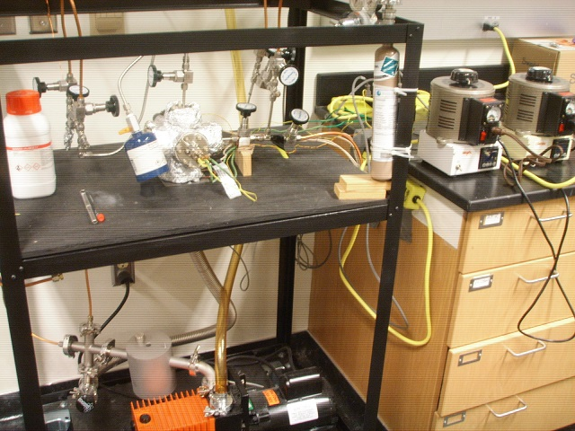

Francisco Zaera Group
Prepared by ZhihuanWeng, January 2014

Table of Content

- General Considerations/Overview of Equipment
- General Laboratory Safety
- Gas and ALD Precursor Handling System
  - Design, Schematics
  - Gas Lines and Delivery
  - ALD Precursor Delivery
    - High Vapor Pressure Precursors
    - Low Vapor Pressure Precursors
    - Working with Pyrophoric Materials
  - General Operation Procedure
  - Maintenance
    - Building Gas Lines
    - Valves
    - Pressure Gauges
    - Mechanical Pumps
    - Finding Leaks
- ALD Reactor
  - General Description
  - Initial Assembly
  - Solid Sample Holder
  - Experimental Procedure
    - Initial Setting Up
    - ALD Cycles
    - Final Steps
  - Maintenance and Troubleshooting
- Typical Experiment Sequence
- Suggested Training for Beginners

- General Considerations/Overview of Equipment

This homemade atomic layer deposition (ALD) reactor, located in room CS 143, is designed to grow thin oxide (Al₂O₃ or SiO₂) films uniformly on the surface (and/or inside the pore) of porous and nonporous powder materials such as SBA-15 and MCM-41.

The ALD reactor is composed of the following parts (see Picture below):

- Reaction chamber: This reaction chamber can be heated up to 120°C by using heating tapes wrapped around its outside.
- Sample holder: Made out of a Ni sheet and heated by a Ni wire. A thermocouple wire pair is spotwelded to the back side of the Ni sheet to follow the temperature of the sample. The sample holder can be modified based on the requirements of the sample to be treated. The highest temperature that can be reached at the sample is around 350°C when full heating power is applied.
- Heating system: Two heating systems are associated with the reactor, one for the chamber and the other for the sample holder.
- Precursor/purging gas delivery line: Two precursor and purging gas delivery lines are attached to the chamber. If the precursor has a high vapor pressure, it can be attached to the system directly, otherwise, a bubbler can be used.
- Vacuum system: The vacuum system is evacuated by a mechanical pump. An Alcatel pump is used. The ultimate pressure in the reactor should be around or below 10 mTorr.

- General Laboratory Safety

Before starting any experimental work in the laboratory, all users must learn The Laboratory Safety Manual and pass all exams. Users must also get familiar with the Injury and Prevention Program (IIPP) and Chemical Hygiene Plans (CHP).

All users must be familiar with the location of the fire extinguishers, safety showers, and other safety equipment before starting anyexperimental work. In Room CS 143:

- Fire Extinguishers: Located next to front door of CS 143.
- Safety Showers and Eyewash Station: Located next to the front door of CS 143.
- Fire Exit: two doors in CS 143
- First Aid Kits: Located next to front door of CS 143.

Some general points to keep in mind:

- Always follow the laboratory safety procedures described in the appropriate documents when handling chemicals and electrical instruments.
- Never touch the parts that are inside the reactor directly with unprotected hands. Wear gloves and make sure that they are clean. Powder free latex gloves should be used.
- The reactor, i.e. stainless steel six-way cross, can be washed with hot water and Liquid-Nox type detergent. Rinse thoroughly when finished. Give the parts a fine rinse in ethanol before baking in a stove to dry.
- Small parts can be submerged in a beaker containing acetone or ethanol and placed in an ultrasonic bath. When using an ultrasonic bath, be sure not to place the beaker into the ultrasonic bath directly, rather suspend the beaker in a bath fluid (water).

- Gas and ALD Precursor Handling System

- Design, Schematics

The gas line was designed to purge the ALD chamber and carry the precursor to the chamber. As shown in above schematic, the two functions of the gas line can be switch by tuning the valves.

- Introduce gas for purge: open V1, V3 and V9, close other valves.
- Introduce gas for carrying precursors (bubbling system): take precursor A as example, open V1, V4, V5 and V9, close other valves.

Gas flow was controlled by the valve, and the pressure in ALD chamber was monitor by pressure gauge.

- Gas Lines and Delivery

As mentioned above, the gas line has two functions, introduce gas to purge chamber and carry precursors to sample holder.

For the delivery of gases:

- Make sure the gas pressure on the gas cylinder side is around 15-20 Psi.
- Do not go above 20 Psi.

- ALD Precursor Delivery

- High Vapor Pressure Precursors

If the precursor has a sufficiently high vapor pressure, it may be delivered directly. The container with the precursor gas, liquid, or solid can be attached directly to the ALD reactor supply line. The precursor and line may require heating to increase the vapor pressure to 100 mTorr.

- Low Vapor Pressure Precursors

- Precursor and Line Heating

- Bubbler

- Working with Pyrophoric Materials

Many ALD chemical precursors are high reactive or flammable. Trimethylaluminum (TMA) in particular, used to deposit Al₂O₃ films, is one of them. TMA also causes eye and skin burns, and is extremely destructive to the tissue of the mucous membranes and upper respiratory tract. TMA may also be harmful if swallowed, inhaled, or absorbed through the skin.

When working with TMA or another pyrophoric precursor, the instructionslisted below need to be followed. Before starting any operation, prepare as follows:

- Carefully review the SOP.
- Do not work with TMA when alone in the Lab.
- Wear the appropriate PPE:
  - Eye protection: Safety glasses with side shields should be worn;
  - Skin and body protection: Wear flame-resistant lab coat, long pants, and closed-toe shoes.
  - Hand protection: At a minimum, wear a nitrile chemical-resistant glove.
- Locate the powdered lime (sand, left bottle in Picture below), fire extinguisher, eyewash and safety shower.

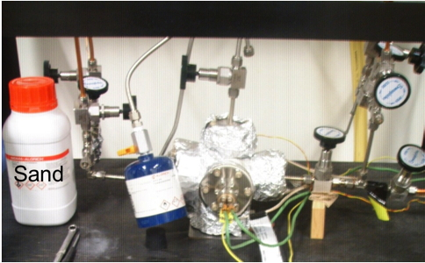

Concerning the set up of the experiment:

- TMA is a volatile liquid. It is stored in stainless steel containers with a ball valve (blue container in Picture above).
- The container must be connected to the ALD reactor via Swagelok fittings.
- Pump the reactor by using a mechanical pump. Keep it pumped all the time.
- In our lab, TMA can only be used when it is connected to a well-pumped reactor.
- The precursors introduced into the reactor by directing its vapor via a leak valve.
- Do not try to get any neat TMA liquids out from the container!

To carry out an ALD process with TMA (or another pyrophoric precursor):
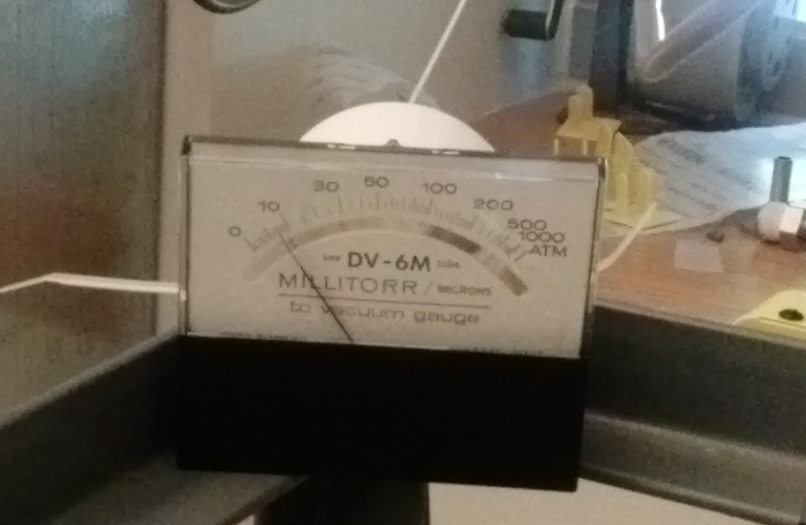
- Check the reactor for possible leaks. The base pressure in the reactor should around 5-10 mTorr, as read in the thermocouple gauge (see Picture on the right). Fix any leaks before connecting the TMA to the reactor.
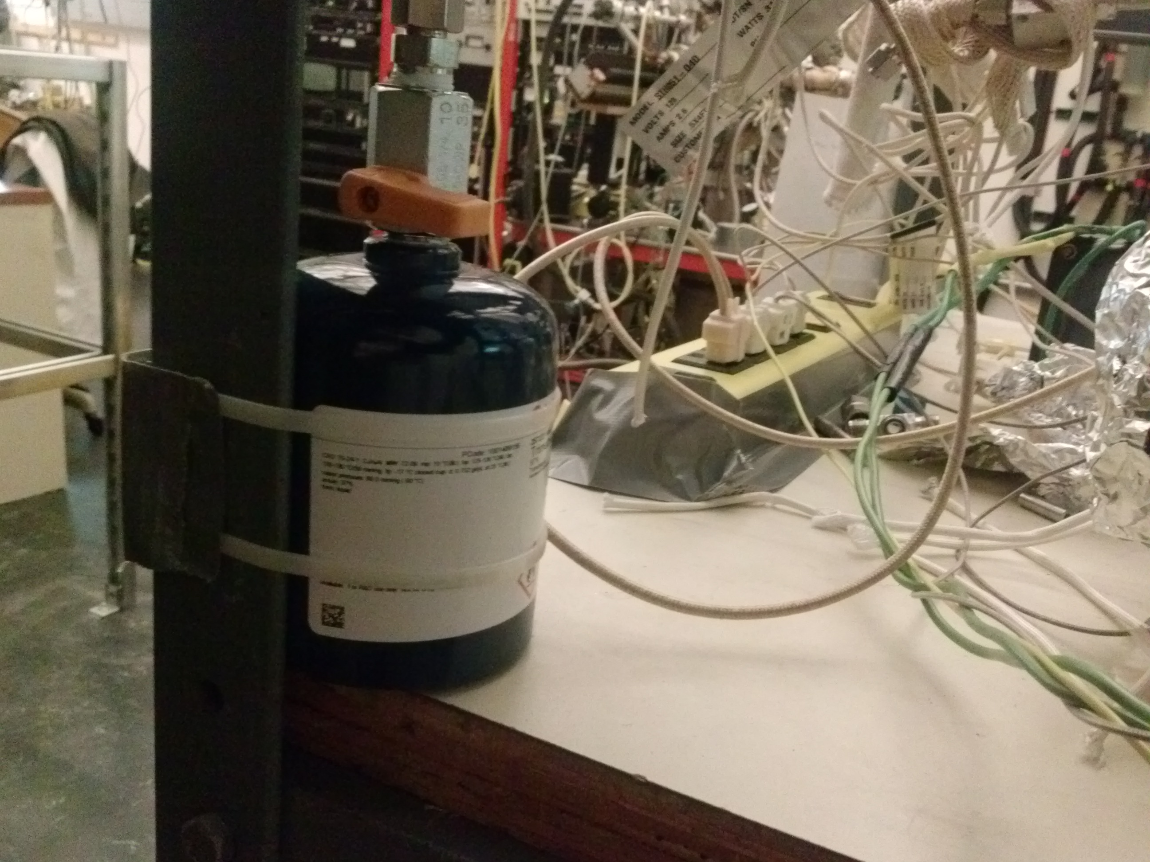
Ball Valve
- Connect the TMA container to the reactor by using a Swagelok fitting. When handling TMA, ware safety glasses, a fire-retardant lab coat, and gloves. When TMA is not in use, the ball valve of the metal container should be always in off position (see Picture on the right).

- Pump the reactor down before initiating the ALD experiments.

- To initiate the ALD cycles, open the ball valve of the TMA container.

- The exposure times to be used in the ALD experiments may be varied from one to a few seconds.

- Right after the TMA exposure, shut off the TMS container ball valve.
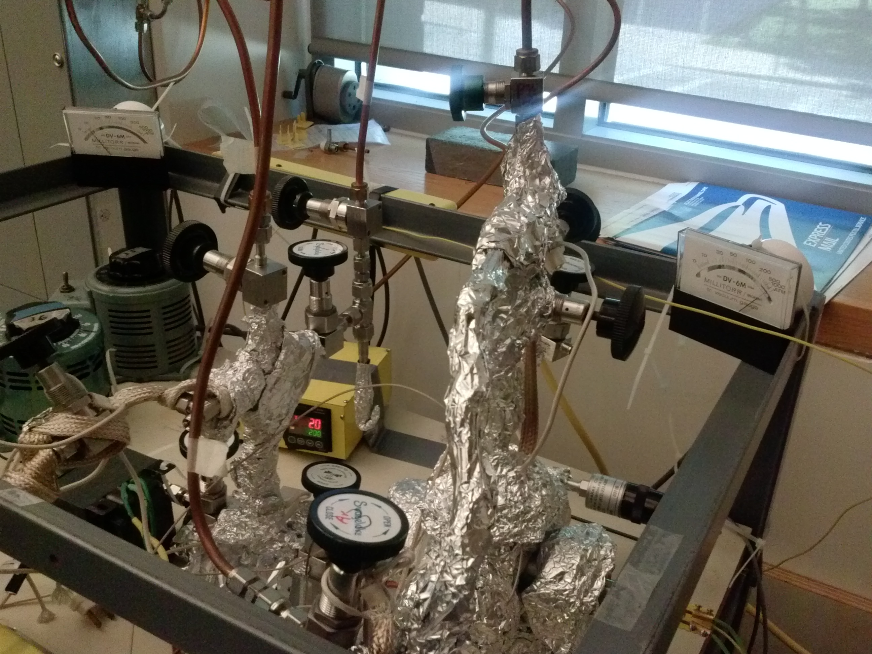
Purging Gas Valve
- Immediately afterwards, introduce a purging gas (Ar or N₂) into the reactor via the purging gas valve (see Picture on the right)and flow it about 1 minute. Adjust the purging gas valve to maintain the pressure in the reactor around 200-500 mTorr. Do not try to backfill the TMA container with other gases.

- The reactor body is normally heated to around 100°C to minimize the amount of water vapor inside the reactor volume. However, no part of the TMA container should be subjected to a temperature higher than 125°F (52°C).

- In case of power failure during the exposure experiments, follow the steps below:

  - Immediately shut off the ball valve of the TMA container.
  - Open the purging gas valve to leak purge gas into the reactor.
  - 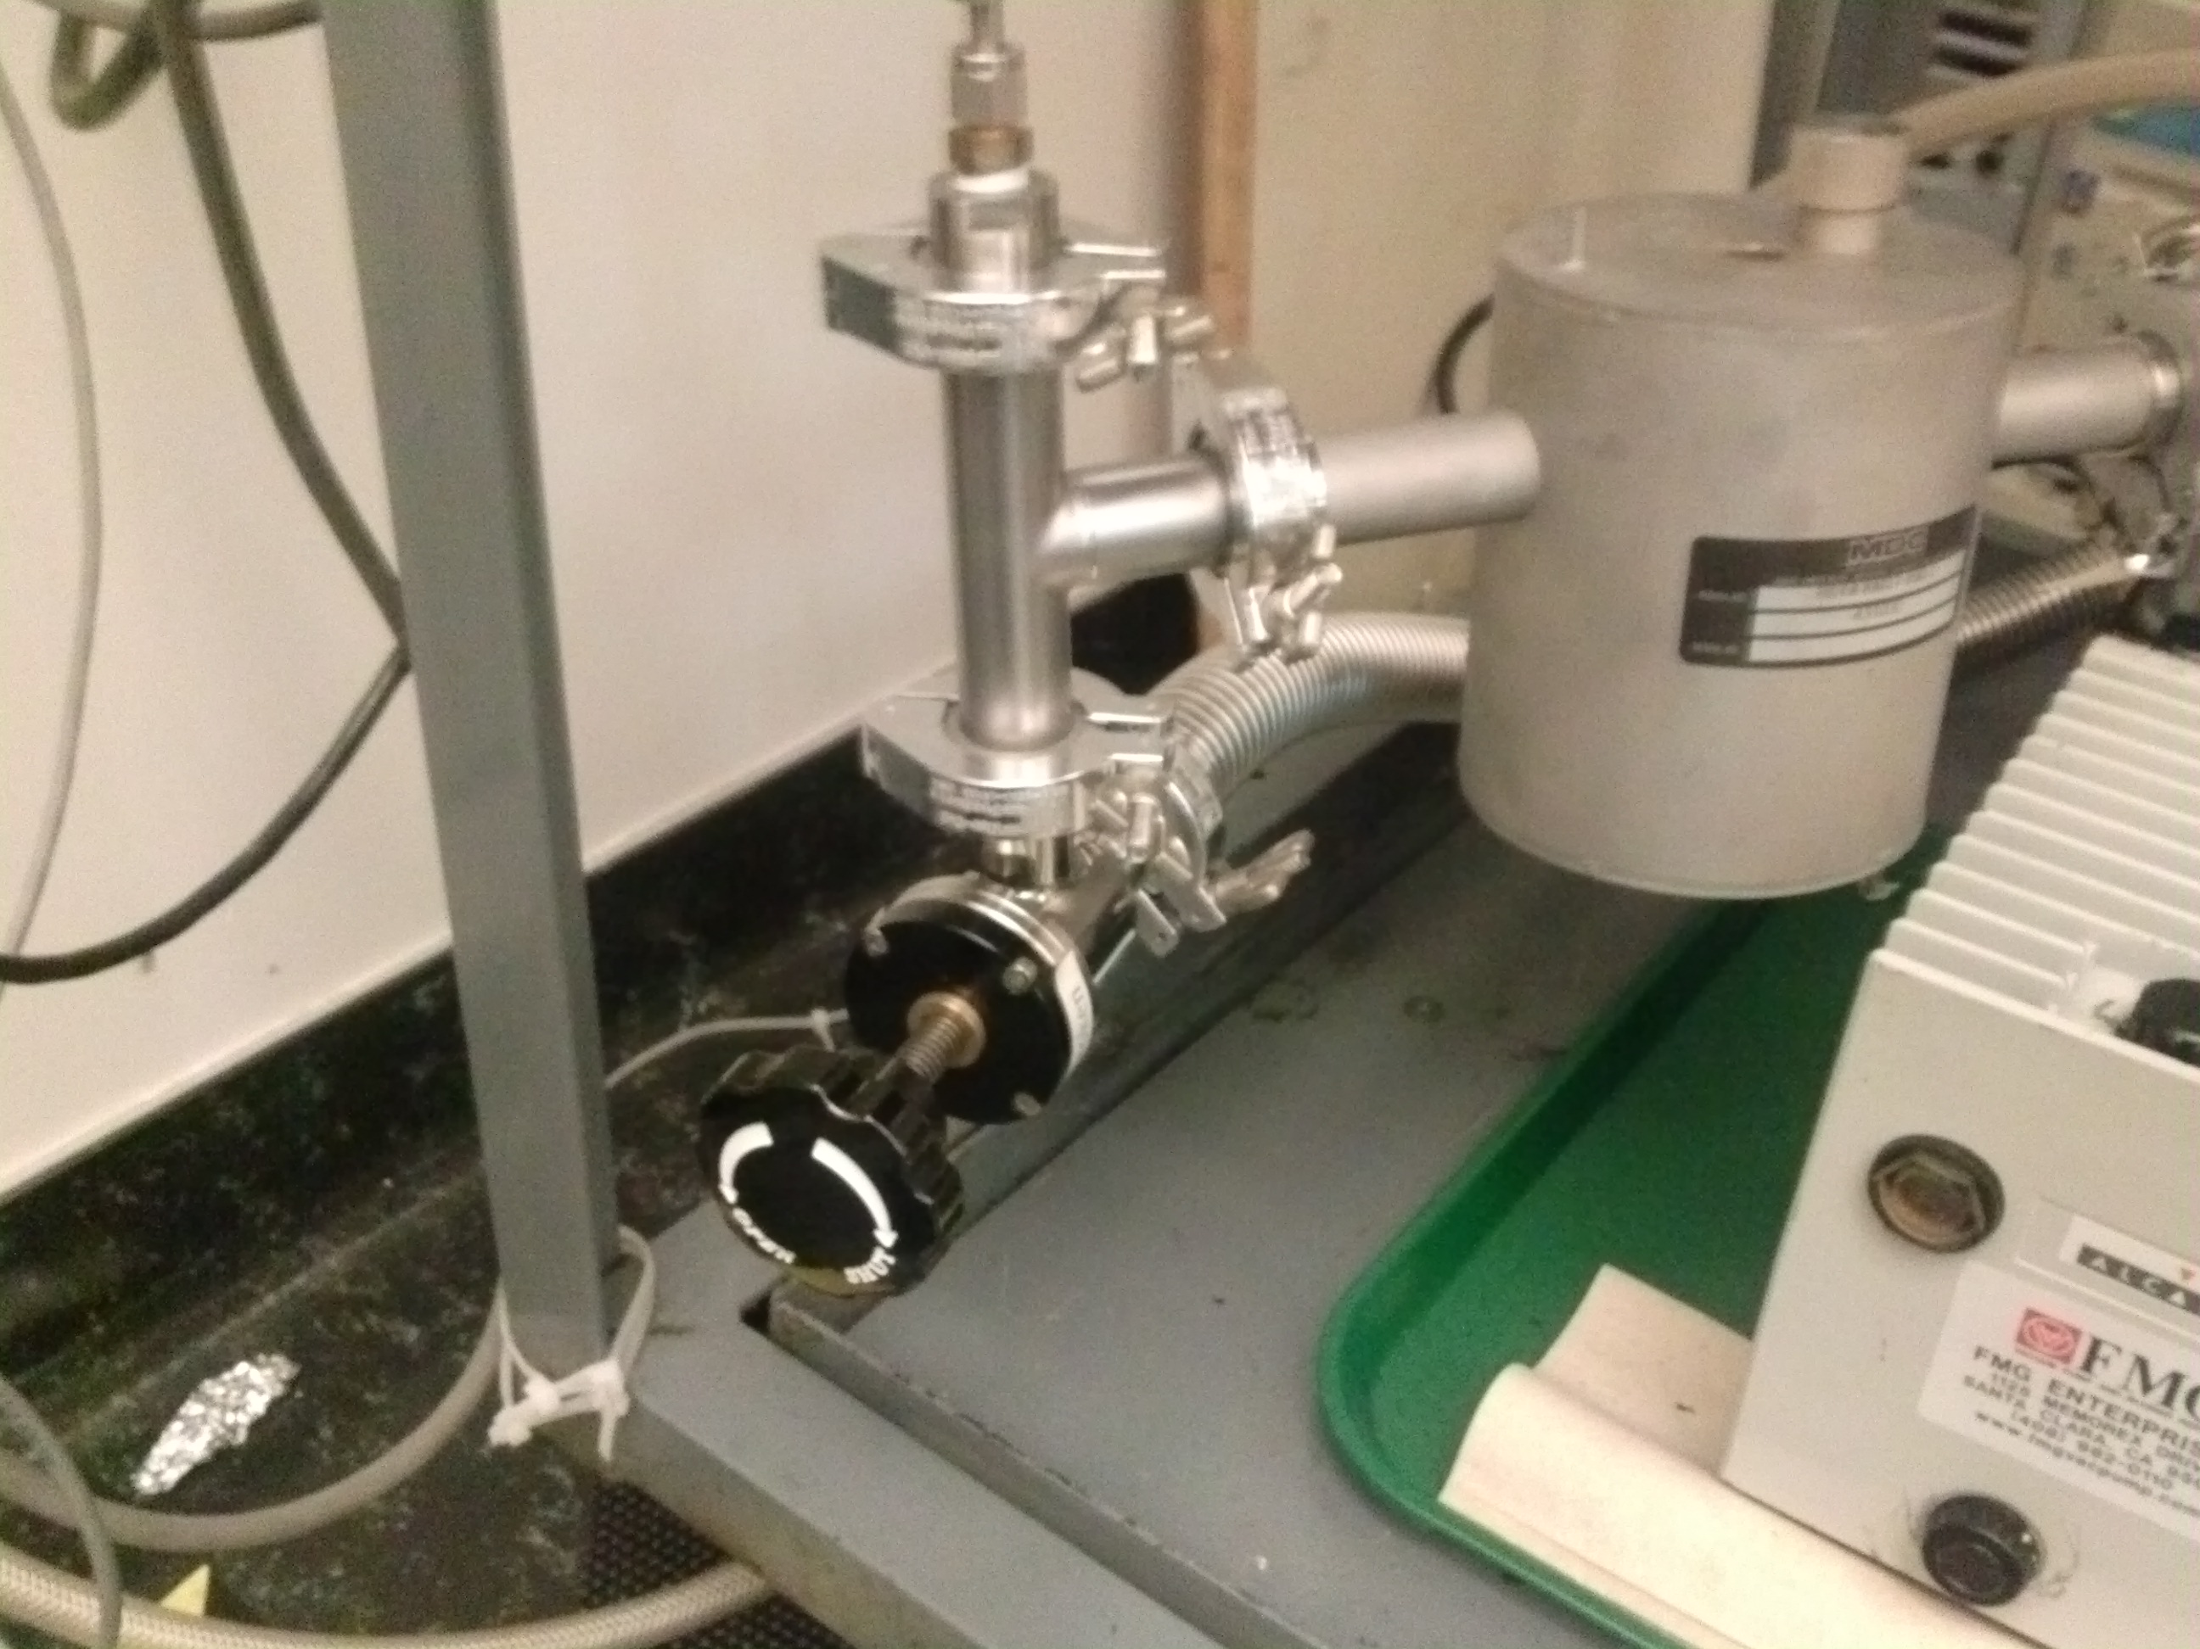Close the angle valve (see Picture on the right) above the mechanical pump.
Angle Valve
  - When the power returns, make sure that the mechanical pump is back and running.
  - Then open the angle valve.
  - At the same time, close the purging gas valve.
  - The pressure in the reactor should drop as it is pumped.

- In case of Fire:

- If a fire comes out from the section between the ball valve and the container:

- Immediately apply dry powder or use a fire extinguisher.
- Do not try to reach or remove the TMA container.
- Call for help if the fire is large.

- If a fire is inside the reactor:

- Immediately close the TMA container ball valve.
- Close the angle valve.
- Introduce the purging gas into the reactor by opening the purging gas valve.

- If a fire comes out from the Swagelok fittings:

- Immediately close the TMA container ball valve.
- Apply dry powder or use a fire extinguisher.
- Check the vacuum in the reactor and connections.

- General Operation Procedure

To pump the reactor:

      - Close all valves, particularly the ones to the gas supply lines.
      - Turn on the rotary vacuum pump.
      - Check the pressure in the line by using the TC gauge that is connected directly to the gas line close to the pump.
      - Once the pressure in the gas manifold is below the 2 mTorr regime, open the valve that connects the dosing line to the batch reactor loop.
      - The pressure reading at this point should be close to 2 mTorr.
      - If this is not the case, close the valve again and check the connections for leaks.

- Maintenance

- Building Gas Lines

To build gas lines, typically stainless-steel (or sometimes copper) tubing is assembled using Swagelock connections (ultra-torr connectors). These connections can create ultrahigh vacuum level of sealing and can be reused if handled properly. Refer to the description of the parts and their handling in the Swagelok catalogue. Avoid mixing brass and stainless steel connections, as brass is softer and ferules and threads can be damaged. All nuts have to go smoothly on the thread; do not force a nut on a connection!

To assemble a section of a vacuum line:

- Clean the tubing with acetone before assembly.
- Cut the tubing to the required length.
- Attach the fitting:
  - Insert the tubing into the fitting (or into a nut and place the ferrule in it, the small ring first).
  - Turn the nut finger-tight against the male component of the Swagelock (the coupling piece, elbow, "T", cross, etc.).
  - Hold the body of the fitting with a back-up wrench.
  - Tighten the nut 1-1/4 turns (only a 3/4 turn for tubing smaller than 3/16").
  - Open the nut again to check if the ferrule is sitting tight and the lower ring cannot be moved.

For easy-to-remove connections, ultra-torr connectors are used, they were employed to connect two tubings with 90º angle.

- Valves

All of the valves used herein were from Swagelok (SS Bellows-Sealed Valve, Gasketed, Spherical Stem Tip, 1/4 in), and they were operated by manual.

Maximum temperature pressure rating: 315 ºC at 27.5 bar;
Room temperature pressuring rating: 37 ºC at 68.9 bar.

- Pressure Gauges

- A thermocouple (TC) gauge is used to measure the pressure in the reactor.
- Thermocouple gauges are prone to burnout, especially when used with corrosive gases.
- If the pressure readout is high:
  - First check to see that the cable connecting the pressure sensor to the readout unit is solid.
  - If the connection is good, it is likely that the TC gauge needs to be replaced.

- Mechanical Pumps

The mechanical pump (Alcatel, 2008A model) requires regular oil changes, approximately once every half-year or when large quantities of corroding or contaminants gases are used in the experiments. The oil can be occasionally degassed by leaking air in the inlet for a short period of time (this heats up the oil), but once the oil becomes dark, changes consistency, or has solid particulate, it is best to change the oil:

- Drain the existing oil from A as shown in right picture.
- Add new mechanical pump oil from B.
- Typically, oil from Kurt Lesker (TK0-19+) is used.
- The volume of this pump is approximately 1 L.
- Fill in the pump with fresh oil using a syringe or a funnel, and the level of oil can be watched from window C.
- Replace the molecular sieve in the sieve trap D at the same time with the oil is changed.
- The used oil and molecular sieve material must be disposed through the Environmental Health and Safety department.

Standard Operation Procedure for Oil Change:

      - Wear proper PPE (gloves, safety goggles, and lab coat).
      - Stop the pump and remove all the connection.
      - Isolate the mechanical pump from the reactor.
      - Wait for 10 min before starting the oil change; the pump oil may still be hot.
      - Lift the pump on a moving cart (there is one stored in CS 137).
      - Place the waste oil bucket below the pump.
      - Remove the top screw of the pump.
      - Slowly unscrew the bottom screw and let the oil drain into the bucket.
      - Make sure that all the oil has been drained.
      - Fill the pump with 0.5L or a little less of clean oil.
      - Rinse the pump by running it for 5 min.
      - Stop the pump and drain the oil (again, wait until it cools off before proceeding).
      - Multiple rinses may be needed depending on the extent of the contamination of the pump. Judge based on the quality of the oil drained after rinsing.
      - Fill the pump with clean oil. Do not overfill.
      - Tighten all the screws and connect the pump back to the reactor.
      - Start the pump and check the base pressure.
      - Place the used oil in the waste bottle with a proper chemical waste tag.

Parts replacement and rebuilding of mechanical pump may be done in the machine shop.

- Finding Leaks

Gas lines should check for leaks once assembled:

- Isolate the gas lines connected with ALD chamber by closing the appropriate valves when possible.
- Open the valve for vacuum, if the value of pressure gauge can’t be lower than 5 mTorr, tighten the ultra-torr connectors.

If the precursors for ALD were sensitive to oxygen and humidity, the line also need to be purged with N₂ before experiments.

            - Isolate the gas lines connected with ALD chamber by closing the appropriate valves when possible.
            - Open the valve for vacuum, and then introduce N₂ into system, and the value of pressure gauge was maintained around 200 mTorr for 5 min.

- ALD Reactor

- General Description

Please see the information in the first part General Considerations/Overview of Equipment.

- Initial Assembly

Please see the information about the safety to work on ALD reactor and some general points to keep in mind, in the second part General Laboratory Safety.

- Solid Sample Holder

- The sample holder is made of a Ni sheet and heated by a Ni wire (the Ni wire was spotwelded to the back site of Ni sheet).
- A thermocouple wire is spotwelded to the back side of the Ni sheet, therefore, the temperature monitored here is the real temperature of Ni foil but not powder.
- The sample holder can be modified based on the sample.
- For powder sample, the powders were placed in a shallow tray in a layer ～1 mm deep and covered with a tight fitting wire cloth lid to contain the SBA-15 while allowing access to the ALD precursor vapors;
- The sample holder was mounted to ALD chamber with 2 3/4" Conflat style flange (see right picture). After add a gasket, the flange with sample holder was fixed by six cap screws. After the reaction, the six cap screws were loosened, and the sample holder can be taken out.

- Experimental Procedure

- Initial Setting Up

To perform a standard ALD experiment:

  - Load a new powder sample in the sample holder:
        - Place ~40 mg of the powder sample in the shallow tray (length 3 cm, width 2 cm, height 0.7cm), as a layer ~ 1 mm deep.
        - Covered with a tight fitting wire cloth lid to retain the powder while allowing access to the ALD precursor vapors.

  - Mount the sample holder on the ALD reactor (See the detail information in above part Solid sample holder).
  - Check the resistance between the two heating electrodes (see Picture above, B is the right connection ).
  - Check the thermocouple reading.
  - Open the angle valve to pump (MDC, KAV-100 model) the system down to around 5mTorr (see Picture A below). Vacuum angle valve is device that regulate the flow of gases a structure or aperture by opening, closing or obstructing a port or passageway. The structure of the angel valve was shown in Picture B below.

  - In most ALD experiments, the ALD reactor needs to be heated. If so, heat the ALD reactor to the desired temperature, typically ~110 ºC, by adjusting the variacs used to run the heating tapes wrapped around the reactor (see Picture C above).
  - Pretreat the sample as appropriate. For most silica-based porous powders:
        - Heat the sample to the desired temperature (typically ~ 200°C) by using the temperature controller. Set the target temperature as 200°C in the controller, and then tune the output voltage to 40 volt in the autotransformer (see Picture C above).
        - Heat the powder for ~ 2 hr in vacuum to degas it and remove any physisorbed water.

- ALD Cycles

Carry out ALD cycles by introducing one precursor at a time and using a purging gas in between, The precursor and gas were introduced from the gas lines by closing the appropriate valves when possible.

- Start the ALD cycle by delivering the trimethylaluminum (TMA) precursor from its stainless steel bottle, which is held at room temperature:
  - Open valve V1 (see Left Picture below).
  - Open valve V2 (see Left Picture below).

  - The TMA vapor is introduced to the chamber without carrier gas, at a pressure of 200 mTorr for 120 s.
- Purge the reactor:
  - Open valve V4 (see Right Picture above), if not open yet.
  - Close valve V3 (see Right Picture above), if not closed yet.
  - Open valve V5 to introduce N₂ gas to the reactor, to purge the system.
  - Purge with 500 mTorrN₂ for 300 s.
- Introduce the second precursor, deionized (DI) water for oxide deposition:
  - DI water is held in a glass tube with a bubbler.
  - Open V6 (see Right Picture above).
  - Regulate valve V7 to control the pressure of water.
  - Typically, use~ 200 mTorr for 120 s.
- Purge the system again, as in Step 2, for 600 s.
- Repeat the steps 1-4 for the designed number of ALD cycles to build the appropriate oxide film thickness.

- Final Steps

After ending the ALD cycles:

- Finish with a purge gas (Ar or N₂) to keep the pressure inside the ALD reactor around 500 mTorr.
- Age the sample at the reaction temperature for ~ 2 hrs.
- Stop all heating, of the reactor and sample.
- When the sample cools down, close the angle valve.
- Stop the purging gas.
- Open the ALD reactor and remove the sample for future analysis.

- Maintenance and Troubleshooting

- Periodically inspect all electrical wiring and pressure connections for corrosion. Suspect parts should be replaced by components supplied by corresponding vendor.
- Periodically clean the ALD chamber, the powder sample will run out of the shallow tray although it was covered by a tight fitting wire cloth lid.
- Before ALD operation, make sure that the amount of precursor in the cell is enough for the reaction.
- Periodically check the pressure gauge, it is easy to be killed by some precursor and contaminant. If the value of pressure gauge can’t reach below 5 mTorr under vacuum, after exclude the leak of connection of system, it will be the problem of gauge.
- Once the pump oil becomes dark, changes consistency, or has solid particulate, it is best to change the oil.

- Typical Experiment Sequence

SBA-15 powder was chosen as typical example to show the ALD process to grow Al₂O₃ film inside the pore, with trimethylaluminum (TMA) and H₂O as precursors.

- Initial Steps

      - Review the SOP of TMA and Al₂O₃ located in room CS143.
      - Wear a flammable-resistant lab coat, safety goggles and nitrile chemical-resistant gloves.
      - Check the pressure of N₂ gas cylinder is around 15 Psi.

- ALD operation

            - Place around 40 mg of SBA-15 in the shallow tray, covered with a tight fitting wire cloth lid.
            - Mount the sample holder on the ALD chamber with 2 3/4" Conflat style flange.
            - Connect the two heating electrodes and thermocouple.
            - Open the pump angel valve, reduce the pressure of ALD chamber below 5 mTorr.
            - Switch on the heating for sample holder and chamber, the temperatures are 200 °C and 110 °C, respectively, and this pretreatment is hold for 2 h prior to ALD cycles.
            - After pretreatment, the TMA vapor is introduced to the chamber without carrier gas at a pressure of 200 mTorr for 120 s, and then the nitrogen gas is passed through the reactor at 500 mTorr for 300 s.
            - The deionized water is held in a glass tube with bubbler, and is injected into reactor at a pressure of 200 mTorr for 120 s, and then the nitrogen gas is passed through the reactor at 500 mTorr for 600 s.
            - The steps 6 and 7 are repeated for five times, respectively.
            - After age the resulting sample at 200 °C under vacuum for 2 h, the final sample named ALD-5-SBA-15 is obtained.
            - Switch off the heating for sample holder and chamber, after the temperature is cooled down to room temperature, loose the flange to take out the sample.

- Suggested Training for Beginners

              - Emergency Action Plan (EAP) and Fire Prevention Plan (FPP)
              - Hazardous Waste Management
              - Laboratory Safety Manual & Chemical Hygiene Plan
              - Personal Protective Equipment (PPE)
              - Injury & Illness Prevention Plan (IIPP)
              - Laboratory Safety Orientation
              - Fire Extinguishers

