RAIRS UHV CHAMBER (#2)

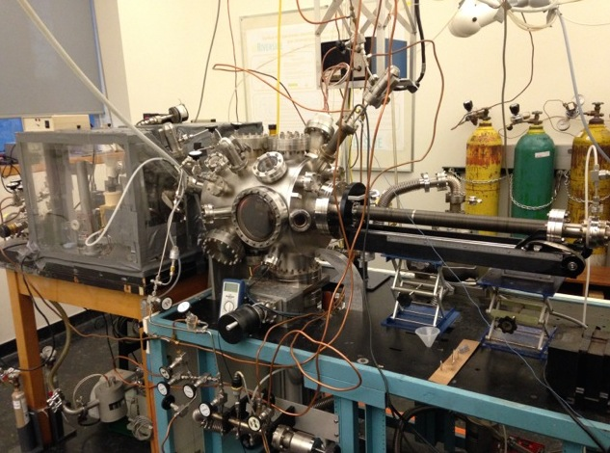

INSTRUCTION MANUAL

Juan Pablo Simonovis, September 2014
Revised Mindika Tilan Nayakasinghe, May 2022

TABLE OF CONTENTS …………………………………………………………………………………..1

- General Considerations/Overview of Equipment………………………………………………………..3
- Vacuum System………………………………………………………………………………………….4
- General UHV chamber (drawing, picture)………………………………………………………….5
- Flange assignment…………………………………………………………………………………..5
- Pumping system (turbopump, cryopump)…………………………………………………………..5
- Ion gauge, Pressure reading, Filament replacement, and maintenance…...………………………...7
- Venting the chamber………………………………………………………………………………..8
- Evacuating the system……………………………………………………………………………....8
- UHV bake out……………………………………………………………………………………….8
- General maintenance………………………………………………………………………………..9
          - Removing and remounting flanges………………………………………………………..9
          - Gaskets…………………………………………………………………………………….9
          - Cryopump…………………………………………………………………………………9
            - Regeneration………………………………………………………………………….9
            - He compressor, absorber……………………………………………………………10
            - He high pressure…………………………………………………………………….11
i. Leak detection………………………………………………………………………………………...11
j. What to do after a power outage……………………………………………………………………...12
- High-pressure cell………………………………………………………………………………………12
        - General chamber…………………………………………………………………………………..12
        - Pumping system (turbopump, cryopump)…………………………………………………………13
        - High-pressure cell operation………………………………………………………………………13
        - Gas feeding and recirculation……………………………………………………………………..14
        - Seals……………………………………………………………………………………………….15
        - Pressure reading…………………………………………………………………………………...15
        - Operation of the system……………………………………………………………………………15
          - Setting up and pressurizing………………………………………………………………15
          - Performing kinetic measurements with MS……………………………………………...16
          - Pumping and opening back to UHV……………………………………………………..16
        - Maintenance……………………………………………………………………………………….17
          - IR windows………………………………………………………………………………17
          - O-Rings…………………………………………………………………………………..17
- Sample………………………………………………………………………………………………….17
  - Mounting a Pt sample (holder, spot welding, adding TC)……………………………………...…17
  - Mounting a copper sample………………………………………………………………………...18
  - Repair of manipulator……………………………………………………………………………...18
    - Power and thermocouple feedthrough…………………………………………………...18
    - Wiring……………………………………………………………………………………18
    - Sample holder……………………………………………………………………………18
    - Manipulator troubleshooting……………………………………………………………..19
  - Heating, cooling, troubleshooting…………………………………………………………………20
  - Biasing the sample………………………………………………………………………………...23
  - Cleaning (Pt(111) single crystal)………………………………………………………………….23
  - Chemical cleaning…………………………………………………………………..23
  - Ar sputtering………………………………………………………………………...24
  - How to determine that it is clean……………………………………………………26
  - Copper (polycrystalline) sample cleaning and in-situ characterization…………...………………26
    - Copper sample preparation………………………………………………..……26
    - Polishing the copper sample…………………………………………………....26
    - Ex-situ chemical cleaning……………………………………………………....27
    - In-situ cleaning…………………………………………………………………27
    - In-situ characterization……………………………………………………..…..27
    - Issue with the thermocouple connection……………………………………….27
  - Temperature reading………………………………………………………………………………27
  - Heating power supply (operation, calibration)…………………………………………………….27
- Gas handling, gas manifold…………………………………………………………………………….32
  - Design, schematics………………………………………………………………………………...32
  - Valves, regular and to UHV……………………………………………………………………….33
  - Tubing, Connectors (Swagelok, etc.)…………………………..………………………………….34
  - Pressure gauges……………………………………………………………………………………35
  - Pumping system (mechanical pump)……………………………………………………………...35
  - General operation procedure………………………………………………………………………36
  - Gas and liquid sample handling…………………………………………………………………...36
  - Maintenance……………………………………………………………………………………….37
- Mass spectrometer (UTI 100)…………………………………………………………………………..37
  - General operation………………………………………………………………………………….37
    - Turning on, off, keeping in stand by……………………………………………………..37
    - Displaying in Oscilloscope………………………………………………………………38
    - Recording MS in PC……………………………………………………………………..39
    - Calibration………………………………………………………………………………..40
    - Maintenance……………………………………………………………………………...40
  - Temperature Programmed Desorption (TPD)……………………………………………………..42
    - General Considerations…………………………………………………………………..42
    - Software……………...…………………………………………………………………..42
    - How to take TPD data………………………………………………………………..…..43
      - General details…...……………………………………………………………..43
      - Running procedure……………………………………………………………..43
      - Data acquisition………………………………………………………………...44
      - Data processing and Editing. …………………………………………………..44
  - Acquiring isothermal kinetic data under high pressure…………………………………..………..44
- Reflection-absorption IR Spectroscopy (RAIRS) ……………………………………………………..44
  - General considerations………………………………………………………………………….....44
  - RAIRS setup (drawing, mirror specs, detector) …………………………………………………..46
  - Sample setup…………………………………………………………………………………..…..46
    - General preparation………………………………………………………………………46
    - Sample positioning……………………………………………………………………….47
    - Calibration………………………………………………………………………………..47
    - Signal optimization………………………………………………………..……………..48
  - Typical FTIR parameters (scanning speed, #scans, iris setting, resolution, acquisition time)……48
  - Acquiring background spectra…………………………………………………………………….48
  - Acquiring sample spectra……………………………………………………………………….....48
  - Operation of polarizer……………………………………………………………………………..49
  - How to obtain RAIRS under high pressure………………………………………………………..49
  - FTIR maintenance……………………………………………………………..…………………..50
    - Replacing the IR lamp………….………………………………………………………..50
    - Replacing the HeNe Laser……….………………………………………………………50
    - Alignment………………………………………………………………………………..51
    - Cleaning the mirrors……………………………………………………………………..52
    - Dry air purging system and box…………………………………………………………53
- Pt dosing……………………………………………………………………………………………….53
- Potential hazards and safety procedures……………………………………………………………….54
- Things to check before going home…………………………………………………………….……..55
- Appendices……………………………………………………………………………………………..56
  - Linearized Temperature with Output Voltages……………………………………………………56
  - Conversion Table for the "TC PREAMP OUT" for Temperature Below 0° C…………………...57
  - Software………………………………………………………….………………………………..58
  - Vendors……………………………………………………………………………..……………..63
  - References……………………………………………………..…………………………………..66

1. GENERAL CONSIDERATIONS/ OVERVIEW OF EQUIPMENT

This document is intended to give the reader the necessary instrument-specific information for the immediate operation of the RAIRS chamber located in the Chemical Science Bldg. room 135. All manuals for supporting equipment should be consulted when detailed information is required. Make sure that all manuals are at hand for these events.

GENERAL.

Repairs to the ultra-high vacuum (UHV) chamber are inevitable. Normally this requires opening the chamber to replace parts. However, some details need special attention when working on those parts that are directly exposed to vacuum:
Never touch parts that are exposed to vacuum with bare hands. Wear gloves and make sure that they are clean. Replace gloves frequently, particularly after touching dirty tools. Use powder-free latex gloves.
Large parts i.e. stainless steel flanges and tubing, can be washed with hot water and Liqui-Nox detergent. Rinse thoroughly when finished. Give the parts a final rinse in methanol or acetone then bake in an oven to dry. Smaller parts can be submerged in a beaker containing an acetone/methanol mixture and placed directly in the ultrasonic cleaner. When using the ultrasonic cleaner, float the beaker in the water bath or suspend it in the bath using a ring stand.

OVERVIEW OF EQUIPMENT.

The RAIRS Ultrahigh Vacuum System consists of a two-tier stainless-steel chamber pumped to a base pressure of 1x 10⁻¹⁰ Torr by using a cryopump. The main level is used for sample cleaning, which is carried out by a combination of argon ion bombardment, annealing, and thermal treatments with O₂. A UTI 100C quadrupole mass spectrometer (MS) retrofitted with a retractable nose cone terminated in a 5 mm aperture is available for temperature programmed desorption (TPD) experiments and for analyzing the gas mixtures product of the high-pressure catalytic experiments. The mass spectrometer is interfaced with a personal computer capable of recording full mass spectra of the gases in the UHV chamber in the 1-300 amu range or alternatively monitors the time evolution of up to 15 chosen masses.

The second level of the UHV system can be accessed by a horizontal long-travel manipulator and it is set up to perform reflection−absorption infrared spectroscopy (RAIRS) experiments. The IR beam from a Bruker Equinox 55 Fourier transform infrared (FT-IR) spectrometer is directed through a polarizer, made to travel inside the UHV chamber through a NaCl window, and focused at grazing incidence (∼85°) onto the sample by using a long focal length (12 in.) parabolic mirror. The reflected beam is then collected, after going through a second NaCl window, by a similar second parabolic mirror and focused onto a narrow-band mercury-cadmium-telluride (MCT) detector. The entire beam path is enclosed in a sealed box purged with dry air and purified by using a scrubber (Balston 75-60) for CO2 and water removal.

The second tier of the UHV also holds a retractable stainless steel cup (∼42 mL total inside volume) that is retrofitted with a Viton O-ring, which can be pressed against the flat surface of a second cylinder mounted on the sample manipulator, behind the sample holder, to form a high-pressure reactor or high-pressure cell that encloses the crystal and isolates it from the vacuum environment. A 1/2-in.-diameter tube is attached to the other end of the cup for gas feeding and gas pumping, which is done by using a manifold equipped with a pressure gauge and a small (∼50 L/s) turbo-pump. Two small NaCl windows are found on opposite sides of the lateral walls of the main body of the cup to allow for the IR beam to travel in and out of the reactor volume to acquire RAIRS data in situ while exposing the sample to atmospheric pressures. A small leak persists between the high-pressure cell and the UHV chamber when in the closed (high-pressure reaction) position because of incomplete sealing by the O-ring. That leak, which causes the pressure in the UHV chamber to rise to approximately 1.0 x 10⁻⁵ Torr upon filling the high-pressure cell with 700 Torr of an Ar/H₂/ C₂H₄ gas mixture, is used to analyze the composition of the gas mixture in the cell continuously versus reaction time by using the mass spectrometer.

Through the ½-in.-diameter tube connected to the back of the cup travels a 1/8-in.-diameter stainless steel tube that feeds the desired gas mixture directly on the platinum sample. This tube leads to an external loop that consists of a series of bellows valves and a Metal Bellows Pump MB-21 capable of recirculating a gas mixture greater than ~ 600 Torr at a flow rate of 6 L/min. This setup allows the high-pressure cell to operate as a well-mixed batch reactor.

2. VACUUM SYSTEM.

a. GENERAL UHV CHAMBER.

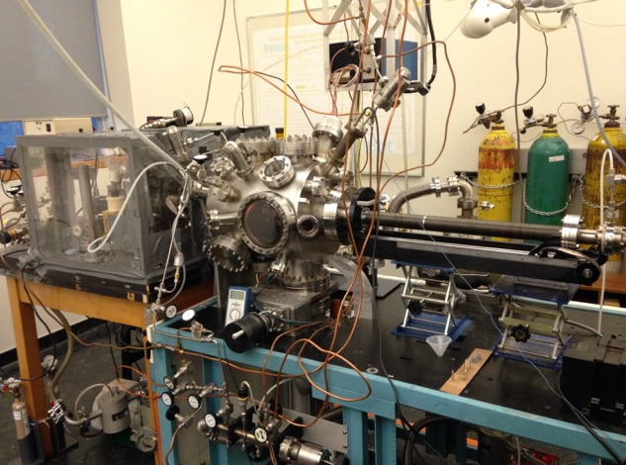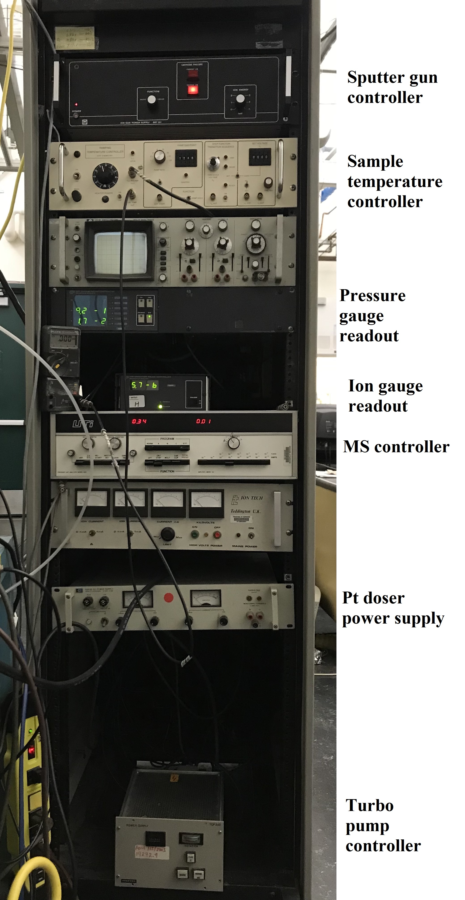

Figure 2.1. General UHV chamber (RAIRS chamber) and the electronic units
b. FLANGE ASSIGNMENT
When closing a port on the UHV chamber with a copper gasket–sealed CF flange, it is very convenient to use a torque wrench. It helps to establish a uniform crash of the gasket and prevents over-tightening, especially if Viton gasket is used instead of copper for a temporary mount. If the chamber will be baked after the mount, less torque should be applied than the maximum, as it is better to tighten bolts a little more after bake-out is done. The following table will help to set a proper torque:

Tabel 2.1. Tightening the bolts with a torque wrench.

Flange size, inch | Bolt number | Torque, lb-ft
1 1/3 | #8–32 | 7
2 ¾ | 1/4–28 | 10
4, 6, 8 | 5/16–24 | 12
10 | 5/16–24 | 15
Viton gaskets, all flange sizes |  | 7

c. PUMPING SYSTEM.

Mechanical Pumps.
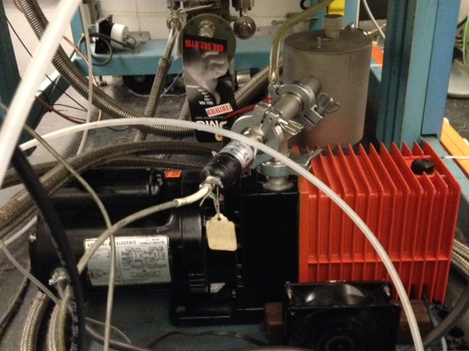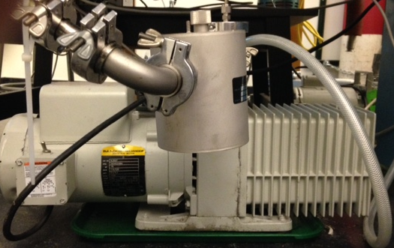
Figure 2.2. Mechanical pumps connected to the RAIRS chamber.

There is an Alcatel 2008A single-phase mechanical pump connected directly to the gas manifold (fig 2.2, left). This pump receives corrosive gasses from the manifold and hence will require maintenance. There is an Alcatel single-phase mechanical pump connected to the TPH050 turbopump. This backing pump is also connected in parallel to differentially pump the rotary platform at the head of the manipulator. Both are equipped with oil traps. These mechanical pumps need to have their oil changed on a regular basis and need to be rebuilt from time to time. Ballasting may be needed. The ballast valve is located on the side.
It is advisable to change the oil every four months, but more frequent oil changes may be necessary if using corrosive substances.

Turbo Pumps.

The UHV chamber has two turbomolecular pumps both of which are oil lubricated. The TPH330 (Pfeiffer) pump controlled by TCP300 (fig 2.3, top left/right) is used to evacuate the chamber to a pressure range in which the cryopump can be switched on without too much of a load. The TPH050 powered by a TCP040 (fig 2.3, bottom left/right) controller and backed by an Alcatel single-phase mechanical pump is used to pump the high-pressure cell (HPC).

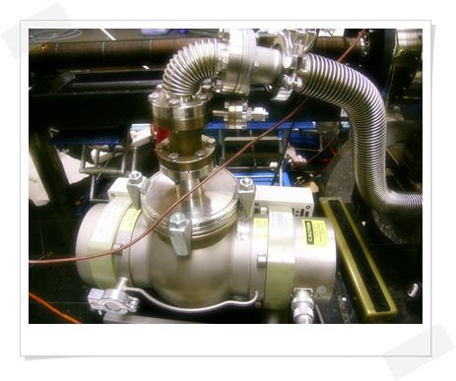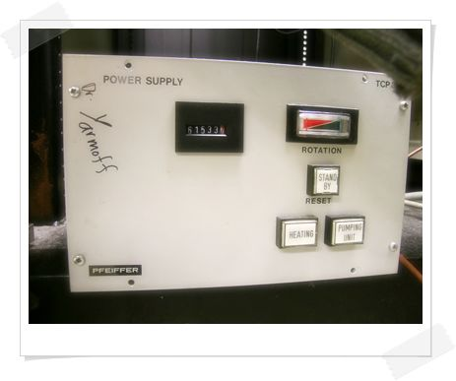
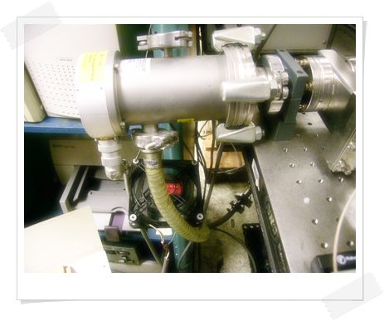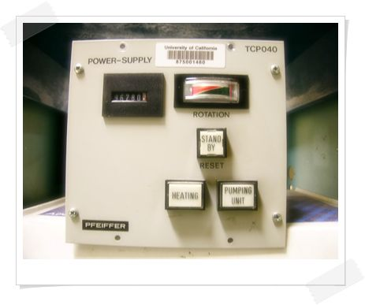
Figure 2.3. Turbomolecular pumps connected to the RAIRS chamber.

Cryogenic Pumps

The Cryopump (Cryo-Torr 8) (fig 2.4, left) is used to reach the UHV working pressure of 10⁻¹⁰ Torr. To achieve this pressure the pump relies on the SC compressor (fig 2.4, right) to circulate and cool down Ultra High Purity (UHP) He. The pump can be isolated from the chamber by the use of a gate valve. This is usually done when maintenance is required. The pump is usually exposed to the chamber when it has reached its optimal temperature and when the base pressure is about 10⁻⁵ Torr. When this pressure range is achieved the metal valve between the chamber and the turbopump can be closed. At this point, the chamber will solely be pumped by the cryogenic system to 10⁻¹⁰ Torr.

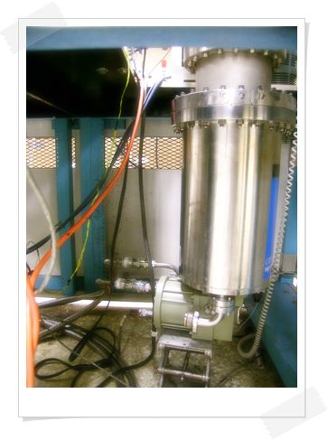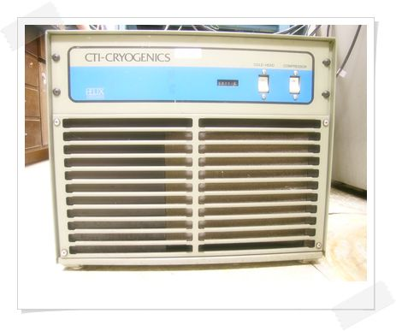
Figure 2.4. Cryo-Torr 8 pump (left) and the model SC compressor (right) connected to the RAIRS chamber

d. ION GAUGE

The main chamber UHV pressure is measured with an open-ended (NUDE) Bayard-Alpert type ionization gauge. Base pressures of 6×10⁻¹¹ Torr have been achieved in this chamber. If the ionization gauge does not turn on, check the continuity of the filament between green and black wires with an ohmmeter (the resistance should be on the order of an ohm). If the filament is open, change to the second filament by connecting the green cable to the pin with the yellow cable. However, if both filaments are open the chamber needs to be vented, the Ion gauge setup needs to be uninstalled and the filaments replaced.

The yellow cable is only for protection. To maintain the Ion gauge, it is necessary to Degas it for a short amount of time after a day's work by setting the “Degas” button on the pressure readout unit. Degassing increases the current that passes through the filament, so if it’s done for too long it decreases its lifetime. If there is an issue with the pressure reading it sometimes helps to turn off the power and then restart the ionization gauge.
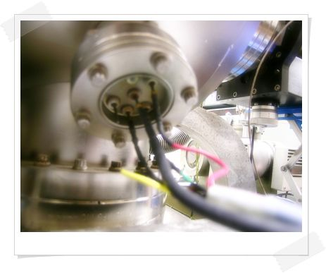
If the pressure inside the chamber is equal to 10⁻⁴ Torr, the Ion Gauge will shut off automatically. Care must be taken when dosing gasses since a big gas load might burn the filament.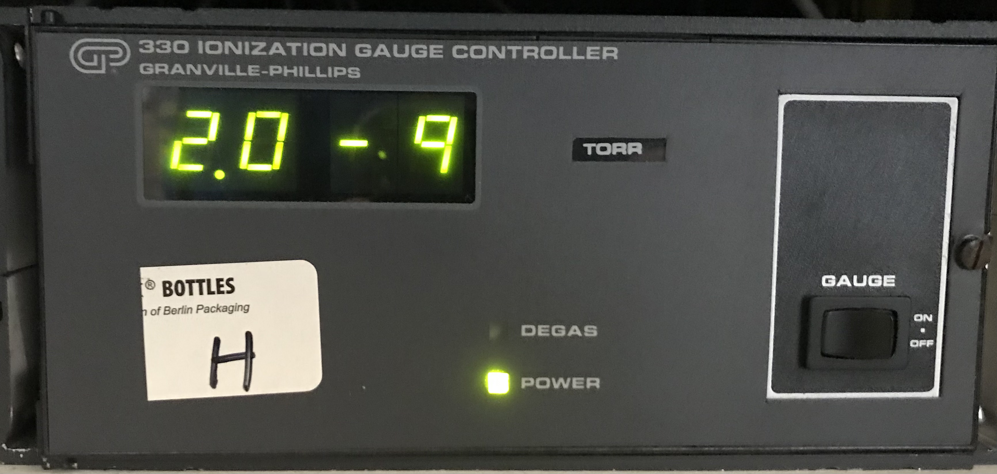

Figure 2.5. The ion gauge and the ion gauge controller connected to the RAIRS chamber.

e. VENTING THE CHAMBER.

As a rule, the chamber is vented with dry nitrogen.

- Switch off the ion gauges by pressing "ON" on the pressure gauge readout.
- Switch off the mass spectrometer by pressing "ON/OFF".
- Close all the leak valves.
- Close the gate valve between the cryopump and the chamber.
- Connect a short length of ¼ inch tubing to one of the unused ports on the manifold from the High-Pressure Cell side and immerse it into liquid nitrogen in a small dewar.
- Make sure the manifold valve close to the small turbo is closed.
- Open HPC in the valve in the chamber and then slowly open the valve on the manifold to let in the nitrogen.
- Wait a few minutes. When the pressure in the chamber has reached 1 atm., it can be opened further to do whatever job necessary.

f. EVACUATING THE SYSTEM.

- Make sure all flanges that were moved are tight and sealed properly.
- Make sure all electrical connections (Ion gun, copper rods, and thermocouples are grounded).
- When evacuating from atmospheric pressure always make sure to rough pump the chamber to 1×10⁻² Torr before turning ON the turbopump.
- Make sure the TPH330 turbopump is connected to the KF-40 connector on the metal valve below the viewport. Use metal flexible tubing, not rubber. Switch on the pump and wait until the pressure in the main chamber is in the low 10⁻⁵ Torr range. This usually takes about 2 ½ hrs. Turn on the ion gauge in the main chamber. The ion gauge will automatically switch OFF when the pressure is above 10⁻⁴ Torr.
- If the pressure in the main chamber is about 10⁻⁵ Torr and the cryopump is cold, close the metal valve between the chamber and the turbopump. Use the torque wrench. Closing torque=35 ft.-lb. Do not tighten this valve more, since this may damage its copper seal.
- Open the valve between the cryopump and the chamber. The pressure should drop quickly to about 10⁻⁷ Torr.
- Bake out the chamber.

g. UHV BAKEOUT.

- Make sure all flanges are tight.
- Position the sample approximately in front of the mass spectrometer.
- Wrap a heating tape and aluminum foil around the bellows on the manipulator.
- Wrap a heating tape and aluminum foil around the sputter gun + mass spectrometer nipple.
- Cover the sodium chloride windows in the IR compartment and all viewports with aluminum foil.
- Connect all heating tapes used to a variac (3 heating tapes around the main chamber body (~80 V), one heating tape around the MS flange (45 V), one heating tape around the sputter gun and the Pt doser flange (45 V), one heating tape around the sample manipulator (45 V), and one heating tape in the second tire of the main chamber (HPC side (45 V))).
- Start the bakeout: use approximately 80 V for the main chamber. Use approximately 45 V for the heating tapes and the IR compartment (see above).
- Bake the chamber for about 48 hrs. The pressure should come down to the lower 10⁻⁸ to mid 10⁻⁹ Torr regime during the bakeout.
- Toward the end of the bakeout (the pressure should be well below 10⁻⁷ Torr), switch ON the filament of the mass spectrometer to degas, by pressing FAR CUP. A residual gas mass spectrum can be taken at this point to check the progress of the bakeout, and the ion gauge can be degassed by pressing "DEGAS" on the pressure readout unit.
- When the bakeout is completed, switch off the heating tapes and the IR lamps and let the chamber cool down for a few hours. Leave the aluminum foil covers on the viewports and sodium chloride windows during this cooling. The pressure should now get down to the usual base pressure of about 10⁻¹⁰ Torr or lower.
- When the chamber is at room temperature, it is ready to use.

h. GENERAL MAINTENANCE.

- Removing and remounting Flanges:

Remove the bolts from the flange. If the flange is oriented vertically, remove the top bolts last. This keeps the flange from dropping before it is ready to be removed. Once the flange has been removed, place it to the side with the copper gasket in place. The gasket will protect the knife-edge. Cover the entire piece with aluminum foil or a plastic flange cap to keep out dust.
When the flange is ready to be remounted, the old copper gasket must be replaced with a new one. Remove the old one with a gloved finger or, if necessary, with a pair of pliers. Use a pulling motion perpendicular to the flange. This will ensure that the knife-edge is not nicked or damaged. If damaged, the knife-edge must be re-machined or the flange replaced with a new one. Place the spent copper gaskets in a central location for recycling.
Place the new copper gasket into the groove of one of the mating flanges, and bring the flange faces together. If the copper gasket falls out of alignment, try again. If repeated attempts to keep the gasket in place fail, then try placing a small piece of tape on the outermost edge of the gasket to secure it to the flange. When the gasket falls into place, the flange faces will be parallel and aligned allowing no lateral play. Be sure to align the notches on the flange faces.
Before tightening the bolts to close the flange, be sure the threads have a light coat of molybdenum disulfide anti-seize lubricant. This will prevent the bolts from seizing up the next time they are removed. Do not, however, use this compound for bolts that are inside of the chamber, as the sulfur will contaminate the vacuum. Finger tighten the bolts to make sure that they go smoothly. The heads of the bolts should be able to close on the flange without a need for a wrench. If not, the nut or the bolt has bad threads and must be replaced. Make sure the gasket does not slip out of its groove. Finally, tighten the bolts with the proper wrench using a crossover pattern to distribute the stress on the flange equally. Tighten until the copper gasket has been ‘cut’. The flanges do not necessarily need to touch.

- Gaskets.

Gaskets make the seal between two Con-Flat-type vacuum flanges. They operate by becoming crushed between the knife edges of the two mating flanges. There are a number of materials used to make gaskets.

Copper: Used extensively, can be baked.

Silver: Used in installations that will be left undisturbed for a long period of time. Less susceptible to oxidation than copper. Also used in cases where knife-edge has been damaged.

Viton: Used in high vacuum conditions such as the gas manifold and is not bakeable at high temperatures.

- Cryopump.

- Regeneration.

This may be necessary if the base pressure of the chamber becomes too high. When the cryopump is to be regenerated, it is necessary to switch it OFF. While the pump gets warm, a lot of gas is released, which is pumped out with a roughing pump.
High partial pressures of non-condensable gases such as Helium, Hydrogen, or Neon (which can be detected by taking a background mass scan) are possible due to the 15K array in the cryopump may have reached full capacity and needs regeneration. Furthermore, if the cold head and the temperature units are working fine but the cryopump failed to maintain UHV, it needed to be regenerated.
Procedure:

- Vent the chamber as described above.
- Switch off the compressor (both switches) on the cryopump.
- Slowly open the manifold valve and evacuate the chamber to approximately 1-2 x 10⁻² Torr. This might take several minutes.
- When the pressure has been reached, close the manifold valve.
- Open the Cryo Pump gate valve all the way.
- Open the valve to the roughing pump and wait until the cryopump is at room temperature (2-3 hrs).
- When the pressure is 1-2 x 10⁻² Torr again proceeds to turn ON the TPH330 turbopump.
- In some cases, when the operating pressure was too high it might be necessary to heat the cryopump carefully to about 70 ˚C or so to guarantee better regeneration. This is carried by wrapping a heating tape around the Cryo Pump and letting it sit for 4–5 hours, or even overnight while pumping with the Turbo Pump at around 10⁻⁵ Torr. If this is not deemed necessary skip directly to step 9 after reaching a pressure of 10⁻⁵ inside the chamber.
- Close the gate valve between the chamber and the cryopump and start the compressor again (both switches).
- After 3 hours the Cryo Pump should be cold again. Close the metal valve that connects the Turbo Pump to the chamber and at the same time open the gate valve between the chamber and the Cryo Pump.
- Follow the normal bake-out procedure from this point on (see above).

Note: If the chamber needs to open during this procedure it is best to do it after step 1.

- He Compressor and adsorber.

The SC compressor on which the Cryopump relies is equipped with a canister filled with an adsorber that acts as an oil and moisture scrubber that prevents the contamination of the He circuit and the cold head (piston) of the pump. It usually needs to be replaced after 13 months.

Removing the adsorber:

- Shut down the compressor.
- Disconnect the compressor input power cable from its electrical power source.
- Disconnect the flex lines from the gas-return and gas-supply connectors at the rear of the compressor.
- Remove the screws holding the compressor rear grille, front grille, rear panel, front panel, and cover. Front and rear panels remain in place.
- Remove the adsorber from the compressor. Save all nuts, bolts, and washers for installing the replacement adsorber.

Installing the adsorber:

- Install the replacement adsorber as follows:
- Remove the dust caps from the self-sealing coupling halves at each end of the replacement adsorber.
- Write the installation date on the adsorber decal.
- Install the replacement adsorber following the steps for compressor adsorber removal in reverse order. Use the hardware saved in step 5 above.
- Connect the adsorber to the compressor's internal piping. Refer to Figure 4.3.
- Check the self-sealing connector flat rubber gasket to make sure that it is clean and properly positioned.
- Make the first turns by hand and then firmly seal the connection using the two wrenches until the fittings "bottom". Refer to Figure 4.3, for proper coupling of the self-sealing connection.
- Replace the cover and the front and rear grilles and secure them with their screws.
- Ensure that the supply pressure gauge reads 245-250 psig (1690-1725 kPa). If additional gas pressure is required, follow the instructions in Section 4.2.1, under Adding Helium Gas.
- Reconnect the return and supply flex lines to the compressor.
- Connect the compressor input power cable to the electrical power source.

- He High Pressure.

The SC He compressor works with an ideal pressure of x psi. Anything below this value will cause the pump to work under substandard conditions that could seriously damage its mechanism. On the back of the compressor, there is a gauge that shows the actual He pressure that is being used in the cryogenic system. Every time maintenance is done to the pump or if the scrubber is replaced the He pressure needs to be adjusted.

To add helium gas:

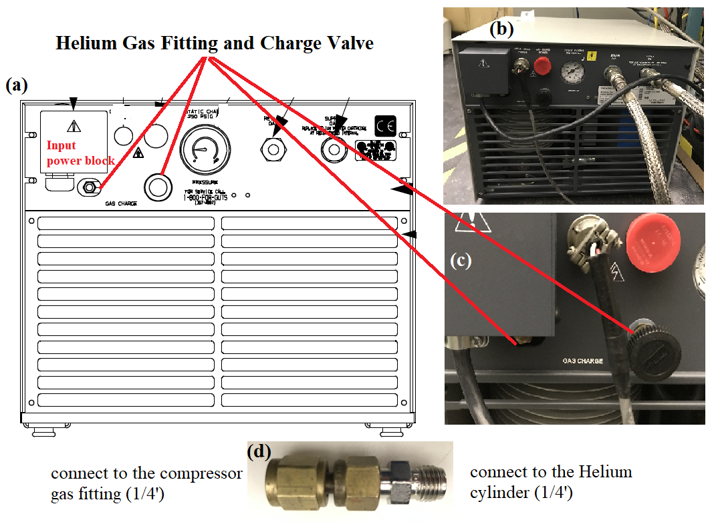
Figure . Rare side of the 8200 compressors.

Helium can be filled following the procedure in the compressor manual (which is also included below). The gas charging valve is easy to locate as in the above figure (a). But, the gas fitting was not easy to locate, which is underneath the compressor input power block. A special Swagelok fitting is needed to connect the He cylinder with the He gas fitting (figure 7(d)), which can be found in the yellow basket, under the table with the Agilent GC system. After figuring out these connections, Helium charging was conducted using the stepwise procedure in the compressor manual.

- Attach a pressure regulator (0-3000/0-400 psig) and charging line to a helium bottle (99.999% pure). DO NOT OPEN THE BOTTLE AT THIS TIME. Purge the regulator and charging lines as instructed in steps a through e below. Do not use helium gas that is less than 99.999% pure.
- Open the regulator a small amount by turning the adjusting knob clockwise until it contacts the diaphragm; then tum approximately 1/8 to 1/4 tum more, so that the regulator is barely open.
- Slowly open the bottle valve, and purge the regulator for 10 to 15 seconds. Tum the regulator knob counterclockwise until the helium stops flowing.
- Connect the charge line to the helium pressure regulator.
- Remove the flare cap of the gas charge fitting on the rear of the compressor. Loosely connect the charge line to the charge fitting.
- Set the helium pressure regulator to 10 to 25 psig (70-125 kPa). Allow helium gas to flow through the charging line and around the loosened flare fitting for 30 seconds to purge the charging line of air. Then tighten the flare nut at the end of the charge line. (The procedure is required to ensure that both the regulator and the charging line will be purged of air and that the air trapped in the regulator will not diffuse back into the helium bottle. For best results, CTI suggests a dedicated helium bottle, regulator, and line, which are never separated, for adding helium.)
- Set the helium pressure regulator to 300 psig (2070 kPa). Depending on the compressor operating state, add helium gas:
- If the compressor is running (approximately 2 hours operating time) under normal operating conditions, slowly open the helium charge valve on the rear of the compressor. When the helium pressure gauge rises to 270-290 psig (1860-2000 kPa), tightly close the charge valve.
- If the compressor is not running, slowly open the helium charge valve. When the helium pressure gauge rises to 245-250 psig (1690-1725 kPa), tightly close the charge valve.
- Ensure that the helium charge valve on the compressor is tightly closed. Shut off the helium pressure regulator on the helium bottle and remove the charging line from the male flare fitting. Shut off the helium gas bottle valve. Reinstall the flare cap.

i. LEAK DETECTION.

A poorer-than-normal vacuum is usually the first indication of a chamber leak. A good indicator is the presence of an oxygen peak on the mass spectrum. A less obvious indication is a higher than normal 14 AMU peak (splitting of N2).
In order to pinpoint a leak, squirt acetone or methanol on suspected areas. When the solvent is drawn into the chamber through the leak, there will be a sudden fluctuation in the pressure indication of the ion gauge. Another method is to blow a fine jet of helium on the suspected area while monitoring the 4 amu peak on the mass spectrometer. Gently blow helium where the flow is sufficient so that it can be felt on wet lips. First, concentrate on the parts that have been opened before the last bake out. If there is a leak, the intensity of the He signal in the mass spectrum should increase immediately.
If no chamber leak can be detected and UHV pressures are still unobtainable, check the hydrogen partial pressure. Hydrogen is the only gas that can significantly back migrate from the roughing side of the turbopump or desorbs from a warming cold head of a cryopump in need of regeneration. Either ballasting the rough pump or changing the rough pump oil can minimize the back migration of hydrogen. It is best to first ballast, or vent the pumping oil.
Major leaks (low vacuum) can be found by backfilling the chamber with no more than 2 atmospheres of argon, then applying soap solution to the suspected areas and looking for the formation of bubbles.

j. WHAT TO DO IN CASE OF A POWER OUTAGE.

Procedure:

- Ensure that the MS filament and the Ion Gauge switches are in the OFF position.
- Isolate the Cryo-Pump by closing all the way the gate valve located at the front of the chamber.
- Turn the compressor and cold head ON/Off switches to the OFF position.
- Vent the chamber by following the procedure presented in subsection (e).
- After a few minutes of venting the chamber, close the metal valve on the back of the chamber using a torque wrench set at 35 ft-lb and detach the nitrogen line.

3. HIGH-PRESSURE CELL (HPC).

a. GENERAL CHAMBER.

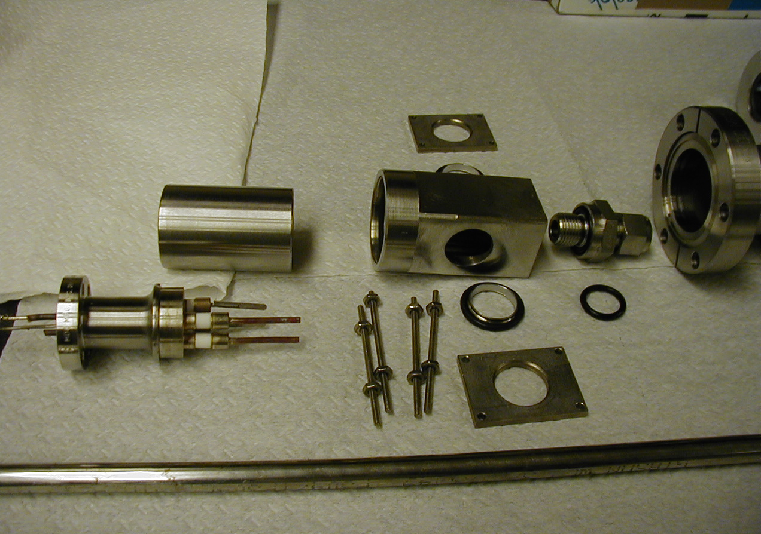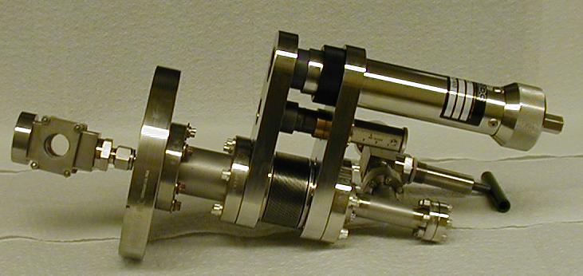

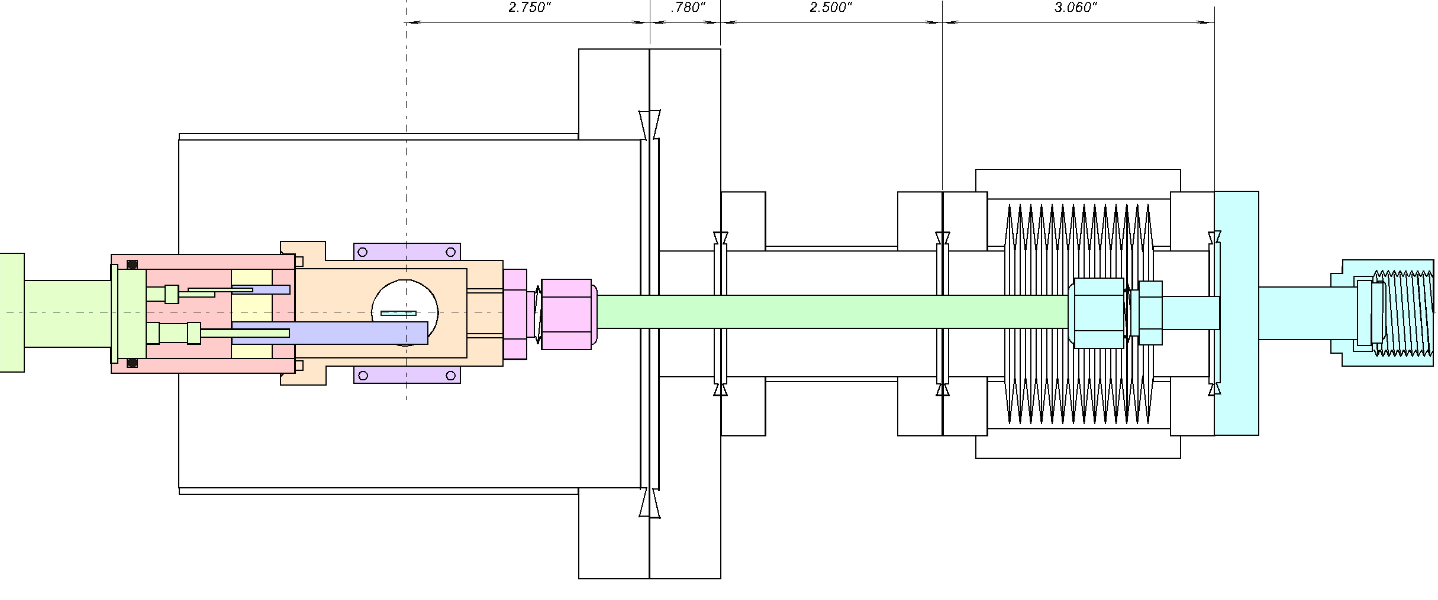
Figure 3.1. High-pressure cell assembly (top) and a schematic diagram of the high-pressure cell (bottom).

The high-pressure cell consists of a stainless steel cup that is set at a fixed angle and possesses a cylindrical inner volume of ~72 mL. The cell is equipped with two NaCl windows that allow the IR beam to pass through it to carry out high-pressure IR experiments. The cup is connected to a ½ inch diameter tube that runs through the end of the chamber, which is composed of a 5 cm travel arm that is enclosed by stainless steel bellows. Through the ½ inch tubing runs 1/8 tube that serves as the gas inlet. In the closed position, the end of this tube lies directly on top of the sample (see picture below).
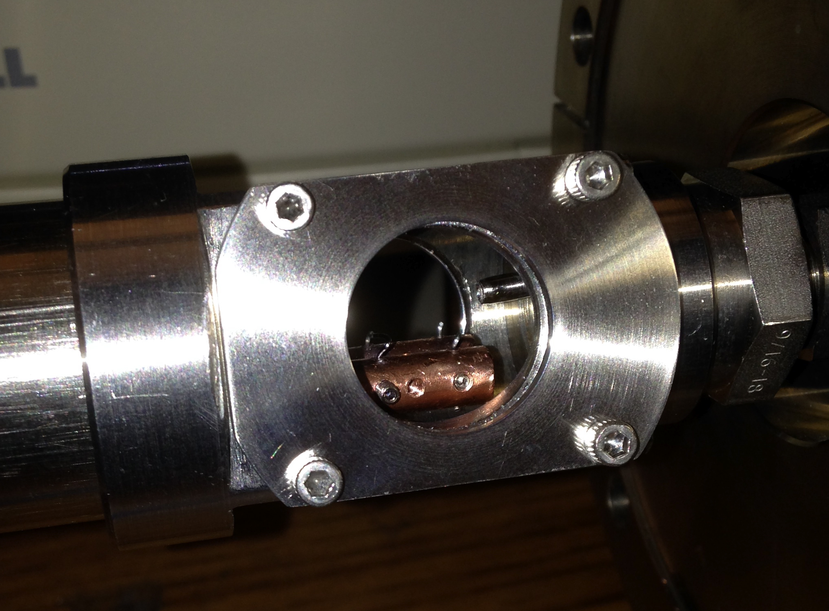
Figure 3.2. The high-pressure cell at the closed position

b. PUMPING SYSTEM.

Mechanical Pumps.

The red Alcatel 2008A single-phase mechanical pump from the manifold is used to pump down all gases from the high-pressure end when gas mixtures are being prepared and when the HPC is being evacuated after an experiment. The white Alcatatel single-phase mechanical pump located under the purge bench is only used as a backing pump for the TPH050 turbopump.

Turbo Pumps.

The TPH050 turbopump powered by the TCP040 controller and backed by the white Alcatel single-phase mechanical pump is used to pump the HPC before opening it to the UHV chamber and to constantly pump down the high-pressure end when it is not in use.

Cryogenic Pumps

When the HPC is open the Cryopump is used to pump down the gases that are adsorbed on the inner walls of the cell and reach the UHV working pressure of 10⁻¹⁰ Torr.

c. HIGH-PRESSURE CELL OPERATION.

The HPC works as a well-stirred batch reactor. In order to operate the cell, the sample manipulator has to be moved to the IR position. Then the stainless-steel cup is moved until it makes contact with the stainless-steel cylinder attached to the end of the sample manipulator (See picture below). At this point, the HPC is screwed in ½ turn so the FFKM O-ring on the cup and the surface of the cylinder makes a tight seal. It is important to use FFKM O-rings (Z1028-122 from Marco Rubber) to make a tight O-ring seal as well as to get good chemical resistance. When this seal has been achieved gases in the order of 700 Torr can be introduced into the cell (Only then!!!). The travel distance of the stainless-steel cup is 5.1 cm., anything less indicates poor sealing.
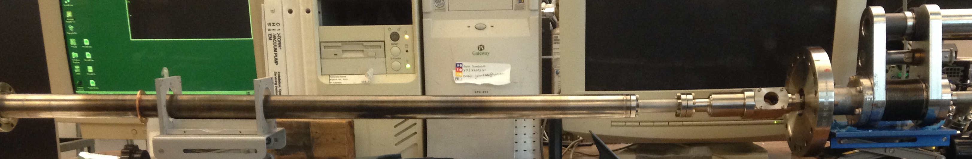
Figure 3.3. The high-pressure cell assembly (outside the UHV chamber)

d. GAS FEEDING AND RECIRCULATION.

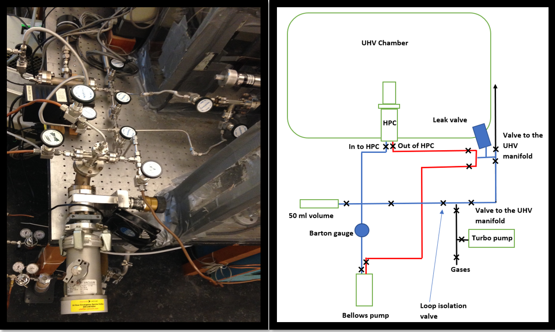

Figure 3.4. The high-pressure cell gas feeding system (left) and a schematic diagram of the high-pressure cell gas feeding system (right).

The HPC gas feeding system is conformed of a three-fold circulation loop located at the-high pressure end of the chamber (all loops share the same pressure gauge):

- Loop # 1: Its sole function is to serve as a flushing line for the bellows pump (BP). This loop does not feed gases into the HPC since its OUT line is connected directly to the gas exhaust that comes down from the ceiling of the lab.
- Loop # 2: Used specifically for gas mixture preparation. This loop is isolated from the HPC by the feed and return valves located on the T that is connected to the external flange of the HPC setup.
- Loop # 3: Used specifically for gas circulation during experiments. This loop allows the HPC to function as a well-mixed High-Pressure Reactor (HPR).

The general gas feeding setup incorporates a series of Swagelok valves, an MB-21 Metal Bellows pump for gas mixing/circulation, a 50 mL stainless steel Swagelok volume used as a gas reservoir for lengthy experiments, and a Baratron Pressure Gauge with a digital readout of up to1060 Torr.

e. SEALS.

All external seals of the high-pressure setup consist of stainless-steel Swagelok parts. The high-pressure cup, however, possesses 2 Viton O-Rings and one FFKM O-ring.

- Two Viton O-rings on the sidewalls: make a tight seal with the NaCl windows of the cup.
- One FFKM O-ring at the UHV end of the cup: Presses against the surface of the cylinder found on the end of the sample manipulator. When the HPC is tightly closed and ~750 torrs of pressure is introduced into the HPC, the UHV chamber pressure can be increased by one order of magnitude (from E-9 torr to E-8 torr).

f. PRESSURE READING.

The pressure reading in the high-pressure end of the system is carried out by means of a Baratron gauge that is equipped with a digital readout. This gauge is capable of reading up to ~ 1060 Torr.

g. OPERATION OF THE SYSTEM.

- Setting up and pressurizing.

Setting up:

- Move the sample manipulator until the position on the scale marks 486.5 cm.
- Adjust the angle of the sample for IR measurements. Make sure you get the maximum number of counts on the IR amplitude.
- Close the HPC by turning the screw on the high-pressure end until the distance on the scale marks 5.1 cm. Make sure to turn the screw slowly when 4 cm is reached to avoid any mishaps in case something is misaligned. Usually, the lack of proper alignment amounts to a maximum travel distance of 4.7 cm.
- Turn ON the MS and set the necessary experimental condition. Load the background for the IR measurements.
- Flush the BP (this step does not necessarily have to be done at this time, it can be done earlier i.e. while prepping the entire system)

Pressurizing the loops:

- Close the valve that feeds the loops.
- Close the gate valve that isolates the TPH050 turbopump.
- If deuterium and an olefin will be used, close the valves that connect to each gas line.
- Pressurize the lines with at least 25 psig of the desired gas.
- Open the valve that connects to the gas line of the desired gas.
- Slowly open the valve that feeds the loops until the desired pressure is reached.
- Close the valve that feeds the loops.
- Open the valve that leads to the UHV manifold and pump down the excess gas.
- When the pressure reading for the UHV manifold reaches the lower limit of the 10⁻² Tor range close the valve that leads to the UHV manifold.
- Repeat steps 4 through 9 for the next gas. (NOTE: If D₂, H_{2,} or Ar are measured first the pressure of the olefin in the line will not be enough to go against the gases in the loop, so they will seep out and the mixture will have to be prepared again).
- Open the IN and OUT valves on the BP.
- Turn ON the BP.
- Mix the gases for at least 15 minutes.
Procedure for flushing the BP:

- Fill the loop with 900 Torr of Ar.
- Open the IN valve of the BP.
- Turn ON the BP.
- Open the exhaust valve of the BP until the pressure in the baratron gauge reads ~710 Torr. When this pressure is reached immediately close the exhaust valve.
- While the pump is operating refill the loop with Ar until the pressure reads 900 Torr.
- Repeat steps 4 through 5 a total of five times.
- Turn OFF the BP.
- Refill the BP with Ar until the pressure reads 900 Torr. The BP must always be pressurized (from 500 to 900 Torr) and must never be pumped down by any means (while the BP is running). Close the IN valve of the BP.
- Pump down the loop with the mechanical pump from the manifold to 10⁻² Torr. Isolate the high-pressure end.
- Open the gate valve to the turbopump.

- Performing Kinetic Measurements with the MS.

Procedure:

- Flush the BP.
- Set up the HPC.
- Turn on the MS: Press the ON button, then press the multiplier button, choose the appropriate gain value, and set the damper to 12 O’Clock (2 O’Clock for very diluted ethylene mixtures).
- Setup the TPD program.
- Pressurize the loop.
- Start the TPD program.
- After mixing the gases for 8-10 minutes, close the valve that connects both sides of loop # 2 and immediately open the feed and return valves to the HPC. Mix the gases with the open HPC in and out valves for further 5-7 minutes (total mixing time of ~15 minutes).
- After mixing, introduce the reaction mixture into the UHV chamber using the leak valve in the loop (see figure 3.4). Slowly open the leak valve and increase the UHV chamber pressure up to 1.0-1.5E-5 torr.
- Monitor the HPC leak on the Ion Gauge readout and track the product traces with the mass spec and the surface species with the IR.
- Run the TPD and MS program as many times as needed.

- Pumping down and opening back to UHV.

Procedure:

- When all IR and MS scans are done turn OFF the BP.
- Close the leak valve.
- Close the IN and OUT valves of the BP.
- Open the valve that isolates the loop from the turbopump manifold (manifold should already be pumped down to 10⁻² Torr!).
- Slowly open the valve that leads to the manifold on the UHV end. Pumped down the HPC to the lower end of the 10⁻² range.
- When the lower end of the 10⁻² range is reached, close the valve that leads to the UHV manifold.
- Open the gate valve to the TPH050 turbopump.
- Pump down the HPC until the pressure reading on the Ion Gauge is about 6.0 x 10⁻¹⁰ Torr.
- When the Ion Gauge pressure reads about 6.0 x 10⁻¹⁰ Torr close the feed and return valves to the HPC.
- Very slowly turn the HPC screw in a counterclockwise fashion. Monitor the pressure increase in the chamber; do not let it go over 1 x 10⁻⁸ Torr. Go back and forth with the screw until a consistent decrease in chamber pressure is achieved.
- When the pressure has reached its lowest value, continue turning the HPC screw until the HPC is fully retracted.
- Degas the Ion Gauge and the MS filaments.

h. MAINTENANCE.

- IR windows.

Part of the consumables of the HPC is the NaCl windows that are pressed tight against the outer walls of the stainless steel cup. Since these windows are always in a UHV environment they have a really long lifetime. They should be replaced if they are foggy or cracked. If a replacement is necessary, the chamber needs to be vented and the high-pressure end of the system needs to be disassembled.
- O-Rings.

The other consumables of the HPC are the Viton O-rings that seal the NaCl windows and the FFKM O-ring that press against the cylinder from the sample manipulator. The ones for the IR windows tend to last a very long time, however, the one that seals with the manipulator can show signs of wear over time. This usually makes it fall from the groove on the stainless-steel cup. If this happens the chamber needs to be vented, the HPC end disassembled, and the O-ring replaced.

4. SAMPLE.

a. MOUNTING A Pt SAMPLE.

The sample is mounted on an in-house ceramic holder allowing samples to be easily removed, mounted, and exchanged between chambers. All chambers have or will have the same sample platform (i.e. feed through) attached to the end of their respective manipulators. The different samples will be connected permanently to their own holder.

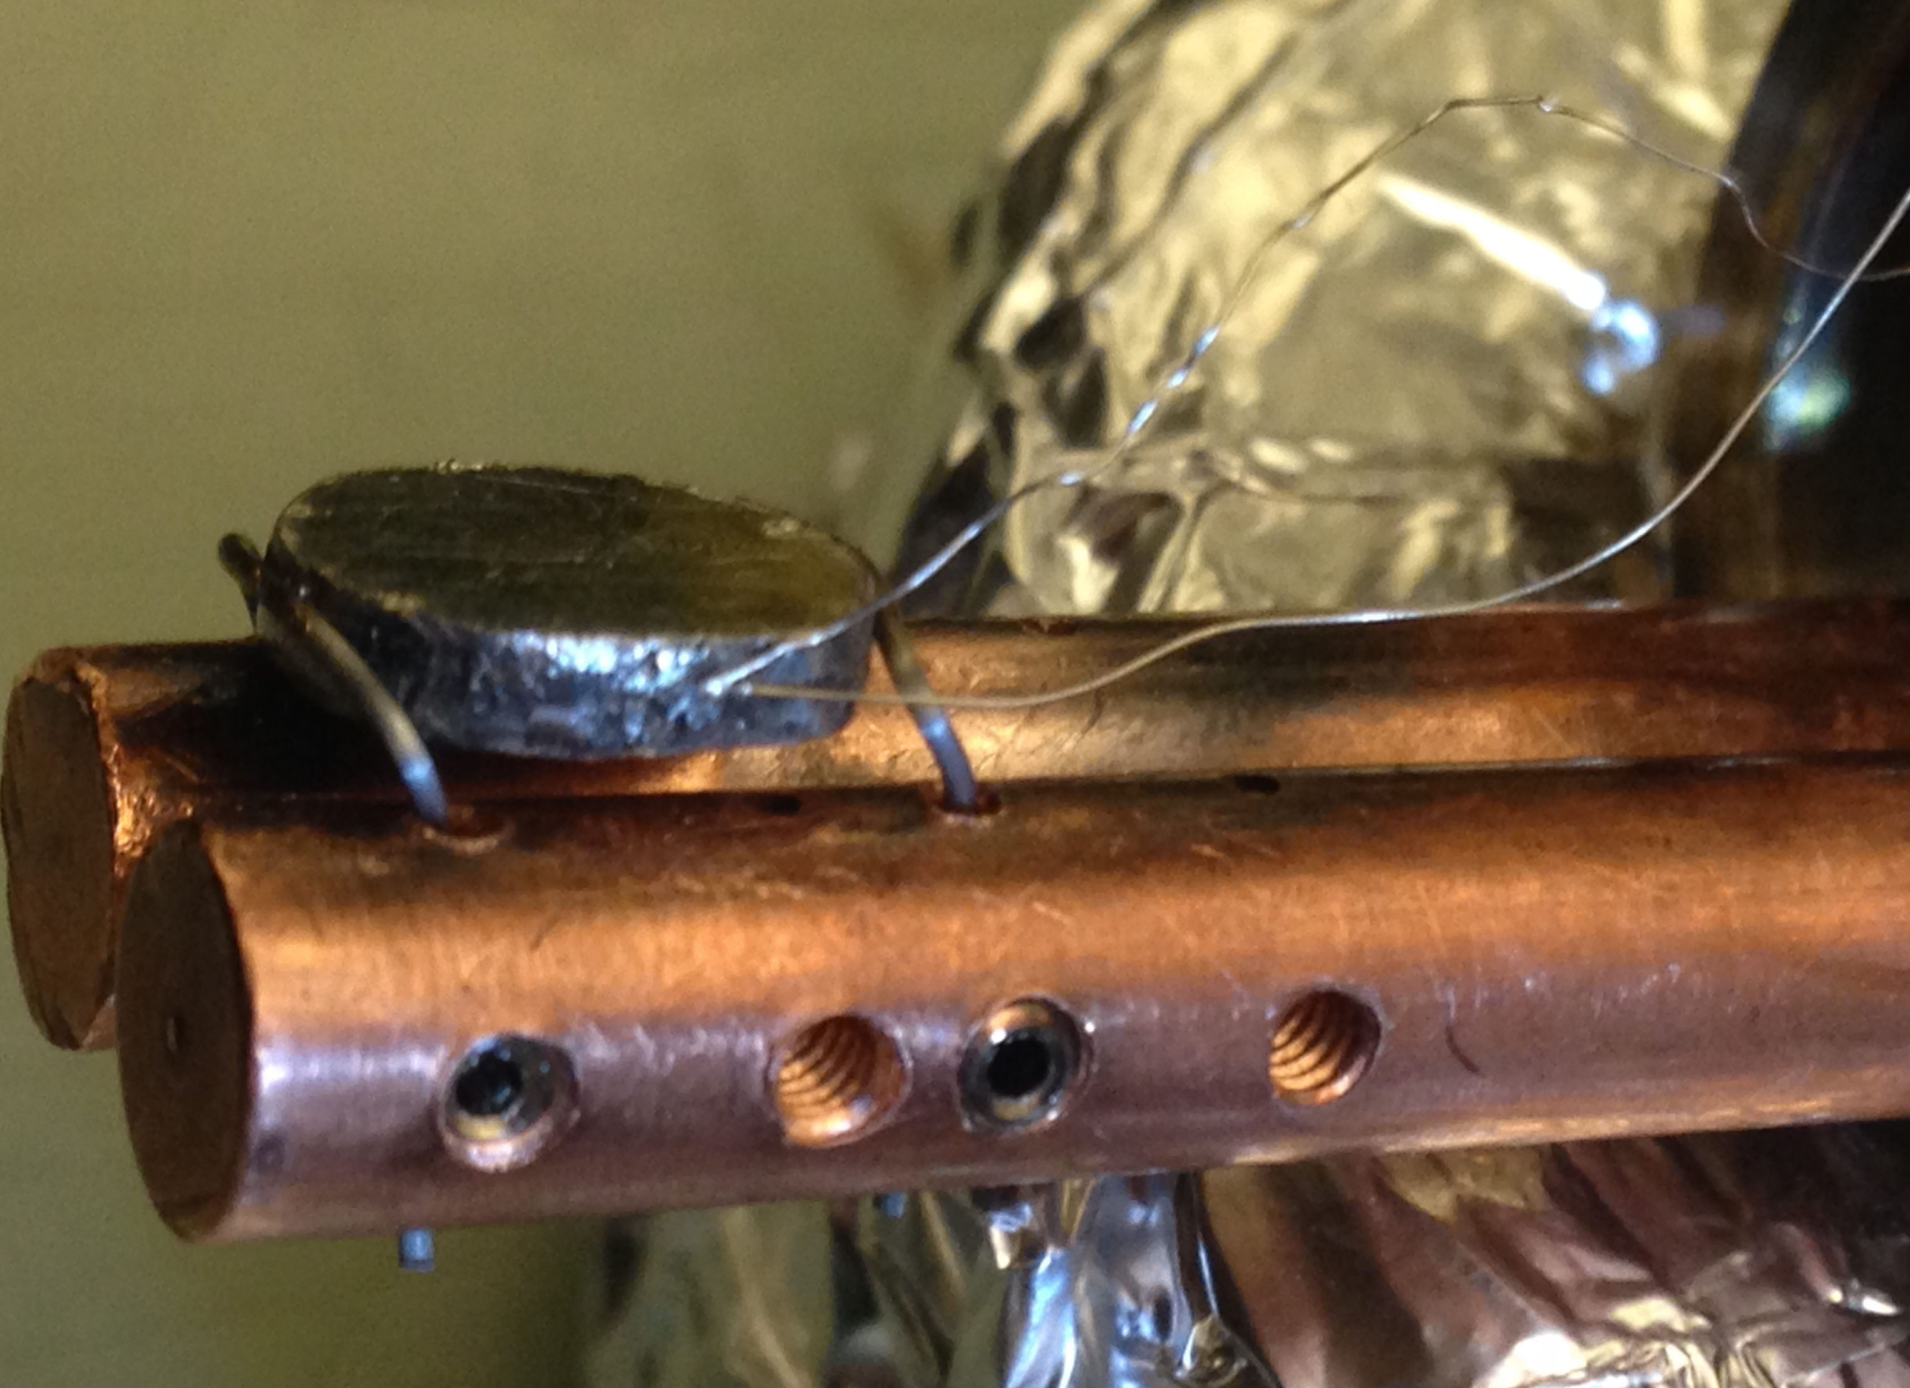
Figure 4.1. A Pt sample mounted on the sample holder

The sample holder connects to the sample platform by four setscrews located on the bottom of the ceramic block. Operationally, the sample is spot welded to molybdenum wires, which are in turn fastened by setscrews to the copper rods in the holder. Making good spot welds will require some practice. Suggested settings to use on the welder are shown below for various combinations of materials.

Table 4.1: Suggested settings to use the welder.

Material | Thickness (inch) | Power Settings
Alumel to Chromel | 0.02 | 60 (low)
 | 0.01 | 20 (low)
Alumel to Platinum | 0.02 | 90 (low)
 | 0.01 | 90 (low)
Chromel to Platinum | 0.02 | 90 (low)
 | 0.01 | 80 (low)
Tantalum to Platinum | 0.5 | 60 (high)

Notes: | 0.01 mm diameter thermocouple wire should be used to connect the sample holder to the sample and 0.02 mm diameter thermocouple wire otherwise.
b. MOUNTING A COPPER SAMPLE

Mounting a copper sample is somewhat challenging compared to the Pt sample, because copper cannot be spot wielded. Therefore, a suitable copper disk should be prepared with groves carved in sides to secure the sample with the heating element and a hole to attach the thermocouple (see figure 4.10). To make a better thermocouple connection, thicker K-type thermocouple wires can be used (0.3302 mm diameter), which fits the hole of the current polycrystalline copper sample well. To make the connection more stable, a tiny copper wire can be inserted into the hole with the thermocouple wire.

c. REPAIR OF MANIPULATOR.

- Power and Thermocouple Feedthrough.

This is the electrical feed through which the sample is mounted. It conducts the thermocouple signal out of the chamber, electrical power to the sample for heating, and heat out of the sample when the liquid nitrogen is flowing. The present system employs a feedthrough purchased from Insulator Seal that requires special order. When requesting this part number, explain that it will be used in a cryogenic application; otherwise, the seals will be chemically attacked by the liquid nitrogen and eventually fail to keep the vacuum.

- Wiring.

If the thermocouple wires or the copper rods inside the manipulator need to be worked on, the manipulator probe has to be taken out. This is a lot of work, so try to avoid this; but if it is necessary:

- Vent the chamber.
- Take the manipulator out of the chamber.
- Remove the sample holder from the end of the power/thermocouple feedthrough.
- Remove the power/thermocouple feedthrough to access the spot-welds.

- Sample Holder.

The sample sits at the end of the manipulator, which sticks in from the left of the chamber and can be rotated or moved from the mass spectrometer position in the chamber to the IR cell. The exact position of the sample is read from the scale at the back of the manipulator and on the rotary feedthrough at the end. The two 1/4" copper rods that run through the manipulator tube are used for heating and cooling the sample. The thermocouple wires also come out at the end of the tube.
The rotary feedthrough is differentially pumped by the roughing pump used for the UHV manifold. The pressure in the differential pumping line is measured with a thermocouple gauge and is displayed in the middle of the pressure readout.

NOTE: ALWAYS MAKE SURE THAT THE CONE ON THE MASS SPECTROMETER IS FULLY RETRACTED BEFORE MOVING THE SAMPLE.!!!!.

- Manipulator troubleshooting

Manipulator linear motion
Figure 4.2. Schematic drawing of the sample manipulator rotating shaft arrangement (a) and a photo with the labels of the real components for the identification.

The shaft collar is (roller bearings) fixed to the moving stand (B) with a snap ring and a set screw (there is no groove to hold the snap ring). The set screw is mainly holding the shaft collar attached to B. A loose set screw may detach the shaft collar from B. Linear motion will not work if the set screw is detached. Also, a loose set screw may lead to accidental sliding of the manipulator. If the set screw is detached/loosened, it can be accessed and tightened without disassembling the manipulator. The bottom part of B might need to be cleaned with a paper towel to clearly visualize the set screw assembly.

Manipulator rotary platform

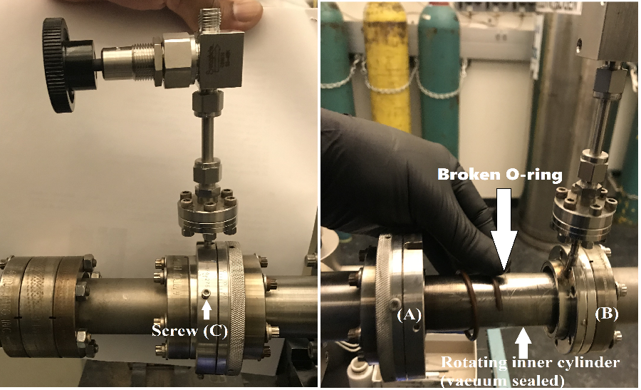
Figure 4.3. Manipulator rotary platform assembly.

The manipulator is composed of an elastomer sealed rotary drive. As depicted in the figure, the inner cylinder is vacuum sealed with two O-rings. The rotation should be smooth and the flanges (A) and (B) should be uniformly aligned while rotating. If the rotation is not smooth and the flanges (A) and (B) lose their alignment while rotation, most likely one of the O-rings (or both) might be damaged. Damaged O-rings can be easily replaceable by opening the rotary platform.

Manipulator rod alignment

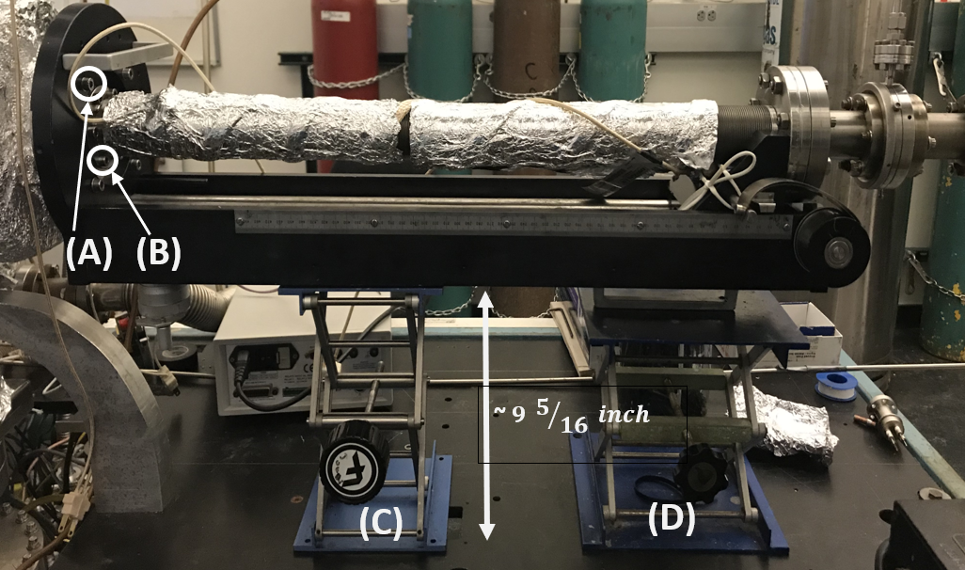
Figure 4.4. Manipulator balanced on two support stands.

Before putting back the manipulator into the chamber after a repair, make sure the mass spectrometer is fully retracted. Adjust the linear position close to zero, which will make it easier to balance the manipulator. Properly balance the manipulator on two support stands using a level tool (the bottom of the manipulator stand should be ~ $9 5/{16} inch$ above the table (see the below figure)). Place the manipulator close to the opening flange and slowly insert it into the chamber. Fine adjust the manipulator height using C and D support stands to properly align the stand. Hand-tight the four A (see the figure) bolts (use a 5 mm Allen wrench) after aligning the manipulator stand. Then, slowly move the metal rod into the chamber and make sure the high-pressure cell cup and the sample holder are not hitting inside the support stand (should move smoothly inside the manipulator support stand inside the chamber). Move the manipulator rod towards the end of the chamber and couple the HPC cup with the HP cell to properly align the metal rod. Then, tighten the bolts (B in the below figure) using a 5 mm Allen wrench.

When the sample is being moved to the IR compartment, make sure that the thermocouple wires do not lie over the back of the manipulator. They are not easy to repair when they break.

d. HEATING, COOLING, AND TROUBLESHOOTING.

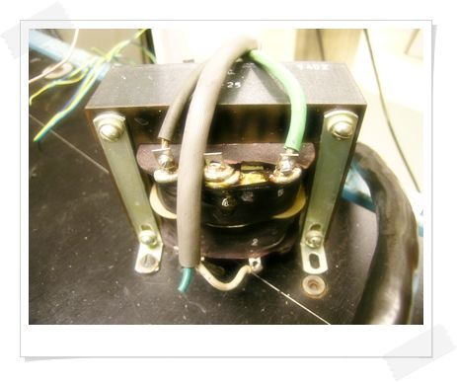
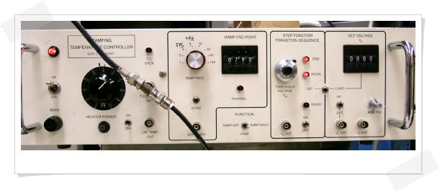
Figure 4.5. Ramping temperature controller (left) and the power supply transformer (right)

See the temperature controller manual (“Ramping Temperature Controller”) for a full set of operating instructions and a complete system description. It is in the lab in a three-ring binder.

The temperature controller with the ramp generator function performs the heating. Heating power is delivered to the sample from a power socket at the rear of the temperature controller, through a step-down transformer to the heating rods at the end of the manipulator. (These are the same tubes through which the liquid nitrogen flows in the cooling process, below.) It is possible that these conductors could short against one another or that the contacts at the top of the manipulator become worn. If heating does not seem to be going at a steady pace, then inspect the wires and contacts.

How to heat the sample:

- Verify that the HEATER POWER switch is off. This switch is located under the black heater power dial on the left.
- Set the heater power to about 50%. This sets the maximum power that can be applied to the sample so that the molybdenum wires supporting the sample will not be melted. Other switches on the right are set to "OFF" and "INTERNAL”.
- Determine the octal code of the endpoint temperature from the manual and dial this value into the RAMP ENDPOINT thumb wheel switch to the right. Set the FUNCTION switch to RAMP/HOLD for TPD or RAMP/OFF for annealing, depending on which function is desired.
- Select a ramp rate of 4-8 (TPD) or 16 (during the preparation of the sample).
- Hit the ramp START switch and the HEATER POWER switch at the same time. The temperature controller will now ramp the sample up to the endpoint temperature. The little bulb next to the heater power switch gives a visual indication of the amount of heating power being applied.

For other heating functions, see the manual.

How to cool the sample:

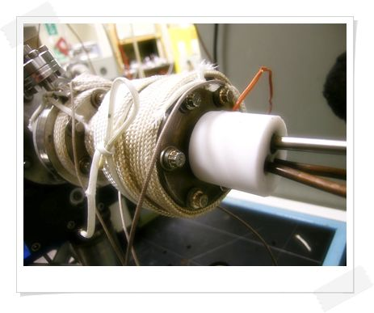
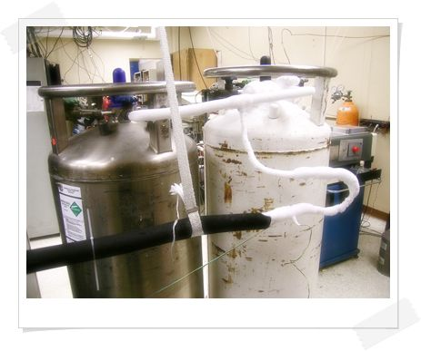

Figure 4.6. Rotary feedthrough of the manipulator (left) and the sample cooling setup with liquid nitrogen (right)
The sample is cooled by liquid nitrogen, which is pressed through 1/4" O.D. stainless tubes in the manipulator.

Procedure:

- Connect a tank of liquid nitrogen to the small stainless tubes with the Swagelok (9/16") connector.
- Turn on the heating tape around the rotary feedthrough of the manipulator (use a variac at about 40%). If the rotary is not heated during the cooling, it will leak after a few hours.
- Open the liquid nitrogen tank and regulate the flow such that a few drops of nitrogen come out of the manipulator. This overflow may be collected.
- It will take about 20 minutes to cool the sample down from room temperature to about 90 K. Once the manipulator is cold, cooling is much faster (5–15 min, depending on the thermal contacts in the vacuum). If the cooling gets slow, verify that the heater power on the temperature controller has been switched off, otherwise, the sample has probably come loose and may have to be remounted.
- Shut down cooling:

- Close the valve on the tank and disconnect the liquid nitrogen tube from the manipulator.
- Connect the air to the stainless tubes and open the valve about halfway. This is to bring the tubes up to room temperature, preventing the condensation of water in the manipulator.
- Turn off the heating tape wrapped around the rotary feedthrough.

Troubleshooting:

The sample does not Heat.

- Check the fuse at the front panel of the temperature controller.
- Verify that all connections between the temperature controller and the external power transformer and between the transformer and the heating rods are made. These contacts tend to become oxidized or even loosen over time. Using a clamp meter, verify that the current is flowing from the transformer to the sample. This should be several amps to as much as 60 amps.
- Verify that the heating power knob on the temperature controller is at its normal setting of 50~60%. A setting below this may not deliver enough heating power to the sample.
- Has a spot weld on the sample come undone?

The recorded temperature does not seem to be correct.

- Take an exploratory TPD of a known system, such as CO adsorbed on Pt(111). If the temperatures of the peaks are not as expected then the sample may be either dirty or the temperature controller needs to be repaired. If the sample has been cleaned thoroughly and the problem persists, then the temperature controller needs to be examined.
- Before removing the temperature controller, double-check that it is in error. Perform a dummy TPD experiment in which the thermocouple in the back of the controller has been inserted into an ice bath. Perform a TPD as usual and see if the temperature being read off the computer is that of the ice bath. If not then it is time to remove the temperature controller from the instrumentation rack for examination.
- NOTE: Most failures of the temperature controller are the result of a blown AD597-AH thermocouple preamplifier chip. Changing out this component usually solves the problem. When the AD597 is replaced, the system needs to be recalibrated with a type K thermocouple immersed in liquid nitrogen. A full calibration procedure can also be performed if desired. These procedures are described in the RAMPING TEMPERATURE CONTROLLER manual.

e. BIASING THE SAMPLE.

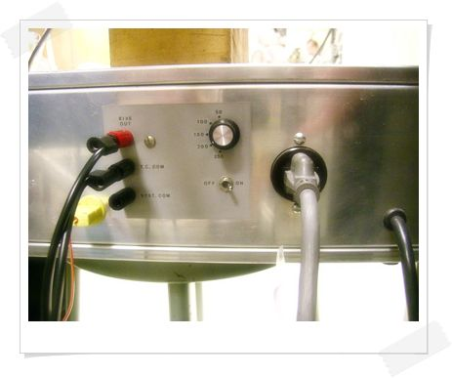
By means of opto-isolation circuitry, the thermocouple and its preamplifier circuit are floating with respect to the system ground, i.e. the chamber and instrumentation chassis. The sample, which is in contact with the thermocouple, can be placed at any desired potential by simply applying that voltage to either of the thermocouple leads or the common of the preamplifier circuit. There are three banana jacks at the rear of the temperature controller where these connections can be made: TC COM (thermocouple common), SYS COM (system common), and BIAS OUT. The controller has an internal bias supply which provides a negative voltage in steps of 50, 100, 150, 200, and 250 volts.
Figure 4.7. Rare of the temperature controller
Procedure:

- To ground the sample or give a zero bias voltage, connect SYS COM to TC COM with a banana cable.
- To apply a negative bias to the sample using the internal bias supply, connect TC COM to BIAS OUT, select the desired voltage, and turn on the switch.
- To apply a negative bias with an external voltage source, connect its positive terminal to SYS COM and its negative terminal to TC COM. To apply a positive bias, reverse the polarity of the voltage supply.
- When using an external source, the bias current can be monitored by connecting a current meter (usually the Kiethly Picoammeter) in series with the voltage source between SYS COM and the terminal of the source.

f. CLEANING (Pt (111) SINGLE CRYSTAL)

The sample is routinely cleaned by 10 min. of Ar sputtering at room temperature, annealing cycles in 2 x10⁻⁶ Torr of oxygen at 500 ˚C, and flashing to about 850 ˚C in vacuum. Between experiments, especially when the sample is cold, the sample is cleaned by heating in oxygen and flashing in vacuum only.

- Chemical cleaning

- Heat the sample to approximately 500 ˚C. If liquid nitrogen is flowing, don't turn it off.
- Introduce approximately 2×10⁻⁶ Torr oxygen in the chamber and wait for 5–10 minutes while maintaining these conditions. The leak valve on the back of the chamber is now used for this purpose.
- Close the oxygen valve and pump out the oxygen until the pressure is about 10⁻⁹ Torr.
- Heat the sample shortly to approximately 850 ˚C.

- Ar sputtering

  - Ion gun-I

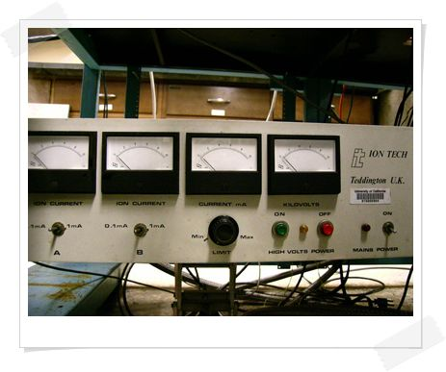
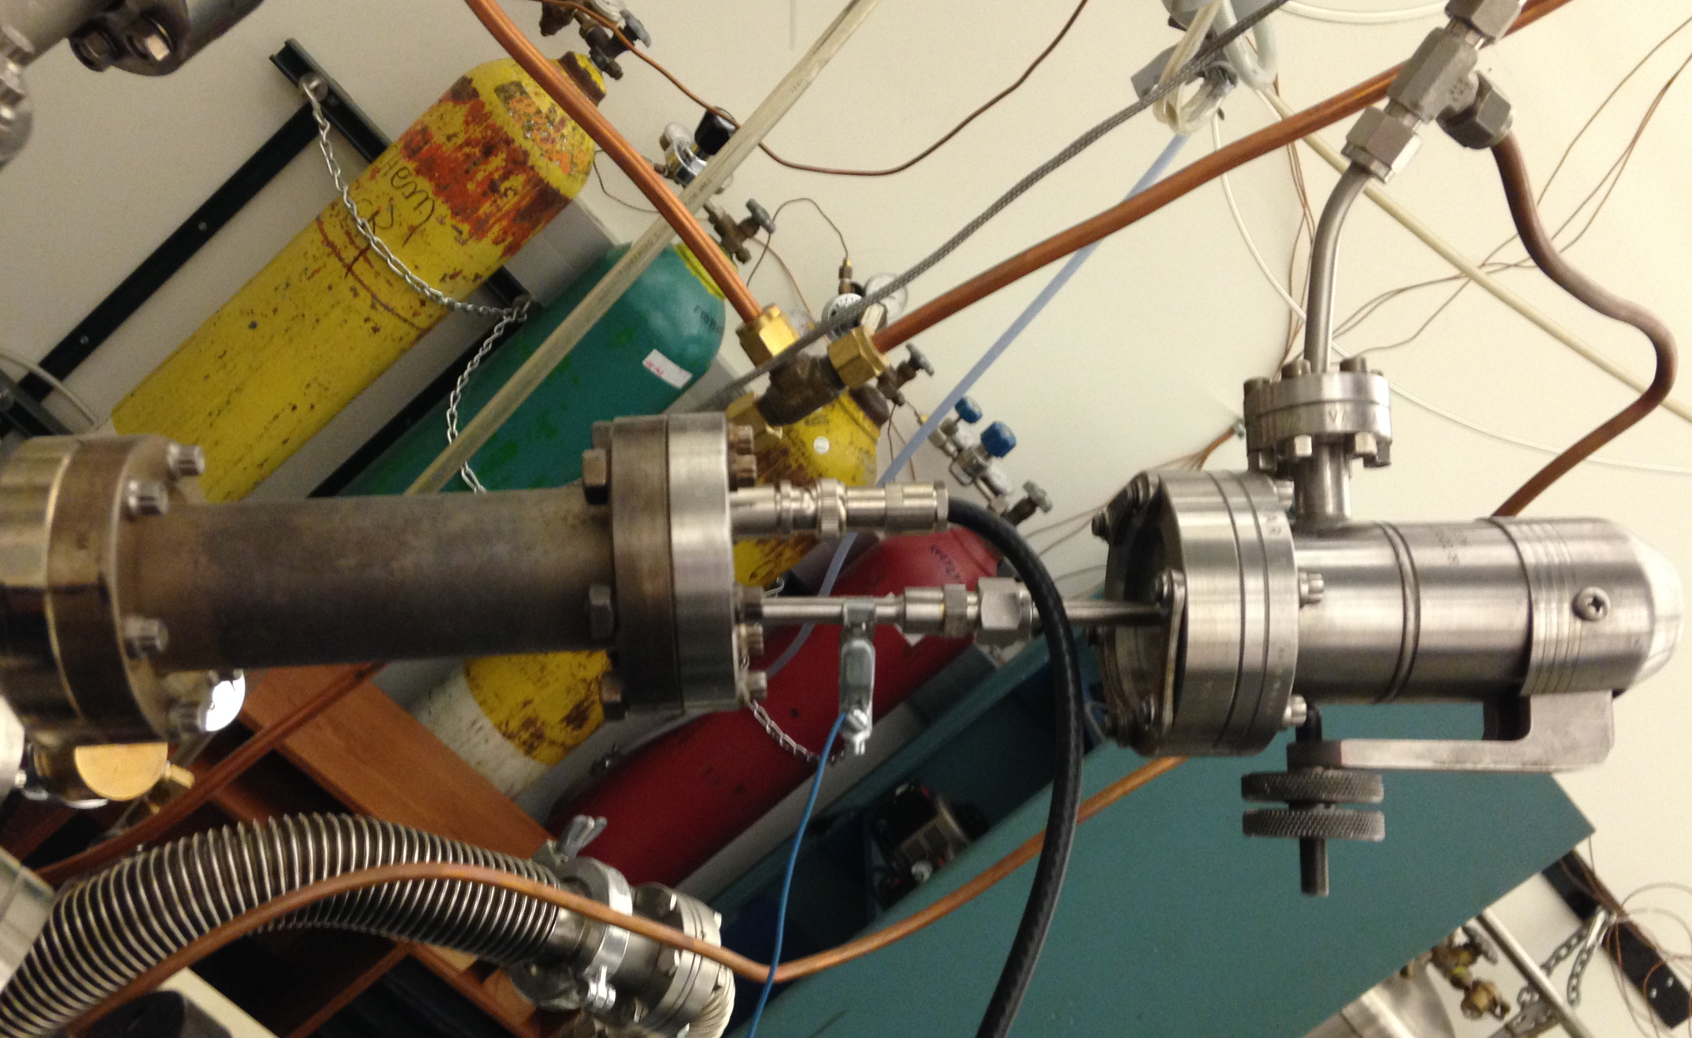
Figure 4.8. Sputter gun assembly (left) and the power supply unit (right).
Operation procedure- Ion gun-I

- Ground the sample at the rear of the temperature controller by connecting the TC COM output to the SYSTEM COM output.
- Move the sample a few millimeters to the left of the mass spectrometer (the indicator on the manipulator points to about 18 mm), and rotate the sample such that the polished face of the crystal points upwards.
- Switch on the main power of the ion gun power supply, located underneath the chamber; and turn the knob "CURRENT mA" to "MIN."
- Close the pump-out valve on the manifold.
- Open the Ar tank, then open and close the gas valve to let some Ar into the line up to the leak valve.
- Open the Ar leak valve on the back of the sputter gun until the pressure in the chamber is 2–3×10⁻⁶ Torr. When opening this valve the pressure will initially increase rapidly to approximately 10⁻⁶ Torr and then go down again. This is normal
- Switch on the high voltage in the ion gun by pressing the green "ON" button. The voltage reads approximately 2 kV.
- Turn the knob "CURRENT mA" up slowly until the current reads approximately 0.5 mA. The voltage should read 3–4 kV now. If the current does not come on, check the connections to the sputter gun.
- When done, switch off the high voltage by pressing the red "OFF" button, turn the knob "CURRENT mA" to "MIN.", close the Ar leak valve, and turn off the main power of the ion gun power supply.

Every time the sample is remounted to the manipulator, the sample position for sputtering has to be determined. This can be done visually. The ion beam is visible as a faint, diffuse blue light when the pressure gauges and the lights in the lab are switched off.

Another method is to measure the sample current by grounding the sample through an ammeter:

- Disconnect the thermocouple and the sample ground.
- Connect the input of an ammeter to the 1/4" copper tubes and the output of the meter to the outside of the chamber (or any other ground).
- Move the sample to the far left.
- Switch on the sputter gun as described above.
- Move the sample slowly to the right: when the sample moves into the ion beam, the reading on the Ampere-meter will suddenly increase. Move the sample about 4–5 mm further to the right to make sure it is centered in the beam.

  - Ion gun-II (temporarily moved ion gun from the Praxis chamber)

This ion gun has an IQE 11/35 type ion source (from SPECS), which can generate an ion current of 10-15 μA with Argon. The special type of Ƴ-oxide coated Ir-cathode is suitable for operation with all noble gases, N₂, and reactive gases like O₂ and H₂. The ion current can be varied by adjusting the gas pressure. The energy range of the ion beam can be continuously varied between 02-5 keV. The source is bakeable up to 200 ⁰C and can be degassed internally.

Operation procedure- Ion gun-II

- Follow the steps 1-2 above, Operation procedure- Ion gun I.
- Switch on the ion gun controller unit (power button, fig 4.9 (bottom)) and turn the function knob to operate mode.
- Follow the steps 3-6 above, Operation procedure- Ion gun I.
- Slowly increase the ion energy and observe the sample current (e.g. with 5E-6 torr of Argon pressure, ~1-1.2 μA sample current can be obtained with 2keV of ion energy (this was observed with a polycrystalline copper sample)).
When finished, turned down the beam energy (up to 0 keV), turn the function knob to 0, and turn off the power button. Close the Argon leak valve and evacuate the gasline.

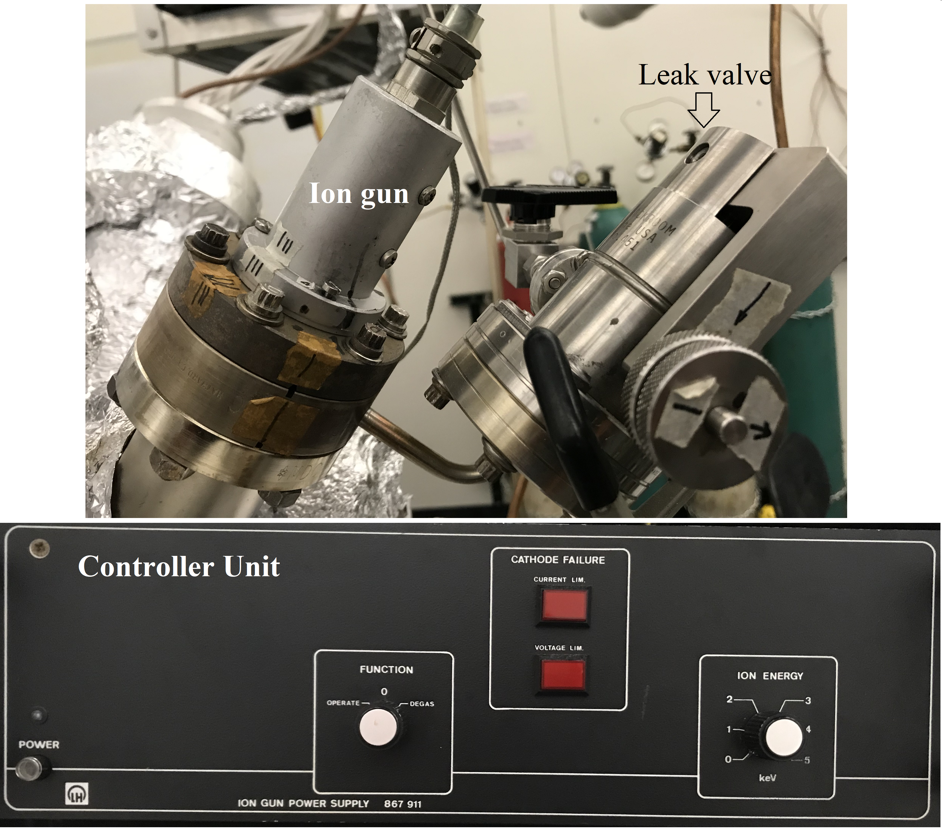
Figure 4.9. Temporarily moved ion gun from the Praxis chamber (top) and the ion-gun controller unit (bottom).

- How to determine that it is clean.

A good indication that the sample is clean is to check the desorption of oxygen (see section TPD). Desorption of oxygen at high temperatures (around 500 ˚C, and starting around 440 ˚C) indicates a low level of surface carbon, and a clean Pt surface. Note: the absence of this oxygen desorption in TPD may also be caused by contamination in the mass spectrometer and does not necessarily mean that the surface is dirty.

g. COPPER (POLYCRYSTALLINE) SAMPLE CLEANING AND IN-SITU CHARACTERIZATION

    - Copper sample preparation

Oxygen-free high conductivity copper (OFHC copper with purity > 99.99%) can be purchased for a very low cost (e.g. from McMaster-Carr). Sample can be prepared by cutting the copper sheet with the help of the machine shop. To fit the RAIRS sample holder, to have efficient sample heating with solid contact with the tantalum heating wires, and to have good contact with the thermocouple wires, the sample can be designed according to the following schematic diagram and the machine shop is capable of doing that for a reasonable price.
Figure 4.10. Sketch of the copper substrate which fits the RAIRS sample holder (A) and a substrate prepared with OFHC copper (B).

    - Polishing the copper sample

As prepared copper substrates with OFHC copper may have minor scratches, which can be easily removed by polishing. Copper substrates can be polished with 400-10000 grit sandpapers. Samples should be sanded progressively with finer grits to remove scratches and eventually obtained smooth surfaces. Colloidal silica suspension can be used to polish the surfaces after polishing with the sandpapers, which removes surface deformations (not visible to the naked eye) and eventually gave mirror-like surfaces. Finally, the samples can be washed with ethanol.

    - Ex-situ chemical cleaning

The purpose of this ex-situ chemical cleaning is to remove the bulk of the surface impurities, mainly carbon and copper oxides. First, sonicate the polished copper sample in ~50 ml of acetone, ~50 ml of 2-propanol, and ~50 ml of DI water (5 minutes in each solvent) to remove grease, oil, and carbonaceous deposits. Then, rinse the sample with 2-propanol for 2 minutes. Next, clean the sample with acetic acid to remove copper oxides. Immerse the sample in a dilute acetic acid solution (1 ml of glacial acetic acid in 30 ml of water) and sonicated for 5 minutes. Finally, rinse the sample with 2-propanol and immediately transfer it to the sample holder to mount in the chamber. Depending on the level of contamination, the sonication time, and the concentration of the acetic acid solution can be changed.

- In-situ cleaning

At the beginning of the polycrystalline copper sample cleaning, anneal the sample up to 1000 K (3-5 min) and sputter off the impurities. After each 30-45-minute sputtering cycle, anneal the sample and repeat this process until a clean sample is obtained. 4-6 hours of Argon sputtering will be sufficient to clean a typical chemically cleaned sample with 5-6 E-6 torr of argon pressure and 2KeV ion energy to have ~1μA of sample current. Sputtering time can be significantly changed depending on the level of contamination.
Cleaning by annealing with molecular hydrogen, reduction of copper oxides by annealing in a carbon monoxide environment, and oxygen annealing to remove carbon impurities are not efficient without initial sputtering.

- In-situ characterization

CO-TPD and CO-RAIRS experiments can be used to characterize the cleanliness of the copper substrate. For a clean copper surface, 3 major TPD features will be observed at ~ 121 K, 163 K, and 205 K. Week CO adsorption peaks will be observed at lower temperatures (110-120 K) for CO adsorption on impurities.
For CO-RAIRS on copper, a doublet at the C-O stretching region (~2100 cm⁻¹) will be observed (A higher-frequency feature at ~2100 cm⁻¹ and a lower-frequency feature at ~2068 cm⁻¹).

- Issue with the thermocouple connection.

Sometimes, it might be difficult to get reproducible CO-TPD data for polycrystalline copper (characteristic to clean copper), even after several argon sputtering-annealing cycles. This can be either due to high sample contamination or loosely attached thermocouple. If the latter is the case, inconsistent lower temperature shifts of the CO-TPD features can be observed. This is due to the wrong temperature calibration. By heating the sample in UHV to determine the red hot glowing temperature, the sample temperature calibration can be tested. If the red hot glowing temperature is well off from the standard value of 785 ±10 K, the thermocouple connection should be repaired.

h. TEMPERATURE READING.

There are two ways of observing the temperature: T.C. PREAMP OUT gives the real temperature in degrees C. LIN TEMP OUT gives you the voltage, which goes along with the octal code and can be converted into ºC from the manual. For voltages under freezing temperature, refer to the temperature controller manual.

- Heating power supply (operation, calibration).

The heart of the heating system is the amplifier in the POWER CONTROL section. It compares a voltage proportional to the temperature, V_{t}, to a reference called the set voltage or V_{s}. When the temperature in the sample rises causing V_{t} to become larger than V_{s}, the amp output decreases causing the HEATER POWER SOURCE to decrease the heater power. If the sample temperature starts to fall, the opposite will occur. In this way, the controller maintains a clearly constant temperature in the sample about the values of V_{s}. The tightness or sensitivity of the regulation depends on the gain of the amplifier. The THERMOCOUPLE AMPLIFIER provides gain, offset, and scaling for the thermocouple signal; and the LINEARIZER removes the slight non-linearity in the response curve of the thermocouple.

The V_{s} and RAMP GENERATOR section is the sources of the SET VOLTAGE, V_{s}. It can hold V_{s} at a constant value or can cause it to increase or ramp up, linearly, to some selectable endpoint value. The CLOCK AND LOGIC section determines what the ramp rate will be and tells the ramp generator to ramp up and shut off during the RAMP/OFF function or to ramp up and maintain a constant temperature for the RAMP/HOLD function. Since the power control amplifier is always trying to maintain V_{t} equal to V_{s}, the temperature in the sample should ramp up linearly along with V_{s}.

Producing a temperature step is not simply a matter of making a hump in V_{s}. If this is done, the large initial difference between V_{s} and V_{t} will cause the system to turn on full heater power. This will be maintained until V_{s} and V_{t} are nearly equal, at which time the heater power will drop, and the system will try to start regulating. Meanwhile, the heating elements, which have been at a very high temperature, contain a large amount of residual heat. This heat will flow into the sample causing a large temperature overshoot.

The solution is to back off on the heater power sometime before the step temperature is reached. If this is done at the right time and in the correct way then the residual heat in the elements will be just sufficient to bring the sample up to the step temperature, with no overshoot, as the system begins to regulate.
Below shows the sequence of events actually used in the temperature controller to create a temperature step. Up until time t1, V_{s} is at some initial value, V_{s1}, so that the system is regulating at temperature V_{t1}. At time t1, a higher value of V_{s} is loaded into the system, say V_{s2}. This large jump causes full heater power to be applied causing a very rapid temperature rise. At some time, t2, before the step temperature is reached the threshold voltage, V_{th}, is reached triggering the lower comparator in the POWER CONTROL section which tells the TRANSITION SEQUENCE LOGIC to turn off the heater power. During the dead time from t2 to t3, the sample coasts up to V_{t2} from the residual heat in the elements. This triggers the upper comparator which tells the TRANSITION SEQUENCE LOGIC to turn the heater power back on. The system now begins regulating again at V_{t2}.

This series of events, called the transition sequence, takes the system from producing a rapidly rising temperature to maintaining a constant, regulated temperature. This approach yields the fastest rise time, the sharpest knee, and no overshoot.

Installation
Plug the heater power cable and the thermocouple into their appropriate sockets. One side of the thermocouple must be connected to the analog ground in the TC AMPLIFIER. If not done externally, this can be done at the terminal block on the circuit board inside the nit.

NOTE: The heater power output gives [0, 120] Volts AC at 3 Amps or a maximum of 0.36 KVA. If the heater has other voltage-current requirements, a transformer must be used.

Controls and Indicators
- MAIN: This consists of a main power indicator lamp, switch, and fuse
- HEATER POWER (DIAL): This is a variable transformer that sets the maximum power that can be applied to the heater.
- HEATER POWER ON/OFF: This allows the operator to turn on or off only the heater power without turning off the main power.
- HEATER POWER (LAMP): This lamp is connected across the heater power output connector. Its intensity is roughly proportional to the power applied to the heater.
- T.C. OPEN: When the thermocouple is disconnected, has an open circuit, or is not grounded as explained in the installation procedure, this light is on. When it is, the THERMOCOUPLE INTERLOCK is activated turning off the heater power.
- T.C. PREAMP OUT: This is the output at pin 6 of the AD597 chip in the THERMOCOUPLE AMPLIFIER circuit. 10 mV/deg C.
- LIN TEMP OUT: This is the linearized temperature, Vt, or the output at pin 14 of the 210 chip in the THERMOCOUPLE LINEARIZER circuit. This signal can be sent to a computer, and with proper software, calibration will give the temperature. See the Octal Temperature Voltage Tables.
- RAMP RATE: This selects the rate of the digital ramp in steps per second. There are 1.267 degrees Celsius per step.
- START: Switch for manual ramp start.
- EXT START: This input starts the ramp externally when pulled to the ground or by applying a logical low.
- RAMP ENDPOINT: Octal thumbwheel switch for setting the ramp endpoint.
- RAMPING: Indicator light on when the ramp is in progress.
- FUNCTION: Places the instrument in the RAMP/OFF, STEP, or RAMP/HOLD mode.
- THRESHOLD VOLTAGE V_{TH} : This is a ten-turn dial pot that sets the lower threshold voltage in the transition sequence. It is calibrated in volts and runs from [0, 10] Volts.
- V_{TH} OUT: This is the THRESHOLD VOLTAGE output.
- READY: Indicator light on when the transition sequence flip flops are in their correct states, ready for the transition sequence.
- BEGIN: Indicator light goes on when Vt is equal to or greater than the threshold voltage, Vth. It also marks the beginning of the transition sequence.
- END: Indicator light goes on when Vt is equal to or greater than the set voltage, Vs. It also marks the end of the transition sequence.
- TRANSITION SEQUENCE ON/OFF: A switch that enables or disables the transition sequence.
- SET-LOAD: This switch has two functions: It sets the transition sequence flip flops to their ready states and loads into the system the value set on the SET VOLTAGE thumbwheel switch.
- SET VOLTAGE V_{S}: An octal thumbwheel switch for selecting the set voltage, Vs.
- INT/EXT: This allows for the choice of the internal or an external source for the set voltage.
- V_{S} EXT: Allows for input of an external set voltage. It must be used with the INT/EXT switch in the EXT position. Input impedance 5 K ohm.
- V_{S} OUT: This output is the set voltage, whether from the internal or an external source.
- FINE ADJ: This allows for fine adjustments in the regulated temperature.

Operating Instructions
- Constant Temperature
- Make the following settings
- HEATER POWER to the desired level.
- HEATER POWER switch in the OFF position
- FUNCTION switch in the STEP position.
- TRANSITION SEQUENCE switch in the OFF position.
- V_{s} INT/EXT switch in the INT position.
- Turn on the main power.
- Dial in the octal value for the desired temperature on the SET VOLTAGE thumbwheel switch.
- Hit the SET/LOAD switch.
- Turn the HEATER POWER switch on. Fine adjustments in the temperature can be made with the FINE ADJUST controller.
- Ramp/Hold
- Repeat steps 1.a.[i-ii].
- Set the FUNCTION switch to the RAMP/HOLD position.
- Dial in the octal value of the starting temperature on the SET VOLTAGE thumbwheel switch.
- Dial in the octal value of the ending temperature on the RAMP ENDPOINT thumbwheel switch.
- Select the desired RAMP RATE.
- Hit the SET/LOAD switch.
- Turn the HEATER POWER switch on. This will start the system regulating at the starting temperature.
- When ready, hit the START switch.
- Ramp/Off: This is identical to the Ramp/Off section except that the FUNCTION switch is set in the RAMP/OFF position.
- Step
- Repeat steps 1.a.[i-ii].
- Dial in the octal value of the starting temperature on the SET VOLTAGE thumbwheel switch.
- Hit the SET/LOAD switch. Turn the HEATER POWER switch on. This loads in V_{s1} and gets the system regulated at the starting temperature.
- Dial in the octal value of the step temperature on the SET VOLTAGE thumbwheel switch.
- Turn the TRANSITION SEQUENCE switch to the ON position.
- Hit the SET/LOAD switch. This loads in V_{s2} and turns on full heater power.
- The sample will begin to heat. When V_{t} == V_{th} the BEGIN light will go on indicating the transition sequence has started. When the END light goes on, the step temperature, V_{t2}, has been attained and the transition sequence has ended. If there is an overshoot, repeat the process starting at 4.b, dialing in a slightly lower value for the threshold voltage. If the END light does not go on, the heater will not turn back on and the sample will begin to cool. Start back up at step 4.b dialing in a slightly higher value for the threshold voltage.

Circuit Description

Thermocouple Amplifier

These three ICs provide gain, offset, and scaling to convert the [-196, 1100] Degree Celsius into a zero to ten-volt signal which is then used as the input to the AD573.

The thermocouple is connected to the input of an analog device AD597AH type K thermocouple conditioner/controller. This IC contains cold reference compensation and amplifies the thermocouple signal to 10 mV per degree Celsius.

The next op-amp sums an offset voltage of approximately 1.45 Volts with the temperature signal so that –196 degrees C produces zero volts at the output, pin 6.

The next op-amp has a gain of about 0.8 and is adjusted so that 1100 degrees C will produce 10.0 Volts. This is necessary because the 10 mV per degree C output of the AD597 with unity gain amplifiers would give 12.5 Volts, which is greater than the maximum allowed (10 v) input voltage of the AD573 10 bit analog to digital converter in the LINEARIZER section of the system.

LINEARIZER

A 555 timer chip wired as an 11.1 kHz stable oscillator produces the basic timing for the A/D and its output latches, the 74LS75 chips.

Half of the 74LS123 triggers the clocks' positive edge and generates a 1-microsecond convert pulse to pin 12 of the AD573. The other half of the chip triggers on the negative edge of the clock and produces a 1-microsecond positive pulse which causes the three 74LS75’s to latch the valid AD573 output data.

The latched AD573 output data is used to address two 2716 EPROMS. They are programmed with data such that when converted back to analog is equal to a linearized thermocouple temperature. The EPROM’s output is connected to a DAC210 ten-bit digital to analog converter. Its output voltage representing the linearized thermocouple temperature, Vt, is fed into the power control section of the system.

Power Control

The linearized temperature, Vt, from the above along with a small variable voltage from the FINE ADJ potentiometer is fed into the inverting input of the power control amplifier, a 741 op-amp. The variable voltage allows small adjustments to be made on the heater power. The reference or set voltage from the Vs and RAMP GENERATOR section is applied to the non-inverting input of the amp. If the temperature, of Vt, should rise the output of the 741 will drop causing the vase current of Q1 to drop which in turn causes the drive current (0 to 20 mA) to the analog switching relay to drop. This reduces the AC power to the heaters bringing the temperature back down. The opposite occurs when the temperature drops too low.
The gain of the power control amplifier can be changed by changing the two resistors, Rg, mounted in PC board sockets.

The linearized temperature is also fed into the positive inputs of the upper and lower 311 comparators. When Vt is above the threshold voltage the lower 311 is in the high state, and when it is above Vs the upper 311 will be in the high state. The BEGIN and END LEDs will always be either on or off depending on whether the 311’s are high or low.

The outputs of the comparators are fed into the upper and lower flip-flops of the TRANSITION SEQUENCE LOGIC. Before the transition sequence begins both comparators are in their low states. When the SET/LOAD switch is hit, the flip flops are SET to their READY states. Here pins 3 and 4 of the 4001 chip will be high and pin 10 will be low. This makes pins 8 and 9 of the 4081 chip high, turning on the Ready light and pin 11 low which holds Q2 off.

When the lower comparator goes high, i.e. when Vth is reached, the transition sequence has begun. The BEGIN light goes on, the lower flip flop changes state turning off the READY light, and pin 11 of the 4081 goes high turning on the Q2 which shorts the base current of the Q1 to the ground. This turns Q1 off which cuts the control current to the analog switching relay, which turns off the heater power. When the upper comparator goes high, the END light goes on and the upper flip flop changes state returning pin 11 of the 4081 to the low state. This shuts off Q2 restoring the base current to Q1 turning the heater power back on. The transition sequence is completed.

V_{s} and Ramp Generator

The three cascaded 74HC193 binary counter produces a 10-bit binary number at the outputs. The number can be counted up, creating a ramp, by applying clock pulses at pin 5 of the first chip or loaded in parallel from the SET VOLTAGE octal thumbwheel switches by pulling puns 11 low with the SET/LOAD switch. The data from the 193’s are applied to the inputs of the DAC210 digital to analog converter whose output is the set voltage which ranges from [0, 10] Volts. This is sent to the POWER CONTROL section.

Also connected to the outputs of the 193’s are three cascaded 74HC85 4-bit magnitude comparators. When a match occurs between the binary number from the 193’s and the number applied to the inputs of the 85’s by the RAMP ENDPOINT thumbwheel switches, pin 6 of the last 85 goes high. This match signal is sent to the CLOCK and LOGIC section.

Clock and Logic

The 2240 chip produces a clock pulse train from [1, 128] pps. This pulse train is gated to pin 5 of the 193 chips in the RAMP GENERATOR section to produce the voltage ramps as described previously. When pin 6 of the 4011 NAND gate chip is high, the pulse train is passed on, and when low the pulse train is blocked off. This is controlled by the logic circuitry.

When the FUNCTION switch is in either of the RAMP positions the R input of the 4013D flip flop is held low. When a START pulse (low) is applied to pin 5 of the 4049 chip, a high pulse is applied to the S input of the flip flop and the Q output goes high. This puts a high level on pin 6 of the 4011 which gates on the clock pulse train and turns on the RAMPING light. When a match condition occurs with the 85 chips in the RAMP GENERATOR section, a positive-going edge is applied to the C input of the 4013 which returns the Q output to low. This gates off the pulse train and turns off the RAMPING light.

If the FUNCTION switch is in the RAMP/OFF position, pin 9 of the 4011 is held high so that when the match signal appears at pin 8, a high level appears at pin 15 of the 4049. This reset pulse is applied to pin 14 of the 193’s and resets their outputs to low which gives a V_{s} value of zero.

With the FUNCTION switch in the STEP position, the R input of the 4013 is held low which holds Q low.

Calibration Procedure
Refer to the THERMOCOUPLE AMPLIFIER schematic. Always turn off the main power when extracting or inserting ICs.

- Extract the second IC in the TC Amp circuit, and short point “b” to the ground.
- Set the 20K pot on the third IC to read 0.0 volts at its output, pin 6.
Reinsert the second IC. Connect a thermocouple and immerse it in liquid nitrogen. Set the OFFSET pot to give a stable output of 0.0 Volts at the output, pin 6 of the third IC. The system may take a few minutes to stabilize after turn-on.
- Extract the first IC (AD597) and apply 11.07 Volts at point ‘a’. The measurement at point ‘a’ must be made with the power on. The 11.07 Volts simulate a temperature of 1100 degrees Celsius. Now set the GAIN pot to real 10.00 Volts at the output.
- With the 10 Volts still at the TC AMP output, set the FS ADJ pot on the DAC210 in the LINEARIZER section to read 10.00 volts at pin 14. This voltage can be measured at the LINEARIZED TEMP OUT connector on the front panel. Remove the 11.07 Volts and reinsert the AD597.
- Dial-in 1777 on the Vs thumbwheel switch. Hit the SET/LOAD switch. Set the FS ADJ pot at the DAC210 in the Vs and RAMP GENERATOR section for output of 10.00 Volts at pin 14 or at the Vs OUT connector on the front panel.
5. GAS HANDLING, GAS MANIFOLD.

The manifold consists of a series of valves and tubing that allow gas delivery to any part of the UHV chamber. It has a thermocouple gauge connected to the end and is evacuated and it is pumped by the red Alcatatel 2008A single-phase mechanical pump under the bench. The readout for the T.C. gauge is on the GP pressure readout.

a. DESIGN AND SCHEMATICS.

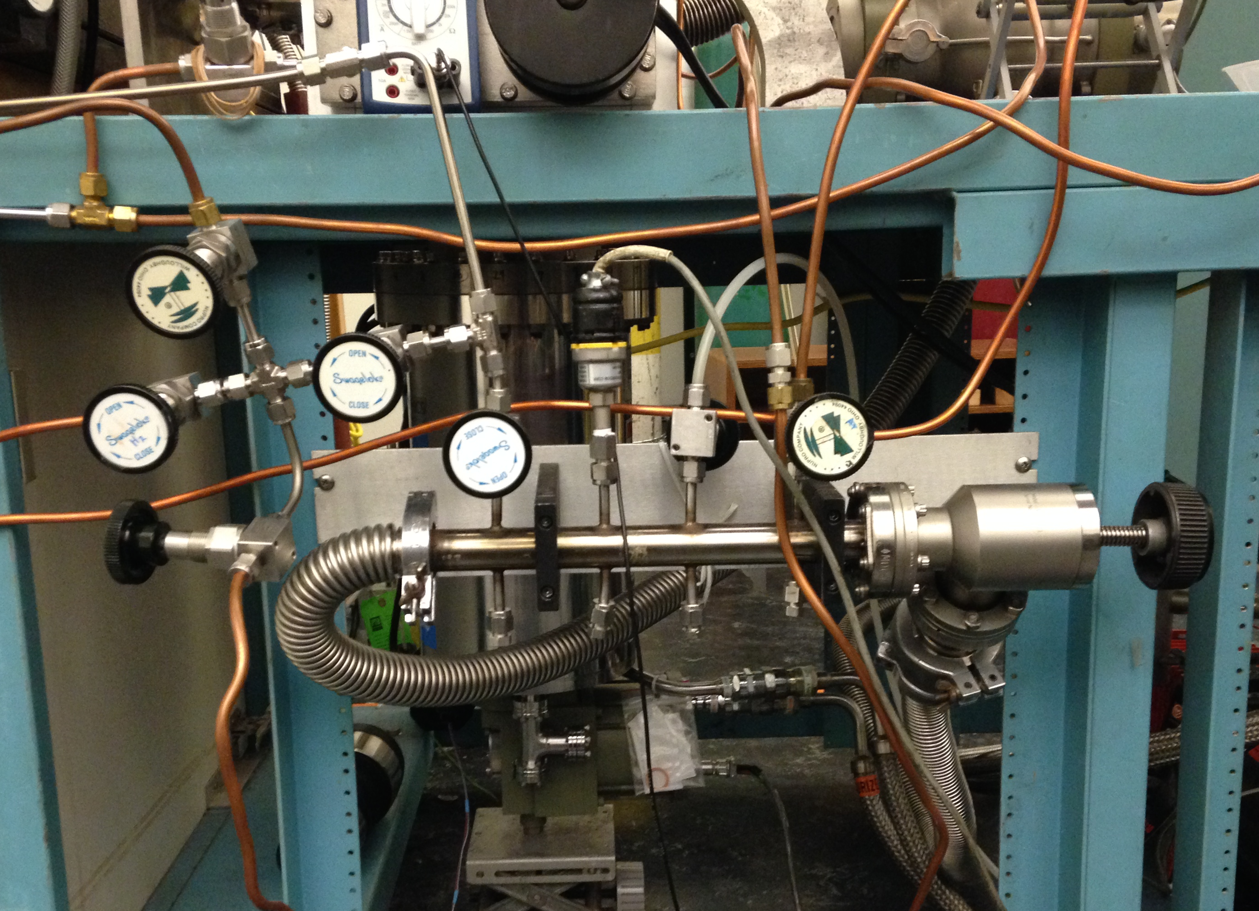
Figure 5.1. Gas-manifold of the RAIRS system.

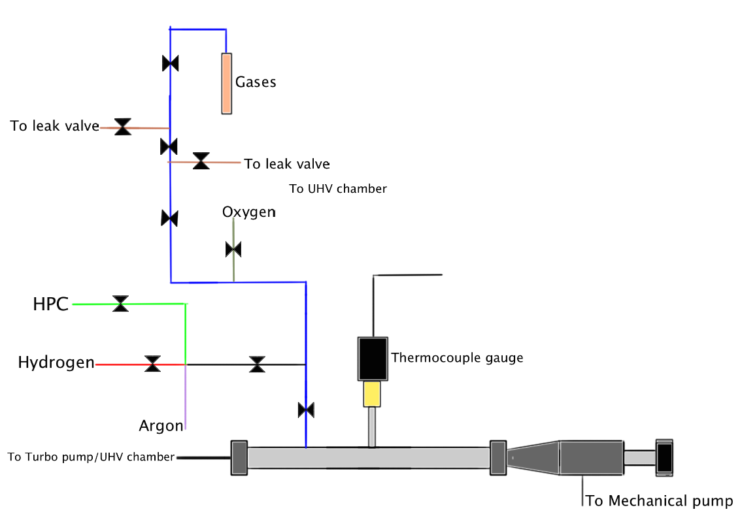
Figure 5.2. A schematic diagram of the gas-manifold of the RAIRS system.
b. VALVES, REGULAR, AND TO UHV.

Regular.

The gas manifold is connected to the pumping systems via a ninety-degree valve. The rebuild parts for this valve include bellows and Viton gasket. This component may need to have its gasket replaced, which is accomplished by removing the head of the valve using a 5/32” Allen key. This will expose the bellows and flapper. Locate the Viton gasket at the end of the flapper and replace it. These valves need only be finger-tightened to make a good seal. Further tightening may cause excessive wear.

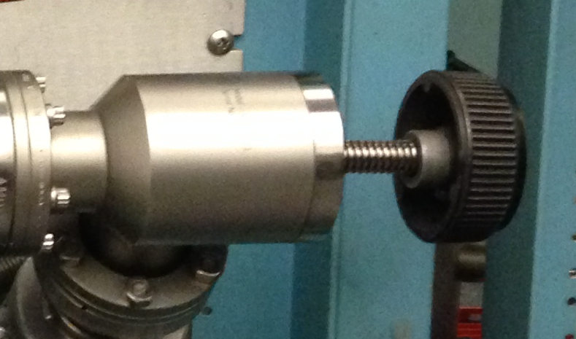

Figure 5.3. The ninety-degree valve connecting the gas manifold and the pumping system.
There is a valve connected to the chamber body that is used to vent the system. This valve is tightened using a quarter-inch ratchet. Parts for this component reconditioning can be obtained from Duniway.

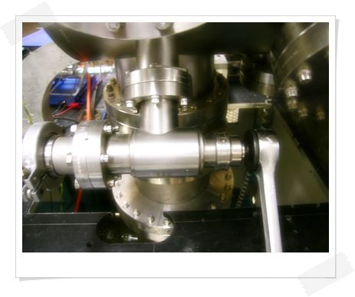

Figure 5.4. The metal valve (8) connected to the chamber body, which is used to vent the system.

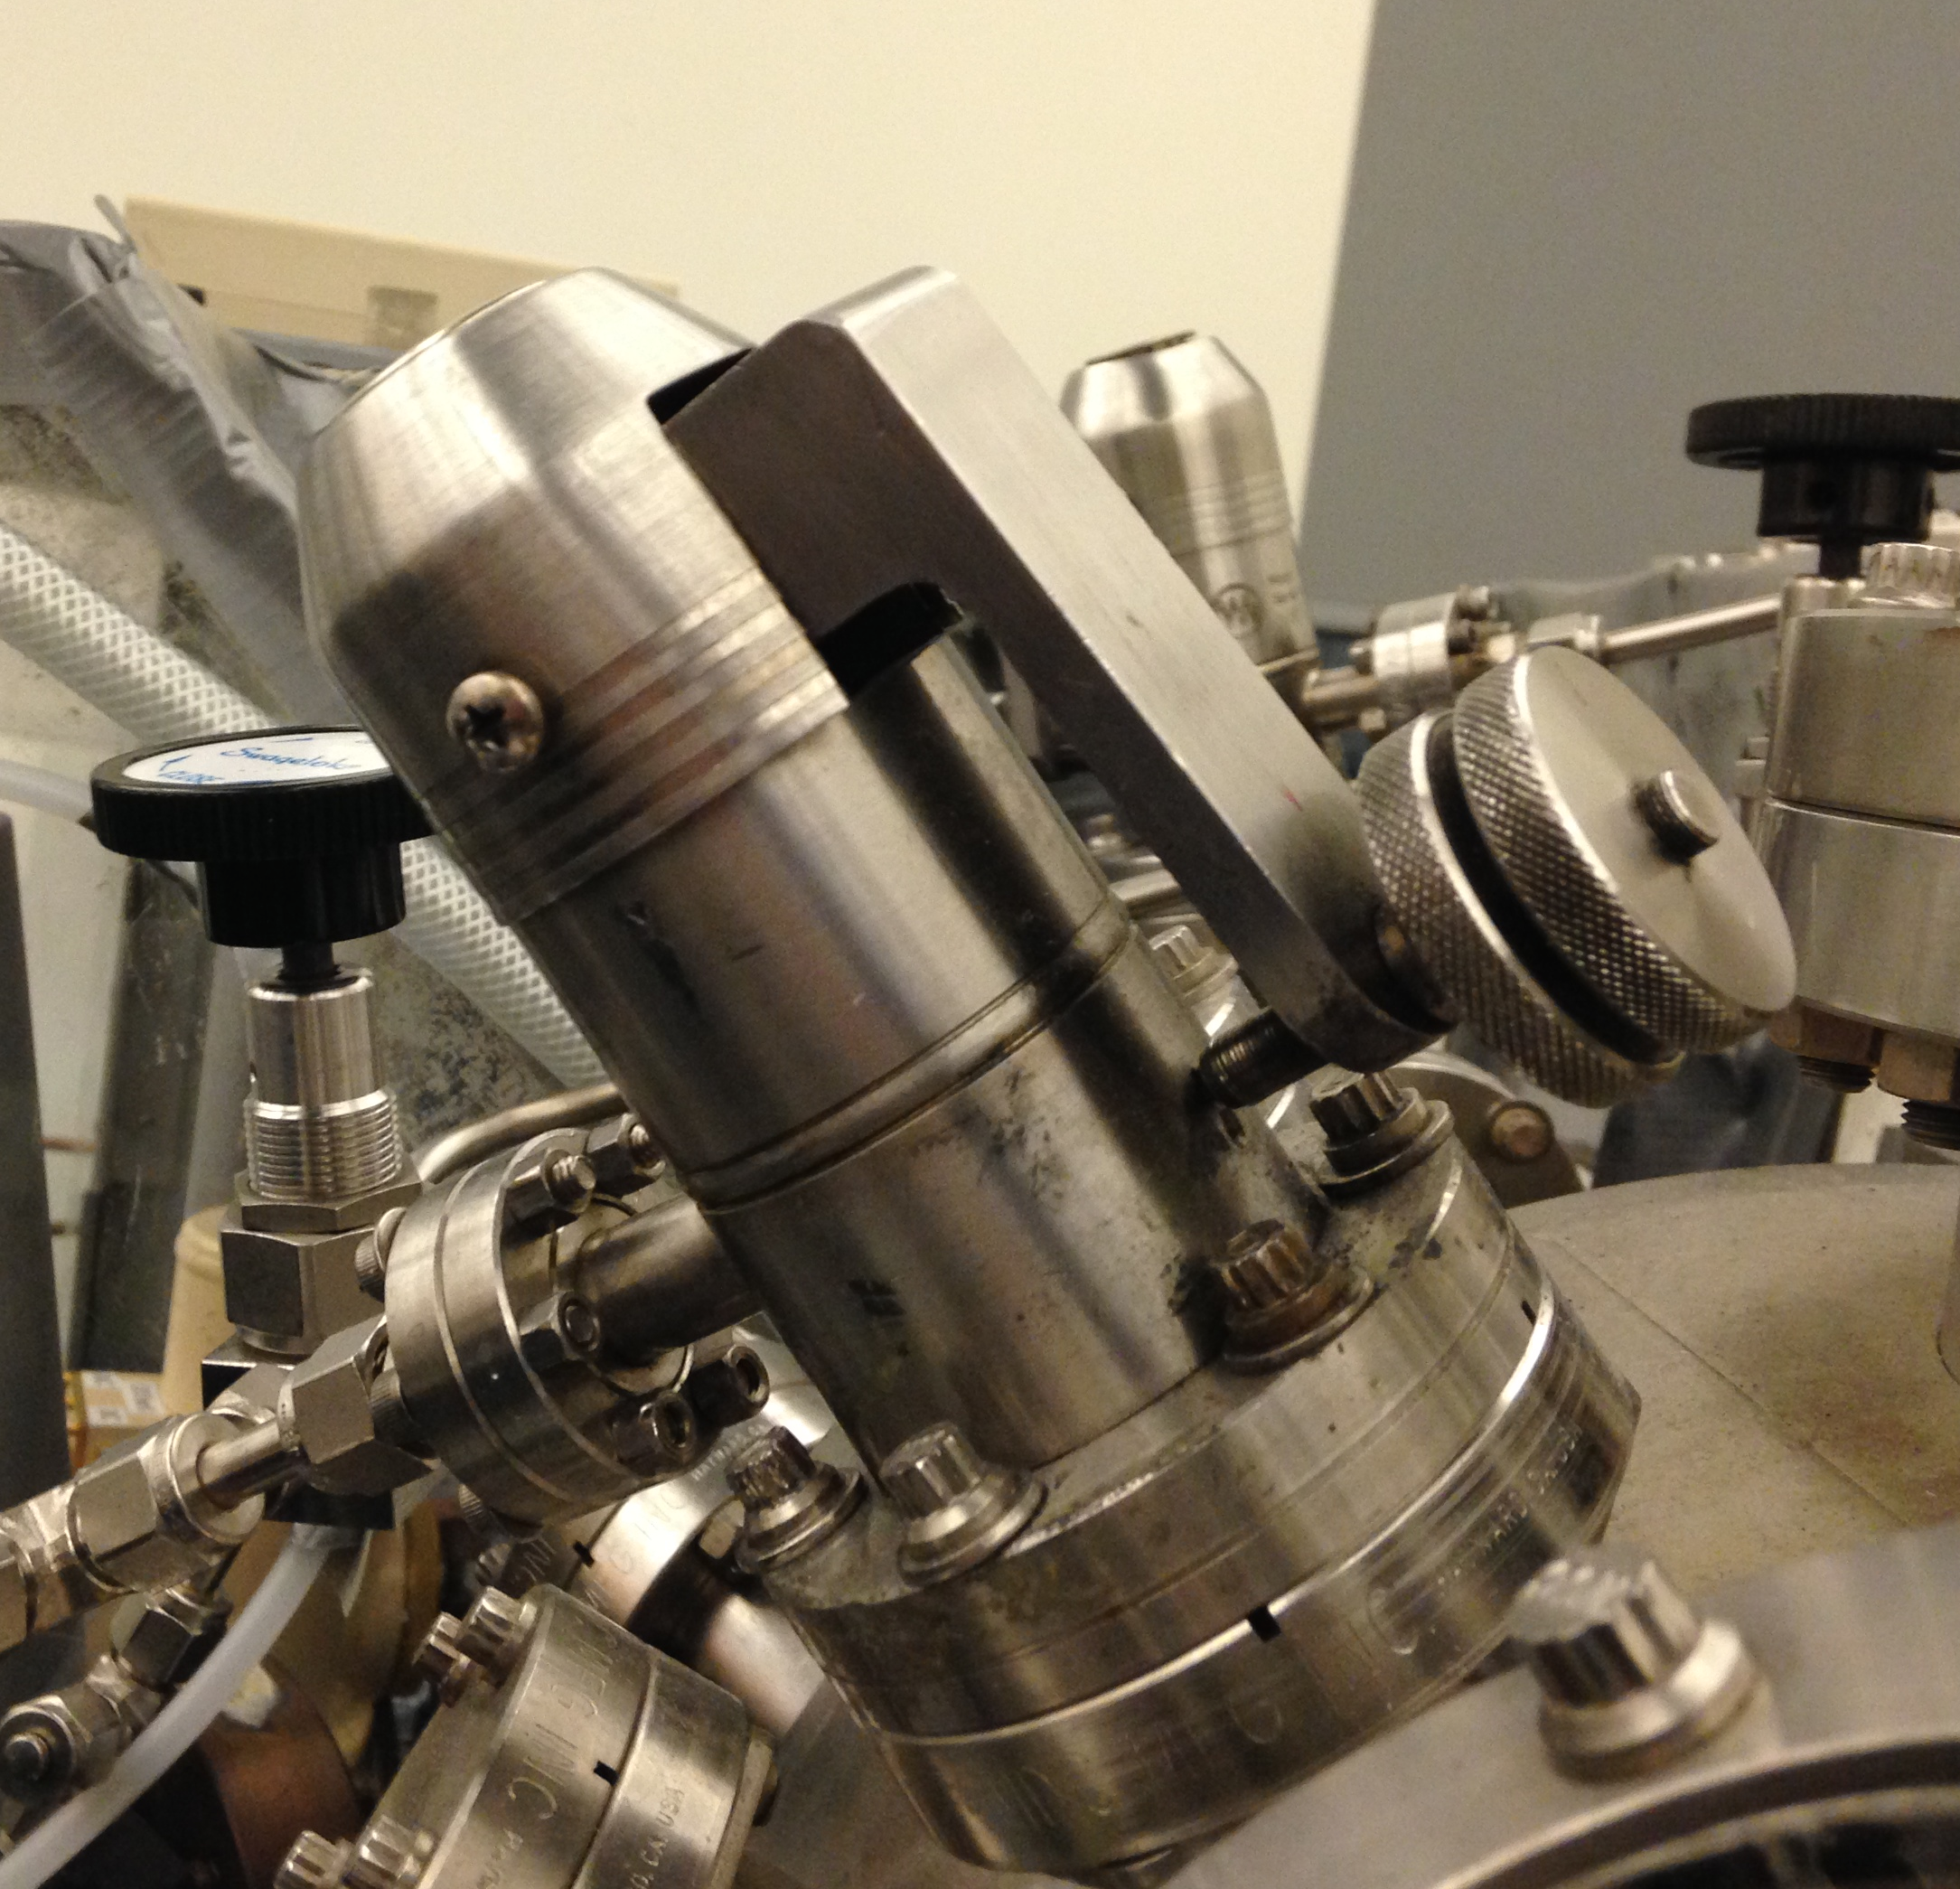
Figure 5.5. A leak valve connected to the RAIRS chamber.

The chamber uses variable leak valves located at a number of positions. These are sensitive and need occasional adjustment. To adjust, remove the protective casing with a Philips head screwdriver and pull it straight out. Tighten the exposed hex nut.

c. TUBING, CONNECTORS.

For a description of the handling of Swagelok fittings, refer to the Swagelok section of the San Diego Valve and Fitting catalog. Avoid mixing brass and stainless steel connections. Since brass is softer, ferrules and threads may become damaged or prematurely worn if crossed with stainless steel. The nuts should start smoothly onto the thread, needing only finger force.

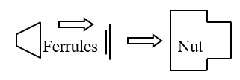
Figure 5.6. Making a Swagelok connection.

- Clean stainless steel tubing with acetone prior to assembly. Cut the tubing to the required length using a tube cutter. Deburr the end with a file.
- Slide the nut and ferrules onto the end of the tube as shown in the above diagram. Insert these into the body of the fitting. Finger tighten the nut first, then go an additional 1¼ turn with a wrench. For ⅛ inch fittings, go only an additional ¾ turn.
- Verify that the tubing and connection are not leaking by pouring acetone over the length while monitoring the pressure.

d. PRESSURE GAUGES.

Thermocouple.

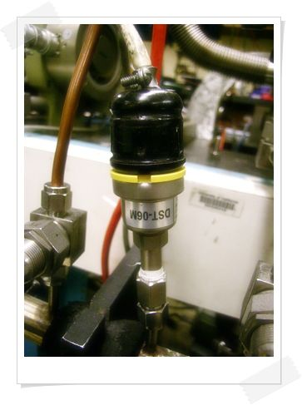
Thermocouple (TC) gauges are used to measure pressures from near an atmosphere down to a few 10⁻³ Torr. They are mounted at various positions on the chamber and are used mainly to give an approximate indication of a rough vacuum. They are prone to burnout, especially in the gas manifold since they can be exposed to corrosive gases there.
If the gauge is working properly, the pressure should read zero, or near zero, when the vacuum is 10⁻³ torr or less. If it does not, try adjusting it with the calibration port on the controller unit. If the gauge cannot be adjusted, remove it and gently flush it out with solvent. If that does not work, then it is time to replace the TC gauge.
Figure 5.7. Thermocouple pressure gauge.

Baratron gauge.

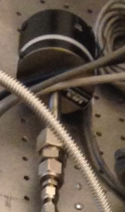
This gauge is located in the high-pressure end of the chamber and is used for preparing gas mixtures for the HPC. It consists of a variable capacitance pressure sensor conformed by a pressure inlet that connects to a small chamber in the sensor body. One wall of this chamber is an elastic metal diaphragm. The backside of this diaphragm faces two electrodes that are contained in a volume, which is permanently evacuated and sealed. When pressure is applied to the diaphragm the distance between it and the electrodes decreases producing a change in capacitance that is traduced as a change in pressure.

Figure 5.8. Baratron pressure gauge.

e. PUMPING SYSTEM (MECHANICAL PUMP).

The gas manifold is pumped down by an Alcatel 2008A single-phase mechanical pump that is connected directly to it. As any mechanical pump it requires scheduled oil changes and every once in a while they need to be rebuilt. Any abnormal sound usually means that the pump needs to be stopped and checked.

f. GENERAL OPERATION PROCEDURE.

There are many ways to operate the gas manifold because there are several ways to feed the gasses into the lines. However, the general steps to keep in mind are as follows:
- Determine which volume valve or line will be filled with the desired gas.
- Trace the line or lines that lead to the desired volume or line.
- Make sure that the manifold is pumped down to 10⁻³ Torr or at least 1.0 x 10⁻² Torr.
- Isolate the pathway that leads to de desired volume or line by closing any peripheral valves.
- Close the valve that leads to the mechanical pump.
- Flush the line and volume with a small amount of gas (~10-15 Torr).
- Open the valve that leads to the mechanical pump and rough pump the line and the volume to the pressure range mentioned in step 3.
- Close the valve that leads to the mechanical pump when the pressure range in step 3 is achieved.
- Fill the target volume or line with the desired pressure.
- Isolate the target volume or line by closing the closest valve that leads to it.
- Pump down the excess gas.
- When an experiment is done, pump down the target volume or line.

g. GAS AND LIQUID SAMPLE HANDLING.

Gas or liquid samples can be fed into the UHV chamber by using the leak valves that are mounted on it. Liquid samples are usually carried in a small test tube that is connected to a stainless steel ¼ inch tube equipped with a Swagelok nut, ferrule, and cone at the end. After collecting the sample in the tube a valve must be installed at the end of it in order to connect it to the line on the leak valve. Gas samples are collected directly from gas lines so the test tube/valve setup is already assembled and ready to be connected to the leak valve.

Procedure for gas samples:

- After connecting the test tube/ valve setup isolate the manifold gas line to the leak valve.
- Slightly open the valve to the test tube to flush the leak valve line. Close the test tube valve.
- Pump down the leak valve line.
- Close the valve to the leak valve line.
- Open the valve to the test tube.
- Open the leak valve until the pressure in the chamber reaches the desired dosage.
- When the dosage is done, close the leak valve.
- Close the valve to the test tube.
- Pump down the leak valve line.

Procedure for liquid samples:

- Connect the test tube/valve setup with the sample to the leak valve line.
- Submerge the glass portion of the test tube in a Dewar filled with liquid nitrogen.
- When the liquid sample is frozen open the valve to the test tube and pump it down.
- When the pressure reaches 1.0 x 10⁻² Torr close the valve to the test tube and waits until the liquid thaws.
- Repeat steps 2-4 three more times or until the pressure in the line does not increase when the frozen sample is being pumped down.
- Close the valve to the test tube.
- Pump down the leak valve line.
- Close the valve to the leak valve line.
- Open the valve to the test tube.
- Dose the necessary amount of the sample into the chamber by opening the leak valve.
- When dosing is done, close the leak valve.
- Close the valve to the test tube.
- Open the valve to the leak valve line and pump it down.

h. MAINTENANCE.

The gas manifold usually requires very little maintenance unless the samples and gases being used are corrosive in nature. Maintenance might involve:

- Replacing corroded tubing or adding a new gas line.
- Replacing worn-out valves.
- Replacing faulty pressure gauges.
- Adding new Swagelok connectors.

It helps to flush the gas lines with an inert gas such as Ar after every experiment to dilute the content of hazardous gases that remain adsorbed on the inner surface of the tubing.

6. MASS SPECTROMETER (UTI 100)

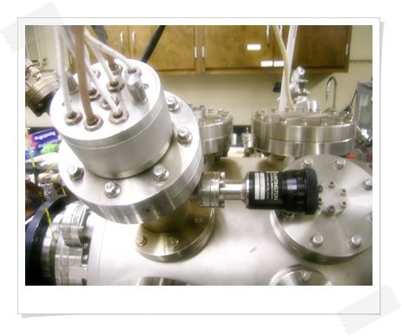
The MS probe is housed within a cone inside the working chamber. The cone tends to limit the introduction of molecules into the probe to those leaving the surface of the sample. The cone position is controlled by rotary feedthrough to the right of the housing. All software applications pertaining to the mass spectrometer can be found in the directory "c:\ms\" (BASICA version). The new software for mass spectrometer operation, UTI Mass spectrometer, and TDS RTC are installed in the computer with XP operating system.

Switch off the multiplier mode whenever data recording is finished to extend the life of the multiplier.
Figure 6.1. UTI 100 mass spectrometer
There are three of four UTI 100C manuals in the lab. They are in large three-ring binders and contain all the needed technical information about these instruments.

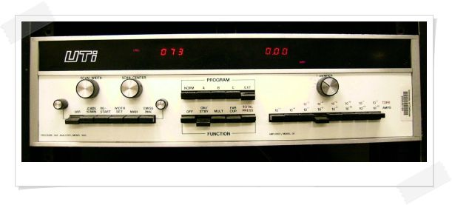
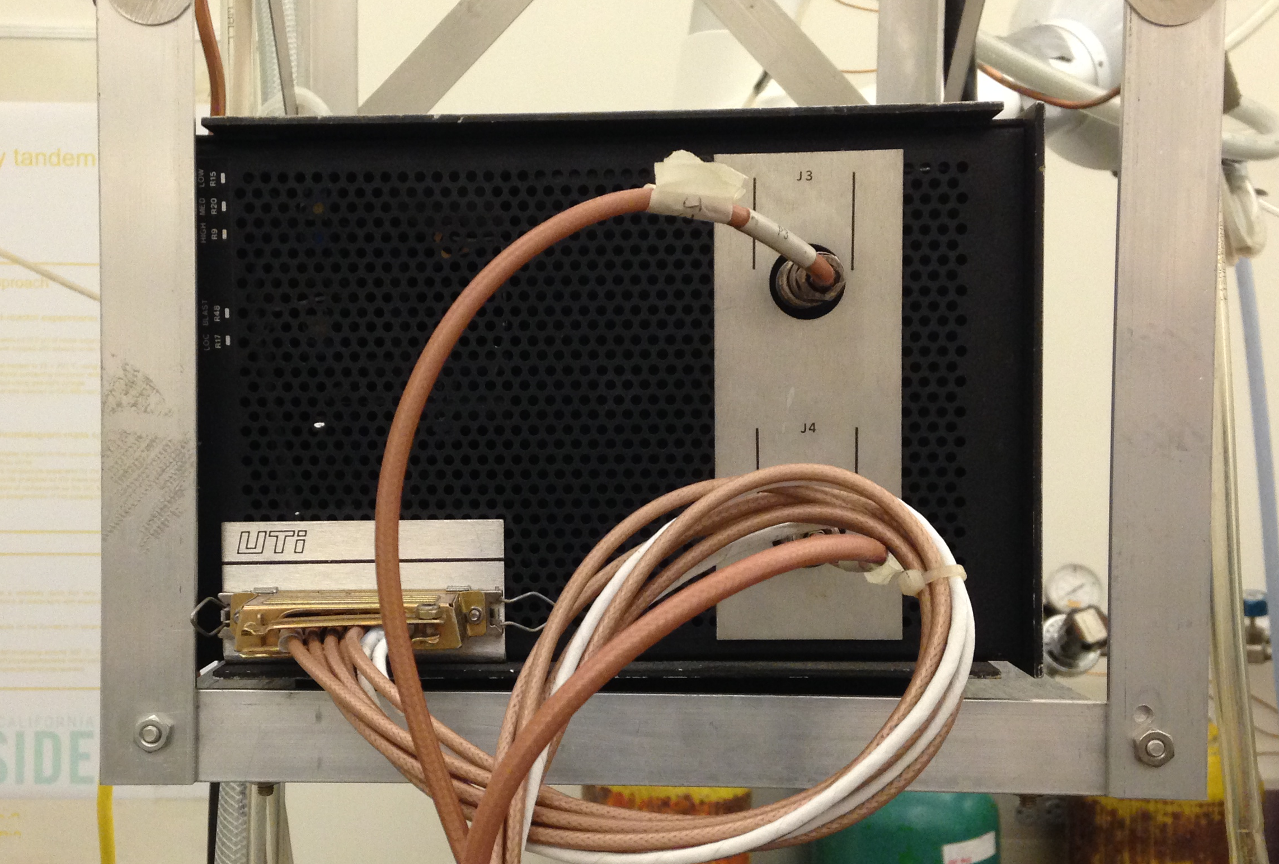Figure 6.2. UTI 100 mass spectrometer controller unit

a. GENERAL OPERATION.

- Turning on, off, keeping in stand by.

Turning it ON:

- Turn the ‘Emission’ dial fully counterclockwise.
- Set the range to 10⁻⁵ AMPS to avoid possible burnout of filament.
- The damper should be completely counterclockwise.
- MAN key depressed
- Press "ON/STBY". Wait a few seconds.
- Press "Multiplier".
- Press "EMISS/(MA)" to display the filament emission current. Slowly increase the current to 2.00 milliamps with the emission knob. Always use the same value to keep experiments comparable. Confirm that the filament protection switch is on. (Open the front panel. The switch is mounted on the end of a circuit board to the upper right side.)

Stand by Mode:

Leave the instrument in this mode if it is to be used within a short amount of time, e.g. a day or even a week.

- Place the instrument in the “ON/STANDBY” mode.
- Set range to 10⁻⁵ Amp.
- Make sure that the emission switch is down.
- Turn the emission knob counterclockwise fully, but not to the point that it clicks off.

Turning it OFF:

If the instrument will not be used for a long period of time, it should be turned off.

- Place the instrument in Faraday cup mode.
- Set range to 10⁻⁵ Amp.
- Turn the emission knob completely counterclockwise, to the point that the knob clicks off.
- Depress the emission switch off.
- Depress the "ON/STANDBY", then depress “OFF”.

- Displaying in the oscilloscope.

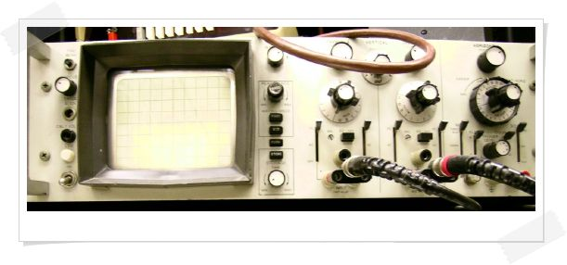
The oscilloscope is connected to the MS and provides a means of observing the mass spectrum. The instrument is an Elenco 25 MHz Oscilloscope Model S-1325. There are two channels labeled CH1 (or X) and CH2 (or Y). Both channels are connected to the rear panel of the MS through BNC cables with CH1 connected to the RAMP GENERATOR and CH2 to SIGNAL OUT. What follows are the recommended settings:
Figure 6.2. Elenco 25 MHz Oscilloscope.

Tabel 6.1. Recommended Oscilloscope settings.

Intensity | N/A (Nominally 1 o’clock)
Focus | N/A (Nominally 9 o’clock)
Trig Level | Fully Clockwise
Coupling | NORM
Source | CH1
Hold Off | Fully Counter Clockwise
X-Y | Pushed In
<>Pos | 8 o’clock
Pos (Pull Alt Trig) | 2 o’clock
CH1 Var | DC
Volts/Div | 1
CH1 Var | DC
Volts/Div | 0.5
Time/Div | 5 mS

Procedure for setting up the oscilloscope:

- Connect the oscilloscope to the rear panel outputs (x to ramp generator, y to signal out). Place the ‘scope in the x-y mode, DC decoupling. It is now set up for displaying the mass spectrum.
Depress "EMISS/(MA)", press "VAR" and adjust sweep time with the knob on the left side.
The display over the range keys shows the intensity. The one over "EMISS/(MA)" gives the mass.
- Scan width and scan center can be varied with their respective knobs while "EMISS/(MA)" is up and "WIDTH" or "MAN" are pressed (only one switch down at a time).
- Switching to "MAN" yields a flat line on the scope since the system is sitting on some fixed mass number rather than sweeping. You can tune from amu=1 until 300 manually with the "Center" knob. The height of the line on the scope gives the intensity of the peak.

- Recording MS in PC.

BASICA Version (old)

The program for this is in the directory “c:\ms\”. In the directory “c:\ms\”, type “basica mspect6”. Follow the steps in the program. Set the mass spec to "EXT" and set the damper to 9 o'clock. Set to the appropriate range. Type "system" to exit, or "run" to run another spectrum. Two files are saved: *.dms, and *.ims. The former contains the actual data, and the latter, information on the spectrum. The files are saved in the directory "c:\". Note: If the intensity has a negative value, the data are saved without a blank between the amu and the intensity value. This causes problems with some data processing programs. It is possible to open the files in Excel and set the column size by hand.

XP Version (new)
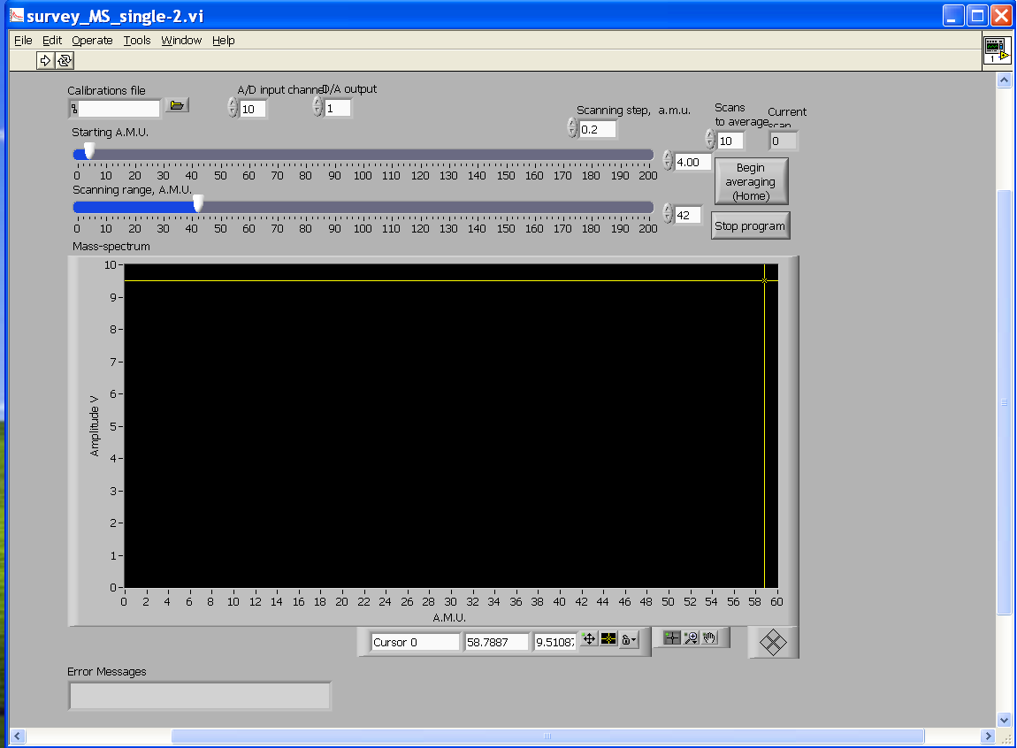
Figure 6.3. The program window for mass scan recording
The program for the mass scan recording is UTI Mass Spectrometer (Start All Programs UTI Mass Spectrometer UTI_Scan_Average) Also, there is a desktop shortcut for the program with the name “UTI_Scan_Average”. Turn on the mass spectrometer (ON/STBY MULT) and open the program on the desktop (UTI_Scan_Average). Click the “Calibration File” and load the calibration file with the extension “.txt” (desktop calibration calibration.txt). Set the parameters as A/D input=10 and D/A Output=1. Set to the appropriate range and set the parameters accordingly (step size, scans to average, etc.). Collect the averaged scans by clicking the sign “ ” in the top left corner (see figure below). At the end of the scan, save the ASCII file.

- Calibration.

The MS will need to be calibrated from time to time. Some calibrations are performed on the instrument and some on the voltages seen by the software. The software calibration is done using a BASICA program and is carried out as follows:

- Go to the directory containing the BASICA program “mscal6.bas”.
- Turn on the MS, and place it in the Faraday Cup mode. The sensitivity determines the voltages seen so set to 10⁻⁸ AMPS, Damper off.
- Leak in a gas of known composition.
- Set the emission current to the desired/optimal value (~2.00 milliamps).
- Choose a peak for calibration from the spectrum displayed on the ‘scope by turning the “SCAN CENTER” knob.
- Then set MS to "MAN" mode and observe intensity for said peak. It may be necessary to turn the “SCAN CENTER” knob for optimal intensity.
- Switch MS to "EXT" mode.
- In software, input the m/z to be calibrated. This will result in the computer program sending to the MS the voltage (i.e. m/z) to be calibrated.
- This voltage may not correspond to a valid m/z on the MS. The m/z that corresponds to the voltage sent can be observed on the MS in the red readout directly above the “SCAN CENTER” knob. The readout to the right corresponds to the intensity of the m/z under consideration.
- Use the commands "UP" or "DOWN" until the MS reads the proper m/z on its readout. Then optimize the intensity that the MS on the other readout.
- Repeat steps 5–10 for all m/z to be calibrated. It is suggested that only a low, a high, and a middle m/z be calibrated.
- Type "system" to exit. The calibration file can be found in the directory "MS".

- Maintenance:

When work has to be done on the mass spectrometer, the cone has to be taken off first. Consult the UTI manual for the repair procedures of the mass spectrometer itself. Make sure you have two 4.5" and one mini flange Cu-gasket before you start.

Taking of the Cone of the Mass Spectrometer:

- Vent the chamber.
- Disconnect the large aluminum quick-disconnect probe connector from the end of the mass spectrometer probe.
- Remove the nipple bearing the mass spec probe at the flange closest to the chamber. (It cannot be removed at the flange bearing the feedthrough until step 6.) Lay the probe/nipple assembly on the desk behind the IR chamber and cover the opening of the chamber.
- Mark the position of the mass spectrometer with respect to the nipple. This makes reassembly much easier.
- Dismount the rotary feedthrough from the side of the nipple. Save the copper gasket.
- Unbolt the feedthrough flange and take the nipple off. Save the copper gasket.
- Loosen the screws that hold the three rods to the ring.
- Take the cone off by unscrewing the rods.

At this point, the mass spectrometer is serviced according to the UTI manual.

Putting back the Cone of the Mass Spectrometer:

- Put the rods back through the holes in the rim and attach the cone to it. Screw the rods about halfway in.
- Put the ends of the rods back into the holes in the ring.
- Tighten the rods to the ring. In doing this, make sure that the lengths of all three rods measured from the top of the ring to the bottom of the cone are exactly the same. Use a caliper, adjust the slotted screws and lock nuts as necessary. If these lengths are not the same, the cone assembly will not slide smoothly. Use a small screwdriver and a 4 mm wrench.
- Make sure that the rack is in its place.
- Set the probe assembly vertically on the feedthrough flange.

In the remainder of the reassembly procedure, it is necessary to verify that the motion of the rotary feedthrough and cone will be smooth. This is accomplished by proper alignment of the rotary feedthrough sidearm with respect to the rack slide assembly on the probe.

- Put the used gasket on the bottom flange, place the nipple on top of it, and match up the alignment marks from step 4 of the cone disassembly procedure, above. Put in a couple of the bolts and finger-tighten them.
- Reinsert the rotary feedthrough with its old gasket and a couple of bolts, making sure that the rack and pinion are engaged.

If everything is aligned, the motion of the system should be smooth.

- Now, reassemble using new gaskets. Tighten the large flange first, then the rotary flange. As the rotary flange is being tightened, check from time to time to see that the motion is smooth. This is somewhat sensitive to the tightening of this flange.

If the alignment has to be started from scratch, look for the alignment tool in the lab. This consists of an aluminum cylinder with a rod through its center. The cylinder exactly fits the I.D. of the rotary sidearm. Note that there is a little socket in the rack slide that accepts the end of the rotary shaft on which the pinion is mounted.

- Put the used gasket on the bottom flange, and place the nipple on top of it. Put in a couple of the bolts and finger-tighten them.
- Line up the rotary sidearm by sight so that the shaft socket in the rack slide is visible and approximately centered in the opening.
- Put the rod from the alignment tool into the shaft socket, and adjust the nipple until the cylinder fits smoothly over the rod and inside the rotary feed through sidearm.
- Reinsert the rotary feedthrough with its old gasket and a couple of bolts, making sure that the rack and pinion are engaged. The motion should be smooth. If not, make fine adjustments on the nipple until it is. If things are well aligned the cone should fall back a little of its own weight.
- Mark the position of the nipple with respect to the probe flange.
- Put a new copper gasket between the nipple and mass spectrometer flange. Align the nipple according to the marks, and tighten the flange. Check if the alignment is correct by using the alignment tool: Initially the aluminum cylinder cannot be moved easily in and out of the sidearm, because the mass spectrometer is sitting too high. As the flange is tightened and the groove in the copper gasket is cut, the aluminum piece should move in and out easily.
- Now mount the rotary feedthrough with a new copper gasket. As the flange is being tightened, check from time to time to see that the motion is smooth. This is somewhat sensitive to the tightening of this flange.

b. TEMPERATURE PROGRAMMED DESORPTION (TPD).

- General Considerations

As mentioned at the beginning of section 6, the cone from the mass spec limits the introduction of molecules into the probe to those leaving the surface. For this reason, TPD experiments require the nose of the cone to be placed directly over the sample at a very short distance during analysis.
TPD experiments are most often started from cryogenic temperatures. To achieve these temperatures refer to section 4c of the manual: Heating, cooling, and troubleshooting.
As mentioned in section 6.a.iv the mass spectrometer is connected to a personal computer that allows recording of the data generated from experiments. The program is also run in BASICA (old version) and an application program designed for XP (new version). However, it is different from the MS program since it does not scan a whole range of masses but only a few. These masses need to be introduced in the program and they depend on the nature of the experiment.

- Software.

BASICA Version (old)

The program to carry out TPD analysis is found in BASICA in the directory “c:\ms\”, type “basica tds2001z”. Follow the steps in the program. Two files, “*. dtd” and “*. itd”, are saved in the directory “c:\ms\data\”. The former contains the actual data, and the latter, information on the experimental conditions. Be always aware of the free space on the hard drive C. When finished, type "system" to exit, or "run" to run another spectrum.

XP Version (new)

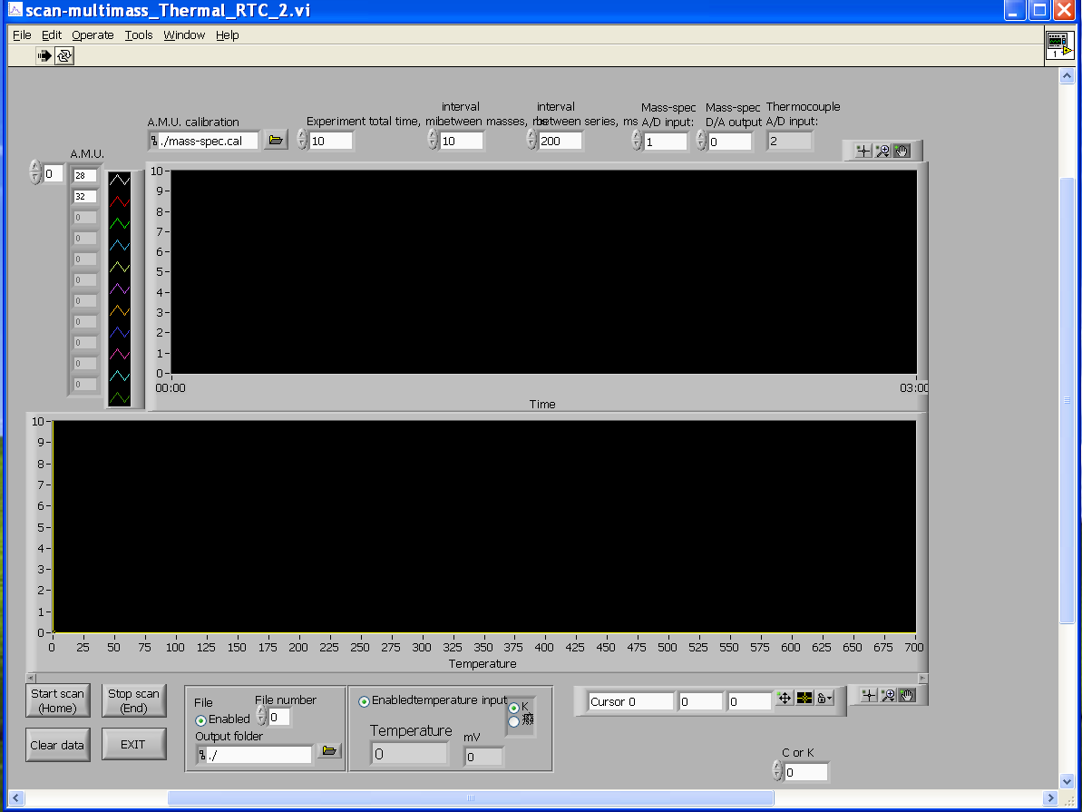
Figure 6.4. TDS measuring program window

The program to carry out TPD analysis is TDS_RTC (C:\Documents and Settings\Administrator\Desktop\MS tds bo) and it also has a desktop shortcut (TDS_RTC). Open the program and load the necessary configuration file to run the TPD experiment including the masses to be collected (.CFG file). Load the calibration file (desktop calibration “calibration.txt”). Change the parameters accordingly (e.g. experimental total time, the interval between masses, etc.). Click “Start scan” to run a TPD experiment and click “Stop scan” to end the scan (buttons located in the lower-left corner of the program window (see figure below)). At the end of the TPD run, an ASCII file can be saved (.DAT file) which can be analyzed using any data processing software.

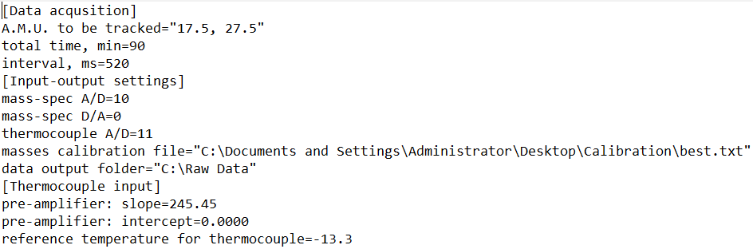

Figure 6.5. A sample configuration file (.CFG file)

- How to take TPD data.

1. General details.

The mass spec must be set to "EXT" and the damper to 10 o'clock. If the damper is set too high, the peaks will be too broad and will tend to overlap. Check this by varying the order in which the amus are taken. Set to the appropriate range. A dry run of the heating will give you the time you need for the TPD. Run the computer and heating simultaneously to get the TPD.

2. Running procedure.

- Before moving the sample manipulator make sure that the MS cone is fully retracted.
- Move the sample and align it with the leak valve on top of the chamber.
- Follow the procedure outlined in section 4.c on how to cool down the sample.
- Load the TPD program. Introduce the masses that will be analyzed.
- Dose the analyte into the chamber by means of the leak valve. Make sure you use the right exposure.
- Follow steps 1 through 4 of section 4.c on how to heat the sample to prepare the temperature controller for analysis.
- Move the sample and place it directly under the nose of the mass spectrometer.
- Turn the rotary stage until the sample is completely parallel to the end of the cone. Try to align the orifice of the cone with the center of the sample. The distance from the tip of the cone to the sample should be 1mm. Always make sure that the thermocouple wires are not touching the cone.
- Stop cooling.
- Start the TPD program at the same time as the heating is started.
- Once the heating ramp and the analysis are done move the START switch on the temperature controller to the OFF position.
- Switch the MS controller to STAND BY mode.
- If no more experiments will be done the heating controller and the MS controller can be shut OFF (make sure to degas the MS filaments before shutting it OFF).
- Retract MS cone and move sample past its position.

3. Data acquisition.

Old computer

The data acquired from the TPD analysis will be stored c:\ms\data\ directory. The files need to be extracted from the computer by means of floppy discs since the computer does not possess USB ports.

New computer (XP Version)

The data can be stored in any directory and files can be extracted using a USB drive.

4. Data processing and Editing.

The files obtained from the TPD analysis are saved as data point tables, which can be opened and processed in excel or any other data processing software (Origin). Temperature desorption spectra (TDS) require the identification of peaks that sometimes overlap. These peaks need to be resolved before they can be assigned an identity. For this, the user should refer to the deconvolution manual and example that is available on the group page.

c. ACQUIRING ISOTHERMAL KINETIC DATA UNDER HIGH PRESSURE.

Follow the procedure outlined in section 3.g of the manual. The program used is the same as for a TPD analysis. Make sure to input the masses of the products that will be followed. A complete kinetic run usually takes about three consecutive TPD scans of 765 s.

7. REFLECTION ABSORPTION IR SPECTROSCOPY (RAIRS).

a. General considerations.

In the RAIRS experiments, the IR beam is taken out of the spectrometer, passed through a polarizer, focused through a sodium chloride window onto the sample in the UHV-chamber at grazing incidence, passed out of the chamber through a second sodium chloride window, and refocused onto the MCT (mercury-cadmium-telluride) detector (ivory cylinder in the purged box).
Make sure that the following connections are made to the spectrometer (assuming that the MCT-detector is used.

- The MCT-detector output is plugged into the internal port with a DB15 connector, which is in the detector compartment of the Equinox 55 as in below figure.
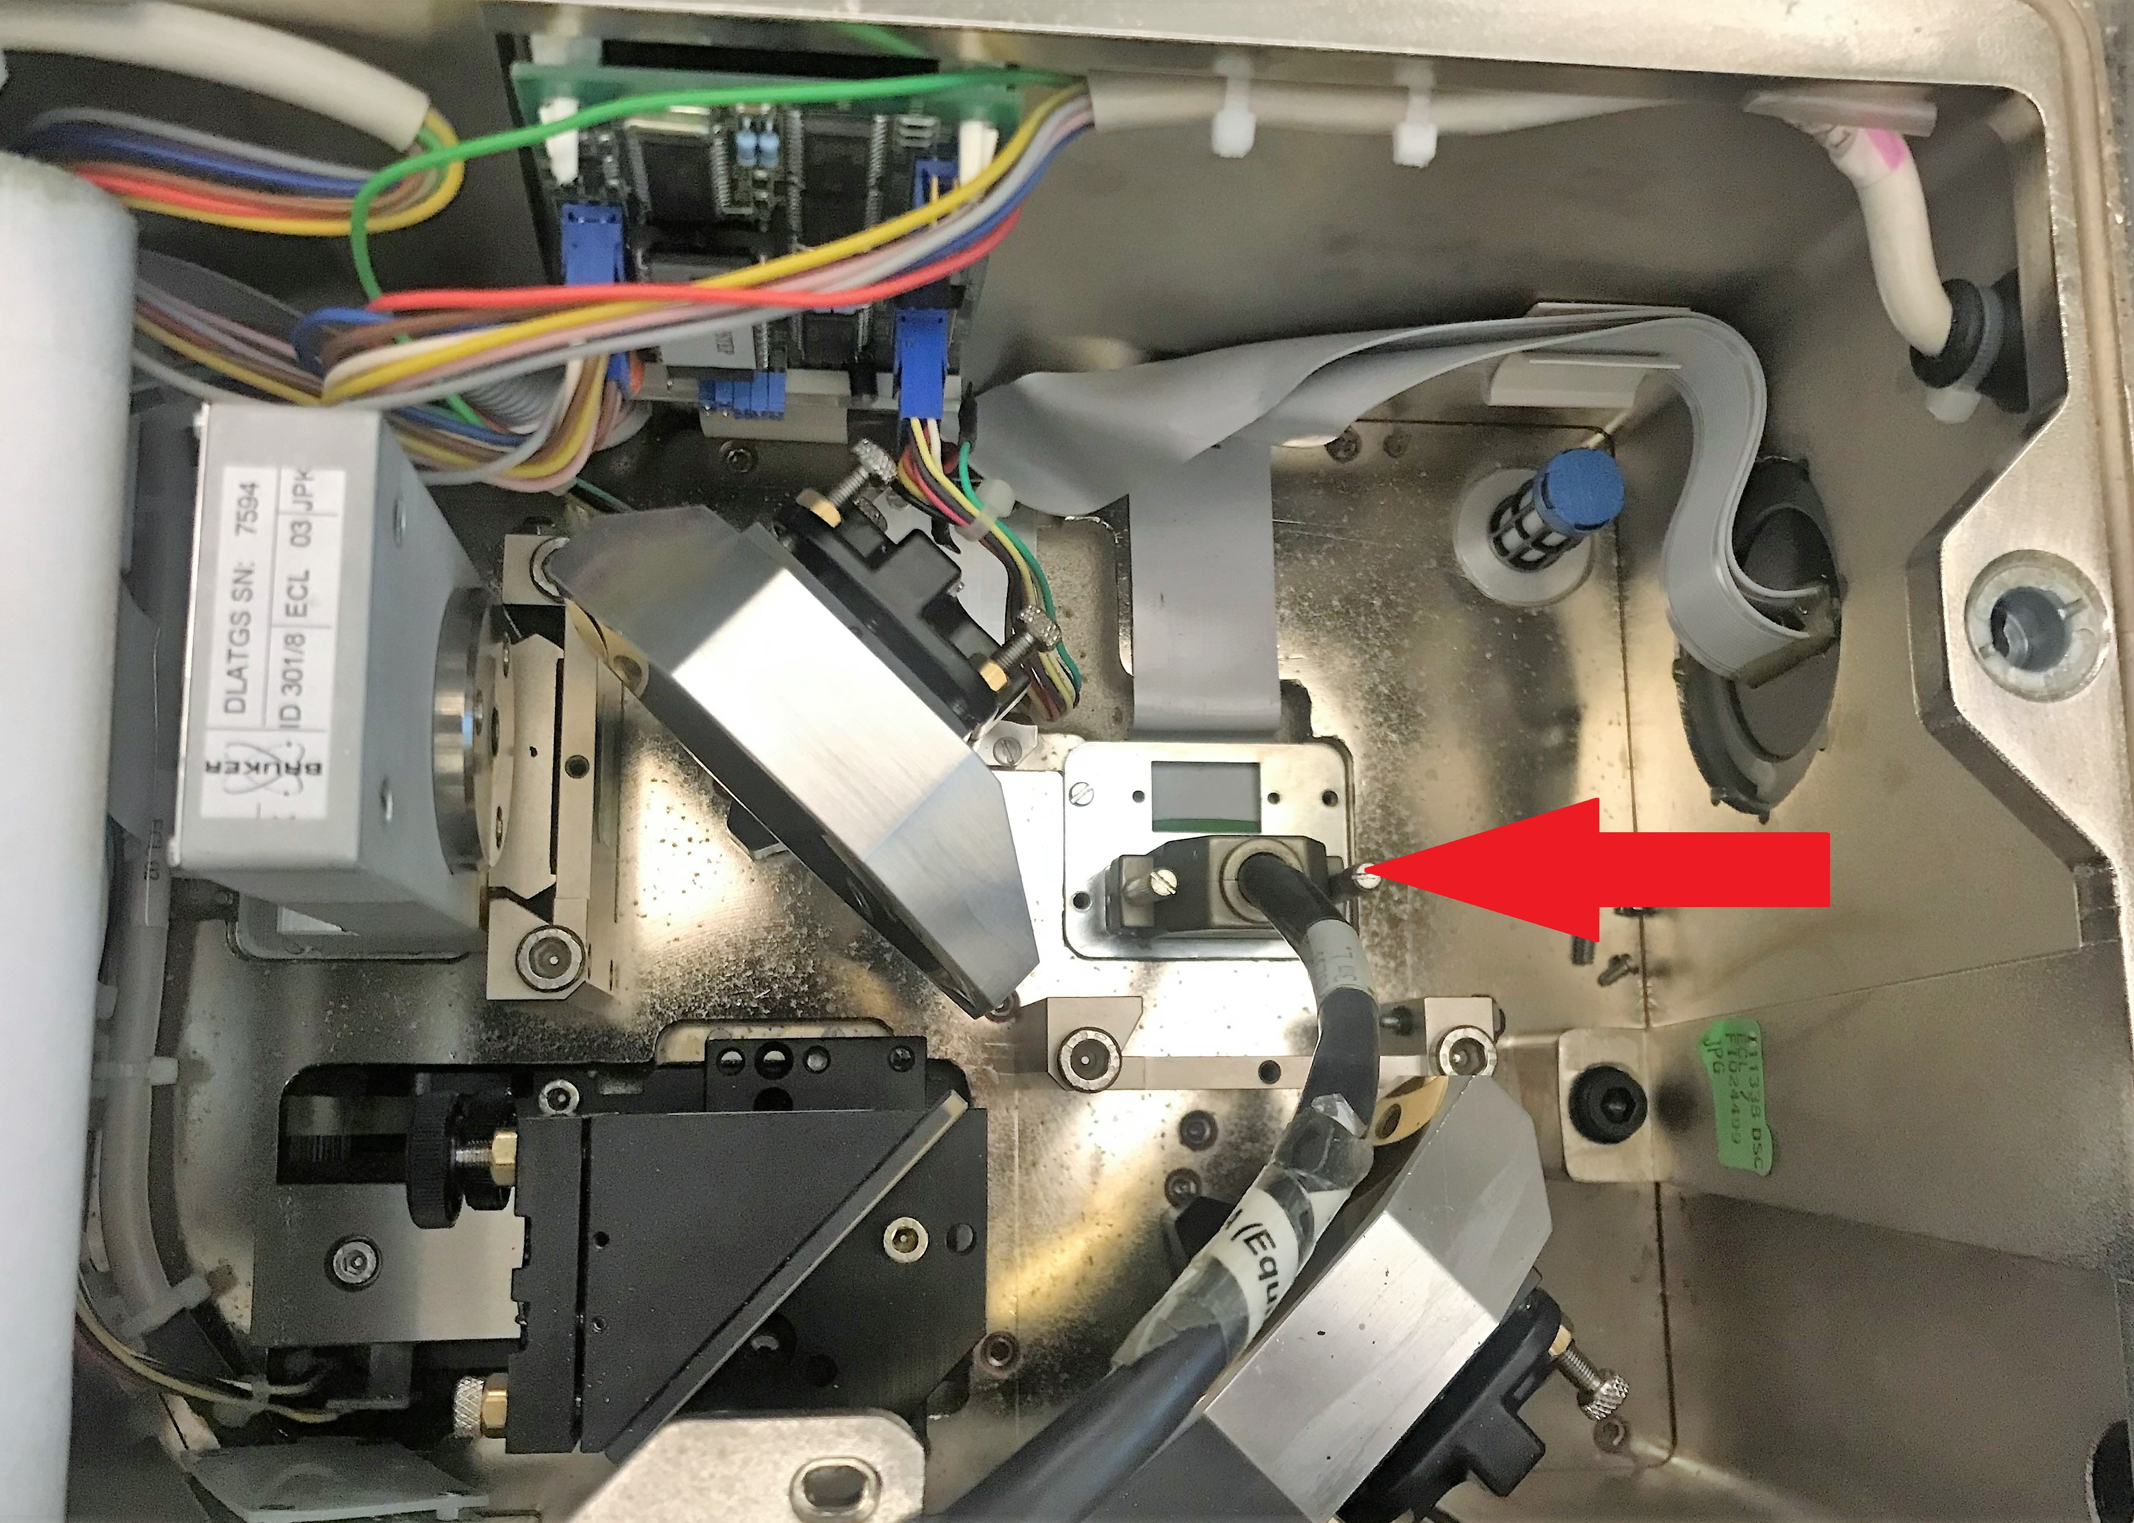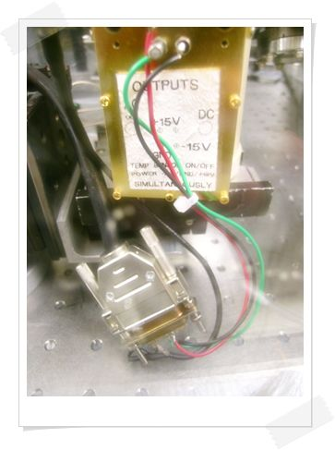
Figure 7.1. The rear side of the IR spectrometer (left) and the MCT-detector output (right).

- Output "LINK" on the rear side of the IR spectrometer is connected to "FLIT Board" of the PC.
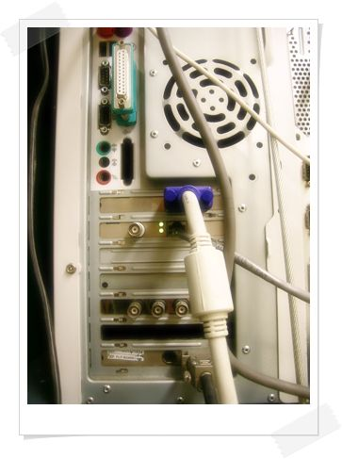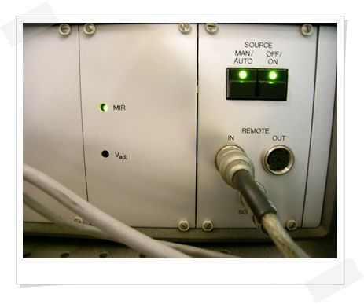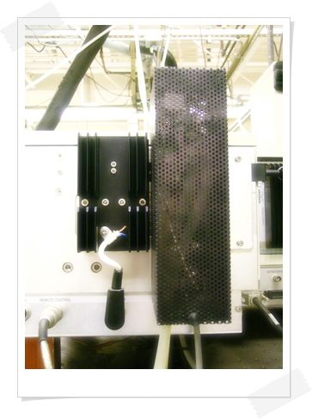
Figure 7.2. The PC controlling the data acquisition and the IR spectrometer controller box.

- Output "REMOTE CONTROL" on the rear side of the IR spectrometer is connected to "IN" of the Controller Box between PC and purged box.
- The cable from the IR source is connected to the "SOURCE" (directly below "IN") of the Controller Box.
- The dry air should be flowing. There are two flow meters, one behind the bench toward the door, and one next to the purged box facing the back of the lab. Both flowmeters should read approximately "100". If not, adjust. This should be checked periodically, even if the IR spectrometer is not used.
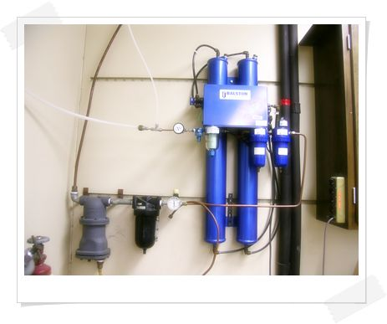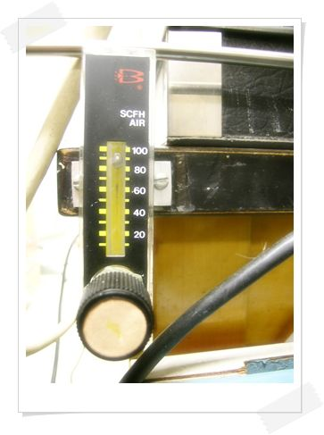
Figure 7.3. The flow meters measuring the dry airflow.

- The IR source is continuously cooled with water taken from the circulating system (AQUATHERM) below the bench. The hose connected to "OUT" should feel slightly warmer than the hose to "IN". If this is not the case, the IR source is off and should be restarted. See the section "Restart IR source" below. This should also be checked periodically.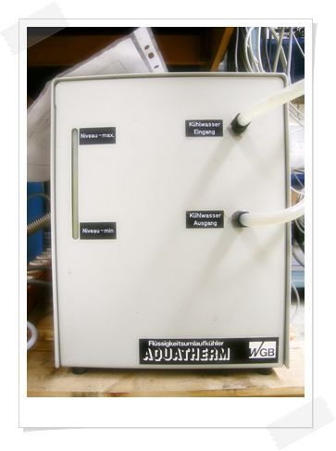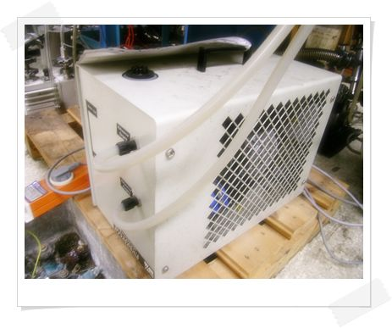
Figure 7.4. IR source water cooling system.
b. RAIRS setup (drawing, mirror specs, detector)

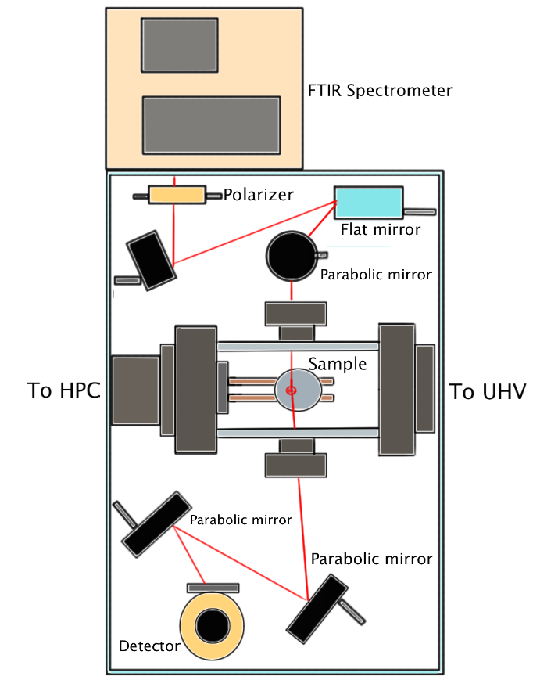
Figure 7.5. Schematic representation of the IR beam path.

c. SAMPLE SETUP.

- General preparation.

Before a RAIRS spectrum can be taken, the detector has to be cooled down to liquid nitrogen temperature:

- Open the lid on top of the purged box and insert a funnel in the hole on top of the detector. Keep the opening to the box as small as possible to minimize the amount of humid air leaking in.
- Pour in the liquid nitrogen. At first, the nitrogen will boil out of the detector. Keep pouring, a little at a time, until the boiling stops and the detector is filled. When the detector is full, the liquid nitrogen will just run off the top of the detector.

Do this well before starting experiments, since about 1/2–1 hr. of purging will be required to remove the water vapor that has leaked into the box. If the detector has been filled according to the procedure above, it should remain cold for 10–12 hrs. The detector can be refilled while doing experiments, but you will have to purge, again, after doing this.

The spectrometer should be in the standby mode before experiments are started:

- The interferometer is running, indicated by the flashing "SCAN" light.
- The display on the bottom line of the OPUS window will read "No Active Task".

If these conditions are not met, reinitializing the bench usually brings the system into this state (see below for procedure).
- Sample positioning

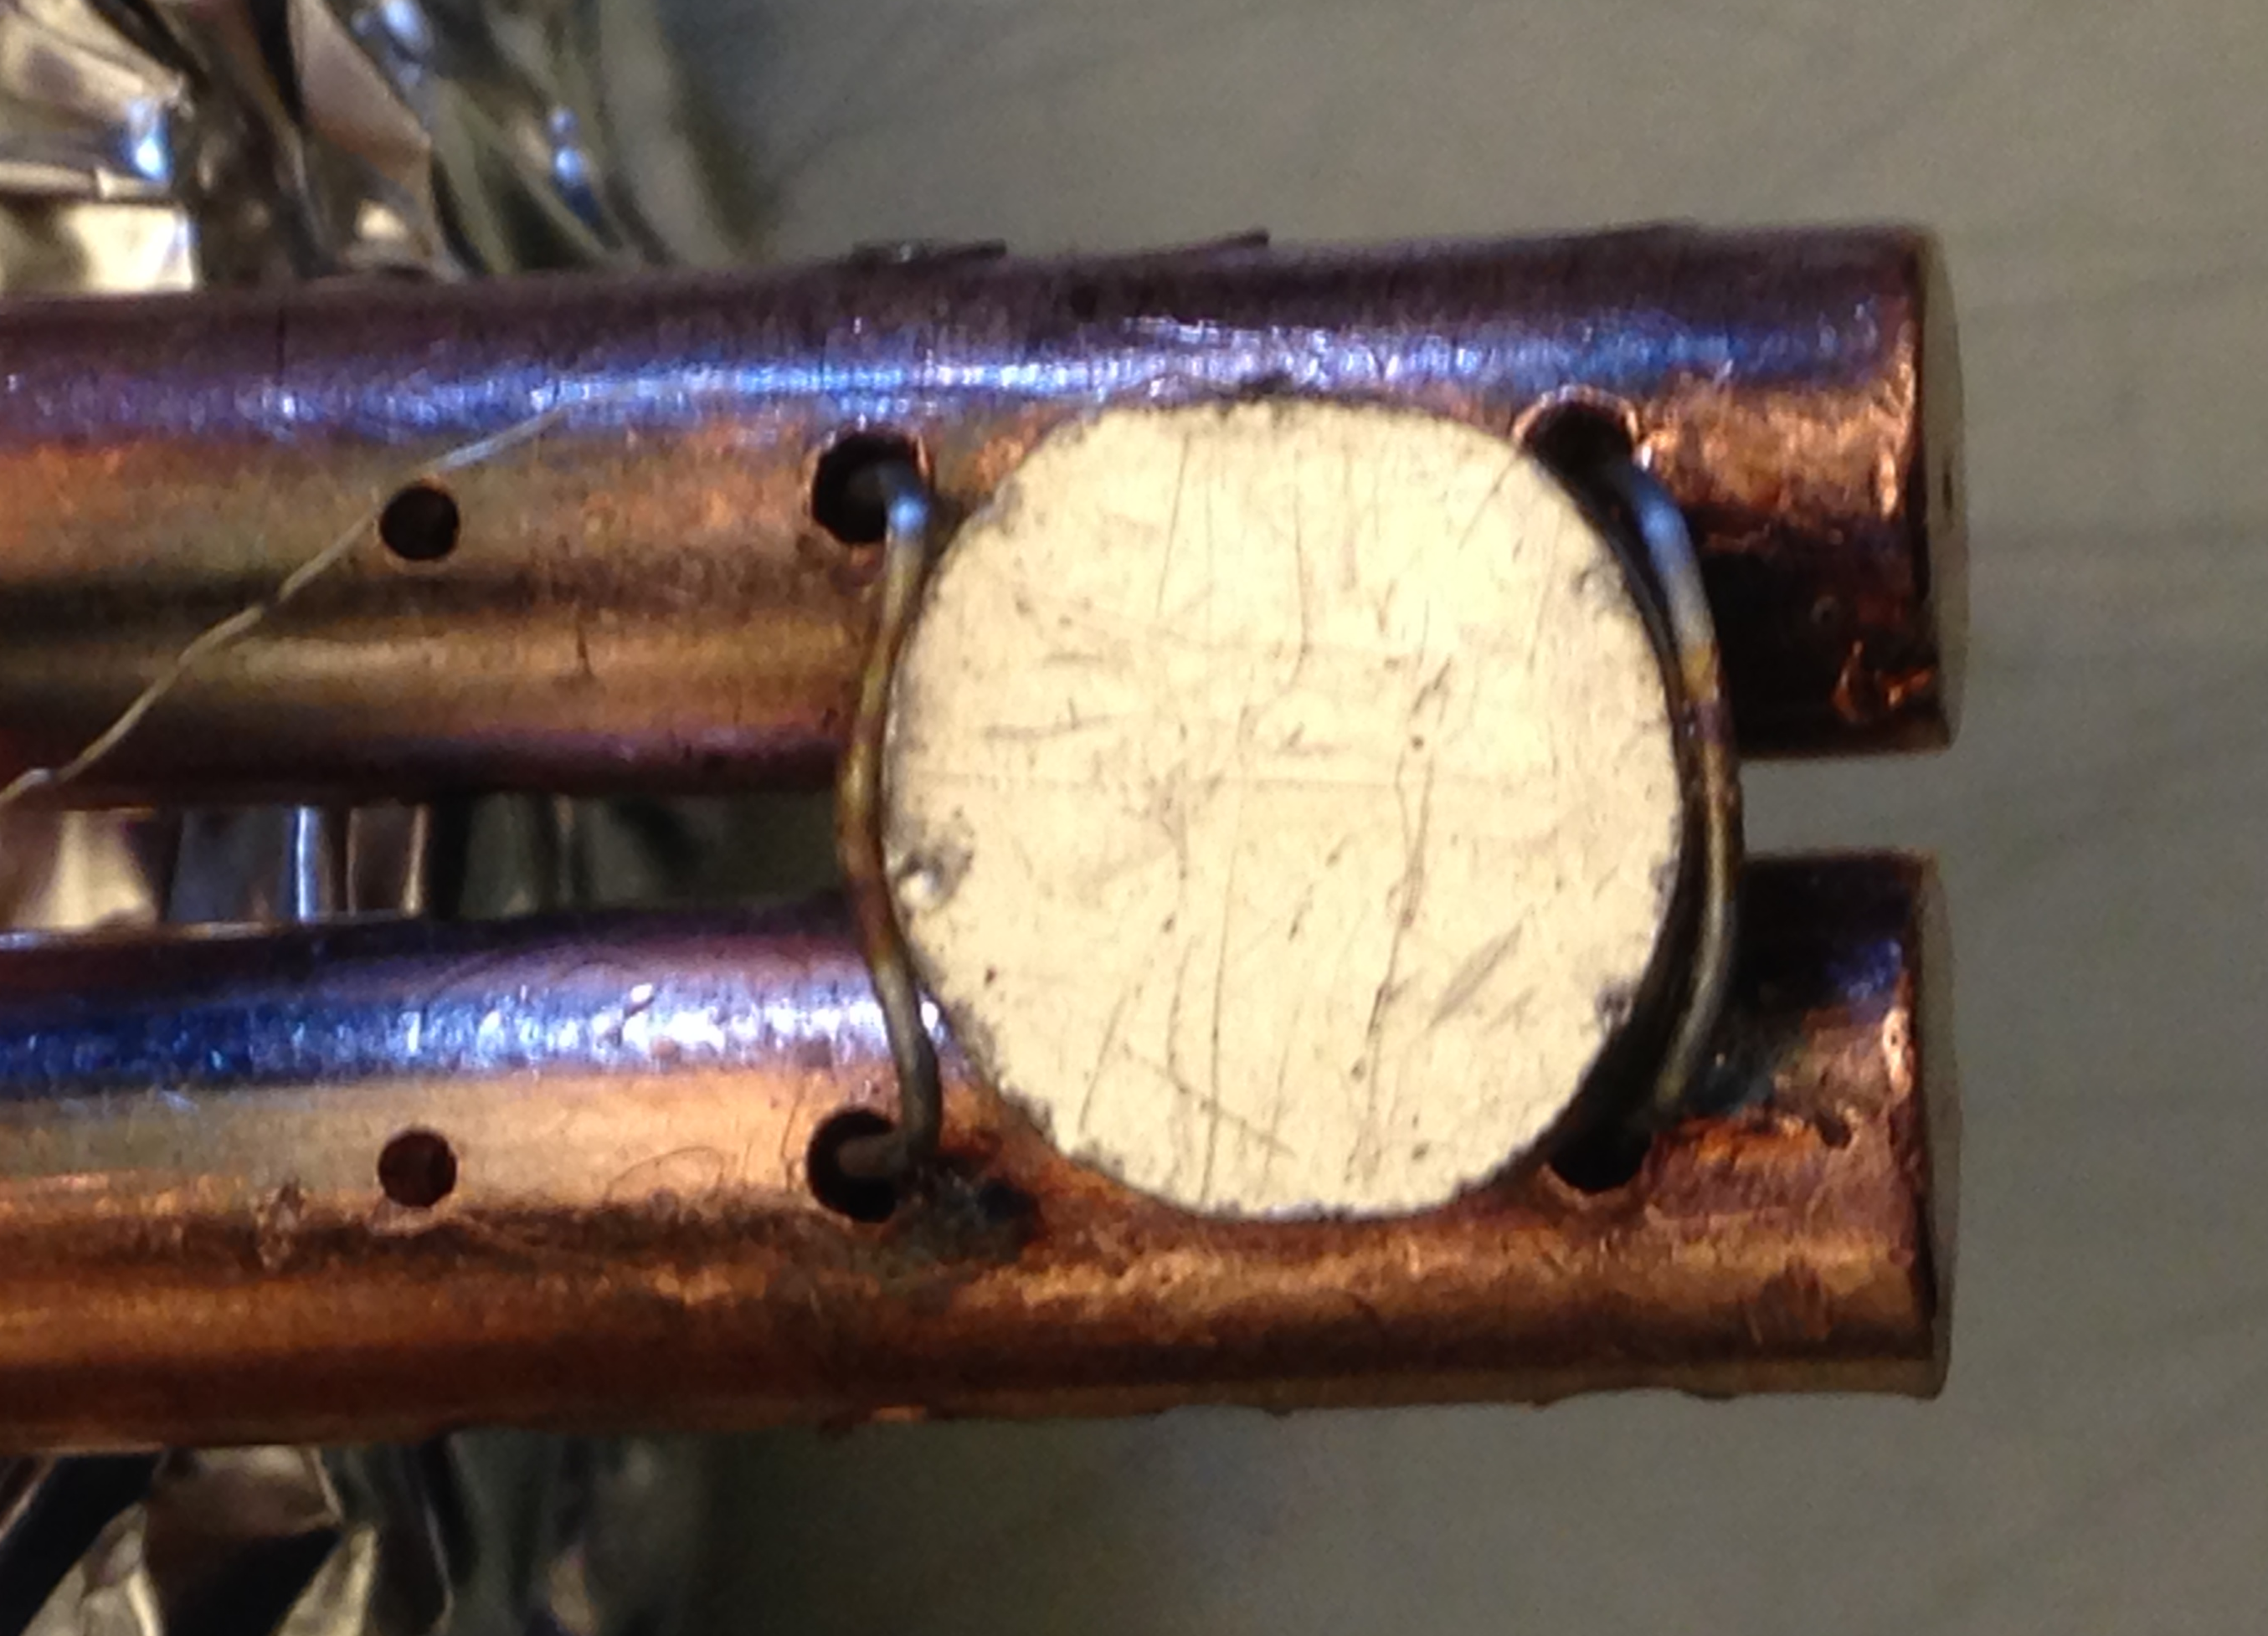

Move the sample to the IR compartment. MAKE SURE THAT THE CONE ON THE MASS SPECTROMETER IS FULLY RETRACTED! The position should be 486.5 mm. (The distance between the sample and the end of the copper rods is 2 mm and the sample should be lifted from the rods ~ 2 mm).
Select "Measure", "Measurement", and "Check Signal" in the Measurement window. If everything is OK the interferogram is displayed on the screen. Check the amplitude and select ADC Count to see easily. Rotate the sample until a maximum value is obtained: The surface should roughly face the leak valve on top of the IR compartment, i.e. rotated by about 20–30˚ out of the horizontal towards the cabinets.
Optimize the sample position by moving and rotating the sample. If the desired intensities are still not reached, then the first mirror intercepting the IR beam may have to be adjusted. Peel off the tape covering the hole in the purged box and adjust the mirror so that a maximum intensity is reached, and cover the hole again. When you do this, you have to allow some time for purging the box! If this still does not work, you have some major alignment to do!

IMPORTANT NOTE: When the manipulator is cold, it shrinks by about 2–3 mm. This means that the sample position determined with a warm manipulator is different from that for a cold manipulator. This is seen by a decrease of the intensity in the "Measurement" mode while cooling the sample after optimizing the position at room temperature. When this happens, the manipulator has to be moved about 2–3 mm further in, but this is hard to do when the manipulator is cold. The trick is to find the optimum position at room temperature and then move the manipulator 2–3 mm further. Later on, only minor adjustments have to be made. The temperature does not affect the optimum rotation angle of the sample, so this can be very well determined when the manipulator is still at room temperature.

- Calibration

Calibration of the IR signal of a particular gas is carried out in the same way that a UV, GC, etc is calibrated. The main goal is to dose the sample with the desired gas at the proper temperature (depending on the gas) with different exposures. The signal intensity obtained is plotted against the exposure used yielding a calibration curve. Using this curve it is possible to estimate the equivalent exposure of an unknown sample. It is important to keep in mind that the values calculated from the IR calibration curve are gross estimates since the intensity of the signal does not only depend on the amount of the chemical species present on the surface.

- Signal optimization

If sample mounting and mirror alignment were carried out properly, the amplitude of the IR signal is optimized by turning the rotary stage counterclockwise until the maximum amplitude is achieved. The amplitude is displayed in the “Measurement” dialog box in the OPUS program under the “ Check Signal” tab.

d. TYPICAL FTIR PARAMETERS (scanning speed, #scans, iris setting, resolution, acquisition time).

- Resolution: 4 cm⁻¹
- # Sample Scans: 2048
- #Background Scans: 2048
- Acquisition time: 4 minutes 50 seconds
- Source setting: MIR Source
- Beamsplitter: KBr
- Local Filter Setting: Open
- Aperture Setting: 3.5 mm
- Measurement Channel: External left (E1)
- Detector Setting: External (MCT)
- Scanner Velocity: 10; 80.0 kHz

e. ACQUIRING BACKGROUND SPECTRA.

Procedure:

- When the sample is clean (!!) and cold (a good temperature is below 100 K), take a background spectrum by selecting "Measurement", "Basic", and "Collect Background". The program displays a message in the bottom line highlighted by a green color indicating that the data are being taken.
- When the message disappears, the measurement is done; and from this point on you can proceed with the experiments (e.g. heat the sample, adsorb gases, etc.) During the data acquisition, the interferogram cannot be seen on the check signal menu. After background scans are finished, the "Measurement" window remains on the screen. The Filename (####.0) is saved automatically on the hard drive and displayed on the left (Window List) of the screen. The file can be saved in other formats on the hard drive. Select "Save File As", then check the file name and path to be saved. If you want an ASCII file, in the "Mode" option on the Save Spectrum window, select "Data Point Table" before clicking the "Save" button.

f. ACQUIRING SAMPLE SPECTRA.

- Prepare the adsorbate on the surface and cool down to the same temperature at which the background was measured.
- Take the sample data by selecting "Collect Sample", and wait until the highlighted message disappears (see also the previous paragraph).
- Start cleaning the sample for the next experiment.

NOTE 1: Make sure that the sample position in the sample scan is exactly the same as in the background scan: Do not try to optimize the sample position between a background and sample scan, even if the signal intensity is lower than it was in the background scan! Also, make sure that the temperature at which the sample is taken is the same as that at which the background was taken so that the contraction of the manipulator is the same in both cases. Do not change any parameters between the background and sample scans.

NOTE 2: Keep accurate records of the data type in the files: Know exactly which files contain the sample ASCII data.

NOTE 3: Keep backups of the OPUS files only. These files contain the actual data from which all other data can be easily derived.

g. OPERATION OF POLARIZER.

The IR setup possesses a 90º polarizer located in front of the beam exit of the spectrometer. This polarizer is activated manually by an external controller that lies on top of the purge box. The controller needs to be set to the appropriate polarization before acquiring spectra. After usage, the switch tends to wear out and at this point, it should be replaced.

h. HOW TO OBTAIN RAIRS UNDER HIGH PRESSURE.

Pressurizing:

- Using the manipulator, transfer the sample into the RAIRS position. Arrange the optics for RAIRS. These procedures are the same as those used in UHV experiments.
- Maintain the sample temperature as required, but don't use liquid nitrogen for cooling since this could cause the sample gas introduced into the cell to be condensed on the sample holder.
- If the clean surface is moved directly into the cell, it can get contaminated easily. Covering the sample surface with adsorbed molecules of the sample gas before pressurizing is one way to avoid this problem. Before the sample is moved into the cell, a small portion of the sample gas should be introduced into the UHV camber from the variable-leak valve to a pressure of 10⁻⁸ to 10⁻⁷ torr.
- Move the cell toward the sample. When the o-ring touches the sample holder, the handle of the stage becomes heavy. So, tighten it up.
- Introduce the high-pressure gas into the cell slowly. Watch the pressure of the UHV chamber. If it goes up, there is leakage in the cell; and the gas introduction should be stopped. The pressure in the chamber should be less than 10⁻⁷ torr with a pressure of 100 torrs in the cell.
- When the sealing of the cell is completed, stop the flow of sample gas into the UHV chamber that was started in step 3 by closing the leak valve.
- Due to window losses, the intensity of the IR beam (interferogram) is reduced by 30% with the sample inside the cell. Adjust the mirrors slightly if needed, but don't move the sample holder or high-pressure cell. Doing so could cause gas to leak into the UHV chamber, which can damage the UHV pumps, Mass Spec, vacuum gauges, and other instruments.

At this point, the pressurization has been accomplished. RAIRS spectra can be acquired. The sample gas can be changed by the operation of valves in the manifold. If the manifold is connected to MS or GC, the product gas can be analyzed. The use of RAIRS, here, is the same as in UHV experiments. Taking the ratio spectra of p and s polarizations is recommended to cancel the signals from gaseous molecules.

Pumping:

- After high-pressure experiments are completed, the sample should be moved back to the UHV chamber in order to do post-reaction analyses or to prepare a clean surface.
- Before opening the cell, it should be pumped below 10⁻² torr by using the pump on the manifold. The use of a turbopump or a diffusion pump is recommended since these can pump the cell down to <10⁻⁶ Torr.
- Close the two valves connected to the cell when the vacuum in the cell is high enough.
- Turn the handle on the stage slowly and move the cell back. When the cell is opened, the sample can be moved back into the UHV chamber.
- The pressure of the UHV chamber should be high because of degassing from the inner wall of the cell. If the pressure is too high, it may be necessary to bake out the chamber.

i. FTIR MAINTENANCE.

Some of the components of the IR spectrometer have a limited lifetime and need to be replaced after prolonged usage. These components are designed to be easily removed and reinstalled.

The following general precautions must be followed before and during any maintenance procedure of the FTIR spectrometer:

- Always make sure that the power feed is in the OFF position.
- Care must be taken when any covers are removed and the spectrometer is still ON. Always avoid:
  - Looking into possible escaping laser radiation.
  - Contacting harmful voltages.
  - Dropping objects on optical or electrical components.

Common maintenance procedures of the IR setup include:

    - Replacing the IR lamp.

Procedure: (for diagrams and schematics of the system refer to the user's manual).

- Turn OFF the spectrometer power switch and disconnect the spectrometer power cord from its socket.
- Allow at least 20 minutes for the source to cool.
- Disconnect the power cord from the source.
- Use a 3mm hex wrench to loosen the two screws that hold the backplate in place.
- Pull the backplate off.
- Disconnect the insulated wires under the plate using a slotted screwdriver.
- Disconnect the source block from the backplate by unscrewing the hex screws.
- Set aside the used source for return to Bruker.
- Attach the new source and block to the backplate using 2 mm hex screws.
- Connect the new source’s wires using a slotted screwdriver.
- Reattach the backplate to the spectrometer using 3 mm hex screws.
- Reconnect the source power cable to the spectrometer.
- Reconnect the spectrometer power cord and turn the spectrometer ON.

Note: Power up the source for at least an hour so that the source can condition itself and stabilize before acquiring data. Acquiring a 100% line at this point is recommended, to confirm the source is behaving properly.

Initializing the source:

- Click on the “Optics Utilities” button in the OPUS “Measurement” dialog box.
- Click on the “Diagnostics” button.
- Click on the “source” field.
- Reset the values by clicking “Reset All” (laser replaced) and leave the function by clicking on the “Exit” button.

    - Replacing the HeNe Laser.

Removal Procedure:

- Turn the spectrometer power switch to the OFF position and disconnect the power plug from its socket.
- Remove the plastic cover and use a Phillips screwdriver to loosen (~ ½ revolution counterclockwise) the screw that holds the power supply compartment lid in place.
- Lift the power supply compartment lid and place it somewhere where it will not be on the way.
- Loosen the hex screw with a 3mm hex wrench. The lid holding the laser head in place will pop up because it is spring-loaded.
- Follow the power cable from the laser head until you find a white plastic quick connector. (Do not disturb the circuit wires or boards running between the circuit boards).
- Lift up the laser power connector so it is above the power supply compartment circuit boards.
- Disconnect the laser head from the laser power supply by gripping both ends of the quick connector and pulling it apart. (do not pull the wires that go into either end of the connector).
- Short the exposed leads on the laser head side of the connector using an insulated screwdriver. (Do not touch any electrically conductive part of the crew driver while performing this step).
- Remove the laser head and connected the table.
- Look at the exit hole from the laser (MAKE SURE THAT THE POWER LEAD TO THE LASER IS DISCONNECTED BEFORE PERFORMING THIS STEP).
- If a black metal shutter is visible \, insert the blade of a slotted screwdriver into the slot on the laser head and turn the screwdriver ~ ¼ of a turn. The shutter should disappear.

Installing Procedure:

- Thread the power cable of the new laser through and connect to the other half of the white plastic power connector (power supply side).
- Place the laser head in the “cradle” below the laser lid making sure the label does not interfere with laser support (rotate the laser tube if the label gets in the way).
- Press on the back of the laser head until the laser head can move no further to the right.
- Drop the laser lid down and resecure the hex screw that holds the laser head snugly in place.
- Connect the two ends of the laser power connector.
- Put the power supply compartment cover back into place.
- Use a Phillips screwdriver to re-secure the cover to the spectrometer.
- Replace the plastic screw over the hood.

    - Alignment.

As a consequence of sample remounting the mirrors in the IR setup will need to be realigned to optimize the signal coming from the detector. The positions of the mirrors on the bench DO NOT need to be changed. These positions are fixed according to the opening on the chamber that allows the beam to pass into the UHV chamber, onto the sample, and to the detector. Alignment is achieved by carefully turning the micrometers attached to the support of each mirror. These micrometers push the mirrors back and forth causing an increase/decrease in the signal amplitude.

NOTE: Mirror alignment is fine-tuning of the IR setup, it does not require big angle changes!

Procedure:

- Move the sample to the IR position. Set the polarization to p polarized.
- Using the rotary stage find the angle that allows the maximum amplitude with the current alignment. When this is done do not touch the rotary stage (make note of the angle).
- Start by moving the mirrors on the detector side. Find the maximum amplitude that mirror realignment allows.
- Move the mirrors on the spectrometer side. Find the maximum amplitude allowed. (Note: Do not move the flat mirror that focuses the beam on the sample! This position is fixed and should be independent of all other alignments as long as the sample mounting was done properly).
- When mirror alignment has produced the maximum amplitude possible, re-explore the amplitude range with the rotary stage.
- Repeat steps 1 through 5 until the amplitude does not increase anymore (with the inner source of the FTIR the maximum amplitude achieved is around 8200 counts and with the external water-cooled source is usually around 10000 counts)

    - Cleaning the mirrors.
General Tips.
If it’s not dirty, don’t clean it! Handling optics increases their chances of getting dirty or damaged, so you should clean optics only when necessary. You should handle optics in a clean, low-dust environment while wearing powder-free acetone-impenetrable gloves or finger clots. Since oil and debris from your hands or used lens tissue can stain or damage optical coatings, you should not touch any transmissive or reﬂective surface of your optic and never reuse a lens tissue. Inspect an optic for dust and stains by holding it near a bright visible-light source. Viewing the optic at different angles allows you to see scattering from dust and stains.
- Use a clean-air duster: Dusting is always the ﬁrst step in cleaning your optics. Wiping a dusty optic is like cleaning it with sandpaper. So always dust with a canned air duster, compressed and ﬁltered air, or nitrogen before wiping any optic. If the dusted optic has no visible stains after you dust it, then remember: “If it’s not dirty, don’t clean it.” If it’s still not clean, proper use of solvents and lens tissue can often do the trick. Wiping a dusty optic is like cleaning your windshield with sandpaper. Always blow the dust off your optic with compressed ﬁltered air or nitrogen before further cleaning it.
- Use solvent and lens tissue: The way to use them depends on the optic, but always wipe slowly and clean the edges ﬁrst. Glass-cleaning solvents will streak, and tissue paper or a t-shirt will scratch, so always clean optics with reagent- or spectrophotometric-grade solvent and a low-lint tissue manufactured for cleaning optics. Always use lens tissue with a solvent, because dry lens tissue can scratch optical surfaces. A good solvent to use is a mix of 60% acetone† and 40% methanol. (Acetone alone dries too quickly to dissolve all of the debris. The methanol slows the evaporation time, and also dissolves debris that acetone alone would not clean.) Isopropyl alcohol is safe and effective, but its relatively slow evaporation can leave drying marks on the optic. Cleaning your optic’s edges before cleaning its faces prevents dirt from being drawn up onto the face. Wiping slowly allows the solvent to evaporate without streaking. Remember, slow and steady clean the optic.
NOTE: Always use acetone-impenetrable gloves when using acetone.
Techniques for cleaning optics:
- The “Drop and Drag” Technique: The “drop and drag” technique is ideal for light cleaning of unmounted optics, such as our Model 51xx mirrors, and Model 580x beam pick-offs. Place your optic on a clean, non-abrasive surface, such as a clean-room wiper. After blowing off the dust using compressed air or nitrogen, lay a piece of unfolded lens tissue over the optic, drop on some solvent, and slowly drag the soaked tissue across the optic’s face. Drop solvent onto your lens paper and drag the soaked tissue slowly across the optic’s face. Remember to clean the edges of your optic before you clean the face.
- The “Brush” Technique: Use the “brush” technique for small optics. Wipe slowly straight across from one edge of the optic to the other. Make a lens-tissue brush by folding the lens tissue so that the fold is as wide as the optic to be cleaned. Do not touch any part of the tissue that will touch the optic. With a hemostat or tweezers, grip the folded tissue parallel to and near the fold. Wet the “brush” with acetone and shake off any excess liquid. Blow off the dust. Place the brush on the optic surface, apply slight pressure with the hemostat, and slowly wipe straight across, from one edge of the optic surface to another. Wipe slowly straight across from one edge of the optic to the other.
- The “Brush” Technique for Small-Diameter or Mounted Optics: You can use a modiﬁed “brush” technique for small-diameter or mounted optics. This technique is ideal for our Models 5511 and 552x polarizers, Models 554x wave plates, and Model 572x-H aspheric lenses. For these optics with hard-to-reach edges, make a small brush by wrapping an optic tissue around the soft tip of a synthetic low-lint swab. In one motion, “paint” the optic perimeter and sweep across the center of the optic. Wiping in a continuous motion prevents drying marks.
- The “Wipe” Technique: (not recommended for metallic coatings) This method is useful for heavier cleaning of stubborn stains. Fold the lens tissue as described in the “brush” technique above, and grip it with your ﬁngers instead of the hemostat. Applying a uniform pressure on the optic edge, slowly wipe across the optic’s face. Use the “wipe” technique to remove stubborn stains on more durable coatings.
- The “Immersion” Technique: For softer coatings, which damage more easily, we recommend using the “immersion” technique. Simply remove any dust from the optic and then immerse it in acetone. If the optic is very dirty, you can use an ultrasonic bath. Rinse and immerse the optic in a fresh solvent a number of times until it’s clean. To dry the optic, carefully blow the solvent off from one direction to avoid leaving drying marks.
Once You Have Cleaned Your Optic: Place the optic in the mount it will be used in or wrap it in lens tissue and place it in its container right away.
    - Dry air purging system and box.

The box containing the IR optics is continuously purged with dry air through a filter in the corner of the lab in the back. There are two flowmeters attached to the table on which the IR spectrometer sits; they should read about 100 all the time.
There is also a little Drierite inside the purged box (blue grains). They turn red when larger amounts of water leak into the box, which happens when you leave something open there or when the compressor is down. Correct the problem when this happens, and put in some new Drierite. If both the Drierite turns red and the airflow reads zero, then the compressor is down. Have the machine shop fix it.

8. Pt DOSING

Figure 8.1. Pt doser.

The Pt doser is prepared to physically evaporate Pt by heating a Pt wire using a heated tungsten filament. A hp DC power supply is used to heat the tungsten filament (figure 2.1 (bottom)).

The tungsten filaments are stable up to 9A and the filaments can burn out at or above 9A of filament current (with the UHV chamber pressure below 2E-8 torr). Also, new Pt doser filaments should be degassed extensively, before starting Pt deposition (~1.5-2 hours). A reasonable Pt flux can be generated by applying 8.0-8.5 A of filament current. Also, the longer deposition times can contaminate the substrate due to the degassing Pt doser. Therefore, it is good to conduct short deposition cycles (10-15 minutes cycles). During Pt deposition, the tungsten filaments burn very brightly, which can warm up the cryopump by thermal radiation. Therefore, it is good to close the cryopump gate valve about ¾ during Pt deposition.

Pt deposition on polycrystalline copper

Thick Pt films on copper can be deposited using the Pt doser. The copper sample temperature should be maintained below 150 K during Pt deposition. The sample can be placed directly below the Pt filament and a Pt deposition cycle can be conducted. By applying ~8.0-8.5 A of filament current using the DC power supply for ~15 minutes, approximately a monolayer of Pt can be deposited on copper. Thick Pt films can be deposited by conducting multiple deposition cycles.
The Pt deposited copper sample can be characterized using CO-TPD or CO-RAIRS experiments. Thin Pt films on copper (~1-2 ML) are not stable above 400 K. Therefore, the CO-TPD temperature range should be limited to 100-400 K. For Pt films with 1-2 ML of Pt coverage, a characteristic CO-TPD feature at ~350 K can be observed. Simultaneously, the disappearance of the CO-TPD features corresponding to copper can also be observed. For lower Pt coverages (below 1ML), a dramatic decrease in the copper CO-TPD features can be observed. Also, the appearance of a broad CO-TPD feature between 200-400 K can be observed as the coverage reaches 1ML.

9. POTENTIAL HAZARDS AND SAFETY PROCEDURES.

The following are basic safety practices to avoid personal injury and instrument damage:

General:

- Always wear the appropriate Personal Protection Equipment (PPE), which includes: a fireproof lab coat, safety glasses or goggles, and gloves when necessary. Always wear non-powdered gloves when handling UHV parts.
- Do not work alone in the lab. A chaperone is not necessary however someone needs to be present to assist you in a case of an emergency.

Mechanical:

- When using tools in the lab always remember to put unused wrenches, hex keys, screws, etc. in a place where they will not be in the way and affect other instrumentation.
- When moving heavy parts use carts and place them securely on benches or tables. Ask for Help!!!.

Electrical:

- When carrying out maintenance on instruments always make sure to turn the power switch to the OFF position. If possible disconnect the power cord from the socket.
- When reinstalling parts always make sure that they are grounded before operating them.
- Do not plug extension cords into extension cords. This represents a serious fire hazard.
- When using Variacs for bakeout make sure to connect them to power outlets from different circuits. These devices draw a lot of current.

Chemical:

- Handle all chemicals in the fume hood.
- Always use nitrile gloves when handling solvents or chemicals.
- Label all chemicals in use (even water). Use the labeling system provided by EH&S.
- When changing the oil on mechanical pumps clean any spill immediately. Use paper towels and dispose of them in a separate bag for EH&S pickup. Any remaining oil on the floor can be cleaned with a few drops of ethanol. Do not use acetone since it damages the plastic cover on the floor.

9. THINGS TO CHECK ON BEFORE GOING HOME.

- Is the heater around the rotary on the manipulator switched off?
- Is the heater power on the temperature controller switched off? The main power can be left on.
- Is air flowing through the copper tubes?
- Is the multiplier of the mass spectrometer switched off? ("ON/STBY" is OK. To outgas mass spectrometer overnight leave it in Faraday cup mode.)
- Is the sputter gun switched off?
- Is the bellows pump pressurized?
- Are the gas lines pumped down?
- Are all the leak valves closed?
- Have you backed up the data you took today on a 3.5" diskette? (Only the *.ITD, *.DTD, *.IMS, *.DMS and OPUS files).

Appendix A: Linearized Temperature with Output Voltages

Equation of the line: Voltage Read
= (0.0077*temp + 1.5118) Volts

Appendix B:

Conversion table for the "T.C. preamp. out"- output on the temperature controller for temperatures below 0 ˚C.

Temperature / K | Temperature / ˚C | Output "T.C. preamp. Out V
70 | -203 | -1.450
80 | -193 | -1.411
90 | -183 | -1.369
100 | -173 | -1.322
110 | -163 | -1.272
120 | -153 | -1.217
130 | -143 | -1.158
140 | -133 | -1.096
150 | -123 | -1.031
160 | -113 | -0.962
170 | -103 | -0.890
180 | -93 | -0.815
190 | -83 | -0.737
200 | -73 | -0.656
210 | -63 | -0.573
220 | -53 | -0.487
230 | -43 | -0.400
240 | -33 | -0.310
250 | -23 | -0.218
260 | -13 | -0.124
270 | -3 | -0.029

Appendix C:

Software

This section contains a hard copy of the software mentioned in this manual, should the user find the included diskette to be defective. A copy of the software should also accompany this manual in the form of a 3.5” diskette. In the event that this diskette is not present and the software can no longer be found on any computer, then the user can type in the software. All code was written using BASICA, not QBASIC which is provided by Microsoft. First, determine if the target computer has a working copy of BASICA before proceeding.

To begin execution of the software, first launch BASICA.EXE. Once the program loads, the individual basic programs can be loaded into the system for use. This is performed by:
load “<filename>” (PRESS RETURN)
run (PRESS RETURN)
When inside the basica program, use the command “system” to exit the software and return to the operating system. The save command will save the file in a BASICA readable only format unless the user appends: “, a” to indicate that the code should be saved in text format.

Overview of software:

“mscal4.bas”: Used for the calibration of the MS.
“mspect6.bas”: Used for the collection of a single spectrum.
“tds2001z.bas”: Used for performing a temperature programmed adsorption.
“BASICA.EXE”: A working copy of the interpretative language needed to execute the above software.

tds2001z.bas:

10 CLEAR
20 COLOR 6,0,0,0
30 CLS
40 ' Program : TDS4.BAS Trent and Neal 8-91; MODIFY 9/92 BY F.ZAERA
50 ' This program uses the PC-LABCARD to send voltages (D/A) to tune UTI MS.
60 ' Temperatures (TC reference must be at zero) and intensities are read 61 ' through A/D channels 10,11 respectively (Connector 2 pins 1,3 PC-Labcard)
70 '
80 ' * LOAD 812PGBAS.BIN DRIVER ******************************
90 '
100 CLEAR, 49152!
110 DEF SEG = 0
120 SG = 256 * PEEK(&H511) + PEEK(&H510)
130 SG = SG + 49152!/16
140 DEF SEG = SG
150 BLOAD "812PGBAS.BIN", 0
160 PCL812=0
170 '
180 '******** INITIALIZE DRIVER USING FUNC 0 **********************
190 '
200 VREF = 10.21 'THIS VALUE MAY NEED ADJUSTING FROM TIME TO TIME
210 MINTIME = 25 'FASTEST PRACTICAL TIME INTERVAL BETWEEN A/D'S
220 MAXTIME = 32 'SLOWEST SQUARE WAVE X2 (MILLISEC)
230 'MAXIMUN ARRAY ALLOCATIONS IS ~21,400
240 DIM DAT%(4) 'STORES FUNCTION VARIABLES
250 DIM BATMAN(15) 'STORED DIGITIZED VOLTAGES TO TUNE MS
260 DIM ROBIN(15) 'STORES MASSES TO BE SCANNED
270 DIM ARY1%(17000) 'STORE TEMPERATURES AND INTENSITIES AS THEY ARE GOTTEN
280 DIM MS(100,2) 'STORES CALIBRATED VOLTAGES FROM MASCAL.CAL
290 PORT% = &H220 'PORT LOCATION ADDRESS
300 DAT%(0) = PORT% 'GET I/O PORT ADDRESS
310 DAT%(1) = 3 'SELECT IRQ 3
320 DAT%(2) = 3 'SELECT DMA 3
330 ER% = 0 'ERROR RETURN CODE
340 FUN% = 0 'FUNCTION 0
350 CALL PCL812(FUN%, DAT%(0), ER%) 'INITIALIZE DRIVER
360 IF ER% <> 0 THEN PRINT "INSTALLATION FAIL !": STOP
370 '
380 '************** READING OLD CALIBRATION ************************
390 '
400 'INPUT AND OUTPUT FILE ARE BOTH NAMED: MSCAL4.CAL
410 ON ERROR GOTO 3000 'ERROR TRAPPING SUBROUTINE
420 NPOINT = 100
430 OPEN "MSCAL4.CAL" FOR INPUT AS # 1
440 FOR I = 1 TO NPOINT
450 INPUT #1, AMU, VOLT
460 MS(I,1) = AMU
470 MS(I,2) = VOLT
480 NEXT I
490 CLOSE #1
500 NPOINT = I-1
510 '
520 '******** SET CHANNELS FOR A/D *********************************
530 '
540 DAT%(0) = 10 'SET START CHANNEL NUMBER (TEMPERATURE)
550 DAT%(1) = 11 'SET STOP CHANNEL NUMBER (SIGNAL FROM MS)
560 FUN% = 1 'FUNCTION 1
570 CALL PCL812(FUN%, DAT%(0), ER%) 'SET SCAN RANGE FOR A/D'S
580 IF ER% <> 0 THEN PRINT "SET SCAN CHANNEL FAILED! ": STOP
590 '
600 '********* SET GAIN ON INPUT VOLTAGE ********************
610 '
620 FOR I = 10 TO 11 'SCAN RANGE FOR A/D
630 DAT%(0) = I
640 DAT%(1) = 0 'GAIN SET TO 1.0
650 FUN% = 23 'FUNCTION 23
660 CALL PCL812(FUN%, DAT%(0), ER%)
670 IF ER% <> 0 THEN PRINT "SET A/D RANGE FAILED! ": STOP
680 NEXT I
690 '
700 '*********** SET UP COUNTER 0 TO ACT AS SQAURE WAVE **********
710 '
720 DAT%(0) = 3 'SETS COUNTER 0 TO OPERATE IN SQUARE WAVE MODE
730 FUN% = 10
740 CALL PCL812PG( FUN%, DAT%(0), ER%)
750 IF ER% <>0 THEN PRINT "SET UP COUNTER FAILED":STOP
760 '
770 '********* GET USER INFORMATION **************************************
780 '
790 INPUT "HOW MANY MASSES TO BE REQUIRED? <1-15> ", MASSNUM '# MASSES TO SCAN
800 IF MASSNUM>15 THEN PRINT "In my humble opinion, the number you just entered is too high!":GOTO 790
810 IF MASSNUM< 1 THEN PRINT "Hey, can't you understand a simple instruction? ":GOTO 790
820 CFACTOR = 4096/VREF 'CONVERTS VOLTAGE TO A PROPORTIONAL STEP FOR D/A
830 FOR I = 1 TO MASSNUM
840 INPUT "ENTER MASS: ", AMU1
843 IF AMU1<1 THEN PRINT "INVALID MASS":GOTO 840
846 Q=1
850 ROBIN(I)=AMU1
853 AMUA=MS(Q,1)
856 AMUB=MS(Q+1,1)
860 IF AMU1>AMUA GOTO 870
863 PRINT "MASS OUT OF CALIBRATION RANGE"
866 GOTO 840
870 IF AMU1<=AMUB GOTO 886
873 Q=Q+1
876 AMUA=AMUB
880 AMUB=MS(Q+1,1)
883 GOTO 870
886 INTERP=(AMU1-AMUA)/(AMUB-AMUA)
890 BATMAN(I)=MS(Q,2)+(MS(Q+1,2)-MS(Q,2))*INTERP
910 BATMAN(I)=BATMAN(I)*CFACTOR
920 BATMAN(I)=CINT(BATMAN(I))
930 NEXT I
940 ERASE MS 'ERASES THIS ARRAY PROVIDING EXTRA MEMORY
950 '
960 INPUT "NAME OF OUTPUT FILE? ", FILE$
970 DISD$="C:\WORK\NEW\"
975 PRINT "DIRECTORY (DEFAULT IS ";DISD$;
977 INPUT DISK$
978 IF DISK$="" THEN DISK$=DISD$
979 REM if right$(disk$,1)<>"\" then disk$=disk$+"\"
980 FILE$=DISK$ + FILE$
990 FILE2$= FILE$ +".DTD"
1000 FILE3$= FILE$ +".ITD"
1002 OPEN FILE2$ FOR INPUT AS #3
1003 PRINT "output file already exists!"
1004 CLOSE #3
1005 INPUT "Overwrite (Y/N)", I$
1006 IF (I$="y" OR I$="Y") THEN GOTO 1008
1007 GOTO 950
1008 OPEN FILE2$ FOR OUTPUT AS #3
1009 CLOSE #3
1010 '
1020 INPUT "ENTER APPROX AQUISITION TIME (LESS THAN 270 SECONDS): ",TTIME
1030 TIMEINTERVAL= (1000*TTIME)/8500
1050 IF TIMEINTERVAL < MINTIME THEN TIMEINTERVAL=MINTIME
1060 IF TIMEINTERVAL < MAXTIME GOTO 1080
1063 PRINT: PRINT "WARNING! UNABLE TO ACQUIRE DATA FOR DESIRED TIME"
1065 PRINT "TIMEINTERVAL SET TO ";MAXTIME
1070 TIMEINTERVAL=MAXTIME
1080 '
1090 PRINT: PRINT "Set MS to EXT......Turn on MULTIPLIER.....Ramp TEMP..."
1091 PRINT:PRINT
1100 INPUT " READY? .........." , A$
1110 IF A$= "" GOTO 1140 'SET UP SQUARE WAVE TRIGGER
1115 INPUT "NEED A TIME INTERVAL (IF NOT HIT RETURN)", A$
1120 IF A$="" GOTO 1040
1125 INPUT "ENTER DESIRED TIME INTERVAL IN MILLISECS: ",TIMEINTERVAL
1130 '
1140 '******* SET UP SQUARE WAVE TRIGGER ***************************
1150 '
1160 IF TIMEINTERVAL<4*MINTIME/3 THEN PULSE=TIMEINTERVAL/3 ELSE PULSE=TIMEINTERVAL/2 'BELIEVE IT. P 172 TRENT BOOK 2
1170 PULSE= PULSE/1000 'CONVERTS TO MILLISECONDS
1180 DIV = 2000000!*PULSE
1190 IF DIV < 2 OR DIV > 65534! THEN PRINT "ENTER CORRECT TIME":GOTO 1040
1200 DIV = CINT(DIV) 'SETS FREQ TO AN INTEGER VALUE
1210 IF DIV > 32767 THEN DAT%(0)= (DIV-65536!) ELSE DAT%(0) = DIV
1220 FUN% = 11
1230 CALL PCL812 (FUN%, DAT%(0), ER%)
1240 '
1250 '****THE HEART OF THIS PROGRAM: PERFORM A/D, D/A CONVERISON ********
1260 '
1270 MASSREPS = (1000*TTIME)/(TIMEINTERVAL*MASSNUM) '"1000" CONVERTS TO SECONDS
1280 IF MASSREPS*MASSNUM > 8500 THEN PRINT "ARRAY WILL BE TOO SMALL":GOTO 1020
1290 MASSREPS = CINT(MASSREPS)
1300 GOTO 1540
1310 CT = 0 'SET COUNT TO ZERO
1320 DAT%(0) = 1 'NUMBER OF A/D'S
1330 DAT%(2)=0 'EXTERNAL TRIGGER
1340 T1=TIMER
1350 FOR K = 1 TO MASSREPS : FOR I= 1 TO MASSNUM
1353 DAT%(1) = BATMAN(I) : FUN% = 15
1356 CALL PCL812PG(FUN%, DAT%(0), ER%)
1360 FUN% = 4 :FOR P=1 TO 2
1370 CT = CT + 1
1380 DAT%(1) = VARPTR(ARY1%(CT))
1390 CALL PCL812PG(FUN%, DAT%(0), ER%) : NEXT
1420 GOSUB 1700
1430 NEXT:NEXT
1440 '
1450 T2 = TIMER
1460 TTIME = T2-T1-9.000001E-02: PRINT "TIME ELAPSED (SEC): ", TTIME;
1480 SOUND 1000,40: SOUND 300,40
1490 MASSTIME = 1000*TTIME/MASSREPS 'TIME (MSEC) BETWEEN A GIVEN MASS READING
1500 INPUT " READY TO CLEAR? <RETURN> ", I
1510 SCREEN 3: COLOR 6,0,0,0
1520 GOTO 1770
1530 '
1540 '************** SET UP GRAPHICS ******************
1550 '
1560 GXSCALE =600/(MASSREPS*MASSNUM)
1570 GXA = 20 : GXB = 620
1580 GDELTAY = 5 'SETS Y SCALE TO 5 VOLTS
1590 GYSCALE = 180/GDELTAY
1600 GYA=10 : GYB= 190
1610 SCREEN 2
1620 KEY OFF
1630 LINE (GXA,GYA)-(GXB,GYA)
1640 LINE (GXB,GYA)-(GXB,GYB)
1650 LINE (GXA,GYA)-(GXA,GYB)
1660 LINE (GXB,GYB)-(GXA,GYB)
1670 GX=GXA
1680 GOTO 1310
1690 '
1700 '********** PLOT POINTS TO SCREEN IN REAL TIME *********************
1710 '
1720 GX= GX + GXSCALE
1730 GY= GYB - ARY1%(CT)*GYSCALE*(VREF/4096)
1740 PSET (GX,GY)
1750 RETURN
1760 '
1770 '**************** SAVING EXPERIMENTAL PARAMETERS *******************
1780 '
1790 OPEN FILE3$ FOR OUTPUT AS #2
1800 INPUT "COMMENTS? ",NAM$
1820 PRINT #2, NAM$
1830 PRINT #2, " "
1840 PRINT #2, " MASSES (AMU): "
1850 FOR I = 1 TO MASSNUM
1860 PRINT #2, ROBIN(I)
1870 NEXT I
1880 PRINT #2, " "
1890 PRINT #2, MASSNUM, "NUMBER OF MASSES SCANNED"
1900 PRINT #2, INT(MASSTIME), "TIME BETWEEN POINTS (MILLISECONDS)"
1910 PRINT #2, INT(TTIME), "TOTAL AQUISITION TIME (SECONDS)"
1920 PRINT #2, MASSREPS, "NUMBER OF DATA POINTS PER MASS"
1930 INPUT "MULTIPLIER VOLTAGE (DEFAULT = 1.4 KeV) ? " , KV
1950 IF KV=0 THEN KV=1.4
1960 PRINT #2, KV, "MULTIPLIER VOLTAGE (KeV)
1970 INPUT "SENSITIVITY (DEFAULT = 10 NANOAMPS) ? " , SENS
1990 IF SENS = 0 THEN SENS = 10
2000 PRINT #2, SENS, "SENSITIVITY (NANOAMPS)"
2010 INPUT "EMISSION CURRENT (DEFAULT = 2 MILLIAMPS) ? " , IEM
2030 IF IEM = 0 THEN IEM = 2
2040 PRINT #2, IEM, "EMISSION CURRENT (MILLIAMPS)"
2090 INPUT "DAMPER DIAL SETTING (DEFAULT = 10 O'CLOCK) ? ",DAMP$
2100 IF DAMP$ = "" THEN DAMP$ = "10 O'CLOCK"
2110 PRINT #2, DAMP$, "DAMPER DIAL SETTING"
2120 CLOSE #2
2130 '
2140 '********* SAVE TEMPERATURES AND INTENSITIES TO OUTPUT FILE *******
2150 '
2160 GOSUB 2350
2170 M$="##.###^^^^"
2180 T$="####.##"
2190 OPEN FILE2$ FOR OUTPUT AS #2
2200 COUNT = 1
2210 FOR H= 1 TO MASSREPS
2220 E=ARY1%(COUNT)
2230 GOSUB 2440
2240 PRINT #2, USING T$; T;
2241 PRINT #2, " ";
2250 FOR I = 1 TO MASSNUM
2260 COUNT = COUNT + 1
2261 M=(ARY1%(COUNT)/(2047))*VREF
2270 PRINT #2, USING M$; M;
2275 PRINT #2, " ";
2280 COUNT = COUNT + 1
2290 NEXT I
2300 PRINT #2,
2310 NEXT H
2320 CLOSE #2
2330 GOTO 4000
2340 '
2350 '************* SET-UP TEMPERATURE CONVERSION ****************
2360 '
2370 'FORMULAS TAKEN FROM NBS MONOGRAPH 125, E IS THERMOCOUPLE READING
2380 'IN MILLIVOLTS BEFORE AMPLIFICATION, T IS DEGREES CELSIUS
2390 B1=23.783697# : C1= -2.4382217# : D1= -.68203073# : E1= -.094854031#
2400 B2=24.153681# : C2= 9.004764E-02 : D2= -.0046004855#
2410 A3= 4.4041973# : B3= 25.19868 : C3= -.090154824# : D3= 1.549693E-03
2420 RETURN
2430 '
2440 '************* TEMPERATURE CONVERSION *********************
2450 '
2451 E = (E/2047)*VREF
2460 E = E*1000 'CONVERT TO MILLIVOLTS
2470 E = E/245.46 'DIVIDE BY AMPLIFIER GAIN
2480 IF E > 0 GOTO 2510
2490 T = B1*E + C1*E^2 + D1*E^3 + E1*E^4
2500 GOTO 2550
2510 IF E > 8 GOTO 2540
2520 T = B2*E + C2*E^2 + D2*E^3
2530 GOTO 2550
2540 T= A3 + B3*E + C3*E^2 + D3*E^3
2550 T = T + 273.15
2560 T = INT(T*10)/10
2570 RETURN
2700 INPUT "CLEAR SCREEN? <RETURN> ", I
2710 COLOR 7,0 'RESTORES BORING B&W SCREEN
2720 CLS
3000 '*********** ERROR TRAPPING SUBROUTINE ****************
3010 '
3020 IF ERR = 62 THEN RESUME 490
3021 IF( ERR = 53 AND ERL=1002) THEN RESUME 1008
3022 IF (ERR =53 AND ERL=1008) THEN PRINT " Error opening output file" :RESUME 950
3030 PRINT "ERR=";ERR;" IN LINE ";ERL
4000 END

Appendix D:

Vendors

Aldrich

1001 West Saint Paul Avenue
Milwaukee, WI 53233
Mail: P. O. Box 355
Milwaukee, WI 53201
U.S.A.
Phone: (414) 273-3850
Fax: (414) 273-4979
Order: 800-558-9160; Fax 800-962-9591
Customer Service: 800-558-9160; Fax 800-962-9591
Technical Service: 800-231-8327; Fax (414) 287-4079
E-Mail: aldrich@sial.com

Alconox Inc.
9 E. 40th St.
New York, NY, 10016

AVAC

Redwood City, CA
415-368-7199
Supplies Ordered: Leak valves, model 2000.

Bio Flex International

1001 N Federal Highway, Third Floor
Hallandale, FL, 33009
Supplies Ordered: Gloves (Part Number: BPF1085)

Duniway Stockroom Corp.

1305 Space Park Way
Mountain View, CA
94043
(800)-446-8811
(650)-965-0764 (fax)
www.duniway .com
Supplies Ordered: Copper Gaskets, Thermocouple gauge tube (Part No. DST-06M) note requires also a quick flange adapter (Part No. KF25-1/8)

Fel-Pro Incorporated

Skokie, IL, 60076
Supplies Ordered: Molybdenum Disulfide Anti-Seize Lubricant (Part No. 51032).

Kurt J. Lesker Co
1515 Worthington Ave.
Chairton, PA, 15025
(800)-245-1656
Supplies Ordered: Oil (5 Gallon Pail: Part No. TKO19+CP), Hoses.

Insulator Seal Corpation

6460 Parkland Drive
Sarasota FL 34243
Phone 941-751-2880
Toll-Free 800-548-9509
Fax 941-751-3841
e-mail: sales@isi-seal.com
Supplies Ordered: Electrical feedthroughs (Part No. 9392015).

McMaster Carr
9630Norwalk Blvd.
Santa Fe Springs, CA 90670-2932
Phone: 562-692-5911
Supplies Ordered: Union (water).

MDC Vacuum Products Corporation
23842 Cabot Blvd.
Hayward, CA, 94545-1651
USA
Phone: 510-265-3500
Toll-Free: 800-443-8817
Fax: 510-887-0626
Supplies Ordered: Electrical feed-throughs.

MKS
3350 Scott Blvd, Bldg: 4
Santa Clara, CA, 95054
Phone: 408-988-4020 ext280
Supplies Ordered: UTI repairs.

NUPRO CO.

Willoughby, OH, 44094
Supplies Ordered: Valves ( Part Number: SS-4BK; R37BL5457B).

Precision Plus Vacuum Components
2055 Niagara Falls Boulevard
Niagara Falls, NY, 14304
Phone: 800-526-2707 x1529
Fax: 800-447-6266
www.precisionplus.com
Supplies Ordered: Rebuild kits for mechanical pumps (Part No. (minor) PPA-52610 (major) PPA-52614.

San Diego Fluid System Technology Co.
1295 Morena Blvd. Suite C
San Diego, CA, 92110
619-276-1122
Supplies Ordered: Local sales rep: Paul. We buy valves and such.

Small Parts Inc.
PO Box 4650
Miami Lakes, FL 33014-0650
Toll-Free: 800-220-4242
Fax: 800-423-9009
Supplies Ordered: Set Screws (#SSX-256/2 and #SSX-256/4) and 0.035 inch Hex Key( #HW-035)

Swagelok
National Contact: Swagelok Co.,

Solon, Ohio, 44139
Local Contact: San Diego Valve and Fitting Co., Inc.,
1295 Morena Blvd, Suite C,
San Diego, CA, 92110

Vacuum Technology Inc.
1003 Alvin Weinberg Dr.
Oak Ridge, TN, 37830
423-481-3342
423-481-3788 (fax)
Supplies Ordered: UTI-100C Repair/Maintenance.

Unitek Miyachi Corp

1820 S. Myrtle Ave
Monrovia, CA
91016
626-303-5676
626-358-8048 (fax)
http://www.unitekmiyachi.com/
Supplies Ordered: Prongs.

Appendix E:

References

- R.S. Barton, J. C. Riviere, A.H. Turnbull; An Introduction to Vacuum Technique; John Wiley & Sons, Inc.; New York; 1962.
- J.H. Moore; C.C. Davis; M.A. Coplan; Building Scientific Apparatus, 2nd. Ed.; Addison-Wesley Publishing Co., Inc.; New York; 1989.
- N.W. Robinson; Ultra-High Vacuum; Chapman and Hall Ltd.; London; 1968.
- P.A. Redhead; J.P. Hobson; E.V. Kornelsen; Ultrahigh Vacuum; Chapman and Hall Ltd.; London; 1968.
- J.A. Dillon; V.J. Harwood; Experimental Vacuum Science and Technology; Marcel Dekker, Inc.; New York; 1973.
- Gurthrie; Vacuum Technology; John Wiley and Sons, Inc.; New York; 1963.

See, for example, section “Deal-Seal CF Flanges” in MDC Vacuum Products catalog
Oil Type: TKO19+, Obtainable from the Kurt J Lester Company.
There is no known recycling center at present.
Fel-Pro Incorporated.
Insulator Seal Part Number: 9392015
Duniway Part No: VV_BELLOWS (Varian # 953-0119), VV-GASKET (Varian # 953-0017).
I DON’T KNOW
Duniway Part No: VLVE-5027
Part No: GSK-5033-1
Duniway VLVE-1000
Duniway Stockroom Corp.
BASICA program located in appendix labeled software.

