Michelle UHV Chamber (#3)
Operating Instructions

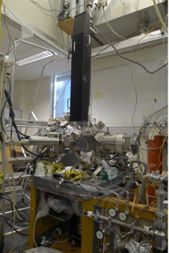

Updates:
Ilkeun Lee, March 2000
Ilkeun Lee, January 2004
Ricardo Morales, January 2005
Xiangdong Qin, Aug 2018
Md Abdul Motin, September 2022

Table of Content
Contents
Table of Content 2
1. Overview of Equipment 6
2. Vacuum System 6
a. General UHV chamber 6
b. Flange assignment 6
c. Pumping 7
d. Pressure reading, Ion Gauge, Filament replacement and maintenance 8
e. Thermocouple gauge 9
f) Ion gauge 9
g. Evacuation of the system 10
f. Venting, Shutting down 10
g. UHV bake out 11
h. General maintenance 12
i. Removing and remounting flanges 12
ii. Gaskets 13
iii. Turbopump 13
iv. Mechanical pump 14
i. Leak detection 14
J. What to do after a power outage 15
3. High High-pressure cell 16
a. General chamber (drawing, picture) 16
b. Pumping system (turbopump) 16
c. Seals 16
d. Maintenance 16
i. IR windows 16
4. Sample 17
a. Mounting (holder, spot-welding, insulator seal, adding TC) 17
b. Repair of manipulator: 18
i) Power and thermocouple feedthrough 18
ii) Sample holder, heating and cooling 19
iii) Rotary stage 19
c. Heating, cooling, troubleshooting 20
i. Heating 20
ii. Cooling with liquid nitrogen 21
iii. Stop cooling 21
iv. Breaking feedthrough (be very careful) 21
d. Biasing 22
e. Cleaning 22
i. Chemical cleaning 23
ii. Ar sputtering_Michelle Chamber Ion gun 23
ii. Sputter cleaning_ Nanoreactor’s Ion gun 23
f. Temperature reading 24
g. Heating power supply (operation, calibration) 24
5. Gas handling, gas m Gas handling, gas manifold 25
a. Design, schematics, valves 25
b. General operation procedure 25
c. Gas, liquid and solid sample handling 25
d. Use of glove box 26
e. Maintenance 27
6. Mass spectrometer (UTI 100)_MS and TPD 27
a. General operation 27
ii. Engaging mass spectrum 27
iii. Standby mode 28
iv. Turn off 28
b. LabView program_Running Analog Scan MS 28
c. Temperature Programmed Desorption (TPD) 30
i) Sample cleaning, dosing and heating controller settings 30
ii) TPD Data acquisition by LabView program 31
iii) The calibration file for TPD 33
c. Calibration of masses_ LabView program 33
d. Installation of LabView program 34
i. System requirements: 34
ii. Installation of LabView software: 36
e. Recording MS with Basica program 37
i. Running MS using Basica: 37
ii. Running TPD using Basica: 38
f. Maintenance: (Filament, Detector, and Protecting cone) 38
7. XPS 39
i. Loading XPS software and turning on spectrometer units 45
ii. Turning on X-ray gun: 46
iii. Data acquisition 47
iv. Turning off 48
8. Ion Gun 48
a. General considerations 48
b. Typical operation 49
c. Alignment and calibration 49
i. Central spot position 49
ii. Rastering 49
d. Sample cleaning 49
8. Low Energy Scattering data acquisition 50
a. Overview 50
b. Preparation 50
i. The standard data acquisition procedure 51
9. Reflection-absorption IR Spectroscopy (RAIRS) 51
a. General considerations 51
b. RAIRS setup (drawing, mirror specs, detector) 51
c. Sample setup 53
i. General preparation 53
ii. Sample positioning 54
iii. Calibration 54
iii. Signal optimization 54
d. Typical FTIR parameters (scanning speed, #scans, iris setting, resolution, acquisition time) 54
e. Acquiring background spectra 54
f. Acquiring sample spectra 55
g. Operation of polarizer 55
h. How to obtain RAIRS under high pressure 55
i. FTIR maintenance 55
i. IR lamp 55
ii. HeNe Laser 56
iii. Alignment 56
iv. Mirrors (cleaning, etc.) 56
v. Dry air purging system and box 57
10. Deposition of SiO₂ and Al₂O₃, H-atom and precursor 57
a. Deposition of SiO₂ 58
b. Grow Al₂O₃ film on Ta substrate 59
c. Dosing of Precursor 60
11. Potential hazards and safety procedures 60

1. Overview of Equipment

Michelle UHV system is located in RM 143 in the chemical science building and it is designed to study surface chemistry. It is equipped with XPS (X-ray Photoelectron Spectrometry), MS (Mass Spectrometry), TPD (Temperature Programed Desorption) and RAIRS (Reflection-absorption Infrared Spectroscopy) techniques. The vacuum is maintained by a turbomolecular pump, mounted to the side of the main chamber. The electronics racks next to the chamber house the control electronics for the X-ray source, the hemispherical analyzer, the ion sputtering gun, MS, and the pressure readout.

2. Vacuum System

a. General UHV chamber

The Michelle UHV system contains a custom-built chamber with a manipulator installed in the perpendicular direction. The whole UHV chamber is supported by a metal frame. The pressure was maintained by a turbomolecular pump.

b. Flange assignment

The assignment for individual flange can be referred to the pictures below.

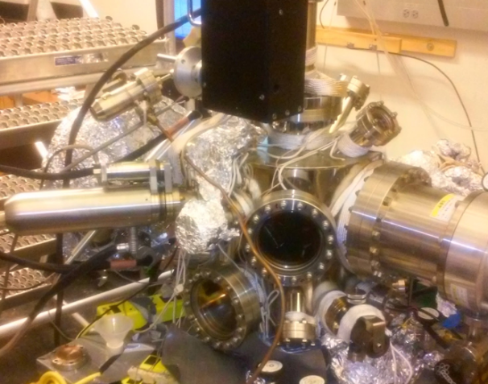
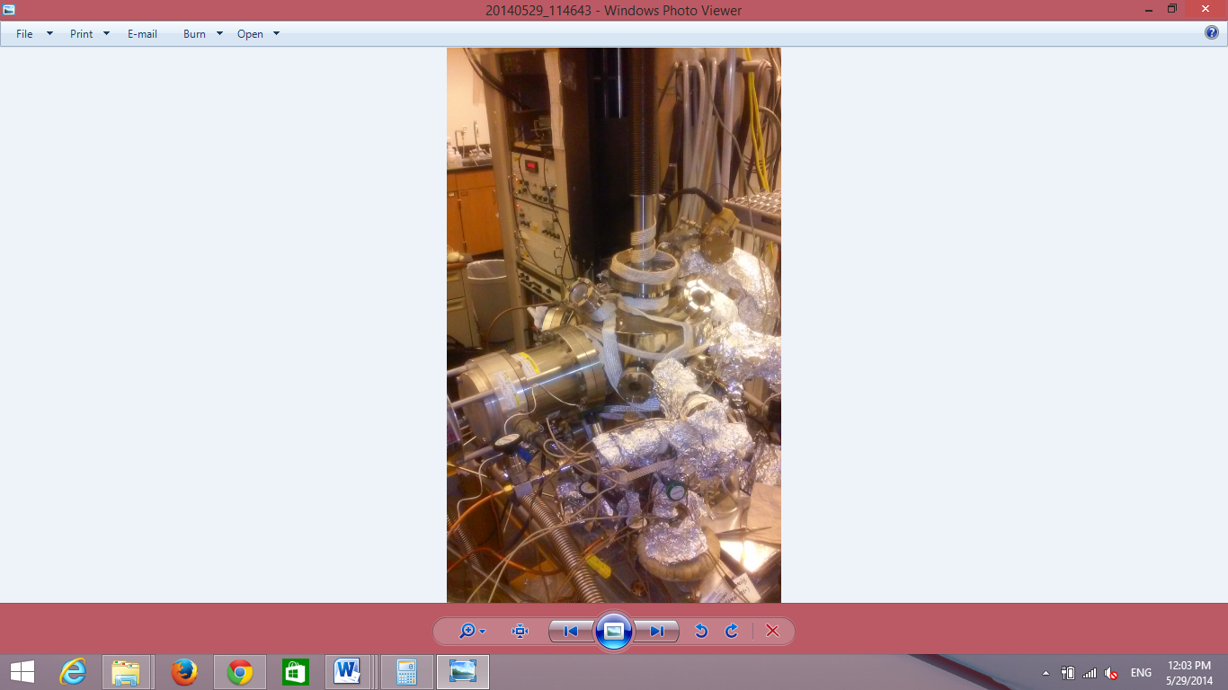
Manipulator Moving Handle
View Port
Turbo Pump
X-ray Gun
Turbo Pump
Leak Valve
Manipulator
View Port

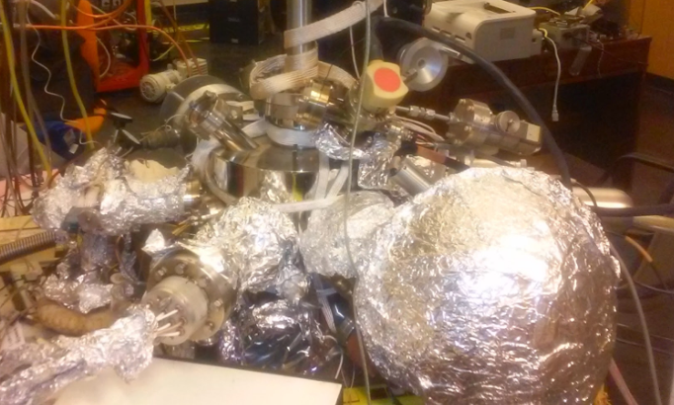
Hemispherical Analyzer
Mass Spec
Ion Gun

c. Pumping

The vacuum system is evacuated by a combination of mechanical pumps and turbo molecular pumps. This combination, together with the vacuum measuring instruments consists of the pumping system. There are two mechanical pumps and two turbo molecular pumps on the instrument. The mechanical pumps are located next to the main chamber’s body and the turbo pumps are directly connected to the chamber via an open flange. (currently Agilent Twis Torr 304 turbo pump is broken)

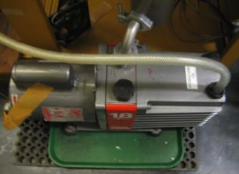
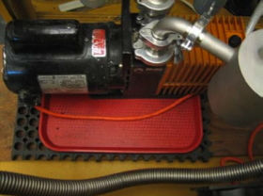
Mechanical Pump II

Mechanical Pump I

Mechanical Pump III

Mechanical pump I is an Alcatel pump with a model number 2012A and its pumping speed is 11 cfm. It is connected directly to the gas manifold. This pump is also connected in parallel to the rotary platform of the manipulator via a stainless steel bellow for differentially pumping. The rotary platform situates at the head of the manipulator. The Alcatel pump also connects to the new installed turbo pump (Agilent TwisTorr 304, the pump is broken now). Mechanical pump II, Edward 18 (two stages, pumping speed 12 cfm), is connected to the turbo pump (Seiko Seiki STP 400). Mechanical pump III, Alcatel 2008A is a backup pump for the small turbo pump (Agilent Twis Torr 304). All mechanical pumps are equipped with oil traps. Ballasting may be needed. The ballast vale is located on the side and it requires a flathead screwdriver for adjustment.

Seiko-Seiki Turbo Pump

The Michelle system consists of two turbo molecular pumps. The Seiko Seiki STP-400 pump, which is pumping the main chamber, is on magnetic bearing. Since this type of pump has no oil, there is no danger of vacuum contamination. However, this system does result in a great deal of electronic noise making experiments prone to many artifacts. The magnetic bearing cannot withstand strong shaking. So do not shake the chamber when this pump is running. Do not attempt to unplug the cable to the pump while the pump is running. This will cause significant damage to the pump. It is recommended to change the battery of the power supply once a year. This battery is supposed to work as a backup during a power outage. This pump is installed horizontally.

The new installed Agilent TwisTorr 304 turbo pump is designed to pump the IR cell at the bottom of the chamber (currently broken). The Agilent TwisTorr 304 FS turbomolecular high-vacuum pump combines Twistorr drag stage technology and Agilent Floating Suspension to provide high performance, reliability and economy. TwisTorr drag stages create high compression ratios for light gases such as Hydrogen and Helium to deliver high throughput and high tolerance of foreline pressure, thereby permitting the use of smaller and more economical backing pumps. This pump is installed perpendicularly.

The connection of the turbo pump to the roughing pump is realized through an angle valve. Close the valve before attempting to shut down the turbo pump. The valve needs to be only finger-tightened to ensure a proper seal. Further tightening may add to excessive wear.

d. Pressure reading, Ion Gauge, Filament replacement and maintenance

There are two types of gauges in the Michelle system. Thermocouple gauge is used to measure the roughing vacuum (form 10⁻³ torr to 1 torr). And the ion gauge is used to measure the high vacuum (from 10⁻¹⁰ to 10⁻⁴ torr). All gauges are read through a Granville Phillips 307 vacuum gauge controller. The top reading of the GP gauge controller is for the ion gauge, the middle reading is for the thermocouple gauge of manifold or Agilent backup line (depends on which TC gauge is connected), the lower reading is for the thermocouple gauge of pre-pump of the Seiko seiki turbo pump.

e. Thermocouple gauge

There are two thermocouple gauges in the system. These are used to measure the rough vacuum. The thermocouple gauges are prone to burnout, especially in the gas manifold when it is used for a temporary holding for potentially corrosive gases.
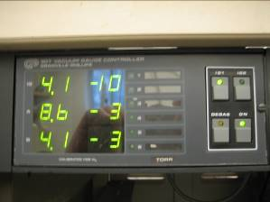
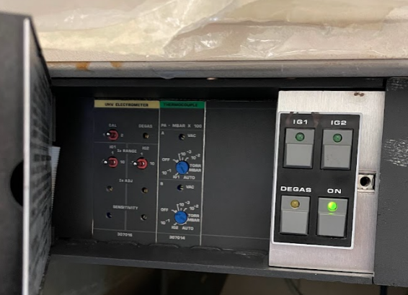
Vacuum Gauge Controller

If the pressure readout is high, first check to see if the cable connecting the pressure sensor to the readout unit is solid. There are two channels of readout on Michelle, swap the suspect cable with the other. If the pressure returns to normal, the problem has to do with the contacts inside the cable. Most problems can be resolved by re-soldering the connections inside the protective metal shield. If swapping the cable does not solve the problem, then it is time to replace the thermocouple gauge. The gauge type is DV-6M. When the corrosive gases are used, the TC gauge readout will slightly increase and can’t go back to the 10⁻³ torr range. This is not a sign of leaking or poor pump performance. As of August 2022, the readout for the manifold line is 3.1 x 10⁻² torr and for main turbo pre-pump line is 2.8 x10⁻² torr.

f) Ion gauge

The pressure in the UHV system is monitored by an open ended Bayard-Alpert type ionization gauge in the main chamber. The ion gauge can be switched on and off by pressing the IG1 switch on the gauge controller. The wires for filament, grid and collector are labeled.
The lifetime of filament in the ion gauge depends on the environment where it works. Replacement of filament is often happened after both of the filaments are burned off. The filament can be easily replaced by a tungsten wire or tungsten belt. Tungsten belt is suggested if available, because it is more easily spot-welded to the supporter. Or the replacement filament can be ordered from Duniway with part number FiL-8A. After installation of a new filament or when the system is exposed to the air for a long time, it is suggested to degas the filament when the system is well-pumped down. Degassing is achieved via the “Degas” button on the GP Vacuum Controller.

The insulating ceramic of filament, grid and collector should be kept clean. Carbon deposits can cause short-to-ground problem. If happened, the carbon deposits can be cleaned and removed by sand paper.

g. Evacuation of the system

Follow these steps to pump down the UHV system.

1) Perform an initial check to determine if all valves (leak valves and valves in gas lines) have been closed.
2) Make sure that all of the remounted flanges have been tightened.
3) With all the angle valves and gate valves closed, switch mechanical pump I, and II. When the TC gauge reaches 2.8 x 10⁻² torr, open the angle valves to pump the system. For the main chamber, the angle valve should be opened slowly to avoid a huge sudden pressure change, which can cause damage to the aluminum foil window on the X-ray source.
4) Do not try to run the turbo pump until the roughing vacuum inside the chamber has reached the mTorr range.
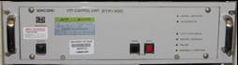
5) If the STP-400 turbo pump controller had been powered down, turn on the power. Wait a couple of seconds until red LED is off before pressing the black “Start” button. Wait for the “Normal Operation” LED to come on before switching the chamber ion gauge. It can take 10 mins for the STP-400 turbo pump to reach full speed.
6) The ion gauge can be turned on around half an hour later. On the gauge control panel set the emission current for the ionization gauge to 0.1 mA. Turn the gauge on by pressing either “IG1”. After the pressure has gone in the 10⁻⁷ Torr range, then reset the gauge controller to 1 or 10 mA emissions. For more information, refer to the manual of the gauge controller.

f. Venting, Shutting down

Follow these steps to shut down and vent the UHV system.

1) Check if all instruments are off.
2) Do not turn off the GP Vacuum Gauge Controller.
3) Check that all valves on the instrument are closed. Close the valves on the gas manifold. Do not forget the valve next to the sputter gun. Close the gate valve at the bottom of the chamber.
4) Turn the ionization gauge off (press switch “IG1”), leave the thermocouple gauge on.
5) Close the angle valve connecting the roughing pump to the turbo pump.
6) After closing these valves then turn the STP-400 turbo pump to standby mode by pressing the red “Stop” button. Do not press the power on/off button. The turbo will take approximately 40 min until it comes to a full stop.
7) Wait for the rotor to full stop. Otherwise, there may be significant damage incurred by the blades as there they are levitated by a magnetic bearing system.
8) The mechanical pumps can be powered down.
9) Introduce the Nitrogen gas into the chamber through the leak valve. Make sure the pressure of the Nitrogen gas is about 15 psi. This will reduce the water that enters the chamber during venting, possibly reducing the total bake out time. A second way is to use the Nitrogen from a liquid nitrogen tank. Put the venting tube into a LN2 tank. Open the Swagelok valve at the end of the venting tube, then slowly to fill the chamber with nitrogen through the leak valve. The venting process is done evidenced by the thawing of the condensed ice on the outsides of the venting tube. Fully open the valve to make sure the pressure inside the chamber equal to atmospheric pressure before open the vacuum chamber

Note: If the system needs to be vented in the hurry, press the “Stop” button on both turbo pump controller. Close the valve to the mechanical pump and then vent slowly. The rotor of the turbo pump will be decelerated by the incoming gas should take about10 min.

g. UHV bake out

Monitor the temperature closely the first time working on the chamber, as this will prevent any unexpected over heating that may result in mechanical failures.

1) Pump out the gas lines connecting the manifold.
2) Relax the leak valves by opening a few turns. This is required as damage may be incurred to the valve at back-out temperature.
3) Remove all connectors: Those include but not limited to:
• Cables to the ion gun;
• Cables and water connection to the X-ray source. Twist external protective cover to loose from locked position. Then loosen the screws holding the internal protection cover and slide it out. Remove high voltage connector. Then remove the water connections by pressing it down and holding the lower ring pressed against the body of the connector, have a bucket in the event that there is spillage.
• Cables to analyzer. Pull all out very carefully! The insulation ceramics can easily be broken.
• Remove the Connector to the MS.
4) Check if heating tapes are sitting in place and are covered with Al-foil. Make sure that the manipulator is OK, as it often needs to be rewound.
5) Connect the internal halogen lamps to a variac. Turn variac slowly to 45% of full power. The pressure should increase to the 10⁻⁶ Torr range.
6) Connect heating tapes to the variacs: Turn to 50 - 60% of full power. Check to make sure them all actually getting warm.
7) Begin heating the sample to prevent buildup of gasses during bake. Note: Make sure that the system is under supervision. In the event of a massive air leak or degassing, the sample may become oxidized.
8) After being satisfied that the heating tapes are working, wrap Michelle completely in Al-foil to minimize heat losses. It is good practice to cover glass ports with aluminum foil to prevent too high temperature gradient across the glass to metal seals.
9) Connect the internal thermocouple to multi-meter to observe the chamber’s interior temperature; not over 150 ºC.
10) Bake until pressure has stabilized, normally one and half days. This should be in the lower 10⁻⁸ range. You can check the gas phase with MS even when the system is hot.
11) It is recommended to turn the MS on during the last half day of baking to allow it to degas in faraday cup mode.
12) Ionization gauge can be degassed right after turning the baking off; press “Degas” on, watch pressure raise; when it starts to drop, turn “Degas” off; change yellow and green connector at the back of the IG; degas second filament; return to the 1st, set to 0.5 mA and increase stepwise to 1 mA and 10 mA
13) When chamber gets cooler, close the relaxed leak valves and the valve for differential pumping of sputter gun. Reconnect all cables.
14) Degas filaments, i.e. MS, X-ray anode, and ion gun. Further degassing can be done all at once and the MS can be left on during this.

X-ray gun: turn cooling water on, turn power supply and HV supply on, select anode, slowly increase filament current while watching the pressure. Final value 4.5 mA, leave on for 30 min, during the last 5 min set HV to 10 kV and increase filament current to have an emission current of approximately 5 mA as displayed on left scale on HV supply.

Old ion gun: turn power supply on, slowly increase filament current to 20 mA while watching the pressure, give the filament some time, it can be slow! Leave on for 30 min, set beam voltage to 2 kV; turn “Raster” on, another 15 min. Refer to manual for further details.

Ion gun borrowed from Nanoreactor: Turn the “function” knob to “operation,” and turn the ion energy knob to 2 KeV.

h. General maintenance

Maintenance and repairing on the Michelle UHV chamber are inevitable. In most the times, this requires opening the chamber to replace/repair parts. Please pay special attentions when working on those parts that are directly exposed to UHV.

• Always follow the department lab safety manual when handling chemicals, operating high-voltage instrument.
• Never touch parts that are exposed to UHV with bare hands. Wear gloves and make sure that they are clean. The type of glove that should be used needs to be powder free latex and the best is the nylon cloth type.
• Large parts, i.e. stainless steel flanges and tubing, can be washed with hot water and Liquid-Nox type detergent. Rinse thoroughly when finished. Give the parts a fine rinse in methanol before baking in a stove to dry.
• Small parts can be submerged in a beaker containing acetone or methanol and placed in an ultrasonic bath. When using the ultrasonic bath, be sure not to directly place the beaker into the ultrasonic bath, and always suspend the beaker in the bath fluid (water).
• The cone on the Mass Spectrometer and the X-ray anode can be moved inside the UHV chamber. Make sure to move them back when they are not used. Rotate the manipulator is safe when both the cone and the X-ray anode is in full back position.

i. Removing and remounting flanges

When remove bolts from the flange that is oriented vertically, remove the top bolts last. This keeps the flange from dropping before it is ready to be removed. Once the flange has been removed, place it to the side with the copper gasket in place. The gasket will protect the knife-edge. Cover the entire piece with aluminum foil or a plastic flange cap to keep out dust. When the flange is ready to be remounted, the old copper gasket must be replaced with a new one. Remove the old one with a gloved finger or, if necessary, with a pair of pliers. Use a pulling motion that is perpendicular to the flange. This will ensure that the knife-edge is not nicked or damaged. If damaged, the knife edge must be re-machined or the flange replaced with a new one. Place the used copper gaskets in a central location for recycling.

Place the new copper gasket into the groove of one of the mating flanges, and bring the flange faces together. If the copper gasket falls out of alignment, try again. If repeated attempts to keep the gasket in place fail, then try placing a small piece of tape on the outer most edge of the gasket to secure it to the flange. When the gasket falls into place, the flange faces will be parallel and aligned allowing no lateral play. Be sure to align the notches on the flange faces.

Before tightening the bolts to close the flange, be sure the threads have a light coat of molybdenum disulfide anti-seize lubricant. This will prevent the bolts from seizing up the next time they are removed. Do not, however, use this compound for bolts that are inside of the chamber, as the sulfur will contaminate the vacuum. Finger tightens the bolts to make sure that they go smoothly. The heads of the bolts should be able to close on the flange without a need of a wrench. If not, the nut or the bolt has bad threads and must be replaced. Make sure the gasket does not slip out of its groove. Finally, tighten the bolts with the proper wrench using a crossover pattern to distribute the stress on the flange equally. Tighten until the copper gasket has been ‘cut’. The flanges do not necessarily need to touch.

ii. Gaskets

The vacuum system is composed of several vacuum equipment and parts. Gaskets/O-rings are used to connect two vacuum equipment or parts in a leak tight manner. There are three of materials used as gaskets/O-rings.

Copper: Used extensively in UHV conditions, bake-able, for conflat (CF) fittings.
Silver (plated copper gasket): Used in applications that will be left undisturbed for a long period of time. It is less susceptible to oxidation than copper.

Rubber O-rings: Used in high vacuum conditions such as the gas manifold and not bakeable to high temperature, for Qwik (KF) fittings.

iii. Turbopump

In general, the two turbo pumps do not require any regular maintenance. It is recommended to change the internal battery of the STP-400 controller once a year. When the power voltage drops below approx. 85% of the rated voltage due to a power failure, the internal battery of the STP control unit automatically activates to supply power to the STP pump in order to maintain normal function of the magnetic bearing (backup operation during a power failure). Two batteries are used in the controller. (PORTALAC Series Small-Sized Sealed Lead-Acid Batteries, PE12V 7F1 : 12 V, 7 Ah)

Follow these steps to replace the battery:
1) Stop the STP pump, and turn OFF the primary power (Switch the breaker "OFF").
2) Unscrew the 4 screws attached to front panel and bring the front panel down towards you.
3) Disconnect internal battery connector.
4) Unscrew battery case screws and pull out battery case from the STP control unit.
5) Unscrew 4 top panel screws from battery case, and remove top panel.
6) Disconnect lug terminal, and pull out the battery from the battery case.
7) Replace the two worn-out batteries with new ones in the battery case, and connect lug terminal correctly (red: "+" side; black: "-" side).
8) Attach top panel to the battery case using 4 top panel screws, using care not to catch the cable between the top panel and the battery case.
9) Connect internal battery connector.
10) Close front panel and tighten the 4 screws that secure the front panel.
11) Record the replacement date of the battery.

iv. Mechanical pump

The mechanical pumps need to have their oil change on a regular basis to prevent their failure. It is advisable to change the oil once a year. However, more frequent oil changes may be necessary if using corrosive gases or chemicals; or whenever ballasting does not improve hydrogen back-migration. Monitor the color of the pump oil. If the color becomes darker, then it is suggested to change the oil. The pump oil used is TKO19+. The filling amount is 800 ml. Oil is stored under the shelves in room 137. It is recommended to change the molecular sieves together with the oil. Used oil and molecular sieves must be disposed through the environmental health and safety department.

Standard Operation Procedure for Oil Change:

1. Wear proper PPE (gloves, safety goggles and lab coat). Isolate the mechanical pump from the UHV system. Stop the pump and remove all the connection. Wait for 20 mins, the pump oil may still be hot.
2. Lift the pump on the moving cart (stored in RM 135). Put the waste oil bucket below the pump. Remove the top screw. Slowly unscrew the bottom screw and leak all the oil into the bucket.
3. Fill the pump with only 0.5L clean oil. Rinse the pump by running it for 5 mins. Stop the pump and drain the oil. Multiple rinses may be needed if the pump is too dirty.
4. Fill the pump with clean oil. Do not overfill. Tight all the screws and connect the pump back to the UHV system. Start the pump and check the base pressure.
5. Put the used oil in the waste bottle with proper chemical waste tag.
Parts replacement and rebuilding of the pump can be done in the machine shop of the college.

i. Leak detection

A poorer than normal vacuum is usually the first indication of a chamber leak. A good indicator is the presence of an oxygen peak on the mass spectrum. A less obvious indication is a higher than normal 14 AMU peak (splitting of N₂).

In order to pinpoint a leak, squirt acetone or methanol on suspected areas. When the solvent is drawn into the chamber through the leak, there will be a sudden fluctuation in the pressure indication of the ion gauge. Another method is to blow a fine jet of helium on the suspected area while monitoring the 4 amu peak on the mass spectrometer. Gently blow helium where flow is sufficient that it can be felt on wet lips. First, concentrate on the parts that have been opened before the last bake out. If there is a leak, the intensity of the He signal in the mass spectrum should increase immediately.

If no chamber leak can be detected and UHV pressures are still unobtainable, check the hydrogen partial pressure. Hydrogen is the only gas which can significantly back migrate from the roughing side of the turbo pump. Either ballasting the rough pump or changing the rough pump oil can minimize the back migration of hydrogen.

j. What to do after a power outage

Procedures for Power Outrage with Notice:
The preparation for the power outrage with notice is similar to normal venting the chamber.
Turn off all the filaments, wait long enough (20 min) for the cooling of the filament. Turn OFF the turbo pump. Close the valve between the turbo pump and mechanic pump. Vent the chamber after the turbo pump fully stops. Turn off and vent the mechanic pump, which is different from the normal venting process where the mechanic is not needed to be off.

Procedure for Power Outrage Unexpected:
1) When unexpected power failure happens, first put all the power supply to OFF position especially those for filaments, such as power supply for ion gauge, mass spectrometer and X-ray gun, and high voltage power supplies. Close all the leak valves. Close the angle valve between the turbo and the mechanic pump.
2) Vent the mechanic pump.
3) If the power outrage is expected to last a long time, vent the main chamber with LN2.
4) If the power is back shortly, first turn on the mechanic pump, after several minutes, turn on the turbo pump and open the valve between the turbo and mechanic pump. After the turn pump reaches its normal status, Ion gauge can be turned on to check the vacuum of the chamber as well as the status of all other instruments.

3. High High-pressure cell

a. General chamber (drawing, picture)

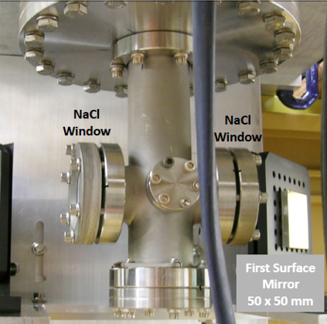
Recently, an IR chamber which is also serving as a high pressure cell is installed to the bottom of the chamber. It is made by a custom-built six-way cross. At current stage, it is only used as an IR chamber. The mini-flanges, which are blanked will be used to deliver gas and install the pressure gauge.

b. Pumping system (turbopump)

The IR chamber is pumped by the Agilent TwisTorr 304 turbo pump, which is installed below the IR chamber. A manually controller gate valve is installed between the IR chamber and the turbo pump. The pumping speed of the turbo pump is 250 l/s.

c. Seals

The IR chamber is separated from the main chamber by an O-ring seal inside the main chamber. On the bottom of the main chamber, an O-ring was installed on a 2.75 inch flange. When the manipulator moved down into the IR chamber, the manipulator rod will press the O-ring to separate the main chamber from the IR chamber. In the IR chamber, two NaCl windows are installed. An O-ring seal is used between the NaCl window and flange in the IR chamber. These three O-ring sets limit the baking temperature of the whole UHV system.

d. Maintenance

i. IR windows

The sodium chloride windows are sealed with a Viton gasket of the type used for Conflat flanges, and protected on the opposite face with a Teflon ring. The whole assembly can be treated as a regular flange, though care should be taken when these flanges are tightened, since the sodium chloride is very brittle!

Reassemble the Sodium Chloride Windows:

1) Put the Teflon ring on the inside of the flange and place the sodium chloride window on top of it. There is a supply of these windows in the desiccator kept in one of the cabinets behind the IR chamber. Make sure you have the right size window; otherwise it will break as the flange is tightened!!!
2) Put a Viton gasket on the flange on the chamber and GENTLY press the window into it. Secure the flange with 2 bolts.
3) Put all the bolts in and finger tighten them.
4) Use a 1/4" wrench and VERY CAREFULLY TIGHTEN THE BOLTS using a crossover pattern to distribute the force evenly.
NOTE: These flanges do not have to be very tight. It is recommended that they be checked for leaks. If a leak if found, tighten the bolts a little more. If there is no leak, stop right there. Further tightening could break the window.
5) Measure an IR spectrum to see if everything works as it should. Verify that the low wavenumber cutoff is close to 700 cm⁻¹.

4. Sample

a. Mounting (holder, spot-welding, insulator seal, adding TC)

Metal single crystal or poly crystal samples are supported and heated by tantalum wires at the end the sample manipulator. The details of mounting a metal sample are as follows:

1) Move the sample down to the position that it can be reached from the 6 inch viewport. The position angle is around 240°.
2) Vent the chamber.
3) Open the 6-inch viewport. If necessary, remove the 2nd viewport on the right-up side as well.
4) Remove the four set screws from the back of the sample holder, as indicated in picture below.

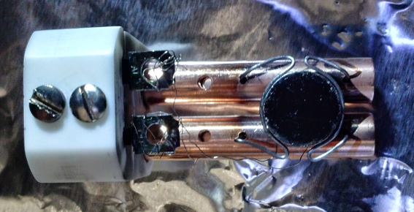
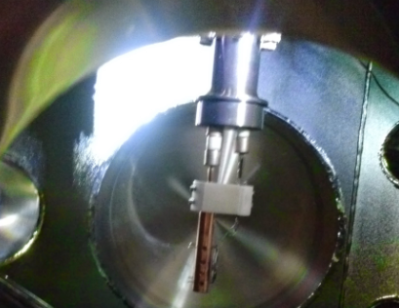
Sample Holder
Remove 4 setscrews

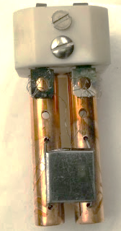

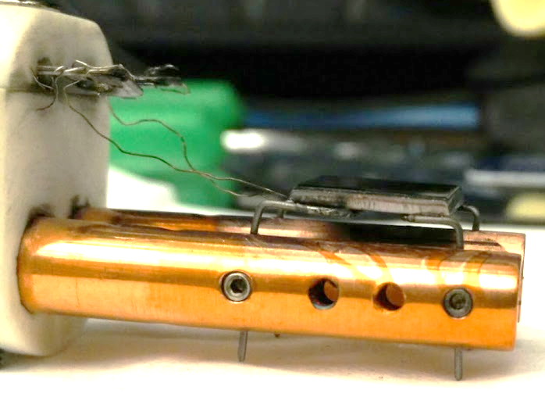

5) Gently pull the sample holder straight down to remove the sample holder from the manipulator and put it on a clean Aluminum foil.
6) Record the sample position before remove the old sample. It is advised to mount the new sample as close as possible to the original position. This will save a lot of time for the IR alignment.
7) Loose the four set screws that hold the tantalum heating wire. Remove the thermocouple wire from the back of the sample. Gently bent the wire to remove the old sample and install a new one.
8) Spot-weld the tantalum wire to the side of the sample and thermocouple wire to the back of the sample.
9) If the thermocouple wire is broken, replace with a new one. CHECK WITH A MAGNET FOR THE PROPER CONNECTION! The alumel wire is magnetic, the chromel is not.
oil
11) Mount the sample holder to the manipulator and close the chamber.

b. Repair of manipulator:

i) Power and thermocouple feedthrough

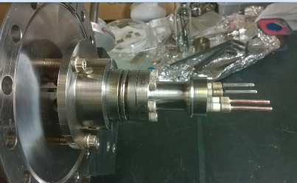
An insulator seal is used as the transform part from the shaft of the manipulator to UHV. The insulator seal has four feedthroughs, which provide K-type thermocouple connections and a pair of copper electrodes. The insulator seal needs to be specially ordered. When requesting this part, tell the person that is intended for cryogenic applications. Liquid nitrogen temperatures require modified feedthroughs where any KOVAR is replaced with 10%Ni30%Cu alloy. Otherwise the seal may fail under liquid nitrogen temperatures. Also oil has been seen on the non-vacuum side of the feedthrough resulting in false voltages. Hence an oil trap before the mechanical pump is essential. Also, care is advisable whenever rotating the sample, as there is considerable weight from the long rod to the ceramic feedthrough. If the sample has been cooled using Liquid Nitrogen, it is necessary to leave the compressed air running overnight to get rid of any water residue inside. Failure to do this will result in a broken feedthrough when LN is used next time. To replace the feedthrough, it will require removing the whole manipulator from the chamber (a lot of work).

The way feedthrough tends to break is if water condenses after a day of exps, that drips down the tube and accumulates in the bottom. The next day, when you cool the manipulator back down, the water freezes and puts stress on the ceramics until they crack. If you are not doing this already, make sure that you flow dry air with a small tube all the way down the manipulator at the end of your experiments, when you stop cooling down the manipulator. Make sure also that the water that condenses outside does not find its way inside the tube.

Removing manipulator from the chamber:

Disconnect all the heating wires, heating tapes, fan, TCs and rotary differential pumping connections. Remember to move the manipulator close to all the way up position. In this way when it is moved, the sample holder will not bump the X-ray source or MS cone etc. and you do not have to lift the heavy manipulator too much. Remove the bolts that connect the manipulator and the chamber (shown in the middle bottom of your picture). Remove manipulator. Here you will need three person (two lift and one guide). Lay down the manipulator on the table, and the 275 nipple (on the top of your picture) can then be removed. You will need to go to the machine shop to weld the copper rod to the new feedthrough.

Please be very careful when you handle the bellows. Any damage to the bellows will be a huge headache. Always blow the LN out right after TPD experiment. You can even leave the dry air flow all the time.

ii) Sample holder, heating and cooling

The sample holder is an in-house ceramic block in which two copper posts are inserted. The purpose of this complex is to provide an easy means to mount and remove the sample. All chambers in this lab have the same insulator seal and sample holder attached to the end of their respective manipulators.

The sample holder connects to the insulator seal by four set screws located on the backside of the ceramic. Operationally, the sample is welded via tantalum wires, which are in turn connected to the copper posts held in the ceramic block via set screws. Spot welding the tantalum can become quite a challenge. Pervious use on a Ni (110) sample yielded the following optimal readings for the Unitek 125 Watts Second spot-welding device.

Heating is achieved by the apply voltage across the copper posts. Cooling is achieved by the injection of liquid nitrogen down the shaft of the manipulator. Water condensation inside the manipulator is another concern. Blowing compressed air down the shaft after experiments will avoid water build-up; however, the compressed air line may be moist and a dry tube is needed.

In this installation, the sample can be cooled down to 90 K by pouring LN2 directly into the shaft of the manipulator in which the non-vacuum side of the feedthrough is immerged in LN2.

iii) Rotary stage

The rotary stage is differentially pumped by the Alcatel mechanical pump. It is normal that the pressure goes up when the sample is rotated. However, the pressure should return to original value within 30s. Otherwise it may suggest a bad seal inside the rotary stage.

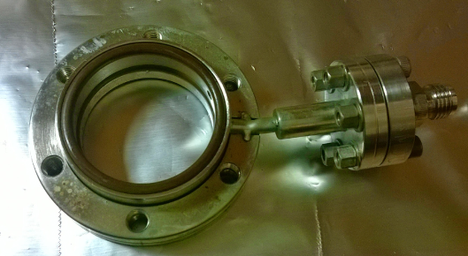
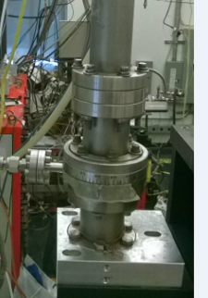

To replace the O-ring seal inside the rotary stage, it requires venting the system and removing the manipulator from the chamber. It is suggested to remove the sample holder first, and then move the manipulator all the way up. After that, the manipulator can be removed from the main chamber. (It is very heavy and requires a couple of person to work together to avoid any collision with the chamber wall.) Lay the manipulator flat on the clean area. Dissemble all flanges and pull the center rod out. The bellows should be supported by soft materials to avoid any bending.
Attention: Currently, the rotary stage is not kind of stiff. The rotation is not very smooth. Wearing a nitrile gloves help to make the rotation easier. Vacuum is still very good, no leaking during rotation.

c. Heating, cooling, troubleshooting

i. Heating
The sample is heated with an AC current supplied by the temperature controller through a variac transformer. Or the sample can heated using a variac controlled transformer directly.

To use the temperature controller for heating:
The transformer must be plugged into the socket in the back of the temperature controller. The thermocouple coming out of the manipulator must be plugged into the yellow TC-socket in the back of the controller. The sample must be properly grounded.

See the Ramping Temperature Controller manual for a detailed description of the temperature controller. An important thing to notice is the little light in the controller which indicates that the controller is (trying) to heat the sample. The intensity of this light is an indication of the heating power. The maximum heating power is set with the variac on the front of the controller, typically about 50-80%.

If necessary, the sample can be heated by a variac connected to the transformer: Connect the transformer input to a variac and regulate the heating power with the variac. Do not connect the transformer directly into the power supply. This causes a very high heating current which will melt the heating wires.

Troubleshooting Sample Heating

Symptom: the sample does not get hot:
Bad contact somewhere in the heater circuit. This could be inside or outside the chamber. The connector to the copper tube may be loose, the wire may be loose in the connector, the wires may be not well connected to the transformer, or the sample support wires in the vacuum are burnt out. The temperature controller operates normally in this case.

Thermocouple is not plugged in, or the thermocouple circuit is broken. In this case the red LED-indicator labeled "TC open" on the front of the temperature controller lights up, and the output power is interrupted to protect the sample support/heating wires.

Symptom: Temperature reading is not stable; the temperature controller may be heating irregularly.
One of the thermocouple wires is touching ground or the heating wire. The critical spot is the point where the thermocouple wires come out of the manipulator: the insulation may be rubbed through here. Sample is not properly grounded.

Symptom: heating is very slow, though a lot of power is used.
Probably the sample support/heating wires are getting loose or oxide built at the outside contact. Check outside connection first. This happens after some time and if it gets too bad, the sample has to be spot-welded again. If this is the case, cooling will be slow; and the lowest temperature that can be reached will be higher.

ii. Cooling with liquid nitrogen

CAUTION: When dealing with liquid nitrogen, safety glasses and cryo-gloves should be worn.

Insert a funnel into the small inlet at the top of the manipulator. Cover top of the manipulator with cloth, surrounding the funnel. Turn on heating tape around the bellows to a power level of 25 V using a variac, and cover that section with cloth.Turn on fan to avoid condensation. Then slowly add about one quarter cup of liquid nitrogen into the manipulator. During the experiment, liquid nitrogen should be added a little at a time (about every 5 minutes) in order to maintain a boiling liquid phase in the manipulator. Pouring in liquid nitrogen little by little initially to avoid cracking of ceramic connections

It takes, typically, about 10 min. to cool the sample down from room temperature to about 90 K. Once the manipulator is cold, cooling is much faster (5-15 min, depending on the contacts between the heating wires and the sample in the vacuum). If the cooling is slow, it is possible that the sample heating/support wires have come loose and the sample will have to be remounted soon.

iii. Stop cooling
Remove the funnel and blow dry air through a tube into the manipulator while the liquid nitrogen boils away, and let it flow until the manipulator is at room temperature and dry. Do not add liquid nitrogen during this step, since if any water has accumulated in the manipulator through condensation, it will freeze and possibly fracture the ceramic feedthrough. Make certain that there is no resistance to the air stream. If there is, there may be some ice inside that is preventing the air from escaping, which will result in a build-up of pressure. It is suggested to leave the air flow overnight after the experiment.

iv. Breaking feedthrough (be very careful)
The way feedthrough tends to break is if water condenses after a day of the experiment using LN2 cooling, which drips down the tube and accumulates in the bottom of the manipulator. The next day, when the manipulator is cooled using LN2 again, the water freezes and puts stress on the ceramics until they crack. If you are not doing this already, make sure that you flow dry air with a small tube all the way down the manipulator at the end of your experiments, when you stop cooling down the manipulator. Make sure also that the water that condenses outside does not find its way inside the tube.

If the sample has been cooled using Liquid Nitrogen, it is necessary to leave the compressed air running overnight to get rid of any water residue inside. Failure to do this will result in a broken feedthrough when LN is used next time.

d. Biasing

By means of opto-isolation circuitry, the thermocouple and its preamplifier circuit are floating with respect to the system ground, i.e. the chamber and instrumentation chassis. The sample, which is in contact with the thermocouple, can be placed at any desired potential by simply applying that voltage to the either of the thermocouple leads or to the common of the preamplifier circuit. There are three banana jacks at the rear of the temperature controller where these connections can be made: TC COM (thermocouple common), SYS COM (system common), and BIAS OUT. The controller has an internal bias supply which provides a negative voltage in steps of 50, 100, 150, 200, and 250 volts.

1) To ground the sample or give a zero bias voltage, connect SYS COM to TC COM with a banana cable.
2) To apply a negative bias to the sample using the internal bias supply, connect TC COM to BIAS OUT, select the desired voltage and turn on the switch.
3) To apply a negative bias with an external voltage source, connect its positive terminal to SYS COM and its negative terminal to TC COM. To apply a positive bias, reverse the polarity of the voltage supply.
4) When using an external source, the bias current can be monitored by connecting a current meter (usually the Kiethly Picoammeter) in series with the voltage source between SYS COM and the terminal of the source.

e. Cleaning

Sample cleaning process depends on the nature of the sample and of the contamination species. Some sample can be cleaned by oxidation –reduction cycles, such as carbon contamination on noble metal surfaces. Some surface species can be removed by heating the sample above the desorption temperature of surface species. But usually, most of the samples can be cleaned by repeated cycles of sputtering and annealing.

i. Chemical cleaning

For heavy carbon contamination on metal surfaces, such as on Ni or Pt surfaces, the sample can be cleaned by heating in 10⁻⁶ torr O₂ at about 800-1000 K, and then reduced by heating in 10⁻⁶ torr H₂ at about 800-1000 K. Repeat the cycle if necessary. For Pt sample, the surface oxygen species can be removed by flashing the sample above 1300 K.

For cleaning Ta substrate, sputtering the Ta substrate using 2 KeV ion energy in 3.5 x 10⁻⁵ torr Ar for 30 minutes followed by oxidation under 2 x 10⁻⁵ torr of O₂ at 600 C for 5 minutes and annealing at 600 C for 5 minutes in UHV.

ii. Ar sputtering_Michelle Chamber Ion gun

1) Move the sample into the proper position
2) Switch on the main power of the ion gun power supply. Increase the filament current to 1.8A. The emission current is about 15mA.
3) Open the Ar leak valve on the back of the sputter gun until the pressure in the main chamber is 2×10⁻⁷ Torr.
4) Turn on the high voltage to the ion gun using the toggle switch. The voltage reads 2 kV. Adjust the emission current to 15 by using the knob rightmost. Under these conditions, the sample current will be about 1-2 µA.
5) After about 10-20 minutes of sputtering, anneal the single crystal to a certain temperature, which depends on the nature of the sample.

NOTE: Every time the sample is remounted to the manipulator, the optimum ion beam conditions for sputtering need to be determined:

1) Place the sample in the desired position.
2) Disconnect the thermocouple plug and the sample heating wires.
3) Connect the center conductor of a BNC cable from the input of the Keithly 480 Picoammeter to the chromel prong of the thermocouple plug and the shield to the chamber (or any other ground). The analog output of the picoammeter should be connected to the Y-channel of the oscilloscope.
4) Switch on the sputter gun as described above.

ii. Sputter cleaning_ Nanoreactor’s Ion gun

Currently, the Nanoreactor’s Ion gun is installed in the Michelle chamber.

- With the current setting, the best sample position is where the sample looks to the front port of the chamber while about 1.3 cm away from the doser.
- Fill the chamber with argon to a pressure range of 7×10⁻⁶ to 4×10⁻⁵ torr by opening the leak valve connected to the ion gun (currently, a pressure of 3.5×10⁻⁵ torr is used for the sputtering).
- Turn the “function” knob to “operation,” and turn the ion energy knob to 2 KeV.
- Measure the current between the ground and a heating wire using a multimeter. Currently, the usual current is in the range of 20-35 µA.
- The sample is usually sputtered for 30 minutes.

- How to determine that it is clean

The cleanness of the sample can be checked by XPS spectra. Usually, the C1s and O1s XPS spectra need to be checked to make sure the sample is clean. Other methods, such as H₂ TPD or CO TPD, are also can be used to check the cleanness of the sample if XPS is not available.

f. Temperature reading

The temperature can be read with a voltmeter connected to the BNC output labeled "TC PREAMP OUT" on the front of the temperature controller. This is the thermocouple voltage amplified by a factor of 245.5, which results in a voltage of (approximately) 10 mV/°C, e.g. 3.27 V is 327 °C etc. Below 0 °C the thermocouple table has to be consulted. To read the temperature, the main switch of the temperature controller has to be on.
The temperature can also be read through a homemade omron temperature controller directly. Connect the thermocouple wire to either ramping temperature controller or omron temperature controller to read the temperature. There may be slightly difference (<10K) in temperature reading between these two methods.

g. Heating power supply (operation, calibration)

The sample is heated by AC current supplied by the temperature controller through a transformer. During normal operation, a linear ramp of sample temperature is suggested in order to avoid overheating. The power limit should not be set too high. Otherwise, the tantalum wires can be burned off or over heating of the sample. 50-80 % power output is suggested for heating the sample up to 1100 K.
The temperature ramp end can be set on the temperature controller. The relationship between the temperature ramp end set value and the “T.C. preamp. Out” can be referred to the temperature conversion table.

5. Gas handling, gas m Gas handling, gas manifold

a. Design, schematics, valves
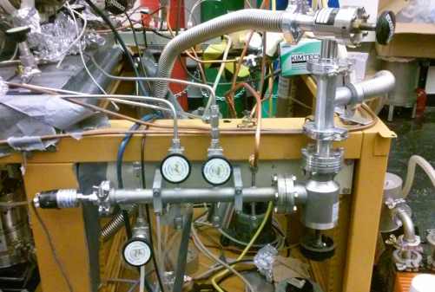
The manifold forms a separate vacuum system. The manifold has a thermocouple gauge connected to one end and is evacuated via a mechanical pump connected on the other end. The reading from this thermocouple pressure sensor is located on the GP Vacuum Controller. There is a valve that can be used to isolate the manifold from the mechanical pump. The manifold is connected to the pump via a ninety-degree angle valve. The rebuild parts include bellows and Viton gasket. The manifold may need to have its gaskets replace occasionally. Close the valve of the differential pumping of the manipulator before shutting down the pump.
The manifold is connected to the UHV chamber through variable leak valves. The variable leak valves are used for controlling the dosing process in experiments. The valves need to be only finger tightened to ensure a proper seal. Further tightening may break the sealing crystal inside.

b. General operation procedure

The two valves on the top of the gas manifold are connected to the leak valves on the chamber: left one to the Ar sputter gun, and the right one to the other side of the chamber, which is used to dose O₂, CO gas or water vapor. The bottom one is for venting the chamber using the LN2.

c. Gas, liquid and solid sample handling

The projects on the Michelle UHV system require introducing the chemical precursor into the system in the gas phase. When handling chemicals, the lab safety role and specified MSDS must be followed.

To use the gas, connect the gas bottle to one of the open leak valve. The gas delivery line can be pumped from the mechanical pump.

For liquid and solid precursors, if the chemicals are not air/moisture sensitive, it can be handled in the fume hood in room 135. Transfer the chemical into the glass/metal container. Then connect the container to the leak valve by CF fitting. For air/moisture sensitive chemicals, please refer to operation procedure in glove box below.

The chemical precursor must be pre-pumped before open the leak valve. Side-pump the precursor with the mechanical pump first. The side pump line has a liquid nitrogen trap. It is suggested to fill the liquid nitrogen when pumping the precursor. For the chemical precursor that has a relative high vapor pressure, freeze the precursor with liquid nitrogen when pumping. Then slowly open the leak valve to further pump the precursor.

The heating of the precursor is achieved by putting a silicon oil bath around the precursor container. Control the oil bath temperature to reach the desired vapor pressure.

d. Use of glove box

A glove box is a sealed container that is designed to allow users to manipulate objects where an inert atmosphere is desired. It has an antechamber which has two doors connect to the glove box and the outside. Follow the steps below when operate the glove box. Here is the short description of operating the glovebox in RM 135. Please refer to the glovebox manual for more details.

(1) Check the oxygen level to ensure that it is in the right range. Check the pressure on the N₂ gas cylinder. If the total pressure of the N₂ gas cylinder is around 500 psi, you can continue using the system. Please notify Dr. Ilkeun Lee after completion. If the pressure is less than 300 psi, please change to a new N₂ gas cylinder following the instruction in Section 2.5. The supplied N₂ pressure should be around 35 Psi. The antechamber is under vacuum, and its pressure is indicated by a gauge.
(2) Press the FCT key. Use the up and down-arrow to select the AutoVac option menu. Press FCT key to access the menu.
(3) Use the up and down-arrow to select the Start Manual Refill Routine. Press FCT key. The antechamber will be filled with N₂ as the pressure gauge in the antechamber indicates. The process will stop automatically once the right pressure is reached. Press the ESC key to return to the normal mode.
(4) Open the outer antechamber door. Place all items (glass-metal container with all necessary tools) onto the pull-out tray. Push the tray back into antechamber. Make sure that the tray does not touch both the inside and outside door. Close the Outer antechamber door.
(5) Press the FCT key. Use the up and down-arrow to select the AutoVac option menu. Press FCT key to access the menu. Use the up and down-arrow to select the Start Manual Evacuation Routine. Press FCT key to start. Leave it for 5 mins. Then press the ESC key to return to the normal mode. (This extra step is added to minimize the problem of O₂ level sudden increase.)
(6) Press the FCT key. Use the up and down-arrow to select the AutoVac option menu. Press FCT key to access the menu. Use the up and down-arrow to select the Start AutoVac Sequence. Press FCT key.
(7) The AutoVac control menu will be displayed on the monitor. The vacuum setpoint (50), pump time (5 min) and number of cycles (3) will be indicated. Press FCT key to start the sequence. Please closely monitor the oxygen level. If the oxygen level increases very fact, press the ESC key immediately to return to the normal mode and notify Dr. Ilkeun Lee. It will take about 20 mins. Once the sequence is completed, it will be displayed on the monitor. Press the ESC key to return to the normal mode.
(8) Open the inner antechamber door. Move the items on the tray into the glovebox. Transfer the chemical into the glass-meal container and close the sample valve.
(9) Open the inner antechamber door. Move the items on the tray in the antechamber. Close the inner door.
(10) Open the outer antechamber door. Remove items from the tray and close the outer door.
(11) Press the FCT key. Use the up and down-arrow to select the AutoVac option menu. Press FCT key to access the menu. Use the up and down-arrow to select the Start Manual Evacuation Routine. Press FCT key to start. Leave it for 5 mins. Then press the ESC key to return to the normal mode.
(7) Record the O₂ level and the pressure of the N₂ gas cylinder in the logbook.

e. Maintenance

The gas manifold is always evacuated by a mechanical pump. Sometimes the base pressure of the gas manifold is not low enough for handling some liquid samples. A LN trap can be added to the gas line to remove water contamination in the gas manifold system.

If liquid sample is used, a reasonable vapor pressure of the liquid sample remains in the gas line, and also in the mechanical pump, for a long time. Change the oil of the mechanical pump and bakeout the gasline are needed to remove the liquid remained in the gas handling system.

6. Mass spectrometer (UTI 100)_MS and TPD

a. General operation
    - Turning on, off, keeping in stand by

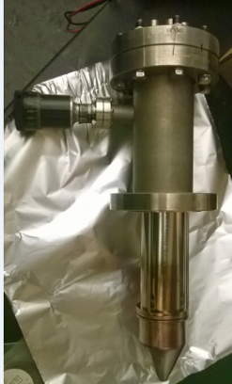
Michelle is equipped with a UTI 100C mass spectrometer (MS) with a nose cone mounted on a z-shift. The cone having a 5 mm diameter can be placed within 1 mm of the front face of the sample via a rotary motion feedthrough. This is to provide greater sensitivity to only those compounds off the surface under investigation. This should be positioned so that it is directly pointing towards the ground. Although it may seem to be more logical to have it pointing towards to the sky for easy access, it has been found through experience that the internal mechanisms require the pull of gravity to prevent a clog from becoming detached. Also the MS needs roughly 45 minutes for the electronics assembly to reach thermal equilibrium and give repeatable results.

ii. Engaging mass spectrum

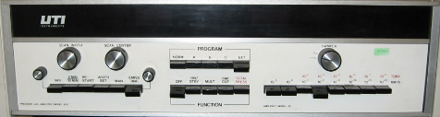

1) Check if the “Emission” dial is turned completely counter clockwise.
2) Set the range to 10⁻⁵ to avoid possible burn out of filament.
3) Damper should be completely counter clockwise.
4) Main key depressed.
5) Press “ON/STBY”. Wait for the instrument to equilibrate.
6) Press “Multiplier”.
7) Press “EMISS/(MA)” to follow the display of the emission of the filament. Slowly increase emission with knob until ~ 1.30 mA. Always use the same value to keep experiments comparable. Check if the protection mode is on (slide front panel out, little switch on right hand side, to the right: protection mode on; to the left: protection mode off).
8) Connect scope (X to ramp generator, Y to signal out), set scope to X-Y mode to observe spectrum with scope (X-Y, DC decoupling)
9) Depress “EMISS/(MA)”, press “VAR” and adjust sweep time with knob on left side. The display over the range keys shows the intensity, whereas the one over “EMSS/(MA)” gives the mass.
10) Scan width and scan center can be varied with the respective knobs while “EMISS/(MA)” is depressed and “WIDTH” or “MAN” are pressed (only one switch pressed at a time).
11) Switch to “MAN” yields a straight line on the scope. You can tune from 1 until 300 amu manually with the “ Center” knob. The height of the baseline gives the intensity of the peak.

iii. Standby mode

This mode is preferable if the instrument will be used within a short amount of time, e.g. a day or even a week.
1) Place the instrument in TOTAL PRESSURE mode.
2) Set range to 10⁻⁵ Amp.
3) Make sure that the emission switch is on.
4) Turn emission knob counter clockwise fully, but not to the point that there is a click off.

iv. Turn off

Turning the MS off is advisable for an extended period of time only, not for over the weekend. For periods of inactivity place the instrument in Standby mode.
1) Place the instrument in Faraday cup mode.
2) Set range to 10⁻⁵ Amp.
3) Turn the emission knob completely counter clockwise, to the point that the knob clicks off.
4) Depress the emission switch off.
5) Depress the “ON/STANDBY”, then depress the “OFF”

b. LabView program_Running Analog Scan MS

MS data is collected using a LabView program “UTI_scan_average.exe”. This program can be found on the desktop and the calibration file is in the Calibration_MS_TPD folder with file name 11.5_Calibration_TMHD_10082020.

1. Make sure that the set range is 10⁻⁵ AMPS and the “Emission” dial is turned completely counterclockwise.
2. Press “ON/STBY and wait 1 hour to warm up the controller.
3. Press MULTI and Press “EMISS/(MA)” to follow the display of the emission of the filament. Slowly increase emission with knob until ~ 1.30 mA. Always use the same value to keep experiments comparable.
4. Run UTI_Scan_average on the desktop.
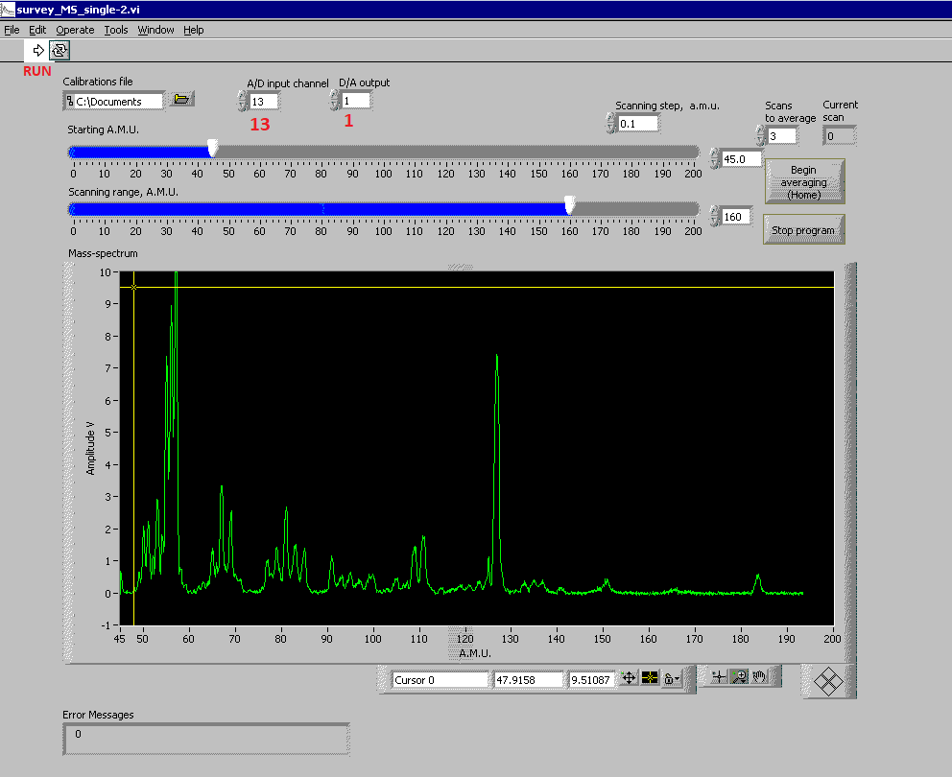
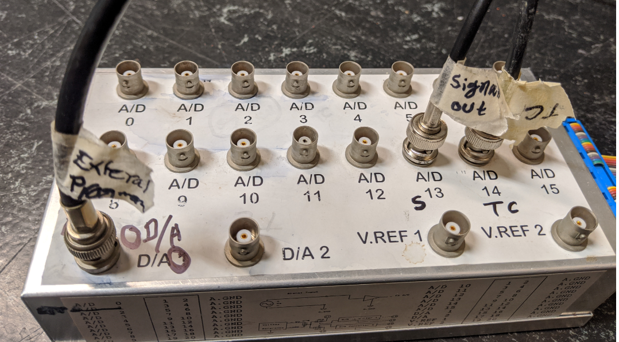
5. Click on the “Calibrations file” and load 11.5_Calibration_TMHD_10082020 (the calibration was performed using TMHD ligand at a resolution value of 11.5).
6. A/D input channel = 13 and D/A =1.
7. Adjust the Starting A.M.U. and scanning range to see the desired part of a mass spectrum;
8. Start the program by clicking "Run" (Arrow sign on the top) button or pressing Ctrl-R
10. Select the number of scans for averaging between them (default 10) and click "Begin averaging" or press Home button at the keyboard;
11. After the last scan, a file dialog will open. Select the folder and file name to save data.
12. Click on “Stop program” to stop data acquisition.
Calibration file for MS
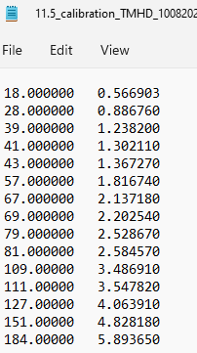

c. Temperature Programmed Desorption (TPD)

TPD measurement is recording the desorption species while linearly ramping the sample temperature. So it is important to make sure the sample can be heated with a linear ramp rate, and also the mass spectrometer is tuned to the right parameter to record the desired mass signal. The TPD data can be taken only on the PC. The PC has to be connected to both the mass spectrometer and the temperature controller.

It may be necessary to outgas the mass spectrometer before doing experiments. Ideally, only hydrogen, water, CO and CO₂ should be observed in the mass spectrum of the vacuum. If other (hydrocarbon) signals are detected, degas the mass spectrometer by turning on the filament (RGA mode) and wait for half an hour or so. The intensity of compounds other than the ones mentioned above should be barely detectable. During the course of the day, the filament is always left on to keep it outgassed.

i) Sample cleaning, dosing and heating controller settings

TPD spectra can be recorded with the interested masses under a certain ramp rate (3-10 K/s). A maximum of 30 mass traces can be recorded simultaneously by the mass spectrometer.

1) Clean the surface by sputtering/annealing. Move the sample to MS position (rotate 95º from the sputtering position) and start cooling.
2) Wait until the sample has reached the desired adsorption temperature and adsorb the gases. The purity of the gases can be checked at this point by taking a quick mass spectrum. After dosing, it may be necessary to wait for a few minutes to pump out the gases; this will reduce the background in the data. Move the cone close to the sample.
3) Make sure the heater power on the temperature controller is off.
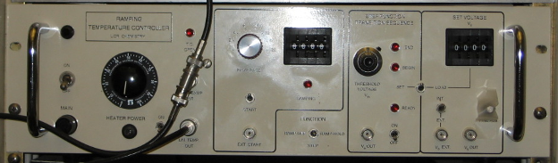
4) Set the maximum heater power to about 50-80%.
5) Set the switch located above the BNC labeled "Vs EXT" to "INT." When this is set to "EXT", the sample will not be heated.
6) Select the function "RAMP-HOLD" if you want the temperature to stay at the final level at the end of the experiment, or to "RAMP-OFF" if you want the temperature to go back to 77 K after the ramp has been completed.
7) Select the heating rate with the "RAMP RATE" selector switch. A good value is "2" which gives a heating rate of approximately 3 K/s. The higher heating rates will normally not be realized because they are heating limited by the maximum heater power.
8) Select the octal value of the initial temperature on the "SET VOLTAGE Vs" thumbwheels then press the "LOAD" switch. (DO NOT FORGET THIS!) Make sure that the initial temperature is well below the actual temperature; otherwise an uncontrolled temperature-jump may occur. Since the data are usually taken from 100-1000, "0000" is always a safe choice. (If the actual temperature is significantly higher, say 300 K, the actual heating just starts later. It will never result in a temperature-jump, when turning on the heater.) "Vs OUT" should then read 0.00.
9) Select the octal value of the end point temperature on "RAMP END POINT" thumbwheels. ("1503" corresponds to approximately. 850 °C or 1120 K. In most of our experiments, “1351” corresponding to about 900 K, is chosen.

ii) TPD Data acquisition by LabView program

1. Make sure that the set range is 10⁻⁵ AMPS and the “Emission” dial is turned completely counterclockwise.
2. Press “ON/STBY and wait 1 hour to warm up the controller.
5) Check the heating power is off. Check RAMP END POINT = 1351, RAMP RATE= 2 (it will give 3 K/s) and SET VOLTAGE = 0000.
6) Connect TC and heating cable to heating controller.
7) Turn on the heating controller and warm up for some time.
4) Modify TPD.CFG file according to the MS scan.
3. Press MULTI and press “EMISS/(MA)” to follow the display of the emission of the filament. Slowly increase emission with knob until ~ 1.30 mA. Always use the same value to keep experiments comparable.
6) Run Shortcut to TDS_RTC on the desktop.
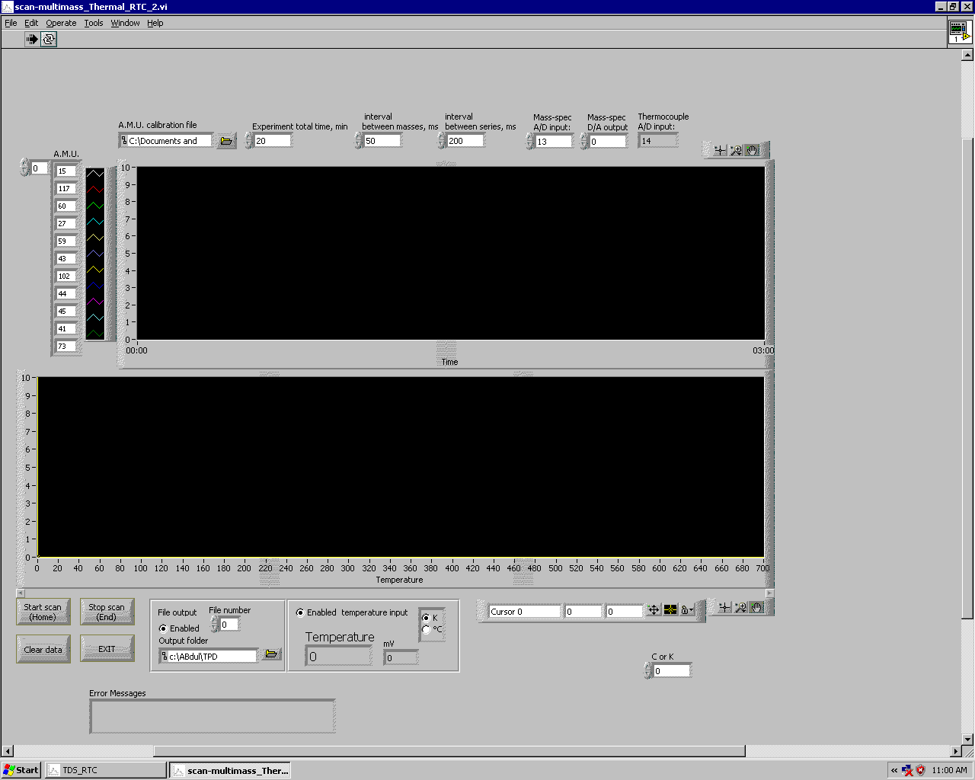
7) Load TPD MS calibration file.
8) Click on A.M.U calibration file.
9) Load MS calibration file.
10) Check Interval between mass 200, Signal out A/D=13, TC=14, mass spectrometer's external program D/A = 0.
11) Click on “Start Scan (Home)” to start.
12) Check the Ramp rate on the heating controller.
13) Press the Load.
14) Turn on the heating power
15. After completion of the TPD, click stop scan and save the data.

iii) The calibration file for TPD
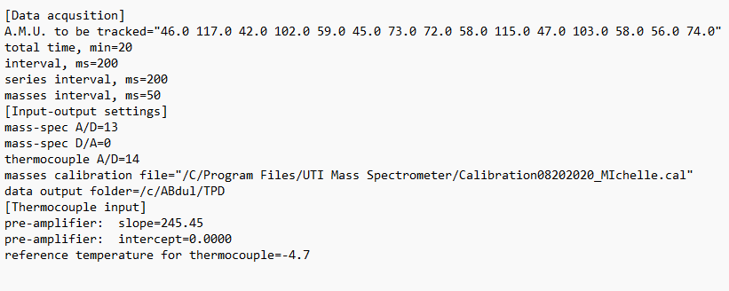

c. Calibration of masses_ LabView program
1. Open file ‘test’. If it doesn’t automatically open, right-click on the file and click on ‘open’. Then select “Notepad” and click OK.
2. Make sure that you see the following number:
0.000000 0.000000
1.000000 0.010000
3. Run the application ‘UTI_scan_average’
4. Select the Calibration file as ‘test’
5. Change A/D input channel to 13 and make sure D/A output is 1.
6. Set starting A.M.U. to 1 and Scanning range, A.M.U. to 150
7. Click on ‘Run’ (right arrow on top left corner)
8. Click ‘Stop program’ right before the scan reached 150
9. Right-click on the scan page and select ‘AutoScale Y’
10. Magnify each peak and note down its exact A.M.U. position. For example:
Water (18) was at 56.6903
CO (28) was at 88.6760
11. Type the A.M.U. of our known substances in the first column and the corresponding AMU value after dividing by 100 in the second column. For the spacing between the columns click ‘Tab’. For example_ The calibration value for Michelle's chamber on 10/06/2020 is;

18.000000 0.566903
28.000000 0.886760
39.000000 1.238200
41.000000 1.302110
43.000000 1.367270
57.000000 1.816740
67.000000 2.137180
69.000000 2.202540
79.000000 2.528670
81.000000 2.584570
109.00000 3.486910
111.00000 3.547820
127.00000 4.063910
151.00000 4.828180
184.00000 5.893650

12. Go to the file ‘test’ in notepad and “Save as”. Input your desired file name with .cal at the end, select ‘Save as type as All files, Encoding as ANSI and save the file.

In order to check if the calibration is accurate, introduce Ar into the chamber and run the program using the new calibration file. Peaks at 40 and 20 should now be visible.

d. Installation of LabView program

i. System requirements:
The PC should be able to run Windows XP at tolerable speed, Pentium-3 500 MHz or faster. It also must have an unoccupied ISA slot at the main board for Advantech PCL-812PG card. To use Omron PID temperature controller or Terranova vacuum gauge controller, connections to COM1 and COM2 ports with RS-232 cables are needed.

Installation of hardware:
- Advantech PCL-812PG LabCard is not a plug-and-play device. First, check the jumper settings on the card for the Base Address, IRQ and DMA. For most configurations, the good settings are IRQ 5, DMA 3 and I/O range 220-22F. Write the settings down. For the location of jumpers, refer to the LabCard manual.
- Check if the Trigger Source is set to External and CN5 socket at the card has no connection between pins 10 and 1.
- Install PCL-812PG into the ISA slot

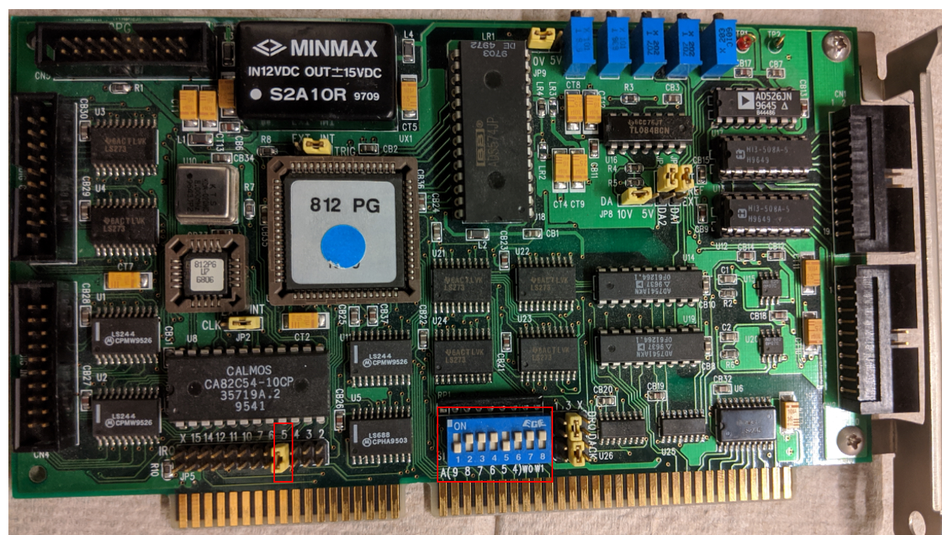

- When starting the computer, go to the BIOS setup screen and set the same IRQ, DMA and base address to be reserved for a Legacy/ISA device. This will prevent Windows from assigning them to plug-and-play devices, which would be interfering with the LabCard.

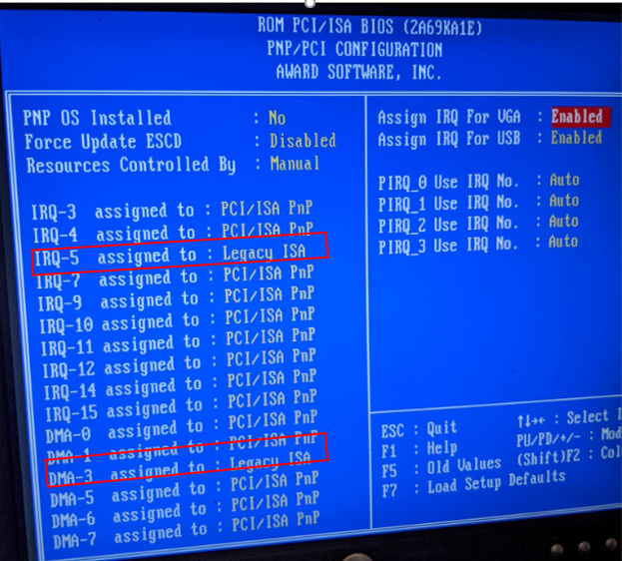
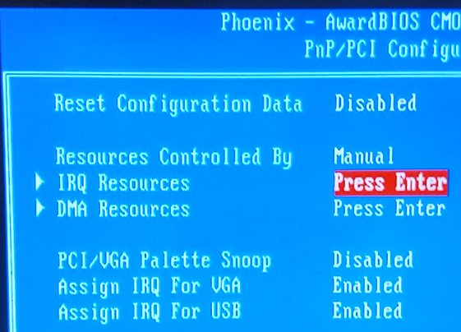

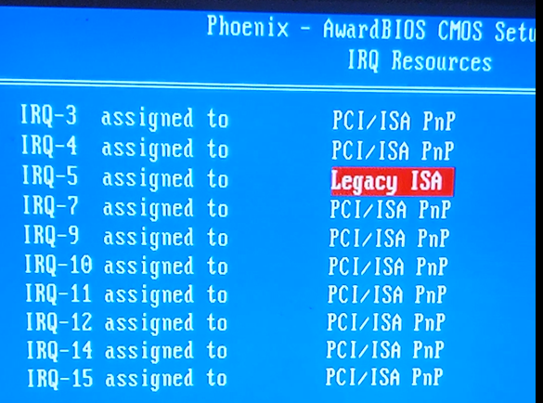

- To work with Omron E5CK controller, connect it to the COM1 port as described in the Omron manual. Make sure the controller settings for COM1 port (baud rate, stop bit, parity, etc.) are the same as for Windows. Use Windows Device Manager to check port settings.
- To work with Terranova 934 vacuum gauge controller, connect it to COM2 with RS-232 cable. Check if the settings for COM2 port are the same for controller and for the Windows.
- To test the instruments connected to COM-ports, PortTest.exe program can be used. Refer to instrument manuals for the communication commands.

ii. Installation of LabView software:

- Install Windows drivers from PCL812.exe. Restart of the PC may be needed at end.
- Install the Advantech device manager_32bit from DevMgr.exe
- Install All_Examples_32 Bit
- Run the device manager. The PCL812 card must appear in the list of devices, select it. Go to Setup menu and check if the settings for IRQ, DMA and base address are the same as for the card jumpers. Switch to Test menu then and read voltages from A/D channels. The numbers should be changing randomly, representing the noise. If they are stuck, the card is not properly set up, most likely the IRQ or I/O address is conflicting with some other device in the computer.

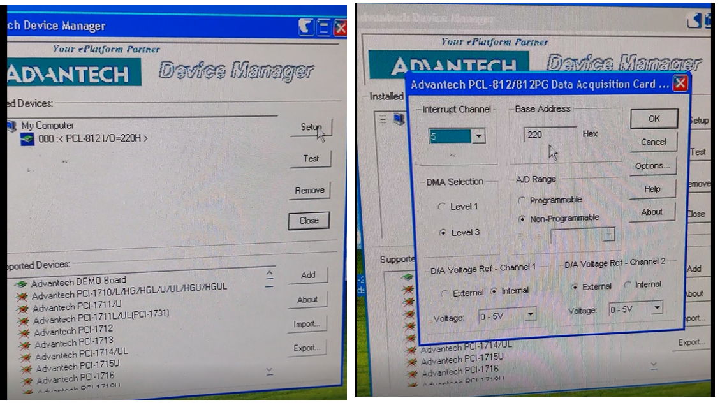
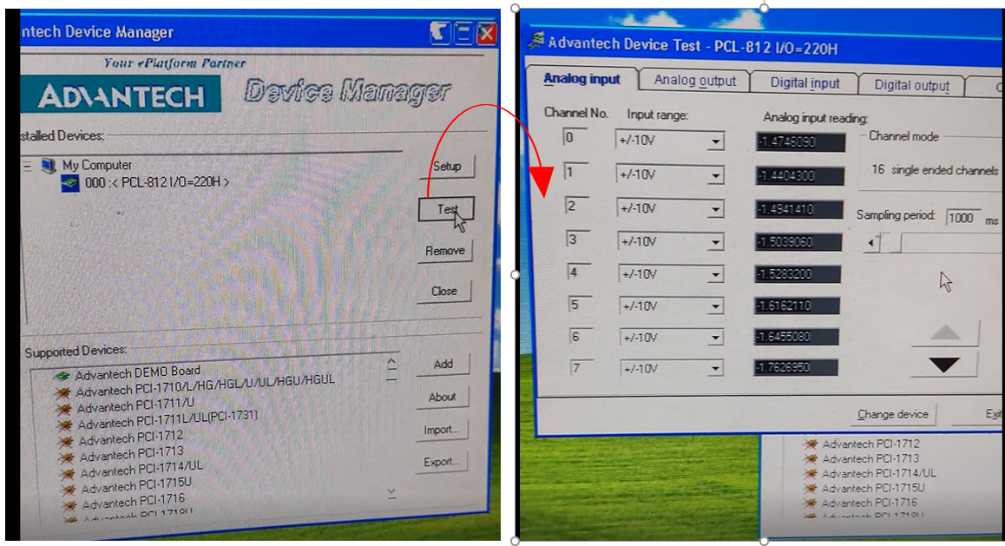
- Run Applications / Install / Install.exe. Select an installation folder for the mass-spectrometer program. This setup will also install necessary system components and may require restart of the PC.
- Copy other EXE files from Applications to the same folder.

e. Recording MS with Basica program

i. Running MS using Basica:
The Basica program for MS is in the GATEWAY2000 windows95 computer. First connect the Signal out, External program and TC cables to the Windows95 computer. For recording MS:

1. Open ms folder in C drive
2. Run Mspect6 file and ** WELCOME TO THE MASS SPECTRA ACQUIRING PROGAM* window will pop up. Press any key to continue and the MSPECT6-BASICA window will pop up.

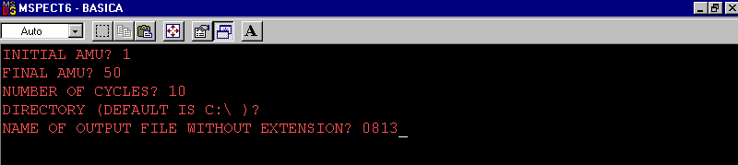
4. Type the initial AMU and press Enter.
5. Type Final AMU and press Enter.
6. Type the number of cycles.
7. Press Enter for Director.
8. Type the Name of the output file without extension and press enter.
9. After completion of cycles the window will pop up.
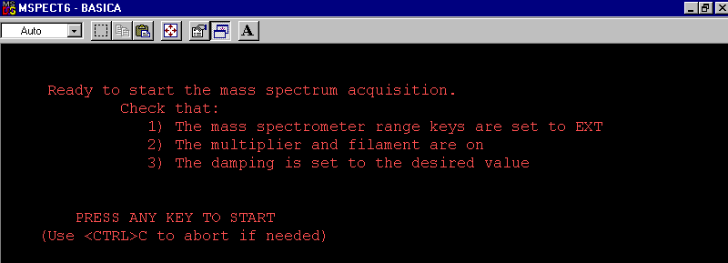
7. Type Ctrl C to abort.
8. Type system to exit or run to continue.

ii. Running TPD using Basica:
The Basica program for MS is in the GATEWAY2000 windows95 computer. First connect the Signal out, External program and TC cables to the Windows95 computer. For recording TPD:
1. Open ms folder in C drive
2. Run Tds6 file and ** WELCOME TO THE TPD ACQUIRING PROGAM* window will pop up. Press any key to continue and the TDS6-BASICA window will pop up.
3. Press any key to continue.
4. HOW MANY MASSES TO BE FOLLOWED? (1-15)? set the desired number of masses.
5. Enter Masses to be followed.
6. Name the output file.
7. Select the directory.
8. Set the acquisition time.
9. Second windows will pop up with all summaries of parameters.
10. Press any key to run.

f. Maintenance: (Filament, Detector, and Protecting cone)

The filament of the MS may need to change after a long time of use or exposure to a higher pressure reactive gas. One indication of the filament failure is that it cannot be turned on and the resistance measurement shows that it is open between the filament electrodes. The replace the filament, the cone has to be removed and the filament is on the top of the MS. Replace it with the correct Rhenium Tungsten filament (diameter = 0.006 inches). This wire can be purchased from Scientific Instrument Services, Inc. and Part No is W45. The turns of the filament should be 12 to 13. The detector (channeltron) of the MS should last for years. If the signal is too low with a higher emission current, it may suggest changing the channeltron. The channeltron is located in the backside of the MS.

Special attention should be paid to the cone. The cone can be moved in and out. When the cone is moved close to the sample, check from the viewport to make sure it is close but not touch the sample. And always move very slowly. The cone must be in full back position when the manipulator is moved (rotational and translational). Otherwise, the cone will collide with the sample, sample holder or the manipulator. Always return the cone to the full back position right after taking the MS/TPD data.

7. XPS

- General considerations, Connections

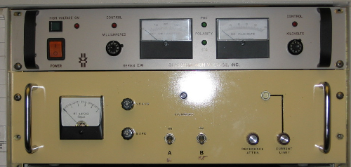
The X-ray gun is a VG XR3E2 Twin Anode gun. The power supply was built by a lab technician. The high voltage (HV) supply is from Glassman. A schematic for the power and a manual for the HV supply can be found in the file cabinet in room 139. There is also a manual for the Glassman.

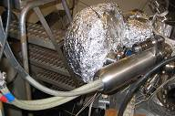
The water cable and HV cable need to be threaded through both the internal protection and outer protective cover. To connect water line, push until a slight click is heard. Do not force insertion as this may crack the HV cable to be electrically isolated. Otherwise, there may be cracking.

Secure internal protective cover with Allen bolts. Put exterior shield on and fix it into locked position, tighten screw to hold it. It is advisable to have a ring stand clamp combination located at the floor, holding the water lines to reduce the strain due to weight.

Lastly insert the filament connector, located beneath the outer protective casing.

- Initial Operation
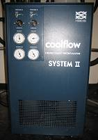
Cooling water is interlocked to the X-ray power supply through a flow switch. Without running the cooling water the X-ray source cannot be powered.

1) The cooling water circulation system is in the corner of RM 143. Verify that the red valve located on the flow regulator is open. There should be no flow present.
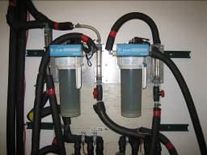
2) There is an opening at the top of the system where you can make sure that the water reservoir is full. Michelle system is presently connected as “Process A”. Toggle the front panel switch to begin the circulation process (see right figure).
3) Make sure that the flow switch is grounded to chamber. Never touch the flow switch while applying the HV to the gun, as the flow switch sits at the same voltage.
4) The direction of the water flow is marked with “→” at the end of the connector. To get efficient cooling water should flow in the correct direction.
5) After making sure that all connectors are secure and properly fitted, engage the cooling water subsystem.
6) After engaging the “Coolflow System II”, the cooling water also needs to be engaged. Pull down the two red handles and two white handles located directly above and on the right of the “Coolflow System II”.
7) The flow to Michelle is controlled at the “B-Pure” flow regulator located directly above and on the behind of the “Coolflow System II”. Notice that the light located at the very top, the system also acts as filter. If the light changes to red, then the filter needs to be replaced. To adjust the flow, locate the red valve. Please note that the flow should not be stopped. If flow to the chamber is to be halted, turn off the “Coolflow System II” and not the red valve, as this will cause a large back pressure between it and the “Coolflow System II”. The optimal flow has been determined to be 0.5 GPM.
Note: A flow rate lower than this minimum will prevent the filament from engaging.
• Make sure that flowing water is reaching the chamber by monitoring the flow meter located on the chamber base.
• The chamber is now ready for the electronics to be engaged.
• To halt flow to the chamber, turn off the “Coolflow System II”. Again, do not shut the red valve as this will cause a large backing pressure.

- Turning the X-rays on

When the cooling water is on, turn on the X-ray gun controller and high voltage power supply. Select the anode (Al or Mg). (As of Aug 2018, only Mg anode can be used. Al anode is contaminated and needs to be recoated). Slowly increase the filament current, and monitor the pressure in the chamber. When the current reaches 4.5A, press the HV button on the high voltage supply and slowing increase to the desire value (Al 12KV, Mg 10.5KV) Then slowly increase the filament current and the emission current, meanwhile watch out the vacuum, until the emission reaches to 10 mA with the filament current at about 4.5 A.

- Turning the X-rays off

Decrease the emission current and filament current to zero, and then reduce the HV to zero. Turn off the X-ray gun controller and high voltage supply. Let the cooling water flow for a while (10-20 min) for thoroughly cooling the X-ray gun before turn it off.

- Maintenance

Always check the water level of the cool flow system. Deionized water is needed in order to reduce the leaking current. The temperature of the cooling water should be around 15-21 ºC.
There is a cooling water interlock system that will shut down the X-ray gun power supply if the water is not flowing. This system should be checked frequently to see that it is working. An overheated anode could be catastrophic. Make sure there are no cooling water leaks inside the anode housing. Replace any fittings that are leaking. Moisture around the high voltage is dangerous.

The gain of the multiplier may drops with time. Turn up the multiplier voltage to see if the signal improves. If not, it may be time to replace the multiplier.

- Replacing the Anode

Replacement of the anode is required if the anode is leaking or the Al/Mg coating is thinned with the Cu surface exposed. The process is not difficult. Note: caution should be paid to the insulating ceramic of the X-ray gun when mounting the X-ray gun. Bring the chamber to air. Remove the source cover and uncouple the conduit assembly. Using a compressed air supply, blow the remaining water out of the anode. Separate the X-ray source from the chamber.

Remove the top anode shield which is mounted the Al window. Take care not to damage the filament which is under the shield. Loosen the small centralizing ceramics located near the bottom of the anode under the anode shield cap. The anode the can now be unbolted at the mini CF flange. Record the orientation.

Put the new anode in. The anode alignment is critical to avoid the anode crosstalk. Take care not to touch the coated anode faces.

- Replacing the Filament (Cathode)

To replace the filaments, remove the X-ray source from the chamber. Remove the top cover which houses the Al window. Now, the filaments can be accessed. It can be replaced with a commercial filament or with thin tungsten wires. It is suggested to install the filament at the same height as the old setting.

- Replacing the Aluminum Window

The aluminum window is made by 2um Aluminum. To replace the Al window, pull out the X-ray source from the chamber. Remove the top cover that houses the Al window. Put it flat on the table, and replace with a new cut piece. The 2um Al window is very fragile.

- Electron Energy Analyzer and Detector System

- Electron Energy Analyzer

The VG100AX spectrometer analyzer is used to investigate the surface of the materials through the analysis of electrons (or ions) given off by a sample. The analyzer acting as a narrow pass filter, passes only those electrons having a specific energy. The VG100AX analyzer has three main components: the lens, the analyzer and the detector.

- General Considerations

It is recommended to read the VG manual prior to this portion of this manual. A few things are slightly adjusted, predominately the interaction between software and hardware, and will be highlighted here.

The controller electronics consists of the following components:
• Digital Multimeter displays voltages (DVM 8006); control switch located on SCU.
• Spectrometer Control Unit (SCU 362) supplies voltages, modus (CAE, CRR), pass energy, lenses potential; switch to remote control (computer).
• Ratemeter and Multiplier Supply (434) controls channeltron voltage and magnetic trim.
• Lens power supply (8508) provides high voltage to lenses.
• Slave unit 356 only for ISS, it supplies drive voltage at the Channeltron front end (see figure, the lowest).

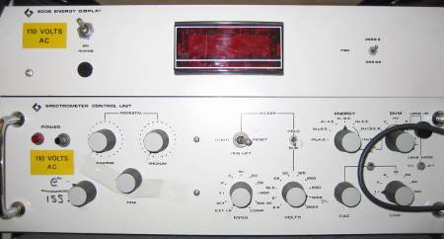
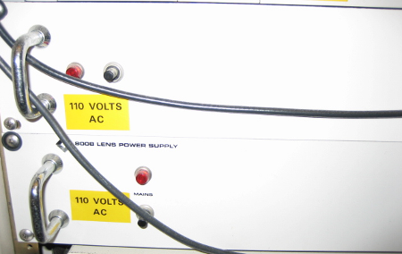

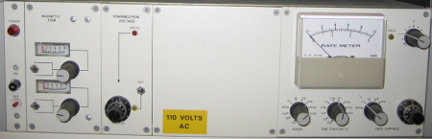

- Initial Operation

Make sure the vacuum is the chamber is good (~10⁻⁹ torr). Analyzer is set to measure electron. A pass energy of 50 eV is used for XPS measurement. 2.9 kV is used for the multiplier.

- Turning the Analyzer on

Turn on the analyzer in the following order by pressing or switching the power button.
1) Spectrometer Control Unit (SCU 362),
2) Digital Multimeter displays voltages (DVM 8006),
3) Ratemeter and Multiplier Supply (434),
4) Lens power supply (8508)

- Turning the Analyzer off

Turn off the analyzer in the following order by pressing or switching the power button.
1) Lens power supply (8508),
2) Ratemeter and Multiplier Supply (434),
3) Digital Multimeter displays voltages (DVM 8006),
4) Spectrometer Control Unit (SCU 362)

- Typical Settings

Pass energy: 50eV. Lens mode: 1-1, Channeltron voltage: 2.9KV.

- Calibration

Before performing an actual XPS experiment, the instrument may need to be recalibrated and the sample will need to be aligned for maximum signal. This needs to be done only once, or whenever the sample has been remounted or moved.

To calibration of the binding energy of the sample, pick a peak from the clean sample using a reference source, such as: “Handbook of X-ray Photoelectron Spectroscopy”. The selected peak should be strong and free of excessive background. Compare the peak position with references; adjust the instrument work function in the software.

To align the surface and determine the right XPS position for sample.
1) Determine a peak from the clean sample using a reference source, such as: “Handbook of X-ray Photoelectron Spectroscopy”. The selected peak should be strong and free of excessive background.
2) Perform a survey scan of a region of promise. Then lock into a strong peak using the energy analyzer.
3) Turn on the instrument.
4) Set the switches as following:
• Hold/Run Run
• Start/Penlift/Reset Reset
• Amplitude 1250
• Time 2 ms
5) Select a position on the energy switch (e.g. Mg KE)
6) Set DVM to E.
7) Adjust the pedestal controls for KE reading on the DVM
8) Set DVM switch to HV and set the pass energy using the “CAE” knobs
9) Set to Run.
10) Turn on the Channeltron and dial in 2.9.
11) Observe on the rate meter, select proper counts range.
12) Rotate the sample slowly. Pay attention not to touch the end of the X-ray source.
13) When a maximum has been observed on the rate meter, then take another survey scan to make sure that the signal is from the sample.
14) Repeat for the rotation or up/down direction.

- Maintenance

The analyzer itself does not require any maintenance during normal operation. Only run the analyzer when the system is at good vacuum.

- Detector

- General consideration

As stated above, the detector should only be operated under UHV conditions.

- Typical operation

The typical operation voltage for the channeltron is 2.9 KV. However, this voltage should be adjusted with time since the channeltron is aging with operation time and chemical exposed.

- Servicing/changing the multiplier

As the Channeltron ages the voltage at which it saturates is increased and the saturation plateau is narrowed. IF the plateau cannot be discerned, the device needs replacing.

To change the Channeltron:
1) Make sure all electronics unites are OFF. Disconnect all cables to the analyzer. Bring the system to air.
2) Note the orientation of the Feedthrough cup with respect to the analyzer. Remove the bolts.
3) Carefully remove the cup away from the analyzer to expose the internal wiring. Make a note on which wire is connected to which feedthrough. Disconnect the wires.
4) Gently screw the Channeltron removal tool (located in the draw under the computer) into the socket in the upper surface of the channeltron assembly.
5) Ensure the wires connected to the lens assembly are correctly positioned and are kept in their position while the channeltron assembly is removed.
6) Gripping the removal tool firmly, pull the channeltron assembly from the main assembly.
7) Remove the two screws which secure the wires in the barrel connector mounted on the outer surface of the cover. Extract the wires form the barrel connect. Remove the wire that attached to the front end of the channeltron.
8) Lift the spring clip to release the channeltron. Remove all the wires connected the channeltron.
9) Reverse the order to install a new channeltron. The part number for the channeltron is CHN01.

- Software

The version of the software is VGX900IC, serial number: 931216. Installation is performed by creating target folder for the software and then copying the software into that folder.
Features:
1) To change the color of the data display for a channel, move cursor under region in question (upper left side), press ALT, press left mouse key. Release ALT and click on region to be redrawn.
2) To set-up an experiment, press “Home”. A default file appears. Other files are saved and can be loaded. If you want to create new files, save them with the extension *.reg.
3) Important for the communication between computer and SCU is that the Xmax value (right lower corner in set-up) is set to AES 3276.8 kV.

- How to take XPS data

In the XPS measurement, first position of the sample in the right position. Then turn on the X-ray source and the detector. Using soft to collect the data

i. Loading XPS software and turning on spectrometer units
The software runs through the DOS. It is recommended to learn basic DOS. To run XPS software type the followings:
1. Turn on GATEWAY2000 computer
2. Press Windows+R to open “Run” box
3. Press enter key
4. Type: cd..
5. Type: cd..
6. Type: cd vg (there is space between cd and vg)
7. Type: vgx900ic
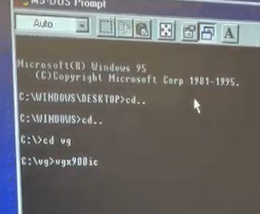

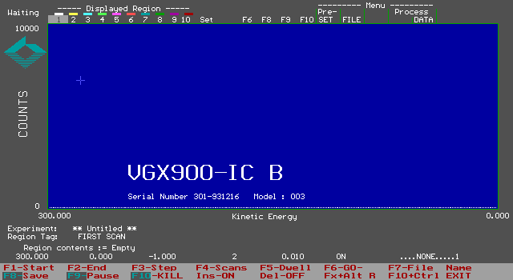
7. The vgx900ic window will pop up.

8. Turn on the XPS controller as follows: 1) Spectrometer Control Unit (SCU 362), 2) Digital Multimeter displays voltages (DVM 8006), 3) Ratemeter and Multiplier Supply (434), 4) Lens power supply (8508)
9. Wait for 1 hour to warm up and after that set all parameters in the “Glassman” controller as follows:

ii. Turning on X-ray gun:
1) Turn on the cooling water line and leave the water running for 20 mins.
2) Align the sample in right place. (Height and angle, current position: Height =2.1’ and angel=170 º)
3) For the current sample mounting, move the x-ray gun all the way in.
4) Turn on the power of “Glassman” but do not press the “High Voltage” button.
5) On the filament control, select the right anode ~A (Al) or B (Mg) (As of Aug 2018, only Mg can be used). If the red light indicates that this subsystem is on does not come on, then it is possible that the total water flow rate is too low.
6) Press the white button next to the two toggle switches. The meter on the left hand side will display the maximum current that will reach the filament. The maximum should be ~ 4.7 A, if this is not the case then adjust it through the knob labeled “Current Limit”.
7) Using the “Reference Atten” knob, dial in 4.5 A. Do this slowly and pay attention to the pressure in the chamber.
8) On the “Glassman” press the green button above the power switch to turn on the high voltage mode. Slowly dial in either 12 kV (for Al) or 10.5 kV (for Mg), monitoring the right-hand side meter. The emission current will increase as well. As this is being performed, there will be a decrease in filament current. Monitor the pressure of the chamber and adjust the speed with this in mind.
9) Go back to the filament control system and slowly adjust the current using the “Reference Atten” dial until a reading of 10 mA of emission current is read off on the “Glassman” control. This corresponds to a source power of 120 Watts for Al and 100 Watts for Mg anode.
10) Check if voltage on hemisphere is zero. Set DVM to E, choose Mg or Al KE, display must show zero. Switch to Al or Mg KE or BE, depending on what kind of a spectrum you want to take.
12) Turn the toggle for channeltron on and increase to 2.90 (depending on the status of the channeltron).

iii. Data acquisition
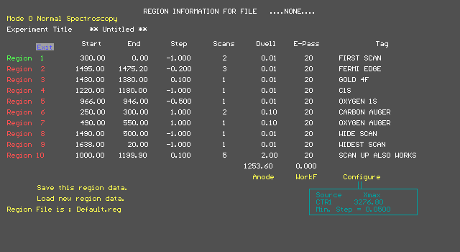
7. Press the Home key and the REGION INFORMATION WINDOW will pop up.
8. Sroll down to Load new region data and all tamplate can be found here. Here are the examples of scan parameters: Survey 1100 – 0 eV, Step -1eV, Scans 5, Dwell 0.05s, Pass energy 50 eV: O1s 540 – 520 eV, Step -0.1eV, Scans 15, Dwell 0.1s, Pass energy 50 eV. For saving new tamplate name the file and end of the file type .reg to save the tamplate.
9. Make sure the Xmax value is set to 3276.8 eV in the program. Also, check that the axis is either BE or KE in accordance to the spectrum you want to obtain (both in a box at the right-hand lower corner).
11. Press F7 to name the file. Press Enter and it will prompt to Experiment where the experimental note can be written.
12. Press F6 to start data acquisition
13. After completion of data acquisition, press F8 to save the file.
14. If the experiment needs to be paused, press F9 to pause then press F10 to stop..
15. Turn channeltron and X-ray gun off during gas admissions and also when you take a break in your experiment.
16. To exit press Ctrl+F10
17. For transfer data, insert a floppy and go to vg folder and transfer it.

iv. Turning off
1. Turn channeltron voltage down and switch it off.
2. Turn off all the units in the spectrometer in reverse order.
3. Decrease the emission current and filament current to zero
3. Reduce the HV to zero
4. Turn the “Glassman” high voltage power supply off
5. Turn off the power supply for filament current control.
6. Let the cooling water flow for a while (10-20 min) to thoroughly cool the X-ray gun before turning it off.
7. Retreat the X-ray gun back from the all-the-way in position. If not, the sample will collide with the end of the X-ray anode when is moved.

- Data processing and editing

The data collected with the VG software generates a Wordpad file. The column on the Wordpad file represents the intensity of the recorded element. The column can be copied and pasted on the xl file and the binding energy can be adjusted based on step value. The Wordpad file can also be converted to the data file using the CasaXPS software.

8. Ion Gun

a. General considerations

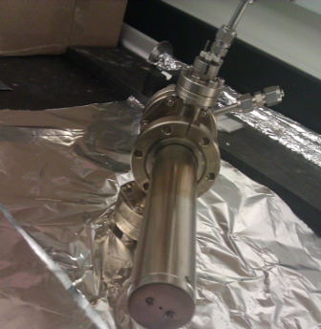
Michelle system is equipped with a Kratos MiniBeam ion gun system. It can provide a high current density, variable diameter, scannable ion beam for precision ion beam studies and application. The ion gun is an UHV device which contains an ion source, an ion extractor section, and electrostatic section for beam focusing, and deflection plates to control the ion beam. The gun is mounted on a 2.75 inch CF flange.

The ion gun system is used to clean the sample. The sample Ni (110) should be cleaned in the UHV environment by a combination of 2 keV Ar⁺ sputter followed by 800 K annealing. Sputtering is normally done with argon. The argon line is shared with UC system and can be pumped with a mechanical pump connected to the gas manifold.

b. Typical operation

To clean the surface:
1) Move the surface to right position. (Z position: 25.5”, angle at 60º)
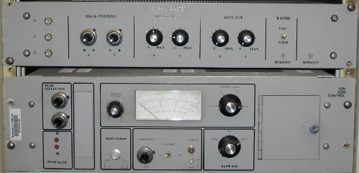
2) Leak the argon into the chamber to a pressure of ~ 1.0×10⁻⁷ Torr.
3) Check for beam voltage and emission are set fully counter-clockwise.
4) Turn on power. Slowly turn filament current on. There may be a delay in display. Dial until 15 mA emission is obtained.
5) Turn voltage switch on, set to 2.0 keV.
6) Measure the sample current using a multi-meter connected to the sample. The sample is grounded through the multi-meter via thermocouple. The current should be around 2.0 μA. Adjustment for the raster size are normally not necessary, but try initially. The “Raster” keeps on during sputtering. Gate size set at maximum for both X and Y. Beam position is set at 5.70(X) and 6.00 (Y). Use large beam size. Check argon pressure occasionally.

To end sputtering:
1) Close the valve for argon.
2) Turn off the voltage and filament current. Turn off power.
3) The pressure in the chamber will reduce to ~1×10⁻⁹ Torr in about 5 mins.

c. Alignment and calibration

i. Central spot position
Currently, the central position is at Z position: 25.5”, angle 60º.

ii. Rastering
Currently, the setting for the rastering is 5 for X-direction knob and 4 for Y-direction knob.

d. Sample cleaning

To clean a sample, cycles of sputtering/annealing may be needed. For Ni, sometimes it is necessary to sputtering the sample while holding the sample at about 500 ºC.

For cleaning Ta substrate, sputtering the Ta substrate using 2 KeV ion energy in 2 x 10⁻⁷ torr Ar for 30 minutes followed by oxidation under 2 x 10⁻⁵ torr of O₂ at 600 C for 5 minutes and annealing at 600 C for 5 minutes in UHV.

8. Low Energy Scattering data acquisition

a. Overview

Low energy ion scattering spectroscopy is a technique with the special feature to solely detect the composition of the topmost surface layer. In most cases, helium and neon gases are used to generate the incident ions. Helium is superior in achieving better peak resolution and intensity, while neon should be used in the case of detecting some heavier atoms, such as iodine. One universal formula (binary collision model) can be used to calculate the energy distribution of the reflected ions. The energy of the scattered ions is determined by both the masses of both incident ions and the surface atoms, and the scattering angles specifically in the chamber. For the Michelle system, the scattering angle is about 225º

b. Preparation

Make sure the slave unit is correctly connected to the energy analyzer. Two additional lines should to be added to switch from XPS to ISS mode. Please refer to VG manual for the details. Here is the short description on how to connect the cables.

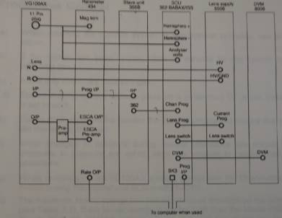
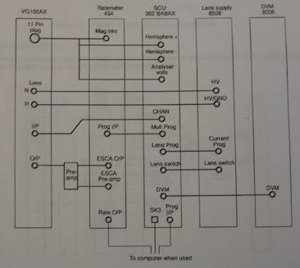

The unit must be turned off before switching from XPS to ISS mode. Open the shelf-door on the backside to locate the control units.
1) Find the BNC cable that is not in use and connect one side to Unit 362, Chan Prog. Connect the other side to Unit 356, 362.
2) Disconnect one side of the cable that is connected to Unit 362, CHAN. And connect it to the TEE at Unit 356, O/P.
3) Disconnect one side of the cable that is connected to Unit 362, Mult Prog. And connect it to the TEE at Unit 356, O/P.

Make sure that the function has been switched from XPS to ISS mode in the controller. Note that in most XPS studies, the pass energy is set as 50 eV, while 120 eV pass energy should be used for ISS experiments.

Make sure that the ion gun, sample and electron analyzer are all installed in the right position. The geometry of these three components proves to be important to give a reasonable yield of ISS signal. If needed, slightly move the sample up and down or rotate the sample to maximize the signal. During operation of ISS, the raster must be in off position (middle). The gate size is set at minimum. Try to use the small or medium beam size.

i. The standard data acquisition procedure

1) Turn on the ion gun power. The ion beam raster should be set as zero in both x and y directions.
2) Tune the filament current to ~15 mA and the ionization voltage to 500 V, respectively. Note: The ionization energy of ion gun is not necessarily set as 500 V for all the experiments. It is depending on the gas chosen and your need.
3) In the spectrometer controller, set the kinetic energy to the estimated peak position using the binary collision model. Then gradually introduce the helium/neon gas into the chamber until the sample current reading reach above 50 nA. It is recommended that without perishing your ISS signal too much, a lower gas pressure should be used (usually 10-8 even 10-9 torr is fine, but we never try higher than 2.0x10⁻⁷ torr).
4) Now you should be able to detect some counts from the ratemeter. If not, try to move and rotate the sample to optimize the ISS signal (check, if the channeltron multiplier voltage is on, if all the connections are right set, if there is enough sample current seen from the pico-ammeter).
5) Then take the ISS spectrum by scanning the kinetic energy within the selected range. Use the same software as XPS.
Note: Previous experiments show that the ISS experiment seems to cause some damage to the channeltron. As the XPS signal intensity drops about 10-20% after ISS experiments are done.

9. Reflection-absorption IR Spectroscopy (RAIRS)

a. General considerations

In the RAIRS experiments, the IR beam is taken out of the spectrometer, passed through a polarizer, focused through a sodium chloride window onto the sample in the UHV-chamber at grazing incidence, passed out of the chamber through a second sodium chloride window and refocused onto the MCT (mercury-cadmium-telluride) detector (ivory cylinder in the purged area).

b. RAIRS setup (drawing, mirror specs, detector)

Recently, the Michelle chamber has been upgraded with an installation of a new IR cell. In our setup, the IR beam is taken from a BRUKER TENSOR 27 IR spectrometer and passed through a polarizer and focused through a NaCl window onto the sample surface at grazing incidence (~85º). The surface acts as a mirror. The reflected beam is then passed through a second NaCl window and focused onto a mercury-cadmium-telluride (MCT) detector. The entire beam path is enclosed in a sealed cover purged with dry air, purified using a scrubber for CO₂ and water removal to minimize interference from gas phase absorption bands associated with atmospheric H₂O and CO₂.
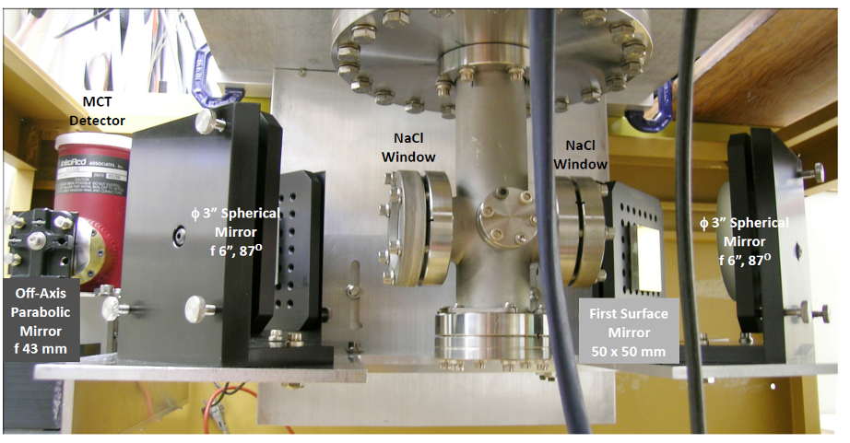

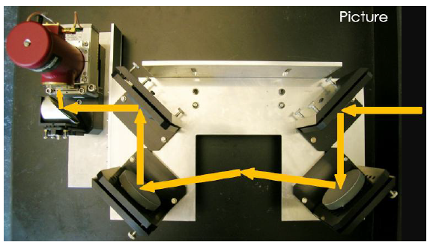
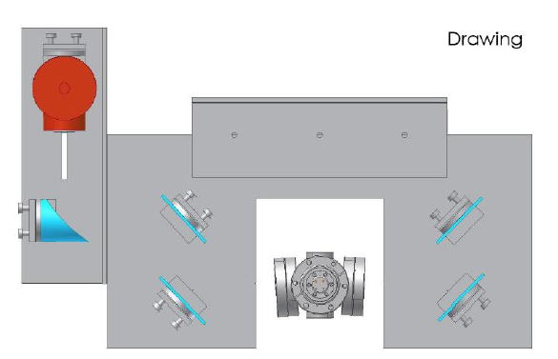

c. Sample setup

i. General preparation

The dry air should be flowing. The parker FTIR purging system should be on all the time. The flow meter that monitors the gas flow into the IR beam path should read approximately 100 SCFH. If not, adjust it. This should be checked periodically, even if the IR spectrometer is not used.

Before a RAIRS spectrum can be taken, the detector has to be cooled down to liquid nitrogen temperature:
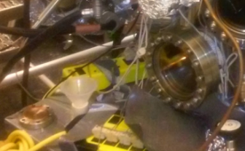
1) Pour in the liquid nitrogen into the funnel that goes to the MCT detector. At first the nitrogen will boil out of the detector. Keep pouring, a little at a time, until the boiling stops and the detector is filled. When the detector is full, the liquid nitrogen will just run off the top of the detector. If the detector has been filled according to the procedure above, it should remain cold for 10–12 hrs. The detector can be refilled while doing experiments.
Liquid nitrogen funnel

2) The spectrometer should be in the stand-by mode before experiments are started:
The interferometer is running, indicated by the flashing "SCAN" light. And the display on the bottom line of the OPUS window will read "No Active Task".

ii. Sample positioning

For current setting, the sample is at the following position for IR measurement. Z: 1.65 inch; Angle: 240º. The angle is critical. Since the control of the rotation is precise, for every IR measurement, the angel should be slightly justified to maximize the amplitude.

iii. Calibration

To check/calibration IR peak position, CO gas can be used. It is well known of the peak position of CO adsorption on metal single crystals at room temperature.

iii. Signal optimization

To optimize the signal, it is essential to get a high amplitude first. The angle is the key factor to play with. The signal to noise ratio can be optimized by changing the flow rate in the purging gas.

d. Typical FTIR parameters (scanning speed, #scans, iris setting, resolution, acquisition time)

Here is the list of typical FTIR parameter in the measurement.
Scanner Velocity: 20 KHz
Number of scans: 512
Aperture setting: 5mm
Resolution: 4 cm⁻¹
Acquisition time: ~ 4-5 min

e. Acquiring background spectra

To generate an absorbance spectrum of a surface species, both a background spectrum, which is taken with the clean surface, and a sample spectrum, which is taken after adsorption (and sometimes reaction) of the molecules on the surface are needed. These background and sample scans are taken separately. The RAIRS data are collected on the PC using the Bruker software called OPUS.

Start the OPUS program; click the short-cut icon of the OPUS program on desktop. Then OPUS the login window appears on the screen. Type "OPUS" in the password line for default operator. For details on the program, consult the manual.

Select "Measure" and then "Measurement". After a few seconds the measurement set-up windows appear on the screen. Load the experiment parameter file. Check the experimental parameters under "Advanced", "Optics", "Acquisition", "FT" and "Display".

When the sample is clean, take a background spectrum by selecting "Measurement", "Basic", and "Collect Background". The program displays a message in the bottom line high-lighted by a green color indicating that the data are being taken.

When the message disappears, the measurement is done; and from this point on you can proceed with the experiments. During the data acquisition the interferrogram cannot be seen on the check signal menu. After background scans are finished, the "Measurement" window remains on the screen. Go to background, click save background. "Save File As", then check the file name and path to be saved. If you want an ASCII file, in the "Mode" option on the Save Spectrum window, select "Data Point Table" before clicking the "Save" button.

f. Acquiring sample spectra

1) Prepare the adsorbate on the surface and cool down to the same temperature at which the background was measured.
2) Take the sample data by selecting "Collect Sample", and wait until the highlighted message disappears (see also previous paragraph). Data will be automatically saved.

NOTE 1: Make sure that the sample position in the sample scan is exactly the same as in the background scan: DO NOT TRY TO OPTIMIZE THE SAMPLE POSITION BETWEEN A BACKGROUND AND SAMPLE SCAN, even if the signal intensity is lower than it was in the background scan! Also, make sure that the temperature at which the sample is taken is the same as that at which the background was taken, so that the contraction of the manipulator is the same in both cases. Do not change any parameter between the background and sample scans.

NOTE 2: In the IR measurement of multiple ALD cycles, it is suggested to save all the data as background. Then do the process manually later.

g. Operation of polarizer

A polarizer is installed right next to the BRUKER TENSOR 27 IR spectrometer and it is in the purging box all the time. The polarizer is mounted on a stage which can be rotated 90º. A controller box is located next to the front side of the spectrometer. P is the component that is perpendicular to the surface, which is IR sensitive. S is the component that is the parallel to the surface. Using the ratio of P/S to compare the data can significantly increase single intensity.

h. How to obtain RAIRS under high pressure

The IR cell is designed to have the ability run experiment at high pressure. However, the setpup is still not finished for this purpose. No experiment has been tried at high pressure yet.

i. FTIR maintenance

i. IR lamp

The IR source lamp are pre-aligned and electrically coded. It can be replaced by user when it fails. To change the IR source:

1) Turn off the instrument before removing the source.
2) Open the source compartment.
3) Loosen the thumb screw of the source holder by about one turn.
4) Gently press the source downwards while turning the lever.
5) Holding the source handle, lift the source out its position.
6) Replace with a new source following the above steps in reverse order.
7) Close the source compartment lid and turn on the instrument.
8) Run OPUS and test.

ii. HeNe Laser

The HeNe laser has a life time and it will need to be replaced when it fails. The laser is in the source/electronics compartment.
To replace the HeNe laser:
1) Turn off the spectrometer.
2) Open the source/electronics compartment. Unscrew the Philips screws by two turns and move the securing bracket aside.
3) Lift the laser unit by 3cm and tilt it slightly clockwise and upwards to remove it from the compartment. Remove the power plug.
4) Replace the laser unit with a new one. And put in the reverse order.
5) Close the compartment and test.

iii. Alignment

The alignment of the sample is critical in the IR measurement. Due to the nature of the chamber, one has to work under the chamber in order to access all the mirrors. And there is only limited access there.
The spectrometer is sitting on top of the wooden stage, and any movement of the spectrometer/stage will cause the signal significant drop or disappear. Do not try to bump, or move the stage.
The mounting of the sample is very critical too. Since the manipulator does not have the ability to move in X and Y direction. Once the sample is mounted, we can only rely on changing the settings on the mirror to do the alignment.
When do the alignment, one should make sure the signal is from sample, not the direct beam.

iv. Mirrors (cleaning, etc.)

Great care should be taken when handling infrared optics. Please note the following precautions:

1) Always wear powder-free finger cots or rubber/latex gloves when handling optics. Dirt and oil from the skin can severely contaminate optics, causing a major degradation in performance.
2) Do not use any tools to manipulate optics -- this includes tweezers or picks.
3) Never place optics on a hard or rough surface. Infrared optics can be easily scratched.
4) All materials used for infrared optics are fragile, whether single crystal or polycrystalline, large or fine grained. They are not as strong as glass and will not withstand procedures normally used on glass optics.
Use an air bulb to blow off any loose contaminants from the optic surface.

Note: Avoid using lab air lines because they usually contain some amount of oil and water. These contaminants can form detrimental absorbing films on optical surfaces.

v. Dry air purging system and box

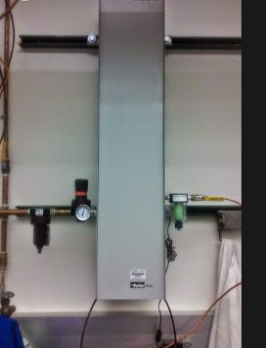
The Michelle system has its own FTIR purging gas system. It is located on the south side of the room. The system is made by Parker-Balston with a model # 75-62. The inlet gas line pressure is regulated. And the maximum inlet pressure allowed is 120 psi. A moisture indicator must be in green under normal operation. It will change to yellow when excess moisture is present in the purge gas. The only maintenance activity required by the Parker Balston FRIR purge gas generator is the annual replacement for the coalescing prefilter cartridge, and occasional replacement of the moisture indicator cartridge.

To remove the filter cartridge, simple unscrew the filter bowl for the head, low the bowl, and remove the element retainer disc at the base of the cartridge. Replace the spent cartridge and reassemble.

Initially, a box was installed for all the optical path. However, the sealing is not good due to the difficult access to certain area. Then the whole optical path, including all the mirrors, polarizer, and detector are covered with plastic wraps and sealed with tapes. The purging gas was delivered inside the wraps using a couple of tubes with a flow rate higher than 100 SCFH. It is necessary to check the seal from time to time. One indication is that the water peak IR measurement increases.

10. Deposition of SiO₂ and Al₂O₃, H-atom and precursor

Two hot filament-based sources are installed in the chamber. One is used to grow SiO₂ on top of the sample, the other one is used to produce hot H-atom when heated. In the Si source, a silicon piece is wrapped 0.5 mm tantalum wire and mounted on feedthrough. In the H-atom source, a 0.5mm tungsten wire is used as a hot source.
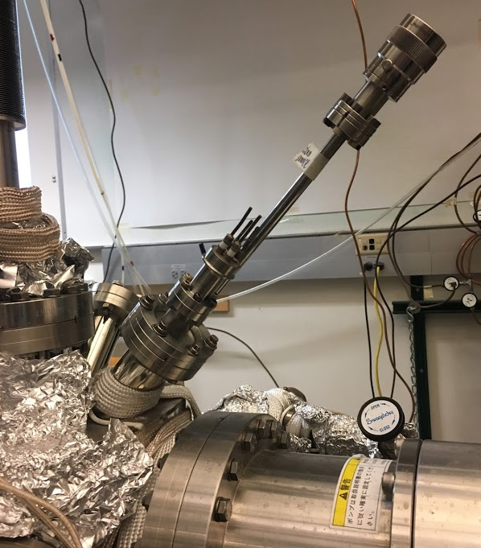
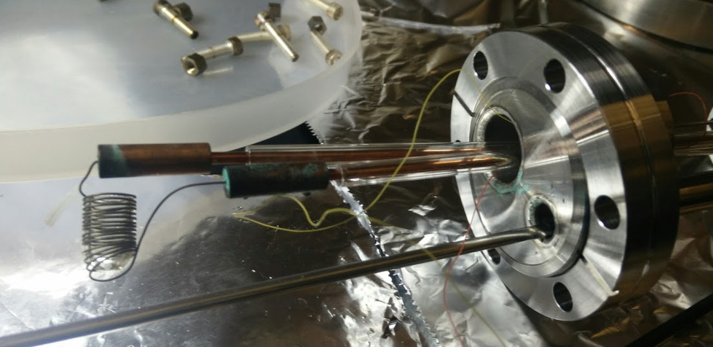
Si Source

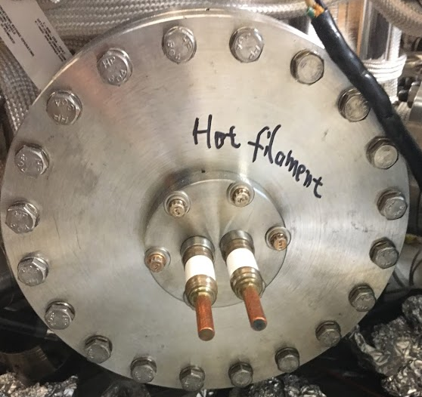

a. Deposition of SiO₂
1) Borrow the power supply from the Victor system.
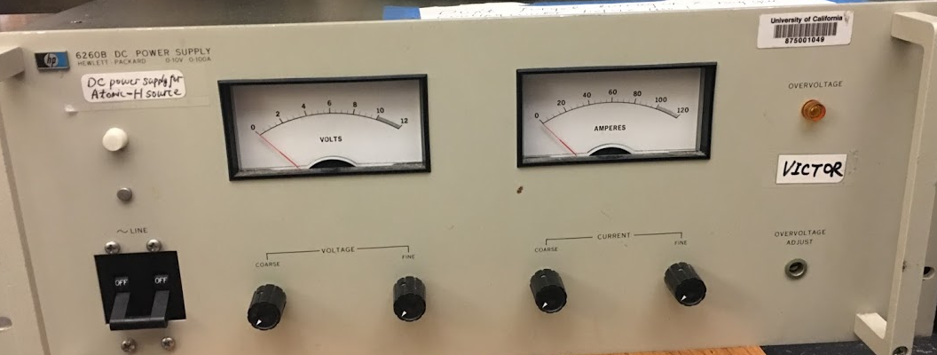

2) Connect the two heating cables to the feedthrough on the SiO₂ source. Make sure the connections are good and the wire is not touched each other.
3) Move the sample right in front of the SiO₂ source.
4. Leak 2 x 10⁻⁶ torr oxygen inside.
4) Turn the current and voltage knobs on the power supply to the minimum. (counterclockwise).
5) Tune on the power for the HP power supply. Slowly increase the voltage by increasing the coarse settings. Monitor the chamber pressure. Tune both voltage and current knobs to reach 10V, 8-9 A. The filament inside the chamber will become red and the temperature of the sample will slowly increase.
6) After the experiment, reduce both current and voltage back to 0. Remove the heating cable from the feedthrough.
7. Oxidized the deposited SiOx film at 600 C under 2 x 10⁻⁵ O₂ for 5 minutes.
8. Check the quality of the film using XPS
Note: If these sources have not been used for a while, it is suggested to degas the filament at lower power first before any scheduled experiment.

b. Grow Al₂O₃ film on Ta substrate

Al₂O₃ film was grown on the Ta substrate by CVD of trimethyl aluminum and water. The procedure as follow:
1) Rotate and move the sample to face the leak valve. Heat the clean Ta substrate to 250 °C.
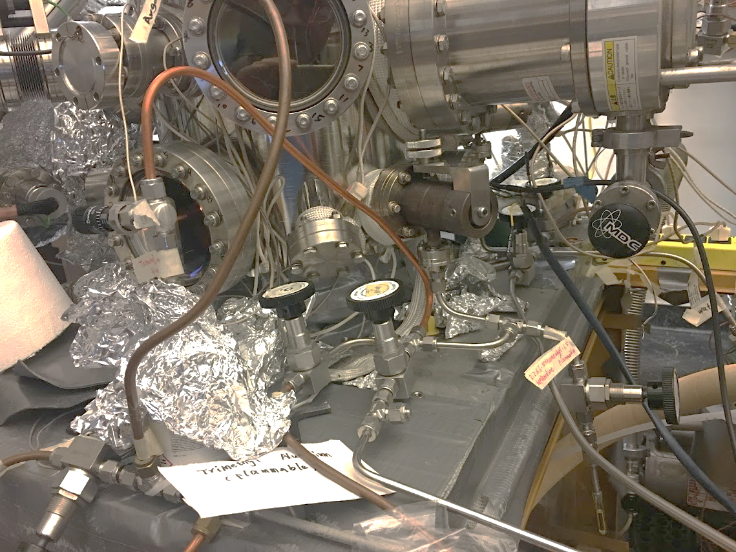
Valve A
Valve B
Valve C
Needle Valve
Leak Valve

2) Make sure valve A and B are closed all the time. The trimethyl aluminum (TMA) bottle valve (yellow, not shown in picture) is closed. Open valve C and need valve to pump the line. Close valve C. Close the needle valve. Open the yellow valve of TMA then open the needle valve. Close the yellow valve and open Valve C to pump away the gas from the line. Repeat one more time.
3) Close valve C and open the yellow valve. Open the needle valve to 0.2 markers. Slowly open the leak valve to reach 2 x 10⁻⁵ torr.
4) On the other side of the chamber, there is a leak valve that controls the H₂O pressure. Open that leak valve to reach 4 x 10^{–5} torr total. Leave for 15 mins. This will grow about 7 nm Al₂O₃ on the substrate.
5) Close all leak valves and TMA valve. Open Valve C to pump down the line.
6) The pressure in the main chamber will slowly reduce. It is suggested to leave overnight to reach a good base pressure.

c. Dosing of Precursor
1. Ni precursor bis(2,2,6,6-tetramethyl-3,5-heptanedionato)nickel(II) is purple color power. It is air sensitive. Transfer the solid into the glass-metal container with a Swagelok valve in the golve box and connect the valve to the system.
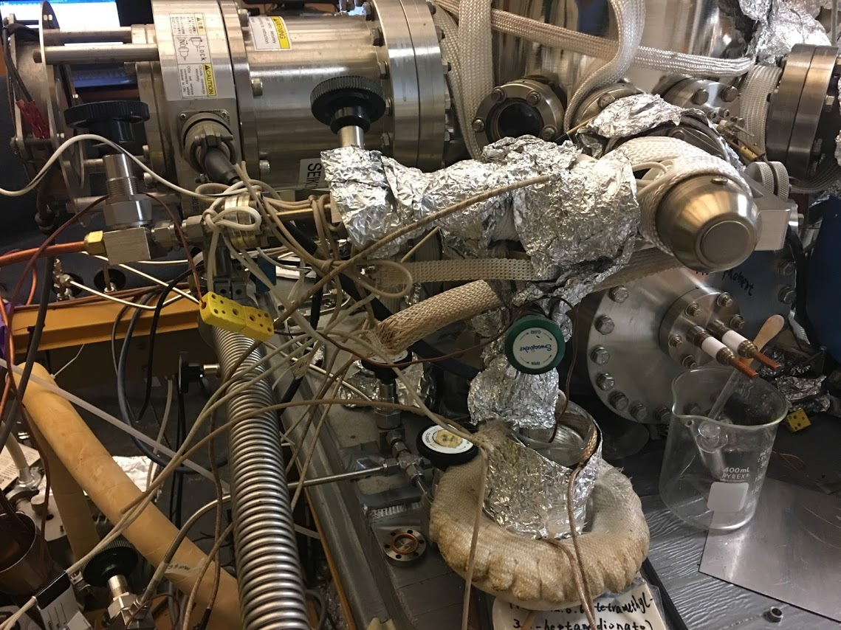
Ru Precursor
Si Oil bath
Leak Valve
Roughing Valve

2. Open the Swagelok valve and the roughing valve to pump away the air and heat the precursor in the silicon oil bath to 140 °C and leave for 1 hour. Close the Swagelok valve for pumping the precursor line and introduce it into the chamber at the desired pressure.

11. Potential hazards and safety procedures

All users must learn the UCR Dept. of Chem. Laboratory Safety Manual and pass all exams prior to getting trained on the Michelle UHV system. Users must get familiar with Injury and Prevention Program (IIPP) and Chemical Hygiene Plans (CHP).

Here are the highlights of the responsibility of the user who want to operate the Michelle UHV system.
1) Annual Review of the CHP as well as review of the appropriate Safety Manuals and Policies
Following all verbal and written laboratory safety rules, regulations, and standard operating procedures required for the tasks assigned
2) Developing good personal chemical hygiene habits, including but not limited to, keeping the work areas safe and uncluttered;
3) Planning, reviewing and understanding the hazards of materials and processes in the laboratory research or other work procedures prior to conducting work;
4) Utilizing appropriate measures to control identified hazards, including consistent and proper use of engineering controls, personal protective equipment (PPE), and administrative controls;
Understanding the capabilities and limitations of PPE issued to them;
5) Gaining prior approval from the Prof. Zaera for the use of restricted chemicals and instruments; Consulting with Prof. Zaera before using these particularly hazardous substances (PHS), explosives and other highly hazardous materials or conducting certain higher risk experimental procedures; Immediately reporting all accidents and unsafe conditions to Prof. Zaera; Completing all required health, safety and environmental training and providing written documentation to Prof. Zaera; Reviewing the plan or scope of work for their proposed research with Prof. Zaera Notifying in writing and consulting with Prof. Zaera, in advance, if the user intends to significantly deviate from previously reviewed procedures
6) Preparing SOPs and performing literature searches relevant to safety and health that are appropriate for the work;

A user must be familiar with the location of fire extinguishers, safety showers, and other safety equipment before he begins work in the Michelle UHV system.
Fire Extinguishers: Located next to front door of RM 143.
Safety Showers and Eyewash Station: Located next to the front door of RM 143.
Fire Exit: two doors in RM 143
First Aid Kits: Located next to front door of RM 143.

It is important for a user to have good work habits when working on the Michelle UHV system. Some of the key elements are listed below:
Personal Protective Equipment: Wear closed-toe shoes and full length pants, or equivalent, at all times when in the laboratory. Utilize appropriate PPE while in the laboratory and while performing procedures that involve the use of hazardous chemicals or materials.
Laboratory Operation: Keep the work area clean and uncluttered
Compressed Gas Cylinders: Compressed gas cylinders are located on the south side of the Michelle UHV system against the wall. They must be chained or strapped to the wall. The cylinders must be always restrained by two chains.
Liquid Nitrogen: Always use appropriate thermally insulated gloves when handling liquid nitrogen.

