Infrared Characterization
System #6: Multi-bounce ATR

Manual

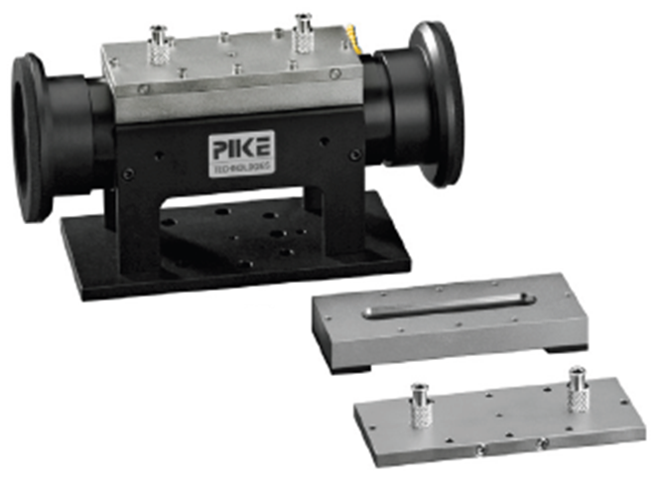

Francisco Zaera Group
Prepared by Alex Gordon, June 2013
Modified by Ilkeun Lee, September 2014
Modified by Yufei Ni, November 2018
Modified by Zihao Wang, January 2024

Table of Contents
1. General Considerations/Overview of Equipment 4
2. General Laboratory Safety 4
3. FT-IR Instrument and General Operation 5
a. Spectrometer General Description 5
b. FTIR Performance Characterization 5
i. Measuring Spectral Signal-to-Noise 5
ii. Maximizing Absorbance Signal 5
c. Main FTIR Parameters 5
e. Detector 6
i. Types 6
ii. Substitution 7
iii. Preparation 7
iv. Maintenance 8
f. Optical Alignment 9
g. Transmittance spectra 9
i. Choice of Background Spectra 9
h. OPUS Software 10
i. Spectra Acquisition 10
ii. Data Processing 12
i. Maintenance 13
i. IR Source 13
ii. HeNe Laser 15
iii. Gas Purging 17
3. Liquid and Gas Handling System 17
a. Schematic 18
b. General Operation Procedure 19
c. Gas and Liquid Sample Handling 19
i. Gases 19
ii. Liquids 19
d. Maintenance 19
e. Valves 20
f. Pressure Gauges 20
g. Mechanical Pumps 20
4. Multi-bounce ATR Cell 21
a. General Description 21
b. Components 21
i. ATR Prism 21
ii. O-Ring 23
c. ATR-IR Cell with Solution Circulation 23
d. Initial Setup 24
e. Beam Alignment 25
f. Cell Cleaning 25
g. Long Term Maintenance 25
6. Typical Experiment Sequence 25
a. Initial Steps 26
b. Setup 26
c. Gas Adsorption 27
d. Adsorption of Organic Molecules (Modifier and Reactant) 27
e. Spectra Acquisition 29
i. Background Spectra 29
ii. Sample Spectra 29
f. Final Steps 30
6. Suggested Training for Beginner 30
7. Reference Materials & Contacts 31
a. Reference Materials 31
b. Contacts 31

1. General Considerations/Overview of Equipment
Please read this manual carefully before using the ATR-IR system and keep it in a suitable place for future reference. Always follow the instruction described in this manual to ensure safety and to avoid damage. Improper use or failure to do safety instructions can result in serious injuries and/or property damage. Especially ensure that the CO alarm on the ceiling is ON when you use CO gas. If it doesn’t work, replace the battery inside or have another one prior to work.

Multi-bounce ATR system is placed on a table in Chemical Science building room 135, and consists of three parts: Fourier-transform infrared (FTIR) spectrometer (Tensor 27, Bruker), , PIKE ATR accessory (500 μL HATR Flow Cell, Ge, 45°), and computer (OPUS program version 7).

The multiple bounce ATR cell is a commercial device sold by Pike Technologies designed to characterize samples deposited on a flat Ge prism, used to guide the light beam from the FTIR instrument as it reflects multiple times through the inner surfaces of this optical element. The geometry is set for total internal reflection, but the evanescent wave projecting towards the outside surfaces affords the detection of molecular species within a few nm of those. Either thin films or powders can be deposited on the outside surface of the prism for IR characterization, and those can be exposed to either gases or liquids, although the cell is specifically designed to deal with liquid/solid interfaces.

The PIKE Technologies’ HATR crystal plate in our lab in a sealed version, as shown in right panel of Figure 1 below. The crystal is a Ge piece, 60 mm long and with 45° beveled edges. The powder sample is dispersed on the surface of the crystal, and the flat metal plate is then attached and sealed on top to ensure that there are no leaks during the flow of the liquid.
Figure 1. Sectional view of the multi-bounce ATR accessory.

2. General Laboratory Safety
Before starting any experimental work in the laboratory, all users must learn The Laboratory Safety Manual and pass all exams. Users must also get familiar with the Injury and Prevention Program (IIPP) and Chemical Hygiene Plans (CHP), and wear PPE according to the Laboratory Hazard Assessment (LHAT, ehs.ucop.edu/lhat/) or Hazard Assessments in Lab Safety Manual.

All users must be familiar with the location of the fire extinguishers, safety showers, and other safety equipment before starting any experimental work. In Room CS 135:

- Fire Extinguishers: Located next to front door of CS 135.
- Safety Showers and Eyewash Station: Located next to the front door of CS 135.
- Fire Exit: two doors in CS 135.
- First Aid Kits: Located next to front door of CS 135.

3. FT-IR Instrument and General Operation

a. Spectrometer General Description
The FTIR instrument used for this system is a Bruker Tensor 27 in Chemical Science building room 135. More details about this instrument can be found in its manual (7th updated edition, September 2011). General FTIR principles are well described in several books. See, for instance: Peter R. Griffiths and James A. de Haseth, "Fourier Transform Infrared Spectrometry", John Wiley & Sons, New York, 1986, and Brian C. Smith, “Fundamentals of Fourier Transform Infrared Spectroscopy (2nd edition), CRC press, Taylor & Francis Group.

The Liquid-Solid IR cell is placed on the outside optical setup of the FTIR spectrometer and use external IR beam line.

b. FTIR Performance Characterization

The FTIR spectrometer should be set up for optimal performance by choosing the appropriate parameters and aligning the sample and optics.

i. Measuring Spectral Signal-to-Noise
Signal-to-noise (S/N) ratio: This is a critical value dependent on the other parameters that should be minimized before performing experiments. It is checked by acquiring back-to-back spectra under identical conditions and ratioing those. S/N ratios can be calculated by the OPUS software (one of “Evaluate” menus), and should be done for two frequency regions, typically 2000–2200 cm⁻¹ (the region with the least noise), and a second in a region of interest, around 3000 cm⁻¹, for example.

ii. Maximizing Absorbance Signal
This is done by choosing a particular IR absorption peak in the spectra in the sample and following that by taking spectra as parameters are optimized.

c. Main FTIR Parameters

- Total intensity (Amplitude): This is measured by the peak-to-peak voltage value on the centerburst of the interferogram, which can be display in the computer screen as other parameters are optimized and sample alignment is performed (see the section 4c). It should be as high as possible.
- Iris opening (Aperture Setting): the iris opening is available with pre-selected sizes from 0.25 to 6 mm. It should be optimized to obtain maximum throughput while minimizing the beam size, to minimize the beam divergence. The original IR beam is approximately 1" in diameter. Based on this value and the focal length of the focusing mirrors, a divergence range at the sample could be calculated. Total light throughput should also be kept at values low enough so the signal is proportional to light intensity (there is a saturation of the detector at high light fluences).
- Scanning rate (Scanner Velocity): the most interesting values available are 10 or 20 kHz for DLaTGS detecter and 80 or 100 kHz for MCT detectors. Faster scanning rates lead to faster data acquisition, but very fast scanning rates may lead to increases in S/N. The maximum scanning rate should be chosen where noise levels are not increased (this can be evaluated by taking S/N measurements for the different scan rates using the same conditions).
- Number of scans (or Scan Times in minutes): to signal average. S/N ratios should be increased as the square root of the number of scans, but too long data acquisition times lead to drifts in IR background and in changes in the nature of the sample (adsorption, etc.).
- Resolution: High resolutions are needed to separate different IR peaks, but require longer acquisition times (require further travel of the interferometer mirror), introduce noise (from the wings of the interferogram), and may reduce total peak signal intensity. Typical value is 4 cm⁻¹, sufficient for surface adsorbates, but sometimes 2 cm⁻¹ is required.
- Amplification (Signal Gain): there are preamplifier gains (Automatic, ×1, ×2, ×4, ×8, or ×16), to be set to optimize signal without saturating the centerburst. The gain at the centerburst may be set separately (at a lower value) than for the rest (wings) of the interferogram.

e. Detector

i. Types
There are three different types of IR detectors: thermal, pyroelectric, and photoconducting detectors. Thermal detector such as thermocouple or bolometer is used over a wide range of wavelengths at room temperature, but not preferred due to slower response time and lower sensitivity than other types of detectors. Pyroelectric detector has a much faster response time as it depends on the rate of temperature change. The most common material is “deuterium L-alanine doped triglycene sulphate (DLaTGS). Photoconducting detector relies on the interaction between photons and a semiconductor such as mercury cadmium telluride (MCT) or indium antimonide (InSb), so response time is much faster and sensitivity is also much higher. Usually it has to be cooled first prior to use for thermal noise. Tensor 27 for DRIFT uses DLaTGS detector on the internal beam line.

Detector | Range (cm⁻¹) | Sensitivity  (cm Hz^{1/2} W⁻¹) | Cooling
DLaTGS | 12,000–350 | >4 x 10⁸ | Room Temperature
MCT Wide Band | 12,000–420 | >5 x 10⁹ | LN₂ cooling
MCT Medium Band | 12,000–600 | >2 x 10¹⁰ | LN₂ cooling
MCT Narrow Band | 12,000–850 | >4 x 10¹⁰ | LN₂ cooling
InSb | 12,800–1850 | >1.5 x 10¹¹ | LN₂ cooling

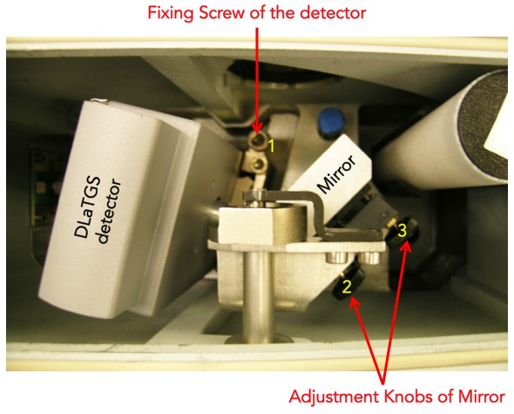
Figure 2. Detector compartment of Tensor 27 FTIR spectrometer.

ii. Substitution
1. Loosen the fixing screw of the detector compartment cover by using 6 mm Allen wrench.
- Open the detector compartment.
- Loosen the fixing screw of the detector with 6 mm Allen screw wrench (see Figure 1).
- Pull the detector straight upward out of the dovetail guide.
- Insert the detector you want into the dovetail guide and press it right down.
- Fasten the Allen screw.
- Close the detector compartment.
- Check the signal intensity using the OPUS program.

iii. Preparation
MCT or InSb detector has to be cooled down to liquid nitrogen temperature prior to use. Always wear blue Cryo-gloves (Tempshield) when you handle liquid nitrogen, LN₂ (please refer SOP of cryogenic materials in the “Lab Safety Manual” folder or download “SOPs Process” (http://research.chem.ucr.edu/groups/zaera/images/documents/4_sop_processes_2013-07.pdf) from our group homepage. Cool the detector with LN₂ using the funnel fill tube. Keep filling the funnel in cone increments. Repeat until reservoir is full (spill over). Cool down time is about 5 to 10 minutes. The detector is at working temperature once the rapid boil off venting has stopped. Place the plug (cap) in the fill port
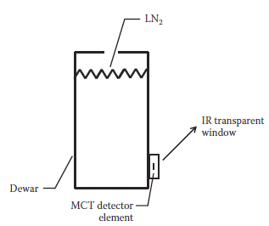

iv. Maintenance
No daily maintenance is required for the detector. The LN₂ dewar may require a vacuum refreshing. If the vacuum level of LN₂ dewar will be decreased below acceptable, then the surface of that vacuum jacket is very cold. Sometimes it is covered with ice because of the condensation of moister form the air, so water peaks appear on the spectra.
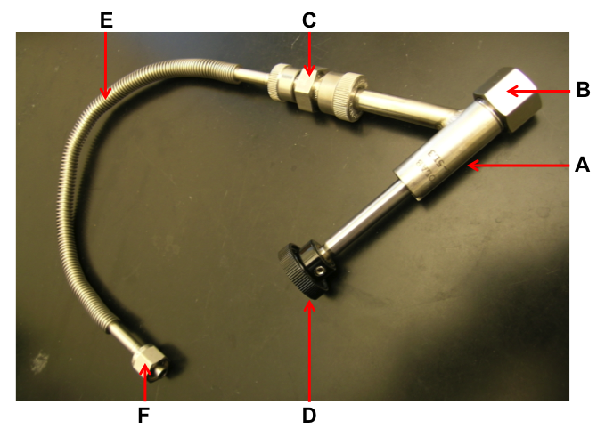
Figure 3. Adapter with flexible metal hose and Swagelok connection.

            - Remove the MCT detector from the spectrometer.
            - Connect the adapter (Figure 2) to one of vacuum valves.
            - Switch on the vacuum pump and open the valve.
            - Inspect the O-ring inside the adapter (B in Figure 2) for signs of wear.
            - Remove the cap from the connection nozzle of the detector.
            - Pull the adapter knob (D in Figure 2).
            - Loosen the coupling nut (B in Figure 2).
            - Push the adapter carefully over the connection nozzle of detector dewar.
            - Fasten the coupling nut hand-tight while holding the adapter and detector.
            - Push the adapter knob in the closed position until the threaded rod of the adapter is in contact with the sealing plug of the dewar evacuation valve.
            - Evacuate the detector dewar.
            - Close the vacuum valve.
            - Screw the threaded rod of the adapter in the connection thread of dewar evacuation valve by turning the adapter knob clockwise.
            - Pull the knob to the open position in order to open the dewar evacuation valve.
            - Evacuate the detector by opening the vacuum valve to pressure less than 10⁻⁶ Torr.
            - Close the dewar evacuation valve by pushing the adapter knob (D in Figure 2).
            - Press adapter knob firmly to the stop position,
            - Screw the threaded rod of the adapter out of the connection thread of the dewar evacuation valve by rotating the adapter knob.
            - Vent the section between vacuum pump and adapter.
            - Pull the knob to the open position.
            - Loosen the coupling nut and remove the adapter from the connection nozzle of the detector dewar.
            - Reinstall the MCT detector in the spectrometer.

f. Optical Alignment

Tensor 27 is equipped with a high stability interferometer with ROCKSOLID permanent alignment. Also detector substitution is possible with Tensor 27. DLaTGS detector is default, and optional MCT detectors are available in our lab. After substituting the detectors, re-alignment is not necessary due to the dovetail detector mounting. However, it has to be done properly whenever any accessory like DRIFTS or ATR system is installed or uninstalled in the sample compartment. Adjustment knobs for the alignment are shown in Figure 1.

            - Remove all the accessory and samples from the IR beam path. Make sure that there is nothing in the sample compartment.
            - MCT detector has to be cooled first prior to measurement.
            - Run OPUS program.
            - Select the “Measurement” menu.
            - Click the “Check Signal” tab.
            - Select the “Interferogram” radio button.
            - The amplitude value indicates the signal intensity that is currently detected.
            - Loosen the fixing screw of the detector compartment cover by using 6 mm Allen wrench.
            - Open the detector compartment.
            - Adjust two knobs (2 and 3 in Figure 1) of the mirror to get the highest value while watching the amplitude on the monitor. If you lost IR beam, use IR card to find it.
            - Once you get a good alignment, close the cover.
            - Wait for 6 hrs at least to be purged completely.

g. Transmittance spectra

i. Choice of Background Spectra

The background spectrum includes spectral contributions from the instrument and the environment. Majority of the environment absorbance is due to water vapor and CO₂. And contribution of the instrument to the spectrum is called the instrument response function including absorbance from the source, beam splitter, mirrors, and detector. A good background is of great significance to the sample measurement. As a result, the absorbance peak of each ‘species’ is supposed to maintain the same otherwise it will lead to bad reproducibility.

Depending on how to prepare your sample, it is strongly recommended to perform the background measurement with a proper material. The purpose of the background measurement is to detect the influence of the ambient conditions (e.g. humidity or temperature) and the auxiliary materials (e.g. solvents) that are required for preparing the sample. The subsequent sample measurement results in the sample spectrum from which the influence is eliminated. So, do both background and sample measurements with the same parameter settings in OPUS program. Ensure that the ambient conditions are identical or at least nearly identical.

h. OPUS Software

OPUS is a suite of software packages for the measurement, processing and evaluation of IR/Raman spectra. The main OPUS window is shown below with Key icons and areas labeled.
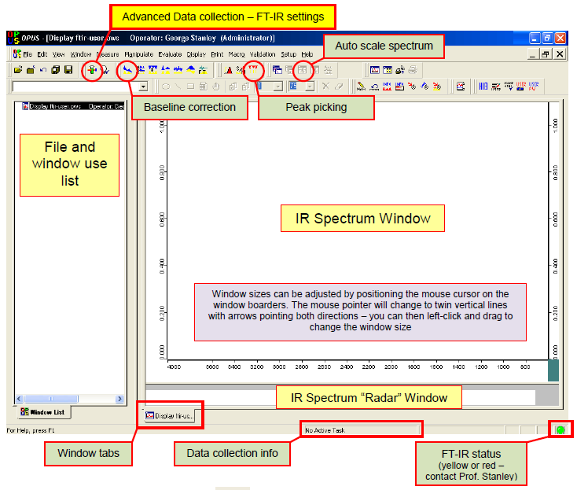

i. Spectra Acquisition
- Start the OPUS program:
  - Click the short-cut icon of the OPUS program on the desktop.
  - The OPUS login window will appear on the screen.
  - Type "OPUS" in the password line (for default operator).
- Select "Measure" and then "Measurement". After a few seconds, the measurement set-up windows will appear on the screen. Check the experimental parameters under "Advanced", "Optics", "Acquisition", "FT", and "Display".
- Set the sample temperature as needed.
- When the sample reaches the desired temperature, take a background spectrum by selecting "Measurement", "Basic", and "Collect Background". The program will display a message in the bottom line high-lighted by a green color indicating that the data are being taken.
- When the message disappears, the measurement is done. From this point on, you can proceed with the experiments (e.g. heating of the sample, adsorption of gases etc.).
- During the data acquisition, the interferogram cannot be seen on the check signal menu. After the background scans are finished, the "Measurement" window remains on the screen.
- Go to “Background” and Click “Save Background” to save the spectrum. The Filename (####.0) is saved automatically on the hard drive and displayed on the left (Window List) of the screen.
- The file can be saved as other formats on the hard drive. Select "Save File As", then check the file name and path to be saved. If you want an ASCII file, in the "Mode" option on the Save Spectrum window, select "Data Point Table" before clicking the "Save" button.
- Fill the chamber with the desired pressure of the reactant gases, at the same temperature used for the acquisition of the background spectrum.
- Take the sample spectra by selecting "Collect Sample", and wait until the highlighted message disappears.
- To take the spectra with different backgrounds saved previously, select “load background” and click any background spectrum.
- Type the sample name and explanation in the lines for sample name and sample form. (e.g. Sample Name: 1% Pt/SiO₂; Sample Form: after CO dosing of 10 Torr for 5 min at -150ºC)
- Take the sample data by selecting "Collect Sample" and wait until the highlighted message disappears.
- Select “load background” again, and click another background spectrum for the next experiment.

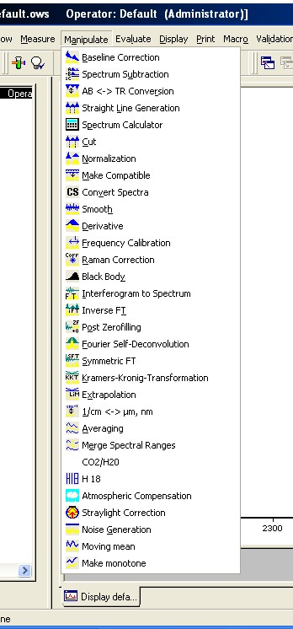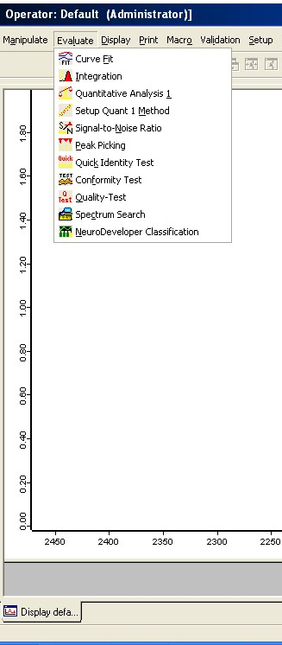

Figure 4. “Manipulate” and “Evaluate” menus in OPUS program.

ii. Data Processing
Very useful processing tools are available in OPUS program. For example, Base Line Correction and Spectrum Calculator are in “Manipulate” menu, while Curve Fit and Integration are in “Evaluate” menu. Use helpful menu to learn how to do them.

i. Maintenance

i. IR Source
Tensor 27 uses only one mid IR source (MIR) in an U-shaped silicon carbide piece, which is pre-aligned, so realignment is not required after replacement. During the spectrometer operation, it becomes very hot and has risk of skin burn. Please avoid any skin contact and wait until the source cools down enough before you remove it.
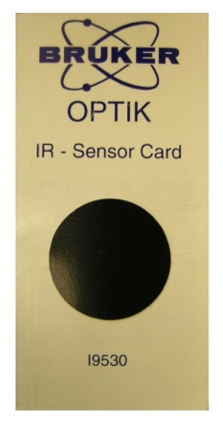
1. Beam Detection

If you like to check the IR beam visually, you can use an IR sensor card (see the right image) supplied from Bruker when the spectrometer was installed. You may confuse the red light on your sample with the IR beam, but actually it is He-Ne laser light (632.8 nm) that travels along the IR beam path.

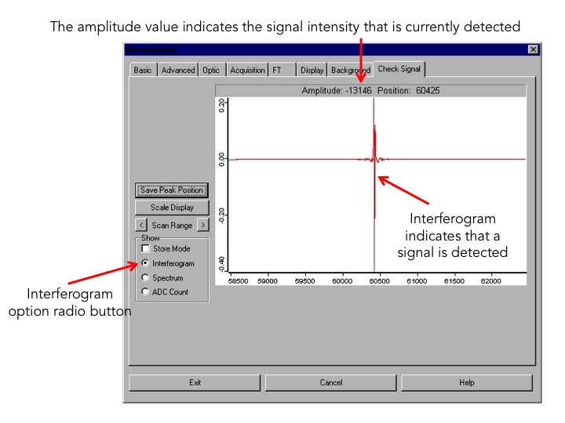

Figure 5. OPUS dialog window for “Measurement”.

2. Intensity Measurement

IR beam signal can be checked on the OPUS program.

1. Remove all the accessory and samples from the IR beam path. Make sure that there is nothing in the sample compartment.
2. Run OPUS program.
3. Select the “Measurement” menu
4. Click the “Check Signal” tab
5. Select the “Interferogram” radio button
6. The amplitude value indicates the signal intensity that is currently detected.

3. Cooling

Tensor 27 uses air-cooled MIR source, so additional cooling system isn’t required for normal operation. However, please do not block the ventilation slot of the source/laser compartment at the spectrometer top-side. During the spectrometer operation, the IR source generates heat, which is dissipated by the slots. Failure to do so can lead to spectrometer component damage.

4. Replacement

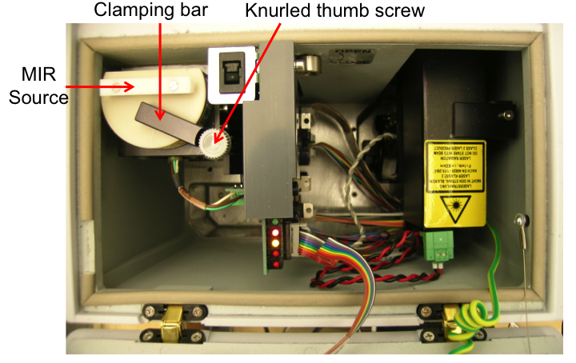
Figure 6. Source/Laser compartment.

            - Switch off the spectrometer.
            - Wait until the source cools down sufficiently.
            - Open the source/laser compartment.
            - Loosen the Knurled thumb screw of the clamping bar (approximately one turn).
            - Press the source downward while rotating the clamping bar aside.
            - Take the source out of the holder.
            - Insert a new source in the operating position holder.
            - While pressing the source downward, rotate the clamping bar over the source.
            - Tighten the knurled thumb screw of the clamping bar about one turn.
            - Close the source/laser compartment.
            - Switch on the spectrometer.
            - Check the signal intensity using OPUS program.
            - Select “Optics Diagnostics” in Measure menu.
            - Click the source icon on the “Instrument Status” window.
            - Click on “Service Info” button.
            - Click on the “Reset” button (Figure 6).
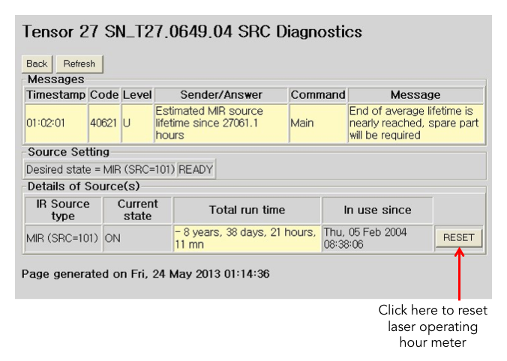
Figure 7. Source diagnostics page.

ii. HeNe Laser
FTIR spectrometer is equipped with a He-Ne laser (632.8 nm), which controls the position of the moving mirror in interferometer for IR beam scanning. If you have a problem with the laser, a red STATUS indicator or a failed performance qualification test (PQ).
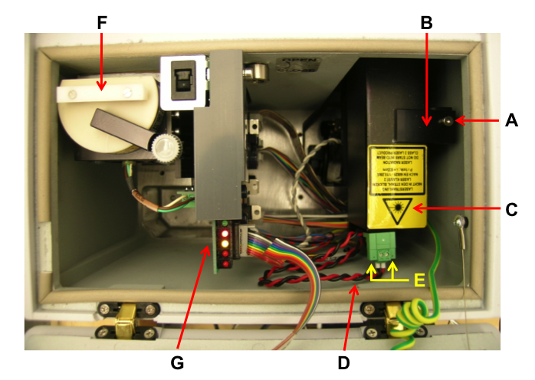
Figure 8. Source/Laser compartment.

1. Measuring and Adjusting Signal Intensity

If you have laser problem, you need to check the laser amplitude. For this test you nee an oscilloscope. There are two test points (LA2 and LB2) on IFM board (G in Figure 7) You should see minimum of 2 V p-p sign wave on these points.

There are parameters that can and should be checked with respect to the HeNe laser intensity.
- HeNe laser output intensity – this value can be checked under measurement. Go “Optics Setup and Service Option”. Select “Service” tab, if the log window is blank. Select “Repeat Diagnostics Test” button, when the results appear take note of the current and initial laser intensity values as well as the number of laser dropout value.
- HeNe laser modulation intensity – this value can be obtained via the measurement. Go “Direct Command Entry Option”. In there type; VEL=6 <Enter>, SCM=3 <Enter>, LAA <Enter>. Do this three times and record the approximate average value given (the value is the peak to peak modulation amplitude in millivolts). LAB <Enter>. Do this three times and record the approximate average value given (the value is the peak to peak modulation amplitude in milllivolts).

2. Replacement

In case of laser malfunction, you have to replace the complete laser module (C in Figure 7), which consists of the laser tube and the laser power supply.

            - Switch off the spectrometer.
            - Unplug the main power cable.
            - Open the source/laser compartment.
            - Loosen the Allen screw (A in Figure 7)
            - Rotate the holding plate (B in Figure 7)
            - Take the laser module out of the holder. Be aware of the fact that the laser module is still connected to the laser supply cable (D in Figure 7).
            - Loosen the two slotted screws (E in Figure 7) and unplug the supply cable (D in Figure 7).
            - Connect the supply cable to the replacement laser module.
            - Fasten the two slotted screws.
            - Open the front shutter of the laser tube if it is closed.
            - Insert the laser module in the holder. Make sure that the laser rests on the holder bottom in a plane manner to ensure the correct orientation of the laser beam.
            - Rotate the holding plate (B in Figure 7) in place.
            - Fasten the Allen screw (A in Figure 7).
            - Close the source/laser compartment.
            - Plug the main power cord
            - Switch on the spectrometer.
            - Check the laser indicator on the spectrometer topside lights yellow after a few seconds. Otherwise, solve this issue.
            - Wait until the STATUS indicator lights green. If the indicator remains red, the laser module is not installed correctly. Correct the laser installation.
            - Check whether the IR signal is detected using the OPUS program.
            - Run the “Optics Diagnostics” in OPUS
            - Open “Instrument Status” window.
            - Click “HeNe laser” icon.
            - Click “Service Infor” button.
            - Click “Reset” button in the laser diagnostics page (Figure 8).
            - Perform an OQ Test using OVP (OPUS Validation Program).
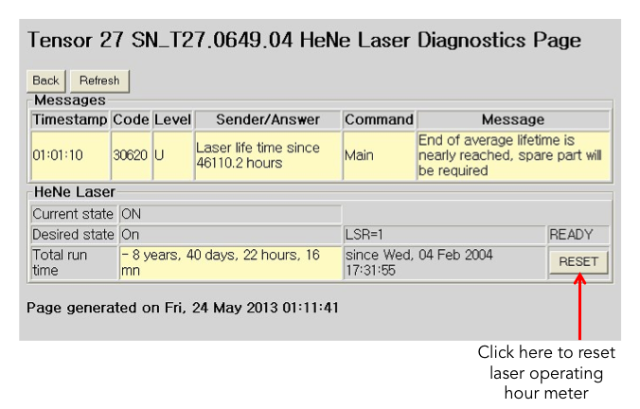
Figure 9. Laser diagnostics page.

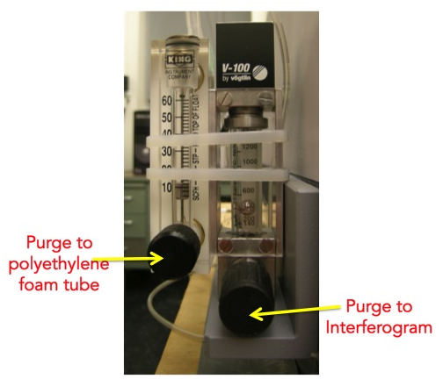
iii. Gas Purging

At least, the optical bench has to be purged with dry air or nitrogen gas as the beam splitter is made of KBr, which is a hygroscopic material. Also, purging the FTIR spectrometer reduces the content of undesired atmospheric interference from moisture and carbon dioxide, which absorb IR light in both detector and sample compartments as well as the optical bench.

Right now the Transmission IR system is purged with dry air. The flow rate is controlled by two rotameters (right image): one is for the optical bench and the detector compartment; the other is for sample compartment.

3. Liquid and Gas Handling System

a. Schematic

The cell is typically set up, so gas flows through the space between the prism and the top plate. The gas flowing system used is represented schematically in the Figure below:

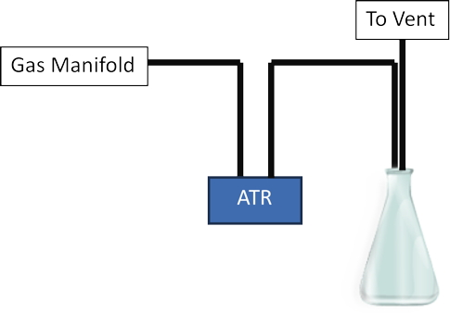
Figure 10. Block diagram of the setup for the multibounce ATR instrument, indicating the arrangement for gas flow.
.
Gas manifold of Liquid-Solid IR system includes Ar, H₂, O₂, and reactant gas lines. The pressure is monitored by two sets of Baratron (10 and 11 in Figure 9) and Pirani Penning (13 and 14 in Figure 9) gauges. One set (10 and 13) is for the IR cell, and the other set (11 and 13) is for gas manifold.
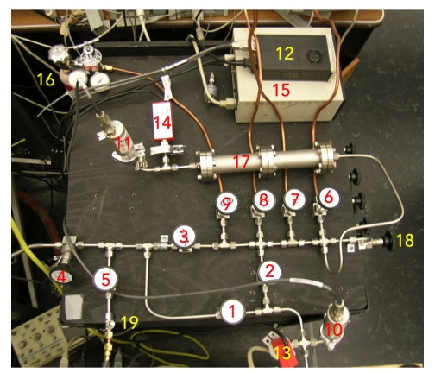
Figure 11. Gas manifold for the transmission IR system.

            - valve to pump the transmission IR cell
            - valve to supply gas
            - main valve to pump gas manifold
            - auxiliary valve to pump gas manifold
            - valve to Liquid/Solid IR cell
            - Ar gas valve
            - H₂ gas valve
            - O₂ gas valve
            - CO gas valve
            - Baratron gauge 1 to monitor the transmission IR cell
            - Baratron gauge 2 to monitor the gas manifold
            - Baratron gauge reader
            - Pirani Penning gauge 1 to monitor the transmission IR cell
            - Pirani Penning gauge 2 to monitor the gas manifold
            - Pirani Penning gauge reader
            - CO gas lecture bottle
            - Tube for gas reservoir
            - Valve to H-D gas manifold (Please don’t open to use!)
            - Low-Flow Metering Valve

b. General Operation Procedure

For Gas Flow

            - Check valves #1, #2, #5, #6, #7, #8, #9, and #18 are closed.
            - Open valves #3 and #4.
            - Wait for lowest vacuum
            - Close valve #4.
            - Fill the tube (17 in Figure 9) with a gas you want.
            - Open valve #5 a little bit.
            - Supply the gas to the IR cell by opening valve #19 properly.

c. Gas and Liquid Sample Handling

i. Gases
- Pumping to lowest pressure before switch to a different gas that prevents gases from mixing together.
- Gas exhaust is supposed to be connected to the house vacuum.

ii. Liquids
- Liquid injection is done with hydrodermic syringe.
- Check SOPs for the liquids used in the experiments.
- If there is a leak from the tube or the cell, stop injection immediately.

d. Maintenance

Please purge the liquid tube with Ar gas after each experiment. Liquid residue may as well corrode the plastic tube and valve. Gas exhaust bottle will be filled with liquid from the cell and tube after several tests. Also, spill out the liquid mixture properly.

All systems in Chemical Science building room 135 including Transmission Catalysis and Victor are sharing the three gas cylinders (O₂, Ar, and H₂). When you need to use any gas, please check first if someone is already using the gas line. If so, you need to let them know you’re going to open the gas valve and a sudden pressure drop may be seen.

e. Valves

Bellow-sealed BK series (e.g. SS-4BK) from Swagelok are preferred for the valves in the manifold system. The valves can be disassembled for cleaning inside, and the PCTFE stem tip is also replaceable.

f. Pressure Gauges
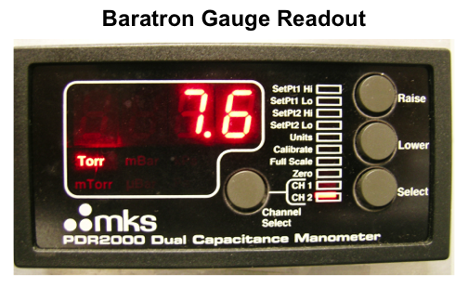
Two different types of pressure gauges are used in the gas manifold. One is Baratron gauge with digital readout for the range from 0 to 1000 Torr to control the amount of reactant gases quantitatively. Channel 1 (CH 1) is to the transmission IR cell side, and channel 2 (CH 2) is to the gas manifold side. The other is thermocouple gauge to monitor vacuum status in the gas manifold and the reaction chamber.

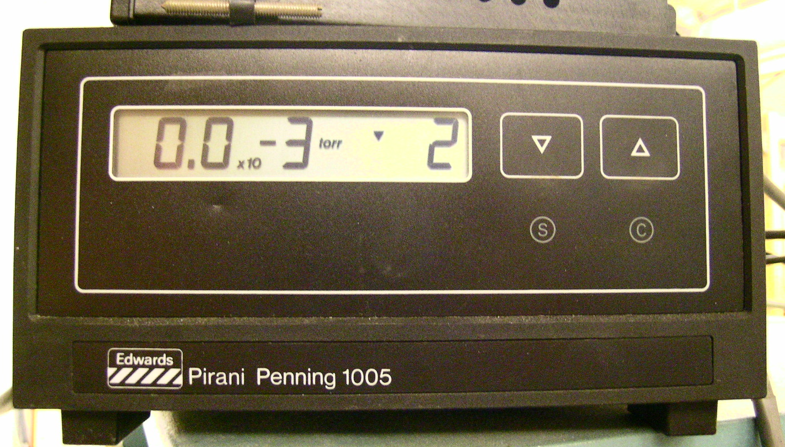
The other is Pirani Penning gauge with digital readout for the range from 10⁻³ to 1 Torr to control to control the amount of reactant gases quantitatively and to monitor the vacuum status. Channel 1 (CH 1) is to the transmission IR cell side, and channel 2 (CH 2) is to the gas manifold side.

g. Mechanical Pumps

The mechanical pump requires regular oil changes, approximately once every half year or when large quantities of corroding or contaminants gases are used in the experiments. The oil can be occasionally degassed by leaking air in the inlet for a short period of time, but once the oil becomes dark, changes consistency, or has solid particulate, it is best to change the oil. The process for handling vacuum oil is available in the SOP of “Pump Oil”. Refer it in our “Lab Safety Manual” or download “SOPs Process” (http://research.chem.ucr.edu/groups/zaera/ \images/documents/4_sop_processes_2013-07.pdf)

4. Multi-bounce ATR Cell

a. General Description

A diagram of the multi-bounce ATR cell is provided below:

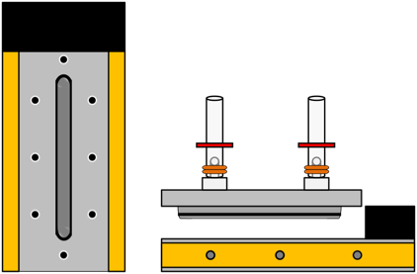
Figure 12. Top (left) and side (right) views of the multiple bounce ATR cell solid/liquid gas experiments.

b. Components

i. ATR Prism

The main element of the multibounce ATR cell is a prism. There are many crystals to choose from. These must be selected by their ability to stand up to the reaction conditions and the experiment itself. Note that acids in particular will not only harm the crystal, but also risk the release of poisonous gasses (i.e. ZnSe and ZnS ATR elements).

The ATR crystal for both the flat plate and trough plate crystals is of a trapezoid shape and is 60 mm long, 10 mm wide and 4 mm thick. In order to produce optimum performance from the accessory, the thickness of the crystal has been carefully chosen. A thicker crystal would result in less bounces of the infrared energy in the crystal, resulting in lower absorbances in the resulting spectrum. A thinner crystal would give more bounces in the crystal, resulting in a greater absorbance in the spectrum, but the overall throughput of the device would be reduced. The crystal dimensions have been chosen to maximize the signal to noise in the resulting spectra.

For ATR, remember that the ATR crystal must have a higher refractive index than the liquid (solution) you are going to use in your experiment, otherwise light will transmit out of the prism and into your sample, scattering out rather that undergoing total reflection, and yielding low or zero signal and/or causing other nondesirable effects.

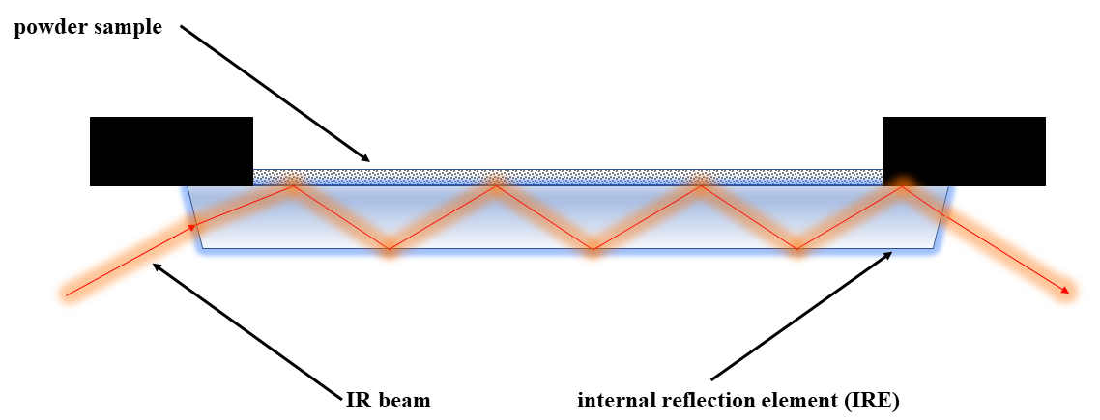
Figure 13. schematic representation of ATR-IR crystal with base plate for FT-IR spectrometer

ATR assembly shown in figure 2 is usually installed in the optical compartment of a commercial spectrometer. IR beam is generated by the spectrometer and then travels inside the internal reflection element (sometimes also referred as ATR crystal) and then collected and processed by the internal detector of spectrometer. Sample is loaded in the form of a thin film evenly dispersed on the IRE surface to achieve optimal signal to noise level. Typically, ATR crystal is made of an IR transparent material which has high refractive index because the refractive index of ATR crystal needs to be higher than that of the sample above it so that total reflection will always occur on the interface.

Table 2. Types of ATR crystals and their selected optical properties
Material | Spectral Region (cm⁻¹) | Refractive index | Depth of penetration at 45º, 10000 cm⁻¹ (μm) |  | Hardness (knoop)
ZnSe | 20,000-500 | 2.43 | 1.66 | 130
ZnS | 22,000-750 | 2.25 | 1.54 | 355
Ge | 5000-600 | 4.01 | 0.65 | 550
Si | 10,000-100 | 3.42 | 0.81 | 11150
Diamond | 45,000-10 | 2.40 | 1.66 | 9000

ATR crystals are expensive. Treat them carefully and consult with Harrick or Pike Technologies before injecting a solvent into the cell if you are unsure of chemical compatibility.

An important aspect of total internal reflection is evanescent wave. Although the ‘entire wave’ is reflected back into original medium (higher refractive index), part of it still penetrates the second medium with smaller refractive index. The evanescent wave tends to travel along the boundary while it doesn’t carry any energy or momentum. It’s only the results of boundary conditions. The depth of penetration depends on wavelength as well as the medium that the incident light travels inside, which can be written as:
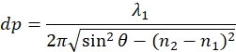

Where dp is the maximum depth that the original incident can penetrate the second medium, which usually decays exponentially as it travels deeper into the medium.

As of November of 2018, the prism in the ATR cell is a Ge piece, 60 mm long.

ii. O-Ring

The ATR cell is sealed with Viton® O-rings. Those can tolerate mildly acidic conditions and most mild organic solvents. Check the compatibility of the chemical you are using with the appropriate O-ring chemical compatibility chart. If needed, there are many sources to purchase O-rings, including Gallagher Fluid Seals (King of Prussia, Pa; Attn.: Kim Gallagher).

If acetone or carbon tetrachloride is required for your experiments, there are various (expensive) Kalrez® O-rings available which can stand up to these solvents. Test the O-ring with the solvents you will use in the experiment prior to running it.

In addition, there is an o-ring underneath the base plate and is pressed in between ATR crystal and the metal base plate. The role of this o-ring is to seal the cell and prevent leaking of liquid to the base assembly, which will lead to severe interference and may even damage the connector and other electronics in the optical compartment of FT-IR spectrometer. Before each experiment, it’s necessary to inspect the condition of the o-ring to avoid possible leaking caused by corrosion.

Note: As of November 2018, the O-rings (and volatiles cover) installed in the ATR cell are Kalrez.

c. ATR-IR Cell with Solution Circulation

Currently (November 2018) ATR-IR cell is set up with the ability to circulate solution in a closed loop. Solution of specific modifier or pure solvent for collection background spectrum. Liquid is filled in an Erlenmeyer flask (typically 250 ml ) with liquid inlet/outlet as well as tubing for gas supply. Liquid phase is saturated with selected gas by continuous gas bubbling.

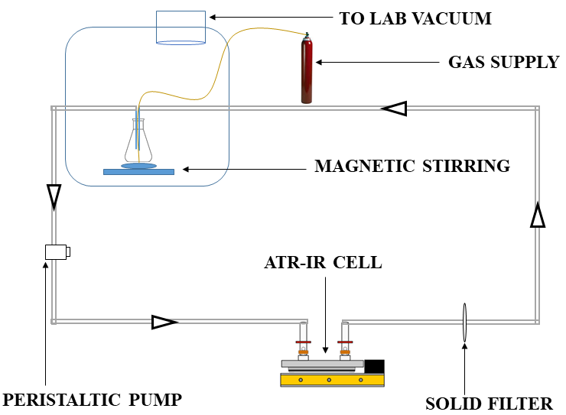
Figure 14. schematic representation of ATR-IR cell and peripheral devices for liquid circulation

Peristaltic pump and gear pump are among the most common types of pumps for circulation liquid in a closed loop. Current ATR-IR apparatus includes a peristaltic pump from Fisher to circulate solution. The biggest advantage of peristatic pump over micro gear pump is no physical contact between solution and internal parts of the pump to prevent contamination that might accumulate over time. However, it’s worth noting that the flow rate might vary based on the choice of tubing.

Though most peristatic pumps can handle particulates, a solid filter is still installed after the exit of ATR cell to prevent solid catalyst from entering the loop. The filter can typically last an experiment cycle which is about 6-8 hours and it needs to be replaced before each experiment to avoid cross-contamination.

Table 3. Features of gear pump and peristaltic pump for liquid circulation by comparison
Features | Gear pump | Peristaltic pump
Liquid displacement | Fixed volume | Depending on tubing type
Pulsation | Minimal to none | Significant
Particulate | Can’t handle particulates | Yes
Viscosity | Lower | Relatively high
Pressure | High | low

d. Initial Setup

- Rebuild the cell after cleaning:
- Place the optics box in the accessory compartment at least 2~3 hours before measurements are taken, because of issues related to purging inside. This purge time is variable and depends on how strong the sample signal is relative to the gaseous water and CO₂ signals.

e. Beam Alignment

In terms of the beam aperture to be used, it is good practice to start with highest setting for ATR, and then fine tune this setting. The higher the setting gives the most signal, but lowering the setting gives better resolution, assuming there is enough light making it into the detector.

Sometimes sine wave or periodic oscillations are seen in the spectra. This is caused by reflections, which interfere with the original infrared beam. Reflections can be caused by misalignment, a birefringent sample, cracks in the ATR prism, or a sample that is highly reflective.

f. Cell Cleaning
The cell should be cleaned after daily use. Perform the following procedure:

- Use a mild organic solvent like ethanol. These are usually effective for cleaning both crystal and cell.
- Use optical tissue, not a Kimwipe or a paper towel, to clean the optical surfaces, as regular tissue may scratch the surfaces or leave lint behind.
- Be careful not to drop the prism, and avoid putting it on top of rough surfaces. Most prisms scratch and/or break very easily.
- All of the top plates (metal or PTFE) can be sonicated as needed, but usually wiping them with solvent is adequate.
- On occasion, the cell must be taken apart and the crystal removed to clean it.
- If you need to perform this operation, first make note of the IR signal intensity before cleaning; you may need to readjust the alignment slightly after this.
- When putting the crystal back into the cell, remember to make sure that the O-ring is slightly compressed. Do not overtighten it, because the crystal can be broken.

g. Long Term Maintenance

In order to provide the maximum transmission in the infrared, with the minimum spectral interferences, the mirrors used in this device are uncoated (bare) aluminum on a glass substrate. Since the coatings are soft, care must be taken to avoid damage. Normally, these mirrors will not need cleaning, since they are contained within the housing of the accessory. If they do need cleaning, they may be gently wiped with a lint free, abrasive free cloth, such as lens tissue, or with a camel hair brush. Under no circumstances must the mirrors be rubbed with paper products such as "Kleenex" since this will produce scratching of the mirror coating.

6. Typical Experiment Sequence

Below a description is provided of the procedure to generate a transmission IR spectrum of a pellet sample. Both background spectra, which are taken with the clean sample, and sample spectra, which are taken after adsorption (and sometimes reaction) of the molecules on the pellet are needed for final spectra, but they are taken separately. The transmission IR data are collected on the PC using the Bruker OPUS software.

a. Initial Steps

- Sign-in the logbook
- Place the optics box in the accessory compartment at least 2-3 hours before measurements are taken. NOTE: It is best to install this at least a few hours before because of issues related to the purge gas; this purge time is variable and depends on how strong the sample signal is relative to the gaseous water (and CO₂) signals.
- Start up the OPUS program
  - Click the short-cut icon of the OPUS program on the desktop.
  - The OPUS login window will appear on the screen.
  - Type “OPUS” in the password line for the default operator
  - Select “Measure” and then “Measurement”
  - After a few seconds, the measurement set-up window will appear on the screen.
  - Check the experimental parameters under “Advanced”, “Optics”, “Acquisition”, “FT”, and “Display”

b. Setup

The first step is to prepare the catalyst to be studied, typically a powder:

- Prepare a thin film of the catalyst on the surface of the prism:
  - Deposit a known amount of catalyst to the ATR prism.
  - In series of experiments, make sure to use the same amount of sample each time.
  - Pipette a few drops of a volatile solvent (ethanol, methanol, acetone) to a vial and transfer the sample in it.
  - Sonicate the mixture until it forms a homogeneous slurry.
  - Add the slurry onto ATR crystal and wait the solvent to dry, to leave behind a thin film of powder.
  - Verify the quality by looking straight down at the crystal orthogonal to the surface. At this angle, you should not see much of the crystal, only the particles. When you tilt the crystal towards or away from you, the crystal should show more visibility.
  - Note that too thick a film may decrease the adsorbate signal because of mass transport issues. Too thin a film, on the other hand, will yield low adsorbate signals.
  - This method is preferred if there is not much catalyst powder available, or if low levels of the powder on the surface are desired.
  - Typical amounts: 3-25 mg of commercial 1 wt% Pt/SiO₂ in 5 mL ethanol.
  - To avoid possible interference caused by solvent, it’s recommended to use the same solvent as adsorption experiment to make the slurry.
- Fasten the metal top plate to the ATR
- Place the ATR cell on the optics box.
- Take a background IR spectrum
- Inject 10–15 mL of solvent into the cell through the inlet or outlet. The absolute volume does not matter as much as using a consistent amount from experiment to experiment. Use a syringe with an extra-long needle to minimize powder displacement.
- Check for the stability of the powder in the cell:
  - Take a second background spectrum, to be used to check on the stability of the powder.
  - Make sure you are careful to minimize any displacement of the film. Take IR spectra and referenced them to the second background. It is difficult to eliminate this problem, but is important to minimize its effect.
  - There may be some trial and error involved, so be prepared to perform some trials.
- Add the 1 mm Teflon® tubing (to be used for gas bubbling) through the inlet side and push it down until you feel it hit the ATR crystal, then raise it between 1 and 3 cm above the crystal surface. The height really depends on how much solvent is added, but again, be consistent. The idea is to get just above the crystal to where there should not be mass transport issues (caused by the lack of the gas getting to the catalyst surface), but also where the gas bubbling action will not displace the sample from the crystal.
- Add 1 mm tubing to the outlet and ensure that it is above the solution line of the ATR cell.
- Connect the other end to a 125 mm flask with an airtight silicone stopper.
- Make sure there is a needle in the stopper for the inlet and another needle for the outlet above the solution line in the flask for gas to escape.
- Use proper gas collection using the portable exhaust collector "hoods" in the lab. Remember that CO, for example, a common reactant used in these experiments, is detected by any CO alarm in the lab. Use an appropriate enclosure (with a slight negative flow) or one of the snorkels extending from the ceiling ventilation.
- Teflon® fittings can be purchased from Cole Parmer to connect to the Luer fittings on the needles.

c. Gas Adsorption

First, a set bubbling rate should be set:

- Bubble the gas of interest, CO or another adsorbate, through the Teflon tube at the inlet.
- Determine the bubbling rate by observing the formation of the bubbles in the outlet flask.
- NOTE: it is good practice to use the same solvent in the flask as is in the cell.
- Control the bubbling rate with a metering valve.
- Assume a bubble diameter of ~1 mm, and count the amount of bubbles over an appropriate amount of time.
- Typical bubbling rate: 1 bubble per second for 2 h (do not stop bubbling during IR data acquisition). However, in most cases, a 40-minute gas bubbling will lead to a saturated surface coverage.

d. Adsorption of Organic Molecules (Modifier and Reactant)

ATR-IR cell can be also used to study the adsorption of modifier molecules as well as reactant on the interface of solid and liquid. Though ATR-IR is not a surface-sensitive characterization intrinsically, it can still distinguish the adsorbed molecules and dissolved ones in liquid phase when proper experimental conditions are implemented because the low depth of penetration mentioned above, which is from several to about 20 μm depending on the wavelength of incident light.
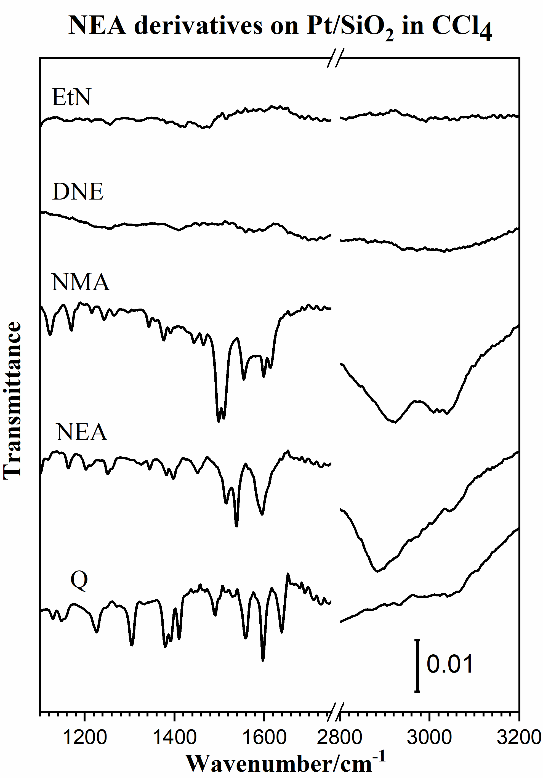
Figure 15. ATR-IR Spectra of 5mM CCl₄ solution of following modifiers: 1-ethylnaphthalene (EtN), (S)- N,N-dimethyl-1-(1-naphthyl)ethylamine (s-DNE), 1-naphthylmethylamine (NMA), (S)-1-(1-naphthyl) ethylamine (s-NEA), quinoline (Q) respectively, with 1% Pt/SiO₂

The figure above shows the adsorption of several compounds dissolved in CCl₄. Since ATR-IR is not surface-sensitive as RAIRS is, it’s always a good practice to measure the uptake of pure compound in the form of corresponding solution or add experiment with oxide support as reference.

e. Spectra Acquisition

Acquire sample IR spectra using similar parameters to those used for the acquisition of the background trace. Typical parameters for data acquisition:
  - Scans: 256.
  - Gain: x1.
  - Aperture: 10 mm.

i. Background Spectra

For temperature-dependent sequences, reference spectra can be obtained during the cooling after pretreatment. These spectra are used as background spectra at the corresponding temperatures.

- Cool down or heat up the sample to the desired or lowest temperature.
- When the sample reaches the desired temperature, take a background spectrum by selecting "Measurement", "Basic", and "Collect Background". The program will display a message in the bottom line high-lighted by a green color indicating that the data are being taken.
- When the message disappears, the measurement is done. From this point on, you can proceed with the experiments (e.g. heating of the sample, adsorption of gases etc.).
- During the data acquisition, the interferogram cannot be seen on the check signal menu. After the background scans are finished, the "Measurement" window remains on the screen.
- Go to “Background” and Click “Save Background” to save the spectrum. The Filename (####.0) is saved automatically on the hard drive and displayed on the left (Window List) of the screen.
- The file can be saved as other formats on the hard drive. Select "Save File As", then check the file name and path to be saved. If you want an ASCII file, in the "Mode" option on the Save Spectrum window, select "Data Point Table" before clicking the "Save" button.
- In temperature-dependent sequences, take and save background spectra during the cooling of the catalyst with about a proper interval (10 to 50 ºC).

ii. Sample Spectra

- Introduce the desired gas or molecules dissolved in a certain solvent into the cell.
- Select “load background” and click the corresponding background spectrum at the same temperature.
- Type the sample name and explanation in the lines for sample name and sample form. (e.g. Sample Name: 1% Pt/SiO₂; Sample Form: after CO dosing for 5 min at 25 ºC)
- Take the sample data by selecting "Collect Sample" and wait until the highlighted message disappears.
- Select “load background” again and click another background spectrum for the next experiment or temperature.

Note: if no background spectrum is loaded after ‘clear background’, an error message might prompt.

f. Final Steps

- Log out of the OPUS software.
- Disconnect 1 mm tubing.
- Remove the solvent form the cell. This can be done by reversing the rotation of peristaltic pump. Extract the tubing in the flask and hold it above the solution and ATR-IR cell should be completely drained within a few minutes.
- Take the cell out from the optics box.
- Detach the Teflon top plate.
- Recycle the powder catalyst.
- Clean the cell, syringe and all other glassware.
- keep them in a dry and clean place.
- Sign out in the logbook.

6. Suggested Training for Beginner

For beginners to learn how to obtain consistent and reliable data, the following training is strongly recommended. The data obtained from the suggested experiments should be contrasted with previous results for the same system and checked by an experienced operator.

A typical spectrum obtained for CO adsorption on a commercial 1 wt.% Pt/Al₂O₃ catalyst is shown (5 mg catalyst in ethanol, 256 scans). CO is known to bond strongly with Pt and other noble metals, and thus, CO titration can be used to show the degree of cleanness of metal surface as well as identify the types of active sites.

In ATR-IR cell, adsorption of CO is usually done by exposing Pt catalyst to CO dissolved in a given solvent, which in most cases is CCl₄. Solvent with strong IR uptake such as water and ethanol will strongly interfere with CO signals and as a result, signature peaks of CO is not observable in those solvents.

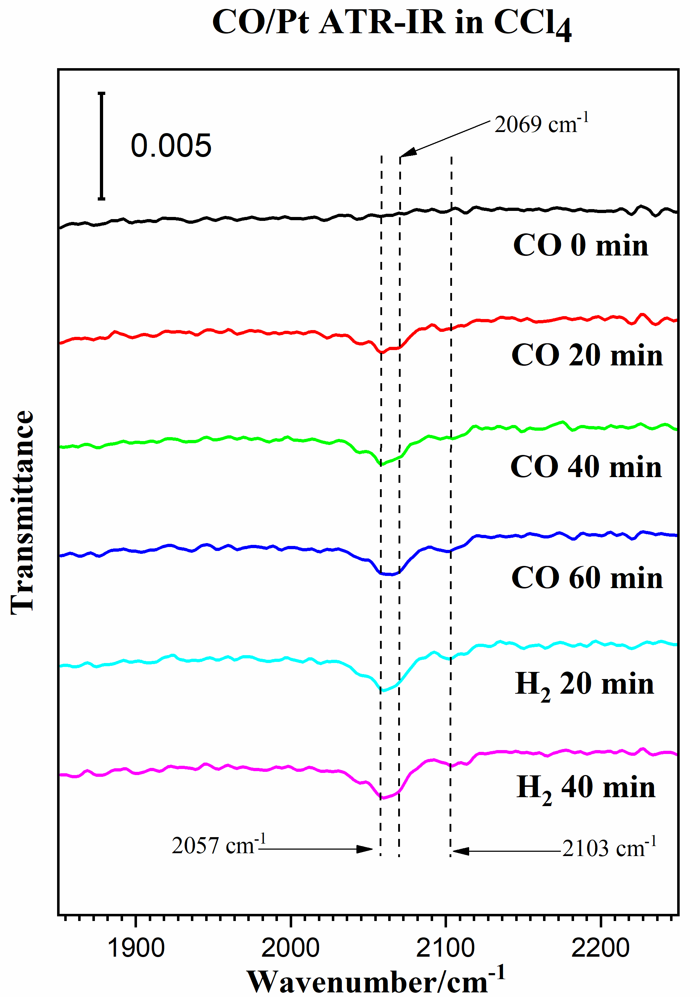
Figure 16. ATR-IR spectra showing CO adsorbed on various sites of Pt/Al₂O₃ and potentially free CO dissolved in CCl₄ (2130 cm⁻¹)

7. Reference Materials & Contacts

a. Reference Materials

Tensor User Manual, 7th updated edition, September 2011

b. Contacts

- Pike Scientific Technical Specialist: Jenni Briggs, briggs@piketech.com
- Harrick Scientific Technical Specialist: Susan Berets, sberets@harricksci.com
- Specac: Sales (and limited technical support) Bob Sirpak, bob.sirpak@specac.com

