**Reactor System #6:**

**Silylation/ALD to Prepare Modified Surfaces to Grow Tunable Thin Films**

Manual

Francisco Zaera Group

Prepared by Mohammed Alam and Hyeonkyeong (Elly) Lee, July 2024

Table of Content

1. General Considerations/Overview of Equipment
2. General Laboratory Safety
3. Gas and ALD Precursor Handling
   1. Design and Schematics
   2. Gas Lines and Delivery
   3. Silylation Inhibitor/ALD Precursor Delivery
      1. High Vapor Pressure Precursors
      2. Low Vapor Pressure Precursors
      3. Working with Organosilane Inhibitors
      4. Working with TDMA-based Metalorganic Precursors
      5. Working with Pyrophoric Chemicals
   4. General Operation Procedure
   5. Maintenance
      1. Building Gas Lines
      2. Valves
      3. Pressure Gauges
      4. Mechanical Pumps
      5. Finding Leaks
4. ALD Reactor
   1. General Description
   2. Initial Assembly
   3. Sample Holder
   4. Experimental Procedure
      1. Initial Setup
      2. Silylation
      3. ALD
      4. Final Steps
   5. Maintenance and Troubleshooting
5. Typical Experiment Sequence
6. Suggested Training for Beginner Users
7. **General Considerations/Overview of Equipment**

Atomic layer deposition (ALD) is a thin-film growth technique that splits the overall chemical reaction into two sequential and self-limiting half-reactions, resulting in the deposition of uniform and conformal films providing exquisite thickness control at the Angstrom level. Silylation is a passivation technique that functionalizes the surface of interest with substituted silyl moieties, typically trimethylsilyl (TMS) inhibitor groups. When these techniques are employed in tandem, hydroxyl-terminated surfaces may be modified to allow for the deposition of tunable ALD films. This reactor has the potential to deposit small and highly dispersed 3D nanoparticles rather than 2D films when the silanol density is reduced in a controlled fashion. While current studies using this system have mainly focused on mesoporous materials such as SBA-15, they may also be extended to flat substrates such as Si(100).

The Zaera Lab has three homemade ALD reactors, with this being the most recent addition. While all three were built for growing thin films on solid surfaces, this reactor system is uniquely designed for controlled inhibitor dosing to enable partial silylation. By doing so, hydroxyl nucleation sites may be chemically removed rendering them unavailable for subsequent ALD reactions, allowing for the tunability of the resulting film grown by ALD. Reactor system #6 is located in CS 143 near the UC Chamber ultra-high vacuum (UHV) system.

This reactor can currently deposit thin TiO2 films via ALD and is equipped with two precursors, tetrakis(dimethylamino) Titanium (TDMATi) and H2O (although more may be added later). Ar purging gas is used between each half-cycle to remove physisorbed species. The (dimethylamino)trimethylsilane (DMATMS) silylation agent is attached to a Swagelok and precision valve connection (in series) which provides control over the inhibitor exposure and thus the density of hydroxyl nucleation centers. The system is comprised of a ConFlat (CF) 5-way cross which houses the 2.75” sample feedthrough. The sample is loaded onto the nickel sample holder and can be resistively heated up to 350°C. The entire reactor can be heated to 150°C to remove water condensed on the walls of the system. Three variable transformers (Variacs) are connected to the system, which can control the heating for the sample, reactor, and metalorganic precursor separately. Two voltmeter/temperature gauges equipped with a K-type thermocouple can monitor the reactor and precursor temperature, while a PID temperature controller monitors and adjusts the sample temperature. An Alcatel (Alcatel 2012AC Dual Stage Rotary Vacuum Pump, MOD ID: 1101101416) rotary vane mechanical pump, capable of pumping the entire reactor system down to approximately below 20 mTorr, is used to remove toxic gaseous species. The oil for this pump should be changed periodically to best maintain its lifetime.

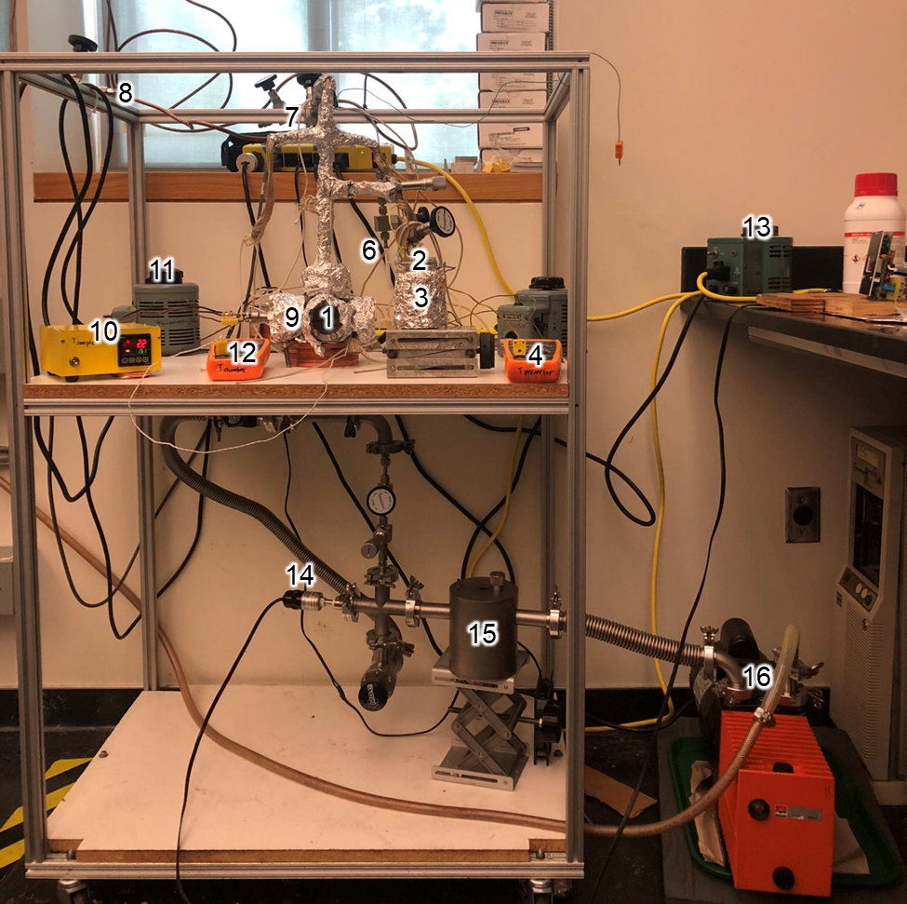

|  |  |  |
| --- | --- | --- |
|  |  |  |
| Left side | Top view | Right side |

1. **General Laboratory Safety**

All users must learn the contents of the Laboratory Safety Manual and pass all required exams before starting any experimental work in the laboratory. Users must also become familiar with the Injury and Illness Prevention Plan (IIPP) and Chemical Hygiene Plan (CHP). All users must be familiar with the location of the fire extinguishers, safety showers, and other safety equipment before starting any experimental work. In Room CS 143:

1. Fire Extinguishers: Located next to the front door of CS 143.
2. Safety Showers and Eyewash Station: Located next to the front door of CS 143.
3. Fire Exit: Two doors in CS 143. If obstructed, use the side door to exit through CS 141.
4. First Aid Kits: Located next to the front door of CS 143.

All users should always wear standard personal protective equipment (PPE) at all times, even in office spaces as EH&S may visit the lab at any moment. After being trained in these preliminary safety measures, make sure to first thoroughly read all standard operating procedures (SOP) and safety data sheets (SDS) related to the procedures and chemicals that will be used prior to conducting any experiment. The following are some general rules to follow:

1. Always follow the laboratory safety procedures described in the appropriate documents when handling chemicals and electrical instruments.
2. Never touch the parts that are inside the reactor directly with unprotected hands. Always wear (powder free latex) gloves and make sure that they are clean.
3. Prior to starting any experiments, ensure that the entire reactor is completely free of any leaks. If any leaks are present, do not proceed with conducting any reactions until the leak can be identified and fixed.
4. Never touch the feedthrough or reactor while they are being heated. This may lead to irreversible injury in the form of severe burns and/or electrical shock. Always allow everything to slowly cool down before handing the reactor.
5. **Gas and ALD Precursor Handling**
6. **Design and Schematics**

A schematic with details regarding the reactor design is shown below.

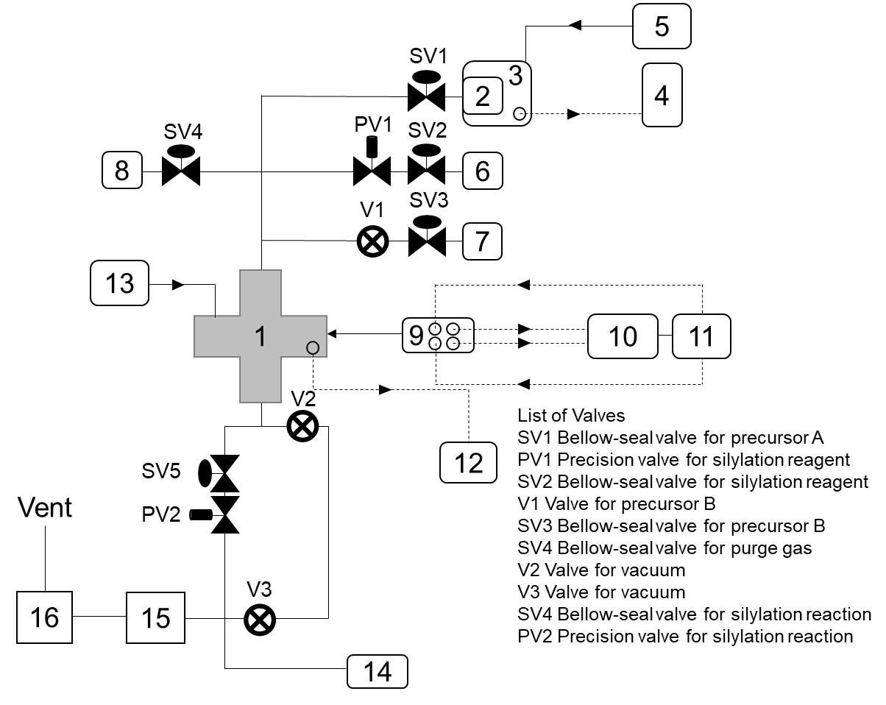

1. **Gas Lines and Delivery**

Ar is used to purge the system after each ALD half-cycle. The line that delivers Ar to the Silylation/ALD reactor (cylinder located next to the Michelle chamber in CS 143) runs through the UC Chamber UHV system. Prior to using the reactor, ensure that the Ar cylinder is full, and the valves for the main tank, regulator, and UC chamber connection (left photo, red circle) are all opened to their normal positions. Then, ensure that the Swagelok valves (right photo, blue circle) near the UC Chamber Ar leak valve are opened to allow Ar to flow through the copper line that goes to the ALD reactor (labeled with tape). If these valves are closed, then no increase in pressure will be observed when Ar purging, which is typically done at ~500 mTorr. Ar dosing for both the UC Chamber and Silylation/ALD Reactor #6 systems at the same time should be avoided; as such, it is recommended to share the Ar usage throughout the day between each user.

Gas cylinder (left) which delivers Ar through the UC Chamber connections (right) to the ALD reactor.

1. **Silylation Inhibitor/ALD Precursor Delivery**
2. *High Vapor Pressure Precursors*

No precursor heating is required for the silylation agent and ALD precursors that have a higher vapor pressure (DMATMS, H2O). These reagents may be dosed at room temperature and delivered to the sample by simply opening the valve connections.

1. *Low Vapor Pressure Precursors*

For ALD precursors that have a low vapor pressure (TDMATi), delivery of the precursor to the sample is achieved through sufficient heating of the reagent (below its decomposition point) using a silicone oil bath. To reduce the condensation of the precursor on the walls of the delivery line and reactor, the entire system should be heated to about 10°C higher than the temperature of the precursor.

1. *Working with Organosilane Inhibitors*

Organosilane inhibitors such as DMATMS are water sensitive and should be stored (in a sealed container away from sunlight), handled, and refilled inside the glovebox under a dry inert N2 environment. The process of dosing these silylation agents should be done in a controlled fashion using a series of precision and leak valves, as their high vapor pressure allows them to be easily evaporated by the roughing pump.

1. *Working with TDMA-based Metalorganic Precursors*

TDMA- precursors such as TDMATi are highly air/water sensitive and reactive. These chemicals may explode or become projectile hazards if they come into contact with water or solvents. They should be stored (in a sealed, covered container away from sunlight), handled, and refilled inside the glovebox under a dry inert N2 environment. They should never come into direct contact with H2O even inside the ALD reactor, as this will result in releasing flammable gases which may ignite spontaneously. Exposure to TDMATi precursors can lead to severe skin burns and/or eye damage. TDMATi is also harmful if swallowed, inhaled, or absorbed through the skin.

When working with TDMATi (or another TDMA- precursor), make sure to follow the preliminary safety measures:

1. Carefully review all necessary SOP and SDS.
2. Wear the following appropriate PPE:
   1. Eye protection: Safety goggles or glasses with side shields
   2. Skin and body protection: Wear a flame-resistant lab coat, long pants that cover the skin, and closed-toe shoes.
   3. Hand protection: Wear nitrile chemical-resistant gloves.
   4. Inhalation protection: Wear a face mask to avoid breathing any toxic fumes/chemicals.
3. Locate the dry sand, fire extinguisher, eyewash, and safety shower stations.
4. Check that there are no leaks within the reactor system. If any leaks are found, stop immediately and do not proceed with the experiment. Fix any leaks prior to connecting TDMATi to the system.
5. The precursor must be connected to the ALD reactor via Swagelok fittings.
6. TDMATi has a low vapor pressure. As such, gentle heating (~40-45°C) is required below its boiling point (~50°C).
7. *Working with Pyrophoric Chemicals*

Many chemical precursors involved in ALD are highly reactive, air/water sensitive, flammable, and even pyrophoric. There are currently no pyrophoric chemicals connected to this reactor system; however, it may be desirable to conduct Al2O3 ALD in the future on this reactor system which will involve the usage of trimethylaluminum (TMA). TMA is a highly pyrophoric and hazardous chemical; exposure to TMA is destructive to the tissue of the mucous membranes and upper respiratory tract and can lead to severe skin burns and/or eye damage. TMA is also harmful if swallowed, inhaled, or absorbed through the skin.

When working with TMA (or another pyrophoric precursor), make sure to follow the preliminary safety measures:

1. Carefully review all necessary SOP and SDS.
2. Never work with TMA when alone in the lab. Always inform at least one other member in the lab prior to starting an experiment involving TMA.
3. Wear the following appropriate PPE:
   1. Eye protection: Safety goggles or glasses with side shields
   2. Skin and body protection: Wear a flame-resistant lab coat, long pants that cover the skin, and closed-toe shoes.
   3. Hand protection: Wear nitrile chemical-resistant gloves.
   4. Inhalation protection: Wear a face mask to avoid breathing any toxic fumes/chemicals.
4. Locate the dry sand, fire extinguisher, eyewash, and safety shower stations.
5. Check that there are no leaks within the reactor system. If any leaks are found, stop immediately and do not proceed with the experiment. Fix any leaks prior to connecting TMA to the system.
6. TMA is a volatile liquid. It is stored in stainless steel (blue) containers with a ball valve (orange). When TMA is not in use, the ball valve of the metal container should be always in the off position (horizontal).
7. The container must be connected to the ALD reactor via Swagelok fittings.
8. Always pump the reactor by using a mechanical pump, as TMA can only be used when it is connected to a system which can be pumped to <100 mTorr.
9. TMA has a high vapor press at room temperature. As such, no heating is required. Heating the container to high temperatures may result in an explosion.
10. Never try and physically extract any liquid TMA from inside the bottle.

To carry out ALD using TMA (or another pyrophoric precursor):

1. Open the ball valve of the TMA container to initiate the first half-cycle. The exposure time may vary from a few seconds to minutes depending on the experiment. Shut off the TMS container orange ball valve in addition to any other Swagelok connections after finishing the dose.
2. Purge the reactor with Ar using the purging gas Swagelok valve, adjusting it to maintain a pressure ~200-500 mTorr. Never backfill the TMA container with other gases.
3. No part of the direct TMA container or nearby areas should be subjected to a temperature higher than 125°F (52°C).
4. In case of power failure during the exposure experiments, follow the steps below:
   1. Immediately shut off the ball valve of the TMA container.
   2. Open the purging gas valve to purge the reactor with Ar for a few minutes, closing it after sufficient time has passed.
   3. When the power returns, make sure that the mechanical pump is back and running.
   4. Check that the nominal base pressure is reached.
5. In case of Fire
6. Between the ball valve and the container:
7. Immediately apply dry sand or use a fire extinguisher.
8. Do not try to touch or remove the TMA container.
9. Call for help and evacuate the building using the nearest exit if the fire is too large.
10. Inside the reactor:
11. Immediately close the TMA container ball valve.
12. Close the angle valve.
13. Introduce Ar gas into the reactor by opening the purging gas valve. If necessary, use a high flow until the flames are extinguished.
14. Call for help and evacuate the building using the nearest exit if the fire is too large.
15. From the Swagelok fittings:
16. Immediately close the TMA container ball valve.
17. Apply dry sand or use a fire extinguisher.
18. Check the vacuum in the reactor and connections after the fire is extinguished.
19. Call for help and evacuate the building using the nearest exit if the fire is too large.
20. **General Operation Procedure**

Pumping reactor down after loading a sample:

1. Pump the reactor down to the nominal base pressure after placing a new sample inside. In the case of powder samples, care should be taken to not evacuate the reactor too quickly as the high pumping throughput would suck out the powder sample through the mesh cover.
2. Check that all Swagelok valves are in the closed position, particularly the ones to the ALD precursors and silylation agent.
3. The mechanical pump should always remain turned on. Turn the pump back on after step 1 in case it was shut off (due to oil change).
4. Slowly open the series of precision and Swagelok valve connections between the pump and the ALD reactor. In the case of powder samples, care should be taken to not evacuate the reactor too quickly as the high pumping throughput would suck out the powder sample through the mesh cover. <500 mTorr during evacuation is recommended.
5. Once the nominal base pressure is attained, slowly heat the sample, ALD reactor, and precursor to the desired temperatures.
6. Open the valve(s) necessary to introduce the ALD precursor or silylation agent into the reactor for a set time period at a desired pressure. The pressure reading at this point indicates the exposure pressure.

Pumping the newly refilled precursor:

* + - 1. Open the Swagelok valve between the pump and the precursor line to pump down the precursor. It is suggested to purify the precursor using three freeze-pump-thaw sequences with LN2 to reduce the consumption of the precursor and remove any residual trapped gas.

Removing sample after finishing an experiment:

* + - 1. Close all precursor valves when the experiment is completed. Slowly shut off all heating.
      2. Once the sample temperature is <40°C, close the valves between the mechanical pump and the ALD reactor. The sample feedthrough flange may now be removed.
      3. Collect the old sample, clean and dry the sample tray, and refill with a new sample.

1. **Maintenance**
2. *Building Gas Lines*

Stainless-steel (SS, or sometimes copper although not recommended) tubing is assembled using Swagelok connections which create UHV-level sealing and are reusable if handled properly. Refer to the description of the parts and their handling in the Swagelok catalogue. Avoid mixing brass and stainless-steel connections; since brass is softer the ferrules and threads can be damaged. All nuts must connect smoothly onto the thread. Forcing a nut onto a connection will destroy the threads, possibly leading to irreversible damage to critical reactor components!

To assemble a new gas line:

1. Clean the SS tubing with acetone before assembly.
2. Cut the tubing to the required length. This length should be carefully measured first so as to not waste the SS tubing.
3. Insert the tubing into a nut with the ferrule inside.
4. Turn the nut finger-tight against the male component of a Swagelok connection (union, elbow, “T” cross, etc.).
5. While holding the body of the fitting with one wrench, tighten the nut using another wrench at least 1-2 full turns (only a 3/4 turn for tubing smaller than 3/16”).
6. Open the nut again to check if the ferrule is tight and the connection is secure.
7. *Valves*

|  |  |  |  |  |
| --- | --- | --- | --- | --- |
| Series | Bellows-Sealed Valves | | Precision Valve  (Bellows-Sealed Metering Valves) | |
| Structure |  | |  | |
| Common  Model | SS-4BG | | SS-4BMG | |
| *P-T*  Ratings | Temperature  [℃] | Working pressure  [bar] | Temperature  [℃] | Working pressure  [bar] |
| -28 to 37 | 68.9 | -28 to 37 | 48.2 |
| to 93 | 57.1 | to 93 | 42.0 |
| to 148 | 45.4 | to 148 | 36.5 |
| to 204 | 34.4 | to 204 | 31.0 |
| to 260 | 31.0 | to 260 | 25.8 |
| to 315 | 27.5 | to 315 | 20.6 |

Most of the valves used on this system are Swagelok (SS Bellows-Sealed Valve, Gasketed, Spherical Stem Tip, 1/4 in) and are operated as instructed in their manual. The most common model used here is SS-4BG. Two precision valves (SS-4BMG) are also connected to the system.

|  |  |
| --- | --- |
| 1. *Pressure Gauges*   A digital thermocouple (TC) gauge is used to measure the pressure inside the reactor. TC gauges may burnout over time, especially when corrosive gases are used. If the pressure readout is too high, check to see that the cable connecting the pressure sensor to the readout unit is secured. If so, next check for any leaks in the system. If the connection is good and the reactor is leak-tight, it is likely that the TC gauge needs to be replaced.  A dedicated digital thermocouple gauge/pressure reader is required at all times to measure a stable base pressure reading (~20 mTorr) and precise/accurate reading (within 5-10 mTorr) during chemical dosing, especially in the case of partial silylation experiments using organosilane inhibitors that have high vapor pressures. When the ALD reactor is not in use, the digital gauge may be shared with the UC Chamber UHV system for the pumping down of the XPS analysis chamber (30 min.-1 Hr.) with the mechanical pump or in the case if silylation is conducted in the preparation chamber under high pressures (~300 mTorr for 15 min). Care should be taken to never measure pressures above 2000 mTorr using the digital gauge as this will result in de-calibrating the gauge and possibly damaging it (expensive). |  |

1. *Mechanical Pumps*

|  |  |
| --- | --- |
| The Alcatel mechanical pump requires periodic oil changes, approximately once every six months or when large quantities of precursors (especially toxic or corrosive) were used during prior experiments. Once the oil becomes dark, changes consistency, or has solid visible particles it is best to change the oil: |  |

Changing mechanical pump oil:

|  |  |
| --- | --- |
| * + - 1. Wear proper PPE (safety goggles, flame-resistant lab coat, nitrile gloves, and face mask).       2. Turn the pump off and remove all the appropriate connections. Isolate the mechanical pump from the reactor.       3. Wait at least 10 min. before draining the oil as the pump oil inside may still be hot.       4. Lift the pump on a moving cart (located under the CS 135 glovebox). CAUTION: The pump is heavy, and the handles may already be slippery due to the presence of oil around the pump. If it is too heavy, it is advised to get another member to help lift the pump onto the cart.       5. Place the oil waste bucket below the pump.       6. Remove the top screw of the pump. Carefully unscrew the bottom screw and fully drain the oil into the bucket. A small volume of oil (<0.5 L) may be added to remove residual contaminants from the pump.       7. Once the oil is drained, cap the bottom screw and hand-tighten. Fill the pump with clean oil. The oil level should lie halfway on the oil gauge. Do not overfill! This may result in over-pressurization leading to the oil bursting out of the pump after it is turned on. Cap the top screw and hand-tighten.       8. Connect the pump back to the reactor. Start the pump and check the base pressure.       9. Place the used oil into the oil waste drum with a proper chemical waste tag. |  |

The molecular sieves trap between the pump and reactor is a safety measure to prevent any backstream of pump oil from going into the lines of the reactor in case of an accident. Should this occur, the molecular sieves should also be replaced:

Changing molecular sieves:

1. Remove the sieves trap from the mechanical pump when it is turned off. Open the top screw and place the used sieves into a waste container with a proper chemical waste tag.
2. Obtain new dry molecular sieves from the oven and refill the trap to the same level as before.
3. Connect the trap to the mechanical pump and begin pumping the reactor system as soon as possible to minimize the time the sieves are in contact with ambient water vapor.
4. Refill the sieves that were used from the container in CS 137 and place them in the oven for the next user.

Replacement/fixing of any parts and rebuilding of the mechanical pump may be done in the machine shop. Always consult with Dr. Ilkeun Lee first prior to contacting anyone from the machine shop and/or other facilities.

1. *Finding Leaks*

Gas lines should be checked for leaks once assembled:

1. Isolate the newly added gas lines connected to the ALD reactor by closing off the Swagelok valves in succession until reaching the line/connections of interest.
2. If the nominal base pressure is not reached, tighten the connections near the newly installed line until the pressure decreases to the expected value.
3. If needed, check for leaks by applying a few drops of a soapy solution to visually check for the formation of bubbles. If needed, use ethanol and monitor the pressure to identify any potential leaks.
4. A leak detector may be needed to isolate the leak if the pressure still does not go down.
5. **ALD Reactor**
6. **General Description**

See the information in section 1 “**General Considerations/Overview of Equipment”**.

1. **Initial Assembly**

See the information in section 3a **“Design and Schematics”.**

1. **Sample Holder**
2. The sample holder is made of a Ni foil (Sigma-Aldrich, Cat. No.: 268259-25G, thickness: 0.125 mm, purity ≥ 99.9 % ) and is connected to the two barrel-connectors on the 2.75” feedthrough using two Ta wires (Thermo-Scientific, Cat. No.: 010349.G5, diameter: 0.02 in., annealed, purity ≥ 99.95 %) (inserted and spot-weld directly into the tray itself). The sample is resistively heated using a transformer which passes current through the feedthrough and Ta wires heating the Ni tray and thus the sample. Refer to the following figure for sample tray assembly.

Sample holder schematic.

1. Thermocouple wires (OMEGA, Fine Diameter Bare Thermocouple Wire, chromel and alumel) are spotwelded to the back of the Ni tray, therefore, the temperature monitored is actually of the Ni tray and not directly of the sample. However, it is assumed that the sample temperature is approximately that of the holder after sufficient thermal pretreatment.

|  |  |
| --- | --- |
|  |  |

Ni tray (front) Ni tray (back)

1. The sample holder can be modified based on the sample composition (powder vs. flat).
2. Powder samples are placed into the Ni tray (~1 mm deep and evenly spread out). A SS mesh (McMaster Carr, Cat. No.: 92715T82, Size: 12 in. x 12 in.) cover is spot welded onto the sample holder to ensure SBA-15 does not fly out of the tray, either during the process of connecting the feedthrough to the reactor or during normal operation. The mesh is porous and thus allows chemical vapors to penetrate through and react with the sample.

Sample feedthrough after spot-welding the SS mesh cover onto the Ni tray.

1. The 2.75” feedthrough is connected to the reactor onto a CF flange. Therefore, a new 2.75” gasket must always be used to ensure that proper air-tight seal is established. Not doing so may lead to large leaks and reduce the lifetime of the mechanical pump.
2. **Experimental Procedure**

1. *Initial Setup*

Carry out the following steps prior to any experiment:

* 1. Place ~50 mg of powder sample into the sample holder tray (~1 mm deep spread evenly). Spot weld a piece of SS mesh onto the tray, covering the sample.
  2. Connect the feedthrough to the ALD reactor.

|  |  |
| --- | --- |
|  |  |

Viewport with the sample holder inside (left) and feedthrough connected to the reactor (right).

* 1. Check the resistance between the two heating electrodes. Check the thermocouple reading.
  2. Open SV5 and PV2 slowly to pump the system down to a base pressure of ~20 mTorr.
  3. Heat the ALD reactor to the desired temperature, typically ~100 ºC, using the appropriate Variac which will supply electrical current through the heating tapes that are wrapped around the reactor.

|  |  |
| --- | --- |
|  |  |

Variacs are used to control the precursor and reactor temperatures (left) and temperature gauge (right).

* 1. Sample pretreatment is almost always required prior to any experiment (unless using a thermally sensitive material). Using the temperature controller, heat the sample to the desired temperature, typically ~ 200°C for 2 hrs. to remove physisorbed water and other contaminants from the sample.

|  |  |
| --- | --- |
|  |  |

PID controller used to regulate sample temperature (left) and Variac controlling sample current (right).

* 1. Slowly anneal the metalorganic precursor to the desired temperature. If needed, degas the precursor for a set time period at a temperature below its sublimation point (typically ~20-40°C less) prior to its use.

1. *Silylation*

Use the following procedure in case surface modification is required prior to ALD:

1. Heat the sample to 150 ℃ and reactor and gas delivery lines to 100 ºC.
2. Dose silylation reagent (e.g., DMATMS) for designated time while PV1, SV2, SV5 and PV5 are partially opened.

|  |  |
| --- | --- |
|  |  |
|  |  |

1. Close SV2 after dosing sequence is complete.
2. Fully open PV1, SV5 and PV5 to pump down any residual reagent vapor and allow base pressure to return.
3. Fully close PV1.

Note: It is important to review the section on handling valves under section 3e **“Maintenance”** prior to conducting the above experiment. Proper knowledge and careful adjustment of both sets of Swagelok and precision valves are required to control the DMATMS exposure.

1. *ALD*

Conduct ALD cycles by introducing each precursor in an alternating fashion, purging the reactor using Ar in between each precursor exposure. The following describes conducting a typical TiO2 ALD cycle on SBA-15 using TDMATi and H2O:

1. Heat the sample, reactor, and gas delivery lines to 100 ºC and the TDMATi precursor to 40 ºC.

|  |  |
| --- | --- |
| 2. Slowly open SV1 connected to the TDMATi precursor tube. Open the valve all the way. The pressure on the digital pressure gauge should increase by a few (<5) mTorr. Dose TDMATi for desired time period (e.g., 20 min.). Close SV1 after the TDMATi dose is complete. The pressure should drop to the base value. |  |

|  |  |
| --- | --- |
| 3. Open SV4 connected to the Ar gas line to purge the system at 500 mTorr for 50 min. Close the valve after Ar purging is complete. The pressure should drop to the base value. |  |

|  |  |
| --- | --- |
| 4. Slowly open V1 and SV3 connected to the H2O precursor tube. Open the valve sufficiently to dose the precursor at 100 mTorr for 2 min. Close the valves after the H2O dose is complete. The pressure should drop to the base value. |  |

5. Open SV4 connected to the Ar gas line to purge the system again at 500 mTorr for 50 min. Close the valve after Ar purging is complete. This completes 1 full TiO2 ALD cycle.

6. Repeat steps 2-5 to conduct more ALD cycles as desired.

The following standard dosing/time sequence is used to grow TiO2 films using this reactor:

TDMATi:Ar:H2O:Ar = 25 min (30 mTorr):50 min (500 mTorr):2 min (100 mTorr):50 min. (500 mTorr)

Note: ALD may also be conducted on powder surfaces modified ex-situ using this reactor, as in the case of using NaOH etched powders which possess enhanced hydroxyl densities. Using such samples will result in the promotion of denser ALD films.

1. *Final Steps*

After completing the experiment:

1. Shut off all heating for the metalorganic ALD precursor, reactor, and sample. In the case of the latter, slowly cool the sample down over time.
2. After the sample is <40°C, close the valves between the mechanical pump and reactor. Remove the sample feedthrough and collect the sample.
3. Refill the clean and dry tray with a new sample.
4. **Maintenance and Troubleshooting**
5. Inspect all electrical wiring and connections for damage frequently. Any faulty components/parts should be replaced and supplied by the corresponding vendor.
6. Clean the ALD reactor periodically as the powder sample may escape during the experiment and become trapped on the cold parts of the reactor or viewport window.
7. Prior to each experiment, check that the volume of each reagent inside the precursor tubes is sufficient to carry out the experiment.
8. Check that the digital pressure gauge is in working condition periodically as it may be easily decalibrated or damaged, even if it is simply knocked over just slightly. If a different base pressure is read after some time without any changes made to the normal operation of the reactor system, it may indicate that the gauge is nearing the end of its lifetime.
9. For the most efficient pumping speeds, lowest base pressure, and longest pump lifetime, change the pump oil periodically after it becomes dark, changes consistency, or has solid visible particles.
10. **Typical Experiment Sequence**

SBA-15 powder was selected as a typical example to demonstrate the ALD process of growing TiO2 films inside the porous structure, using TDMATi and H2O as chemical precursors.

1. **Initial Steps**
   * + 1. Review the TDMATi SOP and SDS sheets located in room CS 143.
       2. Wear a flame-resistant lab coat, safety goggles, and nitrile chemical-resistant gloves.
       3. Check the pressure of the Ar gas cylinder at least 500 psi full.
2. **ALD Operation**

Place approximately 55 mg of evenly dispersed SBA-15 inside the Ni tray, covered with a spot-welded SS mesh fitting.

Mount the feedthrough onto the open 2.75” CF flange of the ALD reactor.

Securely connect the two heating electrodes and thermocouple. Check that the electrodes are fastened properly.

Open V2 and V3 to pump down the ALD reactor below 20 mTorr.

For the sample pretreatment step, heat the sample holder and reactor to 200°C and 100°C, respectively, for approximately 2 hrs. prior to starting the experiment. Slowly heat TDMATi to 40°C.

After the pretreatment is over, reduce the sample temperature down to 100°C. Dose TDMATi using the appropriate valves. The TDMATi vapor is introduced to the reactor (without the use of a carrier gas) at a pressure of 30 mTorr for 25 min.

Purge the reactor using argon gas at 500 mTorr for 50 min. This completes half-cycle A.

The deionized water is held in a glass tube, and is introduced into reactor at a pressure of 100 mTorr for 2 min.

Purge the reactor using argon gas at 500 mTorr for 50 min. This completes half-cycle B.

Repeat steps 6-9 as desired to conduct “X” numbers of ALD cycles.

Slowly turn off the heating for the TDMATi precursor, reactor, and sample. After the sample temperature has cooled down <40°C, loosen the screws on the CF flange to remove the feedthrough.

Collect the power sample and store in a designated vial with a clear labeled description of the experimental details (e.g., TiO2(ALD, x cycles)-SBA-15).

1. **Suggested Training for Beginner Users**

In addition to the department and our own general requirements for lab safety, the following trainings are suggested for beginner users:

1. Handling air/moisture sensitive chemicals
2. Handling pyrophoric materials
3. Working with Swagelok fittings and CF flanges
4. Vacuum systems and gas delivery

Furthermore, it is strongly recommended that each new user take sufficient time to review the following safety topics:

All safety documents uploaded on the Zaera Group website

Emergency Action Plan (EAP) and Fire Prevention Plan (FPP)

Hazardous Waste Management

Hazards Class and Physical Hazards Guide

Laboratory Safety Manuals

Personal Protective Equipment

Laboratory Safety Orientation

Fire Extinguisher Fundamentals

Lab Ethics