Michelle UHV Chamber (#3)
Operating Instructions

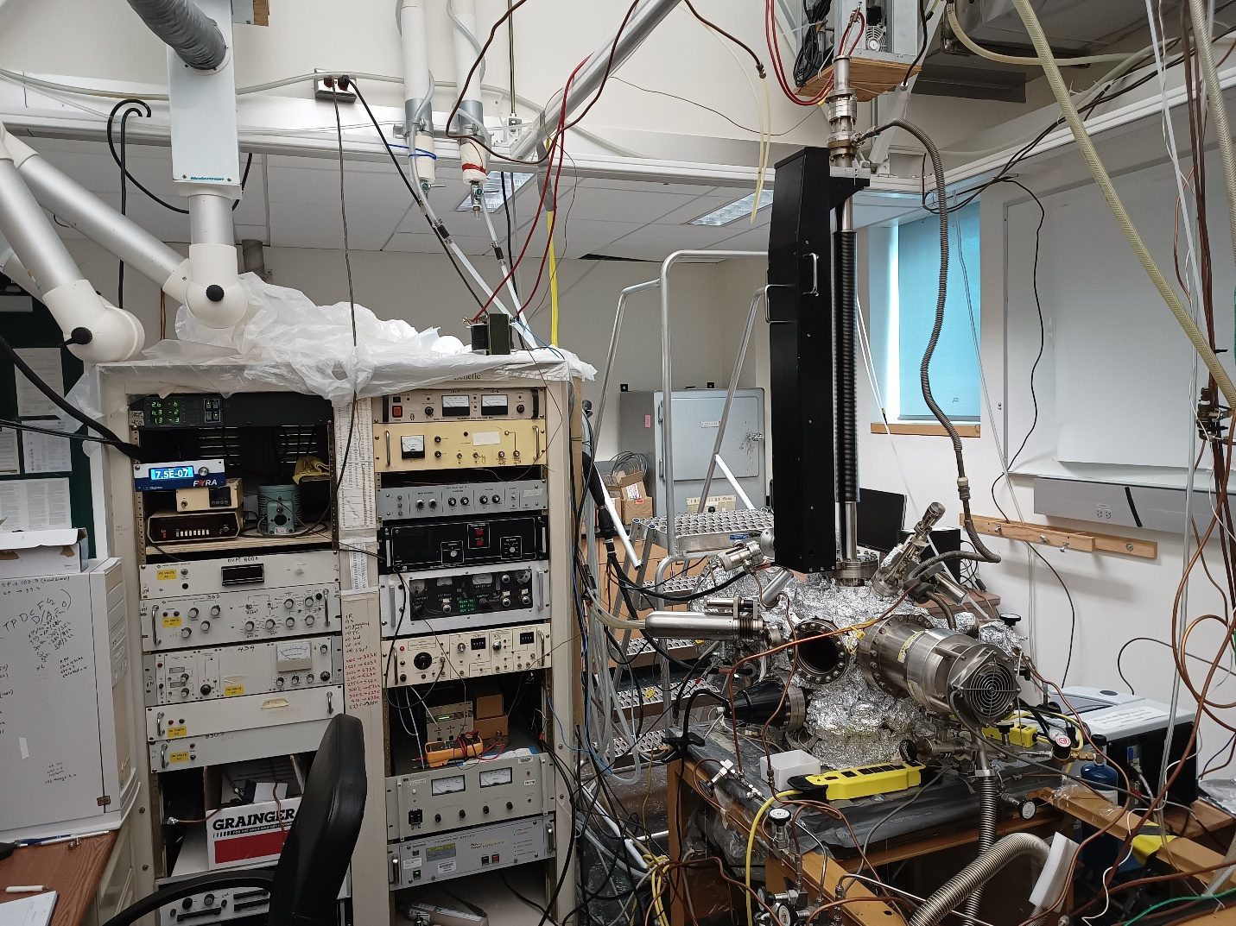

Updates:
Ilkeun Lee, March 2000
Ilkeun Lee, January 2004
Ricardo Morales, January 2005
Xiangdong Qin, August 2018
Md Abdul Motin, September 2022
Philipp A. Haugg, September 2023
Leonhard Winter, October 2026

Table of Contents
1 Overview of Equipment 7
2 Vacuum System 7
2.1 General UHV chamber 7
2.2 Flange assignment 7
2.3 Pumping 8
2.4 Pressure reading, ion gauge, filament replacement and maintenance 10
2.4.1 Thermocouple gauge 10
2.4.2 Ion gauge 11
2.4.3 DigiVac gauge 12
2.5 Evacuation of the system 12
2.6 Venting, shutting down 13
2.7 UHV bake-out 14
2.8 General maintenance 18
2.8.1 ConFlat (CF) flanges 18
2.8.2 Gaskets 19
2.8.3 Removing and remounting CF flanges 19
2.8.4 Turbo pumps 20
2.8.5 Mechanical pump 21
2.9 Leak detection 22
2.10 What to do after a power outage 23
3 High-Pressure Cell 24
3.1 General chamber (drawing, picture) 24
3.2 Pumping system (turbopump) 24
3.3 Seals 25
3.4 IR windows 27
4 Sample 27
4.1 Removing the manipulator from the chamber 27
4.2 Mounting (holder, spot-welding, insulator seal, adding thermocouple) 28
4.3 Leaking bellows 29
4.4 Power and thermocouple feedthrough 30
4.5 Rotary stage 31
4.6 Sample holder 32
4.7 Heating and cooling 33
4.7.1 Heating 33
4.7.2 Cooling with liquid nitrogen 35
4.7.3 Stop cooling 35
4.7.4 Breaking feedthrough (be very careful) 35
4.8 Biasing 36
4.9 Cleaning 36
4.9.1 Chemical cleaning 37
4.9.2 How to determine if it is clean 37
4.10 Temperature reading 37
4.11 Heating power supply (operation, calibration) 38
5 Gas Handling, Gas Manifold 38
5.1 Design, schematics, valves 38
5.2 Gas, liquid and solid sample handling 38
5.3 Leak valves 39
5.4 Use of glove box 40
5.5 Dosing of precursor 41
5.6 Maintenance 42
6 Quadrupole Mass Spectrometer (QMS) 43
6.1 General operation 43
6.1.1 Engaging mass spectrum 43
6.1.2 Standby mode 44
6.1.3 Turn off 44
6.2 LabVIEW program – running analog scan MS 45
6.3 Temperature Programmed Desorption (TPD) 47
6.3.1 Sample cleaning, dosing and Temperature Ramping Controller settings 47
6.3.2 TPD data acquisition by LabVIEW program 49
6.4 Calibration of masses – LabVIEW program 51
6.5 Calibration of temperature input for TPD 52
6.6 Installation of LabVIEW program 54
6.6.1 System requirements 54
6.6.2 Installation of hardware 54
6.6.3 Installation of LabVIEW software 56
6.7 Recording MS with the Basica program 57
6.7.1 Running MS using Basica 57
6.7.2 Running TPD using Basica 58
6.8 Maintenance (filament, detector, and cone) 59
6.8.1 Removing the cone 59
6.8.2 Filament replacement 62
6.8.3 Detector 62
6.8.4 Backplate 63
6.8.5 Ground loops 64
7 X-ray Photoelectron Spectroscopy (XPS) 64
7.1 X-ray gun 64
7.1.1 General considerations, connections 64
7.1.2 Initial operation 65
7.1.3 Turning the X-rays on 67
7.1.4 Turning the X-rays off 67
7.1.5 Maintenance 67
7.2 Electron energy analyzer and detector system 69
7.2.1 General considerations 69
7.2.2 Initial operation 70
7.2.3 Typical settings 71
7.2.4 Calibration 71
7.2.5 Detector 72
7.2.6 Maintenance 73
7.2.7 Software 75
7.3 How to take XPS data 75
7.3.1 Loading XPS software and turning the spectrometer units on 76
7.3.2 Turning the X-ray gun on 77
7.3.3 Data acquisition 78
7.3.4 Turning off 79
7.3.5 Data processing and editing 80
8 Ion Gun 80
8.1 Leybold ion gun 80
8.1.1 Typical sputtering procedure 80
8.1.2 Maintenance 80
8.2 Kratos MiniBeam ion gun 83
8.2.1 Typical operation 83
9 Low Energy Ion Scattering (LEIS) 84
9.1 Overview 84
9.2 Preparation 85
9.3 Standard data acquisition procedure 85
10 Reflection-Absorption Infrared Spectroscopy (RAIRS) 86
10.1 General considerations 86
10.2 RAIRS setup (drawing, mirror specs, detector) 86
10.3 How to do HPC/RAIRS experiments 88
10.4 RAIRS maintenance 94
10.4.1 IR lamp 94
10.4.2 HeNe laser 95
10.4.3 Alignment 95
10.4.4 Mirrors (cleaning, etc.) 95
10.4.5 Dry air purging system and box 96
11 Si Source 97
11.1 Procedure to deposit SiO₂ 97
11.2 Experiences of former users with the Si source, background information 98
12 Hot Filament 101
13 Potential Hazards and Safety Procedures 102

Overview of Equipment
The Michelle UHV system is located in room 143 in the Chemical Sciences Building and is designed to study surface chemistry. It is equipped with XPS (X-ray Photoelectron Spectroscopy), QMS (Quadrupole Mass Spectrometry), TPD (Temperature-Programmed Desorption) and RAIRS (Reflection Absorption Infrared Spectroscopy) techniques. The vacuum is maintained by two turbomolecular pumps, mounted to the side of the main chamber and at the high-pressure cell below the main chamber. The electronics racks next to the chamber house the control electronics for the X-ray source, the hemispherical analyzer, the ion sputter gun, QMS, the temperature controller, the Si source and the pressure readouts.

Vacuum System

General UHV chamber
The Michelle UHV system contains a custom-built chamber with a manipulator installed in the perpendicular direction. The whole UHV chamber is supported by a metal frame. The pressure is maintained by turbomolecular pumps.

Flange assignment
The assignment for individual flanges can be referred to in the pictures below.
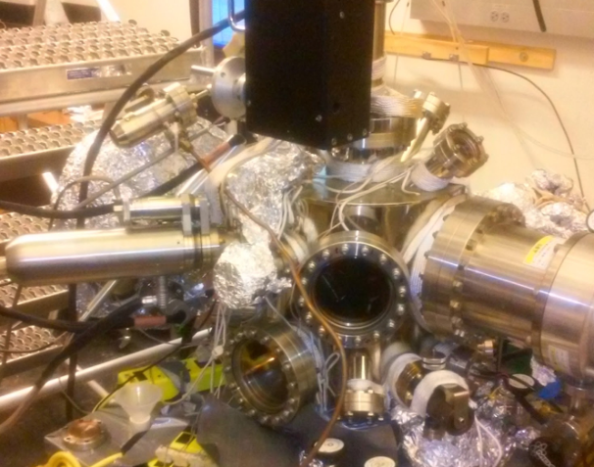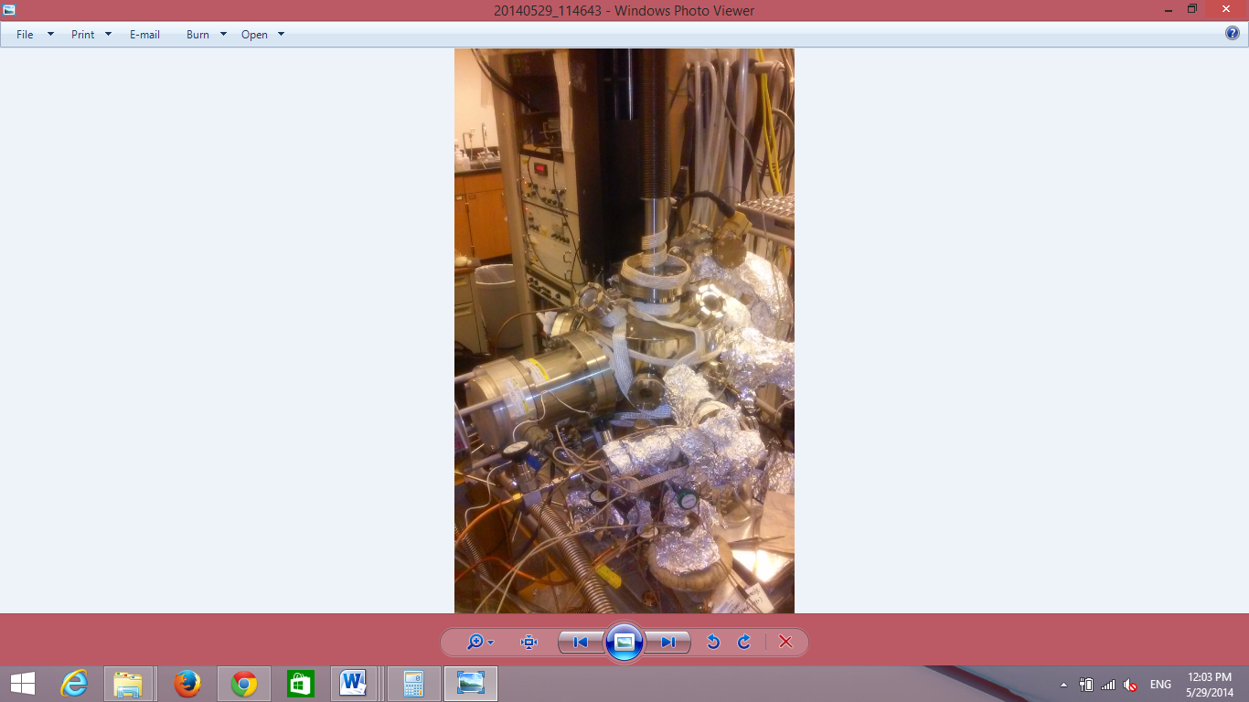
Manipulator Moving Handle
View Port
Turbo Pump
X-ray Gun
Turbo Pump
Leak Valve
Manipulator
View Port
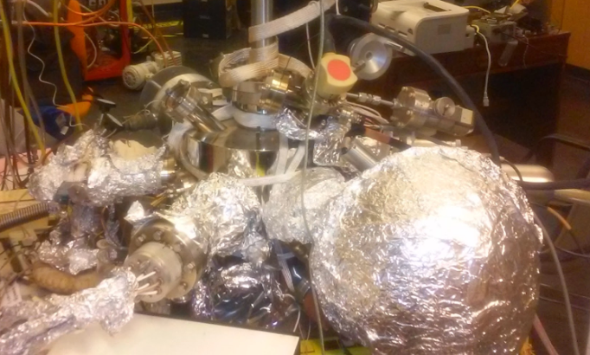
Hemispherical Analyzer
Mass Spec
Ion Gun

Pumping
The vacuum system is evacuated by a combination of mechanical pumps and turbo molecular pumps. This combination, together with the vacuum measuring instruments, consists of the pumping system. There are two mechanical pumps and two turbo molecular pumps on the instrument. The mechanical pumps are located next to the main chamber’s body and the turbo pumps are directly connected to the chamber via an open flange.
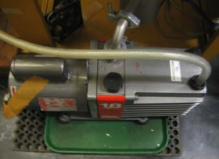
Mechanical Pump I (Edwards)
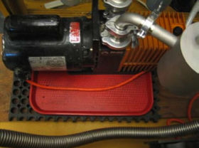
Mechanical Pump II (Alcatel)
Mechanical pump I, Edwards 18 (two stages, pumping speed 12 cfm), is connected to the turbo pump (Seiko Seiki STP 400). This pump is also connected in parallel to the rotary platform of the manipulator via a stainless steel bellow for differential pumping. The rotary platform is located at the head of the manipulator. The Edwards pump also connects to the newly installed turbo pump (Pfeiffer TMU 065) at the high-pressure cell. The Edwards pump was refurbished in the machine shop in March 2024. Mechanical pump II is an Alcatel pump with model number 2012A, and its pumping speed is 11 cfm. It is connected directly to the gas manifold. All mechanical pumps are equipped with oil traps. Ballasting may be needed. The ballast valve is located on the side and it requires a flathead screwdriver for adjustment.
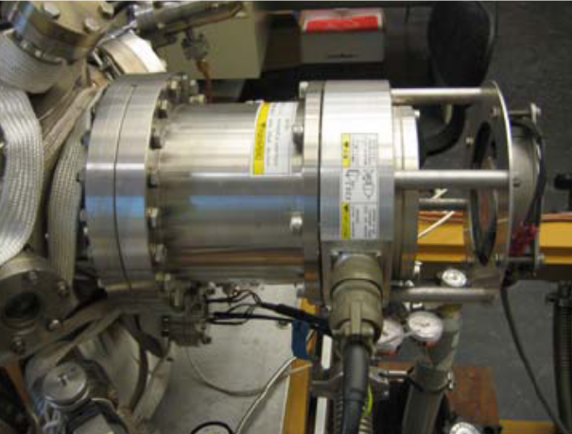
Seiko-Seiki turbo pump
The Michelle system consists of two turbo molecular pumps. The Seiko Seiki STP-400 pump, which is pumping the main chamber, is on magnetic bearing. Since this type of pump has no oil, there is no danger of vacuum contamination. However, this system does result in a great deal of electronic noise making experiments prone to many artifacts. The magnetic bearing cannot withstand strong shaking. So do not shake the chamber when this pump is running. Do not attempt to unplug the cable to the pump while the pump is running. This will cause significant damage to the pump. It is recommended to change the battery of the power supply every few years. This battery is supposed to work as a backup during a power outage. This pump is installed horizontally.
The newly installed Pfeiffer TMU 065 turbo pump is designed to pump the high-pressure and IR cell at the bottom of the chamber.
The connection of the turbo pump to the roughing pump is realized through an angle valve. Close the valve before attempting to shut down the turbo pump. The valve needs to be only finger-tightened to ensure a proper seal. Further tightening may add to excessive wear.
During October 2026, the base pressure of the UHV system is around 1 x 10⁻⁹ Torr. This is the best pressure for the system after intensive bake-out.

Pressure reading, ion gauge, filament replacement and maintenance
There are three types of gauges in the Michelle system. Thermocouple gauges are used to measure the rough vacuum (form 10⁻³ Torr to 1 Torr). The ion gauge is used to measure the high vacuum (from 10⁻¹⁰ to 10⁻⁴ Torr). These gauges are read through a Granville-Phillips 307 vacuum gauge controller. The top reading of the Granville-Phillips gauge controller is for the ion gauge, the middle reading is for the thermocouple gauge of the turbo backing vacuum, and the lower reading is for the thermocouple gauge of the gas manifold.
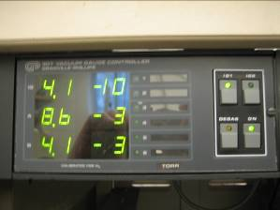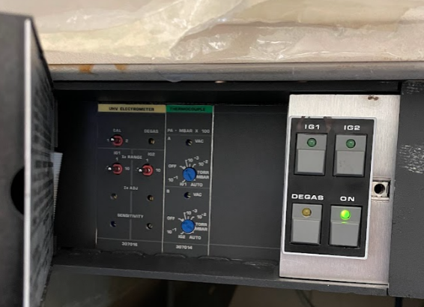
Vacuum Gauge Controller
The third gauge is a combined MEMS Pirani, capacitance, and piezo diaphragm gauge from DigiVac (DPCP Quantum Vacuum Transducer). It is read by the Fyra controller, which also offers the possibility for data logging (not in use yet).

Thermocouple gauge
There are two thermocouple gauges in the system. These are used to measure the rough vacuum. The thermocouple gauges are prone to becoming degraded, especially in the gas manifold when it is exposed to corrosive gases.
If the pressure readout is high, first check to see if the cable connecting the pressure sensor to the readout unit is solid. There are two readout channels on Michelle; swap the suspect cable with the other. If the pressure returns to normal, the problem has to do with the contacts inside the cable. Most problems can be resolved by re-soldering the connections inside the protective metal shield. If swapping the cable does not solve the problem, then it is time to replace the thermocouple gauge. The gauge type is DV-6M. When corrosive gases are used, the TC gauge readout will slightly increase and cannot go back to the 10⁻³ Torr range. This is not a sign of leaking or poor pump performance.
As of September 2026, the readout for the turbo backing vacuum line is 1.4 x 10⁻³ Torr and 1.4 x 10⁻² Torr for the gas manifold line.

Ion gauge
The pressure in the UHV system is monitored by an open-ended Bayard-Alpert type ionization gauge in the main chamber. The ion gauge can be switched on and off by pressing the “IG1” switch on the gauge controller. The wires for the filament, grid and collector are labeled.
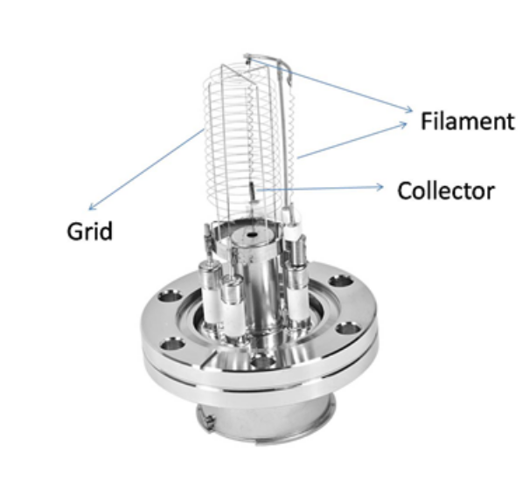
The lifetime of the filament in the ion gauge depends on the environment in which it runs. Replacement of the filaments is usually done after both of the filaments have burned out. The filament can easily be replaced by a tungsten wire or tungsten belt. A tungsten belt is suggested if available, because it is more easily spot-welded to the supporter. Alternatively, the replacement filament can be ordered from Duniway with part number FiL-8A (I think it should be FiL-8B; comment by Leo Winter in Oct 26). Backup filaments might be found in the “UHV Small Parts Ceramics” drawer in room 143. After installing a new filament or when the system is exposed to air for a long time, it is suggested to degas the filament when the system is well-pumped down. Degassing is achieved via the “Degas” button on the Granville-Phillips Vacuum Controller. I usually run two 5 min degas cycles with a 5 min cool-down period between them.
The insulating ceramic of the filament, grid, and collector should be kept clean. Carbon deposits can cause short-to-ground problems. If this is the case, the carbon deposits can be cleaned and removed with sandpaper.

DigiVac gauge
The DigiVac gauge is a combined MEMS Pirani, capacitance, and piezo diaphragm gauge (DPCP Quantum Vacuum Transducer). It has a combined range of 7.5 x 10⁻⁷ Torr to 1000 Torr (although in our experience it does not really work below 1 x10⁻³ Torr). Around 10⁻³ Torr, it switches from the Pirani to the capacitance gauge; around 4 Torr, it switches from the capacitance to the Piezo gauge. It does not require maintenance but should be switched off during bake-out.

Evacuation of the system
Follow these steps to pump down the UHV system.
1) Perform an initial check to determine if all valves (leak valves and valves in gas lines) have been closed.
2) Make sure that all of the remounted flanges have been tightened.
3) With all the angle valves and gate valves closed, switch mechanical pump I, and II on.
4) When the thermocouple gauge of the turbo backing vacuum reaches base pressure, open the angle valve to the Seiko-Seiki turbo slowly to pump the system. For the main chamber, the angle valve should be opened slowly to avoid a huge sudden pressure change, which can cause damage to the aluminum foil window on the X-ray source. You can monitor the pressure drop with the DigiVac gauge.
5) You can close the angle valve at ≈1 Torr and observe if the vacuum is held for ≈5 min, if not, this is an indication of a major leak, like an open leak valve, a misaligned copper gasket, or similar.
6) When the angle valve to the main chamber is closed, slowly open the angle valve to the Pfeiffer turbo pump and evacuate its volume (up to the gate valve). Close it again and also evacuate the volume of the rotary stage by opening the respective Swagelok valve again. When the pressure has stabilized, close the Swagelok valve again.
7) Now evacuate also the main chamber slowly from 1 Torr to ≈5 x 10⁻²Torr. Then, slowly also open the angle valve to the Pfeiffer turbo, and the valve to the rotary stage, so that all three valves are now open. You have to wait with this step until all three parts of the chamber have been individually evacuated to rough vacuum to avoid backstreaming of oily air into one of the other chambers. Now you should also open the gate valve in front of the Pfeiffer turbo (keep the one between the high-pressure cell and the gas manifold closed).
8) If the pressure is below 5 x 10⁻² Torr, you can start both turbos. This should be done simultaneously to avoid backstreaming of oil through one of the turbos. If the STP-400 turbo pump controller had been powered down, turn on the power. Wait a couple of seconds until the red LED is off before pressing the black “Start” button (if it was in stand-by, just press “Start”). The Pfeiffer turbo is started by pressing the “power” button. Wait for the “Normal Operation” LED at the Seiko-Seiki to come on before switching on the chamber ion gauge. It can take 10 min for the STP-400 turbo pump to reach full speed. The panel of LED lights on the Pfeiffer turbo indicates its rotating speed (all lights on = full speed reached).
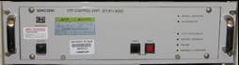
9) The ion gauge can be turned on around half an hour after starting the turbo pump. On the gauge control panel, set the emission current for the ionization gauge to 0.1 mA. Turn the gauge on by pressing “IG1”. After the pressure has gone into the 10⁻⁷ Torr range, reset the gauge controller to 1 or 10 mA emissions. For more information, refer to the manual of the gauge controller.

Venting, shutting down
Follow these steps to shut down and vent the UHV system.
1) Check if all instruments are off (Analyzer, X-ray gun, ion gun, hot filament, mass spectrometer).
2) Do not turn off the GP Vacuum Gauge Controller.
3) Check that all valves on the instrument are closed. Close the gate valve at the bottom of the chamber in front of the Pfeiffer turbo.
4) Turn the ionization gauge off (press switch “IG1”), leave the thermocouple gauges and the DigiVac gauge on.
5) Close the angle valves connecting the roughing pump to the turbo pumps. Close the valve between the rough vacuum and the rotary stage.
6) After closing these valves, turn the STP-400 turbo pump to standby mode by pressing the red “Stop” button. Do not press the “power on/off” button. The turbo will take approximately 40 min to come to a full stop. Leave the turbo pump in standby whenever possible (Switching off/on means that the magnetic bearings have to be activated again, we have seen failures of the pump or the controller during this process in the lab.) Switch off the Pfeiffer turbo pump by pressing the “power” button.
7) Wait for both turbos to come to a full stop. This is indicated by the “Rotation” reading on the Seiko-Seiki controller and by all LEDs on the Pfeiffer controller turning off. Otherwise, there may be significant damage, also because the blades are levitated by a magnetic bearing system in the Seiko-Seiki.
8) The mechanical pumps can be powered down.
9) Introduce nitrogen or argon gas into the chamber through a leak valve. Make sure the pressure of the nitrogen or argon gas is about 15 psi (do not build a bomb!!). This will reduce the water that enters the chamber during venting, possibly reducing the total bake-out time. A second way is to use the nitrogen from a liquid nitrogen tank. Put the venting tube into a liquid nitrogen tank. Open the Swagelok valve at the end of the venting tube, then slowly fill the chamber with nitrogen through a leak valve. In this case, the end of the venting process is shown by the thawing of the condensed ice on the outside of the venting tube. Fully open the valve to make sure the pressure inside the chamber is equal to atmospheric pressure before opening the vacuum chamber. You can monitor the pressure inside the chamber with the DigiVac gauge (the atmospheric pressure in the lab is ≈700 Torr).
Note: If the system needs to be vented in a hurry, you can start venting with argon once the turbo pumps have decelerated to half of their operational speed. The rotor of the turbo pump will be decelerated by the incoming gas. It should take about 10 min.

UHV bake-out
Monitor the temperature closely the first time working on the chamber to prevent any unexpected overheating that may result in mechanical failures.
1) Pump out the gas lines connecting the manifold.
2) Relax the leak valves by opening two full turns. This is required to avoid damage at bake-out temperature.
3) Move the sample up (to the red marking on the transfer rod, z=22.7) and the X-ray gun out, so that all bellows are fully expanded.
4) Remove all connectors: Those include, but are not limited to:
• Cables to the ion gun.
• Cables and water connection to the X-ray source. Twist the external protective cover to loosen it from the locked position. Then loosen the screws holding the internal protection cover and slide it out. Remove the high-voltage connector. Then remove the water connections by pressing it down and holding the lower ring pressed against the body of the connector; have a bucket in the event that there is spillage. You can also use a screwdriver to pull the connectors off. Blow the remaining water out of the inside of the X-ray gun using the pressurized air tube. Pull out the filament lead plug on the bottom of the X-ray gun.
• Cables to the analyzer. Pull all out very carefully! The insulation ceramics can easily be broken.
• Cables to the silicon source and/or the hot filament.
• Cable to the capacitance gauge. Switch off the capacitance gauge first, then pull the cable. In contrast to the ion gauge, the capacitance gauge needs to be switched off for bake-out since the maximum operating temperature is 50 °C.
• Chamber light.
• The halogen lamps, the ion gauge, the sample heating wires and the sample thermocouple should remain connected. The mass spectrometer can stay connected, too (see 11).
5) Cover all windows, bellows and feedthroughs with aluminum foil. This prevents high temperature gradients over glass-to-metal, ceramic-to-metal seals and the welds of the bellows.
6) Check if heating tapes are sitting in place. Make sure that the ones around the manipulator, the X-ray gun, and the high-pressure cell are ok; they usually need to be refitted.
7) Place thermocouples around the chamber (squeeze them between the metal and the heating belts) to monitor the temperature. Currently, they are usually placed on the analyzer, the X-ray gun, the rotary stage of the manipulator, and two parts of the main chamber. Familiarize yourself with which thermocouples are connected to which variac.
8) Test that the thermocouples and heating tapes are working.
9) Cover Michelle with aluminum foil. Do not cover the ion gauge and the halogen lamps, as they have open power connections.
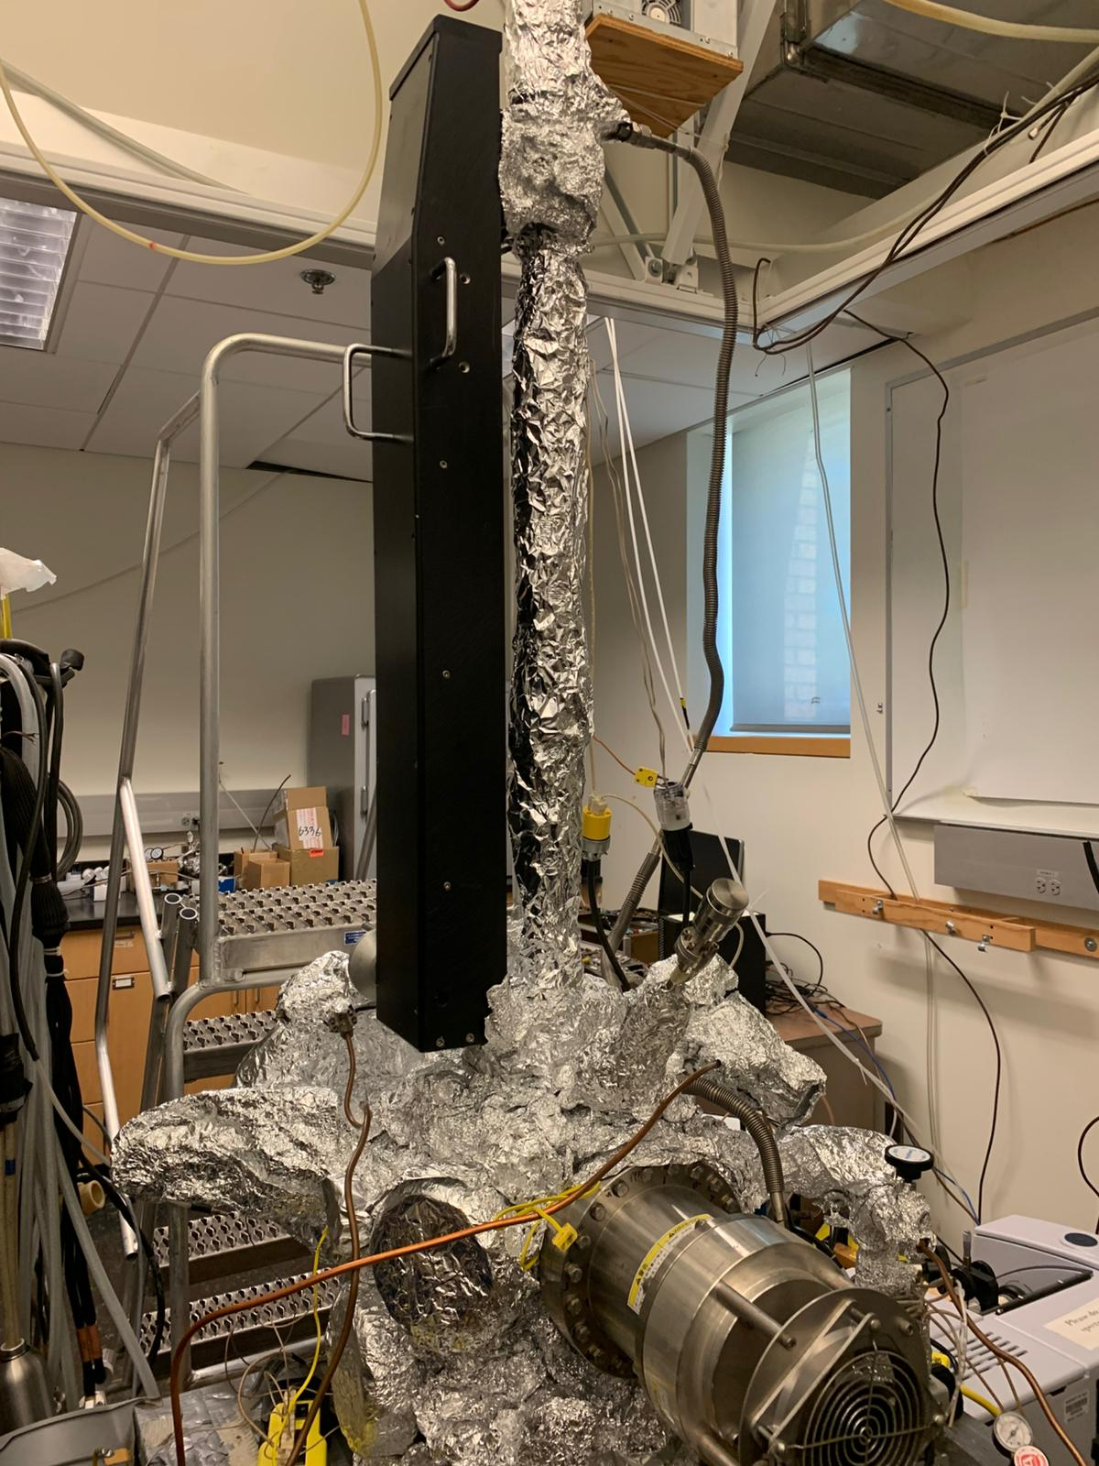
10) Connect the heating tapes to the variacs. Slowly increase the heating power until you reach a target temperature of 140 °C on the hottest thermocouples. You will need to wait at least 30 min until the temperature has stabilized before you make the next change to the variac setting. Some parts of Michelle even take longer to warm up. Typically, about 60-70% is used for the variac in the front of Michelle and about 35-45% for the variac on the back of Michelle. At the same time, increase the power to the internal halogen lamps slowly up to 45%. Heat up the sample to a target temperature of 150 °C/ 423 K.
11) Log the pressure, temperatures, and variac settings in a table in your labbook. (This will come in handy the next time you do a bake-out.)
12) Bake until the pressure has stabilized, normally 2-3 nights. This should be in the lower 10⁻⁸ Torr range. You can check the gas phase with the QMS even when the system is hot.
11) It is recommended to turn the QMS on before the last night of baking. Therefore, press “ON/STBY”, then “FAR CUP”, then turn the “EMISS/MA” knob until the filament current reads 0.15 A. Switch to total pressure mode for degassing by pressing “TOTAL PRESS”.
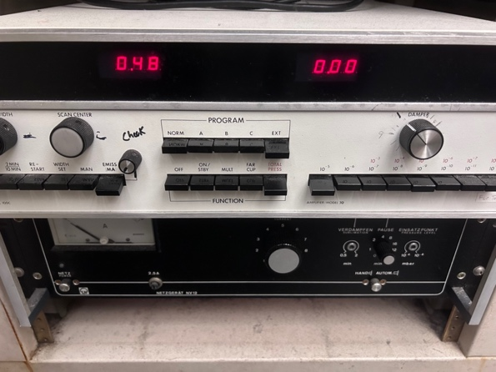
12) To stop the bake-out, slowly decrease the power of the variacs. Monitor the temperatures before starting to unwrap the chamber.
13) The ionization gauge can be degassed right after turning the baking off. Press “Degas”, watch pressure rise; let the pressure drop a bit, and turn “Degas” off after about 5 min; Increase the filament setpoint stepwise to 1 mA or 10 mA. Then repeat “degas” for an additional 5 min (optional).
14) When the chamber gets cooler, remove the aluminum foil where it is in the way. Close the relaxed leak valves. Reconnect all cables.
15) Degas filaments, i.e. QMS (this is usually already done during the last night of bake-out), ion gun, X-ray anode, Si source and/or hot filament.
Leybold ion gun: Turn the “function” knob to “degas”. This runs an automatic degassing procedure that takes about 3 min. I usually repeat this procedure after a 5 min cool-down; switch the controller off to reset the counter of the degas function. To further degas the filament, switch to “operate”, and finally increase the “ion energy” knob to 2 keV after some time.
X-ray gun filament degassing: Turn the cooling water on, turn the power supply and HV supply on, select the anode, and slowly increase the filament current (I usually did 0.2 A every 2 min) while watching the pressure (maximum operating pressure for the X-ray gun is 1 x 10⁻⁷ mbar = 7.5 x 10⁻⁸ Torr, stay below 5 x 10⁻⁸ Torr). At some point, the front part of the X-ray gun will get warm, and the pressure will increase. This depends more on the time the filament is on than on the set filament current. Final value: 4.5 A, leave on for 30 min.
X-ray gun power degassing: Reduce the filament current back to zero and slowly increase the HV up to 10.5 kV (this can be done faster than for the filament current). Increase the emission current slowly (I usually did 0.5 mA every 2 min) while monitoring the pressure. Final value: 10 mA; let it run with that value for at least 60 min. Overall degassing of the X-Ray gun can take several hours. It has to be done individually for both anodes (if both are to be used).
Si source: Increase the voltage of the filament very slowly and carefully. The warm-up of the source is non-linear and somewhat unpredictable, so stay with the chamber for this procedure.
Hot filament: Same as for Si source

General maintenance
Maintenance and repair of the Michelle UHV chamber are inevitable. Most of the time, it requires venting and opening the chamber to replace/repair parts. It is recommended to wait with venting the chamber until something essentially important is broken. Record smaller issues that you want to fix on a “next venting” list. Please pay special attention when working on those parts that are directly exposed to UHV.
• Always follow the department lab safety manual when handling chemicals and operating high-voltage instruments.
• Never touch parts that are exposed to UHV with bare hands. Wear gloves and make sure that they are clean (if you suspect that you may have touched a greasy or contaminated surface, switch to a new pair of gloves). The type of glove that should be used needs to be powder-free latex, and the best is the nylon cloth type.
• Large parts, i.e. stainless steel flanges and tubing, can be washed with hot water and Liquid-Nox type detergent. Rinse thoroughly when finished. Give the parts a fine rinse with isopropanol before baking in an oven to dry.
• Small parts can be submerged in a beaker containing acetone or isopropanol and placed in an ultrasonic bath. When using the ultrasonic bath, be sure not to directly place the beaker into the ultrasonic bath, and always suspend the beaker in the bath fluid (water).
• The cone of the mass spectrometer and the X-ray gun can be moved inside the UHV chamber. Make sure to move them back when they are not used. Rotating the manipulator is safe when both the cone and the X-ray anode are in full back position.

ConFlat (CF) flanges
CF flanges are the de facto standard for (ultra) high-vacuum equipment. Unlike bolts, for example, the metric and imperial systems use the same specifications. However, in the metric system, the size of a flange is named using the inner diameter in millimeters; in the imperial system, the outer diameter in inches is used. DN40 and 2.75” flanges are not only compatible, but they are the exact same thing. The only exception is for flanges with threaded holes, since the thread will follow either a metric or imperial standard. The table below shows an overview of the standard CF flange sizes:
metric name | imperial name | number of bolts | bolt specification | example from Michelle
DN16 | 1.33” | 6 | 8-32 | capacitance gauge
DN40 | 2.75” | 6 | 1/4-28 | X-ray gun
DN63 | 4.5” | 8 | 5/16-24 | QMS
DN100 | 6” | 16 | 5/16-24 | manipulator
DN160 | 8” | 20 | 5/16-24 | Seiko-Seiki turbo

Gaskets
There are three different gasket/O-ring materials used:
Copper: Standard for UHV, bakeable, for ConFlat (CF) flanges.
Silver (plated copper gasket): Used in applications that will be left undisturbed for a long period of time. It is less susceptible to oxidation than copper. It also allows higher bake-out temperatures. Usually, this type is not used on the Michelle chamber.
Rubber O-rings: Used in (high) vacuum conditions such as the gas manifold, not bakeable to high temperatures, for Qwik (KF) flanges.

Removing and remounting CF flanges
If you intend to remove a flange (and its instrument/device) and remount it later (e.g. after repair), mark the orientation of the flange faces towards each other with a Sharpie pen before removing the flange. It will facilitate reassembly in the correct orientation of the instrument. If you are removing bolts from a flange that is oriented vertically, remove the top bolts last. This keeps the flange from dropping before it is ready to be removed. Once the flange has been removed, place it to the side with the copper gasket still in place. The gasket will protect the knife edge. Cover the entire piece with aluminum foil or a plastic flange cap to keep out dust.
When the flange is ready to be remounted, the old copper gasket must be replaced with a new one. Remove the old one with a gloved finger or, if necessary, with a pair of pliers. Use a pulling motion that is perpendicular to the flange. This will ensure that the knife edge is not nicked or damaged. If damaged, the knife edge must be re-machined or the flange replaced with a new one (so do not damage them!). Place the used copper gaskets in a central location for recycling. Inform the responsible person if the supplies of a specific gasket size are low. Place the new copper gasket into the groove of one of the mating flanges, and bring the flange faces together. If the copper gasket falls out of alignment, try again. You can also use a small screwdriver or spatula to push the gasket into place. If repeated attempts to keep the gasket in place fail, then try placing a small piece of tape on the outermost edge of the gasket to secure it to the flange. When the gasket falls into place, the flange faces will be parallel and aligned, allowing no lateral play. Most people align the notches on the flange faces (but this only serves aesthetic purposes).
You can use platenuts if there is enough space on the flange and it does not obstruct plugs or other equipment (for example, like on the QMS). This will facilitate the mounting process, as you only have to use one wrench for tightening. Before tightening the bolts to close the flange, be sure the threads have a light coat of molybdenum disulfide or other anti-seize lubricant. This will prevent the bolts from seizing up the next time they are removed. Do not, however, use this compound for bolts that are inside of the chamber, as the lubricant will contaminate the vacuum. Finger-tighten the bolts to make sure that they go smoothly. If not, you may have to move or rotate the flange a bit to get proper alignment. The heads of the bolts should be able to close on the flange without the need for a wrench. Replace nuts or bolts with bad threads (check before mounting the flange). Make sure the gasket does not slip out of its groove. Finally, tighten the bolts with the proper wrench using a crossover or circular pattern to distribute the stress on the flange equally. Tighten until the copper gasket has been “cut”. The outer parts of the flanges do not necessarily need to touch.

Turbo pumps
In general, the two turbo pumps do not require any regular maintenance. It is recommended to change the internal battery of the STP-400 controller every few years. When the power voltage drops below approx. 85% of the rated voltage due to a power failure, the internal battery of the STP control unit automatically activates to supply power to the STP pump in order to maintain normal function of the magnetic bearing (backup operation during a power failure). Two batteries are used in the controller. (PORTALAC Series Small-Sized Sealed Lead-Acid Batteries, PE12V 7F1: 12 V, 7 Ah)
Follow these steps to replace the battery:
1) Stop the STP pump and turn off the primary power (Switch the breaker "OFF").
2) Unscrew the 4 screws attached to the front panel and bring the front panel down towards you.
3) Disconnect the internal battery connector.
4) Unscrew the battery case screws and pull out the battery case from the STP control unit.
5) Unscrew the 4 top panel screws from the battery case, and remove the top panel.
6) Disconnect the lug terminal and pull out the battery from the battery case.
7) Replace the two worn-out batteries with new ones in the battery case, and connect the lug terminal correctly (red: "+" side; black: "-" side).
8) Attach the top panel to the battery case using 4 top panel screws, using care not to catch the cable between the top panel and the battery case.
9) Connect the internal battery connector.
10) Close the front panel and tighten the 4 screws that secure the front panel.
11) Record the replacement date of the battery.
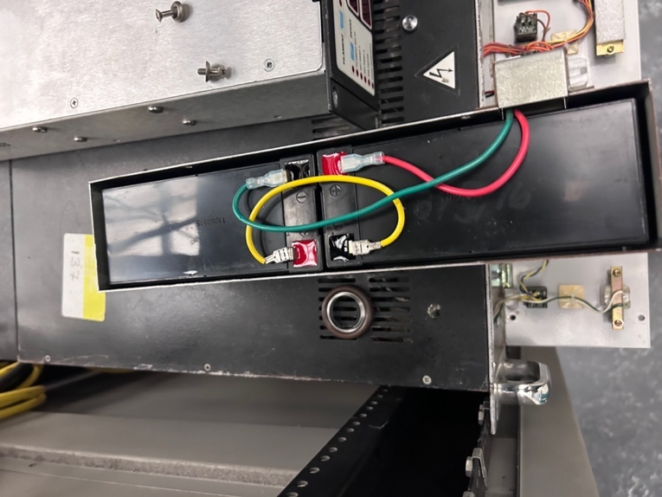
Batteries in the Seiko-Seiki controller

Mechanical pump
The mechanical pumps need oil changes on a regular basis (at least every 12 months) to prevent their failure. More frequent oil changes may be necessary if using corrosive gases or chemicals, or whenever ballasting does not improve hydrogen back-migration. Monitor the color of the pump oil. If the color becomes darker, it is advisable to change the oil. The pump oil used is TKO19+. The filling amount is about 800 mL. Oil is stored in room 137. It is recommended to change the molecular sieves of the oil traps together with the oil (at least every second oil change). Used oil and molecular sieves must be disposed of through the environmental health and safety department.
Standard operating procedure for oil change:
1) Wear proper PPE (gloves, safety goggles, and lab coat). Isolate the mechanical pump from the UHV system. Stop the pump, unplug it, and remove all the connections. Wait for 20 min; the pump oil may still be hot.
2) Lift the pump on the moving cart (stored in room 135). Put the waste oil bucket below the pump. Remove the top screw. Slowly unscrew the bottom screw and drain all the oil into the bucket. (I recommend cleaning the space behind and below the pump once it is out of its usual place.)
3) Fill the pump with only 500 mL of clean oil. Rinse the pump by running it for 5 min. Stop the pump and drain the oil. Multiple rinses may be needed if the pump is too dirty.
4) Fill the pump with clean oil. Do not overfill. Tighten all the screws (but not too tight) and connect the pump back to the UHV system. Start the pump and check the base pressure.
5) Put the used oil in the waste bottle with the proper chemical waste tag. Clean the pump, the cart, the beakers, and the floor with paper towels and ethanol, and put them in the proper chemical waste bag.
Parts replacement and rebuilding of the pumps can be done in the machine shop of the college (Jay is the person to ask). We have rebuilding kits for some pumps stored in the lab (or they can be purchased from Ideal Vacuum). Currently, they are located on the top shelf in room 143. We also might have unused or backup pumps in the lab for intermediate use; talk to your colleagues.
The last oil change was carried out on 2026/05/19. Record the dates of your oil changes somewhere (for example, the next venting list).

Leak detection
A poorer-than-normal vacuum is usually the first indication of a chamber leak. A good indicator for an air leak is the presence of an oxygen peak in the mass spectrum (m/z = 32). A less obvious indication is a higher-than-normal 14 amu peak (splitting of N₂). Another common leak is through leak valves; then you will see the respective gas in the mass spectrum. An easy test to find a leak through a leak valve is to evacuate the gas line behind the leak valve through the gas manifold. If the pressure in the main chamber also drops, the leak valve does not close completely. Usually, this problem can be solved by resetting the stop position or retuning the leak valve (see 5.2 Leak valves).
In order to pinpoint an air leak, squirt acetone or isopropanol on suspected areas. When the solvent is drawn into the chamber through the leak, there will be a sudden fluctuation in the pressure reading of the ion gauge. Another method is to blow a fine jet of helium on the suspected area while monitoring the 4 amu peak with the mass spectrometer (you can use the “TPD function” set up in LabVIEW, 10⁻⁹ magnification is recommended). We have a gas cylinder for this purpose in one of the outside cabinets. Gently blow helium; a flow that can be felt on wet lips is sufficient. First, concentrate on the parts that have been opened before the last bake-out. If there is a leak, the intensity of the He signal in the mass spectrum should increase immediately. Helium is lighter than air, so the leak might also be located above where you are blowing.
If no air leak can be detected and UHV pressures are still unobtainable, check the hydrogen partial pressure. Hydrogen is the only gas that can significantly back migrate from the roughing side of the turbo pump. Either ballasting the roughing pump or changing the roughing pump oil can minimize the back migration of hydrogen.
Another possibility are “virtual leaks” between two compartments of the vacuum chamber. The most common example are leak valves not closing completely. But there can also be leaks through gate or angle valves. Entrapped air, for example behind screws, can also be a problem.

What to do after a power outage
Procedures for power outage with notice:
The preparation for a power outage with notice is similar to normal venting of the chamber.
Turn off all filaments; turn off the turbo pump. Close the valve between the turbo pump and the mechanical pump. Vent the chamber after the turbo pump fully stops. Turn off and vent the mechanical pump, which is different from the normal venting process where the mechanical pump does not need to be off.
Procedure for unexpected power outage:
1) When an unexpected power failure happens, first put all the power supplies to “off” position, especially those for filaments, such as the power supply for the ion gauge, the mass spectrometer, the X-ray gun, and high-voltage power supplies. Close all the leak valves. Close the angle valves between the turbo and the mechanical pumps.
2) Vent the mechanical pump.
3) If the power outage is expected to last a long time, vent the main chamber with nitrogen.
4) If the power is back shortly, first turn on the mechanical pump; after a few minutes, turn on the turbo pump and open the valve between the turbo and mechanical pump. After the turbo pump reaches its normal status, the ion gauge can be turned on to check the vacuum of the chamber. Also, check the status of all other instruments.

High-Pressure Cell

General chamber (drawing, picture)
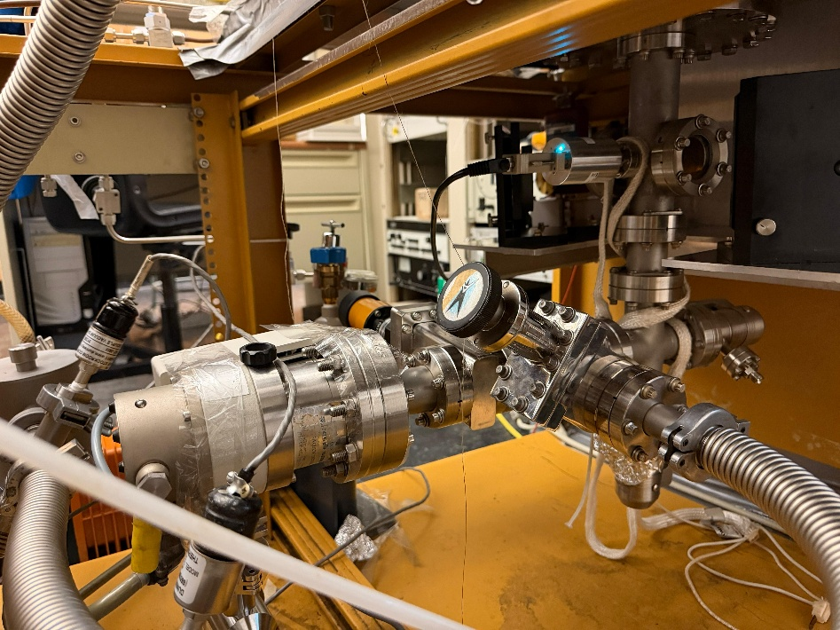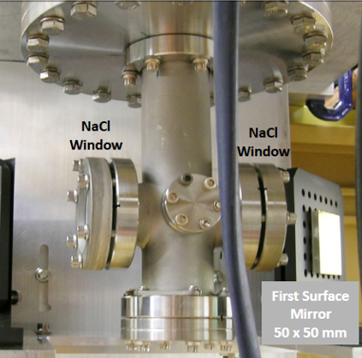
Left: High-pressure cell as of fall 2026. Right: Close-up of the six-way cross (still blanked at the bottom and without the capacitance gauge at the time).
Recently, an IR chamber, which is also serving as a high-pressure cell, has been installed at the bottom of Michelle. The IR chamber is made of a custom-built six-way cross. At a later stage, the IR chamber was upgraded to a high-pressure chamber. There is a Digivac DPCP Quantum Transducer installed on one of the 1.33” flanges of the six-way cross. It is a pressure gauge that uses three different measurement principles depending on the pressure range: From 7.5 x 10⁻⁷ to 7.4 x10⁻⁴ Torr, a MEMS Pirani; from 3.75 x 10⁻³ to 3 Torr, a capacitance diaphragm gauge; from 4.5 to 1000 Torr, a MEMS piezoresistive diaphragm, and in the ranges in between a blend of the respective two measurement principles. The accuracy is given as 50% of the reading between 7.5 x 10⁻⁶ to 7.5 x 10⁻⁵ Torr, 20% of the reading between 7.5 x 10⁻⁵ to 7.5 x10⁻³ Torr, 3% of the reading between 7.5 x10⁻³ to 824 Torr and 1% of the reading between 825 and 900 Torr. The diaphragm gauges have superior performance compared to a thermocouple gauge, for example. The operating temperature of the Digivac gauge is -20 to 50 °C, so it needs to be switched off for bake-out.

Pumping system (turbopump)
Below the small six-way cross, there is a four-way cross installed that leads to two leak valves for gas dosing and another T-junction that leads to a gate valve for pumping with the Alcatel roughing pump and a gate valve that connects to a Pfeiffer turbomolecular pump.
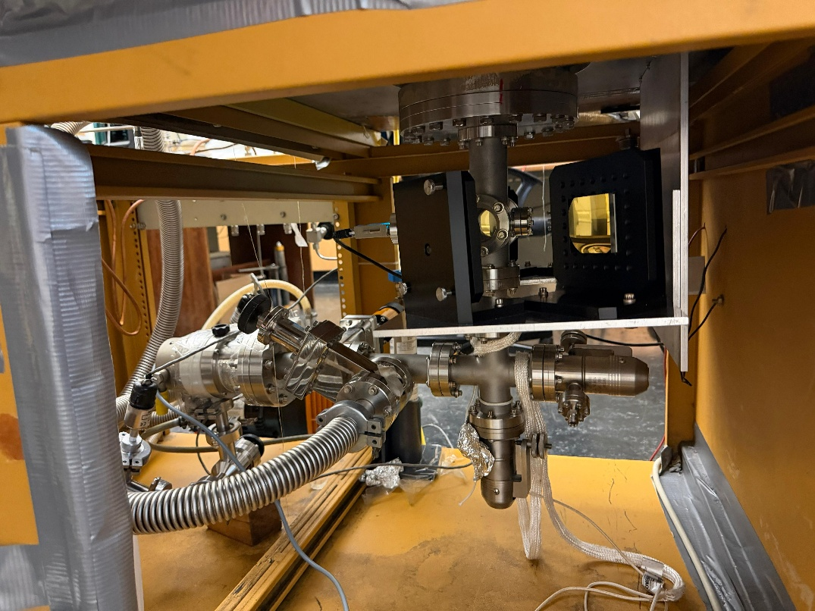
View on the high-pressure cell from the position of the IR spectrometer.

Seals
The HPC is separated from the main chamber by an O-ring seal inside the main chamber (1.35” inner diameter, 3/16” thickness). On the bottom of the main chamber, an O-ring is installed on a 2.75” flange. The screws holding the 2.75” flange are inside the chamber, so use screws with drilled-in holes to avoid virtual leaks by trapping air behind the screw. When the manipulator is moved down into the HPC, the manipulator rod will press the O-ring to separate the main chamber from the HPC. We have experienced issues with the O-ring not sealing properly and/or being ripped. Unfortunately, there is no easy way to see if the O-ring is ripped from the outside.
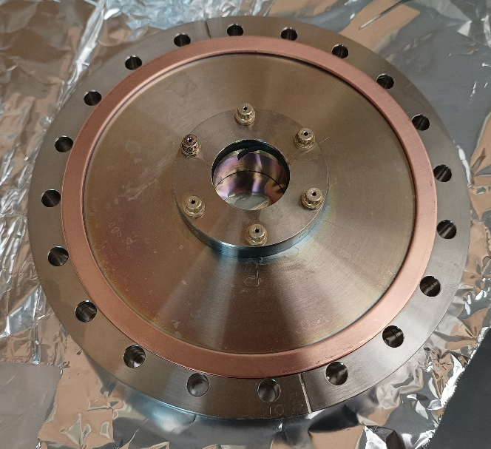
Bottom 8” flange with the 2.75” flange holding the O-ring.
The alignment needs to be perfect for the manipulator to go into the 2.75” flange on the bottom of the chamber. This will hardly be the case, so usually a gentle push on the manipulator is needed while entering the HPC. You should have a look through the lower viewport to control the alignment and see in which direction it is necessary to push. The alignment can also be optimized by moving the manipulator along a clamp that holds the manipulator with three screws. The clamp can be moved towards or away from the black transfer mechanism after loosening the three screws (it can still be somewhat hard because of the weight of the manipulator). There is also a certain play in the direction of the other axis by tightening and loosening the small Allen screws that hold the flange inside the clamp (on the side of the clamp).
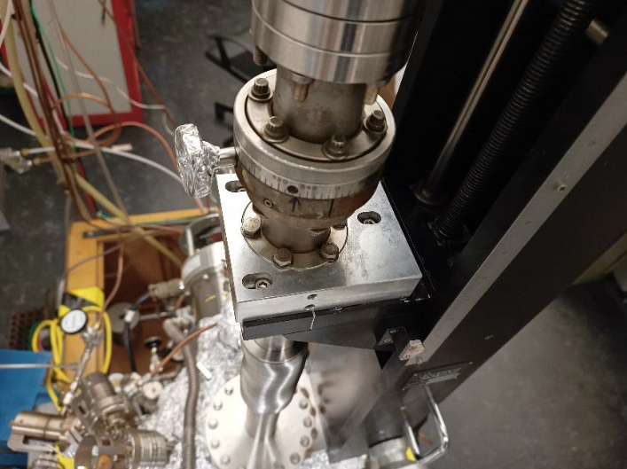
Clamp (silver metallic piece) to optimize the alignment of the manipulator.

IR windows
The sodium chloride windows are sealed with a Viton gasket of the type used for CF flanges, and protected on the opposite face with a Teflon ring. The whole assembly can be treated as a regular flange, though care should be taken when these flanges are tightened, since the sodium chloride is very brittle!
Reassembling the Sodium Chloride Windows:
1) Put the Teflon ring on the inside of the flange and place the sodium chloride window on top of it. There is a supply of these windows in a desiccator kept in one of the cabinets in room 137 (cabinet 137V). Make sure you have the window with the right size; otherwise it will break as the flange is tightened!!!
2) Put a Viton gasket on the flange of the chamber and GENTLY press the window into it. Secure the flange with 2 bolts.
3) Put all the bolts in and finger-tighten them.
4) Use a 1/4" wrench and VERY CAREFULLY TIGHTEN THE BOLTS using a crossover pattern to distribute the force evenly.
Note: These flanges do not have to be very tight. It is recommended that they be checked for leaks. If a leak is found, tighten the bolts a little more. If there is no leak, stop right there. Further tightening could break the window.
5) Measure an IR spectrum to see if everything works as it should. Verify that the low wavenumber cutoff is close to 700 cm⁻¹.

Sample

Removing the manipulator from the chamber
Disconnect all the heating wires, heating tapes, thermocouple connection, and rotary differential pumping connections. Remember to move the manipulator close to the all-the-way-up position (z=22.7). In this way, the sample holder will not bump the X-ray source or mass spectrometer cone, etc., when it is moved, and you do not have to lift the heavy manipulator too much. Remove the bolts that connect the manipulator and the chamber. Remove the manipulator. Here you will need three people: one can hold and lift the manipulator while standing on the ladder, and the other two can guide it and take it over to lift it down. Lay down the manipulator on the table, and the 2.75” nipple (on the top of your picture) can then be removed. Be careful not to hit the sample on any furniture in the lab while carrying the manipulator. Please be very careful when you handle the bellows. Any damage to the bellows will be a huge headache.

Mounting (holder, spot-welding, insulator seal, adding thermocouple)
Metal single crystal or polycrystalline samples are supported and heated by tantalum wires attached to the end of the sample manipulator. The details of mounting a metal sample are as follows:
1) Move the sample down to the position that it can be reached from the 6” viewport.
2) Vent the chamber.
3) Open the 6” viewport. If necessary, remove the 2nd viewport on the right-hand and up side as well.
Alternatively, remove the whole manipulator from the chamber (Leo Winter’s recommendation).
4) Loosen the four set screws from the back of the sample holder, as indicated in the picture below. Make sure not to grab (tightly) the copper rods and the manipulator rod at the same time, as this puts mechanical stress on the brittle feedthrough ceramics. Also loosen the top screws holding the thermocouple connection.
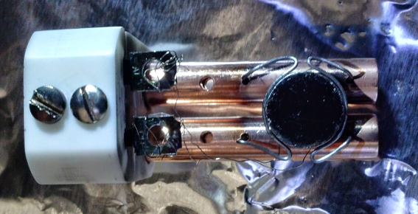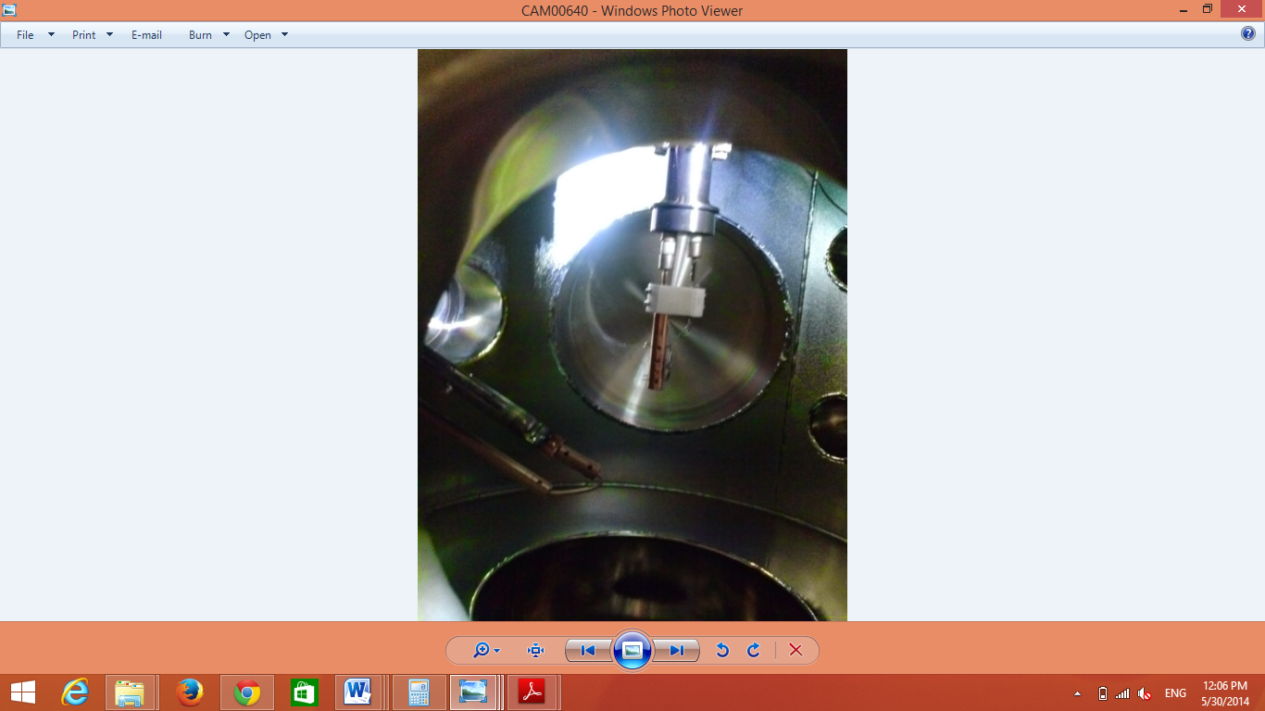
Sample Holder
Remove 4 setscrews
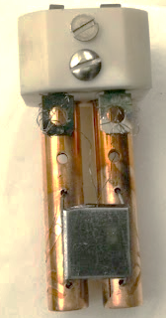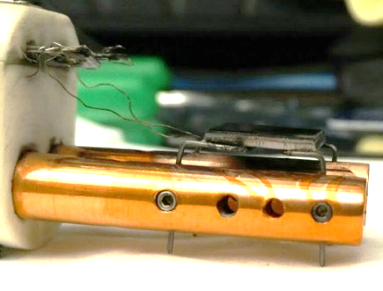
5) Gently pull the sample holder straight down to remove the sample holder from the manipulator and put it on a clean aluminum foil.
6) Record the sample position before removing the old sample. It is advised to mount the new sample as close as possible to the original position. This will save a lot of time for the RAIRS alignment.
7) Loosen the four set screws that hold the tantalum heating wires. Remove the thermocouple wire from the back or side of the sample. Gently bend the wire to remove the old sample and install a new one.
8) Polycrystalline samples need to be polished before installation. We have a set of sandpapers with different roughness. Start with the roughest one and work down to the smoothest one.
9) Spot-weld the tantalum wire to the side of the sample and the thermocouple wire to the back or side of the sample. Copper samples cannot be spot-welded; the heating wire needs to be inserted into grooves at the side of the sample and the thermocouple wire into a hole on the side of the sample.
10) If the thermocouple wire is broken, replace it with a new one. Check with a magnet for the proper connection! The alumel wire is magnetic; the chromel is not.
11) Mount the sample holder to the manipulator and close the chamber.

Leaking bellows
There have been some repeated issues with the manipulator bellows. It showed leaks at the top (the first two bellows). We tried to repair these leaks with VacSeal, and/or epoxy glue. But moving the manipulator up and down can cause the leak to break open again. We have a metal clamp that fixes the first couple of bellows, so that they do not move when the manipulator is moved.
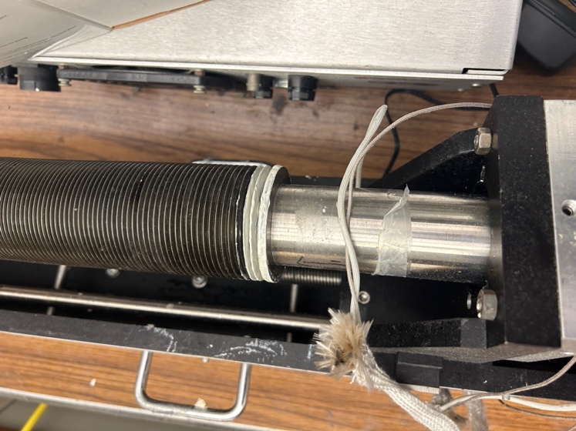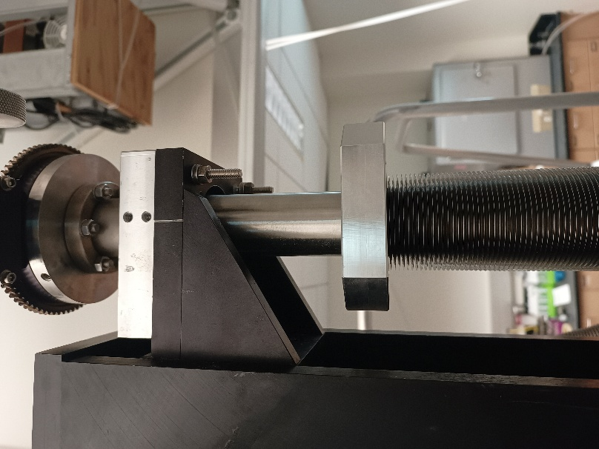
If the bellows need to be replaced, the weld of the bottom flange to the transfer mechanism needs to be redone by the machine shop. The top flange is held by a (retro-fitted) clamping mechanism that is fixed with two screws.
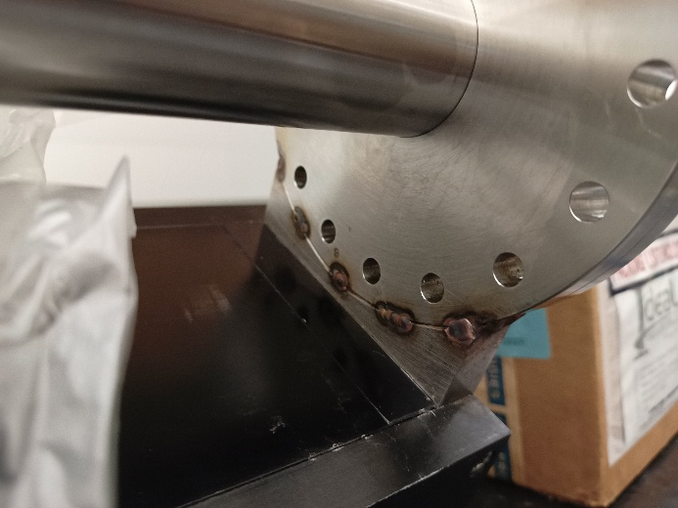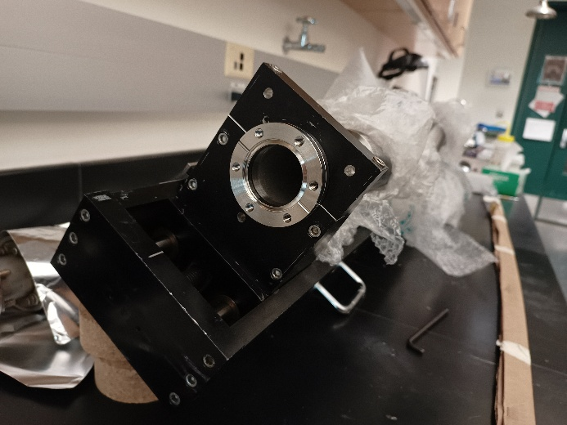

Power and thermocouple feedthrough
An insulator seal is used as the transfer part from the shaft of the manipulator to UHV. The insulator seal has four feedthroughs, which provide K-type thermocouple connections and a pair of copper electrodes. The insulator seal needs to be specially ordered. When requesting this part, tell the person that it is intended for cryogenic applications. Liquid nitrogen temperatures require modified feedthroughs where any KOVAR is replaced with 10%Ni30%Cu alloy. Otherwise, the seal may fail under liquid nitrogen temperatures. MDC precision part-# 9392015 - Thermocouple-Power Feedthrough, Type K, 1 Pair, 5KV, 30 Amps, 1.33" Conflat Flange.
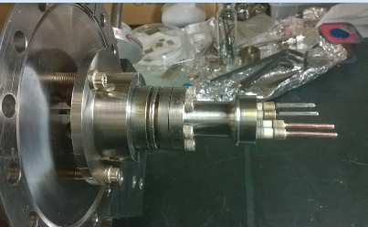
Also, oil has been seen on the non-vacuum side of the feedthrough, resulting in false voltages. Hence, an oil trap before the mechanical pump (it is installed on a stage hanging from the ceiling) is essential if the liquid nitrogen is additionally pumped to achieve lower temperatures (this has not been done in a long time, at least before 2023).
Also, care is advised whenever rotating the sample, moving the heating wires, etc., as there is considerable weight from the long rods to the ceramic feedthrough.
If the sample has been cooled using liquid nitrogen, it is necessary to blow dry the inside of the manipulator rod with compressed air and leave it running overnight to get rid of any water residue inside. Failure to do this will result in a broken feedthrough when liquid nitrogen is used the next time. To replace the feedthrough, it will require removing the whole manipulator from the chamber (a lot of work). The typical way feedthroughs tend to break is if water condenses after a day of experiments, drips down the tube, and accumulates in the bottom. The next day, when you cool the manipulator back down, the water freezes and puts stress on the ceramics until they crack. Make sure that you flow dry air with a small tube all the way down the manipulator at the end of your experiments, when you stop cooling down the manipulator. Let the air run overnight. Make sure also that the water that condenses outside does not find its way inside the tube. An issue is that the compressed air line may be moist and also a dry tube is needed.
Backup feedthroughs are stored in the lab; the person responsible for this is Ameer. If you have to replace the feedthrough, inform the responsible person so that he/she can order a new backup. The copper rods need to be silver-soldered to the feedthrough on the non-vacuum side. This can be done by the CNAS machine shop. The thermocouple wires are spot-welded. Make sure that the copper rods and the thermocouple wires are properly insulated. Usually, we use plastic water pipes (available in the stock room) for this purpose.

Rotary stage
The rotary stage is differentially pumped by the Edwards mechanical pump. The pressure might go up when the sample is rotated. However, the pressure should return to its original value within 30 s. Otherwise, it may suggest a bad seal inside the rotary stage.
To remove the rotary stage, it requires venting the system and removing the manipulator from the chamber. Lay the manipulator flat on a clean area. Remove the sample. Disassemble the respective flange and pull the center rod out. The bellows should be supported by soft materials to avoid any bending. You can use a plastic sheet or an old poster wrapped around the bellows to hold them in place.
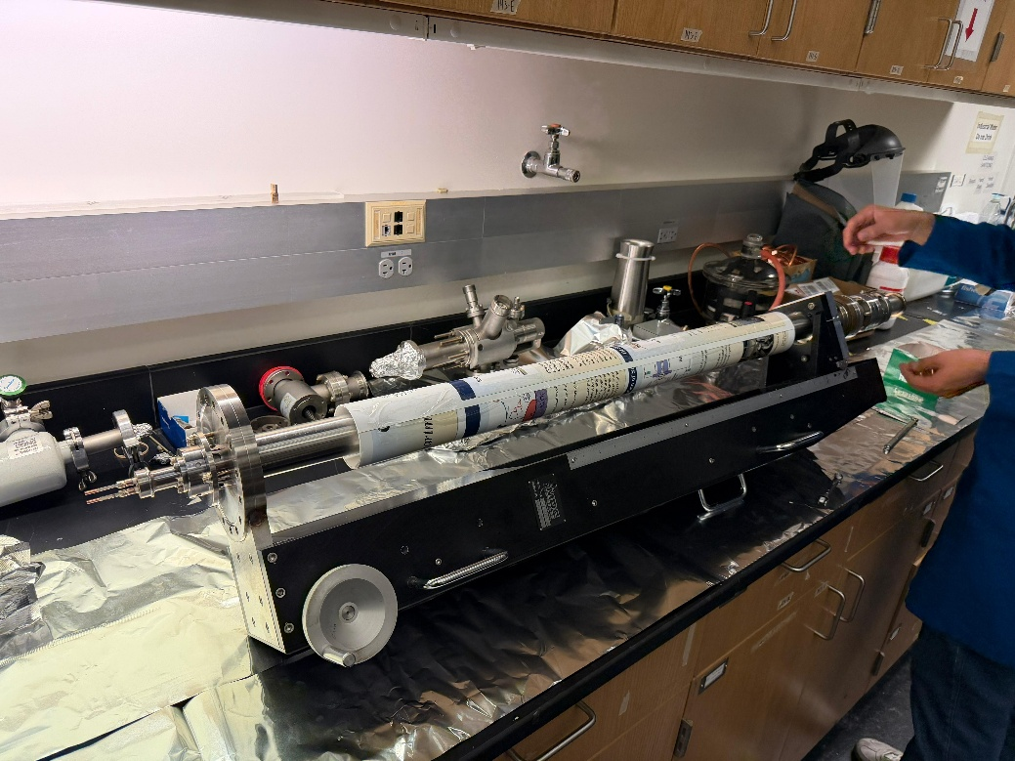

Sample holder
The sample holder is an in-house built ceramic block in which two copper posts are inserted. The purpose of this complex is to provide an easy means to mount and remove the sample. All chambers in this lab have the same insulator seal and a similar sample holder attached to the end of their respective manipulators. The goal is to have exchangeable sample blocks with different samples mounted. However, there are two different shapes of the ceramic blocks around. Michelle needs the one with the flattened edges, shaped like an octagon, not rectangular (marked by the red arrow below) to fit easily through the seal of the high-pressure cell.
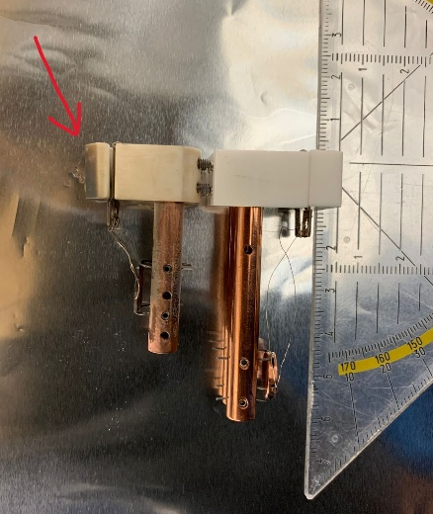
The sample holder connects to the insulator seal by four set screws located on the backside of the ceramic. Operationally, the sample is welded via tantalum wires, which are in turn connected to the copper posts held in the ceramic block via set screws. Spot welding the tantalum can become quite a challenge, and is not possible for copper samples.
A new sample needs to be polished before mounting. We have a set of sandpapers with increasing fineness and a polishing liquid in room 143. For practicality, the sample needs to be polished before welding or squeezing in the heating wires and the thermocouple.
Heating is achieved by applying a voltage across the copper posts. Cooling is achieved by the injection of liquid nitrogen down the shaft of the manipulator. In this installation, the sample can be cooled down to 90 K by pouring liquid nitrogen directly into the shaft of the manipulator, so that the non-vacuum side of the feedthrough is immersed in liquid nitrogen. The cooling performance mainly depends on the quality of the spot-welding of the tantalum wires to the sample.

Heating and cooling

Heating
The sample is heated with an AC current supplied by the home-built temperature controller or the Omron controller through a variac transformer. Or the sample can be heated using a variac controlled transformer directly (not recommended).
To use the home-built temperature ramping controller for heating:
The transformer must be plugged into the socket in the back of the temperature controller. The thermocouple coming out of the manipulator must be plugged into the yellow TC socket in the back of the controller. The sample must be properly grounded.
An important thing to notice is the little light in the controller, which indicates that the controller is (trying) to heat the sample. The intensity of this light is an indication of the heating power. The maximum heating power is set with the variac on the front of the controller, typically about 50-80%. The RAIRS chamber manual and a physical documentation booklet contain more detailed information about the home-built temperature ramping controller.
To use the Omron controller for heating:
Plug the transformer into a variac (we have it set to 52% heating power at the moment) and then the variac into the backside socket of the Omron controller.
If necessary, the sample can be heated by a variac connected to the transformer: Connect the transformer input to a variac and regulate the heating power with the variac. Do not connect the transformer directly to the power supply. This causes a very high heating current, which will melt the heating wires. The target temperature can be set by the arrow controls on the front of the Omron. By (long) pressing the left two controls, different menus can be accessed where parameters like limits, ramp rate, and the PID values can be changed. Refer to the Omron manual for details.
Troubleshooting sample heating
Symptom: the sample does not get hot:
Bad contact somewhere in the heater circuit. This could be inside or outside the chamber. The connector to the copper tube may be loose, the wire may be loose in the connector, the wires may not be well connected to the transformer, or the sample support wires in the vacuum are burnt out. The temperature controller operates normally in this case.
The thermocouple is not plugged in, or the thermocouple circuit is broken. In this case, the red LED indicator labeled "TC open" on the front of the temperature controller lights up, and the output power is interrupted to protect the sample support/heating wires.
Symptom: Temperature reading is not stable; the temperature controller may be heating irregularly.
One of the thermocouple wires is touching ground or the heating wire. The critical spot is the point where the thermocouple wires come out of the manipulator: the insulation may be rubbed through here. The sample is not properly grounded.
Symptom: heating is very slow, though a lot of power is used.
Probably the sample support/heating wires are getting loose, or oxide has built up at the outside contact. Check the outside connection first. This happens after some time, and if it gets too bad, the sample has to be spot-welded again. If this is the case, cooling will be slow, and the lowest temperature that can be reached will be higher. There can also be a short between the two heating wires in the manipulator tube or on top where the connection to the cables is made.

Cooling with liquid nitrogen
CAUTION: When dealing with liquid nitrogen, safety glasses and cryo-gloves should be worn.
Insert a funnel into the small inlet at the top of the manipulator. Start by pouring in liquid nitrogen little by little initially to avoid cracking of ceramic connections. It takes, typically, about 10-20 min. to cool the sample down from room temperature to about 90 K. Once the manipulator is cold, cooling is much faster (5-15 min, depending on the contacts between the heating wires and the sample in the vacuum). If the cooling is slow, it is possible that the sample heating/support wires have come loose and the sample will have to be remounted soon. In the current setup, we start cooling by slowly filling three cups of liquid nitrogen. We refill one cup every ≈75 min. Do not overfill, or the rotary feedthrough will get too cold, which can damage the O-rings.

Stop cooling
Remove the funnel and blow dry air through a tube into the manipulator while the liquid nitrogen boils away, and let it flow until the manipulator is at room temperature and dry. Do not start adding liquid nitrogen again during this step (… do not change your mind and try to continue experiments), since if any water has accumulated in the manipulator through condensation, it will freeze and possibly fracture the ceramic feedthrough. Make certain that there is no resistance to the air stream. If there is, there may be some ice inside that is preventing the air from escaping, which will result in a build-up of pressure. It is suggested to leave the air flow overnight after the experiment.

Breaking feedthrough (be very careful)
The way feedthroughs tend to break is if water condenses after a day of the experiment using liquid nitrogen cooling, which drips down the tube and accumulates at the bottom of the manipulator. The next day, when the manipulator is cooled using liquid nitrogen again, the water freezes and puts stress on the ceramics until they crack. If you are not doing this already, make sure that you flow dry air with a small tube all the way down the manipulator at the end of your experiments, when you stop cooling down the manipulator. Make sure also that the water that condenses outside does not find its way inside the tube.
If the sample has been cooled using liquid nitrogen, it is necessary to leave the compressed air running overnight to get rid of any water residue inside. Failure to do this will result in a broken feedthrough when liquid nitrogen is used next time. If the feedthrough breaks, Ameer is in charge of the new ones. We should always have at least one new feedthrough in the group and order new ones when one is used.

Biasing
By means of opto-isolation circuitry, the thermocouple and its preamplifier circuit are floating with respect to the system ground, i.e. the chamber and instrumentation chassis. The sample, which is in contact with the thermocouple, can be placed at any desired potential by simply applying that voltage to either of the thermocouple leads or to the common of the preamplifier circuit. There are three banana jacks at the rear of the temperature controller where these connections can be made: “TC COM” (thermocouple common), “SYS COM” (system common), and “BIAS OUT”. The controller has an internal bias supply which provides a negative voltage in steps of 50, 100, 150, 200, and 250 volts.
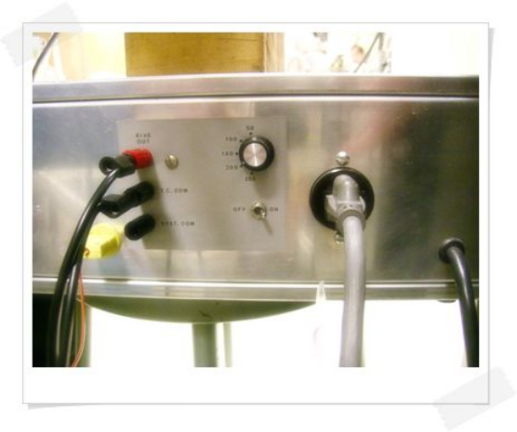
1) To ground the sample or give a zero bias voltage, connect “SYS COM” to “TC COM” with a banana cable.
2) To apply a negative bias to the sample using the internal bias supply, connect “TC COM” to “BIAS OUT”, select the desired voltage and turn on the switch.
3) To apply a negative bias with an external voltage source, connect its positive terminal to “SYS COM” and its negative terminal to “TC COM”. To apply a positive bias, reverse the polarity of the voltage supply.
4) When using an external source, the bias current can be monitored by connecting a current meter (usually the Keithley Picoammeter) in series with the voltage source between “SYS COM” and the terminal of the source.
Note: The last time this was done was before 2023.

Cleaning
The sample cleaning process depends on the nature of the sample and the contamination species. Some samples can be cleaned by oxidation–reduction cycles, such as carbon contaminations on noble metal surfaces. Some surface species can be removed by heating the sample above the desorption temperature of the surface species. But usually, most of the samples need to be cleaned by repeated cycles of sputtering and annealing.

Chemical cleaning
For heavy carbon contamination on metal surfaces, such as on Ni or Pt surfaces, the sample can be cleaned by heating it in 10⁻⁶ Torr O₂ at about 800-1000 K, and then reduction by heating in 10⁻⁶ Torr H₂ at about 800-1000 K. Repeat the cycle if necessary. For the Pt sample, the surface oxygen species can be removed by flashing the sample above 1300 K.
The Ta substrate can be cleaned by sputtering the Ta substrate using 2 keV ion energy in 3.0 x 10⁻⁵ Torr Ar for 60 min followed by oxidation in 2 x 10⁻⁵ Torr of O₂ at 600 °C for 5 min (this step can be left out, try what works best for you) and annealing at 600 °C for 5 min in UHV.
SiO₂ can be cleaned by two cycles of sputtering (2 x 10⁻⁵ Torr Ar, 2 keV, ≈10 µA, 10 min) and oxidation (2 x 10⁻⁵ Torr O₂, 600 °C, 10 min).
Cu can be cleaned by sputtering (3 x 10⁻⁵ Torr Ar, 2 keV, 60 min) and subsequent annealing to 850 K for 5 min. We sputter the Cu sample at a 30° angle (z=21.5, θ=215°).

How to determine if it is clean
The cleanliness of the sample can be checked by XPS. Usually, the C 1s and O 1s XP spectra need to be checked to make sure the sample is clean. Other methods, such as H₂ TPD or CO TPD, can also be used if XPS is not available.

Temperature reading
The temperature can be read with a voltmeter connected to the BNC output labeled "TC PREAMP OUT" on the front of the ramping temperature controller. This is the thermocouple voltage amplified by a factor of 245.5, which results in a voltage of (approximately) 10 mV/°C, e.g. 3.27 V is 327 °C etc. Below 0 °C, the thermocouple table has to be consulted. To read the temperature, the main switch of the temperature controller has to be on.
The temperature can also be read through the small homemade Omron temperature controller (yellow) directly. Disconnect the thermocouple wire from the ramping temperature controller and connect it to the Omron temperature controller to read the temperature. There may be a slight difference (<10 K) in temperature reading between these two methods.
A third method is to run a “dummy TPD”. That means just start a TPD measurement on the QMS computer (you can use the file named “temperature”) without running the mass spectrometer. The file will show the temperature measured live.

Heating power supply (operation, calibration)
The sample is heated by an AC current supplied by the ramping temperature controller through a transformer. The power limit should not be set too high. Otherwise, the tantalum wires can be burned off, and overheating of the sample can happen. 50-80% power output is suggested for heating the sample up to 1100 K. The temperature ramp end can be set on the temperature controller. The relationship between the temperature ramp end set value and the “T.C. preamp. Out” can be referred to in the temperature conversion table. During normal operation, a linear ramp of sample temperature is suggested in order to avoid overheating.

Gas Handling, Gas Manifold

Design, schematics, valves
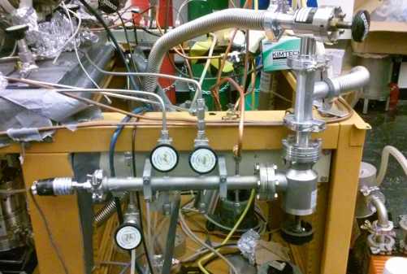
The manifold forms a separate vacuum system. The manifold is pumped by a mechanical pump (the Alcatel pump), and the pressure in this vacuum line can be measured with a thermocouple gauge. The reading from this thermocouple pressure sensor is located on the Granville-Phillips Vacuum Controller. There is a valve that can be used to isolate the manifold from the mechanical pump (at the moment, this valve is leaking slightly when it is closed, October 2026). The manifold may need to have its gaskets replaced occasionally.
The manifold is connected to the UHV chamber through variable leak valves. The variable leak valves are used for controlling the dosing process in experiments.

Gas, liquid and solid sample handling
The projects on the Michelle UHV system require introducing the chemical precursor into the system in the gas phase. When handling chemicals, the lab safety role and specified MSDS must be followed.
To use the gas, connect the gas bottle to one of the open leak valves. The gas delivery line can be pumped through the gas manifold with the mechanical pump.
For liquid and solid precursors, if the chemicals are not air/moisture sensitive, they can be handled in the fume hood in room 135. Transfer the chemical into the glass/metal container. Then connect the container to the leak valve by CF or Swagelok fittings. For air/moisture sensitive chemicals, please refer to the operation procedure for the glove box below (see also Chapter 13).
The chemical precursor must be pre-pumped before opening the leak valve. Side-pump the precursor with the mechanical pump first. For chemical precursors that have a relatively high vapor pressure, freeze the precursor with liquid nitrogen when pumping. Be very careful if you do this with water; the expansion of water when freezing easily breaks the gas vial. The precursors can be heated by putting a silicone oil bath around the precursor container. Control the oil bath temperature to reach the desired vapor pressure.

Leak valves
The leak valves need to be only finger-tightened to ensure a proper seal. Further tightening may break the sealing crystal inside. The best process is to close the leak valve fully and then turn it back by a quarter turn to reduce stress on the thread. The leak valves sometimes need to be retuned. There are two things that can be done:
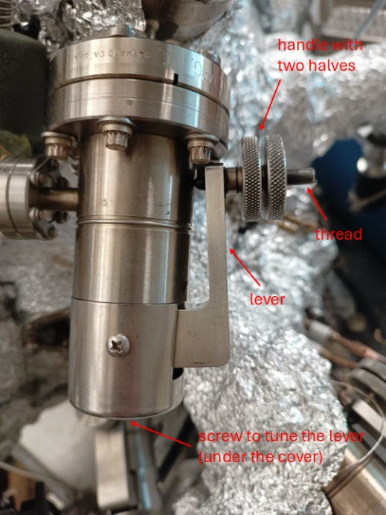
1) Changing the stop position. Loosen the two halves of the handle against each other. Now you can screw each half up and down on the thread without turning the thread itself. If the thread does not turn, the leak valve will not open or close. Screw both halves away from the lever for a couple of turns to give you some room for operation. Now tighten them against each other again, so that turning them will turn the thread and close/open the leak valve. Find the point where the gas starts leaking into the chamber, i.e. the pressure goes above the base pressure. Close the leak valve from this point by two more full turns to give you some “safety buffer”. Keep the thread in this position and loosen the two halves against each other again. Now, turn one by one on the thread towards the lever until the inner one touches the lever and then tighten the outer one against the inner one. This sets the stop position (to two full turns after closing the valve).
2) Retuning the lever. Sometimes changing the stop position is not sufficient anymore to stop the leak valve from leaking in closed position. Then, the lever can be retuned by turning the screw on the end of the leak valve. Very slight fractions of a turn are often enough. Be careful at some point the crystal inside the leak valve might break. After retuning the lever, the stop position has to be reset (see 1).
Note that some valves on Michelle and in the lab have bad threads. It comes from forcing the leak valve against the stop position. There is no sense in doing that! If it feels like the valve does not close properly, just reset the stop position!
If you want to replace the thread on a leak valve, you can do it without venting. Clamp a pencil or a similar object between the lever and the leak valve body, so that the lever does not move towards the body once you are unscrewing the thread. Now you can unscrew the thread completely and replace it with a new one. You can also do this to relubricate the thread (also lubricate the new threads).

Use of glove box
A glove box is a sealed container that is designed to allow users to manipulate objects where an inert atmosphere is desired. It has an antechamber which has two doors connected to the glove box and the outside. Follow the steps below when operating the glove box. Here is a short description of operating the glovebox in room 135. Please refer to the glovebox manual for more details.
1) Check the oxygen level to ensure that it is in the right range. Check the pressure on the N₂ gas cylinder (record both in the logbook). If the total pressure of the N₂ gas cylinder is around 500 psi, you can continue using the system. If the pressure is less than 300 psi, please change to a new N₂ gas cylinder following the instructions in Section 2.5. The supplied N₂ pressure should be around 35 psi. The antechamber is under vacuum, and its pressure is indicated by a gauge.
2) Press the “FCT” key. Use the “up” and “down” arrows to select the “AutoVac” option menu. Press the “FCT” key to access the menu.
3) Use the “up” and “down” arrows to select the “Start Manual Refill Routine”. Press the “FCT” key. The antechamber will be filled with N₂ as the pressure gauge in the antechamber indicates. The process will stop automatically once the right pressure is reached. Press the “ESC” key to return to the normal mode.
4) Open the outer antechamber door. Place all items (glass-metal container with all necessary tools) onto the pull-out tray. Push the tray back into the antechamber. Make sure that the tray does not touch both the inside and outside doors. Close the Outer antechamber door.
5) Press the “FCT” key. Use the “up” and “down” arrows to select the “AutoVac” option menu. Press the “FCT” key to access the menu. Use the “up” and “down” arrows to select the “Start AutoVac Sequence”. Press the “FCT” key.
6) The “AutoVac control” menu will be displayed on the monitor. The vacuum setpoint (50), pump time (5 min) and number of cycles (3) will be indicated. Press the “FCT” key to start the sequence. Please closely monitor the oxygen level. If the oxygen level increases very fast, press the “ESC” key immediately to return to the normal mode. It will take about 20 min. Once the sequence is completed, it will be displayed on the monitor. Press the “ESC” key to return to the normal mode.
7) Get into the gloves and open the inner antechamber door. Move the items on the tray into the glovebox and close the antechamber door again. Transfer the chemical into the glass-meal container and close the sample valve.
8) Open the inner antechamber door. Move the items on the tray into the antechamber. Close the inner door. Get out of the gloves again.
9) Open the outer antechamber door. Remove items from the tray and close the outer door.
10) Press the “FCT” key. Use the “up” and “down” arrows to select the “AutoVac” option menu. Press the “FCT” key to access the menu. Use the “up” and “down” arrows to select the “Start Manual Evacuation Routine”. Press the “FCT” key to start. Leave it for 5 min. Then press the “ESC” key to return to the normal mode.
11) Record the O₂ level and the pressure of the N₂ gas cylinder in the logbook.

Dosing of precursor
1) If the precursor is air-sensitive, transfer it into a glass-metal container inside the glove box. Attach the glass-metal container to a Swagelok valve and close the valve while it is still in the glove box.
2) Transfer it out and connect it to the system. The setup can look something like below. You should have a tee that connects to a leak valve, a connection to the roughing pump/gas manifold with a valve, and the valve/vial combination from 1).
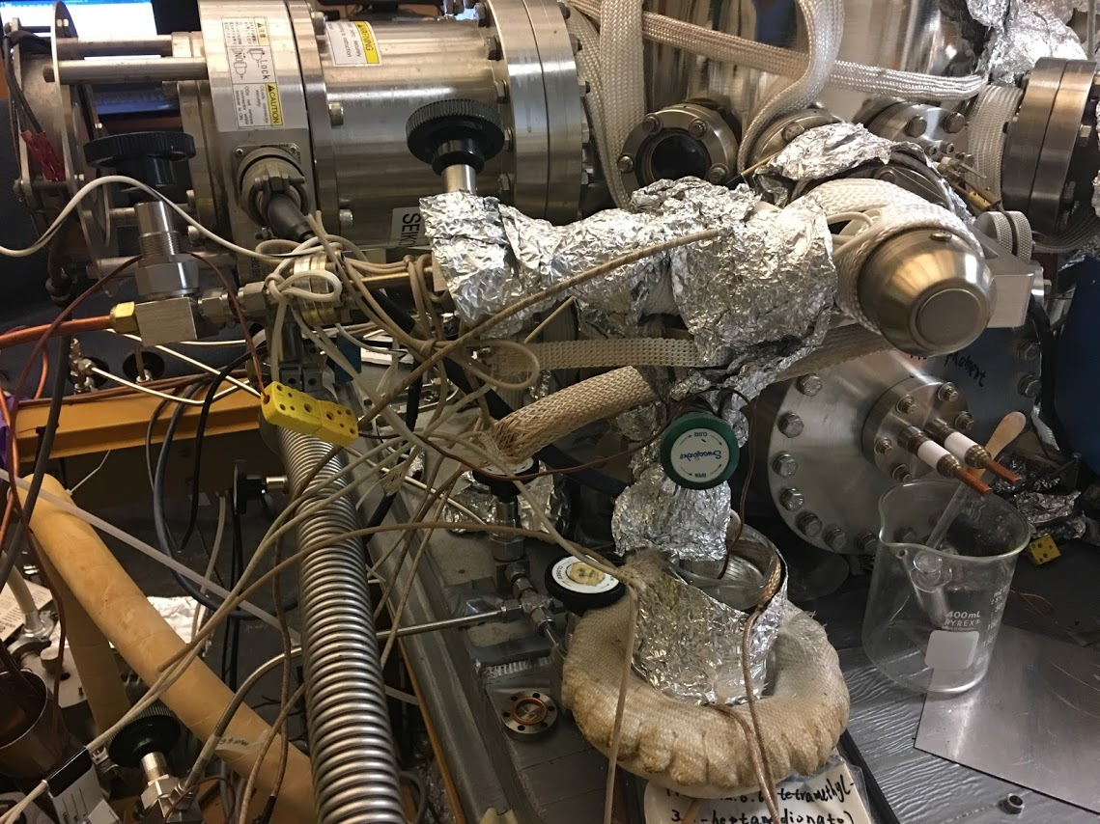
3) Open the Swagelok valve and the roughing valve to pump away the nitrogen atmosphere above the precursor (Depending on the vapor pressure of the precursor, you might need to be a bit careful). You can heat the precursor with a silicon oil bath to increase the vapor pressure. If you are doing this, also heat the gas dosing line with a heating belt. Depending on the precursor, we have done doses with differential pumping (i.e. the valve to the pumping line remains open) or without it.
Ru Precursor
Si Oil bath
Leak Valve
Roughing Valve
4) Introduce the precursor into the chamber at the desired pressure and for the desired time.
Note: Pumping precursors with the roughing pump can lead to deposits of material in the copper tubing and all other pipes. It also degrades the thermocouple gauge, which may need replacement sooner than typical. It is also advisable to do roughing pump oil changes more often.

Maintenance
The gas manifold is always evacuated by a mechanical pump. Sometimes the base pressure of the gas manifold is not low enough for handling some liquid samples. An LN2 trap can be added to the gas line to remove water contamination in the gas manifold system.
If a liquid sample is used, a reasonable vapor pressure of the liquid sample remains in the gas line and also in the mechanical pump for a long time. Changing the oil of the mechanical pump and baking out the gas line are needed to remove the liquid remaining in the gas handling system.

Quadrupole Mass Spectrometer (QMS)

General operation
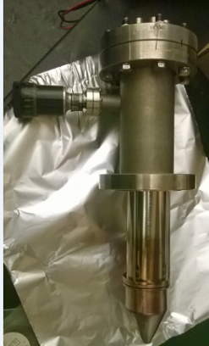
Michelle is equipped with a UTI 100C mass spectrometer (MS) with a nose cone mounted on a z-shift. The cone, having a 5 mm diameter, can be placed within 1 mm of the front face of the sample via a rotary motion feedthrough. This is to provide greater sensitivity to only those compounds really coming off the surface in a TPD experiment. The feedthrough is deliberately placed in an orientation that it points downwards to the ground. Although it may seem to be more logical to have it pointing towards the ceiling for easier access, it has been found through experience that the internal mechanisms require the pull of gravity to prevent a clog from becoming detached. Warm up the MS electronics assembly for roughly 45 min to reach thermal equilibrium and give repeatable results. There are several copies of the UTI manual in the lab, which is very helpful for troubleshooting. The cone and the z-shift are a homebuilt modification and not included in the manual.

Engaging mass spectrum
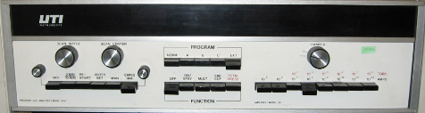
1) Check if the “Emission” dial is turned completely counterclockwise.
2) Set the range to 10⁻⁵.
3) Depress the main key.
4) Press “ON/STBY”. Wait for the instrument to equilibrate (5 s).
5) Press “MULT”.
6) Press “EMISS/(MA)” to follow the display of the emission of the filament. Slowly increase emission with the knob until ≈2.00 mA. Always use the same value to keep experiments comparable. Check if the protection mode is on (slide the front panel out; the little switch on the right-hand side: to the right: protection mode on; to the left: protection mode off).
Now the MS should work on the PC with the two programs. The following steps are for the use of the oscilloscope.
7) Connect scope (X to ramp generator, Y to signal out), set scope to X-Y mode to observe spectrum with scope (X-Y, DC decoupling)
8) Depress “EMISS/(MA)”, press “VAR” and adjust sweep time with the knob on the left side. The display over the range keys shows the intensity, whereas the one over “EMISS/(MA)” gives the mass.
9) Scan width and scan center can be varied with the respective knobs while “EMISS/(MA)” is depressed and “WIDTH” or “MAN” is pressed (only one switch pressed at a time).
10) Switch to “MAN” yields a straight line on the scope. You can tune from 1 to 300 amu manually with the “Center” knob. The height of the baseline gives the intensity of the peak.

Standby mode
This mode is preferable if the instrument will be used within a short amount of time, e.g. a day or even a week.
1) Place the instrument in “TOTAL PRESS” mode.
2) Set the range to 10⁻⁵ A.
3) Make sure that the emission switch is on.
4) Turn the emission knob counterclockwise fully, but not to the point that there is a click-off.
5) Make sure that the protection mode is on (see above or UTI manual).

Turn off
Turning the MS off is advisable only for an extended period of time, not for over the weekend. For periods of inactivity, place the instrument in Standby mode.
1) Place the instrument in “FAR CUP” mode.
2) Set range to 10⁻⁵ A.
3) Turn the emission knob completely counterclockwise, to the point that the knob clicks off.
4) Depress “ON/STANDBY”, then depress “OFF”

LabVIEW program – running analog scan MS
MS data is collected using a LabVIEW program “UTI_scan_average.exe”. This program can be found on the desktop, and the calibration file is in the Calibration_MS_TPD folder. This folder typically contains several calibration files. If the masses are off from the values they should be (e.g. CO at 28.5 amu, not 28.0 amu), a new calibration should be done.
1) Make sure that the set range is 10⁻⁵ A and the “Emission” dial is turned completely counterclockwise.
2) Press “ON/STBY” and wait 1 h to warm up the controller. (Steps 1 and 2 are only necessary if the MS was not in standby.)
3) Press “MULT” and Press “EMISS/(MA)” to follow the display of the emission of the filament. Slowly increase emission with the knob until ≈2.00 mA. Always use the same value to keep experiments comparable.
4) Run “UTI_Scan_average” on the desktop.
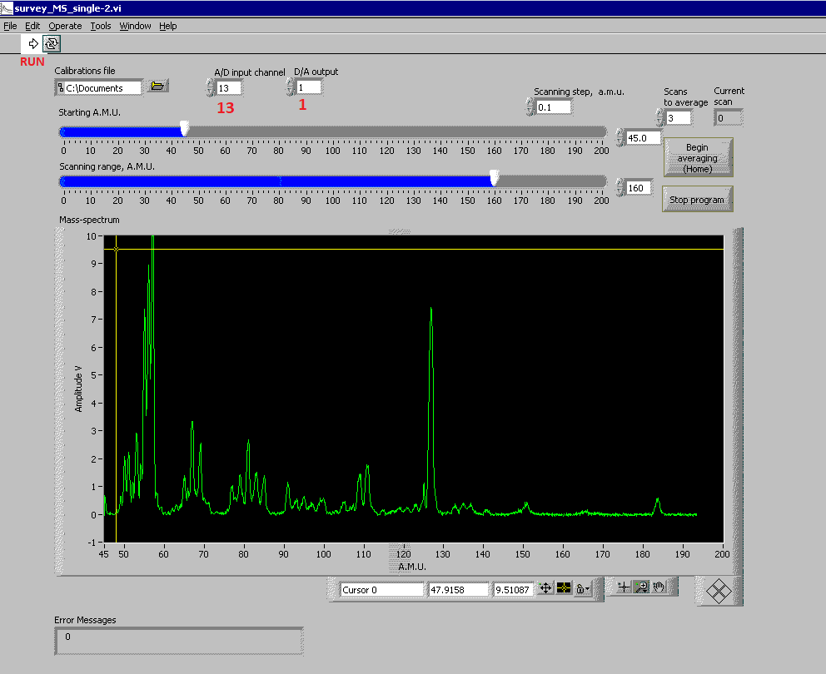
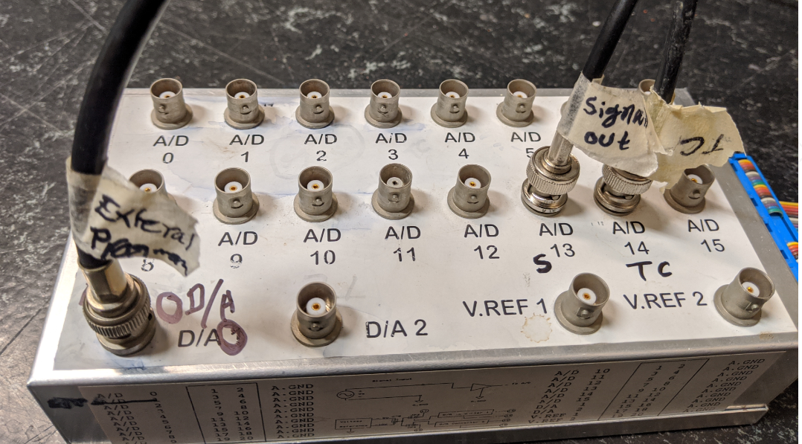
5) Click on “Calibrations File” and load the latest calibration file.
6) “A/D input channel” = 13 and “D/A Output” =1.
7) Adjust the “Starting A.M.U.” and “Scanning range, A.M.U.” to see the desired part of a mass spectrum.
8) Start the program by clicking "Run" (Arrow sign at the top) button or pressing “Ctrl-R”.
9) Switch through the magnifications (one by one) on the UTI controller to get a good signal. Note down the magnification that you used in the labbook.
10) Select the number of scans for averaging between them (default 10) and click "Begin averaging (Home)" or press the “Home” button on the keyboard.
11) After the last scan, a file dialog will open. Select the folder and file name to save the data.
12) Click on “Stop program” to stop data acquisition. (This will not turn off the mass spec itself; you have to do that on the UTI controller, see above.)
Calibration file for MS
The number in the filename, like 11.5, stands for the resolution of the mass spec. This value can be tuned by a knob inside the controller (on the left side after removing the front hatch). The resolution changes how each mass is measured. It changes intensity against peak separation. To reach the knob, the front control panel must be pulled out. Ask for help in the group if you do it for the first time.
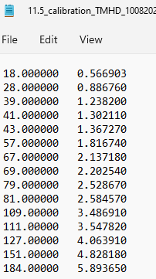

Temperature Programmed Desorption (TPD)
In a TPD measurement, desorbing species are recorded while linearly ramping the sample temperature. So it is important to make sure the sample can be heated with a linear ramp rate, and also that the mass spectrometer is tuned to the right parameters to record the desired mass signals. The TPD data can be taken only on the PC. The PC has to be connected to both the mass spectrometer and the temperature ramping controller.
It may be necessary to outgas the mass spectrometer before doing experiments. Ideally, only hydrogen, water, CO and CO₂ should be observed in the mass spectrum of the vacuum (the residual gas). If other (hydrocarbon) signals are detected, degas the mass spectrometer by turning on the filament (in Faraday cup mode) and wait for half an hour or so. The intensity of compounds other than the ones mentioned above should be barely detectable. During the course of the day, the filament is always left on to keep it outgassed.

Sample cleaning, dosing and Temperature Ramping Controller settings
TPD spectra can be recorded with the interesting masses using a certain ramp rate (1-10 K/s). A maximum of 30 mass traces can be recorded simultaneously by the mass spectrometer.
1) Clean the surface by sputtering/annealing. Move the sample so that it faces the leak valve from which you are dosing the gas/precursor and start cooling.
2) Wait until the sample has reached the desired adsorption temperature and adsorb the gases. The purity of the gases can be checked at this point by taking a quick mass spectrum. After dosing, it may be necessary to wait for a few minutes to pump out the gases; this will reduce the background in the data. Move the sample to the MS position (currently z=21.15 and θ=228°). Move the cone close to the sample (due to misalignment of the cone and the sample, we are not doing that in 2026).
3) Make sure the heater power on the temperature controller is off.
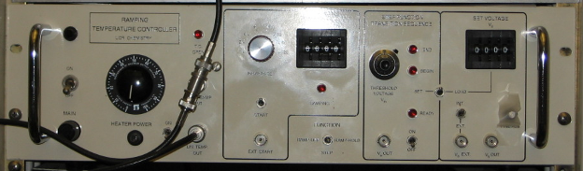
4) Set the maximum heater power to about 50-80%.
5) Set the switch located above the BNC labeled "Vs EXT" to "INT." When this is set to "EXT", the sample will not be heated.
6) Select the function "RAMP-HOLD" if you want the temperature to stay at the final level at the end of the experiment, or to "RAMP-OFF" if you want the temperature to go back to 77 K after the ramp has been completed.
7) Select the heating rate with the "RAMP RATE" selector switch. A good value is "2" which gives a heating rate of approximately 2.5 K/s. The higher heating rates will normally not be realized because they are limited by the maximum heater power.
8) Select the octal value of the initial temperature on the "SET VOLTAGE Vs" thumbwheels, then press the "LOAD" switch. (DO NOT FORGET THIS!) Make sure that the initial temperature is well below the actual temperature; otherwise, an uncontrolled temperature jump may occur. Since the data are usually taken from 100-1000 K or similar, "0000" is always a safe choice. (If the actual temperature is significantly higher, say 300 K, the actual heating just starts later. It will never result in a temperature jump when turning on the heater.) "Vs OUT" should then read 0.00.
9) Select the octal value of the end point temperature on "RAMP END POINT" thumbwheels. ("1503" corresponds to approximately 850 °C or 1120 K. In most of our experiments, “1351” corresponding to about 900 K, is chosen. Ultimately, make sure that your sample can withstand the final temperature.) A table of the temperature conversion is on top of the controller.
The sample heating can also be controlled by the Omron controller. In this case, cool down the sample by setting -200 °C as the setpoint and start the ramp by increasing the setpoint to your desired end temperature. The ramping rate can be set internally in one of the menus. In principle, the Omron controller does not produce strictly linear ramps, because it controls the temperature by switching the heating power completely on or off. However, fluctuations in the heating ramp have also been observed with the Temperature Ramping Controller (it also depends on the sample mounting). Although the heating is regulated by the Omron controller, the LabVIEW program still needs to read the temperature from the Temperature Ramping Controller. Therefore, you need to read the temperature with the Omron and the Temperature Ramping Controller at the same time. Connect two thermocouple wires to the same thermocouple plug (just screw both alumel ends into the alumel screw; same for chromel). This is how the thermocouple reading is currently (October 2026) set up.

TPD data acquisition by LabVIEW program
1) Make sure that the set range is 10⁻⁵ A and the “Emission” dial is turned completely counterclockwise.
2) Press “ON/STBY” and wait 1 h to warm up the controller. (Steps 1 and 2 are only necessary if the MS was not in standby.)
3) Check that the heating power is off. Check “RAMP END POINT” = “1351” (or desired end temperature), “RAMP RATE”= “2” (it will give ≈2.5 K/s) and “SET VOLTAGE” = “0000”.
4) Connect the TC and heating cable to the Temperature Ramping Controller (if not already).
5) Turn on the heating controller and warm up for some time.
6) Modify TPD.CFG file according to the masses you want to scan.
7) Press “MULT” and press “EMISS/(MA)” to follow the display of the emission of the filament. Slowly increase emission with the knob until ≈2.00 mA. Always use the same value to keep experiments comparable.
8) Select a magnification (e.g. 10⁻⁹ A). Note it in your labbook.
9) Run Shortcut to “TDS_RTC” on the desktop.
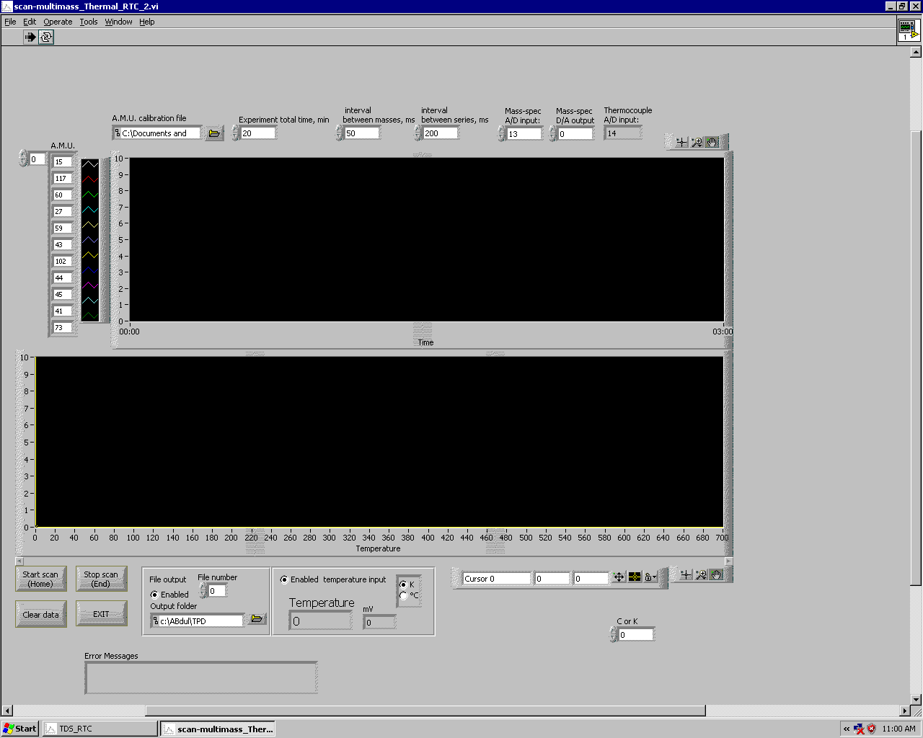
10) Load the “TPD MS” calibration file.
11) Click on the “A.M.U. calibration file”.
12) Load the A.M.U. calibration file. (You can also specify the A.M.U. calibration file in the TPD calibration file and skip steps 11 and 12.)
13) Check that the “interval between masses” is 200 (or how it is desired for your experiment), “Mass Spec A/D Input” = 13, “Mass Spec D/A Output” = 0, “Thermocouple A/D Input” = 14. (They can be specified in the calibration file.)
14) Click on “Start Scan (Home)” to start.
15) Check the Ramp rate on the heating controller.
16) Press “Load”.
17) Turn on the heating power.
18) After completion of the TPD, click “Stop scan (End)” and save the data.
The calibration file for TPD
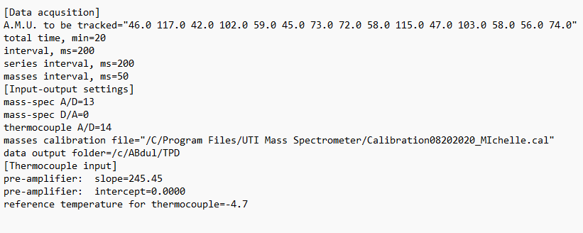

Calibration of masses – LabVIEW program
1) Open the file “test”. If it does not automatically open, right-click on the file and click on “Open”. Then select “Notepad” and click “OK”.
2) Make sure that you see the following numbers:
0.000000 0.000000
1.000000 0.010000
3) Run the application “UTI_scan_average”
4) Select “test” as the calibration file.
5) Change “A/D input channel” to 13 and make sure “D/A output” is 1.
6) Set “Starting A.M.U.” to 1 and “Scanning range, A.M.U.” to 150.
7) Click on “Run” (right arrow in the top-left corner).
8) Select a good magnification.
9) Click “Stop program” right before the scan reaches 150 or alternatively collect a spectrum averaging a few cycles (you will need to do steps 10 and 11 with Origin on your own computer then).
10) Right-click on the scan page and select “AutoScale Y”.
11) Magnify each peak and note down its exact amu position. For example:
Water (18) was at 56.6903
CO (28) was at 88.6760
12) Type the amu of our known substances in the first column and the corresponding amu value after dividing by 100 in the second column. For the spacing between the columns, click “Tab”. For example, the calibration value for Michelle's chamber on 10/06/2020 is:
18.000000 0.566903
28.000000 0.886760
39.000000 1.238200
41.000000 1.302110
43.000000 1.367270
57.000000 1.816740
67.000000 2.137180
69.000000 2.202540
79.000000 2.528670
81.000000 2.584570
109.00000 3.486910
111.00000 3.547820
127.00000 4.063910
151.00000 4.828180
184.00000 5.893650
12) Go to the file “test” in Notepad and select “Save as”. Input your desired file name with “.cal” at the end, select “Save as type” as “All files”, set “Encoding” as “ANSI” and save the file.
In order to check if the calibration is accurate, introduce Ar into the chamber and run the program using the new calibration file. Peaks at 40 and 20 should now be visible.
If you need accurate calibration in the higher mass ranges. Dose a known substance that shows peaks in those ranges during the calibration procedure (for example, the ALD precursor you are currently working with).

Calibration of temperature input for TPD
At the bottom of the TPD calibration file, the thermocouple input parameters need to be specified. They change if a different Temperature Ramping Controller is used or also sometimes just over time. Follow this procedure to determine the correct parameters:
1) Start cooling the sample with liquid nitrogen.
2) Although the heating is regulated by the Omron controller, the LabVIEW program still needs to read the temperature from the Temperature Ramping Controller. Therefore, you need to read the temperature with the Omron and the Temperature Ramping Controller at the same time. Connect two thermocouple wires to the same thermocouple plug (just screw both alumel ends into the alumel screw; same for chromel). This is how the thermocouple reading is currently (October 2026) set up.
3) Heat the sample to specific temperatures (for example, -180 °C, -160 °C, -140 °C, etc.). At each temperature, note down the temperature that you measure with the Omron controller, and at the Temperature Ramping Controller, measure the voltage at “preamp out” with a multimeter.
4) Take a thermocouple table (widely available on the magnificent world wide web) and note down the measured temperatures and the corresponding TC voltages in an Origin table. Add a third column converting the TC voltages in V (if your table gives them in mV). Add a fourth column with your measured “preamp out” voltages (in V).
5) Plot the “preamp out” voltage (as y) against the TC voltage (as x). Apply a linear fit.
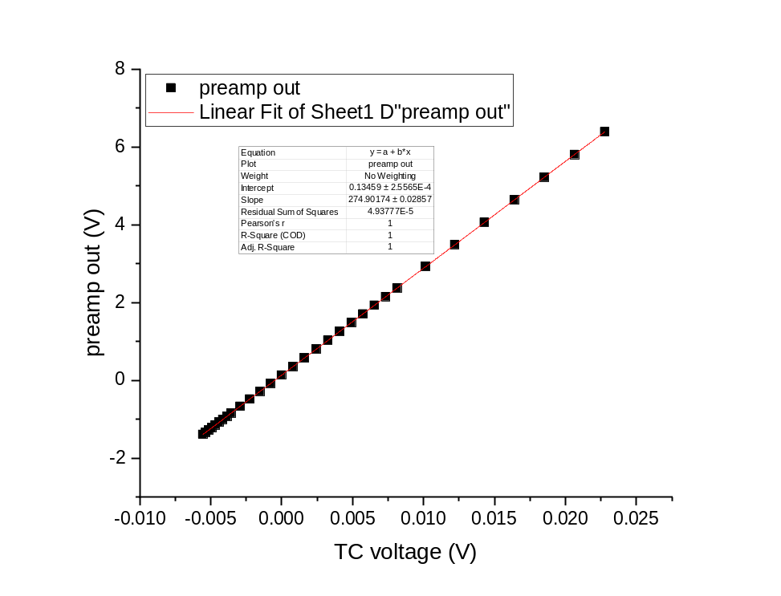
6) The linear fit gives you a value for the slope (something between 200 and 300) and an intercept (smaller than 1). Enter these values into the TPD calibration file in the lines “pre-amplifier: slope” and “pre-amplifier: intercept”
7) Check how good the calibration is by repeating the measurement from 3) and noting down the temperatures the LabVIEW program reads with the new calibration.
8) If there is a constant or somewhat constant offset between the two measured temperatures, you can correct it by entering a non-zero value into the “reference temperature for thermocouple” line. In theory, this should not be necessary.

Installation of LabVIEW program

System requirements
The PC should be able to run Windows XP at tolerable speed, Pentium-3 500 MHz or faster. It also must have an unoccupied ISA slot on the main board for the Advantech PCL-812PG card. To use the Omron PID temperature controller or Terranova vacuum gauge controller, connections to COM1 and COM2 ports with RS-232 cables are needed.

Installation of hardware
- Advantech PCL-812PG LabCard is not a plug-and-play device. First, check the jumper settings on the card for the Base Address, IRQ and DMA. For most configurations, the good settings are IRQ 5, DMA 3 and I/O range 220-22F. Write the settings down. For the location of jumpers, refer to the LabCard manual.
- Check if the Trigger Source is set to External and CN5 socket on the card has no connection between pins 10 and 1.
- Install PCL-812PG into the ISA slot
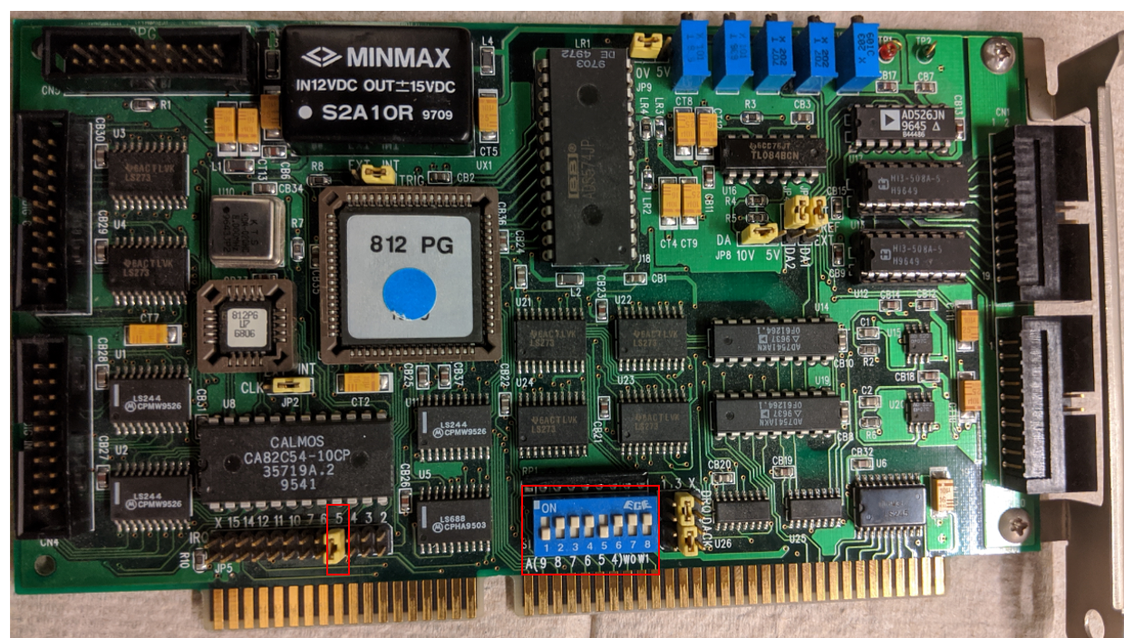
- When starting the computer, go to the BIOS setup screen and set the same IRQ, DMA and base address to be reserved for a Legacy/ISA device. This will prevent Windows from assigning them to plug-and-play devices, which would interfere with the LabCard.
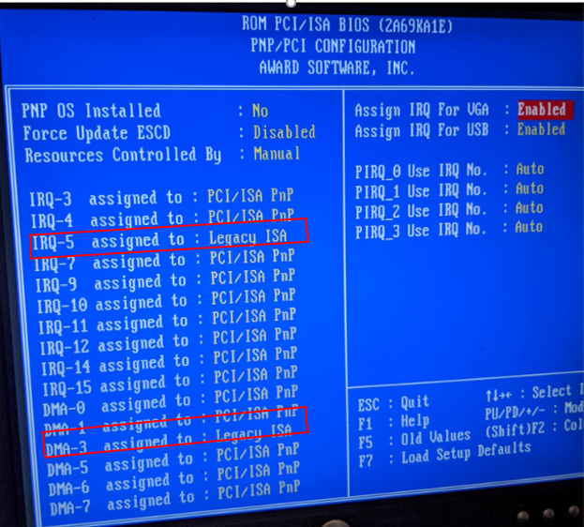
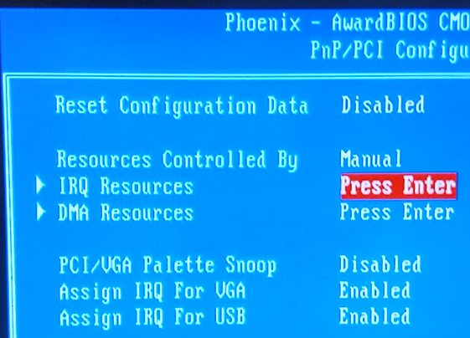
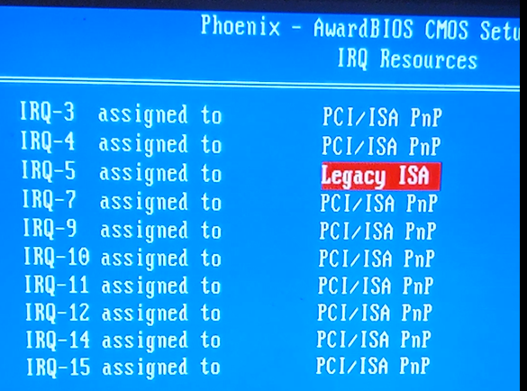
- To work with the Omron E5CK controller, connect it to the COM1 port as described in the Omron manual. Make sure the controller settings for the COM1 port (baud rate, stop bit, parity, etc.) are the same as for Windows. Use Windows Device Manager to check port settings.
- To work with the Terranova 934 vacuum gauge controller, connect it to COM2 with an RS-232 cable. Check if the settings for the COM2 port are the same for the controller and for Windows.
- To test the instruments connected to COM ports, the PortTest.exe program can be used. Refer to instrument manuals for the communication commands.

Installation of LabVIEW software
- Install Windows drivers from PCL812.exe. Restarting the PC may be needed at the end.
- Install the Advantech device manager_32bit from DevMgr.exe
- Install All_Examples_32 Bit
Run the device manager. The PCL812 card must appear in the list of devices; select it. Go to the “Setup” menu and check if the settings for IRQ, DMA and base address are the same as for the card jumpers. Then switch to the “Test” menu and read the voltages from the A/D channels. The numbers should be changing randomly, representing the noise. If they are stuck, the card is not properly set up; most likely, the IRQ or I/O address is conflicting with some other device on the computer.

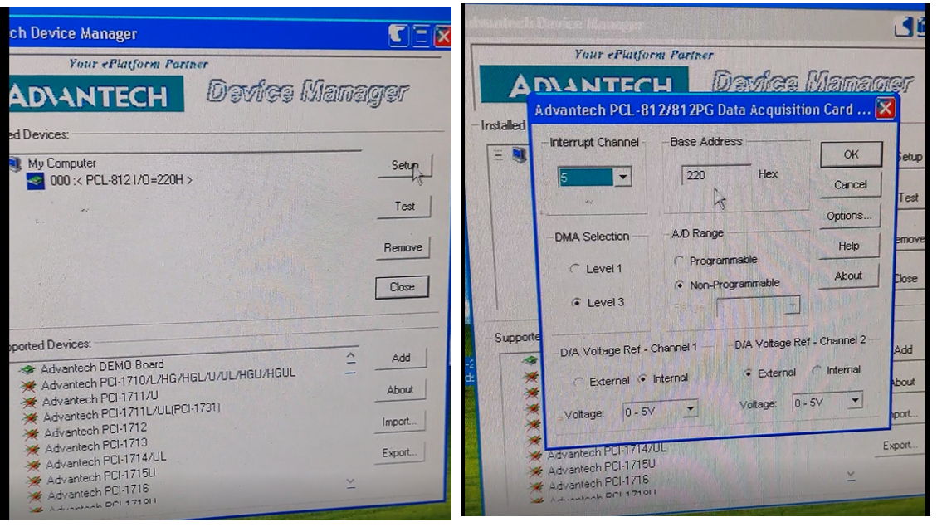
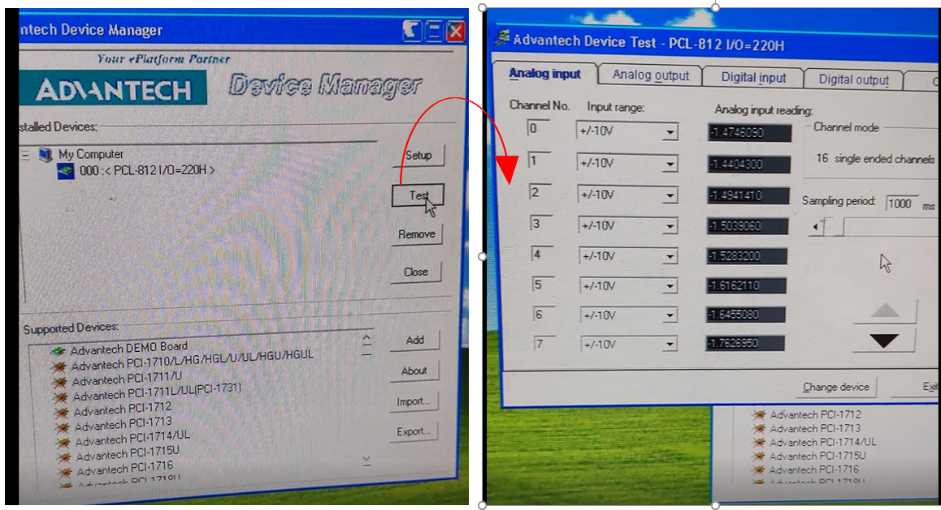
- Run Applications / Install / Install.exe. Select an installation folder for the mass spectrometer program. This setup will also install necessary system components and may require a restart of the PC.
- Copy other EXE files from “Applications” to the same folder.

Recording MS with the Basica program
Note: This has not been done for some time (last time before 2023).

Running MS using Basica
The Basica program for MS is on the GATEWAY2000 Windows 95 computer. First, connect the Signal out, External program, and TC cables to the Windows95 computer. For recording MS:
1) Open the “ms” folder in the “C” drive.
2) Run the “MSPECT6” file, and the “WELCOME TO THE MASS SPECTRA ACQUIRING PROGRAM” window will pop up. Press any key to continue, and the “MSPECT6 - BASICA” window will pop up.
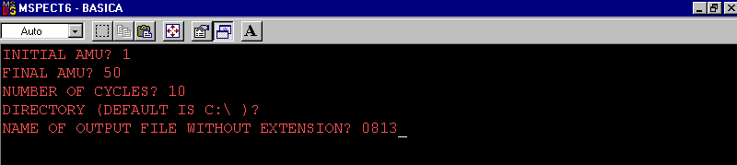
4) Type the initial amu and press “Enter”.
5) Type the final amu and press “Enter”.
6) Type the number of cycles.
7) Press “Enter” for Director.
8) Type the name of the output file without extension and press “Enter”.
9) After completion of the cycles, the window will pop up.
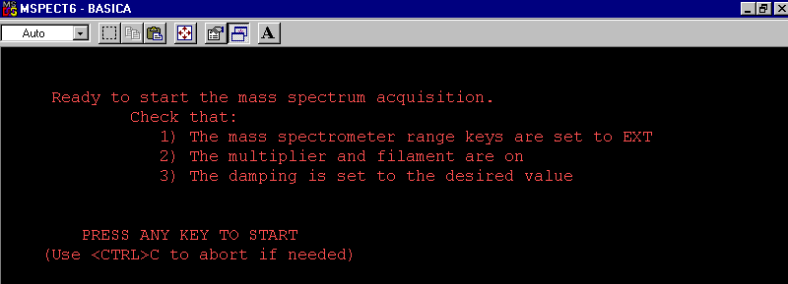
7) Use “Ctrl-C” to abort.
8) Type “system” to exit or “run” to continue.

Running TPD using Basica
The Basica program for MS is on the GATEWAY2000 Windows 95 computer. First, connect the Signal out, External program and TC cables to the Windows 95 computer. For recording TPD:
1) Open the “ms” folder in the “C” drive
2) Run the “Tds6” file, and the “WELCOME TO THE TPD ACQUIRING PROGRAM” window will pop up. Press any key to continue, and the “TDS6 – BASICA” window will pop up.
3) Press any key to continue.
4) “HOW MANY MASSES TO BE FOLLOWED? (1-15)?” Set the desired number of masses.
5) Enter the masses to be followed.
6) Name the output file.
7) Select the directory.
8) Set the acquisition time.
9) A second window will pop up with all summaries of parameters.
10) Press any key to run.

Maintenance (filament, detector, and cone)
Replacement parts for the UTI mass specs are located in several boxes on the shelf next to the toolbox in room 139. Refer to the UTI manual for a more detailed description of the procedures. Note: The cone is a home-built add-on and therefore not mentioned in the manual.

Removing the cone
Special attention should be paid to the cone. The cone can be moved in and out. When the cone is moved close to the sample, check from the viewport to make sure it is close but does not touch the sample. And always move very slowly. The cone must be in the full back position when the manipulator is moved (rotational and translational). Otherwise, the cone will collide with the sample, sample holder, or the manipulator. Always return the cone to the full back position right after taking the MS/TPD data.
If the mass spectrometer needs to be serviced, the cone must be removed. Consult the UTI manual for the repair procedures of the mass spectrometer itself. Make sure you have two 4.5" and 1.33” flange copper gaskets before you start.
Taking the cone of the mass spectrometer off:
1) Vent the chamber.
2) Disconnect the large aluminum quick-disconnect probe connector from the end of the mass spectrometer probe.
3) Remove the nipple bearing the mass spec probe at the flange closest to the chamber. (It cannot be removed at the flange bearing the feedthrough until step 6.) Lay the probe/nipple assembly on a clean working surface and cover the opening of the chamber.
4) Mark the position of the mass spectrometer with respect to the nipple. Consider that the nipple has a rotatable flange, so mark the position of the rotatable flange with respect to the nipple’s main body, too. This makes reassembly much easier.
5) Dismount the rotary feedthrough from the side of the nipple. Save the copper gasket.
6) Unbolt the main feedthrough flange and take the nipple off. Save the copper gasket.
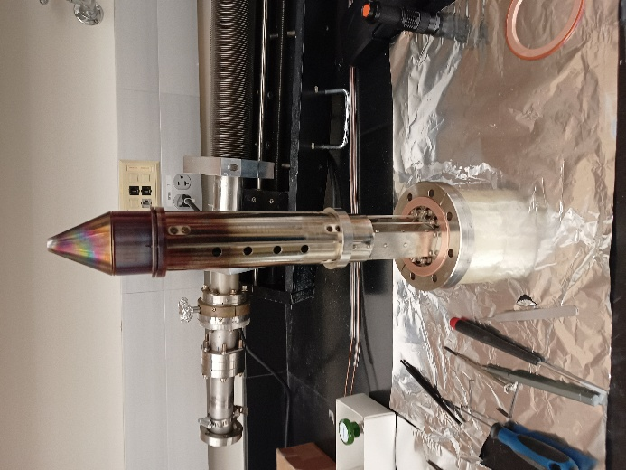
7) Loosen the screws that hold the three rods to the ring.
8) Take the cone off by unscrewing the rods.
9) The additional cover around the ionizer can be removed after unscrewing the holding screws.
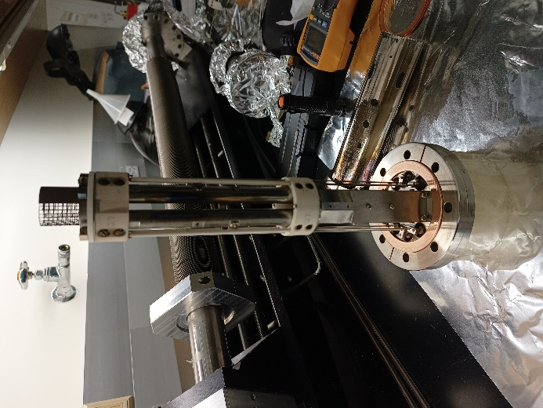
At this point, the mass spectrometer is serviced according to the UTI manual.
Putting back the cone of the mass spectrometer:
1) Put the rods back through the holes in the rim and attach the cone to it. Screw the rods about halfway in.
2) Put the ends of the rods back into the holes in the ring.
3) Tighten the rods to the ring. In doing this, make sure that the lengths of all three rods measured from the top of the ring to the bottom of the cone are exactly the same. Use a caliper, and adjust the slotted screws and lock nuts as necessary. If these lengths are not the same, the cone assembly will not slide smoothly. Use a small screwdriver and a 4 mm wrench.
4) Make sure that the rack is in place.
5) Set the probe assembly vertically on the main feedthrough flange. Use a holder (for example, a roll of tape) so that the weight is not directly on the feedthroughs.
In the remainder of the reassembly procedure, it is necessary to verify that the motion of the rotary feedthrough and cone will be smooth. This is accomplished by proper alignment of the rotary feedthrough sidearm with respect to the rack slide assembly on the probe.
6) Put the used gasket on the bottom flange, place the nipple on top of it, and match up the alignment marks from step 4 of the cone disassembly procedure above. Put in a couple of the bolts and finger-tighten them.
7) Reinsert the rotary feedthrough with its old gasket and a couple of bolts, making sure that the rack and pinion are engaged.
If everything is aligned, the motion of the system should be smooth.
8) Now, reassemble using new gaskets. Tighten the large flange first, then the rotary flange. As the rotary flange is being tightened, check from time to time to see that the motion is smooth. This is somewhat sensitive to the tightening of this flange. If the cone gets stuck, moving the cone by hand a bit can help.
If the alignment has to be started from scratch, look for the alignment tool in the lab. This consists of an aluminum cylinder with a rod through its center. The cylinder exactly fits the inner diameter of the rotary sidearm. Note that there is a little socket in the rack slide that accepts the end of the rotary shaft on which the pinion is mounted.
9) Put the used gasket on the bottom flange, and place the nipple on top of it. Put in a couple of the bolts and finger-tighten them.
10) Line up the rotary sidearm by sight so that the shaft socket in the rack slide is visible and approximately centered in the opening.
11) Put the rod from the alignment tool into the shaft socket, and adjust the nipple until the cylinder fits smoothly over the rod and inside the rotary feed-through sidearm.
12) Reinsert the rotary feedthrough with its old gasket and a couple of bolts, making sure that the rack and pinion are engaged. The motion should be smooth. If not, make fine adjustments on the nipple until it is. If things are well aligned, the cone should fall back a little from its own weight.
13) Mark the position of the nipple with respect to the probe flange.
14) Put a new copper gasket between the nipple and mass spectrometer flange. Align the nipple according to the marks, and tighten the flange. Check if the alignment is correct by using the alignment tool: Initially, the aluminum cylinder cannot be moved easily in and out of the sidearm because the mass spectrometer is sitting too high. As the flange is tightened and the groove in the copper gasket is cut, the aluminum piece should move in and out easily.
15) Now mount the rotary feedthrough with a new copper gasket. As the flange is being tightened, check from time to time to see that the motion is smooth. This is somewhat sensitive to the tightening of this flange.

Filament replacement
The filament of the MS may need to be changed after a long time of use or exposure to a higher pressure reactive gas. One indication of filament failure is that it cannot be turned on, and the resistance measurement shows that it is open between the filament pins. Check the filament pin first before venting the chamber (see 6.8.4). To replace the filament, the cone has to be removed, and the filament is in the top part of the MS. Replace it with the correct rhenium-tungsten filament (diameter = 0.006 inches). This wire can be purchased from Scientific Instrument Services, Inc., and the part number is W45. The turns of the filament should be 12 to 13.
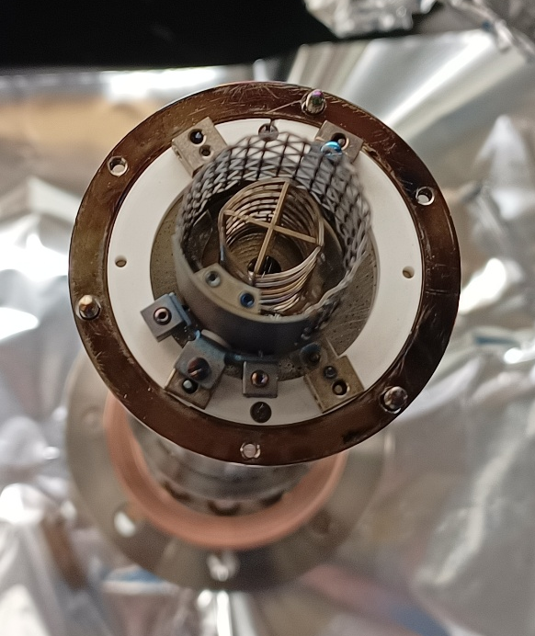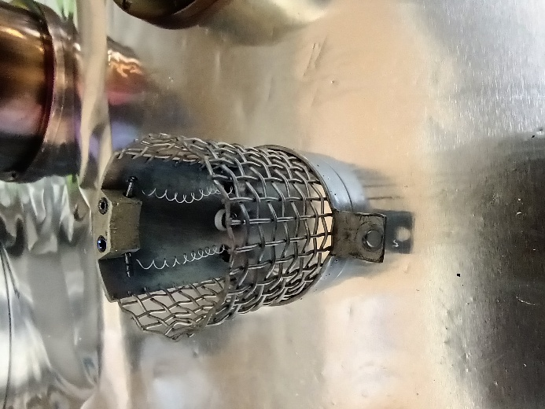

Detector
The detector (channeltron) of the MS should last for years. If the signal is too low with a higher emission current, it may suggest changing the channeltron. The channeltron is located on the backside of the MS. The signal can also be increased by increasing the multiplier voltage by turning a potentiostat on the right side after removing the front panel (refer to the UTI manual).
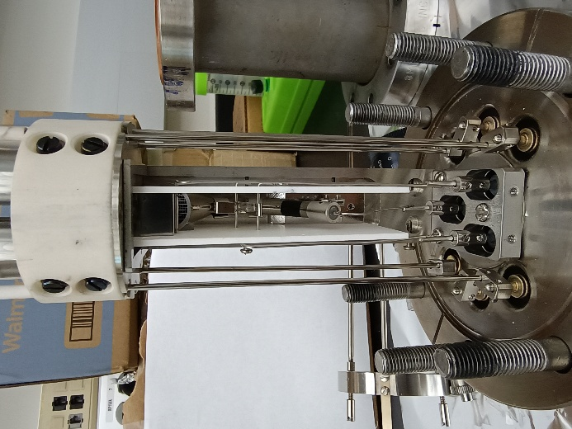
We have repeatedly seen an unstable background due to field emission. It shows in the data as random jumps in the background level that also affect the noise level. The reason are contaminations in the detector, which can be removed/burnt off by high-potting the detector. For that, set the multiplier voltage to the high limit for 1 min (not longer or you will damage the detector). You should see an increase in the chamber pressure. The procedure typically leads to a loss of signal, and you cannot compare intensities to previous experiments anymore.

Backplate
After taking off the back connector of the mass spec, the output of the filament connection is problematic. The connector is used up and it must be adjusted (squeezed together gently) sometimes to get a connection to the controller. Cleaning the pin with the pin cleaner tool also helps. Most of the time, when no emission can be achieved, it is actually this pin and not a burnt filament. The problematic pin is shown below.
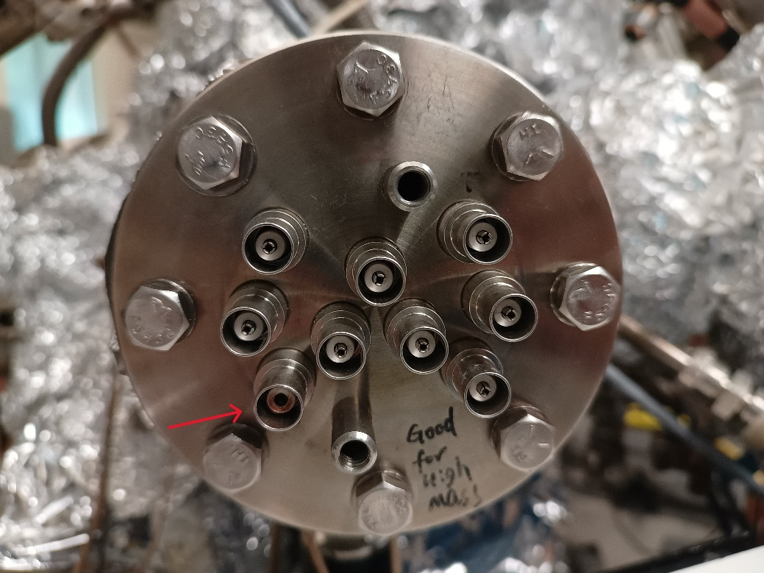

Ground loops
Additionally, ground loops have been a problem for the mass spec, between the controller and the ground. If the mass spec peaks have spikes or double peaks, this might be the cause. To find out, the oscilloscope should be connected to the system, as described above.

X-ray Photoelectron Spectroscopy (XPS)

X-ray gun

General considerations, connections
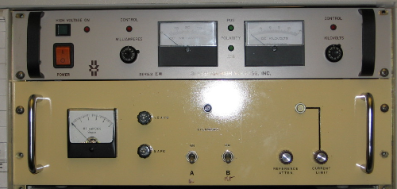
The X-ray gun is a VG XR3E2 Twin Anode gun. The power supply was built by a lab technician. The high voltage (HV) supply is from Glassman. A schematic for the power supply and a manual for the HV supply can be found in the file cabinet in room 139. There is also a manual for the Glassman.
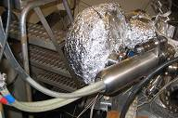
The water pipes and the HV cable need to be fed through both the internal protection and outer protective cover. To connect the water line, push until a slight click is heard. Do not insert them by force, as this may crack the insulation of the HV cable.
Secure the internal protective cover with Allen bolts. Put the exterior shield on and fix it into the locked position; tighten the screws to hold it. It is advisable to have a ring stand clamp combination located on the floor, holding the water lines to reduce the strain due to weight.
Lastly, insert the filament connector, located beneath the outer protective casing.

Initial operation
Cooling water is interlocked to the X-ray power supply through a flow switch. Without running the cooling water, the X-ray source cannot be powered.
1) The cooling water circulation system is in the corner of room 143. Verify that the red valve located on the flow regulator is open. There should be no flow present.
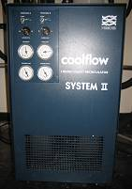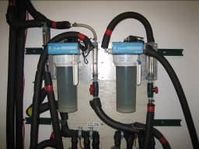
2) There is an opening at the top of the system where you can make sure that the water reservoir is full. The Michelle system is presently connected as “Process A”. Toggle the front panel switch to begin the circulation process (see figure).
3) Make sure that the flow switch is grounded to the chamber. Never touch the flow switch while applying the HV to the gun, as the flow switch sits at the same voltage.
4) The direction of the water flow is marked with “→” at the end of the connector. To get efficient cooling, water should flow in the correct direction.
5) After making sure that all connectors are secure and properly fitted, engage the cooling water subsystem.
6) After engaging the “Coolflow System II”, the cooling water also needs to be engaged. Pull down the two red handles and two white handles located directly above and to the right of the “Coolflow System II”.
7) The flow to Michelle is controlled at the “B-Pure” flow regulator located directly above and behind the “Coolflow System II”. Notice the light located at the very top. If the light changes to red, the filter needs to be replaced. To adjust the flow, use the red valve. Please note that the flow should not be stopped. If flow to the chamber is to be halted, turn off the “Coolflow System II” and not the red valve, as this will cause a large back pressure between it and the “Coolflow System II”. The optimal flow has been determined to be 0.5 GPM.
Note: A flow rate lower than this minimum will prevent the filament from engaging.
• Make sure that flowing water is reaching the chamber by monitoring the flow meter located on the chamber base.
• The chamber is now ready for the electronics to be engaged.
• To halt flow to the chamber, turn off the “Coolflow System II”. Again, do not shut the red valve as this will cause a large backing pressure.

Turning the X-rays on
When the cooling water is on, turn on the X-ray gun controller and high voltage power supply. Select the anode (Al or Mg). (As of Aug 2018 and still in Oct 2026, only the Mg anode can be used. The Al anode is contaminated and needs to be recoated). Slowly increase the filament current, and monitor the pressure in the chamber. When the current reaches 4.5 A, press the HV button on the high voltage supply and slowly increase to the desired value (Al 12 kV, Mg 10.5 kV). Then slowly increase the filament current and thereby the emission current, meanwhile watching the pressure, until the emission reaches 10 mA with the filament current at about 4.4-4.6 A.

Turning the X-rays off
Decrease the emission current and filament current to zero, and then reduce the HV to zero. Turn off the X-ray gun controller and high voltage supply. Let the cooling water flow for a while (10-20 min) to thoroughly cool the X-ray gun before turning it off.

Maintenance
Check the water level of the “Coolflow System II” regularly. Deionized water is needed in order to reduce the leakage current. We are using Millipore water from the machine on the second floor. The temperature of the cooling water should be around 15-21 ºC.
There is a cooling water interlock system that will shut down the X-ray gun power supply if the water is not flowing. This system should be checked regularly to see that it is working. An overheated anode could be catastrophic. Make sure there are no cooling water leaks inside the anode housing. Replace any fittings that are leaking. Moisture around the high voltage is dangerous.

Replacing the anode
Replacement of the anode is required if the anode is leaking or the Al/Mg coating is thinned with the copper surface exposed. The process is not difficult. Note: caution should be paid to the insulating ceramic of the X-ray gun when mounting the X-ray gun. Bring the chamber to air. Remove the source cover and uncouple the conduit assembly. Using a compressed air supply, blow the remaining water out of the anode. Separate the X-ray source from the chamber.
Remove the top anode shield, which is mounted to the Al window. Take care not to damage the filament, which is under the shield. Loosen the small centralizing ceramics located near the bottom of the anode under the anode shield cap. The anode can now be unbolted at the 1.33” CF flange. Record the orientation.
Put the new anode in. The anode alignment is critical to avoid anode crosstalk. Take care not to touch the coated anode faces.

Replacing the filament (cathode)
If the current through the filament cannot be turned on by the controller, first check that the cooling water runs and then the fuses on the front panel of the controller. If these are working, check the pins at the bottom and back of the gun as seen below.
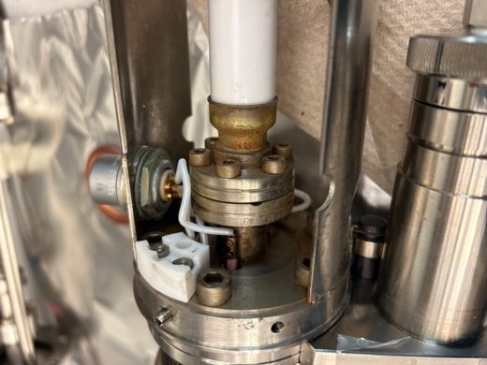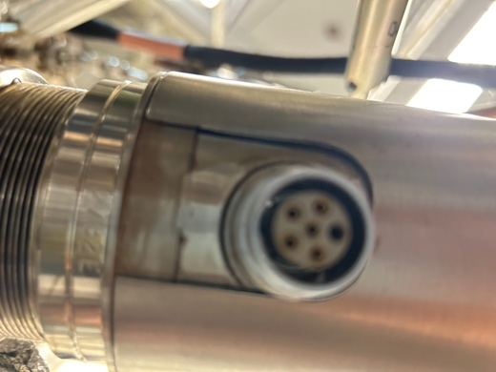
The filaments are connected through three pins. Hence, three of the five should have a connection to each other, and the other two should not. Recently, it has been a problem that the barrel connectors have been loosened over time, and there was no connection to the filament. The barrel connectors are shown above on the left. Connection between barrel connectors to pins (right) can be checked.
To replace the filaments, vent the chamber and remove the X-ray source from the chamber. Remove the top cover, which houses the Al window. Now, the filaments can be accessed. It can be replaced with a commercial filament or with thin tungsten wires. It is suggested to install the filament at the same height as the old setting. A picture of a properly connected filament is shown below.
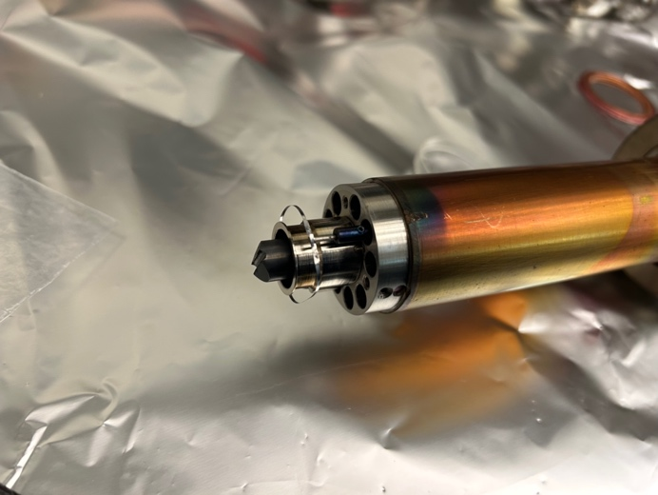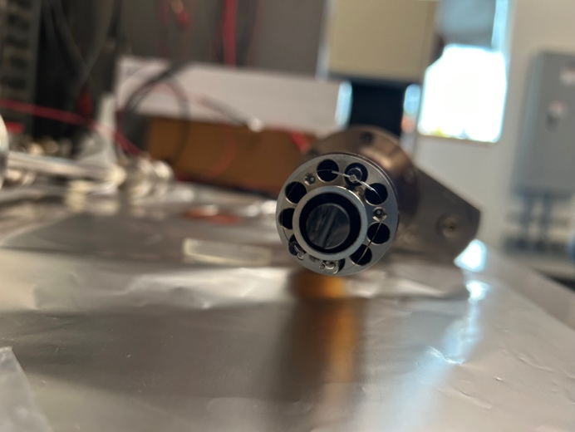

Replacing the aluminum window
The aluminum window typically gets contaminated over time, and it is necessary to replace it somewhat regularly. The aluminum window is made of 2 µm aluminum foil (stored in the metal foil cabinet in room 143). To replace the aluminum window, vent the chamber and pull out the X-ray source. Remove the top cover that houses the aluminum window. Put it flat on the table, and replace it with a newly cut piece. Take care; the 2 µm aluminum window is very fragile.

Electron energy analyzer and detector system
The VG100AX spectrometer analyzer is used to investigate the surface of the materials through the analysis of electrons (or ions) emitted by a sample. The analyzer acts as a narrow-pass filter, passing only electrons with a specific energy. The VG100AX analyzer has three main components: the lens, the analyzer, and the detector.

General considerations
It is recommended to read the VG manual prior to the next portion of this manual. It is actually helpful and not too lengthy. It is located on the top shelf of Michelle’s desk. A few things are slightly adjusted, predominantly the interaction between software and hardware, and will be highlighted here.
The controller electronics consist of the following components:
• Digital Multimeter displays voltages (DVM 8006); control switch located on SCU.
• Spectrometer Control Unit (SCU 362) supplies voltages, modes (CAE, CRR), pass energy, lens potential; switch to remote control (computer).
• Ratemeter and Multiplier Supply (434) controls channeltron voltage and magnetic trim.
• Lens power supply (8508) provides high voltage to lenses.
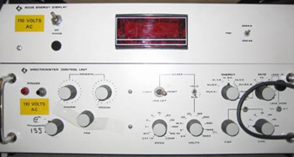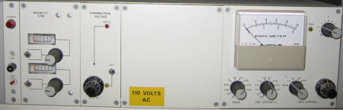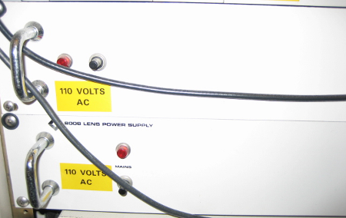
• Slave unit 356 is only for ISS; it supplies drive voltage at the Channeltron front end (see figure, the lowest).

Initial operation
Make sure the vacuum in the chamber is good (≈10⁻⁹ Torr). The analyzer is set to measure electrons. A pass energy of 50 eV-60 eV is used for XPS measurements (keep it constant to keep experiments comparable). 2.9 kV is currently used for the multiplier (October 2026). The multiplier voltage needs to be increased from time to time to make up for intensity loss (see 7.2.5).

Turning the analyzer on
Turn on the analyzer in the following order by pressing or switching the power buttons.
1) Spectrometer Control Unit (SCU 362),
2) Digital Multimeter displays voltages (DVM 8006),
3) Ratemeter and Multiplier Supply (434),
4) Lens power supply (8508)

Turning the analyzer off
Turn off the analyzer in the following order by pressing or switching the power buttons.
1) Lens power supply (8508),
2) Ratemeter and Multiplier Supply (434),
3) Digital Multimeter displays voltages (DVM 8006),
4) Spectrometer Control Unit (SCU 362)

Typical settings
Pass energy: 50 eV-60 eV (optimize it for your needs). Lens mode: 1-1, Channeltron voltage: 2.9 kV (needs to be adjusted from time to time).

Calibration
Before performing an actual XPS experiment, the instrument may need to be recalibrated and the sample will need to be aligned for maximum signal. This needs to be done only once, or whenever the sample has been remounted or moved.
To calibrate the binding energy of the sample, pick a peak from the clean sample using a reference source, such as the “Handbook of X-ray Photoelectron Spectroscopy”. The selected peak should be strong and free of excessive background. Compare the peak position with references; the work function can be adjusted by turning a potentiometer (see manual for details). Smaller adjustments can be done by referencing the spectra to a specific signal in CasaXPS.
To align the sample and determine the right XPS position.
1) Determine a peak from the clean sample using a reference source, such as the “Handbook of X-ray Photoelectron Spectroscopy”. The selected peak should be strong and free of excessive background.
2) Perform a survey scan of a region of interest. Then lock into a strong peak using the energy analyzer.
3) Turn on the instrument.
4) Set the switches as following:
• “Hold/Run” “Run”
• “Start/Penlift/Reset” “Reset”
• “Amplitude” “1250”
• “Time” “2 ms”
5) Select a position on the energy switch (e.g. “Mg KE”)
6) Set “DVM” to “E”.
7) Adjust the pedestal controls for “KE” reading on the “DVM”
8) Set the “DVM” switch to “HV” and set the pass energy using the “CAE” knobs
9) Set to “Run”.
10) Turn on the Channeltron and dial in 2.9 kV.
11) Observe on the rate meter; select the proper counts range.
12) Rotate the sample slowly. Pay attention not to touch the end of the X-ray source.
13) When a maximum has been observed on the rate meter, then take another survey scan to make sure that the signal is from the sample.
14) Repeat for the rotation or up/down direction.
Comment by Leo Winter: I preferred to take spectra of a suitable region (e.g. Cu 2p for the copper sample) with a few scans for different positions. Then, determine the intensity and choose my measurement position.

Detector
As stated above, the detector should only be operated under UHV conditions (<8 x 10⁻⁹ Torr). The operation voltage for the channeltron is set to 2.9 kV in October 2026. However, this voltage should be adjusted every now and then because the channeltron is aging with operation time and chemical exposure. To determine a new operating voltage, record a few spectra of a suitable region, varying the multiplier voltage in 50 V steps (do not go too high). Plot the intensity versus multiplier voltage. The ideal operating voltage is at the knee of the plot, i.e. the beginning of the plateau.
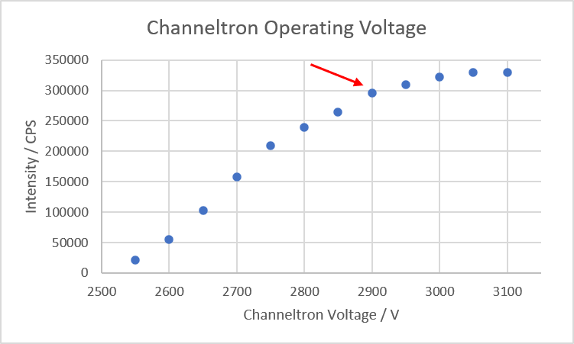
Another parameter that can be optimized is the discriminator voltage. It can be set with the dial at the top right of the “Ratemeter and Multiplier Supply (434)” controller. The discriminator discriminates between dark counts and real counts. If the setting is too low, you will get excessive background and noise; if it is too high, you will reduce the intensity of the signal. Record a few spectra with different settings and determine the signal/noise ratio (e.g. divide the “Area” by the “Std Dev” values in the CasaXPS “Regions” tab). In the example below, you can see that the noise goes up significantly for settings 1 and 1.5. These two settings are not sufficient to suppress dark counts. You could choose setting 2.5 or 3 as optimal settings (maybe not 2, because it is too close to the breakthrough of dark counts).

Maintenance
The analyzer itself does not require any maintenance during normal operation. Only run the analyzer when the system is at good vacuum. The gain of the multiplier may drop with time. The multiplier voltage can be increased somewhat regularly to improve the signal. At some time the multiplier needs to be replaced. The procedure is described in the VG manual and to some extent below.
Servicing/changing the multiplier
As the Channeltron ages, the voltage at which it saturates is increased, and the saturation plateau is narrowed. IF the plateau cannot be discerned, the device needs replacing.
To change the Channeltron:
You will need the channeltron removal tool (it is located together with the old channeltrons in a Photonis box in the bottom drawer), a new channeltron, and a new cable connector (you can find an old one in the same box; a new one may not be available in the lab and they are not reusable).
1) Make sure all electronics units are off. Disconnect all cables to the analyzer. Bring the system to air.
2) Note the orientation of the feedthrough cup (the flange with the “star-shaped” feedthroughs on it) with respect to the analyzer. Remove the nuts (you can leave the bolts inside).
3) Carefully remove the cup away from the analyzer to expose the internal wiring. Make a note of which wire is connected to which feedthrough. Disconnect the wires.
4) Gently screw the Channeltron removal tool (located in the drawer under the computer) into the socket in the upper surface of the channeltron assembly.
5) Ensure the wires connected to the lens assembly are correctly positioned and are kept in their position while the channeltron assembly is removed. They need to be on the bottom (flat) side of the channeltron unit; otherwise, the channeltron unit cannot be pulled past them.
6) Gripping the removal tool firmly, pull the channeltron assembly from the main assembly. Put it on a clean working surface. You can leave the channeltron removal tool attached and clamp it to a stand. Make sure not to break the fine wires forming a grid over the channeltron entrance (attached to the channeltron housing).
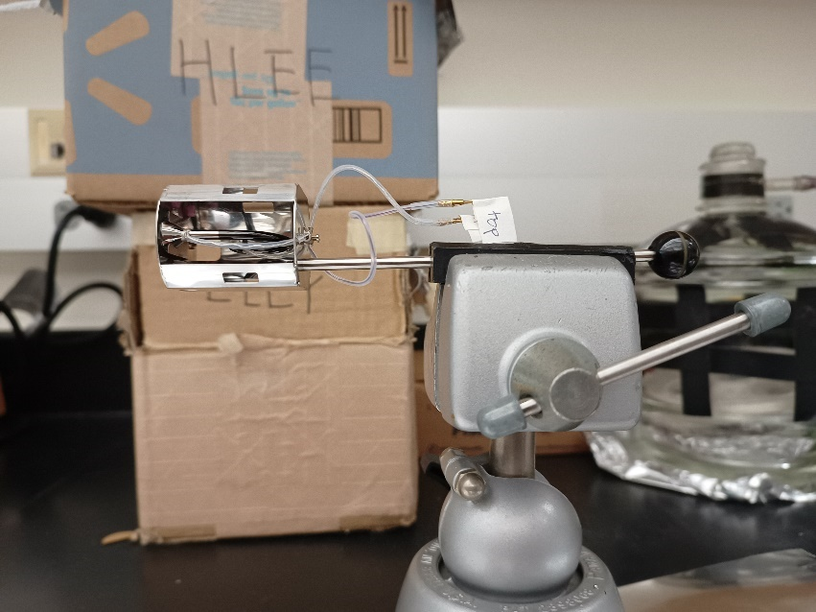
7) Remove the two screws that secure the wires in the barrel connector mounted on the outer surface of the cover. Extract the wires from the barrel connector. Put the outside wire aside and keep it for later. Move the wire that is attached to the front of the channeltron inside the case.
8) Lift the spring clip to release the channeltron by using a small screwdriver to lift the clip (but do not unscrew the clip). Pull the old channeltron out of the case, and check that the end wire follows smoothly.
9) Clip the back wire of the old channeltron and release the PTFE covers from both wires.
10) Fit the insulation to the new channeltron wires.
11) Fit the back end wire through the cover and insert the channeltron into the clip. Use a small screwdriver to hold open the clip. Be careful to not damage the zig-zag wire.
12) Fit the front end wire out of the cover. Cut it to the right length and insert it into the barrel connector together with the outside wire. Tighten the screws of the barrel connector.
13) Cut the back end wire to the right length and fit the new connector. Use a crimp tool to close the connector.
14) Grip the case with the channeltron removal tool and fit it back into the main assembly. Make sure that the channeltron is inserted in the right direction, so that the analyzer slit opening faces the channeltron. Make sure that the lens wires are out of the way (on the bottom side of the flange) and that the clamps clip on the channeltron assembly.
15) Put a new copper gasket on the feedthrough cup.
16) Refix the wires (refer to your notes from 3). It can be a bit tricky due to the confined space.
17) Hand-tighten the flange and check with a multimeter that no pins are shorted to another.
18) Tighten the nuts.
The channeltron was replaced the last time on 2024/04/04.
The original part is a Photonis channeltron part number 30150. The multiplier mounted at the moment is a DeTech 22-610-C-LWL purchased for $748 in 2024.
The procedure is also explained in the VG Manual.

Software
The version of the software is VGX900IC, serial number: 931216. Installation is performed by creating a target folder for the software and then copying the software into that folder.
Features:
1) To change the color of the data display for a channel, move the cursor under the region in question (upper left side), press ALT, and press the left mouse key. Release ALT and click on the region to be redrawn.
2) To set up an experiment, press “Home”. A default file appears. Other files are saved and can be loaded. If you want to create new files, save them with the extension “*.reg”.
3) Important for communication between the computer and SCU is that the “Xmax” value (right lower corner in set-up) is set to AES 3276.8 kV.

How to take XPS data
First, turn on the spectrometer controls and the cooling water. Then, bring the sample and the X-ray gun into the right position. Then turn on the X-ray source and the detector. Use the software to collect the data.

Loading XPS software and turning the spectrometer units on
The software runs with MS-DOS; it can also be run on Windows 95, but not on Windows 98 or newer. It is recommended to learn basic DOS.
1) Turn on the XPS controller as follows: 1) Spectrometer Control Unit (SCU 362), 2) Digital Multimeter displays voltages (DVM 8006), 3) Ratemeter and Multiplier Supply (434), 4) Lens power supply (8508).
2) Wait a bit to warm up (note by Leo Winter: the manual used to say 1 h, I think this is excessive).
3) Turn on the GATEWAY2000 computer.
4) Press “Windows+R” to open “Run” box (if you use Windows 95) or restart the computer in MS DOS mode.
5) Press the “Enter” key.
6) Type: “cd..”.
7) Type: “cd..” (if necessary to get to the “C” drive).
6) Type: “cd vg” (there is a space between cd and vg).
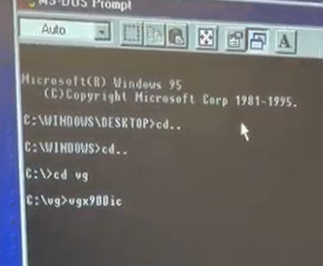
7) Type: “vgx900ic”.
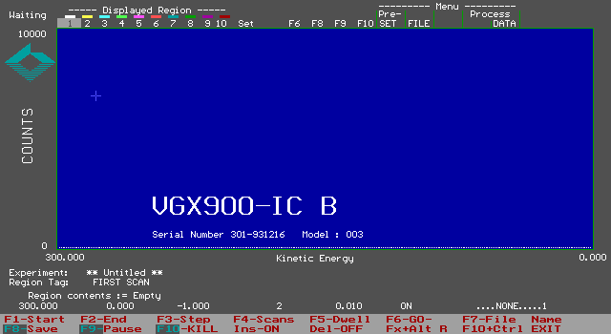
7) The “vgx900ic” window will pop up.

Turning the X-ray gun on
1) Turn on the cooling water line and leave the water running for a few minutes.
2) Bring the sample into the right position. Current position in October 2026: z=21.4 (or 21.3 when the manipulator is cooled) and θ=273º)
3) For the current sample mounting, move the X-ray gun in by 16.5 turns.
4) Turn on the power of the “Glassman” but do not press the “High Voltage” button.
5) On the filament control, select the right anode – “A” (Al) or “B” (Mg) (As of Aug 2018 and Oct 2026, only Mg can be used). If the red light does not come on, then it is possible that the total water flow rate is too low or one of the fuses is blown.
6) Press the white button next to the two toggle switches. The meter on the left-hand side will display the maximum current that is allowed to reach the filament. The maximum should be ≈4.7 A, if this is not the case, then adjust it through the knob labeled “Current Limit”.
7) Using the “Reference Atten” knob, dial in 4.5 A. Do this slowly and pay attention to the pressure in the chamber. Let the filament warm up for 2-5 min (especially if it is the first measurement of the day).
8) On the “Glassman”, press the green button above the power switch to turn on the high voltage mode. Slowly dial in either 12 kV (for Al) or 10.5 kV (for Mg), monitoring the right-hand side meter. The emission current will increase as well. As this is being performed, there will be a decrease in filament current. Monitor the pressure of the chamber and adjust the speed with this in mind.
9) Go back to the filament control system and slowly adjust the current using the “Reference Atten” dial until a reading of 10 mA of emission current is read off on the “Glassman” control. This corresponds to a source power of 120 W for Al and 100 W for the Mg anode.
10) Check if the voltage on the hemisphere is zero. Set “MINS” to “Set”. Set “DVM” to “E”, choose “Mg KE” or “Al KE”, display must show zero. Switch to “Al KE”, “Al BE”, “Mg KE” or “Mg BE”, depending on what kind of spectrum you want to take. Set “MINS” back to “EXT I/P”. Note by Leo Winter: You do not need to do this every time. As long as you do not touch the dials, it will not change. Recently (2026), there was also an issue with the “Digital Multimeter displays voltages (DVM 8006)” showing ghost values.

Data acquisition
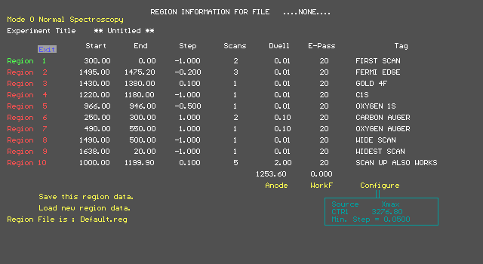
1) Press the “Home” key and the “REGION INFORMATION WINDOW” will pop up.
2) Scroll down to “Load new region data.” and all templates can be found here (you need to know the filename).
Here are some examples of scan parameters:
Survey: 1100 – 0 eV, Step -1 eV, Scans 2, Dwell 0.2 s, Pass energy 60 eV
O 1s: 541 – 525 eV, Step -0.1 eV, Scans 20, Dwell 0.2 s, Pass energy 60 eV
C 1s: 292 – 278 eV, Step -0.1 eV, Scans 20, Dwell 0.2 s, Pass energy 60 eV
Note that the “E-Pass” energy setting in the software is only for documentation. The actual pass energy used by the spectrometer has to be set on the “Spectrometer Control Unit (SCU 362)”. For that, switch “MINS” to “Set”. Set “DVM” to “HV”. Use the “CAE” dial to adjust the pass energy. Switch back “DVM” to “E” and “MINS” to “EXT I/P”.
To save a new template, name the file and end it with the file type .reg.
3) Make sure the Xmax value is set to 3276.8 eV in the program. Also, check that the axis is either BE or KE in accordance with the spectrum you want to obtain (both in a box at the right-hand lower corner). Press “ESC” to return back to the main window.
4) Press “F7” to name the file. The filename can only be 8 characters long; use a “yymmddnn” (year, month, day, number) format. Press “Enter”, and it will prompt you to “Experiment”, where the experimental note can be written.
5) Turn the toggle on the “Ratemeter and Multiplier Supply (434)” for the channeltron to “on” and increase to 2.90 kV (depending on the status of the channeltron). You can also leave the voltage set and just use the switch to turn the channeltron on and off.
6) Press “F6” to start data acquisition
7) After completion of data acquisition, press “F8” to save the file.
8) If the experiment needs to be paused, press “F9” to pause, then press “F10” to stop.
9) Turn the Channeltron and X-ray gun off during gas admissions and also when you take a break in your experiment. Always turn off the Channeltron when you are not recording data.
10) To exit, press “Ctrl+F10”.
11) For data transfer, insert a floppy and go to the “vg” folder and transfer it.

Turning off
1) Turn the channeltron voltage off (if not done already).
2) Turn off all the units in the spectrometer in reverse order.
3) Decrease the emission current and filament current to zero.
4) Reduce the HV to zero.
5) Turn the “Glassman” high-voltage power supply off.
6) Turn off the power supply for filament current control.
7) Let the cooling water flow for a while (10-20 min) to thoroughly cool the X-ray gun before turning it off.
8) Retreat the X-ray gun back from the sample. If not, the sample will collide with the end of the X-ray anode when it is moved.

Data processing and editing
The data collected with the VG software generates a WordPad file. The column in the WordPad file represents the intensity of the recorded element. The column can be copied and pasted into the Excel file, and the binding energy can be adjusted based on the step value.
The WordPad file can also be converted to the data file used by the CasaXPS software (.vms). Copy all files that need to be merged into one folder that does not contain any other file. Then select in CasaXPS “File” – “Convert and Merge …”. Navigate to the folder with your data. Type in “yourdesiredfilename.unw -anode Mg”. Click “Open”. (If you use the Al anode, leave out “ -anode Mg”.)

Ion Gun

Leybold ion gun
The Michelle system is equipped with a simple Leybold ion gun used for sample cleaning by sputtering. This ion gun was previously mounted on the Nanoreactor chamber.

Typical sputtering procedure
1) The current position for sputtering is z=21.5 (21.4 if the manipulator is cooled), θ=215°.
2) Dose Ar through the leak valve attached to the Leybold ion gun. Currently, 3.0 x 10⁻⁵ Torr are used (possible range 7 × 10⁻⁶ to 5 × 10⁻⁵ Torr).
3) Turn the “function” knob to “operate”, and turn the “ion energy” knob to 2 keV.
4) You can check the current between the sample and ground with a multimeter. For that, make sure to disconnect all grounding connections to the sample (heating wires and thermocouple). Currently, the usual current is in the range of 10 µA.
5) The sample is usually sputtered for 30-60 min.
6) To finish sputtering, close the leak valve again. Set the “ion energy” knob to “0” and move the “function” knob to “0”. Wait a few seconds before turning off the controller.
During sputter gun operation, you can see the glowing filament through the front window. This is a good way to check if the filament is still intact.

Maintenance
It might be necessary to replace the filament if it burns through. You can see the filament glowing during operation of the sputter gun. The resistance between the two filament pins (marked by “F”) should be around 0.6 Ω, all other pins should be open to each other and the ground.
The procedure to replace the filament is as follows:
1) Vent the chamber (2.8).
2) Disconnect the Ar gas line from the leak valve.
3) Unbolt the sputter gun and remove it together with the leak valve. To remove the bolts, the protective cover of the feedthroughs needs to be removed. Mount it back on before starting to work on the ion gun to protect the feedthroughs. Cork rings or other supports can be helpful if you want to lay the sputter gun on its side.
4) Before you replace the filament, place a new copper gasket between the flange with the Ar line and the main feedthrough flange. The procedure is a bit tricky:
5) Loosen the screw that holds the electrical connection to the base of the gun (red arrow in the picture below). Remove the wire from the screw.
6) Loosen the two set screws that hold the filament leads (blue arrows in the picture below). Attention: One of the filament leads is no longer glued into the ceramic feedthrough leading to the head of the gun. It may start moving as soon as the set screw is loosened. This can damage the filament, so mount your new filament later (see below).
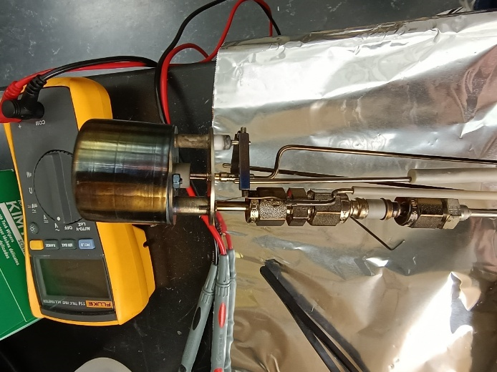
7) Now the front part of the ion gun can be lifted off (see left picture below). The Ar line and the central electrical connection are just stuck into the front part.
8) Unscrew the three Allen set screws in the main feedthrough flange. Now you can lift off the Ar line with its flange (see right picture below).
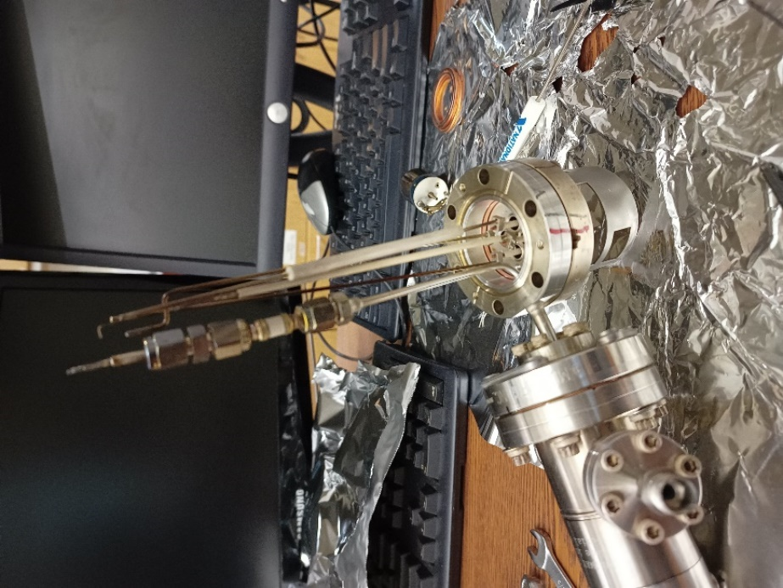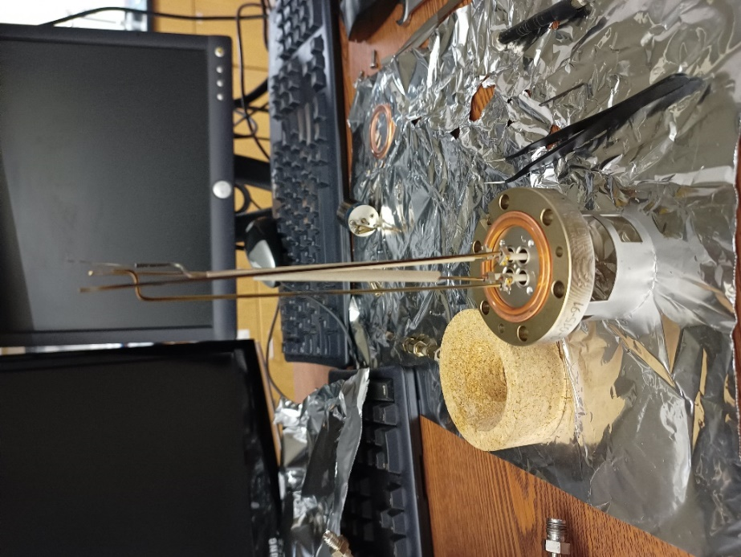
9) Now you can replace the copper gasket between the main feedthrough flange and the gas line flange.
10) Connect the two flanges again by finger-tightening the three Allen set screws.
11) Fit the front of the ion gun again, tighten the two set screws, and reconnect the wire to the ground plate.
12) Remove the front cover by unscrewing the two nuts and lifting it off.
13) The filament is mounted with two holders. You can spot-weld a wire to the two holders as a new filament. Last time, a tungsten-rhenium (97:3) wire with 0.25 mm thickness was used. Remove the set screws and clean the holders with a file before spot-welding. Last time, spot-welding was done with 5-6% maximum energy.
14) Fit in the new filament, making sure not to touch the grid and the housing. Mount back the housing (this is much easier with the sputter gun lying on its side).
15) Check the connections between the pins. All should be open to each other except the two filament pins (app. 0.6 Ω).
16) Remove the protective cover for the feedthroughs again to make space for the bolts.
17) Put back the sputter gun, make sure all gaskets are sitting and start tightening the bolts. Since you have three gaskets at once, it can be a bit tricky. You can use a small screwdriver to fit the gaskets.
18) Reconnect the Ar gas line and fit the protective cover for the feedthroughs again.

Kratos MiniBeam ion gun
Furthermore, the Michelle system was equipped with a Kratos MiniBeam ion gun system. It has been moved to the UC chamber as of October 2026. The LEIS measurements require this ion gun to be installed on the flange above the analyzer. In principle, the Specs ion gun currently mounted on Victor should also work for LEIS. The Leybold ion gun is too simple (no focusing optics).
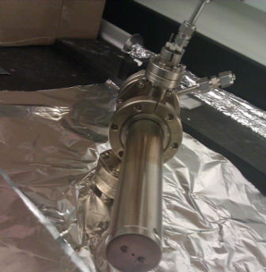
The Kratos MiniBeam ion gun can provide a high current density, variable diameter, scannable ion beam for precision ion beam studies and applications. The ion gun is a UHV device that contains an ion source, an ion extractor section, an electrostatic section for beam focusing, and deflection plates to control the ion beam. The gun is mounted on a 2.75” CF flange. This ion gun can in principle be used for sample cleaning by sputtering and as an ion source for low-energy ion scattering (LEIS) experiments. There was an issue with the main controller reported since the incident with flooding in the lab in 2020. We tested the controller in 2026, and it seems to be working fine, but there was indeed an issue with a shorted filament.

Typical operation
To clean the surface:
1) Move the sample to the right position (should be the same as for XPS).
2) Leak argon into the chamber to a pressure of ≈1.0×10⁻⁷ Torr.
3) Check that the beam voltage and emission are set fully counter-clockwise.
4) Turn on power. Slowly turn on the filament current. There may be a delay in the display. Dial until 15 mA emission is obtained. If the reading maxes out, it indicates that the filament protection switch has been activated. You need to restart the controller.
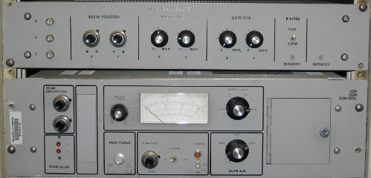
5) Turn the voltage switch on and set it to 2.0 keV.
6) Measure the sample current using a multimeter connected to the sample. The sample is grounded through the multimeter via the thermocouple. The current should be around 2.0 μA. Adjustment for the raster size is normally not necessary, but try it initially (last setting: 5 for the X-direction knob and 4 for the Y-direction knob). The “Raster” stays on during sputtering. Gate size set at maximum for both X and Y. Beam position is set at 5.70(X) and 6.00(Y). Use the large beam size. Check the argon pressure occasionally.
To end sputtering:
1) Close the valve for argon.
2) Turn off the voltage and filament current. Turn off power.
3) The pressure in the chamber will reduce to ≈1×10⁻⁹ Torr in about 5 min.

Low Energy Ion Scattering (LEIS)

Overview
Note: LEIS has not been measured on Michelle for a long time. At least not since 2020.
Low energy ion scattering spectroscopy is a technique with the special feature of solely detecting the composition of the topmost surface layer. In most cases, helium and neon gases are used to generate the incident ions. Helium is superior in achieving better peak resolution and intensity, while neon should be used in the case of detecting some heavier atoms, such as iodine. One universal formula (binary collision model) can be used to calculate the energy distribution of the reflected ions. The energy of the scattered ions is determined by the masses of both the incident ions and the surface atoms, and the scattering angles specifically in the chamber. For the Michelle system, the scattering angle is about 225º.

Preparation
Make sure the slave unit is correctly connected to the energy analyzer. Two additional lines should be added to switch from XPS to ISS mode. Please refer to the VG manual for the details. Here is a short description of how to connect the cables.
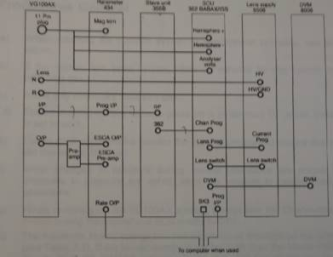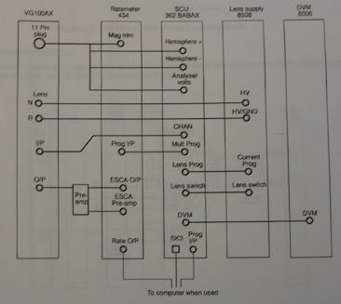
The unit must be turned off before switching from XPS to ISS mode. Open the rack door on the back side to locate the control units.
1) Find the BNC cable that is not in use and connect one side to “Unit 362, Chan Prog”. Connect the other side to “Unit 356, 362”.
2) Disconnect one side of the cable that is connected to “Unit 362, CHAN”. And connect it to the “TEE” at “Unit 356, O/P”.
3) Disconnect one side of the cable that is connected to “Unit 362, Mult Prog”. And connect it to the “TEE” at “Unit 356, O/P”.
Make sure that the function has been switched from XPS to ISS mode in the controller. Note that in most XPS studies, the pass energy is set as 50-60 eV, while 120 eV pass energy should be used for ISS experiments.
Make sure that the ion gun, sample, and electron analyzer are all installed in the right position. The geometry of these three components proves to be important to give a reasonable yield of ISS signal. If needed, slightly move the sample up and down or rotate the sample to maximize the signal. During operation of ISS, the raster must be in the off position (middle). The gate size is set to minimum. Try to use the small or medium beam size.

Standard data acquisition procedure
1) Turn on the ion gun power. The ion beam raster should be set to zero in both x and y directions.
2) Tune the filament current to ≈15 mA and the ionization voltage to 500 V, respectively. Note: The ionization energy of the ion gun is not necessarily set to 500 V for all the experiments. It depends on the gas chosen and your needs.
3) In the spectrometer controller, set the kinetic energy to the estimated peak position using the binary collision model. Then gradually introduce the helium/neon gas into the chamber until the sample current reading reaches above 50 nA. It is recommended that without perishing your ISS signal too much, a lower gas pressure should be used (usually 10⁻⁸ even 10⁻⁹ Torr is fine, but we never try higher than 2.0x10⁻⁷ Torr).
4) Now you should be able to detect some counts from the ratemeter. If not, try to move and rotate the sample to optimize the ISS signal (check if the channeltron multiplier voltage is on, if all the connections are set, if there is enough sample current seen from the picoammeter).
5) Then take the ISS spectrum by scanning the kinetic energy within the selected range. Use the same software as for XPS.
Note: Previous experiments show that the ISS experiment seems to cause some damage to the Channeltron. The XPS signal intensity drops about 10-20% after ISS experiments are done.

Reflection-Absorption Infrared Spectroscopy (RAIRS)

General considerations
In the RAIRS experiments, the IR beam is taken out of the spectrometer, passed through a polarizer, focused through a sodium chloride window onto the sample in the UHV chamber at grazing incidence, passed out of the chamber through a second sodium chloride window, and refocused onto the MCT (mercury-cadmium-telluride) detector (ivory cylinder in the purged area).

RAIRS setup (drawing, mirror specs, detector)
The Michelle chamber has been upgraded with the installation of a new IR and high-pressure cell (see also Chapter 3). In our setup, the IR beam is taken from a “BRUKER TENSOR 27” IR spectrometer and passed through a polarizer and focused through a NaCl window onto the sample surface at grazing incidence (≈85º). The surface acts as a mirror. The reflected beam is then passed through a second NaCl window and focused onto a mercury-cadmium-telluride (MCT) detector. The entire beam path is enclosed in a sealed cover purged with dry air, purified using a scrubber for CO₂ and water removal to minimize interference from gas phase absorption bands associated with atmospheric H₂O and CO₂.
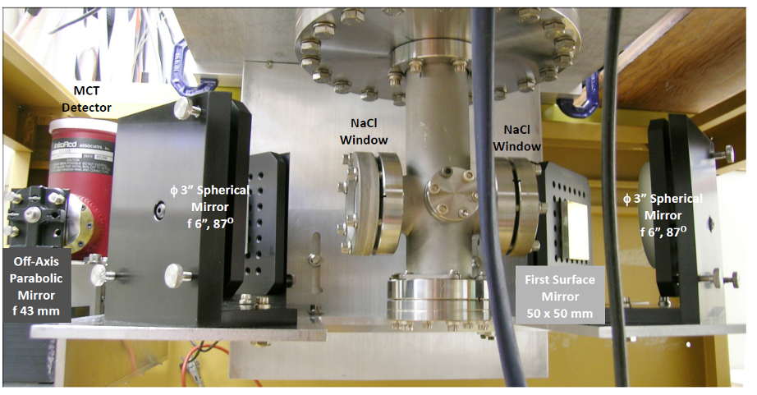
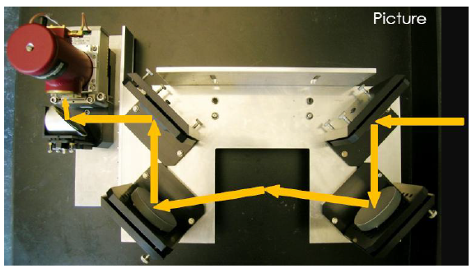
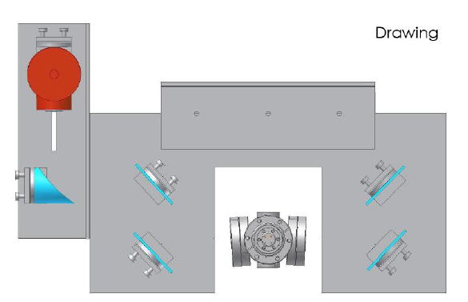

How to do HPC/RAIRS experiments
To generate an absorbance spectrum of a surface species, both a background spectrum, which is taken with the clean surface, and a sample spectrum, which is taken after adsorption (and sometimes reaction) of the molecules on the surface or during exposure to a high pressure of a gas, are needed. These background and sample scans are taken separately. The RAIRS data are collected on the PC using the Bruker software called OPUS.
The dry air should be flowing. The Parker FTIR purging system should be on all the time. The flow meter that monitors the gas flow into the IR beam path should read approximately 100 scfh. If not, adjust it. This should be checked periodically, even if the IR spectrometer is not used.
1) Before a RAIRS spectrum can be taken, the detector has to be cooled down to liquid nitrogen temperature. Pour liquid nitrogen into the funnel that goes to the MCT detector. At first, the nitrogen will boil out of the detector. Keep pouring, a little at a time, until the boiling stops and the detector is filled. When the detector is full, the liquid nitrogen will just run off the top of the detector. If the detector has been filled according to the procedure above, it should remain cold for 4-6 h. The detector can be refilled while doing experiments; however, it will cause an increase in IR intensity in the first ≈10 min after filling. Best practice is to start cooling the detector 20-30 min before starting the measurement.
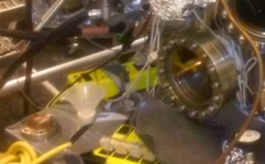
Liquid nitrogen funnel
2) Start the Windows 10 computer next to the Tensor 27.
3) Start the program “Oracle VirtualBox”
4) Start the virtual machine “WindowsXP” by selecting it and clicking “Start”. This will start a virtual Windows XP computer inside the Windows 10 computer. This is necessary because our OPUS version does not run on Windows 10. The virtual machine should be treated like a real computer (power it down; do not just close the window).
5) Start the program “OPUS 6.5” (User ID: Administrator, Password: OPUS). There is also a manual for the program in one of the drawers of the IR desk.
6) You can check the status of the detector and the other connected devices by clicking on the dot in the lower right (it is red or green depending on the status). The spectrometer should be in stand-by mode before experiments are started. The interferometer is running, indicated by the flashing "SCAN" light. The display on the bottom line of the OPUS window will read "No Active Task" (after quitting the “Instrument Status” window).
7) Click on “Measure” -> “Advanced Measurement” and check the measurement parameters. In the "Basic" tab, you can load an experiment parameter file (“.xpm”). Check the experimental parameters under "Advanced", "Optic", "Acquisition", "FT" and "Display". Enter today’s date (yyyymmdd) as “File name” in the “Advanced” tab, and check the path where the files will be saved; the measurements will be saved in the format yyyymmdd.n (n being a number starting from 0). In October 2026, we are using the settings in the screenshots below:
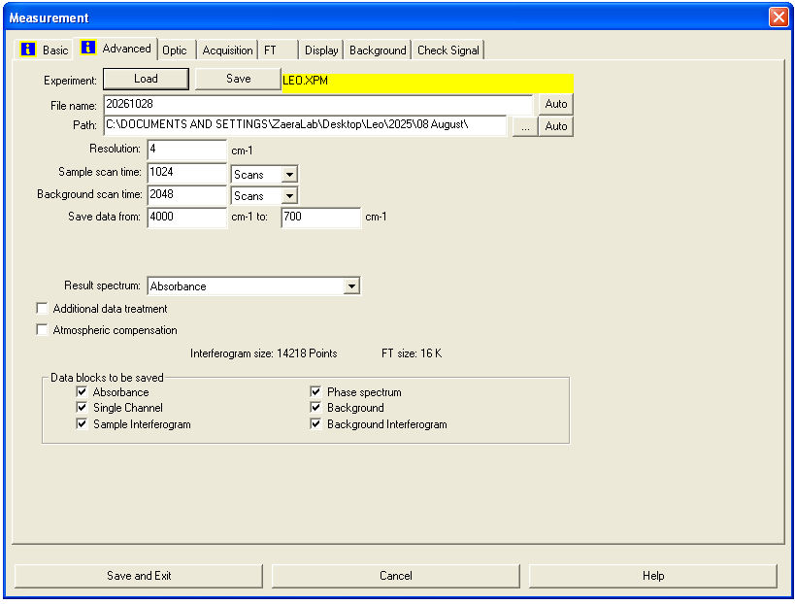
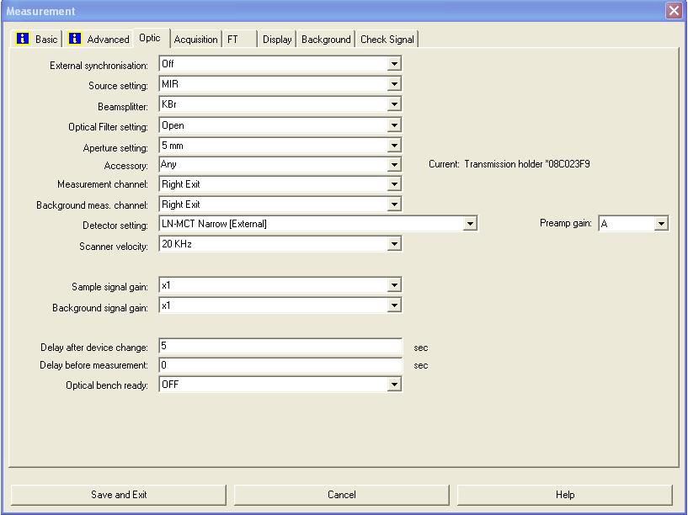
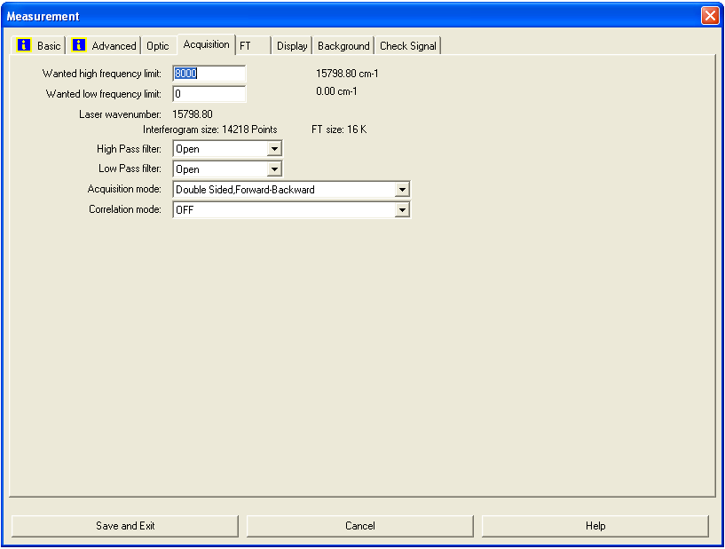
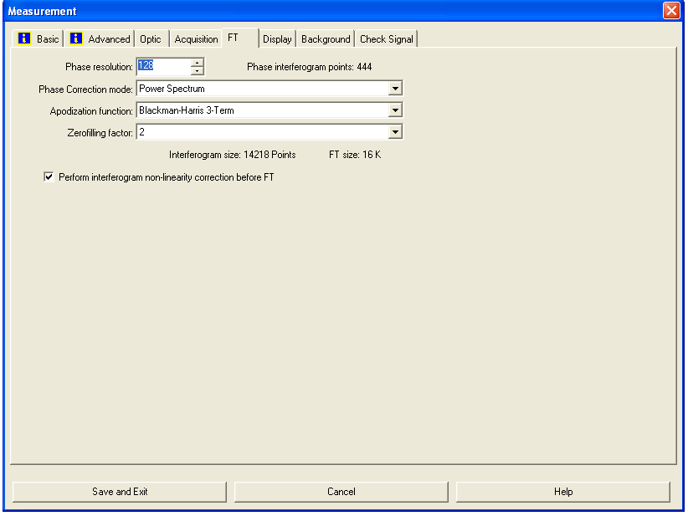
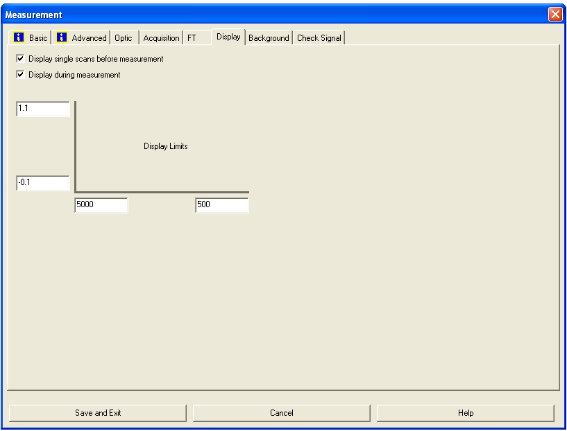
8) Transfer the sample to the high-pressure cell. Make sure that it goes smoothly through the seal between the main chamber and the high-pressure cell. It may be necessary to push or pull on the manipulator to correct slight misalignments. Look through the large viewport on the bottom of Michelle to check the alignment (move the lamp to the other viewport). In October 2026, the IR position is at z=2.3, θ=94°. Adjust the angle before transferring into the HPC to avoid excessive wear on the sealing O-ring (small adjustments of the angle are ok).
9) Go to “Measure” -> “Advanced Measurement” and go to the “Check Signal” tab to get a live measurement of the RAIRS signal intensity (“ADC count” is most convenient).
10) Optimize the signal intensity by slightly turning the sample back and forth (changes of 0.1° will make a difference).
11) A polarizer is installed right next to the BRUKER TENSOR 27 IR spectrometer, and it is in the purging box all the time. The polarizer is mounted on a stage which can be rotated 90º. A small remote switch is located next to the front side of the spectrometer or on the desk. p is the component that is perpendicular to the surface, which is where adsorbates are IR-sensitive. s is the component that is parallel to the surface. By using p-s difference spectra, the signal/noise can be improved significantly, and signals from the gas phase can be eliminated. Switch the polarizer to s polarization by clicking the remote switch to “s”. Wait 1 min or so until the polarizer has moved, and switch back to the middle position to avoid unnecessary wear on the turning mechanism. (If the RAIRS intensity has stabilized, the polarizer movement is finished).
12) Take a background spectrum with s polarization by going to the “Basic” tab and clicking on “Background Single Channel”. The program displays a message in the bottom line highlighted by a green color indicating that the data are being taken. When the message disappears, the measurement is done. During the data acquisition, the interferogram cannot be seen in the “Check Signal” tab. In October 2026, we use 2048 scans for the backgrounds.
13) After the background scans are finished, the "Measurement" window remains on the screen. Go to “Background” and click “Save Background”.
14) Move the polarizer to p polarization by clicking the remote switch to “p”. Wait 1 min or so until the polarizer has moved, and switch back to the middle position to avoid unnecessary wear on the turning mechanism. (If the RAIRS intensity has stabilized, the polarizer movement is finished).
15) Take a background spectrum with p polarization by going to the “Basic” tab and clicking on “Background Single Channel”. Once the measurement is done, save the background by going to “Background” and clicking “Save Background”.
16) For experiments at high pressure, close the gate valve in front of the small turbo pump.
17) Introduce a gas/gasses through the leak valves at the bottom of the HPC. Monitor the pressure in the HPC with the DigiVac gauge. Also monitor the pressure in the main chamber (do not go above 5 x 10⁻⁵ Torr). The HPC is hardly pumped, so the leak valves and pressure response act differently from dosing gases in the main chamber. Wait until the pressure has stabilized. Corrections might be necessary throughout the experiment.
18) Move the polarizer to s polarization. Double-click on the s background (typically “yyyymmdd.0”) in the left window “OPUS Browser”, go to the “Background” tab in the “Measurement” window and click “Load Background”. Record an s sample spectrum by going to the “Basic” tab and clicking "Sample Single Channel". A preview of the spectrum appears. Click on “Start Measurement” to start averaging your desired number of scans (in October 2026, we use 1024 scans). Wait until the highlighted message at the bottom of the screen disappears; the data will be automatically saved. Do not change any parameter between the background and sample scans. You can also record all the data as backgrounds and do the analysis manually. However, even in the case of the “sample scans”, the raw data of the recorded intensity is saved, which allows you to do different analyses later (for example, difference spectra).
19) Move the polarizer to p polarization and record a p sample spectrum by clicking “Measure” -> “Advanced Measurement”. Select the p background from the menu on the left (typically yyyymmdd.1) and click “Background” -> “Load Background”. Start the measurement by clicking “Basic” -> “Sample Single Channel” -> “Start Measurement”.
20) Do the rest of your experiments (for example, a series of different pressures) in an analogous way to points 17) to 19).
21) Close the leak valve(s). Wait until the pressure has dropped below 0.1 Torr (it will leak through the seal into the main chamber). Note: We mounted a gate valve to the rough vacuum to speed up this pumping step, but opening this gate valve leads to contamination with pump oil in the HPC. (Good ideas for improving this step are welcome.)
22) Open the gate valve to the turbo once the pressure has dropped below 0.1 Torr.
23) Pump the HPC at least 15 min with the turbo, then transfer the sample back to the main chamber.
24) Save your data by selecting the respective spectrum in the left “OPUS Browser” tab and clicking “File” -> "Save File As". Then, check the file name (we use yyyymmddnn format) and path to be saved. If you want an ASCII file, select "Data Point Table" in the "Mode" tab in the “Save File As” window before clicking the "Save" button.
25) Transfer your files from the virtual Windows XP machine to the Windows 10 computer by drag and drop (“CTRL+C” and “CTRL+V” do not work for some reason). You can then use a memory stick to transfer the data from the Windows 10 computer.
26) Power down the virtual Windows XP machine, close “Oracle VirtualBox” and power down the Windows 10 computer.

RAIRS maintenance

IR lamp
The IR source lamp is pre-aligned and electrically coded. It can be replaced by the user when it fails. To change the IR source:
1) Turn off the instrument before removing the source. Let it cool down for at least 1 h.
2) Open the source compartment.
3) Loosen the thumb screw of the source holder by about one turn. These screws are a bit brittle due to their age.
4) Gently press the source downwards while turning the lever.
5) Holding the source handle, lift the source out of its position.
6) Replace with a new source following the above steps in reverse order.
7) Close the source compartment lid and turn on the instrument.
8) Run OPUS and test.
The IR source was replaced with a brand-new one in June 2026. The part number is Q328/7: MIR source for TENSOR / VERTEX 70 / VECTOR 33. Make sure to order from “Bruker Optics” not “Bruker Biospin”.

HeNe laser
The HeNe laser has a lifetime, and it will need to be replaced when it fails. The laser is in the source/electronics compartment.
To replace the HeNe laser:
1) Turn off the spectrometer.
2) Open the source/electronics compartment. Unscrew the Philips screws by two turns and move the securing bracket aside.
3) Lift the laser unit by 3 cm and tilt it slightly clockwise and upwards to remove it from the compartment. Remove the power plug.
4) Replace the laser unit with a new one. Put it in by following the steps in reverse order.
5) Close the compartment and test.

Alignment
The alignment of the sample is critical in the RAIRS measurement. Due to the nature of the chamber, one has to work under the chamber in order to access all the mirrors. And there is only limited access there. The spectrometer is sitting on top of the wooden stage, and any movement of the spectrometer/stage will cause the signal to drop significantly or disappear. Do not try to bump or move the stage (if you need to move the spectrometer for maintenance, mark the position of the wooden stage; realignment of the mirrors will be necessary nevertheless). The mounting of the sample is very critical too. The manipulator does not have the ability to move in the X and Y directions, so once the sample is mounted, we can only rely on changing the settings on the mirrors to do the alignment. During the alignment, one should make sure the signal is from the sample, not the direct beam (move the sample up; the signal should drop to almost zero). To align the mirrors, do several optimization cycles maximizing the signal intensity by adjusting all the screws on all mirrors and the sample angle (For example, follow the beam path starting with the three screws of the first mirror, followed by the three screws of the second mirror, etc.). The plastic wrappings need to be removed for mirror alignment.

Mirrors (cleaning, etc.)
Great care should be taken when handling infrared optics. Please note the following precautions:
1) Always wear powder-free finger cots or rubber/latex gloves when handling optics. Dirt and oil from the skin can severely contaminate optics, causing a major degradation in performance.
2) Do not use any tools to manipulate optics -- this includes tweezers or picks.
3) Never place optics on a hard or rough surface. Infrared optics can be easily scratched.
4) All materials used for infrared optics are fragile, whether single crystal or polycrystalline, large or fine-grained. They are not as strong as glass and will not withstand procedures normally used on glass optics.
Use an air bulb or a nitrogen cylinder to blow off any loose contaminants from the optics surfaces.
Note: Avoid using lab air lines because they usually contain some amount of oil and water. These contaminants can form detrimental absorbing films on optical surfaces.

Dry air purging system and box
Michelle has its own FTIR purging gas system. It is located on the south side of room 143. The system is made by Parker-Balston with a model #75-62. The inlet gas line pressure is regulated; the maximum inlet pressure allowed is 120 psi. A moisture indicator must be in green under normal operation. It will change to yellow when excess moisture is present in the purge gas. The only maintenance activity required by the Parker Balston FTIR purge gas generator is the annual replacement of the coalescing prefilter cartridge, and occasional replacement of the moisture indicator cartridge.
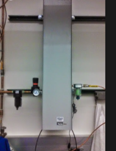
To remove the filter cartridge, simply unscrew the filter bowl for the head, lower the bowl, and remove the element retainer disc at the base of the cartridge. Replace the spent cartridge and reassemble.
Note: Initially, a box was installed for the entire optical path. However, the sealing is not good due to the difficult access to certain areas. Then the whole optical path, including all the mirrors, polarizer, and detector, was covered with plastic wraps and sealed with tape. The purging gas was delivered inside the wraps using a couple of tubes with a flow rate higher than 100 scfh. It is necessary to check the seal from time to time. One indication is that the water peaks in the IR measurements increase.

Si Source
The Si source is a silicon piece wrapped by 0.5 mm tantalum wire and mounted on a feedthrough.
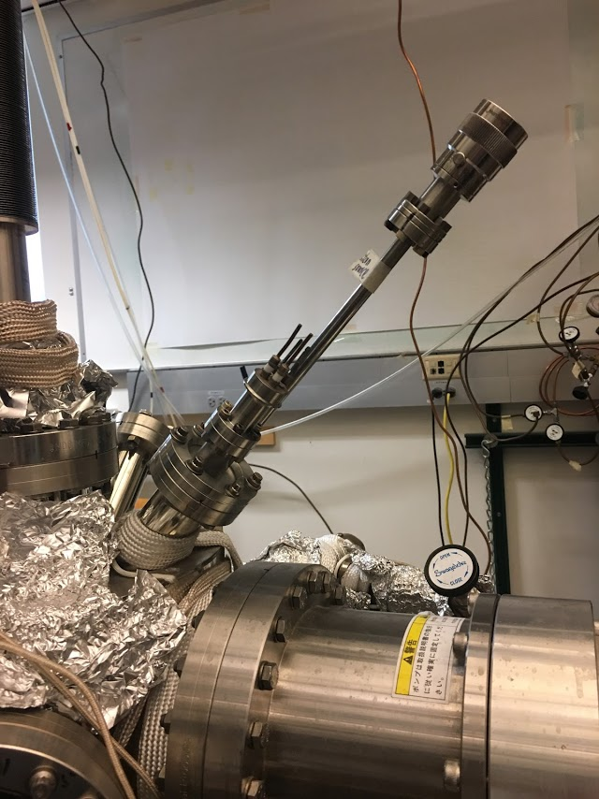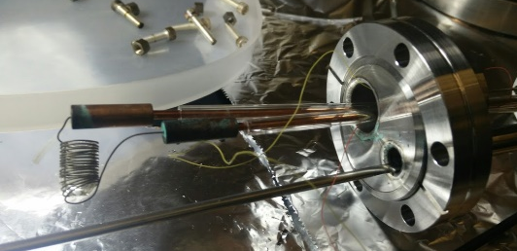
Si Source

Procedure to deposit SiO₂
1) Use the power supply borrowed (pretty permanently) from the Victor system.
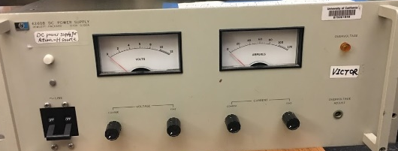
2) Connect the two heating cables to the feedthrough on the SiO₂ source. Make sure the connections are good and the wires are not touching each other.
3) Move the sample right in front of the SiO₂ source.
4) Leak 1 x 10⁻⁵ Torr O₂ through a leak valve.
5) Turn the current and voltage knobs on the power supply to the minimum. (counterclockwise).
6) Turn on the power for the HP power supply. Slowly increase the voltage by increasing the coarse settings. Monitor the chamber pressure. Tune both voltage and current knobs to reach 5.5 V, 8 A. The filament inside the chamber will become red, and the temperature of the sample will slowly increase.
7) After the experiment, reduce both current and voltage back to 0.
8) Oxidize the deposited SiO_{x} film at 600 °C under 2 x 10⁻⁵ Torr O₂ for 5 min.
9) Check the quality of the film using XPS.
Note: If these sources have not been used for a while, it is suggested to degas the filament at lower power first before any scheduled experiment.

Experiences of former users with the Si source, background information
After long use, the Si source can not provide enough Si. If no film growth is observed anymore, the source might have to be changed. It is simply a tungsten wire around a piece of Si wafer. A picture of the working Si source and a broken (burned) source are shown below.
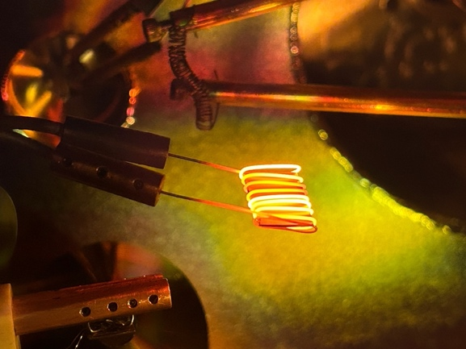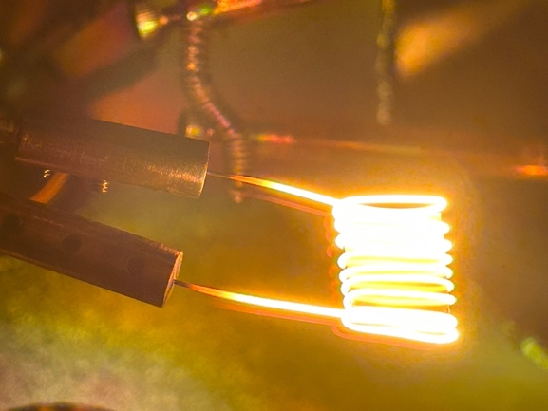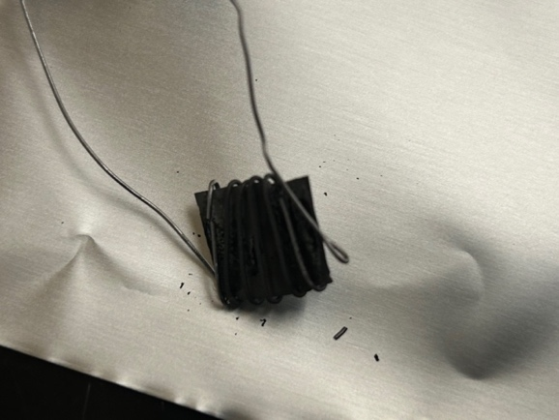
Depending on the Si source and its age, the settings for the growth of SiO₂ have to be optimized. The filament should be really bright and have a white glow, so you cannot look inside the chamber anymore.
According to the literature, the typical way to clean a Si wafer is to heat the sample to 1200 K. It is known that the SiO₂ layer desorbs as SiO radicals. One interesting thing is that SiO desorption takes place at the interface between Si and the SiO₂ layer. The following XPS spectrum showed that O 1s is getting smaller as the sample temperature increases and that the oxygen intensity is very small after heating to 1140 K.
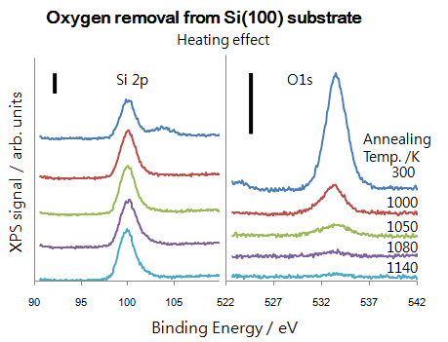
The Si doser is made of a silicon wafer piece wrapped by a tungsten wire (tantalum wire also works, but with different settings for the current then). The Si wafer piece is heated by passing current (8-10 A) through the tungsten filament. The actual required current depends on the size of the filament, the O₂ partial pressure, and the desired flux of SiO₂ deposition. The higher the O₂ partial pressure, the higher the flux of SiO₂ deposition.
Usually, 10 nm SiO₂ films can be prepared by depositing SiO₂ with the Si doser in about 1 x 10⁻⁵ Torr O₂ for 60 min with a current of about 10 A passing through the filament at the substrate of 300 K and subsequent annealing in O₂ at 1000 K for 10 min. Note: the Si doser flux should be compatible with the O₂ pressure; otherwise, only partially oxidized SiO_{x} samples will be prepared, evidenced by the appearance of Si 2p XPS peaks between 99 and 103 eV.
SiO₂ thin film grown on Si(100) wafer
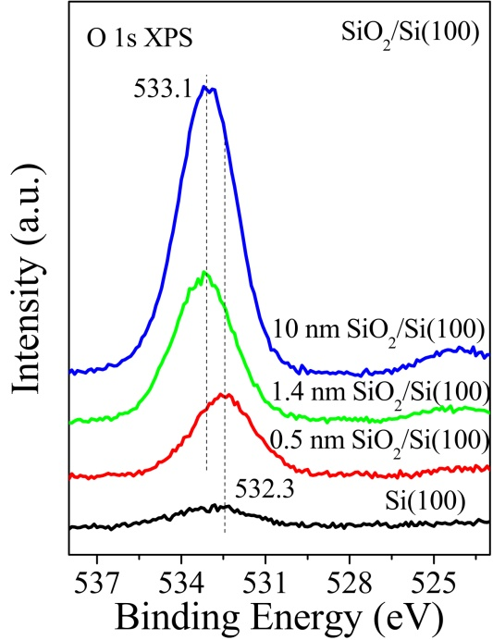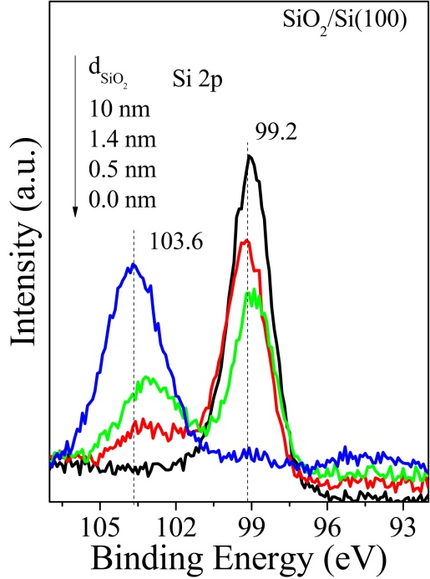
Si 2p and O 1s XPS spectra of SiO₂/Si(100) prepared by depositing SiO₂ from a Si doser in 1 x 10⁻⁵ Torr O₂ for different times, followed by annealing to 1100 K in 1 x 10⁻⁵ Torr O₂ for 10 min. The thickness of SiO₂ was estimated by the ratio of Si⁴⁺/Si⁰ combined with the electron inelastic mean free path in SiO₂ (λ=3.2 nm used in this case).
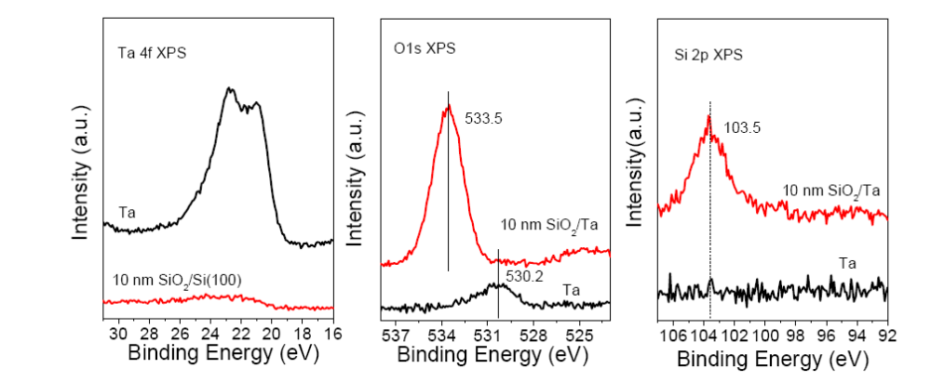
SiO₂ thin film grown on Ta plate
Ta 4f, O 1s and Si 2p XPS of 10 nm SiO₂/Ta. SiO₂/Ta was prepared by depositing SiO₂ in 1 x 10⁻⁵ Torr O₂ at room temperature and subsequently annealed at 1100 K (sample left in the chamber).
An easy check for the SiO₂ deposition is to look at the sample. Clean Ta looks silver, in the middle, yellowish is a very thin film of SiO₂ and a thick SiO₂ film looks purple. Comment by Leo Winter: Invisible SiO₂ films are typically thick enough; just check with XPS if you can still see the substrate.
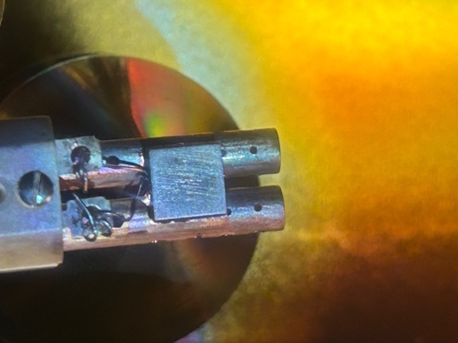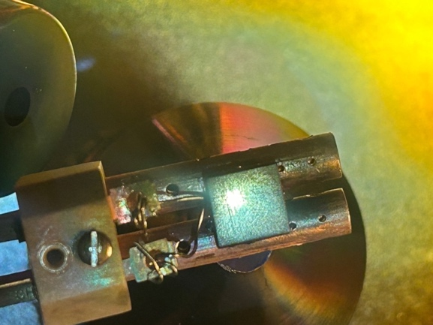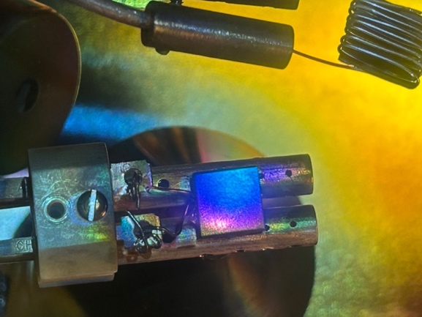

Hot Filament
The hot filament can be used to generate H atoms by cracking H₂ gas. In the H-atom source, a 0.5 mm tungsten wire is used as a hot filament. H atom exposure can be done by following this procedure:
1) Use the power supply borrowed (pretty permanently) from the Victor system.
2) Connect the two heating cables to the feedthrough of the hot filament. Make sure the connections are good, and the wires are not touching each other.
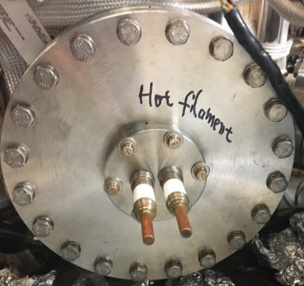
3) Move the sample right in front of the hot filament. Last position: z = 20.3, θ=30°.
4) Leak hydrogen into the chamber through a leak valve. Last hydrogen pressure: 1 x 10⁻⁵ Torr.
5) Turn the current and voltage knobs on the power supply to the minimum. (counterclockwise).
6) Turn on the power for the HP power supply. Slowly increase the voltage by increasing the coarse settings. Monitor the chamber pressure. Tune both voltage and current knobs to reach 10 V, 8 A. The filament inside the chamber will become red, and the temperature of the sample will slowly increase.
7) After the experiment, reduce both current and voltage back to 0.
8) Stop dosing H₂.
Note: If the filament has not been used for a while, it is suggested to degas the filament at lower power first before any scheduled experiment.

Potential Hazards and Safety Procedures
All users must learn the UCR Department of Chemistry Laboratory Safety Manual and pass all exams before getting trained on the Michelle UHV system. Users must get familiar with the Injury and Prevention Program (IIPP) and Chemical Hygiene Plans (CHP).
Here are the highlights of the responsibilities of the user who wants to operate the Michelle UHV system.
1) Annual review of the CHP as well as review of the appropriate safety manuals and policies. Following all verbal and written laboratory safety rules, regulations, and standard operating procedures required for the tasks assigned.
2) Developing good personal chemical hygiene habits, including but not limited to, keeping the work areas safe and uncluttered.
3) Planning, reviewing, and understanding the hazards of materials and processes in the laboratory research or other work procedures before conducting work.
4) Utilizing appropriate measures to control identified hazards, including consistent and proper use of engineering controls, personal protective equipment (PPE), and administrative controls. Understanding the capabilities and limitations of PPE issued to them.
5) Gaining prior approval from Prof. Zaera for the use of restricted chemicals and instruments. Consulting with Prof. Zaera before using these particularly hazardous substances (PHS), explosives, and other highly hazardous materials, or conducting certain higher-risk experimental procedures. Immediately reporting all accidents and unsafe conditions to Prof. Zaera. Completing all required health, safety, and environmental training and providing written documentation to Prof. Zaera. Reviewing the plan or scope of work for their proposed research with Prof. Zaera. Notifying in writing and consulting with Prof. Zaera, in advance, if the user intends to significantly deviate from previously reviewed procedures.
6) Preparing SOPs and performing literature searches relevant to safety and health that are appropriate for the work. A user must be familiar with the location of fire extinguishers, safety showers, and other safety equipment before he begins work with the Michelle UHV system.
Fire Extinguishers: Located next to the front door of room 143.
Safety Showers and Eyewash Station: Located next to the front door of room 143.
Fire Exit: Two doors in room 143.
First Aid Kits: Located next to the front door of room 143.
It is important for a user to have good work habits when working on the Michelle UHV system. Some of the key elements are listed below:
Personal Protective Equipment: Wear closed-toe shoes and full-length pants, or equivalent, at all times when in the laboratory. Utilize appropriate PPE while in the laboratory and while performing procedures that involve the use of hazardous chemicals or materials.
Laboratory Operation: Keep the work area clean and uncluttered.
Compressed Gas Cylinders: Compressed gas cylinders are located on the south side of the Michelle UHV system against the wall. They must be chained or strapped to the wall. The cylinders must always be restrained by two chains.
Liquid Nitrogen: Always use appropriate thermally insulated gloves when handling liquid nitrogen.

