Operating Instructions

UHV Chamber #6: Nanoreactor

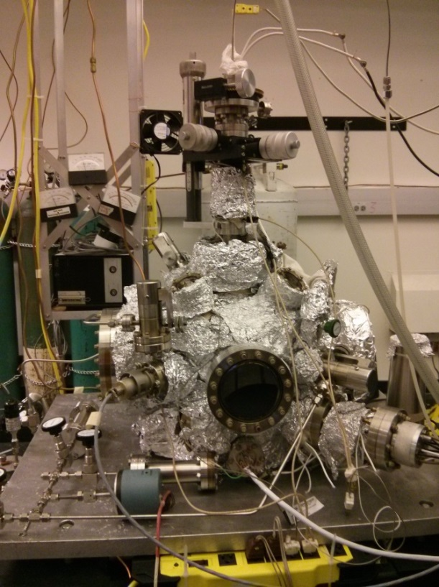

**Yujung Dong, May 2014**

**Revised January 2017**

**Francisco Zaera Lab**

Contents

1. General Considerations 4

1.1. Precausions for UHV operation concerning safety and instrument 5

2. Vacuum System 6

2.1. Evacuating the system 6

2.2. Venting the instrument 6

2.3. UHV Bakeout 6

2.4. Ion gauge 7

2.5. General maintenance 7

2.5.1. Mechanical pump oil change 7

2.5.2. Recirculator 8

2.6. Leak detection 8

3. Sample 8

3.1. Mounting 8

3.2. Heating and cooling 9

3.2.1. Heating the sample 9

3.2.2. Cooling with liquid nitrogen 10

3.3. Cleaning 10

3.3.1. Sputter cleaning 10

3.3.2. Annealing in oxygen 10

3.3.3. Temperature reading 11

4. Gas Handling 11

4.1. Design, schematics 11

4.2. General operation procedure 12

4.3. Maintainence 12

4.4. Valves 12

4.5. Pressure gauges 13

5. High-flux doser 13

5.1. Desgin, schematics 13

5.2. Regular operation: molecular beam experiment 13

5.3. Analysis of molecular beam experiment data 14

6. Mass Spectrometer 15

6.1. General operation 15

6.2. Calibration 15

6.3. Maintenance 16

7. Software 16

8. General Experimental Procedures 17

8.1. Temperature-programmed desorption (TPD)/Thermal desorption spectroscopy (TDS) 17

8.2. Molecular beam experiments 18

# General Considerations

This turbo-pumped chamber is set up so that a local pressure is set in front of a sample through a capillary doser, and the gas composition is analyzed by the mass spectrometer. It is equipped with an ion gun for sputter-cleaning of the sample.

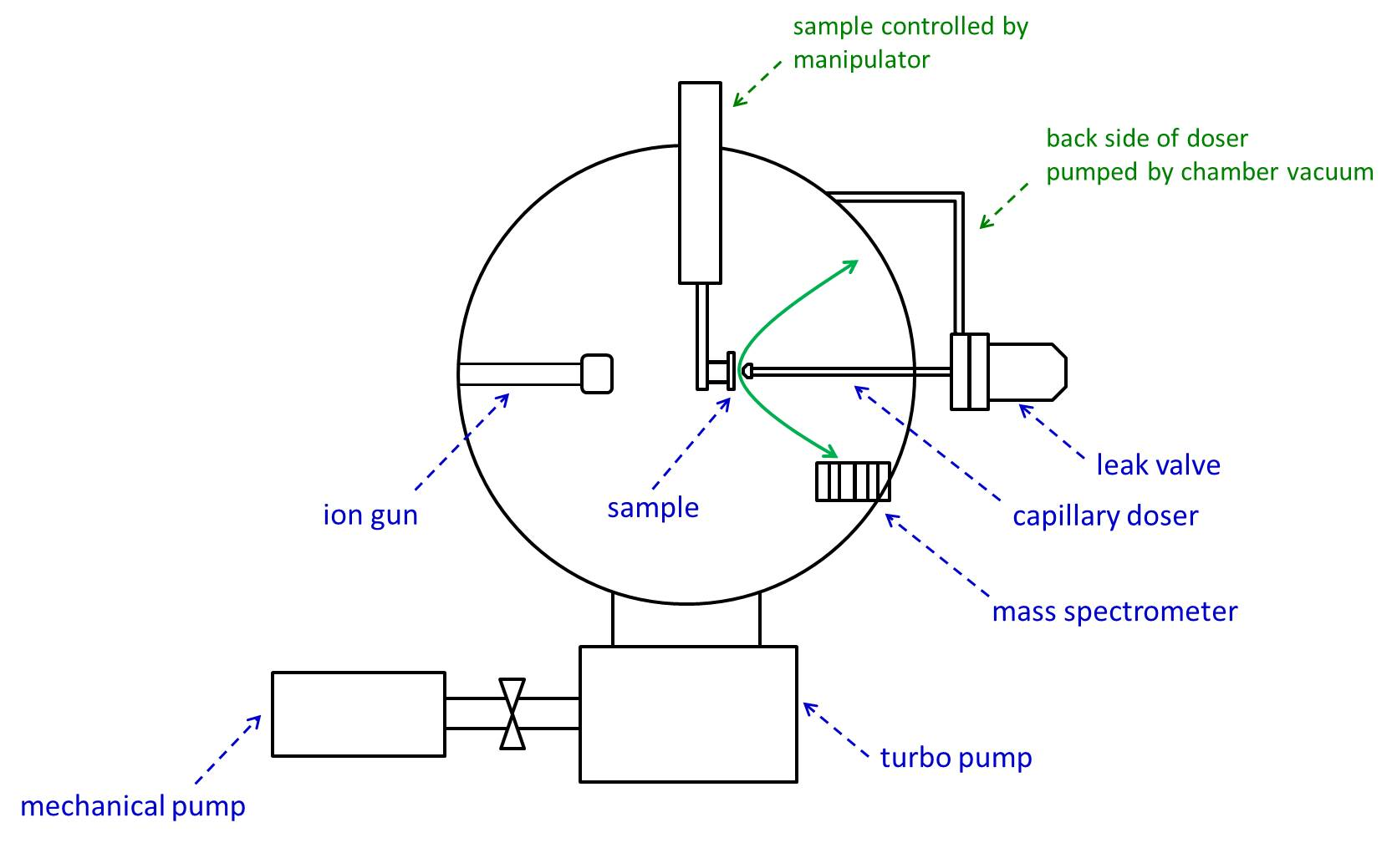

## Precautions for UHV operation concerning safety and instrument

1. When using UV lamp for chamber baking, watch out for the high voltage between the two feedthroughs that are exposed.
2. During chamber bakeout, watch out for the high temperature. Make sure that no cables are touching the chamber.
3. When heating sample, make sure to disconnect multimeter used for the measurement of current during sputtering.
4. When opening gas lines, always make sure that the line is pumped and empty, to avoid gas exposure.
5. When opening gas lines, always make sure that valves connected to the gas tank are closed, so that you are not pumping from the tank.
6. Mechanical pumping should precede turbo pumping.
7. A pumping volume with vacuum should never be open to a stopped mechanical pump due to the backstreaming of pump oil:
8. Gas manifold should be open to air when turning off mechanical pump.
9. Valve between mechanical pump and turbo pump should be closed when turning off turbo and mechanical pump to break the vacuum.
10. Make sure the gas cylinder valve is closed when pumping manifold section.
11. When heating sample or chamber, be cautious so the seal of the manipulator does not heat up. This can be simply done by flowing air into the feedthrough.
12. Avoid moisture condensation into the feedthrough as much as possible when cooling with liquid nitrogen.
13. Safety glasses must be worn when dealing with liquid nitrogen.
14. Multiplier and emission of the mass spectrometer must not be on at high pressure.
15. Ion gauge must be off at high pressure, especially when oxygen is present.
16. Wear gloves when touching parts that go into the chamber.

# Vacuum System

## Evacuating the system

If the chamber is at atmospheric pressure, the following are the steps necessary to regain ultra-high vacuum.

1. Make sure all parts of the chamber are closed.
2. Turn on mechanical pump (if off).
3. Open valve between mechanical and rotary stage of the manipulator. Let the section pump down a few minutes.
4. Slowly open valve between mechanical and turbo pumps. Let it pump down to ~20-30 militorr.
5. Turn on turbo pump by pressing the “start” button on the turbo pump controller. There will be a metallic noise as the turbo pump is accelerated. First, the “acceleration” light turns on, then the “normal operation” light will turn on.
6. After stabilizing and leaving it on for about 5-10 minutes, turn on ion gauge and check the pressure.
7. Let it pump down into the 10-8 Torr range.
8. Bake.

## Venting the instrument

When the chamber needs to be opened to replace/modify a part in the chamber, or the pump needs to be stopped due to power situations, etc., the following steps are needed to be done to bring the chamber pressure up.

1. Fill in the manifold with nitrogen by connecting the manifold to a liquid nitrogen container through a tube.
2. Make sure mass spectrometer and ion gun are off.
3. Close valve between the mechanical and turbo pumps.
4. Close valve between mechanical and rotary stage of the manipulator.
5. Press the stop button of the turbo pump controller.
6. Flow in nitrogen through a leak valve into the chamber.
7. Turn off ion gauge.
8. The turbo pump will start making a metallic noise as it stops.
9. Wait until the turbo pump stops completely before opening the system up to air.

## UHV Bakeout

Chamber bakeout is needed to bring the pressure down to the ultimate range by desorbing molecules from the chamber walls (especially water).

1. If the sample has been newly remounted, check the heating before baking the chamber once the pressure is in the 10-8 range.
2. Disconnect mass spectrometer and ion gun cables.
3. Connect heating tapes to variacs. It can be checked if there are any short circuits within the heating tape or between the heating tape and the chamber by measuring the resistance with a multimeter.
4. One of the variacs has a double output of voltage, and is checked with a “x2” sign. When using this variac, point the knob at half the value of the desired voltage.
5. Flow air into the feedthrough to prevent deformation of rotary slide gasket.
6. Turn on UV lamp, use 60 V. The lamp in the chamber turns on bright.
7. Turn on the variacs for the heating tapes. Use 45 V for the heating tapes on the chamber with the variac, use 30 V for the ones on the bellows and mass spectrometer flange.
8. Shortly, try touching the heating wires to see if they are heating up. If they are not heating up, this may indicate a broken heating wire or short between a heating wire and the chamber. A malfunctioning heating wire should be removed, otherwise, it causes strange behavior in voltage.
9. Check the rise and stabilization of pressure.
10. Bake for about 1-2 days. The pressure reached while baking is about 4-5x10-9 Torr for a chamber that has a base pressure of 1.5x10-9 Torr when cooled.
11. After the bake is over and cooled down to a luke warm temperature, connect the cables back, and degas the ion gauge, ion gun, and mass spectrometer. Degas the ion gauge by pressing the “degas” button. Degas the mass spectrometer by pressing the “Far Cup” button. Degas the ion gun by turning the knob to “degas” position.

## Ion gauge

The main chamber UHV pressure is measured with an open-ended (NUDE) Bayard-Alpert type ionization gauge. If the ionization gauge does not turn on, check the continuity of the filament between green and black wires with an ohmmeter (the resistance should be on the order of an ohm). If the filament is open, change to the second filament by connecting the green cable to the pin with the yellow cable. The yellow cable is only for protection. Sometimes it helps to turn the power off and on to restart the ionization gauge. Degassing is achieved by setting the “Degas” button on the pressure readout unit.

## General maintenance

### Mechanical pump oil change

The oil of the mechanical pump is generally changed once every 4-6 months depending on the type and volume of gas used: more frequent change may be needed when using more corrosive gases. The condition of the oil can also be checked with the color of the oil seen through the window. Some oil can be added if the oil level is low.

1. Isolate the pump from other parts of the manifold. When stopping the pump, vent the manifold as you turn the switch off, otherwise, there will be backstreaming of pump oil into the manifold due to the higher pressure in the pump compared to the manifold. Venting can be easily done by opening the cap for the molecular sieve container. The solenoid valve attached to the mechanical pump is for the purpose of blocking the oil backstreaming when the pump is stopped.
2. Put manifold on the frame used for mechanical pump oil change.
3. Put oil tray under the pump and open the screw to drain the oil into the tray.
4. Open the top input screw, close the drain screw, pour in new oil through a funnel.
5. Close the top input screw, bring the pump down from the frame.
6. Connect the pump back to the manifold.

### Recirculator

When using the refrigerating recirculator for water cooling of the turbo pump, the water level should be checked every week and water should be added up to the level. Currently the recirculator is broken, and the turbo pump is air cooled.

## Leak detection

A leak is suspected when the chamber pressure is higher than normal. Currently the base pressure of the chamber is around 1.7x10-9 Torr. The first step to take when a leak is suspected is to check the mass spectrum. With a leak, there is a higher signal for m/z= 18 (water), 28 (N2), and 32 (oxygen) than normal.

The easiest way to find a leak is to spray acetone around the suspected areas. If the pressure fluctuates after acetone is sprayed on the area, that part is suspected for the leak. Another method is to flow helium to the suspected areas while tracking the m/z=4 with the mass spectrometer.

The decrease in baking pump performance can also be a reason for the increase in chamber pressure. In this case, check the performance of the mechanical pump by directly measuring the pressure achievable with the mechanical pump. Accordingly, the oil/molecular sieves of the mechanical pump may be changed, or otherwise, the mechanical pump should be repaired.

# Sample

## Mounting

When the heating connections become loose, it may be necessary to remount the sample. To remount the sample, the pump/system should be shut down, and the manipulator should be brought out. When bringing out the manipulator, the sample should be moved backwards, and care should be taken so that the sample does not hit the doser or the sputter gun.

Mo wires are used with the concern about high pressure of hydrogen. Ta wires can be used for the ease of handling. The wires should be spot-welded to the sample. Chromel and alumel thermocouple wires are also spot-welded to the sample with a lower power setting. The set screws are loosely screwed on during the making of the assembly, and tightened at the end. The thermocouple wires meet at a single point, and the point is spot welded to the sample. The correct port for the chromel and alumel connections can be tested with a magnet (alumel=magnetic). After mounting of the sample, the contacts can be tested by measuring the resistances between the heating wires or between a heating wire and thermocouples.

Currently, the sample is mounted so that it is 9 mm above the copper wires. The sample position at this point affects the range that it can move inside the chamber, thus affecting the sputtering position and the position in front of the doser.

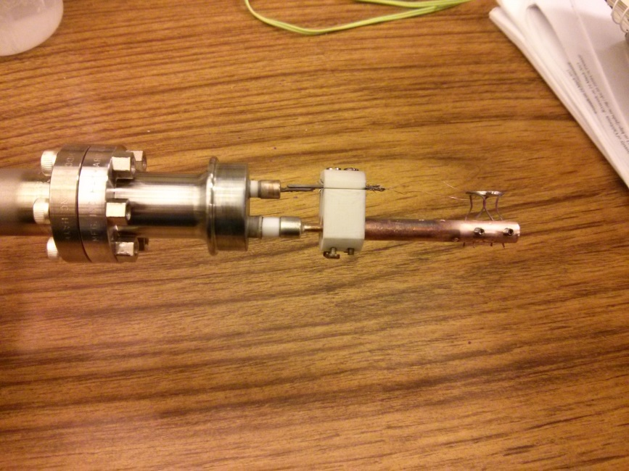

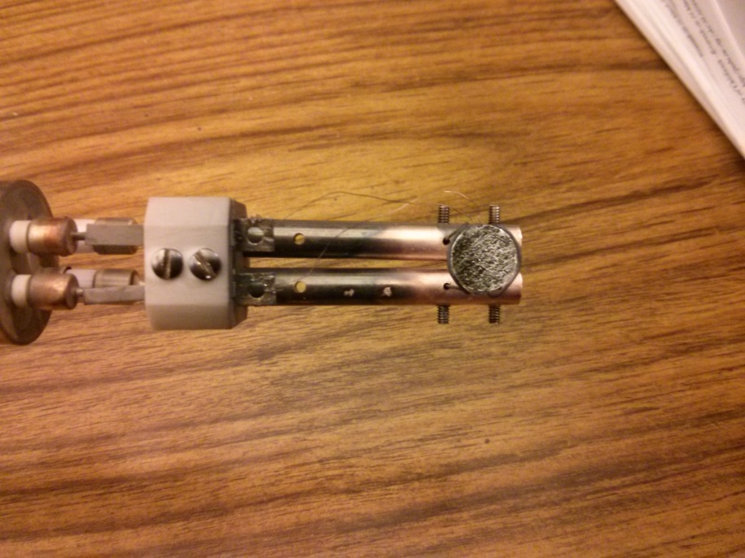

## Heating and cooling

For detailed directions for the temperature controller, refer to the OMRON user manual.

When heating without liquid nitrogen cooling, air cooling can be used to avoid heating and deforming of the rotary stage gasket.

### Heating the sample

The chamber should be pumped down at least to a moderate vacuum (~10-7 Torr) when heating the sample. The sample can be heated using the TDS_Omron.exe program or directly using the temperature controller if the mass spectrometer signal is not needed. Refer to the “Mass spectrometer software” section of this manual for the procedure for the first way, and the OMRON user manual for the ways to implement and execute patterns. When the sample is newly mounted, the temperature ramp should be checked if it is linear. If not, the autotune function can be used to find good tuning values for the temperature programming. The autotune values can be used as is, or modified manually for better results.

### Cooling with liquid nitrogen

CAUTION: When dealing with liquid nitrogen, safety glasses and cryo-gloves should be worn.

For liquid nitrogen cooling, place the funnel with the long copper tubing into the feedthrough. Cover top of the manipulator with cloth, surrounding the funnel. Turn on heating tape around the bellows to a power level of 20 V using a variac, and cover that section with cloth. Turn on fan to avoid condensation. Pour in liquid nitrogen little by little initially to avoid cracking of ceramic connections, and keep the lid of the funnel closed when not pouring in liquid nitrogen. Fill the funnel with liquid nitrogen every time the liquid nitrogen level has dropped down to a low level. When the experiment is over, slowly start blowing inside the funnel with air, proceeding to blow inside the copper tube. When the liquid nitrogen in the funnel is dried out, take out the funnel, and slowly insert the air into the feedthrough. Block the entrance of the feedthrough with a paper towel so that condensed moisture does not get into the feedthrough. Condensed moisture (ice) is a major reason that a ceramic feedthrough can be broken, so great care should be taken to avoid this throughout the whole time that liquid nitrogen is in the feedthrough. Leave the air on until the temperature of the sample is stabilized at room temperature.

## Cleaning

The sample needs to be cleaned before each experiment. Currently, a polycrystalline Pt disk is being used. For this sample, the sample preparation consists of sputter-cleaning with Ar+ ions, annealing in oxygen, and flashing to high temperature to remove oxygen. The cleanliness of the sample can be checked by CO or H2 TPD after the treatment.

### Sputter cleaning

1. With the current setting, the best sample position is where the sample looks to the front port of the chamber while about 1.3 cm away from the doser.
2. Fill the chamber with argon to a pressure range of 7×10-6 to 5×10-5 Torr by opening the leak valve connected to the ion gun (currently, a pressure of 2×10-5 Torr is used for the sputtering). This leak valve is not in perfect condition, however, will do its purpose.
3. Turn the “function” knob to “operation,” and turn the ion energy knob to 1.
4. Measure the current between ground and a heating wire using a multimeter. Currently, the usual current is in the range of 20-35 µA.
5. The sample is usually sputtered for 30 minutes.

### Annealing in oxygen

1. Fill in chamber with oxygen (5x10-7 Torr) by opening leak valve.
2. Using TC pattern, heat the sample up to the annealing temperature (850-100 K) and anneal for 20 minutes.
3. After annealing, cool down the sample in oxygen, turn off oxygen, then flash to 1100-1200 K to remove any oxygen.
4. Repeat the above twice.

### Temperature reading

To check if the temperature reading of the temperature controller is correct, an ice-point compensator can be connected between the thermocouples, then the voltage is measured with a multimeter. The voltage can be converted to temperature using thermocouple reference table for type K thermocouples (http://www.pyromation.com/downloads/data/emfk_c.pdf).

# Gas Handling

## Design, schematics

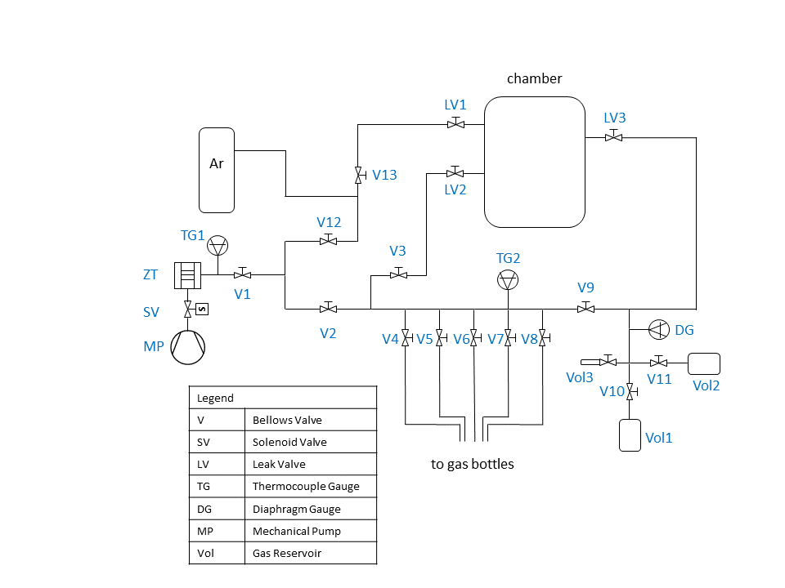

Currently, there are two manifold sections that are pumped by the same mechanical pump. One part is for argon used for sputtering: it is connected to the back of the leak valve connected to the sputter gun (LV1). The other part is connected to another leak valve (LV2) and the leak valve connected to the doser (LV3). The gases currently connected to the manifold are: hydrogen, oxygen, CO, and ethylene. Two gas reservoirs are connected in parallel to a line that connects to the doser. The volumes of the containers are both 170 cc. The volume of the lines behind the leak valve (LV3) down to V9 is 47.708 cc. The additional reservoir (Vol3) has a volume of 1.356 cc.

Update: The argon manifold is now pumped by a separate pump.

## General operation procedure

Before the manifold is filled with gas, the parts of the manifold being filled should be pumped down to the base pressure read by the thermocouple gauge. However, ALWAYS make sure that the main valve for the gas cylinder is closed before pumping, so that the cylinder is not getting pumped. The manifold should be well pumped down before filling with gas also to avoid contamination of the gas source by residual gas in the manifold. To fill in the manifold, isolate the manifold part from the pump by closing a valve to the pump, then fill in the gas by opening the valve to the gas regulator. It is ideal to flush the manifold part to be filled twice by filling and pumping the part. Gas regulator outlet pressure should be higher than atmospheric pressure (14.7 psi) to avoid leak of air into the regulator/manifold.

Gas mixing is done by filling in the volumes with each gas with the desired pressure ratio, then opening the valves to mix the gases. The ideal gas equation is used to calculate the ratio of the number of gas molecules. The small gas reservoir (Vol 3) is used when a high ratio of gases is needed, which is the usual case for alkene hydrogenation experiments. In such case, alkene is flown in to Vol3, and H2 or D2 is flown into either Vol1 or Vol2. When the gases are mixed, the mixed gas occupy individual gas volumes + the volume behind the doser (V9-LV3). The pressure is measured by the baratron. A gas mixing time of 3 hrs is needed for a good mixing of the gases.

## Maintainence

Before bringing any manifold part up to air, make sure that the manifold is empty. Otherwise, the gas will be released to the air. When stopping the pump, vent the manifold as you turn the switch off, otherwise, there will be backstreaming of pump oil into the manifold due to the higher pressure in the pump compared to the manifold. Venting can be easily done by opening the cap for the molecular sieve container. The solenoid valve attached to the mechanical pump is for the purpose of blocking the oil backstreaming when the pump is stopped.

The base pressure of the manifold should be monitored with the thermocouple gauges. The mechanical pump oil should be changed. The molecular sieves can also be baked using the heating rod placed in the middle of the molecular sieve container.

## Valves

The valves that are used for the manifold are Swagelok SS-4BK bellows valves. Leak valves are used for controlling the flow of the gas in the manifold into the chamber.

## Pressure gauges

There are two thermocouple gauges connected to the manifold: one close to the mechanical pump, and one on the gas filling section. They are used to give an approximate indication of rough vacuum. A baratron manometer is placed on the doser back volume to measure the pressure for the molecular beam experiments.

# High-flux doser

## Desgin, schematics

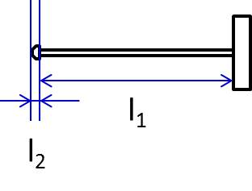

l1 = 6" 5/16" = 176.2 mm

l2 = 3/16" = 4.76 mm

d1 = 2xr1 = 0.08" = 2.2098 mm

d2 = 2xr2 = 0.0059" = 0.15 mm

The molecular beam is formed by flowing gas through a high-flux doser through a leak valve. The back side of the doser has a connection to the chamber for better pumping of gas inside the doser. The connection should be closed when performing the molecular beam experiment so that the gas is directed to the doser.

## Regular operation: molecular beam experiment

1. Set up configuration file for the study and load it to the TDS_Omron.exe program.
2. The gases should be mixed in the part of the manifold behind the doser for three hours according to the section 4.2 of this manual.
3. Place sample in front of the doser so that it is about 2mm from the doser. The position of the sample with respect to the doser can be known by measuring the current between the sample and ground to find out the point where the sample is almost touching the sample, then moving the distance back by changing the y-position.
4. Turn mass spectrometer emission/multiplier on. For molecular beam experiments, usually a low emission of ~0.5 mA is used.
5. Close the valve that connects the back of the doser to the vacuum.
6. Flow in gas mixture by slowly opening the leak valve. Note the position of the leak valve and the corresponding chamber pressure measured by the ion gauge of the chamber.
7. Note the change of the pressure of the gas mixture measured by the baratron. This is used for the calculation of the flux.
8. The sensitivity scale is changed for a short period of time if there is a signal that is off scale (normally hydrogen signal which is usually detected at lower sensitivity).
9. When sufficient data is acquired, close the leak valve.
10. Stop program and save data file. Turn off multiplier.
11. Open valve for the line behind the doser.
12. Flush the doser with H2 or Ar.
13. After a molecular beam experiment, a day may be needed to pump down the system to the base pressure.

## Analysis of molecular beam experiment data

The gas profile of the chamber background (as opposed to the gas profile in front of the sample) during a molecular beam experiment is analyzed first, then used for the analysis of the gas in front of the sample in conjunction with the flux information from the baratron measurement. To analyze the chamber background:

1. From the molecular beam experiment described above, convert the mass spectrometer reading into the corresponding ion gauge reading using the gas calibration information. Often times for the molecular beam experiments, the gas pressure is in the range where the pressure-signal relationship is not linear, especially for hydrogen. In this case, the signal should be converted to the ion gauge pressure using the calibration chart in this range, rather than dividing the MS signal with the sensitivity factor.
2. Convert the ion gauge pressure for each gas into real pressure using the ion gauge sensitivity factor of the gas (Pactual / sens. factor = Pion gauge). Appendix A includes the sensitivity factor of some widely used gases.
3. The composition of the input gas can be calculated from the pressure of the gases considering the stoichiometry of the reaction.

The pressure in front of the sample can be calculated from the change in gas reservoir pressure using the Hertz-Knudsen formula for incident flux, Flux = Pressure / (2πmkT)1/2 :

1. Considering the gas volume behind the doser, convert the pressure change measured by the baratron (Torr/s) to molecues/s using the ideal gas law (pV=nRT).
2. Using Maryam’s result that the beam diameter was 2 mm when the sample was 2 mm away from the beam using propylene oxide, transform molecues/s to flux (molecules/m2*s).
3. According to the kinetic theories of gas, Flux = Pressure / (2πmkT)1/2 (Hertz-Knudsen formula for incident flux). In this equation, the conversion between the flux and pressure depends on the molecular weight. Therefore, the flux ratio of gases and gas composition are different: the flux ratio of gases is related to the composition of gases through the square root ratio of the masses (Flux1/Flux2 = P1/P2 × (m2/m1)1/2). With this relation, the flux ratio is calculated from the pressure ratio of input gas calculated from the MS signal.
4. Combining the total flux (molecules/m2*s) calculated in step 2 and the flux ratio calculated in step 3, calculate the flux for each gas.
5. Using Flux = Pressure / (2πmkT)1/2, convert the flux of each gas into pressure. This is the local pressure in front of the sample.

# Mass Spectrometer

## General operation

In general operations, the VAR and EMIS buttons are pressed down. In NORM mode the signal is seen in an oscilloscope, and the signal is sent to the computer acquisition unit in the EXT mode. Usually EXT mode is used with this unit. The operation of the software is described in section 7 of this manual.

To turn on the instrument, press ON/STBY.

To turn off the instrument, press OFF.

The manual suggests a 20 min period for warming up the electronics after turning on.

When turning it on after a long period of being off (e.g., in the morning), it can be degassed by turning on the emission (MULT) for about 3-5 minutes.

To put the instrument in data acquisition mode, turn on emission by pressing down MULT.

On this unit, usually an emission of 0.5 mA is used for the molecular beam experiments to avoid damage to the filament during operation at high pressures, and 0.7 mA is used for TPD.

Currently, the damper is set at 10:30 direction as a compensation between short response time and better signal-to-noise ratio. Lower damping results in shorter response time without cross-talking between masses. With the current setting, the response time is about 25 ms. The A.M.U. series interval should be set so that it is longer than the response time multiplied by the number of masses.

## Calibration

The calibration of the peak positions is done through a calibration file. The calibration text file used currently looks like the following:

0 0

2 0.05

18 0.7

28 0.65

44 1.44

50 1.59

The numbers are modified so that the peaks are centered using the UTI_scan_average.exe program (section 7). A gas of interest may be leaked in to check the alignment of specific mass numbers.

## Maintenance

The mass spectrometer generally does not need regular maintenance. When the emission fails due to filament degradation, they can be replaced by Stan. Refer to the manual for a complete description of the system.

# Software

The software for the use of the mass spectrometer is a labview-based program, but no instructions or original code is left. However, with the following procedures, basic operations can be done. The related programs are in the folder “UTI Mass Spectrometer” in desktop.

For a full spectrum of a mass range, use the file UTI_scan_average.exe, and for simultaneous acquisition of multiple mass points, use TDS_Omron.exe.

To use the UTI_scan_average program, press the button for “calibration file” to assign the location for the calibration file. Step size and mass range can be set. With the MULT button pressed, and the Emission set at the desired value, press the arrow button to obtain spectrum. The spectrum can be saved by pressing the “begin averaging” for the number of “scans to average” set. Once the acquisition is done, it will ask for the file number and location. Press “Stop program” to stop acquiring data.

To use the TDS_Omron.exe, a configuration file is needed with the extension of .cfg. Here, you set the details of the data acquisition, and the current setup for a CO TPD is set as the following:

[Data acqusition]

A.M.U. to be tracked="28.0, 44"

total time, min=90

series interval, ms=89

[Input-output settings]

mass-spec A/D=1

mass-spec D/A=1

thermocouple A/D=1

masses calibration file="C:\Documents and Settings\Praxis\Desktop\YUJUNG\cal.txt"

data output folder=/c/rawdata

[Thermocouple input]

pre-amplifier: slope=245.00860

pre-amplifier: intercept=0.00000

reference temperature for thermocouple=-13

For the ethylene hydrogenation reaction using doser, the following configuration is being used:

[Data acqusition]

A.M.U. to be tracked="2.2, 25, 26, 27, 29, 30"

total time, min=107

series interval, ms=610

[Input-output settings]

mass-spec A/D=1

mass-spec D/A=1

thermocouple A/D=1

masses calibration file="C:\Documents and Settings\Praxis\Desktop\YUJUNG\cal.txt"

data output folder="/C:\Documents and Settings\Praxis\Desktop\YUJUNG"

[Thermocouple input]

pre-amplifier: slope=245.00860

pre-amplifier: intercept=0.00000

reference temperature for thermocouple=-13

When the program is opened, it will ask for the location of the configuration file. The data can be acquired by pressing the “Start scan” button. Temperature patterns saved in the temperature controller can be initiated by choosing the pattern number and pressing the “Execute pattern” button. To end acquisition, press “End scan.”

# General Experimental Procedures

Check pressure of the chamber (ion gauge) and manifold (thermocouple gauge)

Turn on instruments and warm up for five minutes.

Degas ion gun and mass spectrometer:

* ion gun: Turn the “function” knob to “degas” position. The “current lim” light will turn on, and the pressure in the chamber will rise due to the degassing of the filament. When the degassing is over and the light blinks, turn the knob back to “0”
* mass spectrometer: turn on the multiplier for three minutes.

Clean the sample according to section 3.3 of this manual.

## Temperature-programmed desorption (TPD)/Thermal desorption spectroscopy (TDS)

1. When cooling with liquid nitrogen, cool down until the temperature is stabilized.
2. At the desired dosing temperature (either room temperature or liquid nitrogen temperature), dose the gas using a leak valve. Measure the amount dosed in the units of Langmuir (L) by measuring both dosing time and pressure.
3. After the gas is pumped down, turn on the multiplier of the mass spectrometer.
4. Execute the desired linear temperature ramp by pressing “start scan,” choosing the pattern number, and pressing the “execute pattern” button.
5. When temperature ramp is over, stop scan, then save the file.

## Molecular beam experiments

Carry out experiments according to section 5.2.

Appendix A.



