**Reactor System #4:**

**ALD Reactor for Flat substrate and Powder Deposition**

Manual

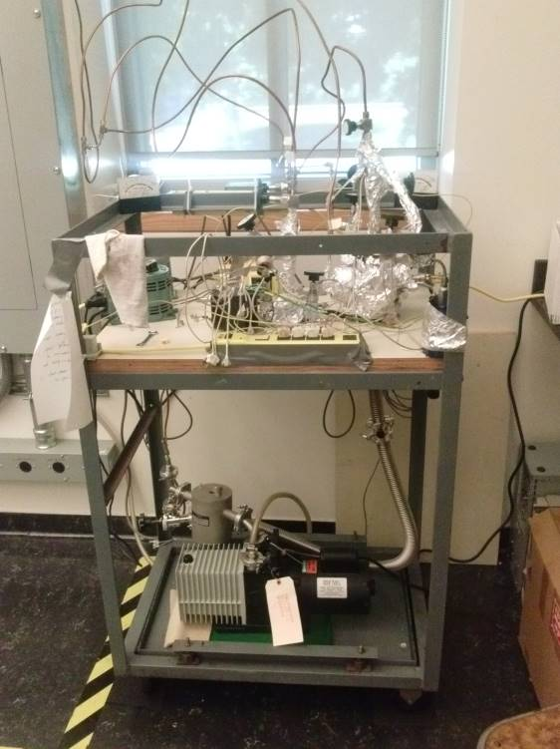

Francisco Zaera Group

Prepared by Xiangdong Qin, Aug 2018

Modified by Barnali Sutradhar, July 2020

# Table of Content

1. General Considerations/Overview of Equipment
2. General Laboratory Safety
3. Gas and ALD Precursor Handling System
   1. Design, Schematics
   2. Gas Lines and Delivery
   3. ALD Precursor Delivery
      1. High Vapor Pressure Precursors
      2. Low Vapor Pressure Precursors
      3. Working with Pyrophoric Materials
      4. Working with Air/Moisture Sensitive Materials
   4. General Operation Procedure
   5. Maintenance
      1. Building Gas Lines
      2. Valves
      3. Pressure Gauges
      4. Mechanical Pumps
      5. Finding Leaks
4. ALD Reactor
   1. General Description
   2. Initial Assembly
   3. Solid Sample Holder
   4. Powder Sample Holder
   5. Experimental Procedure for solid flat sample
      1. Initial Setting Up
      2. ALD Cycles
      3. Final Steps
   6. Experimental Procedure for powder sample
      1. Initial Setting Up
      2. ALD Cycles
      3. Final Steps
   7. Maintenance and Troubleshooting
5. Typical Experiment Sequence
6. Suggested Training for Beginners
7. **General Considerations/Overview of Equipment**

Atomic Layer Deposition (ALD) is a technique that allows grows of thin films layer by layer. The goal is achieved by introducing the reactant separately onto the substrate. There are two homemade ALD reactors designed to be used for the growth of solid films on small flat surfaces and powders. They are located in the Chemical Science building, Room 143. The general operation procedures described here apply to both ALD reactors.

In the ALD reactor system, a small reaction chamber (six-way cross) houses the Nickel-made sample holder, where the substrate can be heated up to 350 ⁰C. The gas feeding line can introduce gas, liquid or solid precursor (by vapor) into the reaction chamber. Purging gas is used between two precursor exposures. The whole ALD reactor can be heated up to 150 ⁰C to avoid the water contamination. A separate pumping line is set up to purify the precursor without contaminate the sample in the reaction chamber. A butterfly valve is installed to adjust the exposure pressure by controlling the pump speed. An Alcatel 2008A vacuum pump is used to pump the system down to a few mtorr.

1. **General Laboratory Safety**

Before starting any experimental work in the laboratory, all users must learn The Laboratory Safety Manual and pass all exams. Users must also get familiar with the Injury and Prevention Program (IIPP) and Chemical Hygiene Plans (CHP).

All users must be familiar with the location of the fire extinguishers, safety showers, and other safety equipment before starting any experimental work. In Room CS 143:

1. Fire Extinguishers: Located next to front door of CS 143.
2. Safety Showers and Eyewash Station: Located next to the front door of CS 143.
3. Fire Exit: two doors in CS 143
4. First Aid Kits: Located next to front door of CS 143.

Some general points to keep in mind:

1. Always follow the laboratory safety procedures described in the appropriate documents when handling chemicals and electrical instruments.
2. Never touch the parts that are inside the reactor directly with unprotected hands. Wear gloves and make sure that they are clean. Powder free latex gloves should be used.
3. The reactor, i.e. stainless steel six-way cross, can be washed with hot water and Liquinox type detergent. Rinse thoroughly when finished. Give the parts a fine rinse in ethanol before baking in a stove to dry.
4. Small parts can be submerged in a beaker containing acetone or ethanol and placed in an ultrasonic bath. When using an ultrasonic bath, be sure not to place the beaker into the ultrasonic bath directly, rather suspend the beaker in a bath fluid (water).
5. **Gas and ALD Precursor Handling System**
6. **Design, Schematics**

A simplified diagram of the ALD reactor is listed below.

**Precursor 1**

**To Pump**

**TC Gauge**

**Sample**

**Heater and**

**Temperature Controller**

Swagelok valve

**Butterfly Valve**

**Mechanical Pump**

**Precursor 2**

**Purge Gas**

Here the reactor is made of a 2.75 inch 6-way cross. A mechanical pump provides the pumping for the reactor and precursor line. A butterfly valve is installed to allow high vapor exposure. The sample is seating in the sample holder, which is facing the end of the gas delivery line. The sample can be heated to 350 ⁰C. A thermocouple gauge is installed in one of the flange to monitor the pressure inside the reactor. The gas line includes the precursor delivery line, purging gas delivery line and the pump line. The gas delivery line is made of ¼ inch stainless tube. The end of the line is connected to a tube with inner diameter 0.75 inch. The end of this tube is only a couple millimeter from the sample. The new formed film within this design shows better uniformity than without the thick tube.

1. **Gas Lines and Delivery**

In the ALD reaction, gas can be used as purging gas (N2 and Ar) or reactant (H2, O2 etc.) To deliver the gas into the system, connect the tube from the gas cylinder to the ALD reactor. Use one of the Swagelok valve in the gas line. Make sure the gas pressure on the gas cylinder side is around 15-20 Psi, and do not go above 20 Psi. During the ALD reaction, the whole system is continuously pumped by the mechanical pump. Slowly open the Swagelok valve that connected to the desired gas. At the same time monitor the pressure in the reactor. The typical exposure pressure for gas is about 100~1000 mtorr.

1. **ALD Precursor Delivery**
2. *High Vapor Pressure Precursors*

For the chemical precursors that have a higher vapor pressure (H2O, TMA), no heating of the precursor is needed. The precursor is brought to the substrate by continuous pumping.

1. *Low Vapor Pressure Precursors*
2. Precursor and Line Heating

For the chemical precursors that have a low vapor pressure, delivery of the precursor can be achieved by heating the precursor to high temperature (not necessary to the melting point). To reduce the condensation of the precursor on the delivery line and the reactor chamber, all the gas delivery line and the reactor will be heated to about 10⁰C higher than the temperature of the precursor. The heating was achieved by heating tapes. Use the Variacs to control the heating power. To heat precursor, it is suggested to use a water or silicon oil bath.

1. Bubbler

A second method to deliver the chemical precursor with low vapor pressure is to use the bubbler system. Here the carrier gas will bring the low vapor pressure precursor into the reactor.

A homemade bubbler system is illustrated on the right side. Here a Swagelok ¼ inch Tee is used. A ¼ inch tube is welded to a 1/8 inch tube. The end of the ¼ tube is connected to one side of the Tee. The end of the 1/8 inch reaches the bottom portion of the precursor container. The precursor container is made from a metal to glass adaptor. Two Swagelok valves are installed for each bubbler. The carrier gas will can carry the low vapor pressure precursor into the reactor.

1. *Working with Pyrophoric Materials*

Many ALD chemical precursors are high reactive or flammable. Trimethylaluminum (TMA) in particular, used to deposit Al2O3 films, is one of them. TMA also causes eye and skin burns, and is extremely destructive to the tissue of the mucous membranes and upper respiratory tract. TMA may also be harmful if swallowed, inhaled, or absorbed through the skin.

When working with TMA or another pyrophoric precursor, the instructions listed below need to be followed. Before starting any operation, prepare as follows:

1. Carefully review the SOP.
2. Do not work with TMA when alone in the Lab.
3. Wear the appropriate PPE:
   1. Eye protection: Safety glasses with side shields should be worn;
   2. Skin and body protection: Wear flame-resistant lab coat, long pants, and closed-toe shoes.
   3. Hand protection: At a minimum, wear a nitrile chemical-resistant glove.
4. Locate the powdered lime (sand, left bottle in Picture below), fire extinguisher, eyewash and safety shower.

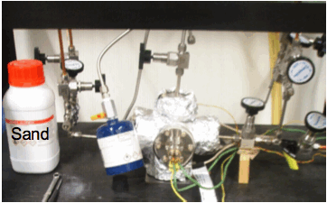

Concerning the set up of the experiment:

1. TMA is a volatile liquid. It is stored in stainless steel containers with a ball valve (blue container in Picture above).
2. The container must be connected to the ALD reactor via Swagelok fittings.
3. Pump the reactor by using a mechanical pump. Keep it pumped all the time.
4. In our lab, TMA can only be used when it is connected to a well-pumped reactor.
5. The precursor is introduced into the reactor by directing its vapor via a Swagelok valve.
6. Do not try to heat the TMA container. TMA has a high vapor press at room temperature.
7. Do not try to get any neat TMA liquids out from the container!

To carry out an ALD process with TMA (or another pyrophoric precursor):

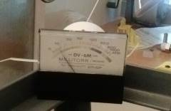

1. Check the reactor for possible leaks. The base pressure in the reactor should around 5-10 mtorr, as read in the thermocouple gauge (see Picture on the right). Fix any leaks before connecting the TMA to the reactor.
2. Connect the TMA container to the reactor by using a Swagelok fitting. When handling TMA, ware safety glasses, a fire-retardant lab coat, and gloves. When TMA is not in use, the ball valve of the metal container should be always in off position (see Picture on the right).

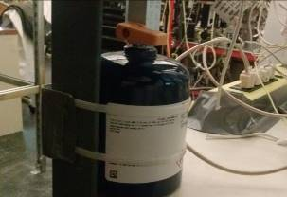

**Ball Valve**

1. Pump the reactor down before initiating the ALD experiments.
2. To initiate the ALD cycles, open the ball valve of the TMA container.
3. The exposure times to be used in the ALD experiments may be varied from one to a few seconds.
4. Right after the TMA exposure, shut off the TMS container ball valve.

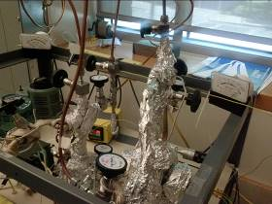

**Purging Gas Valve**

1. Immediately afterwards, introduce a purging gas (Ar or N2) into the reactor via the purging gas valve (see Picture on the right) and flow it about 1 minute. Adjust the purging gas valve to maintain the pressure in the reactor around 200-500 mtorr. Do not try to backfill the TMA container with other gases.
2. The reactor body is normally heated to around 100°C to minimize the amount of water vapor inside the reactor volume. However, no part of the TMA container should be subjected to a temperature higher than 125°F (52°C).
3. In case of power failure during the exposure experiments, follow the steps below:
   1. Immediately shut off the ball valve of the TMA container.
   2. Open the purging gas valve to leak purge gas into the reactor.
   3. Close the angle valve (see Picture on the right) above the mechanical pump.

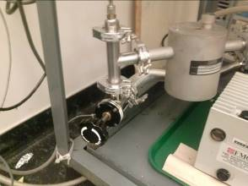

**Angle Valve**

* 1. When the power returns, make sure that the mechanical pump is back and running.
  2. Then open the angle valve.
  3. At the same time, close the purging gas valve.
  4. The pressure in the reactor should drop as it is pumped.

1. In case of Fire:
2. If a fire comes out from the section between the ball valve and the container:
3. Immediately apply dry powder or use a fire extinguisher.
4. Do not try to reach or remove the TMA container.
5. Call for help if the fire is large.
6. If a fire is inside the reactor:
7. Immediately close the TMA container ball valve.
8. Close the angle valve.
9. Introduce the purging gas into the reactor by opening the purging gas valve.
10. If a fire comes out from the Swagelok fittings:'
11. Immediately close the TMA container ball valve.
12. Apply dry powder or use a fire extinguisher.
13. Check the vacuum in the reactor and connections.
14. *Working with Air/Moisture Sensitive Materials*

A lot of ALD chemical precursors are air and moisture sensitive. In this case, the glove box is used to transfer the sample. Please follow the instruction of glovebox for further details.

1. **General Operation Procedure**

Start pumping after installing a new sample:

* + - 1. Check of all the valves are closed, particularly the ones to the gas supply lines.
      2. The mechanical pump is left on for all the time. Open the angle valve between the pump and the ALD reactor to pump down the reactor.
      3. Once the pressure in the reactor is below the 5 mtorr regime. Slowly heat the ALD reactor and the gas delivery line to desired temperature.
      4. Open the valve that connects the dosing line to the reaction to introduce precursor into the reactor.
      5. The pressure reading at this point indicates the exposure pressure.

Pumping the precursor after installing a new precursor:

* + - 1. To pump the precursor, close the angle valve between the mechanical pump and the reactor.
      2. Open the Swagelok between the pump and the precursor line to pump down the precursor. It is suggested to freeze the precursor using the LN2 bath to reduce the consumption of the precursor.

Removing sample after exposure:

* + - 1. When the experiments are done, make sure all precursor valves are closed. Introduce purge gas into the system. Stop heating.
      2. When the sample cools down, increase the purge gas pressure and close the angle valve. At the same time, start loose the bolt on the sample holder flange.
      3. Remove the sample holder flange and change the sample.

1. **Maintenance**
2. *Building Gas Lines*

To build gas lines, typically stainless-steel (or sometimes copper) tubing is assembled using Swagelok connections. These connections can create ultrahigh vacuum level of sealing and can be reused if handled properly. Refer to the description of the parts and their handling in the Swagelok catalogue. Avoid mixing brass and stainless steel connections, as brass is softer and ferules and threads can be damaged. All nuts have to go smoothly on the thread; do not force a nut on a connection.

To assemble a section of a vacuum line:

1. Clean the tubing with acetone before assembly.
2. Cut the tubing to the required length.
3. Attach the fitting:
   1. Insert the tubing into the fitting (or into a nut and place the ferrule in it, the small ring first).
   2. Turn the nut finger-tight against the male component of the Swagelok (the coupling piece, elbow, "T", cross, etc.).
   3. Hold the body of the fitting with a back-up wrench.
   4. Tighten the nut 1-1/4 turns (only a 3/4 turn for tubing smaller than 3/16").
   5. Open the nut again to check if the ferrule is sitting tight and the lower ring cannot be moved.
4. *Valves*

In the gas/precursor delivery line, Swagelok valve are used. The most common model used here is SS-4BG. This valve can be used at up to 200 °C. The other type valve used is for gas purge line only, where there is no need to heat. It is SS-4BK.

The valves are manually controlled. Open the valve slowly to reach the desired pressure.

1. *Pressure Gauges*
2. A thermocouple (TC) gauge is used to measure the pressure in the reactor.
3. Thermocouple gauges are prone to burnout, especially when used with corrosive gases.
4. If the pressure readout is high:
   1. First check to see that the cable connecting the pressure sensor to the readout unit is solid.
   2. If the connection is good, it is likely that the TC gauge needs to be replaced.
5. *Mechanical Pump*

The mechanical pump (Alcatel 2008A) requires regular oil changes, approximately once every half-year or when large quantities of corroding or contaminants gases are used in the experiments. The oil can be occasionally degassed by leaking air in the inlet for a short period of time (this heats up the oil), but once the oil becomes dark, changes consistency, or has solid particulate, it is best to change the oil:

1. Wear proper PPE (gloves, safety goggles and lab coat). Isolate the mechanical pump from the UHV system. Stop the pump and remove all the connection. Wait for 20 mins, the pump oil may still be hot.

2. Lift the pump on the moving cart (stored in RM 137). Put the waste oil bucket below the pump. Remove the top screw. Slowly unscrew the bottom screw and leak all the oil into the bucket.

3. Fill the pump with only 0.5L clean oil. Rinse the pump by running it for 5 mins. Stop the pump and drain the oil. Multiple rinses may be needed if the pump is too dirty.

4. Fill the pump with clean oil. Do not overfill. Tight all the screws and connect the pump back to the UHV system. Start the pump and check the base pressure.

5. Put the used oil in the waste bottle with proper chemical waste tag.

1. *Finding Leaks*

Gas lines should check for leaks once assembled:

1. Isolate the gas lines in sections by closing the appropriate valves when possible.
2. Pressurize the line and check for bubbling while spraying a few drops of a soapy solution such as "Snoop".
3. If that does not work, spray helium around the suspect connection and look for any pressure change in the gas manifold with the thermocouple vacuum gauge.
4. A third way of identifying leaks is to use acetone or 2 propanol, pouring some drops in the suspected connection and looking for pressure changes inside the manifold.
5. Ultimately, if the pressure inside the manifold cannot be brought down, or if it increases rapidly upon closing the valve to the pump, a leak detector may need to be used to isolate the leak.
6. **ALD Reactor**
7. **General Description**

The ALD reactor system includes the gas/precursor delivery line, pumping line, reactor and the sample holding/heating stage.

1. **Initial Assembly**

The reactor which is made by 2.75 inch 6-way cross has six CF flanges. One is used for thermocouple connection. The 2nd one is used to connect to the pump. The 3rd one is connects the feedthrough, which has two copper electrodes and K-type of thermocouple. The 4th one is the view port, where we can check the sample position. The 5the one is used for precursor/gas entrance. The 6th flange is an extra one.

1. **Solid flat Sample Holder**

A mini flange, which houses the insulator seal that has four feedthroughs, is mounted to the 2.75 inch flange. These feedthroughs provide K-type thermocouple connections and a pair of copper electrodes for heating. The sample holder is made of a Ni sheet and heated by a Ni wire. It connects to the two copper electrodes in the feedthrough. A thermocouple wire is spot-welded to the back side of the Ni sheet. The sample can be inserted into the sample holder using tweezers. Three sides of the sample are touched by the sample holder when it is full in position.

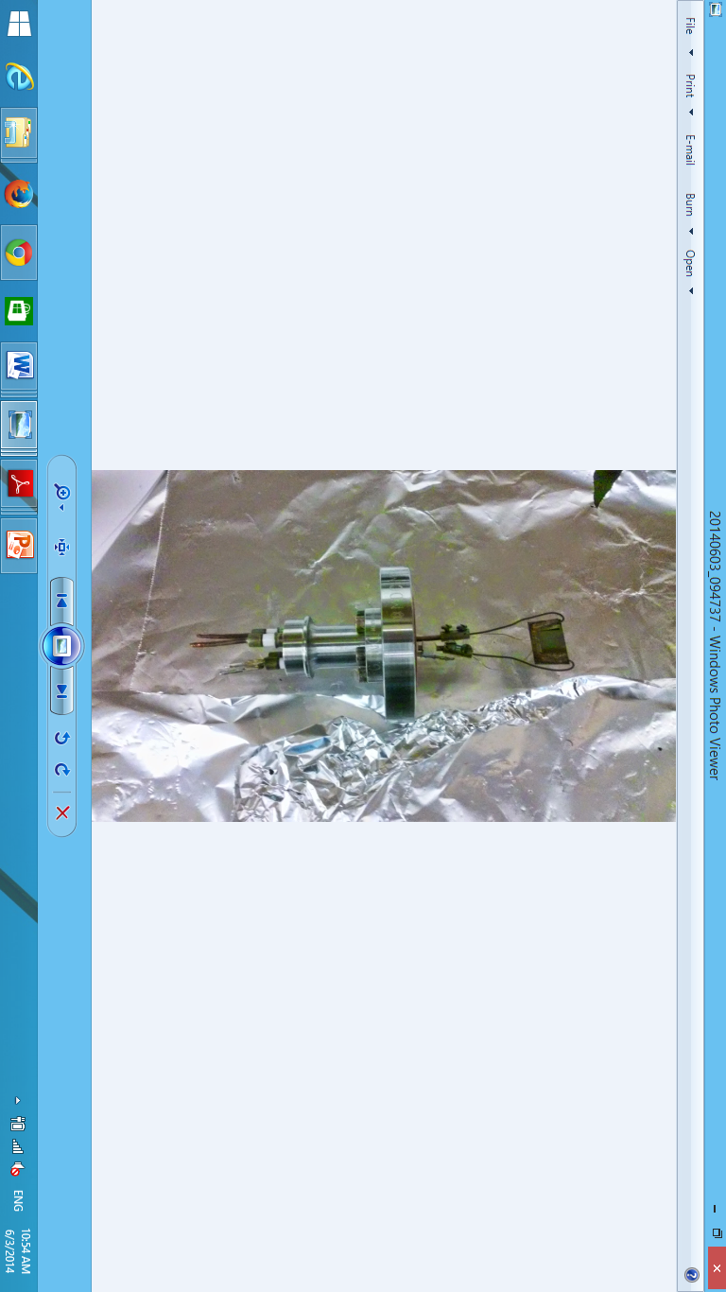

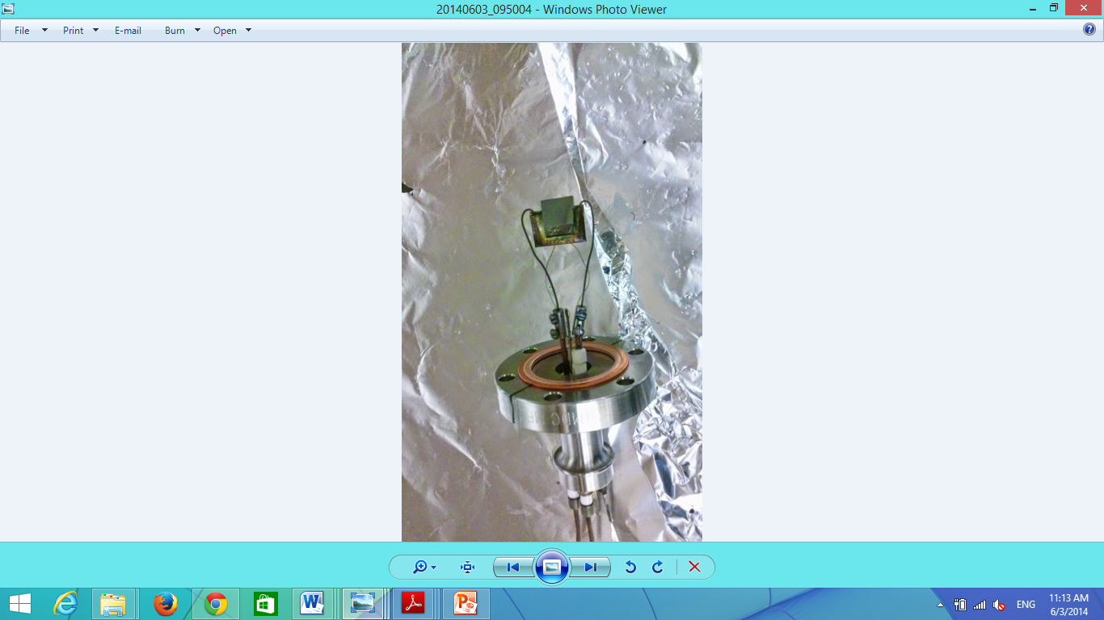

The sample size is about 0.43inch by 0.53 inch. However, It should be mentioned that the sample holder can be modified based on the sample. Larger size sample can also be accommodated by making a new sample holder.

The sample it heated by a transformer which is controlled by a variac. The highest temperature that the sample can reach is around 350ºC when full heating power is applied.

1. **Powder sample holder**

The flat sample holder can be replaced by a powder sample holder by losing the two screws on the mini-flange and remove the thermocouple wires from the back.

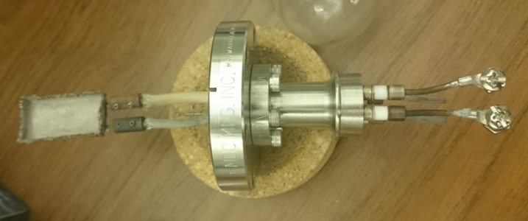

A powder sample holder is attached to the mini-flange by two screws. The thermocouple wire is spot welded on the back of the sample holder. After the powder sample is placed inside, a mesh cover is spot welded on top of the sample holder to prevent loss of powder during pumping and purging. The mesh size is 200x600 with 0.0024 diameter. (From McMasterCarr)

1. **Experimental Procedure for solid flat sample**
   * 1. *Initial Setting Up*

To perform a standard ALD experiment:

* 1. Insert a new sample into the sample holder and mount the sample with the 2.75inch flange to the ALD reactor.
  2. Check the resistance between two heating electrodes, it should be about 1-2 Ω. Check the resistance between one of the electrodes with the chamber body. It should be greater than 20M Ω.
  3. Make sure the temperature reading is good.
  4. Open the angle valve to pump the system down to around 5 mtorr.
  5. In most ALD experiments, the ALD reactor needs to be heated. If so, heat the ALD reactor to the desired temperature, typically ~110 ºC, by adjusting the variacs used to run the heating tapes wrapped around the reactor.
  6. Heat the sample to the desired temperature by using the using the variac.

1. *ALD Cycles*

Deposition of Al2O3 from water and trimethylaluminum (TMA) will be used to illustrate the operation of the ALD reactor. Recipes for other materials can be found in the literature.

1. Install a sample (Silicon oxide). Pump the system down. Heat the ALD reactor and gas deliver line to 110 ºC. Heat the sample to 150 ºC.

2. Slowly open the ball valve that is connected to the TMA precursor. Adjust the pressure in the ALD reactor to 500 mtorr. Exposure time is 1s. Close the yellow ball valve.

3. The pressure will drop slowly from 500 mtorr. When it reaches about 50mtorr, open the purging gas valve to purge the system. Set the pressure at 1 torr and the purge time 60s.

4. Stop the purging gas by close the valve. The pressure in the reactor drops immediately to about 5 torr. Open the Swagelok valve that controls the 2nd precursor, H2O. Leave the valve all the way open, and the pressure in the ALD reactor is about ~100 mtorr. Leave for 5s.

5. Close the Swagelok valve of the H2O, the pressure will drop immediately. Introduce the purging gas again by open the corresponded Swagelok valve. Leave it purging for 60s at 1torr.

6. Repeat 2-5 steps for more cycles.

7. For reference, the measured deposition rate in this reactor for Al2O3 at 150 ºC is about 1.3 Å/cycle. (Results derived from XPS and ellipsometry measurements).

1. *Final Steps*

After ending the ALD cycles:

1. Finish with a purge gas (Ar or N2) to keep the pressure inside the ALD reactor around 500 mtorr.
2. Stop all heating, of the reactor and sample.
3. When the sample cools down, close the angle valve.
4. Stop the purging gas.
5. Open the ALD reactor and remove the sample for future analysis.
6. **Experimental Procedure for powder sample**
7. *Initial Setting Up*

To perform a standard ALD experiment:

1. Weigh 50.0mg solid powder and distribute evenly inside the sample holder.
   1. For transferring the powder to the weight machine use this spatula showed in the figure but before using it clean it with ethanol.

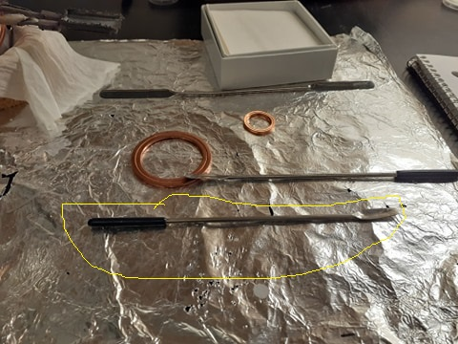

* 1. transfer the powder to the powder sample holder and distribute evenly

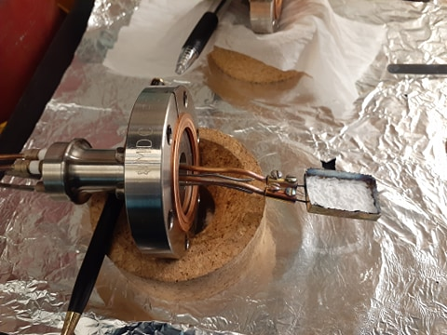

* 1. Spot weld the stainless-steel mesh on top of the sample holder.
* This is the picture of the spot welding machine

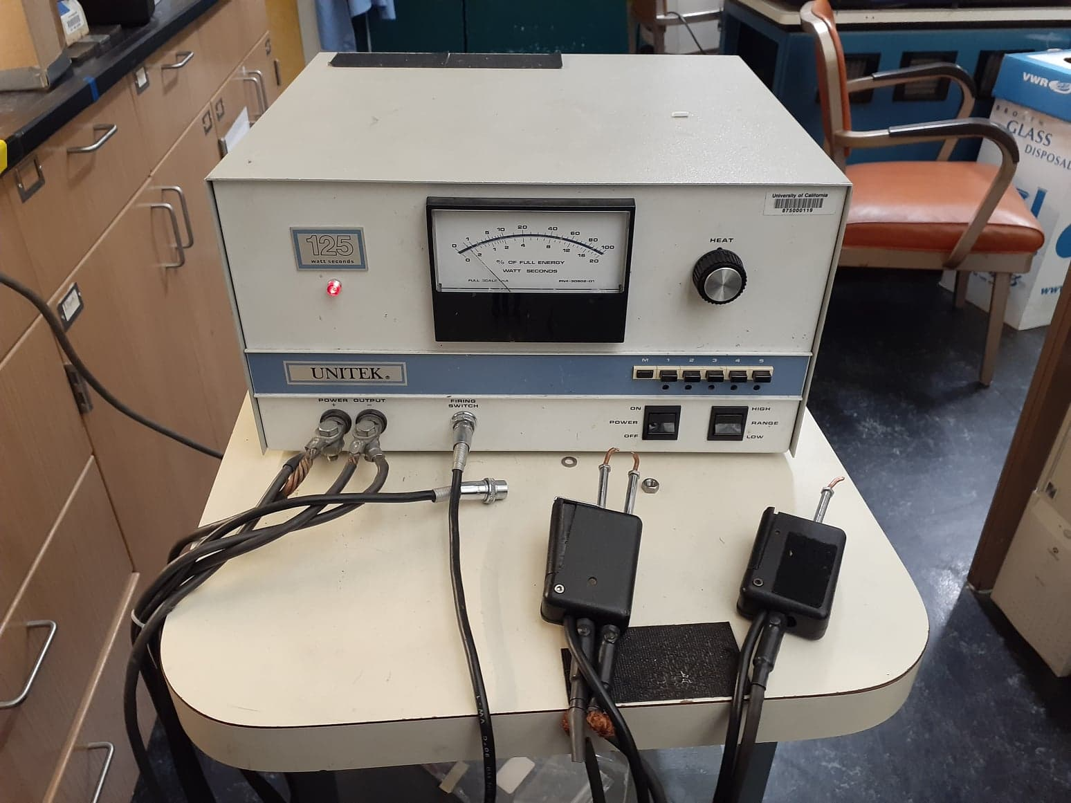

* You have to use this spot welder for the spot welding procedure (shown below)

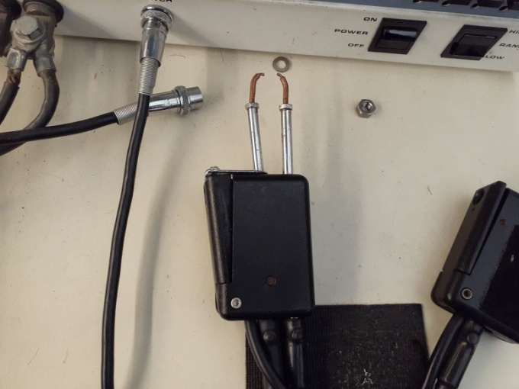

* You have to attach the mesh like this and hold the spot welder like this (shown below)

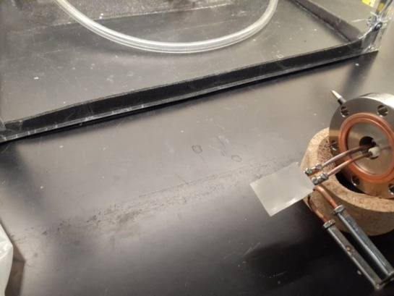

* While doing this you have to press this with the leg like shown in the figure below

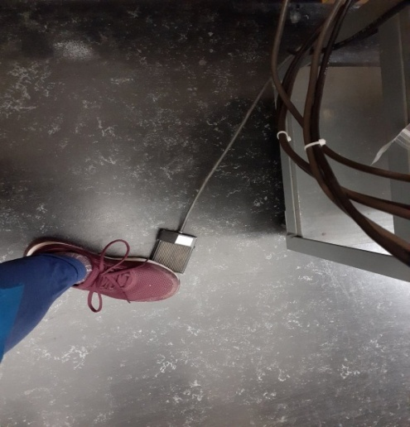

It should be done just at the same time you are pressing the mesh onto the sample holder with the spot welder

* This photo below is taken after the cover.

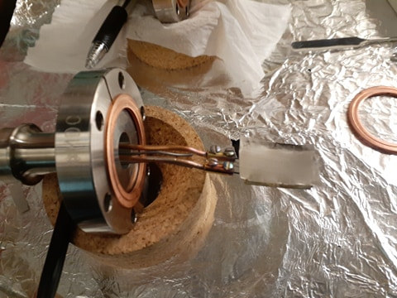

1. Mount the sample with the 2.75 inch flange to the ALD reactor. The following is the photo of ALD reactor before inserting the sample.

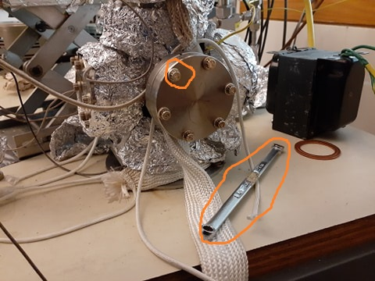

1. Open the bolts using this wrench (shown below)

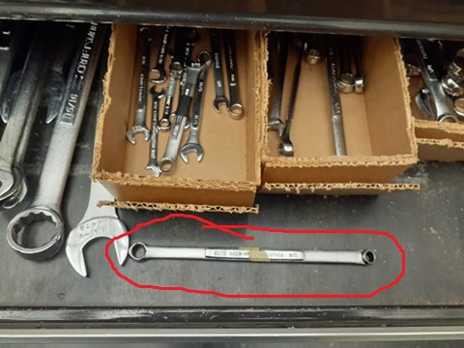

1. Then insert the sample like this (shown below)

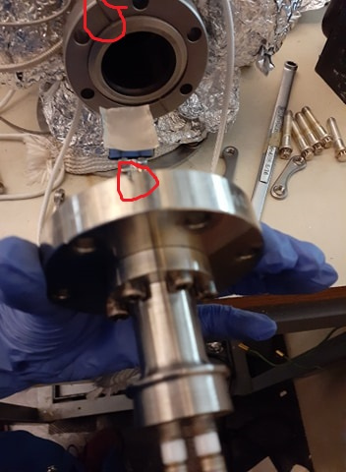

There is a mark in the sample holder and also on the machine. You need to match those marks to fix it properly.

1. Then insert all the bolts into the holes while holding the sample in one hand. There are six bolts and three nuts (shown below) through which the bolts would be fitted. Hold the nuts behind like this while inserting the bolt through it.

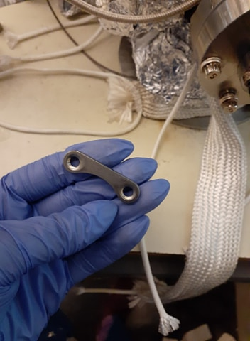

1. Then tighten the bolts using the same wrench. After full attachment it would seem like this.(shown below)

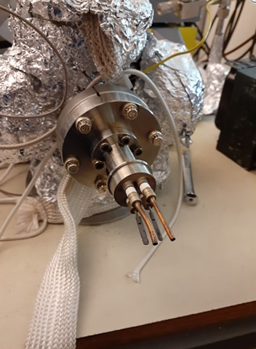

1. Then connect the thermocouple and the heaters like this.(shown below)

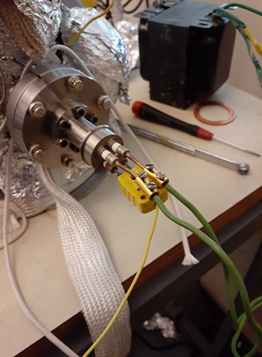

Yellow one is the thermocouple and the upper two are the heaters.

1. Tighten the screws of the heaters with the screw driver.

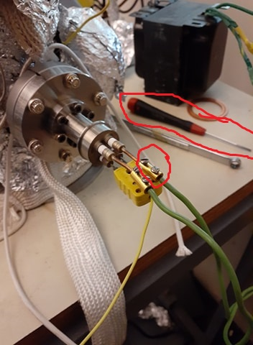

So it is now ready for experiment.

1. Check the resistance between two heating electrodes, it should be about 1-2 Ω. Check the resistance between one of the electrodes with the chamber body. It should be greater than 20M Ω.
2. Make sure the temperature reading is good.
3. Open the angle valve to pump the system down. Open it slowly so that the pressure stays between 500 to 1000 mtorr. Make sure all the other valves are closed. Recognize it by the mark ‘Pump’. Observe the pressure in the vacuum gauge.

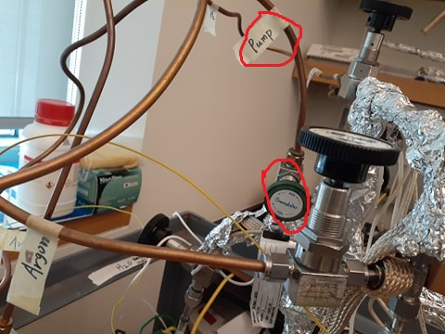

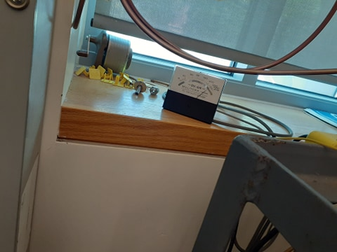

1. In most ALD experiments, the ALD reactor needs to be heated. If so, heat the ALD reactor to the desired temperature, typically ~110 ºC, by adjusting the variacs used to run the heating tapes wrapped around the reactor.

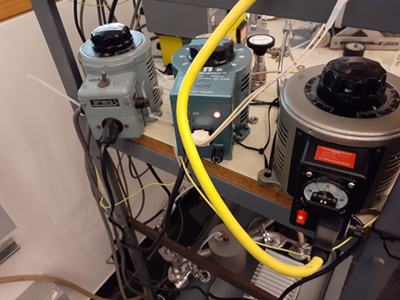

1. If needed, heat the sample and the precursors as well. Heat the sample to the desired temperature by using the variac. If you feel that the heating is too slow or too fast then you can change the power by using these regulators.

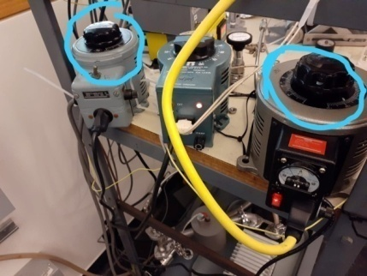

1. When the temperature reaches to the desired temperature and from the vacuum gauge you see that pressure has been decreased and has gone to its initial point (that means vacuum is achieved inside the chamber) then you can start your cycle.
2. Before starting your cycle you have to close the precise vacuum valve and open the bulk vacuum which is located under the chamber.

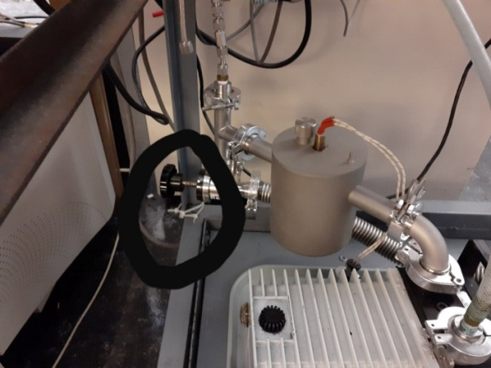

1. *ALD Cycles*

Deposition of TiO2 on SBA-15 from water and tetrakis (dimethylamido) titanium (TDMAT) will be used to illustrate the operation of the ALD reactor.

1. Install a sample (SBA-15). Slowly open the valve to pump the system down. Heat the ALD reactor and gas deliver line to 100 ºC. Heat the TDMAT precursor to 40 ºC. Heat the sample to 100 ºC.

2. Slowly open the Swagelok valve that is connected to the TDMAT precursor. Open the valve all the way and the exposure pressure is about a few mtorr. Exposure time is 20 mins. Close the valve after exposure.

3. Open the purging gas valve to purge the system. Set the pressure at 1 torr and the purge time 50 min.

4. Stop the purging gas by close the valve. The pressure in the reactor drops immediately to about 5 torr. Open the Swagelok valve that controls the 2nd precursor, H2O. Leave the valve all the way open, and the pressure in the ALD reactor is about ~100 mtorr. Leave for 1 min.

5. Close the Swagelok valve of the H2O, the pressure will drop immediately. Introduce the purging gas again by open the corresponded Swagelok valve. Leave it purging for 50min at 1torr.

6. Repeat 2-5 steps for more cycles.

1. *Final Steps*

After ending the ALD cycles:

1. Finish with a purge gas (Ar or N2) to keep the pressure inside the ALD reactor around 500 mtorr.
2. Stop all heating, of the reactor and sample.
3. When the sample cools down, close the angle valve.
4. Stop the purging gas.

Open the ALD reactor and remove the sample for future analysis.

1. **Maintenance and Troubleshooting**

The hot wall reactor reduces the amount the precursor deposited on the reactor wall. However, the reactor could become dirty after many cycles. So it is necessary to clean the reactor at regular basis. One indication of a dirty reactor is the view port becomes vague. To clean the reactor, completely dissemble all flanges and clean inside the reactor with sand paper. Clean with acetone and ethanol, and then baked in the oven.

If the precursor is corrosive, the TC gauge may become damaged with precursor exposure. One indication of the damaged TC gauge is that the reading of the base pressure increases with the precursor dosing times. To replace the TC gauge, vent the system. Disconnect the cable to the pressure gauge. Remove the TC gauge by dissemble the 1/8 NPT port. Install a new one.

Since most of the ALD precursors are reactive, the oil in the mechanical pump may need to change more frequently. Refer to previous section for oil change instruction.

1. **Typical Experiment Sequence**

One of the advantages of this homemade ALD is that users will have the freedom to test any precursors. So the gas/precursor delivery line may change from time to time. However, the basic experimental sequence remains the same.

1) Install all the precursors (gas, liquid, or solid)

2) Pre-pump the precursor to remove any gas in the container and purify the precursor. Freeze-pump-thaw cycles may be needed.

3) Install a new sample. Pump the system down.

4) Leak the purging gas, at the same time heat the reactor to desired temperature (typically ~110 ºC).

5) If needed, heat the precursor.

6) Introduce precursors in sequence, and pure the system between exposures.

7) Cool down the system while leave the purging gas running all the time.

We have established the standard to grow Al2O3 in the ALD reactor.

Time: TMA/Ar/H2O/Ar = 1s/60s/5s/60s

Pressure: TMA/Ar/H2O/Ar = 500mtorr/1 torr/100mtorr/1 torr

1. **Suggested Training for Beginners**

In addition to the department requirements for the lab safety, it is suggested the following training for beginners:

1) Handle air/moisture sensitive chemicals

2) Handle Pyrophoric Materials

3) Working with Swagelok fitting and CF flange.

4) Vacuum basics, pump oil change.

5) Gas line delivery.